MMF Beta 1 Requirements Specification

Version 1.1

October 1, 2015

Table of Contents
1. Executive Summary 3
1.1 Project Overview 3
1.2 Purpose and Scope of this Specification 3
2. Product/Service Description 3
2.1 Product Context 3
2.2 User Characteristics 3
2.3 Assumptions 3
2.4 Constraints 3
2.5 Dependencies 4
3. Requirements 4
3.1 Modification of portfolio by Investor 4
3.1.1 Requirement specification and user scenarios 4
3.1.2 User interface wireframes 4
3.2 SIP and Auto-execution on Recommended Portfolio 7
3.2.1 Requirement specification and user scenarios 7
3.2.2 User interface wireframes 8
3.3 Gamified Personal Details Questionnaire 10
4. Requirements Confirmation/Stakeholder sign-off 11
APPENDIX 12
Appendix A. Definitions, Acronyms, and Abbreviations 12
Appendix B. References 12

Executive Summary

Project Overview
MMF Beta 1 is the first phase of development of ManageMyFortune.com platform after the Alpha release. While Alpha release was intended for internal audience, the Beta release would be targeting a larger set of audience which would still be selected set of people by MMF. There are three phases of the planned Beta release and various system requirements and business activities are divided into these phases.

Purpose and Scope of this Specification
Purpose of this specification is to describe and finalize the various functional and technical development requirements for the features that need to be implemented in the system for Beta 1.
In scope
This document addresses requirements related to phase Beta 1 of MMF portal. Following are the requirements within scope:
- Modification of portfolio by investor.
- SIP and Auto-execution.
- Gamified Questionnaire for investment management
Out of Scope
The following items are out of scope for development:
- Regulatory constraints for auto-execution and SIP functionality.

Product/Service Description

Product Context
We need to build 3 distinct features on top of the existing alpha release state of development. Of these, except for the ‘Gamified Questionnaire’, rest of the three features involve incremental development over the existing code and integration points with the backend systems. Hence understanding of the existing code and backend infrastructure would be essential for this development. Especially the SIP and auto-execution will have dependency on the Geojit team for integration with the FLIP system (the backend system for trading operations under geojit’s control).

User Characteristics
Following are the user roles that will use and be impacted by current development:
- Investor
- Advisor
- New Registered user (without trading account)
- admin

Assumptions
- We have at least 2 developers well versed with the code and at least one design (UI/UX) resource
- It would be possible to merge the changes with production branch at any given point
- Regulatory procedures will be taken cared in advance before the coding starts on any given feature
- Any coordination with external teams will not cause any delays

Constraints
- parallel operation with an old system
- dual development processes
- limited human resources
- unconfirmed design resource
- developers new to the system
- access control and security architecture not clearly known

Dependencies
Dependencies that affect the requirements:
- Regulatory clearances and backend integration for SIP features,
- Design work on particular feature need to be completed before developing it.

Requirements

Modification of portfolio by Investor

Requirement specification and user scenarios

Current Behavior:
- Currently, an advisor can create and edit portfolio by specifying allocations for various asset classes and listing the recommended securities in each of the asset class.
- When an Investor signs up a contract with an advisor, the advisor can recommend one of the portfolios created by him/her to the investor
- Investor can then allocate funds in the portfolio and execute the portfolio i.e. buy/sell the recommended securities.
- Investor cannot make any changes to the portfolio i.e. the allocation percentage for asset classes or the securities listed under an asset class cannot be changed. Investor cannot add or remove any securities from the recommended portfolio.

Expected Behavior:
- Once the portfolio is recommended to the investor, the investor should be able to:-
  - Change the allocation on any of the given securities provided the total allocation within its asset class remains in the specified range for the asset class allocation.
  - Investor should be able to remove any of the securities from any of the asset classes
  - Investor should be able to add any of the securities under any of the asset classes
  - After any modifications to the portfolio, the investor should be able to execute the portfolio
  - Portfolio should be readjusted to reflect the changes, any excess amount to be added to cash balance, any additional allocation to an asset class be balanced out by reducing allocations equally from rest of the asset classes.
  - Any removed securities would be sold off
  - Any added securities would be bought

User interface wireframes

Current page (Bottom Section of the ‘View Portfolio’ screen) shown to the investor listing the recommended asset classes and securities:
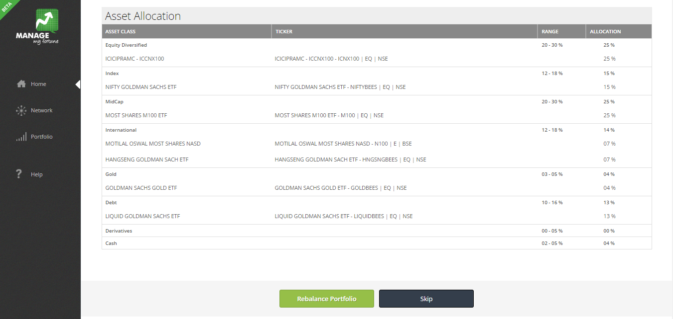

Once the investor clicks on ‘Rebalance Portfolio’ button, the ‘Rebalance Portfolio’ page is shown where investor can execute the trade.

Top Section:

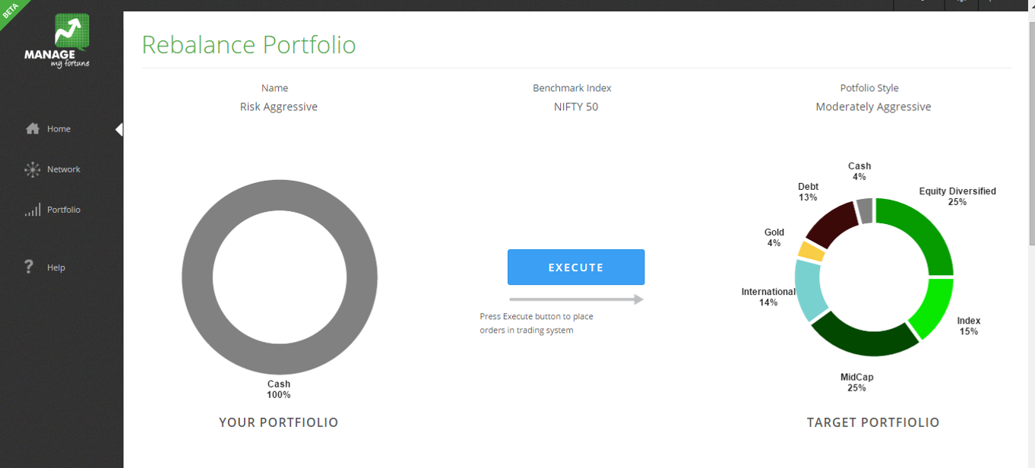

Bottom Section:

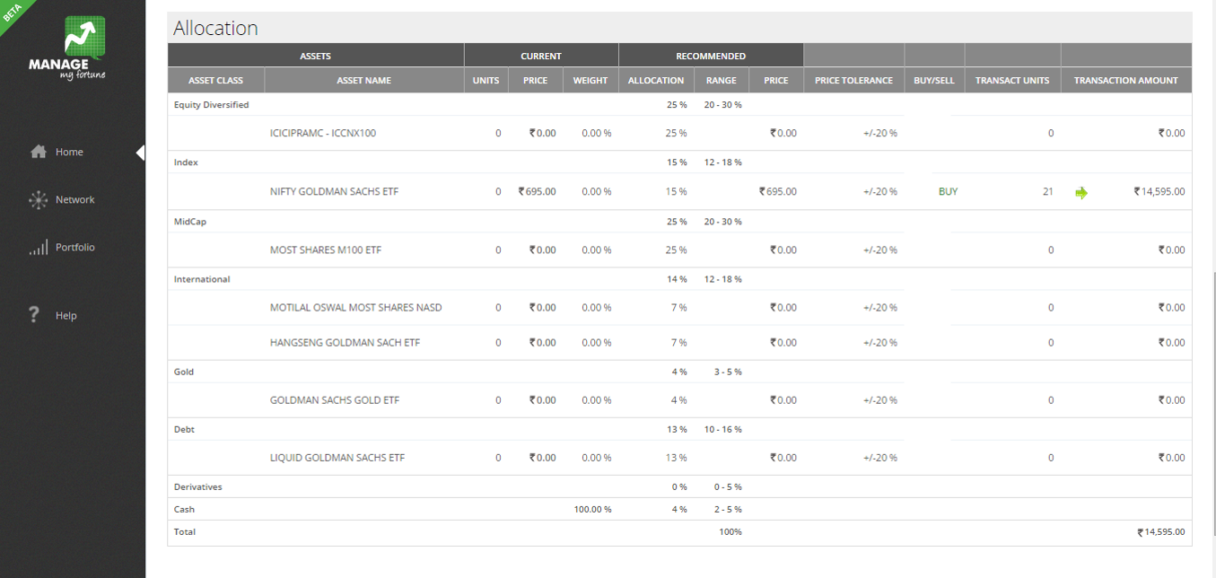

Expected Behavior:

The view portfolio page remains the same except for addional button for SIP functionality (explained in 3.2). The ‘Rebalance Portfolio’ page is modified in order to allow investor to modify the recommended portfolio before execution.

Exected page presented to the investor:
In the table in bottom section of the page, an additional column for “Target Wieghts” is added. This column would be pre-loaded with the recommended or last assigned allocations. The investor may make modify and specify this column entries to change the portfolio before execution.
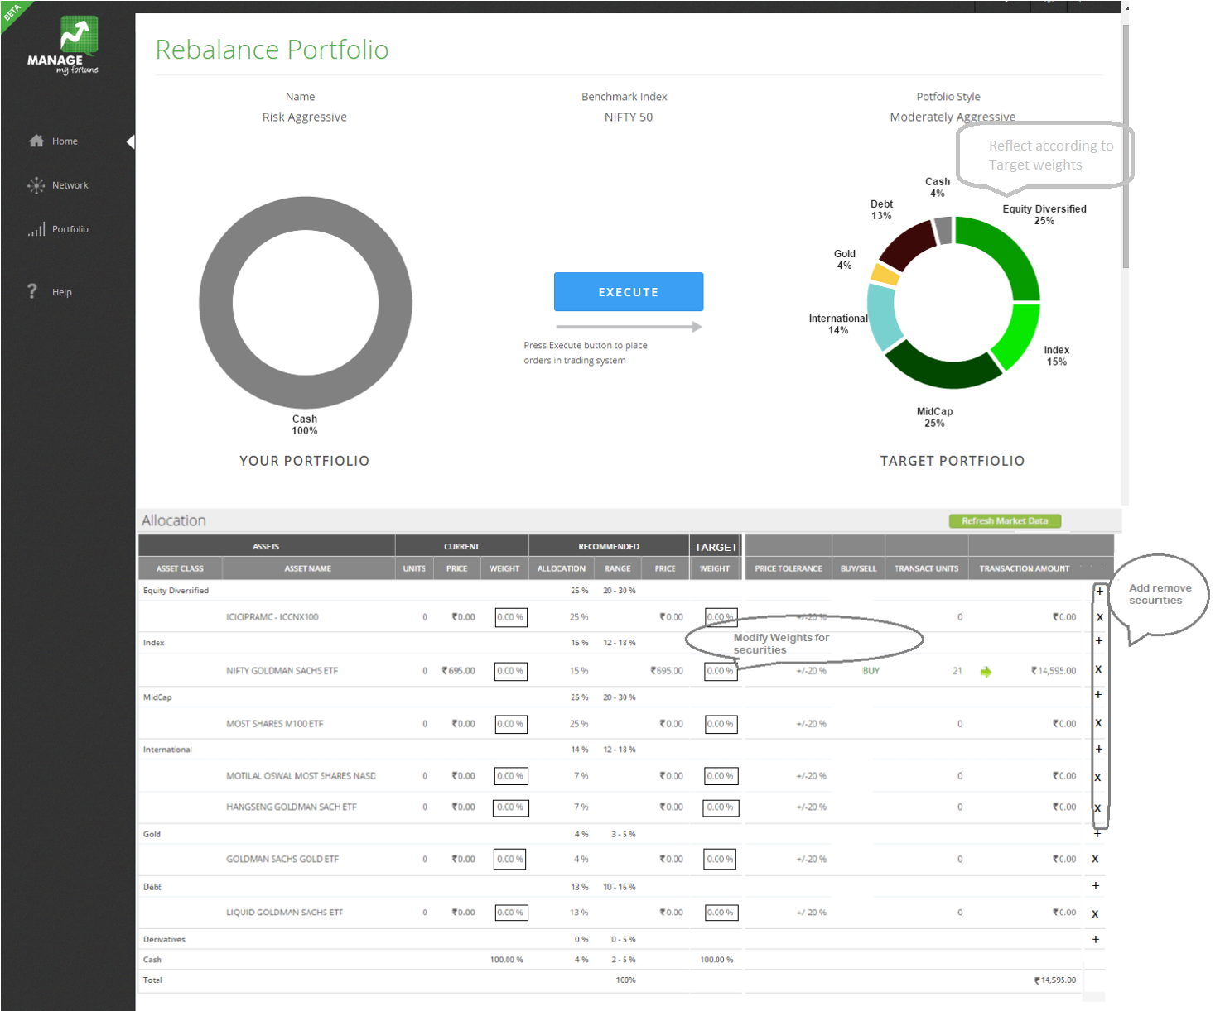

SIP and Auto-execution on Recommended Portfolio

Requirement specification and user scenarios

Pre-requisite
- ECS mandate from the investor to transfer funds to Geojit trading account (Check with Geojit)
- Trading account for the investor

SIP feature is presented to an investor after entering a contract with an advisor. Once the advisor recommends a portfolio to an investor:
- Investor can allocate funds to the account and rebalance the portfolio i.e. execute the portfolio with the available funds in the account. This is a normal SIP less scenario.
- In addition to executing the portfolio manually at once, the investor should have facility to enable SIP functionality for the portfolio
- Hence when the investor visits the ‘View Portfolio’ page, there needs a button on the page to Enable/Disable SIP functionality
- On Clicking ‘Enable SIP’, if the investor has opted for SIP for first time,
  - A Form needs to be shown to the investor for providing necessary inputs for SIP feature
  - The inputs include:
    - Amount to be transferred for SIP on regular interval (Min Rs. 10K)
    - Frequency of SIP (Monthly, Quarterly)
    - Starting Date for SIP execution
    - Trading account login details ( Username, Password on the Geojit’s SIP login page)
    - Confirmation to terms and conditions for SIP
    - Table of portfolio allocations where investor can modify the allocations for the securities.
    - ECS Mandate form for transferring amount from investor’s bank account to Geojit’strading account. (To be captured in initial the account opening form in advance, not on the SIP settings page.)
- Once the ‘Enable SIP’ form is submitted:
  - The ‘Enable’ button should be replaced by ‘Disable’ button and ‘Update’ button should be available.
- While the SIP is enabled:
  - 3 Days prior to the given SIP execution date, funds equal to the SIP amount need to be transferred to the investor’s trading account, hence an ECS request is made to the investor’s bank account with specified SIP amount.
  - An email is sent out to the investor notifying the scheduled SIP with detailed portfolio and reminder to ensure the amount availability in the bank account.
  - On the day of execution, if the amount available in the investor account is more than or equal to the amount required for execution, then the SIP amount is distributed among the securities in the portfolio in their original proportion, and the maximum possible units of the securities are bought for the given amount at their current market price.
  - If the amount available is less than the required, then the investor is notified about the event via email.
  - For every SIP transaction, the trade details are put into the Geojit’s SIP system through FLIP API and the trades are auto-executed without the investor having to provide login details every time.
- All the fee calculation and returns calculation processes remain the same as in case of manual executions.
- When investor opts to disable SIP:
  - The ‘Disable SIP’ button is replaced by ‘Enable SIP’
  - Investors data regarding SIP settings remains as it is
  - But no trades are executed further on regular basis by the system
  - Investor can add funds and rebalance the portfolio manually if needed
- If the investor had opted SIP in past and wants to enable the feature again:
  - The same above form should be presented
  - The form should be pre-filled with the past data
  - At investor’s will, the inputs in the form can be modified

User interface wireframes

On the ‘View Portfolio’ page, there should be a button for enabling/disabling SIP feature.

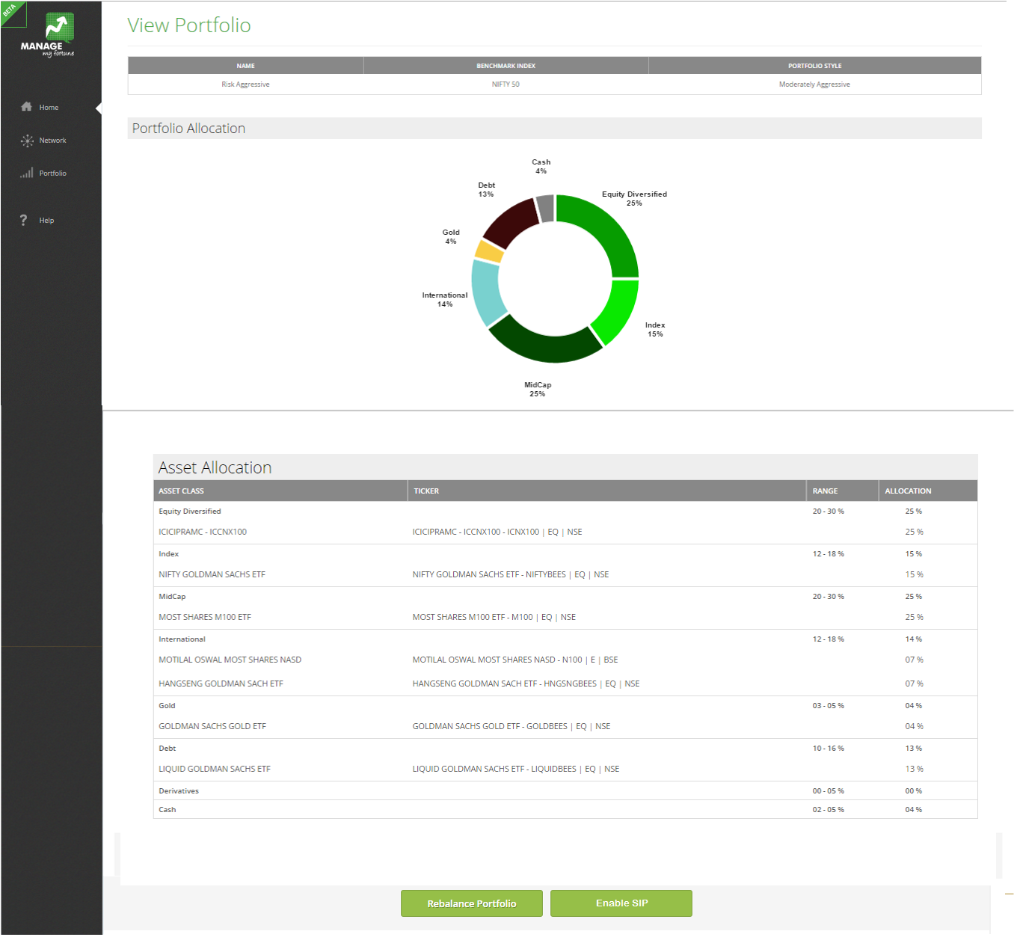

On clicking Enable SIP Feature, following ‘SIP Settings’ page should be presented:

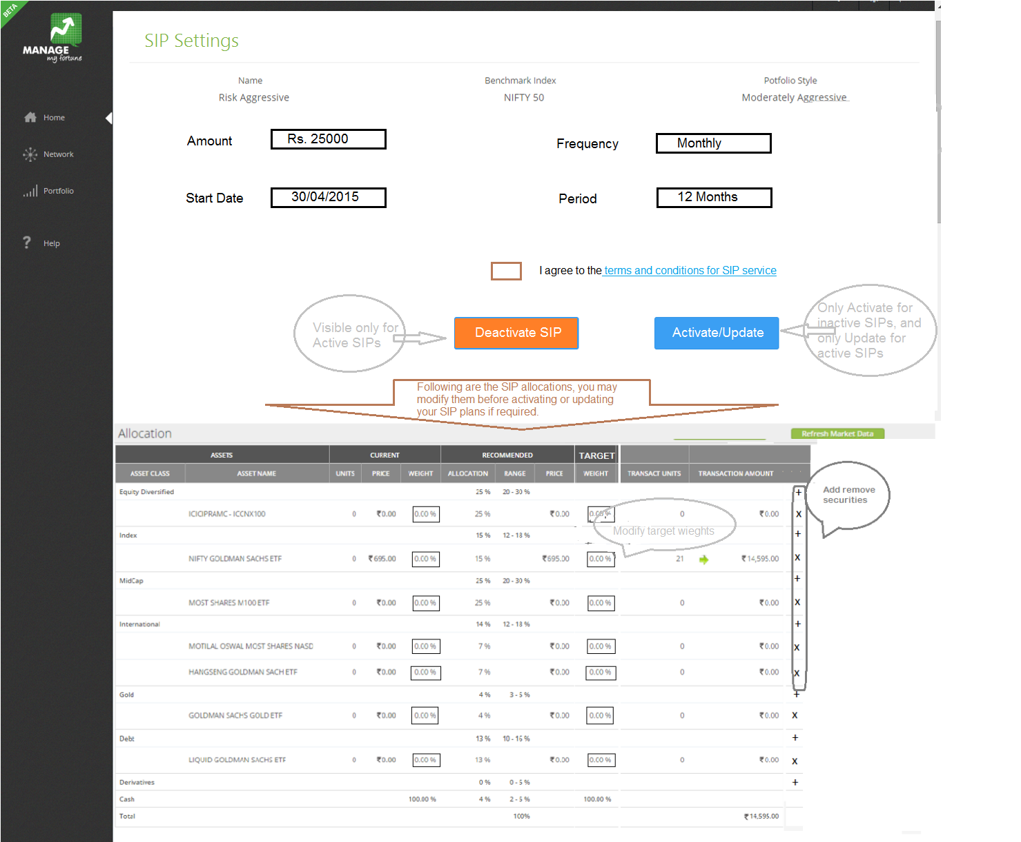

Gamified Personal Details Questionnaire

Gamified personal details involves collecting important data regarding a potential investor’s current financial status and desired life goals. Based on the this information, a financial plan is presented to the investor in a visual dynamic form that reflects the achievability of the life goals, impact of few savings and investment decisions, and few external factors such as inflation and rate of interests etc. The future projections are best represented in terms of interactive graphs showing the investor’s assets and liabilities over the period of expected life span.

Intended user role: A registered user that still has either not activated a trading account or has not entered into a contract with an advisor yet. (For current implementation the tool would be accessible to a registered user having trading account, as currently logins are not allowed for non-trading users.)

The details on the inputs to be collected and graphs to be plotted are given in the spreadsheet model “MMF Financial Planning Tool v1.0.xlsx”. General guidelines for designing screens are:
- Should consist of at the most 2 screens, one for capturing initial data and second for showing the graphs
- The page on which graphs output are show, should allow user to modify important inputs instantly on the same page
- For inputs that may take more space (e.g. details on life goals) on the screen should be stacked in a dropdown or accordion style design
- The inputs also involve a set of assumptions which may have effect on the output. These assumptions should also be editable but hidden in an accordion which may be opened if required by the user
- The graphs should be dynamic, it should at least be possible to zoom in and out on a particular section of the graph. (refer google finance graph for analogy)
- Since there are 5 graphs that need to be displayed, a tabbed display may be designed for navigating through the graphs on the same page.

Note: for current implementation, ‘Risk Profile’ should be kept user defined. Ultimately the risk profile will be taken from the output of ‘Risk Profiling’ questionnaire but that should be done post a comprehensive reshuffle of the application’s process flow.

Requirements Confirmation/Stakeholder sign-off

Meeting Date | Attendees (name and role) | Comments
1-oct-2015 | Sameer, Rahul, Rakesh, Nipul, Suman | Functionality all right, need to confirm SIP related payment process with Geojit.

APPENDIX
- Definitions, Acronyms, and Abbreviations
MMF: ManegeMyFortune.com web platform
Advisor: Type of user on MMF platform that can connect with potential investors for providing investment advisory services.
Investor: Type of a user on MMF platform that can connect with investment advisors for making investment decisions and executing them through the MMF platform.

- References
“MMF Financial Planning Tool v1.0.xlsx” – Model for financial planning tool.

Additional Comments
More detailed Requirement Traceability Matrix, Test plan and elaborate UI/UX wireframes would be incorporated in subsequent version of the document.

