# Design for Transaction and Cash balance transfer

# Scope

Describe design of daily transaction and cash balance data transfer from Back Office (BO) to MMF.  
MMF uses these data for order execution status, cash balance, return calculation, portfolio performance calculation etc.

# Prerequisite

A common database should be available, both MMF and back office has read and write access to it. Back office will insert transaction and cash balance to appropriate tables of this database. MMF will read transaction and cash balance from this database. Writing and reading of transaction and cash details are controlled by job in both Back office and MMF side. The Jobs are scheduled to execute at a configured time daily. Data transfer controlled by entries available in JOB_SCHEDULE_TB. Value in column scheduled_date of JOB_SCHEDULE_TB considered as the actual transaction date. MMF will work based on this.

# Data transfer logic

**Tasks of job at Back office side**

* Insert the transaction details for the day into table MMF_DAILY_TRANSACTIONSUMMARY.
* After completion transaction details, put an entry in JOB_SCHEDULE_TB with following values. This is to inform MMF job, transaction details for the day available.
  + Type = TXN
  + Status = STAGED
  + Scheduled date = transaction date
* Next insert daily cash balance into MMF_DAILYCLIENTBALANCE.
* After completion of cash balance, put an entry in JOB_SCHEDULE_TB with following values. This is to inform MMF job, cash details for the day available.
  + Type = CASH
  + Status = STAGED
  + Scheduled date = transaction date
* To handle the holiday (or the day doesn’t have transaction and cash), system will insert a dummy entries in JOB_SCHEDULE table. This is to inform MMF job there is no transaction and cash entries for the day. Values as follows
  + Type = TXN_DUMMY
  + Status = STAGED
  + Schedule date = transaction date
  + Type = CASH_DUMMY
  + Status = STAGED
  + Scheduled date = transaction date
* Clear 5 day old transaction, cash and job schedule entries.

**Tasks of Job at MMF side**

* Check staged TXN/ CASH entries available in JOB_SCHEDULE_TB.
* Verify previous days TXN /CASH jobs are completed for the scheduled TXN and CASH. If those completed only system start process current data.
* Start transfer transaction details, based on scheduled_date of the STAGED TXN job.
* After transfer transaction for a date update the status of TXN job COMPLETED
* Then transfer cash for the date. Update status CAH job COMPLETED. This process will continue until process all the staged TXN and CASH entries

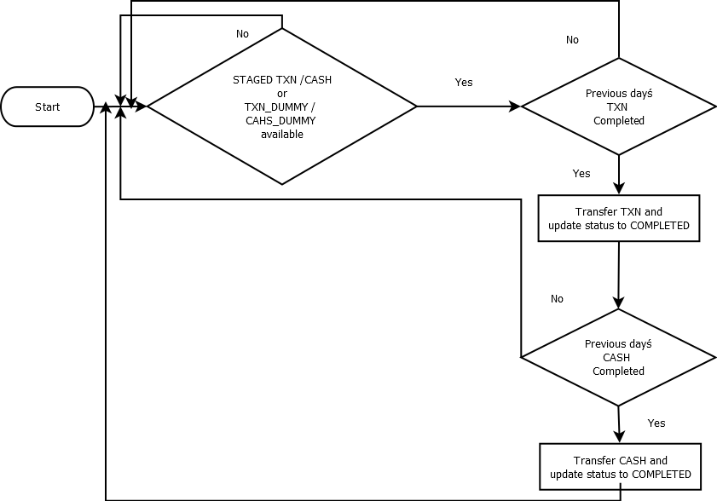

# Tables

JOB_SCHEDULE_TB

|  |  |  |
| --- | --- | --- |
| **Column** | **Type** | **Description** |
| Id | Integer | Primary key |
| Type | Varchar(40) | This column is used to identify the type of data.  Possible values are TXN, CASH,TXN_DUMMY,CASH_DUMMY |
| Status | Varchar(40) | This column value is used to identify the status of scheduled job. Possible values are STAGED, INPROGRESS, COMPLETED, ERROR |
| Schedule_date | Datetime | The actual transaction date |
| Lastupdatedon | Datetime | Record modified date (system date) |
|  |  | Type, status and scheduled_date combination should be unique |

MMF_DAILY_TRANSACTIONSUMMARY

|  |  |  |
| --- | --- | --- |
| **Column** | **Type** | **Description** |
| Id | Integer | Autoincrement |
| Trandate | Datetime |  |
| TradeCode | varchar(16) |  |
| OrderNo | varchar(64) |  |
| Product | varchar(32) | Equity, FO, CDS, Debt, MFSS |
| Security | varchar(32) |  |
| Instrument | varchar(32) | Not For Equity & MFSS |
| Contract | varchar(32) | Not For Equity & MFSS |
| BuySell | varchar(1) |  |
| Quantity | Numeric(15,2) | Default 0 |
| Price | Numeric(15,2) | Default 0 |
| Units | Numeric(15,2) | Default 0 |
| Volume | Numeric(15,2) | Quantity * Units * price |
| Brokerage | Numeric(15,2) | Default 0 |
| OtherCharges | Numeric(15,2) | all chargers other than brokerage |
| Channel | varchar(32) |  |
| Euser | Varchar(16) |  |
| LastUpdatedOn | Datetime |  |
|  |  |  |
| Primary Key | Trandate, TradeCode,OrderNo,Product |  |

MMF_DAILY_CLIENTBALANCE

|  |  |  |
| --- | --- | --- |
| **Column** | **Type** | **Description** |
| Id | Integer | Autoincrement |
| Trandate | Datetime |  |
| TradeCode | Varchar(16) |  |
| LedgerBalance | Numeric(15,2) |  |
| Euser | Varchar(16) |  |
| Lastupdatedon | Datetime |  |
|  |  |  |
| Primary key | Trandate,tradecode |  |

Mail Chain

Hi Amal,  
  
As discussed, attached the data transfer design.  
Please provide your thought on the same.  
  
Regards,  
Anuroop.s  
On 12-06-2014 14:45, AMAL wrote:

Dear Sudheer;

Please create below tables & write a sp to dump data to it on daily basis.

Segments : Equity ( NSE, BSE ), FO ( NSE, BSE ), CDS ( NSE, MCXSX ), MFSS ( NSE ),  DEBT ( NSE )

|  |  |  |
| --- | --- | --- |
| **Table Name :** | **MMF_Daily_TransactionSummary** |  |
|  |  |  |
| Trandate | Datetime |  |
| TradeCode | varchar(16) |  |
| OrderNo | varchar(64) |  |
| Product | varchar(32) | Equity, FO, CDS, Debt, MFSS |
| Security | varchar(32) |  |
| Instrument | varchar(32) | Not For Equity & MFSS |
| Contract | varchar(32) | Not For Equity & MFSS |
| BuySell | varchar(1) |  |
| Quantity | Numeric(15,2) | Default 0 |
| Price | Numeric(15,2) | Default 0 |
| Units | Numeric(15,2) | Default 0 |
| Volume | Numeric(15,2) | Quantity * Units * price |
| Brokerage | Numeric(15,2) | Default 0 |
| OtherCharges | Numeric(15,2) | all chargers other than brokerage |
| Channel | varchar(32) |  |
| Euser | Varchar(16) |  |
| LastUpdatedOn | Datetime |  |
|  |  |  |
| Primary Key | Trandate, TradeCode,OrderNo,Product |  |
|  |  |  |
| **Table Name :** | **MMF_Daily_ClientBalance** |  |
|  |  |  |
| Trandate | Datetime |  |
| TradeCode | varchar(16) |  |
| LedgerBalance | Numeric(15,2) |  |
| Euser | Varchar(16) |  |
| LastUpdatedOn | Datetime |  |
|  |  |  |
| Primary Key | Trandate, TradeCode |  |

Regards  
  
Amal Paul  
Geojit Technologies Pvt Ltd.

**From:** [Sreeraj P](mailto:sreeraj@geojit.com)

**Sent:** Tuesday, June 10, 2014 6:34 PM

**To:** ['Amal Paul'](mailto:amal_p@geojit.com)

**Cc:** ['Anuroop'](mailto:anuroop_s@geojit.com) ; ['Anil Kumar N'](mailto:anil@geojit.com) ; ['Shaju David'](mailto:shaju_d@geojit.com)

**Subject:** RE: Back office data for MMF

Dear Amal,

Kindly come for a discussion.

Regards

Sreeraj

**From:** Shaju David [<mailto:shaju_d@geojit.com>]   
**Sent:** Tuesday, June 10, 2014 6:30 PM  
**To:** 'Sreeraj P'  
**Cc:** 'Anuroop'; 'Anil Kumar N'  
**Subject:** RE: Back office data for MMF

Further to our discussions please find the updated requirement

Daily Transaction Summary Staging Table

|  |  |  |
| --- | --- | --- |
| **Field** | **Type** |  |
| order_id | varchar(100) |  |
| order_date | datetime |  |
| Buy_or_sell | varchar(50) |  |
| trade_code | varchar(50) |  |
| venue_code | varchar(100) |  |
| security_code | varchar(100) |  |
| security_units | int(11) |  |
| security_volume | decimal(7,2) | Units * price |
| brokerage | decimal(7,2) |  |
| tax_n_levies | decimal(7,2) | all chargers other than brokerage |
| channel | varchar(50) |  |

Client Cash Balance Staging Table

|  |  |
| --- | --- |
| **Field** | **Type** |
| trade_code | varchar(50) |
| ledger_balance | decimal(7,2) |
| ledger_date | datetime |

Thanks

**Shaju David**

E: 1913, M: 9995800104

M: 9447092550

**From:** Sreeraj P [<mailto:sreeraj@geojit.com>]   
**Sent:** 10 June 2014 15:37  
**To:** 'Shaju David'  
**Cc:** 'Anuroop'; 'Anil Kumar N'  
**Subject:** RE: Back office data for MMF

**1 Tax** means all chargers other than brokerage?

2. **Security price** will be average price

Am I correct?

**From:** Shaju David [<mailto:shaju_d@geojit.com>]   
**Sent:** Tuesday, June 10, 2014 3:07 PM  
**To:** 'Sreeraj P'  
**Cc:** 'Anuroop'; 'Anil Kumar N'  
**Subject:** Back office data for MMF  
**Importance:** High

Dear Sreeraj,

Further to our discussions yesterday, we need the following data from Backoffice on a daily basis.

As discussed we need only the summary information and it needs to be automatically updated to the MMF database.

Daily Transaction Summary Staging Table

|  |  |
| --- | --- |
| **Field** | **Type** |
| order_id | varchar(100) |
| order_date | datetime |
| trade_code | varchar(50) |
| security_code | varchar(100) |
| venue_code | varchar(100) |
| venue_script_code | varchar(100) |
| security_units | int(11) |
| security_price | decimal(7,2) |
| brokerage | decimal(7,2) |
| tax | decimal(7,2) |
| buy_sell | varchar(50) |
| channel | varchar(50) |

Client Cash Balance Staging Table

|  |  |
| --- | --- |
| **Field** | **Type** |
| trade_code | varchar(50) |
| ledger_balance | decimal(7,2) |
| date | datetime |

Thanks

**Shaju David**

E: 1913, M: 9995800104

M: 9447092550

--

Regards

Anuroop.S