**QUANTITATIVE**

1. **Precision, Recall, F1 Score**

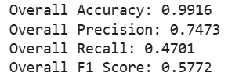

1. **AUC-ROC**

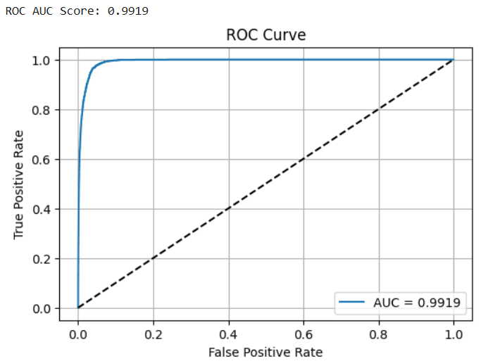

3.Precision-Recall

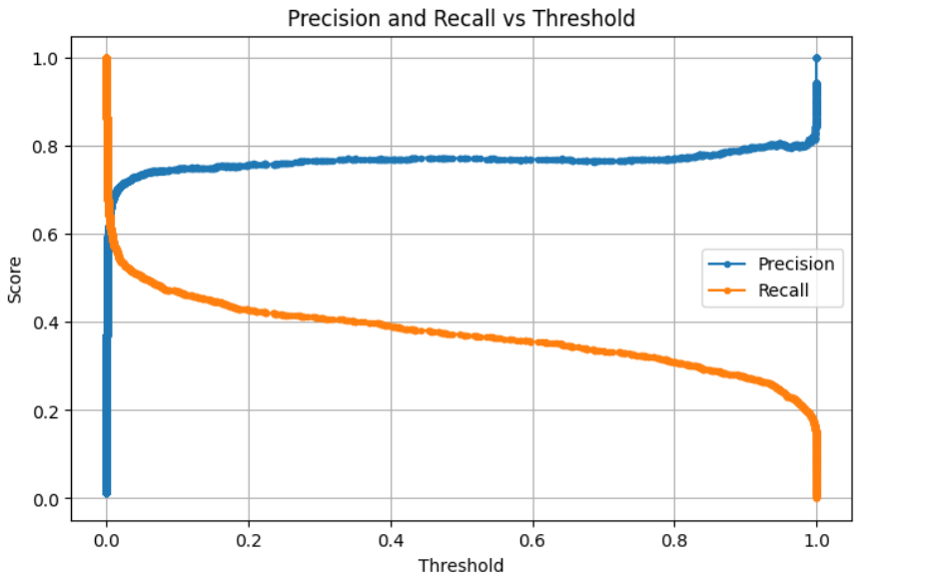

4.Feature Importance

