Name: <Your Name>

Purdue Username: <Your PUID>

Instructor: <Qiu/Liu/Uslu>

**Problem 1.**

**(1) Estimated Functions:**

(*Write numerical values for and )*

**(2) Data Visualization:**

*(Insert plot obtained from data in poly.txt. Note that the plot below is not the solution)*

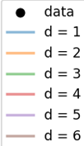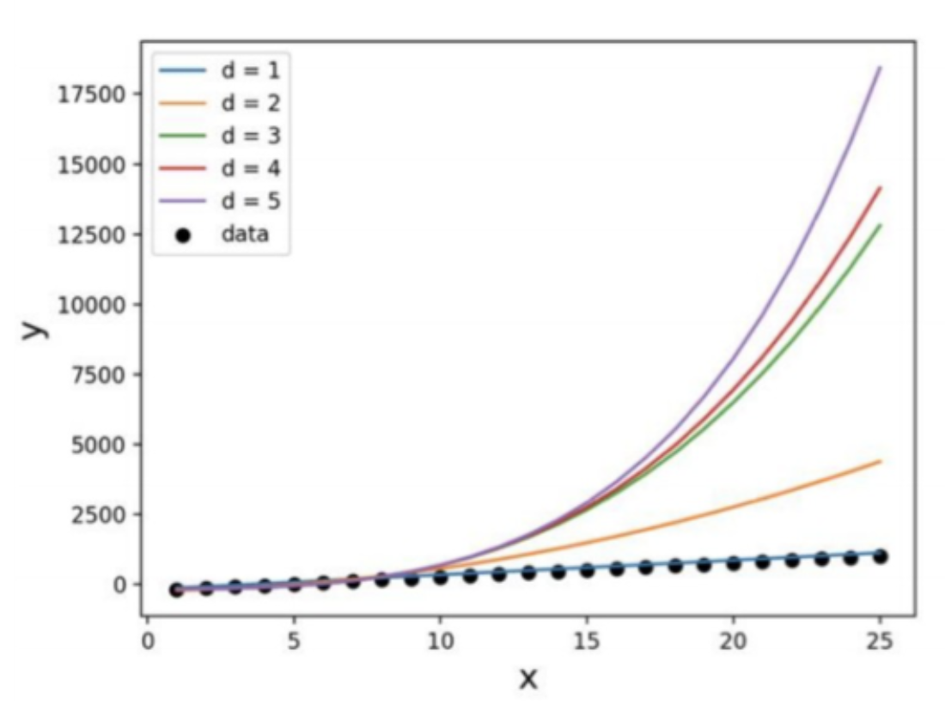

**(3) What degree polynomial does the relationship seem to follow? What does this mean for the other degree polynomials? Please explain your answer.**

*(Discuss relationship of data and state a numerical value for the best-fitting polynomial degree)*

Sample answer:

The data seems to best follow a first order polynomial (i.e., a line) which can be seen from the   
low error between the estimated regression function, and the data in the plot above.

**(4) If we measured a new data point, what would be the predicted value of , based on the polynomial identified as the best fit in Question (3)?**

Sample answer:

If we measured a new data point, x = 2, the corresponding predicted value would be = …

**Problem 2.**

**(1) Plot the mean squared error as a function of lambda in Ridge Regression:**

*(Insert plot obtained by completing the* ***main*** *function. Note that the plot below is not the solution)*

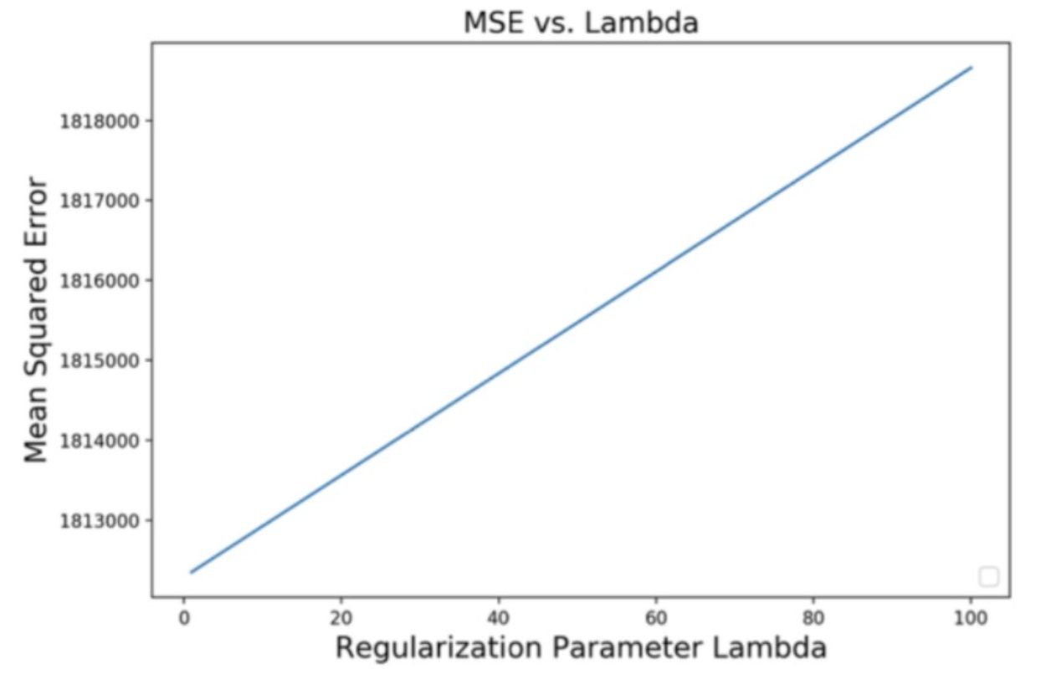

**(2) Find best lambda:**

Sample answer: *(insert numerical values for c and d)*

Based on the range of Lambda values tested, the best lambda value is , which yields an MSE of as shown on the plot above.

**(3) Find equation of the best fitted model:**

(*Insert numerical values for ’s and )*

**(4) Plot the predicted stock prices and actual stock prices using Google data**

*(Note that the plot below is not the solution)*

