Nicolas Sarkis

March 29, 2023

CSE 212

Word count: roughly 3500 words or less.

Please include the question in your report, for easier grading.

In this assignment, you redesign the user interface of your system in order to improve the problematic task you identified in Project Assignment 01.

This redesign is intended to be a reflective exercise based upon the theory, principles, and guidelines presented in Chapter 5 of the Stone et al. textbook, and part 3 (design part). We are as interested in the process of design as in the design decisions that you make, so you must justify your approach throughout. Read the whole assignment before starting the redesign.

**Question 1**: Introduction - [about 200 words, 3 points] Write a brief introduction, that:

1. places the report in context as the second assignment for CSE212, with respect to Assignment 01 and the course as a whole.
2. summarizes the purpose and content of the report.

In this report we start the design and modeling phase of our project. Using what we have learned from the first assignment, we will create a redesign that solves users' pain points. We will improve the layout of the dashboard by combining the card and list views, as well as including the course grades over each course. We will adjust the sidebar menu in course view to eliminate the tabs that are not used by professors, and pin and highlight the more important tabs such as assignments and grades. We will use strategies learned in class to re-engineer Canvas, such as creating use cases and utilizing them to create conceptual designs. From these conceptual designs we will create sketches and a prototype, which will eventually be shown to current Canvas users to observe their thoughts and feedback. We will justify and defend our design choices from a computer science perspective, explaining how each new change lines up with the design principles learned in class.

**Question 2**: Work re-engineering - [about 600 words, 12 points]

Work re-engineering is explained in Chapter 8 of Stone et al. and Chapter 11 of Sharp et al.

* 1. (4 pts) Create a use scenario that describes how the redesigned user interface will support your selected task. Be sure to thoroughly explain how the new design will be an improvement upon the original/ current design of the system.

The first task we will focus on is accessing the grade of an individual assignment. Our user, John Doe, is a freshman who is new to Canvas. John would like to check his grade on an assignment called Homework 5 in his CSE 212 class. John starts out by logging into Canvas, and is now at the dashboard page. John sees CSE 212 in the cards on the top of the page. He clicks his course and instantly sees "Grades," as it is one of the pinned tabs on the top of the

sidebar. John selects this tab and is able to see all the grades he has received in this course. He finds the assignment he is looking for and reviews his grade. The entire task took John about one minute to complete, and he is satisfied with the process since it is straightforward.

With the old UI, the dashboard is in list view by default, and when there are no future assignments for a course, the course does not show up. There is nothing signaling that he can switch to card view using the unlabeled hamburger menu in the top right, so John uses the courses tab on the left navigation bar, which takes an extra click. With the new design, we combined the two views, so the user can always navigate to each course from the dashboard. Upon reaching the course page, John sees the side list of tabs. At first glance John does not see the grades tab because it is not in the same place as his BIO 116 class, which frustrates him. He must scroll through over a dozen identical tabs to find the one that says "Grades." With the new design, the grades tab is in the same place, no matter which course you are in. The new system also allows you to go directly to the grade shown in the card view.

* 1. (8 pts) Create an essential use case for the use scenario. Justify how the different tasks have been allocated between the user and the system.

We will be using a search and request resource to demonstrate the task allocation for the use case above.

|  |  |
| --- | --- |
| **User’s Purpose** | **System responsibility** |
| Log in to Canvas | Validate user credentials |
| Complete MFA request | Validate MFA request, open dashboard |
| Select a course | Open the course home page |
| Select the grades tab | Open the grades page |
| Select assignment to review | Open the assignment |
| Close webpage | Sign out |

**Question 3**: Conceptual design - [about 900 words, 18 points]

Conceptual design is explained in Chapter 8 of Stone et al. and Chapter 11 of Sharp et al. There are examples of the below 3 questions in the textbook and/or the slides.

* 1. (4 pts) Create a concrete use case corresponding to the essential use case. Mark up the concrete use case, indicating the task objects and attributes.

Google Docs does not have a double underline feature, so attributes are bolded.

|  |  |
| --- | --- |
| **User’s Action** | **System response** |
| Student enters **credentials** into the login screen and clicks log in | System checks the **credentials** and sends a MFA request to the student's mobile device |
| Student approves of the MFA request on a mobile device | System verifies MFA and brings the student to the dashboard page |
| Student selects a course by clicking on a card in the card view | System opens the course’s home page |
| Student selects the grades tab that is pinned to the top of the gray list on the left of the screen | System opens the grades page with the **grade** of every assignment in that course sorted by **due date** (by default) |
| Student searches for and clicks on desired assignment to review it | System opens the assignment and displays its information in full detail, including **grade**, **assignment name**, and **rubric** |

* 1. (6 pts) Based on the concrete use case and the work you carried out for Assignment 01, create an object–attribute–action table for the primary task objects.

|  |  |  |
| --- | --- | --- |
| **Task object** | **Attributes** | **Actions** |
| Student | Login | View |
|  | Name | Add |
|  | Name recording | Edit |
|  | Password | Delete |
|  | Phone number | Save |
|  | Pronouns |  |
|  | Contact |  |
|  | Biography |  |
|  | Links |  |
|  | Profile picture |  |
|  | University/Institution |  |
|  | Enrolled courses |  |

|  |  |  |
| --- | --- | --- |
| **Task object** | **Attributes** | **Actions** |
| Course | Course name Instructor Students enrolled  Tabs included (eg. is the Files tab hidden or not) Assignments Announcements  Discussion posts Syllabus | View Add Edit Delete Save  Enroll student  Unenroll student |

|  |  |  |
| --- | --- | --- |
| **Task object** | **Attributes** | **Actions** |
| Assignment | Assignment name Description  Type of submission (quiz, text file, video, etc.)  Due date  Available dates (dates that the assignment opens and closes) Grade  Rubric Comments  Score details  Group or individual assignment | View Add  Edit (due date, title, description, etc.) Delete  Save  Submit Resubmit  Add comment  Reopen submissions (after assignment is closed) |
|  |  | Input grade  Add rubric comments Edit grade |

* 1. (8 pts) Create a detailed content diagram for the part of the system you described in your essential use case.

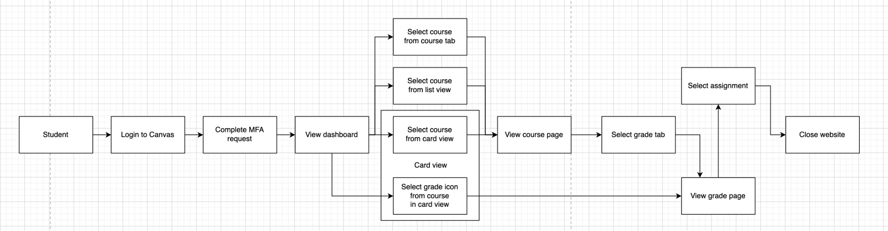

This content diagram has strong correlation to the system and its essential use case and not a markedly different interpretation of it. Users at the beginning completes the MFA flow to login. After logging in, users have four ways to access the system, with two from card view. And, instead of just one way to access the grade view, there are now two ways to get there, with one directly from card view. Should users not access the grade view from card view, users will select course from the three other options: the course tab, the list view, or the cards in card view themsleves, select grade tab, then from there can select assignment. Finally, after finishing their assignment, users can close the page.

**Question 4**: Prototype of the re-designed interface - [about 400 words, 20 points]

Prototyping is explained in Chapter 6 and in various places in part 3 of the Stone et al. text, and Chapter 12 of the Sharp et al. textbook.

Create a prototype of a re‑designed interface for the system you are studying. You can choose to create:

* + - a low-fidelity prototype, either using paper, screen dumps, or drawings using software tools of your choice.
    - a high-fidelity prototype using the prototyping tool included with the course, or another tool of your choice.

Describe the new interface in your assignment. Provide sketches or screen dumps to illustrate how the users interact with the interface, and how it deals with the previously problematic task you identified in Assignment 01. This description should match the use scenario in Question 2.1 above. If it does not, explain why the two are different. You do not need to be concerned about producing a 'perfect' design at this point, as you will be undertaking a practical evaluation of the usability of your re-design, with users, for Assignment 03. Our suggestion is to use Invision, https://[www.invisionapp.com/](http://www.invisionapp.com/) because it will be very useful for your evaluations later in Assignment 3.

In your prototype, you can include images and other software components from sources such as the web, CD-ROMs, and others, but you must reference these in your assignment. Do not submit any software with your assignment. Even if you decide to create a high-fidelity prototype, you must find a way to create a self-contained report. Typically, this will involve taking screen dumps from your prototype and including these close to the relevant sections in your assignment.

Figure 1:

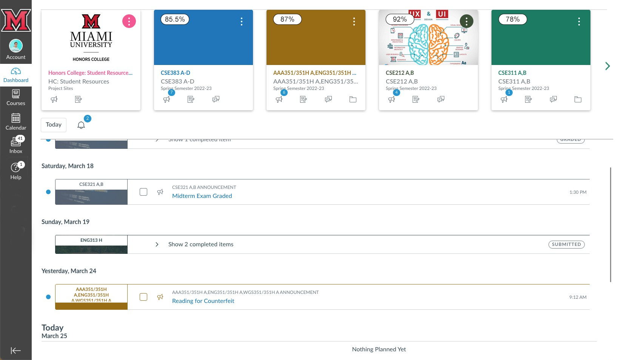

Figure 1.1:

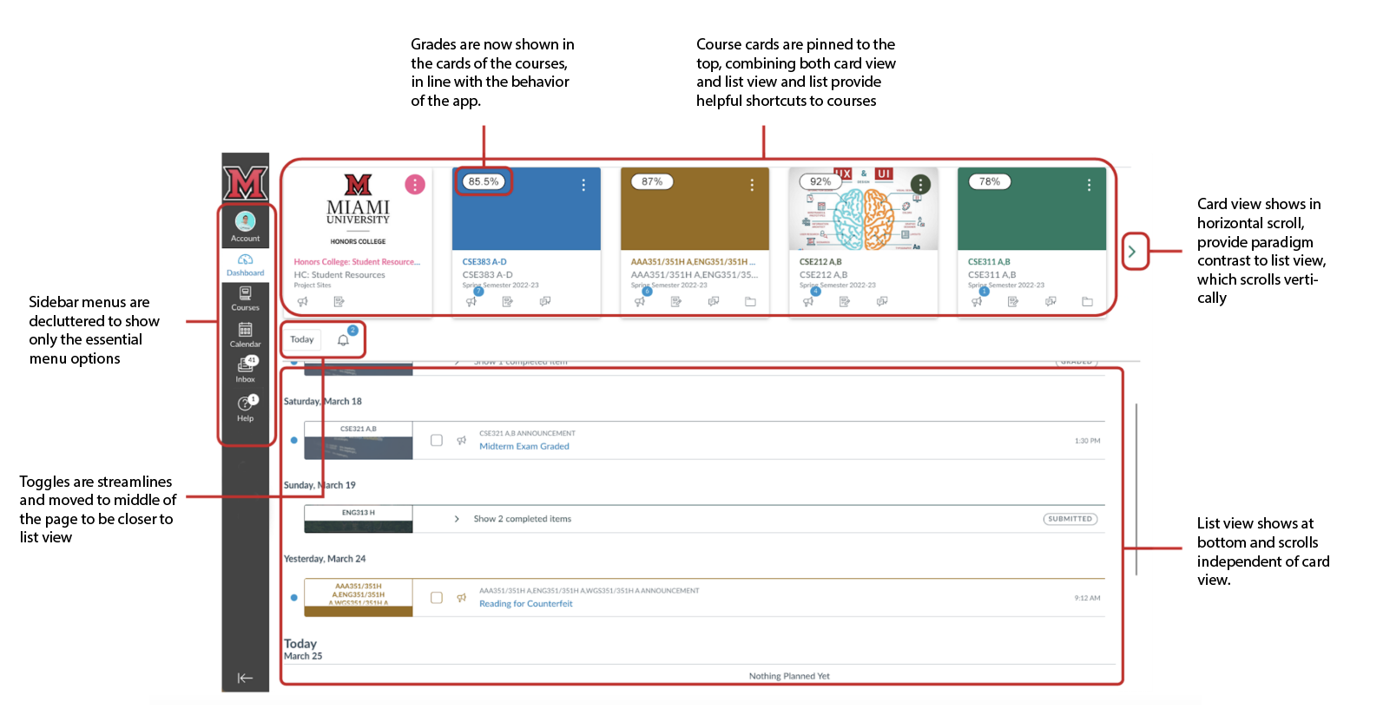

Instead of an unlabeled hamburger menu alternating between "List view" and "Card view," the updated design integrates these two views. The card view is fixed at the top, offering instant shortcuts to the courses users have enrolled in.

Each card now features an easily glanceable grade average in the top left corner, enabling users to monitor their progress in all courses and being a direct shortcut to the Grades tab of the respective course, providing convenient access to grade information.

Menu items such as "Today" and "Notification" have been relocated to the middle of the page, adjacent to the list view. The number of menu items has been condensed to the two most essential functions.

The number of sidebar items has been trimmed to the five most important.

Figure 2:

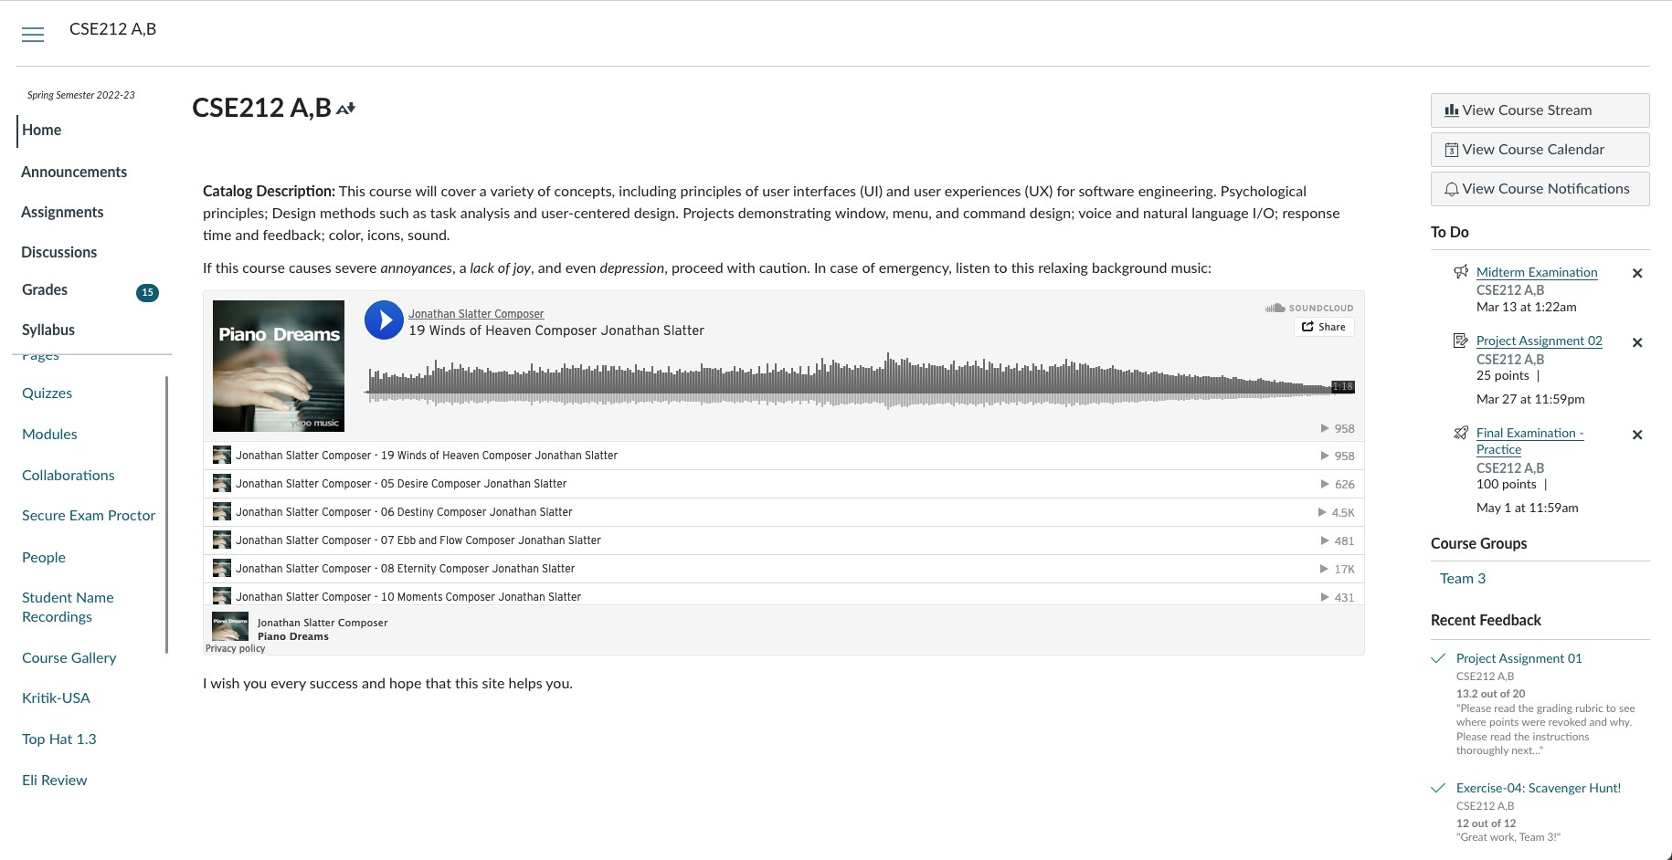

Figure 2.1:

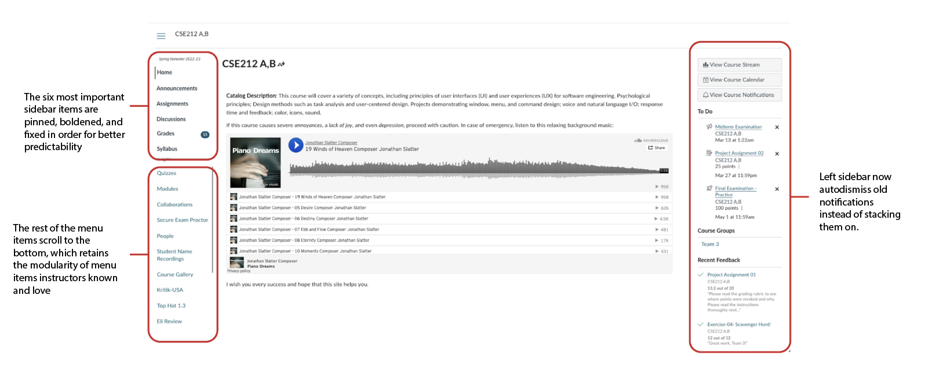

For the course view, the six most accessed items are now pinned and fixed in order to the top of the side element. These elements are boldened to separate them stylistically from the rest of the items. The rest of the items are still fully customizable and toggleable to instructors.

The right-side element now has auto dismissal of past events, preventing them from cluttering up the to-do list of users.

**Question 5**: Justification of the redesigned interface - [about 1200 words, 40 points]

* 1. (4 pts) Explain how your design uses the information in the content diagram from the conceptual design you created in Question 3, above.

The redesign of the system does not affect the login flow of Canvas, but after login, users now have three ways to access a course from the dashboard: the Courses tab, the list view, and the card view. From here, users can navigate to the Grades tab. Alternatively, from the dashboard users can select the grade icon in a course card to go directly to the grades tab. Users can then select the assignment, then close the website.

* 1. (6 pts) Choose either (a) or (b) below.

*Metaphor and interaction styles are described in Chapter 10 and Chapter 11 of the Stone et al. textbook, respectively, and in Chapter 7 of Sharp et al.*

1. Identify a metaphor used in your redesign. You could choose a small part of the interface, such as the symbol used on a particular icon, or you could choose a wider metaphor, such as the overall interaction style. Describe the metaphor and its use in the re-designed system. Explain how the metaphor promotes an appropriate user mental model. You may find that the steps of the human–action cycle are helpful here.
2. If you did not use any metaphorical elements in your redesign, perhaps because you chose a command-line interface, explain how you arrived at this decision. Explain how your new design will promote an appropriate user mental model. You may find that the steps of the human–action cycle are helpful here.

Our redesign did not introduce any new metaphors, and other metaphors were removed for the purpose of simplicity. Through our own experience and from gathering information from other users, we found that each user's mental model and understanding of Canvas was slightly different, and none of the users had taken the time to investigate the site and fully understand its features. Students assumed that the best way to achieve a goal was a clunky, unnatural sequence of steps, and many of the simpler solutions that students were unaware of were hidden behind interface metaphors which did not immediately convey their purpose.

As an example, the current design includes a notebook icon in the top-right corner of the dashboard when in List View mode, which causes a tab to slide out displaying grades for each course. None of the students we spoke to were aware of this feature, believing that each course grade had to be checked individually. Because the purpose of the notebook icon is not immediately clear, and most users do not strongly associate a certain icon such as a notebook with course grades, they would not be aware of this feature unless they were actively looking for it. When the feature is not immediately visible, and another, much more tedious option exists, the user does not repeat the human-action cycle, because their goal has already been achieved by a different, more tedious sequence of actions.

We decided to remove this notebook icon and simply display a student's grade on top of the card for the relevant course, so each grade could be visible from the dashboard. By removing this metaphor, we hope to make it so students are more aware of the features of the site, and their mental model will more fully encompass the way that the site can be used.

*Simplicity, structure, consistency, and tolerance are explained in Chapter 9 of Stone et al.*

* 1. (8 pts) Justify your design in terms of the four design principles, aiming for about 4 sentences each:

simplicity structure consistency tolerance.

*The choice of interaction devices is explained in Chapter 12 of Stone et al. and Chapter 7 of Sharp et al.*

To increase simplicity, we had a few minor changes that allowed for a cleaner looking design. We removed the dashboard title at the top of the page, since the sidebar indicate you are on the dashboard. We removed the History and Groups icons on the sidebar, since they provide confusing and unneeded functionality, and removed the buttons to show all course grades or navigate between views, since these options are both now available on the dashboard.

For structure, we kept the design organized and sensible. We combined the list and card view on the dashboard, which is an improvement from having both mutually exclusive and hidden in an unlabeled dropdown. We also moved the Today and Notifications buttons to the center of the screen above the list view, since it is more relevant to the list of assignments than to the cards for each course.

To improve consistency, we structured the design of each page in a way that is similar to other pages, to make the UI easier to remember. We learned that many users struggle to find specific tabs on the course view, since they are in a different place for every course. We decided to pin the six most important tabs to the top, so that they appear in the same place regardless of which course is selected. We will restrict the professors ability to move these six tabs around to ensure consistency.

In terms of tolerance, a student is already prevented from doing most risky actions on the site, so the main "mistake" a student might make is to miss the deadline for an assignment. To prevent this, we changed the To Do list to auto-dismiss old assignments, so the user will not have remember to manually do this. This way, the list will not constantly be full, and old assignments will not hide new, upcoming assignments. On the current site, if the user doesn't remember to dismiss their old assignments, new assignments will go unnoticed, and the student might miss a deadline.

* 1. (9 pts) Justify your choice of interaction devices for your redesign. Explain how your choice was influenced by the following considerations.

While creating our design, we had to think about the different types of people and technologies which can access Canvas. Canvas can be used by anything with internet access, but our redesign focuses strictly on PC/laptop access, since the user interface is different for mobile devices. Keyboards can be used to traverse the website using arrow keys, tab, and enter, or by using the find function control or command F depending on the type of device you are using. Some keyboards are not the same layout as others, but since all tasks can and

should be completed with a mouse, we did not take this into consideration. Pointers are also used and are the main way in which the website is traversed, using a mouse or touchpad to click on tabs/buttons. Interaction devices chosen are generally the simplest and most common types of devices, so that more advanced or complex equipment does not become a barrier to use.

1. The users, tasks, environment, and domain of this system. You will need to refer back to the work you carried out for Assignment 01 in order to do this.

Canvas is used by millions of people, so the range of users varies greatly. Canvas is used for people from freshman year all the way to those pursuing a doctoral degree, so age is something that we needed to factor in. In the majority of colleges including Miami, students are required to have a laptop so they can access online resources. Canvas requires the most basic computer skills, which all users should already have. A large concern for a certain type of users is those with a physical disability such as hand tremors/parkinsons, these users would struggle greatly when trying to use a mouse. For these users, a keyboard would be much easier, since this does not require hand dexterity.

For tasks, it is likely that students will have multiple tabs open or be working on multiple things at once. For this reason, we wanted to make our design as simple as possible, as Canvas should be something you only need to spend a minute or two on rather than having to search for an item for a longer period of time. All tasks involving Canvas are relatively simple, involving point and clicks using a mouse, trackpad, stylus, or even a touchscreen. There is not much required to be able to perform each task, and although it may be preferred to have a computer that can load things as fast as you click them, that is not necessary. Canvas is a very basic tool that does not require very much space, and only a web browser is needed to run it.

User environment varies greatly with users. Everyone uses it while on campus and has the same level of connection, but when users go home to use it things change. Some users use a PC rather than laptops, which allows for a much faster system. From a physical environment point of view, users may be much more distracted based on where they are working. Like mentioned before, there is not much space needed to run this website. The most basic of laptops can run Canvas, so you do not need a very robust device. Additionally, Canvas takes little to no space, and almost every computer comes with a web browser already installed.

The domain of the system is education, which means that no specialized,

industry-specific devices should be required to access Canvas. It should be navegable using a standard keyboard and mouse, which most students have access to, whether on a desktop or a laptop.

1. The technical characteristics of the devices.

The most-used device for Canvas is a laptop, which is a portable device. Laptops vary in type, from an adequate Dell XPS laptop to a much more powerful Razor. The Canvas webpage takes very little to run, so either of these devices would be suitable. A user can use a pointing device such as a trackpad, mouse, or pen to use to traverse the webpage. They can also use a keyboard, as this would help those with disabilities or those with a broken mouse or trackpad.

The other device that we focused on is a PC/desktop, which is not portable and is normally only set in computer labs or home setups. These devices vary in power, but again, that is not an issue when it comes to Canvas. When using a desktop, users generally only use a mouse and keyboard — there are no trackpads or pens.

1. Organizational and financial constraints.

There are no real organizational or financial constraints for Canvas. A university has access to it by buying licenses in bulk for the website, which allows them to save money.

Canvas is a very robust website, so when it does break there is plenty of organizational support through Instructure or Miami’s help desk. In order to attend Miami, everyone has to buy a laptop, so that is the only financial constraint when it comes to this website. Miami has plenty of different support systems when it comes to funding a laptop, so every student is able to purchase one to access Canvas.

Your discussion must include a discussion of at least one device that you considered but was found not to be feasible. Explain your reasons for rejecting it.

Our rejected device is mobile phones. Even though Canvas can be accessed through a web browser app downloaded on a phone, the experience does not scale down, hence the availability of a mobile app. We are strictly focusing on the web version of Canvas, not the mobile application. If we were to try and consider a design suitable for both mobile devices and computers, we would be sacrificing the effectiveness and efficiency of the version we have created. Lower screen real estate will cause paradigm shifts, requiring two separate designs.

Another rejected device would be joysticks. While they could theoretically be used, it would be the hardest and not practical. A mouse, being vastly more popular than joysticks, achieves everything a joystick does but in a much better fashion.

*The psychological principles and software components are explained in Chapter 5 and Chapter 13 of the Stone et al. textbook, respectively.*

* 1. (9 pts) Select three of the components listed below.
     + Text
     + Color
     + Images
     + Moving images
     + Sound
     + Layout

For each of the components you selected above, justify the use of the components in your interface with reference to all of the following psychological principles:

* + - users see what they expect to see
    - users have difficulty focusing on more than one activity at a time
    - it is easier to perceive a structured layout
    - it is easier to recognize something than recall it

You may find it helpful to contrast your improved choices with the use of software components in the original system.

The biggest use of color is on the dashboard, where a color is assigned to each course. Users can easily change these colors, allowing them to match the colors to their own personal associations. For example, one student might associate math with the blue, and science with the green. They can more easily recognize a course if they are allowed to change the colors to match. Additionally, in List View, it is much easier to focus on one course at a time by looking at only the assignments of the relevant color. Although we combined List and Card view, we decided to retain this color-coding feature due to its versatility.

We made a minor change in color and text by darkening and bolding the text for the six most pertinent tabs in the course view. Here, color is used for grouping, indicating that these six tabs are special and have been pinned to the top of the list for each course. The blue tabs below are subject to the instructor's discretion, and may vary between courses.

The original site lacks structure and predictability, as tab order varies for each course and students must search through a long list of identical-looking tabs each time. Now, users will see the same six black tabs for every course, creating a more predictable navigation experience that aligns with user expectations.

Images are generally used as the course cards on the dashboard or as screen metaphors and icons. We opted not to alter the course card images, as they effectively capture users' attention and prompt them to open the course view. However, many interface metaphors are ineffective, failing to draw the user's attention and often not being strongly associated with the feature they depict, such as the notebook icon discussed in section 5.2

Rather than replacing these interface metaphors with more engaging images, we combined their functionality with existing features, so the user will not have to redirect their attention between different parts of the application. This approach also makes it so users will more naturally run into information, rather than needing to remember to seek it out.

The major layout change we made was merging the Card View and List View pages. Currently, these are presented as two distinct "views" of the dashboard, implying that they display the same information differently. Whereas Card View displays the student's courses, with a small To Do list in the corner, List View displays a list of upcoming assignments. Oddly, in addition to the hamburger menu that allows switching between views, clicking "Show All" at the bottom of the To-Do list also opens the List View. This action confuses users, as they expect an expanded

To-Do list but are instead taken to an entirely new page with an unfamiliar format.

In our dashboard redesign, we retained a condensed version of the course cards for easy navigation to each course page, while removing the To-Do list and displaying the List View beneath the cards. This approach combines the benefits of each view, eliminating the need for users to discover each layout and decide between them.

Design areas are explained in Chapters 16, 17, and 18 of the Stone et al. textbook, which we do not cover entirely in class. You will have to do some independent reading on this topic.

* 1. (4 pts) Identify the design area(s) you have chosen for your redesign. State which guidelines are appropriate to these design areas, and why. How have these specific guidelines influenced your redesign?

The design area of Canvas is a web page. Canvas generally does not use the GUI widgets outlined in the textbook, apart from the tabs, which are commonly used to navigate between pages.

Guidelines for web pages:

* + - **High-quality content.** Canvas already includes a huge amount of important features and information, so we are generally not adding new content to the site. The current site tends to provide more information and functionality than necessary, so if anything, we are removing or hiding features that are rarely used or redundant.
    - **Often updated.** The site itself rarely needs to be updated, but its design allows instructors to post content and make changes often, which students need to be aware of. Canvas usually notifies students when changes are made, but our redesign makes course grades more clearly visible, so students notice when they are updated, and improves the To Do list feature, so students will be more aware of changing deadlines on their assignments.
    - **Minimal download time.** Canvas is very simple and includes few videos and graphics. Nobody we spoke to expressed issues with the download time, so we are not focusing on this guideline.
    - **Ease of use.** This is our main consideration. The current site provides too much information and too much flexibility, reducing users' ability to find things quickly. By improving consistency and removing or combining redundant features, users will be able to better focus their attention while using the site, as well as being able to understand the entirety of the site rather than a select number of functions.
    - **Relevant to user's needs.** Most needs are already met by the Canvas site, so this is not a main concern of our redesign. The main issue is that these solutions are tedious or difficult to find, which is an ease of use problem. We will remove features which are irrelevant to user's needs, such as the Groups and History tabs.
    - **Unique to the online medium.** Canvas is best-suited for an online site, as information is constantly being posted and changed by instructors. This is not a concern for our redesign.
    - **Net-centric corporate culture.** In this case, the website itself is the service/product, rather than a tool used to provide one. Because of this, the website is prioritized by Canvas, and we will not focus on this guideline.

**Question 6**: Conclusion and quality of the report - [about 200 words, 3 points for the conclusion, 4 points for quality]

Write a conclusion that:

1. describes what you have achieved in the report
2. restates the main points of your work including any recommendations and proposed future actions.

Your report will also be assessed for its overall quality – its consistency, coherence, completeness, and legibility.

This report outlines our intended redesign of the Canvas site. We have modified the site to address the issues identified in our first assignment, and we have justified our decisions using the principles learned in class. We started with work re-engineering and conceptual design, mainly focusing on the goals of checking assignment grades and identifying upcoming assignments. We then provided a prototype of the redesigned site, with modifications such as combining List View and Card View, displaying the course grades on top of each card, and eliminating unnecessary features such as the Groups and History tabs. We justified these decisions using concepts such as the user's mental model, the steps of the human-action cycle, the four design principles, and psychological principles. We fully considered the context in which the system would be used and any other factors which might influence our decisions, and confirmed that the current design area was the correct choice for Canvas. In all, we have described our redesign of the site and fully justified each change. In our next report, we intend to evaluate the redesigned system to determine whether the changes have had the intended effects.