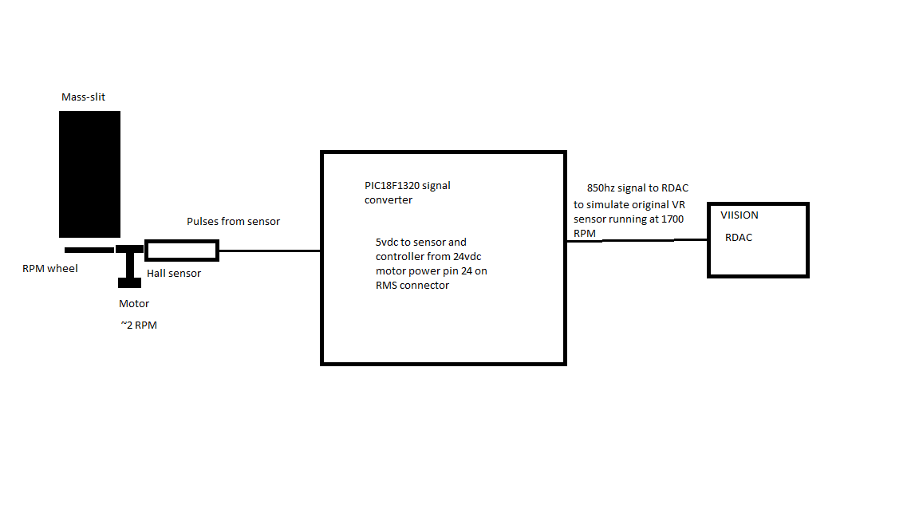

This MOD replaces the high speed RMS spin motor and VR sensor with a 1.9RPM motor and zero HZ Hall sensor. The original sensor generated a ~840Hz signal that is emulated by the PIC controller module.

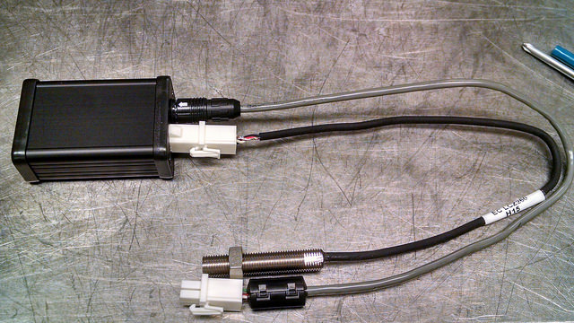

The only adjustment is the signal level output R1 shown here on the PCB. Normally set for mid position.

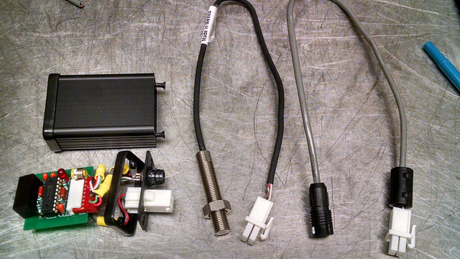

The original sensor is removed and replaced by the Hall sensor with the same gap between the toothed wheel. 24 VDC for the new module is tapped from the RMS Assy wiring harness.

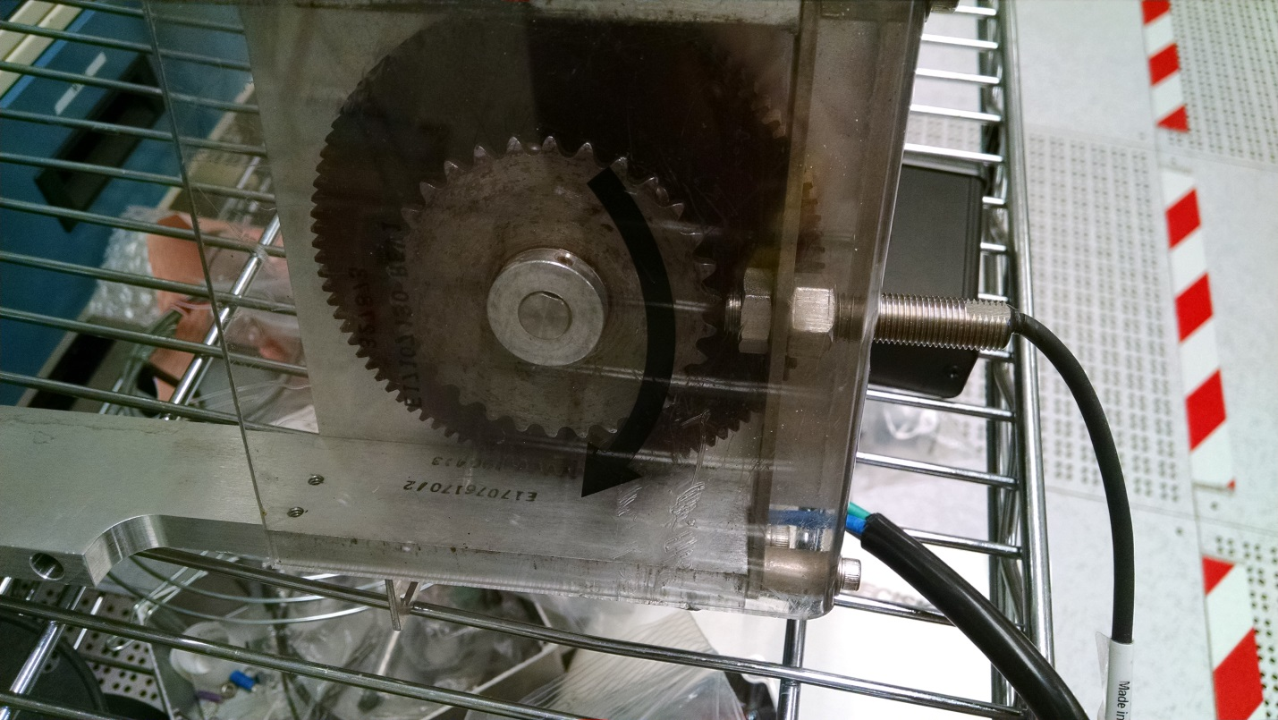

From the software code

/\*

\* Driver for slow speed RMS monitor/speed signal generator

\* std input 57 pulses per min, output 850Hz

\* Runs on the PIC18F1320, with watchdog and software checks to be

\* sure we only generate the correct signal when the motor is running.

\*

\* Version

\* 0.1 config chip to translate input pulses to the correct RPM signal

\* 0.2 rs-232 debug RX DIP-pin7, TX DIP-pin8

\* 1.0 beta production test version.

\*

\* HiRose din connector 1 sig out, 2 sig ret, 3 shield/gnd, 4 24vdc power in, 5 rs-232 rx, 6 rs-232 tx

\*

\* Sensor connector:

\* Cherry gs100502 sensor : BRN/Vcc-Pin4, BLK/OUT-Pin1, BLU/GND-Pin2

\* Honeywell LCZ260 : RED/Vcc-pin4, WHT/OUT=pin1, BLK/COM0pin2

\*

\* RMS Assy connector: 1 SLIT-FOR, 2 SLIT-REC, 3 +24, 4 +24, 6 power 24v gnd, 10 24v power gnd

\* 11 TACH sig, 12 TACH ref/gnd

\*

\* Power for the controller box is tapped from pin 3 or 4 for power, pin 10 for ground and connected to

\* pin 4 on the RMS for power and pin 3 for ground on the

\* original Molex sensor connector. This 24vdc is converted inside the controller with a isolated

\* ground DC-DC converter to 5vdc for the controller and Honeywell Hall-effect sensor.

\* The pic microcontroller senses the pulses from the Hall-effect device, checks for the correct

\* timing of signals and controller operation and then outputs a signal to emulate the signal

\* produced from the original high-speed motor at ~850hz. If the signal is lost, out of timing spec or

\* the internal software checks fail the uC will reboot to see it that will recover normal operation

\* with a good RPM signal.

\*/

When the RMS power is applied by turning on the suppression voltage from the Viision control screen it takes a few seconds for the correct signal to be output to the RDAC speed input so you may get a ‘speed error’ if you quickly try to turn on the extraction in manual. There should be no errors during normal operation in AUTO tune mode.

Wiring diagrams.

[schematic](mass_slit_scm.pdf)

[board](mass_slit_brd.pdf)

