DEPARTMENT OF COMPUTER SCIENCE AND ENGINEERING,
R. V. COLLEGE OF ENGINEERING
(Autonomous Institution under VTU),
Bangalore – 560 059
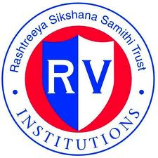
A Project report on
“TIME SERIES DATA MINING TOOL”

Submitted in partial fulfillment of the requirements for the award of the degree of

Bachelor of Engineering
in

Computer Science & Engineering

By

SAMIR SHERIFF | 1RV09CS093
SATVIK N | 1RV09CS095
VAISHAKH B N | 1RV09CS114
Under the guidance of

Dr. G. Shobha Mrs. Shantha Rangaswamy

Dean & Professor Assistant Professor

Department of CSE Department Of CSE

Carried out at
Department Of Computer Science & Engineering
R. V. College of Engineering

Bangalore – 560 059

(Academic Year : 2013 )

