2024-02-17 - Handout – Binary Search

# Q1. Find First and Last Position of Element in a Sorted Array (Leetcode #34)

Link: [Find First and Last Position of Element in Sorted Array - LeetCode](https://leetcode.com/problems/find-first-and-last-position-of-element-in-sorted-array/description/)

Given an array of integers nums sorted in non-decreasing order, find the starting and ending position of a given target value.

If the target is not found in the array, return [-1, -1].

**Example 1:**

**Input:** nums = [5,7,7,8,8,10], target = 8 **Input:** nums = [5,7,7,8,8,10], target = 6

**Output:** [3,4] **Output:** [-1,-1]

# Q2. Search a 2D matrix (Leetcode #74)

Link: [Search a 2D Matrix - LeetCode](https://leetcode.com/problems/search-a-2d-matrix/description/)

You are given an m x n integer matrix matrix with the following two properties:

* Each row is sorted in non-decreasing order.
* The first integer of each row is greater than the last integer of the previous row.

Given an integer target, return true *if the target* *is in* matrix *or* false *otherwise*.

You must write a solution in O(log(m * n)) time complexity.

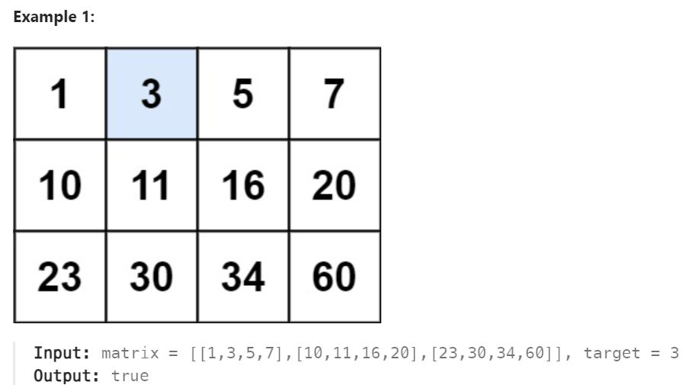

# Q3. Find minimum in rotated sorted array (Leetcode #153)

Link: [Find Minimum in Rotated Sorted Array - LeetCode](https://leetcode.com/problems/find-minimum-in-rotated-sorted-array/description/)

Suppose an array of length n sorted in ascending order is **rotated** between 1 and n times. For example, the array nums = [0,1,2,4,5,6,7] might become:

* [4,5,6,7,0,1,2] if it was rotated 4 times.
* [0,1,2,4,5,6,7] if it was rotated 7 times.

Notice that **rotating** an array [a[0], a[1], a[2], ..., a[n-1]] 1 time results in the array [a[n-1], a[0], a[1], a[2], ..., a[n-2]].

Given the sorted rotated array nums of **unique** elements, return *the minimum element of this array*.

**Example 1: Input:** nums = [3,4,5,1,2]; **Output:** 1

**Explanation:** The original array was [1,2,3,4,5] rotated 3 times.

# Q4. Closest Binary Search Tree Value (Leetcode #270)

Link: <https://leetcode.com/problems/closest-binary-search-tree-value/description/>

Given the root of a binary search tree and a target value, return *the value in the BST that is closest to the* target. If there are multiple answers, print the smallest.

