In place of having the minimap that follows the main character:

* Include a button that will open up the entire map of the location
* The map will not show unexplored regions
* If the player comes in contact with a certain undiscovered region, it will now appear on the map
* The explored regions will display icons for resources, structures, and roads
* Else, the map will remain blank

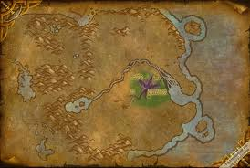

* Green area is explored
* The rest remains blank