**Table of contents**

**Table of contents for Software Requirement Specification**

1. Introduction

1.1 Purpose

1.2 Intended Audience

1.3 Project Scope

1.4 References

1. Overall Description

2.1 Product Perspective

2.2 Product features

2.3 Users Characteristics

2.4 Operating Environment

2.5 Design and implementation constraints

2.6 Assumptions and dependencies

1. System features

3.1 Functional Requirements

1. External Interface Requirements

4.1 Performance requirements

**Introduction**

1.1 **Purpose**

The purpose of this document is to build a billing software application for a vending machine for ease of availability of food and payment.

1.2 **Intended Audience and Reading suggestions**

This project is a prototype for vending machines and it is for college premises. The target audience is the college faculty, students and staff.

1.3 **Project scope**

## 

## 

## 

## **2. OVERALL DESCRIPTION**

**2.1 PRODUCT PERSPECTIVE**

The following project is a vending machine payment system

Product Details: The software is a prototype of a vending machine. It displays all the products and the customer can add items into their cart.

Payment Options: Once products have been added to the cart the total amount will be displayed with a QR code. The only way of Payment is E-Wallet.

**2.2 PRODUCT FEATURES**

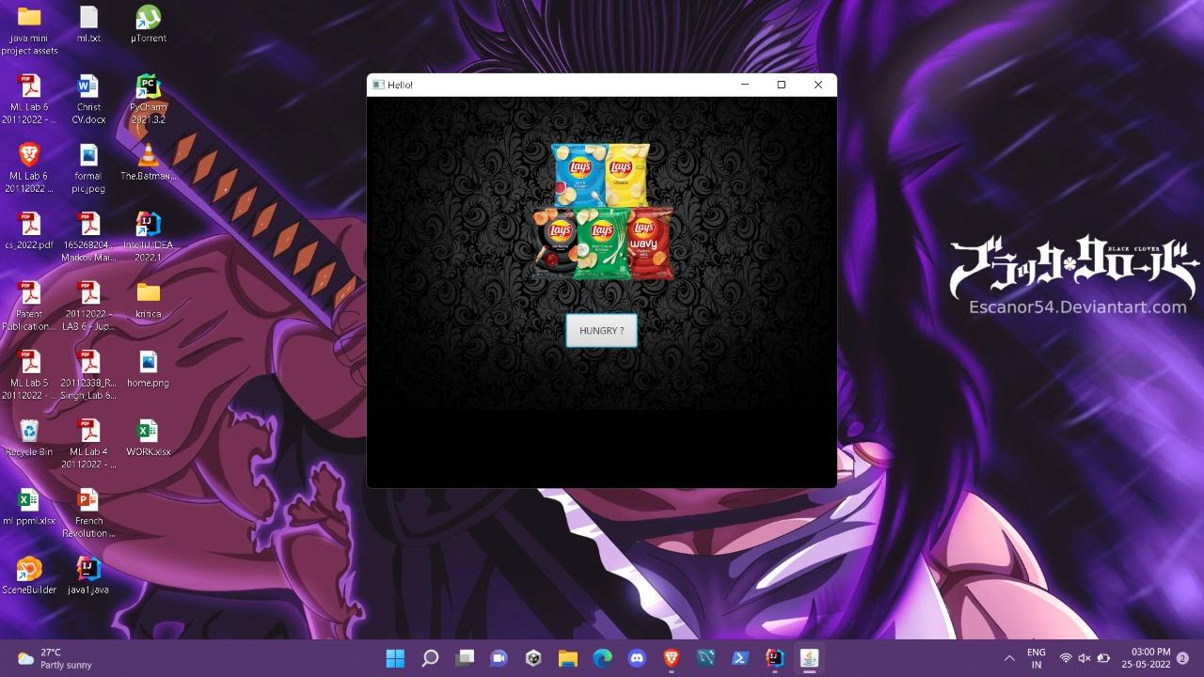

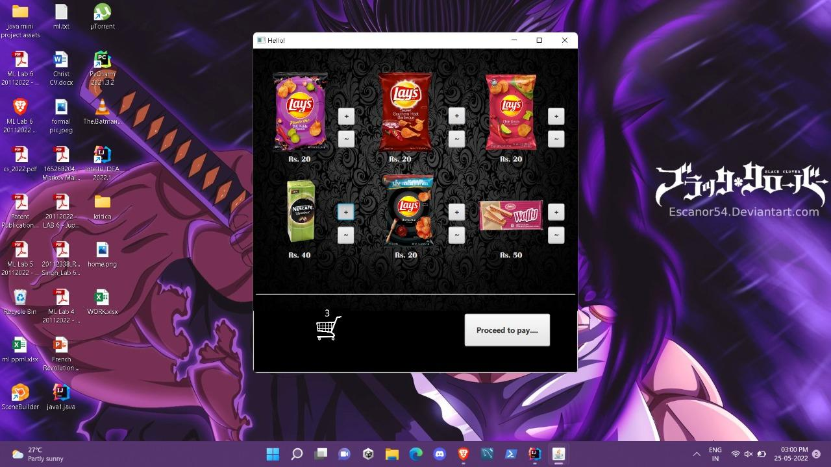 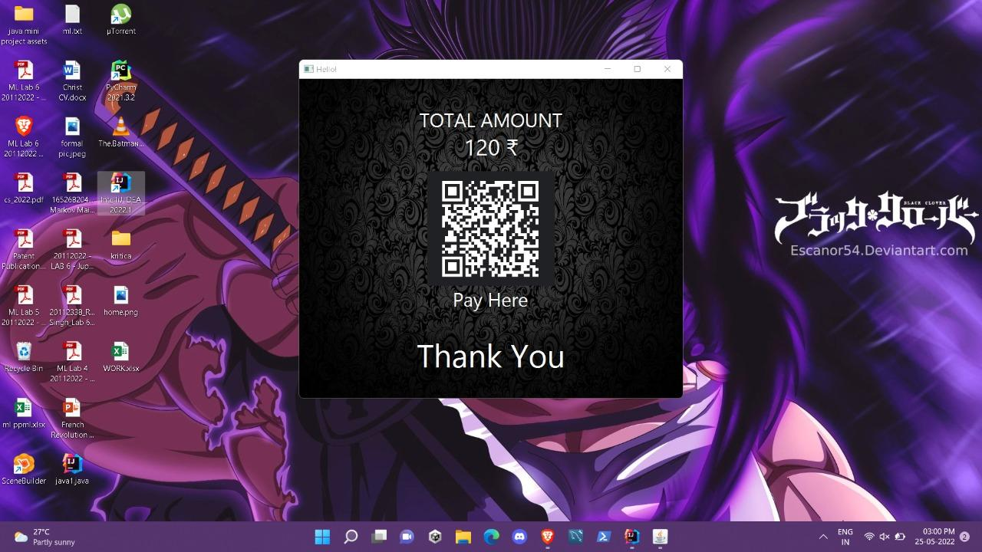

**2.4 OPERATING ENVIRONMENT**

The operating environments used for the project are as follows

* Java FX
* Scene builder
* Gluon
* Intellij Idea

**2.5 DESIGN and IMPLEMENTATION CONSTRAINTS**

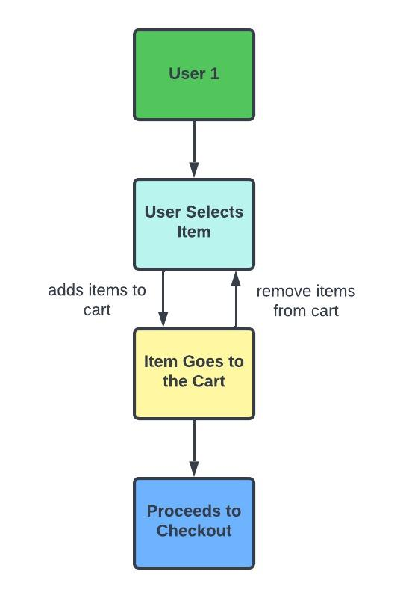

**2.6 Assumptions and dependencies**

Let us assume that this vending machine has following uses:

* Students can only pay through E wallets
* It is a campus based system
* People are only looking for snacks
* Once the payment is done the items they selected will drop

Dependencies

The software is depending on a bank for the direct payment and also for generation of the QR code

**3. SYSTEM FEATURES**

**3.1 DESCRIPTION and PRIORITY**

This project is for the campus and is necessary as it adds to campus facilities. As the product is profitable for the university and convenient to use.

**3.2 STIMULUS/RESPONSE SEQUENCES**

* The client will be welcomed and be redirected to the main page with products
* The user will be able to add or delete items from the cart
* Once Client is done with selecting they will be redirected to the final page
* All the products will be added and a final amount will be displayed along with the QR code.

**3.3 FUNCTIONAL REQUIREMENTS**

- The System functions include:

- Client Server System

The term client/server refers primarily to an architecture or logical division of responsibilities, the client is the application (also known as the front-end), and the server is the Bank Transaction (also known as the back-end).

4. EXTERNAL INTERFACE REQUIREMENTS

**4.1 USER INTERFACES**

* Front-end software: Scene Builder
* Back-end software: Java FX

**4.2 HARDWARE INTERFACES**

* Windows.
* A browser which supports CGI, HTML & Javascript.

**4.3 SOFTWARE INTERFACES**

Following are the software used for the vending machine application.

| **Software used** | **Description** |
| --- | --- |
| Operating system | We have chosen Windows operating system for its best support and user-friendliness. |
| Java Fx | To implement the project we have chosen java fx language for its more interactive support. |
|  | . |

**4.4 COMMUNICATION INTERFACES**

This project supports all types of vending machines. We are using simple electronic forms for the payment transaction etc.