**D.A.S.A.**

User Manual

**Contributions**

|  |  |  |
| --- | --- | --- |
| **Date** | **Author** | **Comment** |
| 2/16/2016 | Nathan Brown | Initial Creation |
|  |  |  |

**Table of Contents**

* Introduction 3
* Getting Started 3
* Voice Control System (VCS) 5
  + Full Command List 5
  + Detail of Commands 6
* Web Control System (WCS) 8
  + Managing Profiles 8
    - Creating a Profile 8
    - Deleting a Profile 8
    - Administrator Actions 9
  + Using a Profile 9
  + Managing Shower (Admin Only) 9
    - Voice control incremental settings 9
    - Usage statistics 10

**Introduction**

Thank you for choosing Donald, the Automated Shower Assistant (Dasa). The purpose of this document is to describe in detail the many features of Dasa, as well as how to use those features effectively. Dasa has two main modes of operation, both of which are separated into different sections in this document:

* Voice Control System (VCS) is used for voice control of Dasa while showering
* Web Control System (WBS) is used for external control of Dasa when not in the shower, as well as the management of profiles.

Once the system has been installed into your home or business by our qualified staff, you will only need to complete a few specific steps to get the system up and running for your needs. Please read the “Getting Started” section directly below if you are at this point in setup. If not, the table of contents at the beginning of the document can direct you to a specific section for assistance.

**Getting Started**

To begin, please log on to www.dasa.com with the credentials provided to you by our qualified staff by clicking the button labeled “Shower Portal” on our homepage. From here, you will be directed to the Web Control System (WCS) homepage.

Once in the WCS homepage, you will be faced with a variety of options, including:

* Profile Login
* Manage Profiles
* Manage Shower (Admin Only)

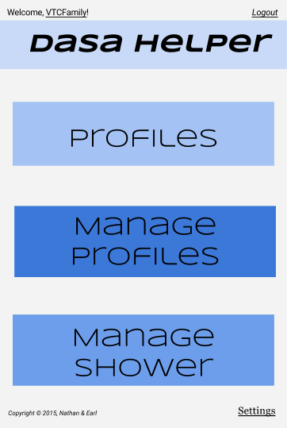All four of these sections are discussed in detail within their specified sections of the document. For now, simply click on “Manage Profiles”. This will load a new page at which time you will be prompted (if this is a first time setup) to create an administrator profile. *NOTE: the credentials you received to log into the system are for the shower as a whole (this is an extra security measure). The information you use for your profiles and administrator profile will NOT be the same thing, so it is wise to use a different set of credentials.*

Note that this administrator profile will be the main profile for the shower system and will thusly have the privileges to alter all shower and profile settings (see the section labeled “Administrator Privileges” located under the heading labeled “Managing Profiles”). Once you have input your new administrator credentials, you may now set up the rest of the profile as you see fit (see the section labeled “Creating a Profile” located under the heading “Managing Profiles”).

Figure 1: A (Mobile) example of the WCS Homepage

Once you have finished creating the administrator profile, you are ready to begin using your Dasa system. Please refer to the following sections for further use of the system.

**Voice Control System (VCS)**

The VCS handles all user interaction during real time shower actions. Therefore, it is important to familiarize yourself with the commands list below and what each command does. Please remember that the VCS relies upon spoken word and is therefore not always 100% accurate. Please exercise caution and concise pronunciation when using the VCS.

**Full List of Commands**

Below is an overview of the entire command set for which Dasa will respond. Please use these phrases when you wish to take an action while showering. Below the list will be a detailed overview of all of the commands.

* “Dasa On”
* “Dasa Off”
* “Dasa Stop”
* “Dasa Reset”
* “Dasa Back”
* “Dasa Forward”
* “Dasa Left”
* “Dasa Right”
* “Dasa Down”
* “Dasa Up”
* “Dasa Mode Shower”
* “Dasa Mode Jet”
* “Dasa Mode Massage”
* “Dasa Mode Rain”
* “Dasa Temperature Lower”
* “Dasa Temperature Higher”

**Detail of Commands**

***“Dasa [On | Off]***”

Once this command is spoken and recognized, the water flow will either shut off or turn on, and any backlogged commands will be cleared.

***“Dasa [Back | Forward]”***

Once this command is spoken and recognized, the shower head will either move to the *back* or the *front* of the shower the amount specified by the administrator (See “Voice control incremental settings”).

***“Dasa [Left | Right]”***

Once this command is spoken and recognized, the shower head will either move to the *right* or the *left* sideof the shower the amount specified by the administrator (See “Voice control incremental settings”).

***“Dasa [Up | Down]”***

Once this command is spoken and recognized, the shower head will either move to the *bottom* or the *top* of the shower the amount specified by the administrator (See “Voice control incremental settings”).

***“Dasa Mode [Shower | Jet | Massage | Rain]”***

Once this command is spoken and recognized, the shower head will alter its outflow of water to be *shower, jet, massage,* or *rain*.

***“Dasa Temperature [Lower | Higher]”***

Once this command is spoken and recognized, the shower system will alter the temperature of water *lower* or *higher* by the temperature amount specified by the administrator (See “Voice control incremental settings”).

***“Dasa Stop”***

Once this command is spoken and recognized, the shower system will halt whatever command it is currently attempting to execute, and will also clear any backlogged commands.

***“Dasa Reset”***

Once this command is spoken and recognized, the shower system will halt whatever command it is currently attempting to execute, clear any backlogged commands, and place itself at the *front* of the shower at the *highest* position.

**Web Control System (WCS)**

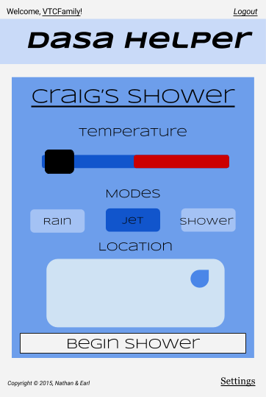Below is a detailed overview of how to use the WCS, including managing profiles, using profiles, and changing shower settings. This web application is intended to be used as a helper to the VCS to provide a means of setting up a shower remotely (by way of a profile), managing users, and controlling the system as a whole.

Figure : A (Mobile) Example of the Shower Page of a specific profile.

**Managing Profiles**

**Creating a Profile**

To create a profile in the WCS starting from the homepage in WCS, simply click/tap Manage Profiles > Click the Create button at the top of the page. This will prompt you to enter a new set of credentials. After this, the Shower Page will be displayed (Fig. 2) and you may edit the shower settings for that profile or use the shower as you wish.

**Deleting a Profile**

To Delete a profile in the WCS starting from the homepage in WCS< simply click/tap Manage Profiles > Click the Delete button next to profile you wish to delete > enter credentials.

Figure 3: A (Mobile) example of the Shower Page for a specific profile

**Administrator Actions**

The administrator has the ability to delete, edit, view, or manage any profile within the system. Because of this, it is important that the administrator credentials be closely guarded. It is advised that the user NOT use the administrator account for showering, but rather only manage profiles.

**Using a Profile**

To use a profile in the WCS starting from the homepage in WCS, simply click/tap Profiles > Click the profile name you wish to use > enter your credentials. At this point the Shower Page will be displayed for the current profile (Fig. 2). Changes to this page are automatically saved upon alteration. *NOTE: Only the user for that profile and the administrator have access to any given profile. Also, when the shower is currently in use by another user, the “Begin Shower” button will be greyed out and it will be impossible to actually start a shower. However, it will be possible to alter and save any changes to the profile.*

**Managing Shower (Administrator Only)**

Another ability of the administrator is to control the incremental amounts the showerhead/temperature changes to each time a voice command is uttered. On top of this, the administrator can also view usage statistics for specific profiles or the shower as a whole.

**Voice control incremental settings**

To alter the incremental settings for the VCS on the WCS, simply click/tap Manage Shower > Enter administrator credentials > Change Increments. This will display a page with multiple values for incremental settings, including the left/right, up/down, back/front movement, and the higher/lower temperature alteration settings.

**Usage statistics**

To view the usage statistics settings on the WCS, simply click/tap Manage Shower > Enter administrator credentials > Usage Statistics. This will display a page with detailed results regarding the usage statistics for profiles and the shower as a whole.