# Stereovideo monitoring and physiological trials reveal metabolic demands of reef fishes in the wild

Nina M. D. Schiettekatte1,2*, Francesca Conte1,2*, Beverly French3, Simon J. Brandl1,2,4, Chris Fulton5, Alexandre Merciere1,2, Tommy Norin6, Sébastien Villéger7, Valeriano Parravicini1,2

1 PSL Université Paris: EPHE-UPVD-CNRS, USR 3278 CRIOBE, Université de Perpignan, 66860 Perpignan, France

2 Laboratoire d’Excellence “CORAIL,” Perpignan, France

3 Center for Marine Biodiversity and Conservation, Scripps Institution of Oceanography, University of California, San Diego, CA, USA

4 FRB, CESAB, Montpellier, France??

5 Research School of Biology, The Australian National University, Canberra, ACT, Australia

6 Technical University of Denmark, DTU Aqua: National Institute of Aquatic Resources, 2800 Kgs, Lyngby, Denmark

7 Université Montpellier, CNRS, IFREMER, IRD, 34 095 Montpellier, France

* Contributed equally

Correspondance to: N.M.D.S.; Email: [nina.schiettekatte@gmail.com](mailto:nina.schiettekatte@gmail.com)

## Abstract

The metabolic rate of living organisms is an underlying driver of all processes within ecosystems in our transitioning world. In the marine realm, fishes perform an essential consumer role. However, the field metabolic rate, representing the pace of life of fishes in the wild is still poorly documented. Moreover, little is known about how field metabolic rates scale with biomass (i.e. the metabolic scaling coefficient). This limits our ability to accurately estimate the metabolic rate of wild fish communities. Here, we propose a novel approach to quantify the field metabolic rate by combining traditional respirometry techniques, and stereo-video systems, and we exemplify our approach with a case study of seven coral reef fish species. Specifically, we quantify the standard and maximum metabolic rate for each species across varying body mass. Further, we measured both the body size and the swimming speed of multiple individuals throughout the day in situ. Finally, relying on known relationships between metabolic rates and swimming speeds, we predicted field metabolic rates for each species across their size range. Finally, we scaled up our estimates at assemblage level according to visual census data in Mo’orea (French Polynesia). We show that the activity scope (i.e. the ratio between the field metabolic rate and the standard metabolic rate) varies on average between 1.2 and 1.8 across species. We further demonstrate that, for certain species, the scaling coefficient is well above the theoretical value of 0.75. Finally, scaling up to the assemblage level, exemplifies the potential pitfalls of comparing the metabolic rates of heterogeneous reef fish assemblages based on standard metabolic rates instead of field metabolic rates. We suggest that the coupling of physiological trials with stereo-video analysis provides a useful, non-destructive path to estimate field metabolic rates of fishes in their natural environment, which opens the door to more accurate predictions of the role of fishes in the flux of energy and elements in ecosystems.

## Introduction

Anthropogenic stressors such as climate change, over-harvesting, and pollution are globally affecting biological communities at an unprecedented rate (Halpern et al. 2008; Venter et al. 2016). There is a growing concern that impacted communities may not be able to sustain key ecosystem functions and provide indispensable ecosystem services to humanity (Cardinale et al. 2012). In this context, tools to quantify and monitor ecosystem processes are indispensable (Tilman, Isbell, and Cowles 2014). However, while there is a long-standing tradition in measuring ecological processes in mesocosms and controlled in situ experiments, the assessment of rates of ecological processes in natural conditions is still in its infancy (Reich et al. 2012), especially for marine ecosystems (Brandl, Tornabene, et al. 2019).

In the marine realm, fishes represent one of the most thoroughly studied, ecologically important, and economically valuable group of consumers (Bozec, Gascuel, and Kulbicki 2004; Tamayo, Anticamara, and Acosta-Michlik 2018). Yet, due to their mobility and the challenges of the marine environment, measuring nutrient and energy fluxes derived from fish communities is complex (Wilson et al. 2010). Nevertheless, there have been several attempts to quantify ecological functions performed by fishes, ranging from their contributions to nutrient and carbon cycling to herbivory and biomass production (Villéger et al. 2017; Brandl, Rasher, et al. 2019). These functions are usually quantified at the individual level, where some empirical or theoretical knowledge about the physiological requirements of individuals facilitate calculations of organismal processes, that can then be scaled up to community levels through an additive framework (Barneche et al. 2014; Allgeier et al. 2014; Brandl, Tornabene, et al. 2019; Morais and Bellwood 2019). While there are inherent limitations to this approach, individual-based modeling currently represents our best means to quantify ecological processes across communities of mobile, aquatic organisms. Nevertheless, the accuracy of these approaches inevitably depends on our capacity to precisely estimate physiological requirements and expenditures of individuals in their natural environment.

The metabolic rate of living organisms is an essential determinant of their physiological requirements and therefore represents a crucial parameter to estimate the of the flow of energy and nutrients in any ecosystem (Brown et al. 2004; Allen, Gillooly, and Brown 2005). Theory predicts that individual metabolic rate increases sub‐linearly with body mass according to a power function with a scaling coefficient of approximately 0.75 (West, Brown, and Enquist 1997; Gillooly et al. 2001; Brown et al. 2004). This theoretical value has been widely accepted and holds roughly true for marine fishes (Barneche et al. 2014).

Metabolic rates of fishes are generally evaluated through two metrics: i) standard metabolic rate (SMR; FRY 1957; Vinberg 1960), which corresponds to the metabolic rate of an inactive and fasting individual (Clark, Sandblom, and Jutfelt 2013), and ii) maximum metabolic rate (MMR), which corresponds to the aerobic metabolic rate of an animal that is exercising at full capacity (Norin and Clark 2016). Knowledge of these two metrics allows for calculations of a fish’s Factorial Aerobic Scope (FAS), which is the ratio between MMR and SMR and represents the capacity to elevate metabolic rate above maintenance to support energetically demanding tasks such as physical activity (Clark et al., 2013). FAS tends to increase with body mass, as the scaling coefficient of MMR is often observed to be higher than 0.75 (Killen et al. 2007; Glazier 2005). Both SMR and MMR can be estimated relatively accurately in the laboratory through measurements of oxygen uptake rates (Binning, Roche, and Layton 2013; Brett 1964; Clark, Sandblom, and Jutfelt 2013; Clark et al. 2012; Norin and Malte 2011; Norin and Clark 2016). However, animals in the wild rarely reside at SMR or exercise maximally. Thus, calculations of energy expenditures in fishes are hamstrung by our capacity to accurately estimate metabolic rates in wild fishes that pursue their normal, daily activities in their natural environment.

The field metabolic rate (FMR) represents the average metabolic rate of an individual in the wild (Chung et al. 2019; Nagy 2005) and lies somewhere between SMR and MMR (Roche et al. 2013). On average, free-living fishes in their natural habitats will only exploit a given proportion of their aerobic scope (Norin and Clark 2016). Thus, the Factorial Scope for Activity (FSA), which corresponds to the ratio between the FMR and the SMR, is a better reflection of energy expenditure in the wild (Chung et al. 2019), although internal homeostatic processes such as digestion and reproduction also bear a given energetic cost. In terrestrial vertebrates, where the doubly-labeled water technique has allowed for widespread quantification of FMR (Webster and Weathers 1989), the metabolic scaling coefficient of FMR tends to be higher than that of SMR (~0.8; Nagy 2005). While the metabolic scaling coefficient of MMR in fishes ranges around a similar value, but the FMR scaling coefficient remains poorly documented (Norin and Clark 2016).

Since FMR challenging to measure for water-breathing animals in the aquatic environment (Treberg et al. 2016), it has only been estimated for a small number of fishes (e.g. Lucas, Johnstone, and Priede 2011; Murchie et al. 2011; Cruz-Font, Shuter, and Blanchfield 2016; Chung et al. 2019). These estimates are largely derived from biotelemetry approaches that rely on accelerometry tags and heart rate measurements calibrated with rates of oxygen uptake in the laboratory (Treberg et al. 2016; Gräns et al. 2009). A major limitation of biotelemetry is that their application is limited to large individuals (Gräns et al. 2009). More recently, FMR has been estimated from the isotopic composition of carbon in fish otoliths (Chung et al. 2019). However, this approach relies on destructive sampling and the generality of the undoubtedly promising results are yet to be validated across a broad range of species. Thus, alternative pathways to determining fish FMR may improve our capacity to understand fishes and their contributions to ecosystem functioning.

Here, we propose a new approach to estimate FMR and FSA in fishes, which relies on the assumption that FMR lies between SMR and MMR. Specifically, we measured SMR and MMR using traditional respirometry techniques in the laboratory, and then quantified in situ swimming speeds of seven reef fish species using underwater stereo-video systems to derive FMR and FSA on the basis of known relationships between metabolic rate and swimming speed, which allowed us to compare the metabolic scaling coefficients of SMR, MMR, and FMR for all seven species. By combining our results with underwater visual census data of fish size and abundance on reefs around Mo’orea, French Polynesia, we also quantified assemblage-level SMR and FMR. In doing so, we demonstrate the viability and applicability of our approach to tackle questions across fields of organismal, community, and ecosystem ecology in the marine biome.

## Methods

Our approach is based on the relationship between swimming speed and metabolic rate (Binning, Roche, and Layton 2013; Norin and Clark 2016; Torres and Childress 1983). Specifically, we rely on the assumption that the standard metabolic rate (SMR) represents the metabolic rate of an individual when its swimming speed is zero (), while the maximum metabolic rate (MMR) represents the oxygen consumption rate of individuals at their maximum – or critical – swimming speed ()(Figure 1). Further, we assume that metabolic rates variy predictably with swimming speed following a traditional power function (Brett 1964; Korsmeyer, Steffensen, and Herskin 2002). Therefore, on the basis of knowledge of SMR and MMR along with the and of individuals, the field metabolic rate (FMR) of a species can be estimated if the average swimming speed () of individuals for a specific body size is known. We measured SMR and MMR using respirometry techniques, obtained through empirical data available in the literature, and estimated using stereo-camera video recordings in the field. We then used these estimates of FMR to quantify the Factorial Scope of Activity (FSA), and the metabolic scaling coefficient of FMR. Finally, in order to evaluate the impact of assessing assemblage-level oxygen consumption on the basis of FMR instead of SMR, we scaled up our estimates at assemblage level according to visual census data of fish sizes and abundances in Mo’orea (French Polynesia).

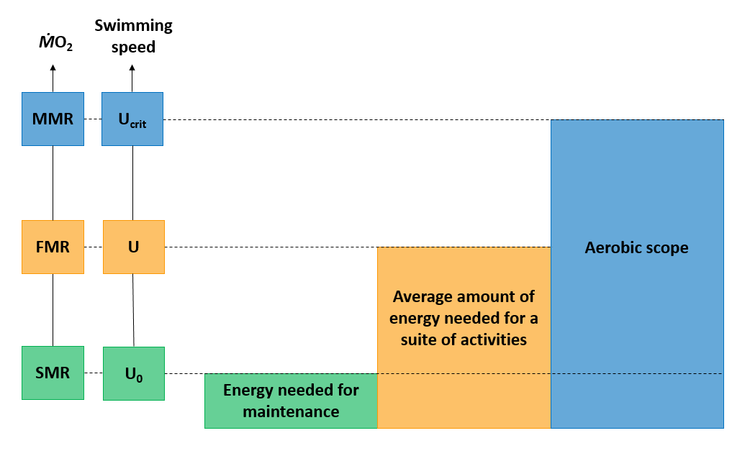Figure 1. Definition of terms used to describe aspects of fish metabolism and their inter-relationships. SMR is standard metabolic rate calculated as the oxygen uptake rate ( at swimming speed 0 (). FMR is field metabolic rate measured as at spontaneous swimming speed (). MMR is maximum metabolic rate, which can be measured as the at maximum (critical) swimming speed ().

### Model species

In our assessment, we focused on seven reef fish species with varying body sizes and shapes, trophic strategies, and behavioral patterns: *Cephalopholis argus* (family Serranidae), a large, fusiform, sedentary piscivore; *Chaetodon ornatissimus* (family Chaetodontidae), a small-bodied, laterally compressed, obligate coral feeder; *Chromis iomelas* (family Pomacentridae), a small, schooling planktivore; *Ctenochaetus striatus* (family Acanthuridae), a medium-sized, grazing detrivore; *Naso lituratus* (family Acanthuridae), a large-bodied, grazing herbivore feeding on macroalgae; *Odonus niger* (family Ballistidae), a large-bodied schooling planktivore; and *Zebrasoma scopas* (family Acanthuridae), a compressed, small-bodied, grazing herbivore feeding on filamentous algae. All data were collected in Mo’orea, French Polynesia, between March 2018 and November 2018. For respirometry experiments, individuals were collected in the lagoon (depth range 1-6m) next to Opunohu Bay (17.4928°S, 149.8555°W) with hand nets and clove oil.

### Standard and maximum metabolic rate

To quantify SMR and MMR, we conducted intermittent-closed respirometry experiments at 28°C (Steffensen 1989; Clark, Sandblom, and Jutfelt 2013) on a total of 68 individuals across the seven study species. After an acclimatization and fasting period of 48 h in aquaria, the fish were individually transferred to a water-filled tub at 28°C and sequentially chased by the experimenter until visibly exhausted (Norin and Malte 2011; Clark et al. 2012). Once the chasing was concluded, each individual was immediately placed in a respirometry chamber submersed in an ambient and temperature-controlled tank, where they were left for approximately 24 h. The intermittent respirometry cycles consisted of a measurement (closed) period followed by an open period during which the respirometry chambers were flushed with fully aerated water from the ambient tank. Based on previous work (Norin and Clark 2016), we considered oxygen consumption during the first closed cycle (directly after transferring the fish) to be reflective of the individual’s MMR (at complete exhaustion). Depending on fish size, respirometry chambers ranged in volume (including tubes and pumps) from 0.4 to 1.2 L, and measurement and flush periods lasted between 2 to 9 min and 3 to 5 min, respectively. SMR was calculated as the average of the 10 % lowest values measured during the entire period, after the removal of outliers, while MMR was calculated from the slope of the first measurement period (Chabot, Steffensen, and Farrell 2016).

### Swimming speed

We used two underwater stereo-video systems that were placed on the seafloor to record fish movements. Each video system consisted of two small action cameras (GoPro Hero6 Black), mounted 90 cm from each other at an angle of approximately 6°. This method allows three-dimensional (3D) measurements (S. Butail and Paley 2012; Hughes and Kelly 1996). To analyze the recorded videos, we used VidSync, an open-source Mac application providing accurate 3D measurements (Neuswanger et al. 2016), which allow for the synchronization, calibration, and analysis of videos. We recorded calibration videos to correct for the nonlinear optical distortion of the images due to camera lenses and underwater housings, and to define the 3D coordinate system (x, y, z) used throughout the analyses, to calculate the fishes’ positions in space. Errors in length measurements through video analysis increase with distance from the cameras (Neuswanger et al. 2016). Thus, for each underwater stereo-video system, we fitted a linear regression model describing the error in measurements as a function of their distance from the nearest camera, which we used to adjust all measurements of distances and fish lengths (Figure S1). We recorded twenty stationary stereo-videos between November 19th 2018 and December 2018 12th. Videos were recorded at 12 to 14 m depth on the reef slope at the Tiahura long-term monitoring site in Mo’orea (17 ° 29 ‘00.6 " S, 149 ° 54’ 20.9 " W) and at five different time-periods: 5:00–7:00, 8:00–10:00, 11:00–13:00, 14:00–16:00, and 17:00–18:00. Each recording lasted for ~1-1.5 h. We then took measurements during three 10 min sequences with intervals of 10 min starting at the end of an acclimatization period of 2 min to account for the presence of divers. We took measurements for all fishes visible in both cameras for 3 to 5 s during the three 10 min sequences. For each individual, fork length was measured three times from the videos as the straight-line distance between the fish’s head and its tail fork, and three to five consecutive swimming speeds were measured as the distance the fish moved over 3 to 5 s. Final fish lengths and swimming speeds were then calculated as the mean of the repeated measurements. In total, we recorded lengths and speeds for 634 individuals.

### Maximum swimming speed

We extracted maximum swimming speeds () from Fulton (2007). was defined by Brett (1964)] as the swimming speed at which a fish becomes exhausted and stops swimming when it is exposed to regular incremental changes in speed in an experimental flume. In these experimental conditions, measured at corresponds to the MMR (Norin and Clark 2016). In Fulton (2007), of 192 individuals of five families and their corresponding lengths were measured, and these measurements were then used in the present study to relate maximum swimming speed with body size and aspect ratio of the tail, as a proxy for variations in swimming ability (retrieved from Fishbase; Froese, Thorson, and Reyes (2014)). We also included random effects of the interaction between family and body shape on the intercept and slope of body size.

### Data analysis

We quantified FMR and factorial scope for activity (FSA) by combining multiple regression models, that describe the relationships between SMR and MMR with body mass, swimming speed (), and maximum swimming speed (; from Fulton 2007) with body size. First, we used the respirometry data to fit a relationship between either SMR or MMR and body mass using a Bayesian hierarchical model, while taking into account the co-variation between MMR and SMR measurements. We define the transformation of SMR and MMR to be normally distributed with a mean () and a standard deviation () as follows:

where is the individual, is the species, is the type of metabolic rate (SMR or MMR), is the global intercept of the regression; is the effect on the intercept for each species and type of metabolic rate, is the global slope of , is the effect on the slope of for each species and type of metabolic rate. We obtained the mean intercept and slope per species by summing global- and species-level parameters. We used an informative normal prior for the global slope coefficient (i.e. scaling coefficient) with average 0.75 and 0.1 as the standard deviation (West, Brown, and Enquist 1997). For all other parameters, we used uninformative priors as defined by Burkner PC (2017).

Second, using the data retrieved from the video analyses, we fitted a hierarchical Bayesian regression model for estimating fish swimming speed as a function of body length. We defined the transformation of swimming speed to be student-t distributed with degrees of freedom (), mean (), and a standard deviation ().The student’s t-distribution was applied to build a robust regression, as the nature of our data includes outliers (Motulsky and Brown 2006).

where is the individual, is the species, is the global intercept of the regression, is the effect on the intercept for each species, is the global slope , is the effect on the slope of for each species. For each species, their corresponding regression coefficients were estimated by summing two effects of the model: the global parameter and the species-specific effect on the global parameter.

Thirdly, we fitted a similar model to predict maximum swimming speed in function of body length on the family level using data extracted from Fulton et al. (2007):

where , is the interaction of family and body shape, is the global intercept of the regression, is the effect on the intercept for each family and body shape, is the global slope of , is the effect on the slope of for each family and body shape. Here, we also applied the student’s t-distribution and used general uninformative priors. We then used this model to estimate the maximum swimming speed of the species included in our study.

### Factorial aerobic scope, field metabolic rate and factorial scope for activity calculations

We predicted the Factorial Aerobic Scope (FAS), field metabolic rate (FMR), and Factorial Scope for Activity (FSA) for the full size range of all model species (per cm). To estimate the fish’s FAS at each possible length, we first predicted their SMR and MMR by calculating their weight using published length-weight relationship accessed through FishBase (Froese, Thorson, and Reyes 2014), and making predictions based on our model parameters. For each iteration of the prediction, FAS was calculated as (Fry 1947; Killen et al. 2016). Finally, we summarized the FAS for each species at all sizes by taking means, standard deviations, and 95% credible intervals.

FSA is obtained by dividing the fish’s FMR ( at average speed ) by their SMR. To describe the relationship between and swimming speed (), Brett (1964) used the traditional power function: . Here, we applied the -transformed form (Korsmeyer et al., 2002). Consequently, the following equation was used in this study to determine individual FMR:

where we consider the slope . Here, is predicted through our model relating length and swimming speed, is predicted for each length and species using our model for family-level maximum swimming speeds, and SMR and MMR is predicted as stated above. To include an estimate of uncertainty, we included 1000 iterations of estimates of the swimming speed . For , SMR and MMR we used the median of the predicted values in this step.

Once FMR was determined, we calculated FSA with the following equation:

We repeated this for each iteration and then summarized FSA per species per size. We assumed that fish rested for 12 h (i.e. sleeping) (Marshall 1972). As such, for all studied species we assumed that they are active during the day and inactive during the night, which aligns with the information available on the studied species.

### Scaling up to assemblage-level

In 2016, reef fish communities were monitored in 13 sites on the outer reef around Mo’orea using underwater visual census. During each census a diver swam along a transect of 25m and counted all fishes within a width of 2m. All fishes were identified to the species level and their length was estimated to a precision of 1cm. Each transect covered an area of 50 m², except Tiahura and Haapiti that covered an area of 100 m² each.  
At each site, three transects were surveyed, except for Tiahura and Haapiti where 4 and 2 transects were observed respectively.  
We extracted data for our model species from this database, which resulted in 802 individuals across the 7 species. Then, for each site, we quantified the SMR and FMR for each individual using the above-mentioned methodology. Finally, we calculated the total SMR and FMR of the fish assemblage composed of the seven species at each site by adding up individual estimates.

## Results

### Standard and maximum metabolic rate

The regression model predicting metabolic rates ( SMR and MMR) as a function of body mass with varying slopes and intercepts per species had a Bayesian of 0.96 (Table 1; Figure 2). The average metabolic scaling coefficient across species was 0.73 for SMR and 0.78 for MMR (Table 1). The median species-specific scaling coefficients varied between 0.71 and 0.76 for SMR, and between 0.77 and 0.78 for MMR.

Table 1: Overview of species-specific slope coefficients of the regression of log10-transformed SMR and MMR in function of log10-transformed body mass. The intercept for each species is expressed as the back-transformed value, which is essentially the predicted metabolic rate for an individual of 1g

| species | SMR slope | SMR (weight = 1g) | MMR slope | MMR (weight = 1g) |
| --- | --- | --- | --- | --- |
| *Cephalopholis argus* | 0.71 (0.6;0.79) | 0.003 (0.0018;0.0045) | 0.78 (0.7;0.88) | 0.0119 (0.0076;0.0173) |
| *Chaetodon ornatissimus* | 0.71 (0.62;0.79) | 0.0036 (0.0028;0.0046) | 0.78 (0.71;0.86) | 0.0089 (0.0069;0.0111) |
| *Chromis iomelas* | 0.74 (0.61;0.88) | 0.0028 (0.0023;0.0035) | 0.78 (0.67;0.89) | 0.0083 (0.0065;0.0103) |
| *Ctenochaetus striatus* | 0.76 (0.69;0.84) | 0.0042 (0.003;0.0054) | 0.78 (0.71;0.84) | 0.01 (0.0076;0.0129) |
| *Naso lituratus* | 0.74 (0.61;0.91) | 0.0039 (0.0028;0.0052) | 0.78 (0.69;0.96) | 0.0143 (0.0093;0.0194) |
| *Odonus niger* | 0.72 (0.63;0.83) | 0.0025 (0.0015;0.0036) | 0.78 (0.7;0.87) | 0.0123 (0.0081;0.0172) |
| *Zebrasoma scopas* | 0.71 (0.66;0.77) | 0.0037 (0.003;0.0046) | 0.77 (0.72;0.83) | 0.0078 (0.0061;0.0096) |

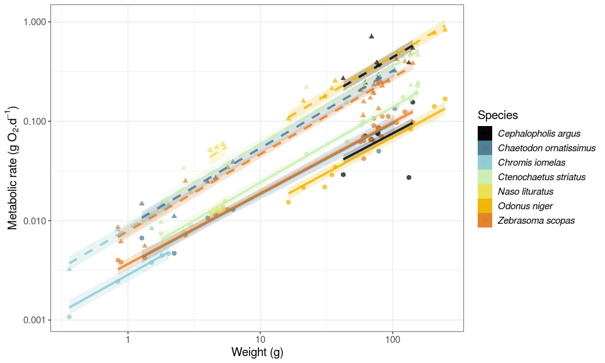

Figure 2. Linear regressions between log10-transformed metabolic rate (g O2 d−1) and weight (g) for the study species, predicted by model 1. Dots represent empirical measurements. Solid and dotted lines respectively represent MMR and SMR predicted mean values per species of the response distribution for model 1. Transparent areas are the 95% credible intervals of the fitted values of the regression.

### Swimming speed

The regression model that predicts species-specific swimming speed in function of body size had a median Bayesian of 0.57 and its residual variance () was 0.37. The average slope values per species varies between 0.18 and 0.97 (Figure 3, Table S2). At the individual scale, the 95% credible interval of swimming speed predictions varies between 28.5 and 32.4 cm across all studied species and all size classes. For maximum swimming speed, our model showed an increase with body size and aspect ratio (Table S3), with a median Bayesian of 0.46. We then used this model to estimate maximum swimming speeds of our study species (Figure 3).

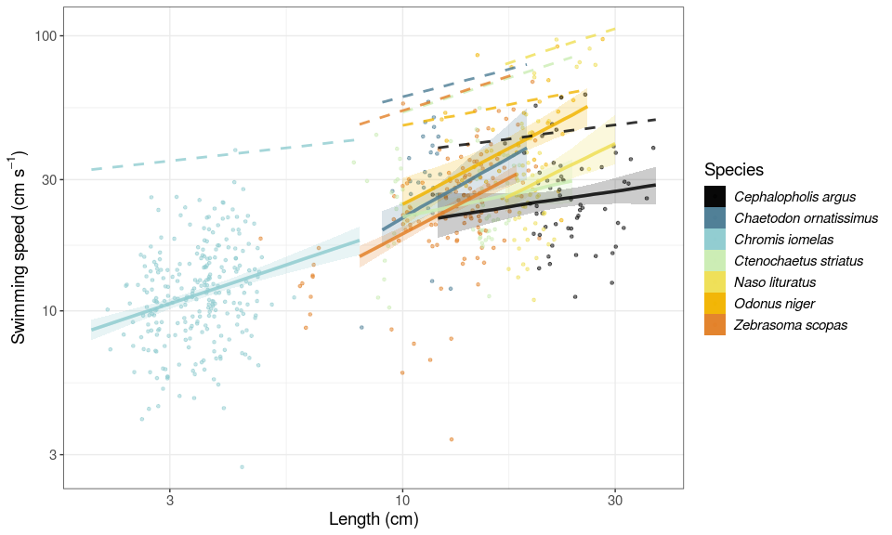

Figure 3. Linear regressions between log10-transformed speed (cm s−1) and length (cm) for the seven studied fish species. Dots represent the raw data of individuals measured through stereovideo analysis. Solid lines and shaded areas represent the predicted mean values, and associated 95% credible interval of swimming speeds. The dotted lines represent the predicted maximum swimming speeds.

### Field metabolic rate, factorial aerobic scope and factorial activity scope estimations

We estimated FMR, FAS, and FSA across the size range of our study species as observed in the monitoring dataset from Mo’orea in 2016. Across all species and size classes, average FMR estimates ranged between 0.001 and 1.013 g O2 at the individual level (Table S4). FAS and FSA estimates range between 2.4 and 7.0, and between 1.2 and 2.8 respectively. The scaling coefficient of FMR was higher than the SMR coefficient for all species, except *C. striatus* (Figure 4a). The scaling coefficient of FMR was considerably higher than the MMR coefficients for *N. lituratus* and *O. niger*. Thus, FSA increased with size for most species (Figure 4b).

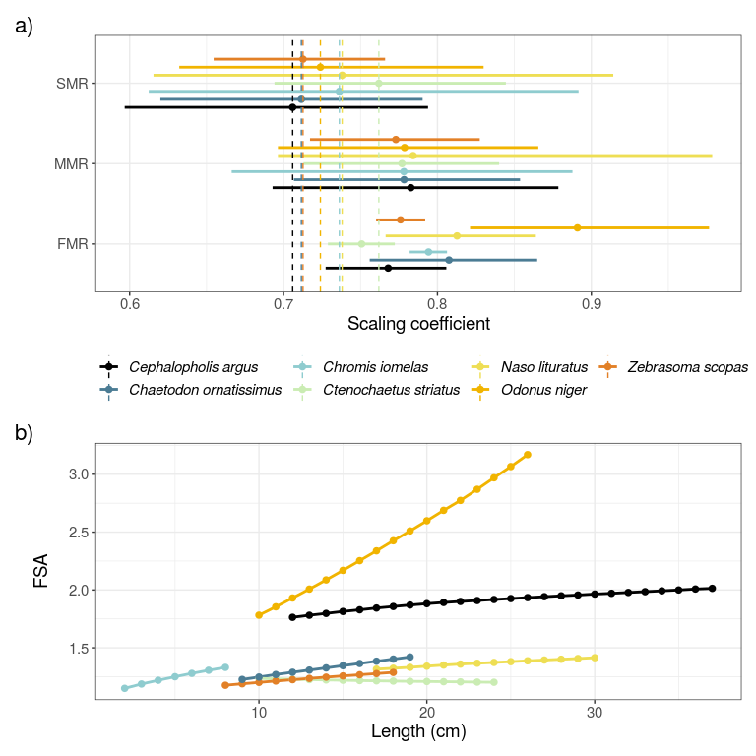

Figure 4. a) Fitted slopes or scaling coefficients with body mass for SMR, MMR, and FMR. b) Predicted FSA for the seven species across their body size range.

### Assemblage-level predictions

Scaling up SMR and FMR at community level shows a remarkable difference between the two estimates of oxygen consumption rate, SMR being on average about half of the estimated FMR. The total SMR (± SD) of each fish community per studied site lie between 0.026 ± 0.009 and 0.325 ± 0.021 g O2 m−2 d−1 across all sites (Figure 5). Further, the total FMR (± SD) varies between 0.036 ± 0.014 g O2 m−2 d−1 and 0.465 ± 0.07 g O2 m−2 d−1. The variation in total SMR and FMR at the assemblage-level between sites is related to the abundance of the studied fish assemblages per site (see Figure S4).

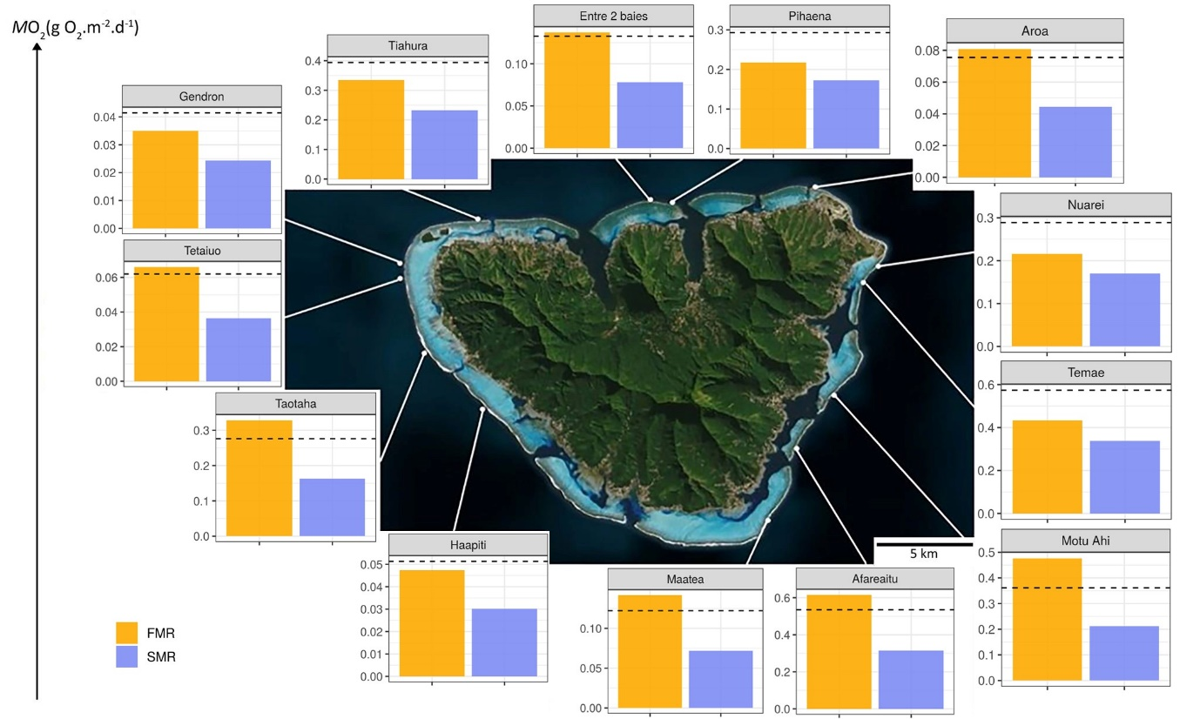

Figure 5. Yellow and blue barplots respectively present the total community oxygen consumption rates (based on the field metabolic rate and standard metabolic rates (in units of g O2 m−2 d−1) of fish assemblages at the 13 studied sites represented by white points on the map.

Afareaitu, Maatea, Motu Ahi, Taotaha and Tetaiuo have a total FMR about twice as high as the total SMR, and these are sites where C. argus and O. niger constitutes dominate the reef fish assemblage. On the contrary, sites dominated by C. striatus (50 to 95% of the total reef fish abundance) have a total FMR 1.27 to 1.41 times higher than the total SMR (i.e. Nuarei, Pihaena, Temae, Tiahura).

## Discussion

Field metabolic rate (FMR) is an essential organismal property that mediates elemental fluxes across the tree of life, thus influencing system-wide movements of energy and nutrients. Yet, particularly for marine fishes, FMR is difficult to obtain and rarely considered at the community level due to the lack of quantitative data on the activity of dominant fish species (Treberg et al. 2016). Here, we couple experimental data on metabolic rates with field observations through stereo-video analysis to estimate field metabolic rates in fishes, and we exemplify our approach with a case study of seven common coral reef fish species. We show that the factorial scope of activity (FSA) of reef fish species varies substantially across species and demonstrate that, for certain species, the metabolic scaling coefficient of FMR is well above the theoretical value of 0.75. Moreover, our results highlight the potential pitfalls of estimating the community-level metabolic rate of heterogeneous reef fish assemblages based on SMR instead of FMR. Since our study species are commonly found on coral reefs across the Indo-Pacific, and span a range of trophic levels from higher order carnivore to planktivores, corallivores and herbivore/detritivore, our results are likely to be broadly applicable to coral reef fish assemblages. We suggest that the coupling of physiological traits with stereo-video analyses provides an excellent opportunity to estimate field metabolic rates of fishes in marine environments that allow for visual assessments.

The metabolic rates of our study species varied predictably with body mass, in accordance with the metabolic theory of ecology (Brown et al. 2004), with the average slope value of our model approximating the allometric exponent of 0.75 predicted by West, Brown, and Enquist (1997). Furthermore, our FSA is consistent with previous estimates for small fresh-water fish, in which the FMR was obtained through a combination of bioenergetic modeling and behavioral observations and was on average 1.9 times higher than SMR (Trudel and Boisclair 1996). However, for several other fish species FMR estimates were up to five times higher than SMR estimates, and in tuna, the difference was as high as nine-fold (Brill and Bushnell 1991; Chabot, Steffensen, and Farrell 2016).

These contrasting estimates may relate to the swimming speed and the aerobic capacity of the studied species (Clark, Sandblom, and Jutfelt 2013). In our case study, the two fishes with the highest FSA were *O. niger* and *C. argus*, which appear to exploit approximately one third of their aerobic capacity in their natural environment. On the other hand, fishes with a lower FSA (i.e. *C. iomelas*, *C. ornatissimus*, *C. striatus*, and *Z. scopas*) are more active, relative to their maximum swimming capacities. Therefore, their FSA is closer to their FAS.

This corrobates the notion that field metabolic rate in fishes is strongly influenced by ecological traits, such as size, trophic level and habitat use (Brown et al. 2004; Killen et al. 2016; Nash et al. 2015). Small fishes tend to have a lower aerobic capacity than bigger species (Brown et al. 2004). Further, larger sizes in fishes permit the establishment of larger home ranges (Nash et al. 2015). Furthermore, predators often have a higher metabolic capacity, compared to herbivores (e.g., *C. argus* vs. *Z. scopas*), and pelagic fishes often have higher metabolic potential than benthic fishes (e.g., *O. niger* vs. *C. striatus*), as they have high locomotory demands because of their mobility in a 3D environment (Killen et al. 2016; Nash et al. 2015).

Beyond interspecific differences, our results suggest that FMRs scale differently with body mass compared to SMRs. Except for *C. striatus*, all species had a scaling coefficient for FMR, considerably higher than 0.75. Consequently, the FSA is positively correlated with body size. Thus, large individuals of a species may consume more oxygen in their natural environment than previously assumed. Importantly, there is a higher interspecific variability of the scaling coefficient of FMR compared to SMR and MMR. For some species, such as *C. argus*, the scaling coefficient of FMR is similar to the scaling coefficient of SMR. However, for other species such as *N. lituratus* and *O. niger*, the scaling coefficient of FMR is much higher. As such, community-level metabolic rates should vary predictively with both community composition and intraspecific size structure (Barneche et al. 2014; Allen, Gillooly, and Brown 2005)). Failing to account for this variation may lead to severe underestimates of the contribution of large mobile fishes to the total respiration of fish communities.

Indeed, our assemblage-level estimates indicate that total estimated metabolism of reef fish communities can increase up to two-fold compared to the total SMR to its corresponding total FMR (Chung et al. 2019; Clark, Sandblom, and Jutfelt 2013). However, the ratio between community-level FMR and SMR is extremely variable, thus suggesting that universal corrections to convert SMR into FMR are not an option.

While our approach offers a novel way to estimate the activity rate of fishes, some limitations have to be considered. First, we used family-level maximum swimming speeds to reconstruct the relationship between metabolic rate and swimming speed (Fulton 2007). Even though we did account for variation in body shapes, this may introduce some bias into the calculations, as species within a family and body shape can differ substantially. Furthermore, our method relies on the assumption that metabolic rate varies predictively with swimming speed following a traditional power function (Brett 1964; Korsmeyer, Steffensen, and Herskin 2002). Ideally, this relationship should be verified empirically by measuring swimming speed and respiration rate simultaneously in the laboratory. Finally, we quantified FSA assuming that fishes’ spontaneous swimming activity follows strict circadian cycles, with all activity occurring diurnally. However, activity patterns of reef fishes are often flexible (Zhdanova and Reebs 2006). While, in principle, all our studied families are diurnally active, some species, for example in the Serranidae can be nocturnally active (Mourier et al. 2016). Thus, our assumption can cause potential underestimates of FSA in *C. argus*. Currently, stereo-video recordings are unable to quantify fish swimming speeds at night, as measurements are inaccurate and imprecise with the darkness and bad visibility (Neuswanger et al. 2016). However, infrared lighting in stereo-video recordings could provide a solution to observe nocturnal behaviour and movement in fishes (Bassett and Montgomery 2011).

Despite these limitations, our proposed method may increase our knowledge of field metabolic rates in fishes and improve community level estimates of elemental fluxes. So far, the quantification of FMR is limited to laboratory techniques that are reliant on destructives sampling, or restricted to species that are big enough to be tagged with biotelemetry equipment (Chung et al. 2019; Treberg et al. 2016; Brodie et al. 2016). When combined with respirometry trials, stereo-video offers a nondestructive alternative to these techniques that can be applied to all species that can be reliably observed using in situ cameras. While the post-hoc treatment of the stereovideo outputs demands significant time and effort, the development of open source software to automatize data collection from video will greatly strengthen our precise and non-destructive approach to quantifying reef fish FMR (Bassett and Montgomery 2011; Guénard et al. 2008).

Anthropogenic stressors such as overfishing and climate change are affecting fish communities across the globe, increasing the concern that impoverished fish communities may not be able to sustain ecosystem functioning and provide the ecosystem services that are indispensable for human well-being. To monitor and compare the functioning of ecosystems, it is essential to quantify key ecosystem processes such as nutrient cycling, herbivory, predation, growth and others (Brandl, Rasher, et al. 2019). Indidvidual metabolic rate is an essential component to accurately estimate all of these processes. Our work represents an attempt to move towards a higher accuracy in the estimation of the physiological needs of fishes in their natural environment.

## Supporting information

Figure S1. Linear regressions between the error (cm) in measurements collected by video analysis and the distance (cm) from the nearest camera for both underwater stereo-video systems. Each colour represents an underwater stereo-camera system used in this study. Grey areas are linear regressions standard error.

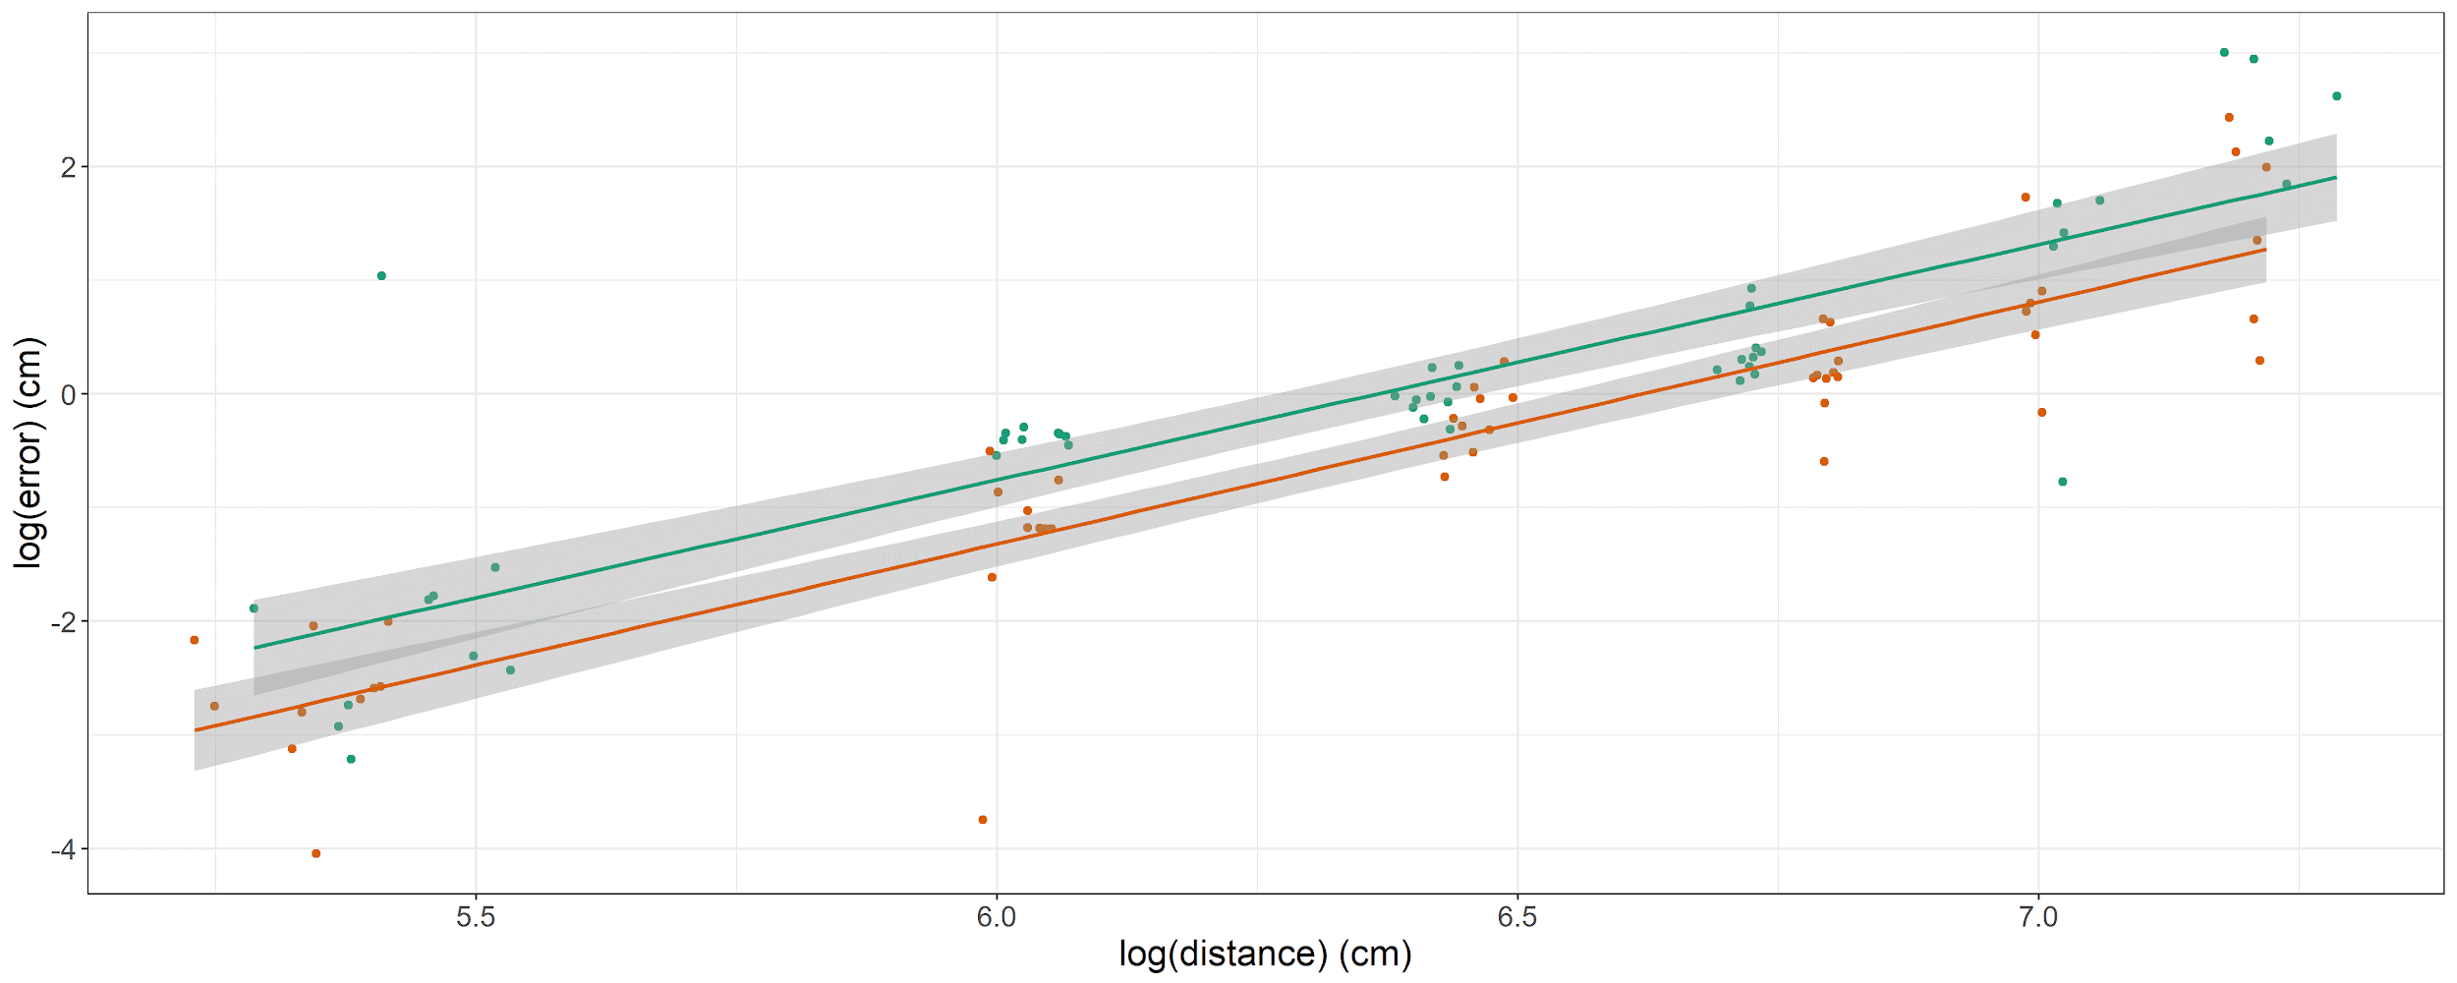

Table S2: Overview of species-secific slope and intercept coefficients of the regression of log10-transformed swimming speed in function of log10-transformed body length (in cm).

| species | slope | intercept |
| --- | --- | --- |
| *Cephalopholis argus* | 0.24 (-0.24;0.65) | 1.09 (0.57;1.79) |
| *Chaetodon ornatissimus* | 0.91 (0.15;1.83) | 0.43 (-0.54;1.23) |
| *Chaetodon pelewensis* | 1.17 (0.59;1.87) | 0.13 (-0.46;0.65) |
| *Chlorurus spilurus* | 0.98 (0.66;1.32) | 0.32 (-0.13;0.74) |
| *Chromis iomelas* | 0.54 (0.33;0.76) | 0.77 (0.64;0.88) |
| *Ctenochaetus striatus* | 0.35 (-0.1;0.75) | 0.99 (0.54;1.51) |
| *Naso lituratus* | 0.79 (0.28;1.76) | 0.44 (-0.74;1.17) |
| *Odonus niger* | 0.84 (0.27;1.33) | 0.55 (-0.04;1.27) |
| *Zebrasoma scopas* | 0.85 (0.61;1.12) | 0.43 (0.14;0.71) |

Table S3: Overview of regression parameters of log10-transformed maximum swimming speed in function of log10-transformed body length (in cm), aspect ratio, and with varying intercepts and slopes per interaction of family and body shape.

| term | estimate | std.error | lower | upper |
| --- | --- | --- | --- | --- |
| Intercept | 1.13164259 | 0.16716793 | 0.84902941 | 1.3870020 |
| log10Length_cm | 0.38445643 | 0.15436668 | 0.14054679 | 0.6423632 |
| aspect_ratio | 0.09291249 | 0.02186236 | 0.05744778 | 0.1286521 |
| sd_Family:BodyShapeI__Intercept | 0.25952929 | 0.15404290 | 0.07857226 | 0.5390915 |
| sd_Family:BodyShapeI__log10Length_cm | 0.26960130 | 0.14319841 | 0.09334734 | 0.5231086 |
| cor_Family:BodyShapeI__Intercept__log10Length_cm | -0.87223427 | 0.22010068 | -0.99655534 | -0.5143248 |

Table S4: Overview of average species and size-secific estimates of SMR, MMR, FMR, FAS, and FSA

| Family | Species | length | SMR | MMR | FMR | FAS | FSA |
| --- | --- | --- | --- | --- | --- | --- | --- |
| Acanthuridae | *Ctenochaetus striatus* | 10 | 0.045 | 0.112 | 0.066 | 2.522 | 1.236 |
| Acanthuridae | *Ctenochaetus striatus* | 11 | 0.055 | 0.140 | 0.081 | 2.532 | 1.232 |
| Acanthuridae | *Ctenochaetus striatus* | 12 | 0.068 | 0.171 | 0.098 | 2.539 | 1.228 |
| Acanthuridae | *Ctenochaetus striatus* | 13 | 0.081 | 0.206 | 0.117 | 2.547 | 1.225 |
| Acanthuridae | *Ctenochaetus striatus* | 14 | 0.096 | 0.244 | 0.138 | 2.554 | 1.222 |
| Acanthuridae | *Ctenochaetus striatus* | 15 | 0.112 | 0.287 | 0.161 | 2.557 | 1.220 |
| Acanthuridae | *Ctenochaetus striatus* | 16 | 0.130 | 0.333 | 0.186 | 2.565 | 1.217 |
| Acanthuridae | *Ctenochaetus striatus* | 17 | 0.149 | 0.383 | 0.213 | 2.571 | 1.215 |
| Acanthuridae | *Ctenochaetus striatus* | 18 | 0.170 | 0.438 | 0.242 | 2.575 | 1.213 |
| Acanthuridae | *Ctenochaetus striatus* | 19 | 0.192 | 0.496 | 0.273 | 2.579 | 1.210 |
| Acanthuridae | *Ctenochaetus striatus* | 20 | 0.215 | 0.558 | 0.306 | 2.587 | 1.209 |
| Acanthuridae | *Ctenochaetus striatus* | 21 | 0.241 | 0.625 | 0.340 | 2.592 | 1.207 |
| Acanthuridae | *Ctenochaetus striatus* | 22 | 0.267 | 0.696 | 0.377 | 2.596 | 1.206 |
| Acanthuridae | *Ctenochaetus striatus* | 23 | 0.296 | 0.770 | 0.416 | 2.600 | 1.204 |
| Acanthuridae | *Ctenochaetus striatus* | 24 | 0.326 | 0.850 | 0.458 | 2.605 | 1.202 |
| Acanthuridae | *Naso lituratus* | 17 | 0.132 | 0.595 | 0.215 | 4.529 | 1.316 |
| Acanthuridae | *Naso lituratus* | 18 | 0.149 | 0.679 | 0.246 | 4.568 | 1.323 |
| Acanthuridae | *Naso lituratus* | 19 | 0.168 | 0.769 | 0.279 | 4.608 | 1.331 |
| Acanthuridae | *Naso lituratus* | 20 | 0.188 | 0.868 | 0.316 | 4.648 | 1.341 |
| Acanthuridae | *Naso lituratus* | 21 | 0.209 | 0.973 | 0.356 | 4.690 | 1.351 |
| Acanthuridae | *Naso lituratus* | 22 | 0.232 | 1.085 | 0.398 | 4.718 | 1.359 |
| Acanthuridae | *Naso lituratus* | 23 | 0.256 | 1.203 | 0.443 | 4.749 | 1.366 |
| Acanthuridae | *Naso lituratus* | 24 | 0.281 | 1.329 | 0.491 | 4.784 | 1.374 |
| Acanthuridae | *Naso lituratus* | 25 | 0.308 | 1.462 | 0.542 | 4.808 | 1.381 |
| Acanthuridae | *Naso lituratus* | 26 | 0.335 | 1.601 | 0.595 | 4.830 | 1.388 |
| Acanthuridae | *Naso lituratus* | 27 | 0.364 | 1.748 | 0.651 | 4.855 | 1.395 |
| Acanthuridae | *Naso lituratus* | 28 | 0.394 | 1.904 | 0.710 | 4.874 | 1.401 |
| Acanthuridae | *Naso lituratus* | 29 | 0.425 | 2.065 | 0.772 | 4.901 | 1.408 |
| Acanthuridae | *Naso lituratus* | 30 | 0.458 | 2.235 | 0.838 | 4.927 | 1.415 |
| Acanthuridae | *Zebrasoma scopas* | 8 | 0.022 | 0.054 | 0.029 | 2.480 | 1.176 |
| Acanthuridae | *Zebrasoma scopas* | 9 | 0.028 | 0.070 | 0.038 | 2.536 | 1.189 |
| Acanthuridae | *Zebrasoma scopas* | 10 | 0.035 | 0.089 | 0.049 | 2.583 | 1.201 |
| Acanthuridae | *Zebrasoma scopas* | 11 | 0.042 | 0.111 | 0.061 | 2.629 | 1.213 |
| Acanthuridae | *Zebrasoma scopas* | 12 | 0.051 | 0.136 | 0.074 | 2.669 | 1.225 |
| Acanthuridae | *Zebrasoma scopas* | 13 | 0.061 | 0.164 | 0.089 | 2.708 | 1.236 |
| Acanthuridae | *Zebrasoma scopas* | 14 | 0.071 | 0.194 | 0.106 | 2.741 | 1.246 |
| Acanthuridae | *Zebrasoma scopas* | 15 | 0.082 | 0.228 | 0.124 | 2.776 | 1.257 |
| Acanthuridae | *Zebrasoma scopas* | 16 | 0.094 | 0.264 | 0.144 | 2.808 | 1.267 |
| Acanthuridae | *Zebrasoma scopas* | 17 | 0.107 | 0.304 | 0.166 | 2.840 | 1.277 |
| Acanthuridae | *Zebrasoma scopas* | 18 | 0.121 | 0.347 | 0.190 | 2.871 | 1.287 |
| Balistidae | *Odonus niger* | 10 | 0.028 | 0.170 | 0.073 | 6.010 | 1.782 |
| Balistidae | *Odonus niger* | 11 | 0.035 | 0.211 | 0.094 | 6.105 | 1.854 |
| Balistidae | *Odonus niger* | 12 | 0.042 | 0.258 | 0.119 | 6.195 | 1.931 |
| Balistidae | *Odonus niger* | 13 | 0.050 | 0.311 | 0.149 | 6.288 | 2.008 |
| Balistidae | *Odonus niger* | 14 | 0.058 | 0.369 | 0.184 | 6.360 | 2.087 |
| Balistidae | *Odonus niger* | 15 | 0.067 | 0.432 | 0.224 | 6.432 | 2.169 |
| Balistidae | *Odonus niger* | 16 | 0.077 | 0.502 | 0.270 | 6.496 | 2.253 |
| Balistidae | *Odonus niger* | 17 | 0.088 | 0.577 | 0.323 | 6.564 | 2.338 |
| Balistidae | *Odonus niger* | 18 | 0.099 | 0.658 | 0.382 | 6.623 | 2.425 |
| Balistidae | *Odonus niger* | 19 | 0.111 | 0.745 | 0.448 | 6.678 | 2.510 |
| Balistidae | *Odonus niger* | 20 | 0.124 | 0.838 | 0.521 | 6.730 | 2.598 |
| Balistidae | *Odonus niger* | 21 | 0.138 | 0.938 | 0.603 | 6.787 | 2.688 |
| Balistidae | *Odonus niger* | 22 | 0.152 | 1.043 | 0.692 | 6.836 | 2.774 |
| Balistidae | *Odonus niger* | 23 | 0.167 | 1.155 | 0.793 | 6.890 | 2.870 |
| Balistidae | *Odonus niger* | 24 | 0.183 | 1.274 | 0.905 | 6.944 | 2.969 |
| Balistidae | *Odonus niger* | 25 | 0.200 | 1.399 | 1.026 | 6.993 | 3.067 |
| Balistidae | *Odonus niger* | 26 | 0.217 | 1.531 | 1.159 | 7.036 | 3.170 |
| Chaetodontidae | *Chaetodon ornatissimus* | 9 | 0.027 | 0.081 | 0.040 | 2.967 | 1.227 |
| Chaetodontidae | *Chaetodon ornatissimus* | 10 | 0.034 | 0.104 | 0.051 | 3.031 | 1.247 |
| Chaetodontidae | *Chaetodon ornatissimus* | 11 | 0.042 | 0.130 | 0.065 | 3.089 | 1.269 |
| Chaetodontidae | *Chaetodon ornatissimus* | 12 | 0.051 | 0.159 | 0.080 | 3.145 | 1.289 |
| Chaetodontidae | *Chaetodon ornatissimus* | 13 | 0.060 | 0.192 | 0.097 | 3.200 | 1.308 |
| Chaetodontidae | *Chaetodon ornatissimus* | 14 | 0.070 | 0.228 | 0.116 | 3.252 | 1.326 |
| Chaetodontidae | *Chaetodon ornatissimus* | 15 | 0.082 | 0.268 | 0.138 | 3.302 | 1.346 |
| Chaetodontidae | *Chaetodon ornatissimus* | 16 | 0.094 | 0.312 | 0.162 | 3.341 | 1.365 |
| Chaetodontidae | *Chaetodon ornatissimus* | 17 | 0.107 | 0.359 | 0.189 | 3.382 | 1.384 |
| Chaetodontidae | *Chaetodon ornatissimus* | 18 | 0.121 | 0.411 | 0.218 | 3.423 | 1.403 |
| Chaetodontidae | *Chaetodon ornatissimus* | 19 | 0.136 | 0.466 | 0.250 | 3.463 | 1.421 |
| Pomacentridae | *Chromis iomelas* | 2 | 0.001 | 0.002 | 0.001 | 2.729 | 1.150 |
| Pomacentridae | *Chromis iomelas* | 3 | 0.002 | 0.006 | 0.003 | 2.867 | 1.187 |
| Pomacentridae | *Chromis iomelas* | 4 | 0.004 | 0.011 | 0.005 | 2.966 | 1.220 |
| Pomacentridae | *Chromis iomelas* | 5 | 0.006 | 0.019 | 0.009 | 3.056 | 1.250 |
| Pomacentridae | *Chromis iomelas* | 6 | 0.009 | 0.029 | 0.014 | 3.127 | 1.279 |
| Pomacentridae | *Chromis iomelas* | 7 | 0.013 | 0.042 | 0.021 | 3.188 | 1.306 |
| Pomacentridae | *Chromis iomelas* | 8 | 0.018 | 0.057 | 0.029 | 3.247 | 1.331 |
| Serranidae | *Cephalopholis argus* | 12 | 0.027 | 0.139 | 0.068 | 5.180 | 1.763 |
| Serranidae | *Cephalopholis argus* | 13 | 0.032 | 0.169 | 0.082 | 5.276 | 1.781 |
| Serranidae | *Cephalopholis argus* | 14 | 0.037 | 0.201 | 0.097 | 5.383 | 1.797 |
| Serranidae | *Cephalopholis argus* | 15 | 0.043 | 0.238 | 0.114 | 5.470 | 1.814 |
| Serranidae | *Cephalopholis argus* | 16 | 0.050 | 0.278 | 0.133 | 5.570 | 1.828 |
| Serranidae | *Cephalopholis argus* | 17 | 0.057 | 0.321 | 0.153 | 5.654 | 1.844 |
| Serranidae | *Cephalopholis argus* | 18 | 0.064 | 0.368 | 0.174 | 5.738 | 1.857 |
| Serranidae | *Cephalopholis argus* | 19 | 0.072 | 0.418 | 0.197 | 5.819 | 1.870 |
| Serranidae | *Cephalopholis argus* | 20 | 0.080 | 0.473 | 0.222 | 5.891 | 1.882 |
| Serranidae | *Cephalopholis argus* | 21 | 0.089 | 0.531 | 0.249 | 5.965 | 1.892 |
| Serranidae | *Cephalopholis argus* | 22 | 0.099 | 0.594 | 0.277 | 6.033 | 1.901 |
| Serranidae | *Cephalopholis argus* | 23 | 0.109 | 0.660 | 0.306 | 6.101 | 1.909 |
| Serranidae | *Cephalopholis argus* | 24 | 0.119 | 0.731 | 0.337 | 6.166 | 1.918 |
| Serranidae | *Cephalopholis argus* | 25 | 0.130 | 0.805 | 0.371 | 6.228 | 1.926 |
| Serranidae | *Cephalopholis argus* | 26 | 0.141 | 0.884 | 0.406 | 6.285 | 1.934 |
| Serranidae | *Cephalopholis argus* | 27 | 0.153 | 0.967 | 0.442 | 6.358 | 1.942 |
| Serranidae | *Cephalopholis argus* | 28 | 0.166 | 1.055 | 0.481 | 6.410 | 1.950 |
| Serranidae | *Cephalopholis argus* | 29 | 0.179 | 1.147 | 0.521 | 6.466 | 1.956 |
| Serranidae | *Cephalopholis argus* | 30 | 0.193 | 1.244 | 0.564 | 6.517 | 1.965 |
| Serranidae | *Cephalopholis argus* | 31 | 0.207 | 1.345 | 0.608 | 6.565 | 1.971 |
| Serranidae | *Cephalopholis argus* | 32 | 0.221 | 1.451 | 0.654 | 6.612 | 1.979 |
| Serranidae | *Cephalopholis argus* | 33 | 0.236 | 1.562 | 0.702 | 6.658 | 1.985 |
| Serranidae | *Cephalopholis argus* | 34 | 0.252 | 1.677 | 0.753 | 6.711 | 1.993 |
| Serranidae | *Cephalopholis argus* | 35 | 0.268 | 1.797 | 0.805 | 6.755 | 2.000 |
| Serranidae | *Cephalopholis argus* | 36 | 0.285 | 1.924 | 0.860 | 6.799 | 2.008 |
| Serranidae | *Cephalopholis argus* | 37 | 0.302 | 2.054 | 0.916 | 6.843 | 2.014 |

Figure S5. Fish abundance (m-2) of the studied sites. Each colour represents the abundance of a specific studied reef fish species.

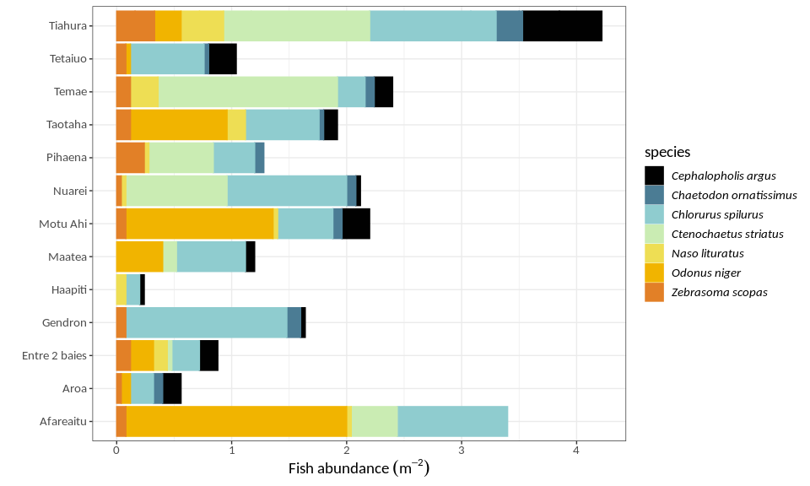

## References

Allen, A. P., J. F. Gillooly, and J. H. Brown. 2005. “Linking the global carbon cycle to individual metabolism.” *Functional Ecology* 19 (2):202–13. <https://doi.org/10.1111/j.1365-2435.2005.00952.x>.X

Allgeier, Jacob E., Craig A. Layman, Peter J. Mumby, and Amy D. Rosemond. 2014. “Consistent nutrient storage and supply mediated by diverse fish communities in coral reef ecosystems.” *Global Change Biology* 20 (8):2459–72. <https://doi.org/10.1111/gcb.12566>.X

Barneche, D. R., M. Kulbicki, S. R. Floeter, A. M. Friedlander, J. Maina, and A. P. Allen. 2014. “Scaling metabolism from individuals to reef-fish communities at broad spatial scales.” *Ecology Letters* 17 (9):1067–76. <https://doi.org/10.1111/ele.12309>.X

Bassett, D. K., and J. C. Montgomery. 2011. “Investigating nocturnal fish populations in situ using baited underwater video: With special reference to their olfactory capabilities.” *Journal of Experimental Marine Biology and Ecology* 409 (1-2):194–99. <https://doi.org/10.1016/j.jembe.2011.08.019>.X

Binning, Sandra a., Dominique G. Roche, and Cayne Layton. 2013. “Ectoparasites increase swimming costs in a coral reef fish.” *Biology Letters* 9 (1):20120927–7. <https://doi.org/10.1098/rsbl.2012.0927>.X

Bozec, Yves-Marie, Didier Gascuel, and Michel Kulbicki. 2004. “Trophic model of lagoonal communities in a large open atoll (Uvea, Loyalty islands, New Caledonia).” *Aquatic Living Resources* 17 (2):151–62. <https://doi.org/10.1051/alr:2004024>.X

Brandl, Simon J, Douglas B Rasher, Isabelle M Côté, Jordan M Casey, Emily S Darling, Jonathan S Lefcheck, and J Emmett Duffy. 2019. “Coral reef ecosystem functioning: eight core processes and the role of biodiversity.” *Frontiers in Ecology and the Environment, Advance Online Publication.*, July. John Wiley & Sons, Ltd. <https://doi.org/10.1002/fee.2088>.X

Brandl, Simon J, Luke Tornabene, Christopher H R Goatley, Jordan M Casey, Renato A Morais, Isabelle M Côté, Carole C Baldwin, Valeriano Parravicini, Nina M D Schiettekatte, and David R Bellwood. 2019. “Demographic dynamics of the smallest marine vertebrates fuel coral reef ecosystem functioning.” *Science* 364 (6446). American Association for the Advancement of Science:1189–92. <https://doi.org/10.1126/science.aav3384>.X

Brett, J. R. 1964. “The Respiratory Metabolism and Swimming Performance of Young Sockeye Salmon.” *Journal of the Fisheries Research Board of Canada* 21 (5):1183–1226. <https://doi.org/10.1139/f64-103>.X

Brill, Richard W., and Peter G. Bushnell. 1991. “Metabolic and cardiac scope of high energy demand teleosts, the tunas.” *Canadian Journal of Zoology* 69 (7):2002–9. <https://doi.org/10.1139/z91-279>.X

Brodie, Stephanie, Matthew D. Taylor, James A. Smith, Iain M. Suthers, Charles A. Gray, and Nicholas L. Payne. 2016. “Improving consumption rate estimates by incorporating wild activity into a bioenergetics model.” *Ecology and Evolution* 6 (8). John Wiley; Sons Ltd:2262–74. <https://doi.org/10.1002/ece3.2027>.X

Brown, J H, J F Gillooly, A P Allen, V M Savage, and G B West. 2004. “Toward a metabolic theory of ecology.” *Ecology* 85 (7):1771–89. <https://doi.org/Doi 10.1890/03-9000>.X

Burkner PC. 2017. “brms : An R Package for Bayesian Multilevel Models using Stan.” *Journal of Statistical Software* 80 (Plummer):1–28. <https://doi.org/10.18637/jss.v080.i01>.X

Cardinale, Bradley J., J. Emmett Duffy, Andrew Gonzalez, David U. Hooper, Charles Perrings, Patrick Venail, Anita Narwani, et al. 2012. “Biodiversity loss and its impact on humanity.” Nature Publishing Group. <https://doi.org/10.1038/nature11148>.X

Chabot, D., J. F. Steffensen, and A. P. Farrell. 2016. “The determination of standard metabolic rate in fishes.” *Journal of Fish Biology* 88 (1):81–121. <https://doi.org/10.1111/jfb.12845>.X

Chung, Ming-Tsung, Clive N. Trueman, Jane Aanestad Godiksen, Mathias Engell Holmstrup, and Peter Grønkjær. 2019. “Field metabolic rates of teleost fishes are recorded in otolith carbonate.” *Communications Biology* 2 (1). Springer US:1–10. <https://doi.org/10.1038/s42003-018-0266-5>.X

Clark, Timothy D., Michael R. Donaldson, Sebastian Pieperhoff, S. Matthew Drenner, Andrew Lotto, Steven J. Cooke, Scott G. Hinch, David A. Patterson, and Anthony P. Farrell. 2012. “Physiological benefits of being small in a changing world: Responses of coho salmon (Oncorhynchus kisutch) to an acute thermal challenge and a simulated capture event.” *PLoS ONE* 7 (6):1–8. <https://doi.org/10.1371/journal.pone.0039079>.X

Clark, Timothy D, Erik Sandblom, and Fredrik Jutfelt. 2013. “Aerobic scope measurements of fishes in an era of climate change: Respirometry, relevance and recommendations.” <https://doi.org/10.1242/jeb.084251>.X

Cruz-Font, Liset, Brian J. Shuter, and Paul J. Blanchfield. 2016. “Energetic costs of activity in wild lake trout: a calibration study using acceleration transmitters and positional telemetry.” *Canadian Journal of Fisheries and Aquatic Sciences* 73 (8). Canadian Science Publishing:1237–50. <https://doi.org/10.1139/cjfas-2015-0323>.X

Froese, R., J. T. Thorson, and R. B. Reyes. 2014. “A Bayesian approach for estimating length-weight relationships in fishes.” *Journal of Applied Ichthyology* 30 (1):78–85. <https://doi.org/10.1111/jai.12299>.X

FRY, F.E.J. 1957. “THE AQUATIC RESPIRATION OF FISH.” In *The Physiology of Fishes*, 1–63. Elsevier. <https://doi.org/10.1016/b978-1-4832-2817-4.50006-8>.X

Fry, FEJ. 1947. “Effects of the environment on animal activity.” *Univ. Toronto Stud. Biol. Ser.* 55 (68):1–62.

Fulton, C. J. 2007. “Swimming speed performance in coral reef fishes: Field validations reveal distinct functional groups.” *Coral Reefs* 26 (2):217–28. <https://doi.org/10.1007/s00338-007-0195-0>.X

Gillooly, James F., James H. Brown, Geoffrey B. West, Van M. Savage, and Eric L. Charnov. 2001. “Effects of size and temperature on metabolic rate.” *Science*. <https://doi.org/10.1126/science.1061967>.X

Glazier, Douglas S. 2005. “Beyond the ’3/4-power law’: Variation in the intra- and interspecific scaling of metabolic rate in animals.” *Biological Reviews of the Cambridge Philosophical Society* 80 (4):611–62. <https://doi.org/10.1017/S1464793105006834>.X

Gräns, A., M. Axelsson, K. Pitsillides, C. Olsson, J. Höjesjö, R. C. Kaufman, and J. J. Cech. 2009. “A fully implantable multi-channel biotelemetry system for measurement of blood flow and temperature: A first evaluation in the green sturgeon.” *Hydrobiologia* 619 (1). Springer:11–25. <https://doi.org/10.1007/s10750-008-9578-7>.X

Guénard, Guillaume, Daniel Boisclair, Ola Ugedal, Torbjørn Forseth, and Bror Jonsson. 2008. “Comparison between activity estimates obtained using bioenergetic and behavioural analyses.” *Canadian Journal of Fisheries and Aquatic Sciences* 65 (8):1705–20. <https://doi.org/10.1139/F08-080>.X

Halpern, Benjamin S., Shaun Walbridge, Kimberly A. Selkoe, Carrie V. Kappel, Fiorenza Micheli, Caterina D’Agrosa, John F. Bruno, et al. 2008. “A global map of human impact on marine ecosystems.” *Science* 319 (5865):948–52. <https://doi.org/10.1126/science.1149345>.X

Hughes, N F, and L H Kelly. 1996. “New techniques for 3-D video tracking of fish swimming movements in still or flowing water.” <https://doi.org/10.1139/f96-200>.X

Killen, Shaun S., Isabel Costa, Joseph A. Brown, and A. Kurt Gamperl. 2007. “Little left in the tank: metabolic scaling in marine teleosts and its implications for aerobic scope.” *Proceedings of the Royal Society B: Biological Sciences* 274 (1608):431–38. <https://doi.org/10.1098/rspb.2006.3741>.X

Killen, Shaun S., Douglas S. Glazier, Enrico L. Rezende, Timothy D. Clark, David Atkinson, Astrid S. T. Willener, and Lewis G. Halsey. 2016. “Ecological Influences and Morphological Correlates of Resting and Maximal Metabolic Rates across Teleost Fish Species.” *The American Naturalist* 187 (5):592–606. <https://doi.org/10.1086/685893>.X

Korsmeyer, Keith E, John Fleng Steffensen, and Jannik Herskin. 2002. “Energetics of median and paired fin swimming, body and caudal fin swimming, and gait transition in parrotfish (Scarus schlegeli) and triggerfish (Rhinecanthus aculeatus).” *The Journal of Experimental Biology* 205 (Pt 9):1253–63. <http://www.ncbi.nlm.nih.gov/pubmed/11948202>.X

Lucas, Martyn C., Alastair D. F. Johnstone, and Imants G. Priede. 2011. “Use of Physiological Telemetry as a Method of Estimating Metabolism of Fish in the Natural Environment.” *Changed Publisher: Wiley*. Taylor & Francis Group. <https://doi.org/10.1577/1548-8659(1993)122<0822:UOPTAA>2.3.CO;2>.X

Marshall, N. B. 1972. “Normal Sleep in Animals and Man [Abridged]: Sleep in Fishes [Abstract].” *Journal of the Royal Society of Medicine*. <https://doi.org/10.1177/003591577206500235>.X

Morais, Renato A., and David R. Bellwood. 2019. “Pelagic Subsidies Underpin Fish Productivity on a Degraded Coral Reef.” *Current Biology* 29 (9). Cell Press:1521–1527.e6. <https://doi.org/10.1016/j.cub.2019.03.044>.X

Motulsky, Harvey J., and Ronald E. Brown. 2006. “Detecting outliers when fitting data with nonlinear regression - A new method based on robust nonlinear regression and the false discovery rate.” *BMC Bioinformatics* 7:1–20. <https://doi.org/10.1186/1471-2105-7-123>.X

Mourier, Johann, Jeffrey Maynard, Valeriano Parravicini, Laurent Ballesta, Eric Clua, Michael L. Domeier, and Serge Planes. 2016. “Extreme Inverted Trophic Pyramid of Reef Sharks Supported by Spawning Groupers.” *Current Biology* 26 (15). Elsevier Ltd:2011–6. <https://doi.org/10.1016/j.cub.2016.05.058>.X

Murchie, Karen J., Steven J. Cooke, Andy J. Danylchuk, and Cory D. Suski. 2011. “Estimates of field activity and metabolic rates of bonefish (Albula vulpes) in coastal marine habitats using acoustic tri-axial accelerometer transmitters and intermittent-flow respirometry.” *Journal of Experimental Marine Biology and Ecology* 396 (2). Elsevier:147–55. <https://doi.org/10.1016/j.jembe.2010.10.019>.X

Nagy, Kenneth A. 2005. “Field metabolic rate and body size.” The Company of Biologists Ltd. <https://doi.org/10.1242/jeb.01553>.X

Nash, Kirsty L., Justin Q. Welsh, Nicholas A.J. Graham, and David R. Bellwood. 2015. “Home-range allometry in coral reef fishes: comparison to other vertebrates, methodological issues and management implications.” *Oecologia* 177 (1):73–83. <https://doi.org/10.1007/s00442-014-3152-y>.X

Neuswanger, Jason R., Mark S. Wipfli, Amanda E. Rosenberger, and Nicholas F. Hughes. 2016. “Measuring fish and their physical habitats: versatile 2D and 3D video techniques with user-friendly software.” *Canadian Journal of Fisheries and Aquatic Sciences* 73 (12):1861–73. <https://doi.org/10.1139/cjfas-2016-0010>.X

Norin, T., and T. D. Clark. 2016. “Measurement and relevance of maximum metabolic rate in fishes.” *Journal of Fish Biology* 88 (1):122–51. <https://doi.org/10.1111/jfb.12796>.X

Norin, T., and H. Malte. 2011. “Repeatability of standard metabolic rate, active metabolic rate and aerobic scope in young brown trout during a period of moderate food availability.” *Journal of Experimental Biology* 214 (10):1668–75. <https://doi.org/10.1242/jeb.054205>.X

Reich, Peter B., David Tilman, Forest Isbell, Kevin Mueller, Sarah E. Hobbie, Dan F.B. Flynn, and Nico Eisenhauer. 2012. “Impacts of biodiversity loss escalate through time as redundancy fades.” *Science* 336 (6081). American Association for the Advancement of Science:589–92. <https://doi.org/10.1126/science.1217909>.X

Roche, D. G., S. A. Binning, J. L. Rummer, Y. Bosiger, and J. L. Johansen. 2013. “Finding the best estimates of metabolic rates in a coral reef fish.” *Journal of Experimental Biology* 216 (11):2103–10. <https://doi.org/10.1242/jeb.082925>.X

S. Butail, and D A Paley. 2012. “Three-dimensional reconstruction of the fast-start swimming kinematics of densely schooling fish.”  *Royal Society Interface* 9 (66):77–88.

Steffensen, John Fleng. 1989. “Some errors in respirometry of aquatic breathers: How to avoid and correct for them.” *Fish Physiology and Biochemistry* 6 (1). Springer Netherlands:49–59. <https://doi.org/10.1007/BF02995809>.X

Tamayo, Natasha Charmaine A., Jonathan A. Anticamara, and Lilibeth Acosta-Michlik. 2018. “National Estimates of Values of Philippine Reefs’ Ecosystem Services.” *Ecological Economics* 146 (January 2017). Elsevier:633–44. <https://doi.org/10.1016/j.ecolecon.2017.12.005>.X

Tilman, David, Forest Isbell, and Jane M. Cowles. 2014. “Biodiversity and Ecosystem Functioning.” *Annual Review of Ecology, Evolution, and Systematics* 45 (1). Annual Reviews:471–93. <https://doi.org/10.1146/annurev-ecolsys-120213-091917>.X

Torres, J. J., and J. J. Childress. 1983. “Relationship of oxygen consumption to swimming speed in Euphausia pacifica - 1. Effects of temperature and pressure.” *Marine Biology* 74 (1). Springer-Verlag:79–86. <https://doi.org/10.1007/BF00394278>.X

Treberg, Jason R., Shaun S. Killen, Tyson J. MacCormack, Simon G. Lamarre, and Eva C. Enders. 2016. “Estimates of metabolic rate and major constituents of metabolic demand in fishes under field conditions: Methods, proxies, and new perspectives.” *Comparative Biochemistry and Physiology -Part A : Molecular and Integrative Physiology* 202. Elsevier Inc.:10–22. <https://doi.org/10.1016/j.cbpa.2016.04.022>.X

Trudel, M., and D. Boisclair. 1996. “Estimation of fish activity costs using underwater video cameras.” *Journal of Fish Biology* 48 (1):40–53. <https://doi.org/10.1111/j.1095-8649.1996.tb01417.x>.X

Venter, Oscar, Eric W. Sanderson, Ainhoa Magrach, James R. Allan, Jutta Beher, Kendall R. Jones, Hugh P. Possingham, et al. 2016. “Sixteen years of change in the global terrestrial human footprint and implications for biodiversity conservation.” *Nature Communications* 7 (1). Nature Publishing Group:1–11. <https://doi.org/10.1038/ncomms12558>.X

Villéger, Sébastien, Sébastien Brosse, Maud Mouchet, David Mouillot, and Michael J. Vanni. 2017. “Functional ecology of fish: current approaches and future challenges.” *Aquatic Sciences* 79 (4). Birkhauser Verlag AG:783–801. <https://doi.org/10.1007/s00027-017-0546-z>.X

Vinberg, G. 1960. *Rate of metabolism and food requirements of fishes*. Nanaimo B.C.: Distributed by the Fisheries Research Board of Canada Biological Station.

Webster, M D, and W W Weathers. 1989. “Validation of single-sample doubly labeled water method.” *American Journal of Physiology-Regulatory, Integrative and Comparative Physiology* 256 (2):R572–R576. <https://doi.org/10.1152/ajpregu.1989.256.2.R572>.X

West, Geoffrey B., James H. Brown, and Brian J. Enquist. 1997. “A general model for the origin of allometric scaling laws in biology.” *Science* 276 (5309):122–26. <https://doi.org/10.1126/science.276.5309.122>.X

Wilson, S. K., M. Adjeroud, D. R. Bellwood, M. L. Berumen, D. Booth, Y.-M. Bozec, P. Chabanet, et al. 2010. “Crucial knowledge gaps in current understanding of climate change impacts on coral reef fishes.” *Journal of Experimental Biology* 213 (6):894–900. <https://doi.org/10.1242/jeb.037895>.X

Zhdanova, Irina V., and Stéphan G. Reebs. 2006. “Circadian Rhythms in Fish.” *Fish Physiology* 24 (C):197–238. <https://doi.org/10.1016/S1546-5098(05)24006-2>.X