*diego general comments*

**1) no need to emphasise how misleading it might be to rely solely on standing biomass for conservation targets. Your results are powerful and novel enough without any of that.**

**2) We need to wordsmith the text some more to get readers onboard with the equality fluxes = functions.**

**3) The chosen model predictors. It would help I think if their justifications were intertwined with the early main-text paragraphs. Not drivers, perhaps “predictors” or “potential drivers” might be a safer solution.**

**4) The main text needs a succinct, yet clear description of how the modelling choice outputs a “trade-off” among the five fluxes. While the ugly details can be shoved in the Methods and Supplementary Info, the reader needs those ingredients to appreciate what you mean by the term trade-off, and how important / reliable they are.**

*comments Nick* **some circularity in there at present** **missing clarity regarding why each step in the analyses (e.g. moving from organismal traits to species level) is a logical progression from the last.**

*comments jake* **overall message is a bit vague and you would be better served to pull a few key things out and run with htem.**  **I think instead of mixing messages about global and local conseravation you just be all out there with it and say: real conservation of coral reefs will require both actions global and local. I think your 70% stat is really really cool and is something to hang your hat on.** **JA: : I think that the text is quite verbose and has too many fancy words. I will minimize the extent to which I edit out your adjectives moving forward because it is your MS your and your right to word things how you want – and that is fine. But as you see how I have edited things so far that I think there are an excessive number of adjectives (and the ones that are used are a bit over the top) and importantly they distract from the message. Again, that is just my opinion, you do you.**

*comments Deron* **I wonder if the heat map showing tradeoffs among the ecosystem functions would be worth putting in the main MS. I thought it was really cool! Maybe integrate it into Fig 2 or something if possible.**

**nmds: should production be in gC?**

**Nowhere are the actual rates of the different fluxes presented. All that readers get to see are residuals or effect size plots or correlations.**

**I think one thing that would be really nice in the supplement would be to have a figure identical to that of Fig 1. that actually presented the data on the maps instead of the residuals. It would be really informative to be able to look at the residuals in Fig 1 vs. the real data in the supplement. Something to consider.**

**Also on figure 1 maybe putting the units of each flux to emphasize to the reader that you are measuring things in N, P, or C for all of the different metrics.**  **fluxes vs functions!!**

# Trade-offs redefine the vulnerability of reef fish functions

Nina M. D. Schiettekatte, (core team:) Simon J. Brandl, Jordan M. Casey, Nicholas A. J. Graham, Diego R. Barneche, Deron E. Burkepile, Jacob E. Allgeier, (other data contributors:) Katrina S. Munsterman, Fabien Morat, Alexandre Mercière, Yves Letourneur, Enrico L. Rezende, Graham J. Edgar, Rick D. Stuart-Smith, Jesús E. Arias-Gonzaléz, Alan M. Friedlander, Alison L. Green, Osmar J. Luiz, F. A. Rodríguez‐Zaragoza, Laurent Vigliola, Michel Kulbicki, Sergio R. Floeter (supervisors:) Sébastien Villéger, Valeriano Parravicini

**Elemental fluxes underpin the functioning and productivity of all global ecosystems, thus maintaining fluxes (i.e. functions) is essential to the preservation of life1. Coral reefs flourish under nutrient-poor environments, and host a high diversity of fishes providing nutrition to millions of people2. Understanding the ability of coral reefs to maintain healthy functioning is essential to conserving coral reefs and the services they provide to humanity, especially under the escalating pressures of fishing3,4 and climate change6. Here, we determine the predictors and vulnerability of five key functions that are mediated by fishes across the tropics. We demonstrate that critical trade-offs exist among functions, such that no reef fish community structure is capable of maximizing all five functions simultaneously. In addition, we reveal that there is a high degree of functional dominance across communities. However, the identity of these species varies significantly across reefs, with ~70% of all species contributing disproportionally to a function in a given community. Finally, we highlight unbalanced vulnerability to human stressors across functions. Our results introduce a conundrum in coral reef conservation, i.e. we cannot maximize all functions, and imply that the successful preservation of coral reef functioning requires both conserving high fish diversity globally, and applying locally administered solutions.**

The flow of elements through biological communities fuels all life on Earth1. There is a strong consensus on the importance of preserving these fluxes, also defined as ecosystem functions1. However, quantitative monitoring of multiple functions is still in its infancy for many ecosystems due to methodological challenges, and therefore their trade-offs, drivers, and vulnerability remain poorly understood, impeding informed management7. For millennia, humans have managed nature with an economic mindset to maximize desirable functions such as plant or animal biomass production8. However, efforts to maximize one function may negatively impact another9. To make informed management decisions that pertain to ecosystem functioning, it is critical to quantify multiple functions simultaneously in order to understand the mechanisms that drive potential trade-offs10.

Coral reefs are among the most diverse and productive ecosystems on earth, and they provide indispensable ecosystem services to humans2. As coral reefs thrive in nutrient-poor waters, efficient nutrient recycling is the key to their productivity11. However, the integrity of coral reefs is threatened by a plethora of anthropogenic stressors, such as intensive exploitation and climate change6. Over the past decade, severe biodiversity declines have brought coral reef functioning and services to the forefront of scientific discourse7,12,13. However, our capacity to quantitatively evaluate, monitor, and compare reef functioning primarily relies on static proxies of functions, such as fish biomass, and functional richness based on qualitative species traits14–16. Consequently, we know little about the co-occurrence of functions and their drivers, which currently provides us with limited guidance for coral reef management in our rapidly changing world17.

Here, we integrate principles of biogeochemistry and traditional ecological assessments to advance understanding and conservation of the fluxes that underpin reef functioning. Specifically, we use a combination of novel data and phylogenetic extrapolation techniques to parametrize bioenergetic models on an individual level for 1010 reef fish species. We integrate these bioenergetic models with 9,118 reef fish communities at 585 sites across the world’s reefs to (1) quantify five key ecosystem functions performed by fishes (nitrogen excretion, phosphorous excretion, biomass production, herbivory, and piscivory) as well as their trade-offs, (2) determine the ecological predictors of variation in ecosystem functions using Bayesian mixed models, (3) estimate the contribution and dominance of different species to each function, and (4) assess the vulnerability of functions.

Combining novel approaches including phylogenetic extrapolation of quantitative traits and individual-level bioenergetic models with underwater visual census community data enabled us to quantify five key ecosystem functions performed by fishes (i.e. nitrogen excretion, phosphorous excretion, biomass production, herbivory, and piscivory) across the world’s reefs for the first time, highlighting the functional variation that exists beyond biomass effects. Biomass is the most commonly employed indicator of coral reef functioning7,15,18, and there is a strong relationship between biomass and all five functions. Yet, for communities with similar total fish biomass, different functions varied up to 10 to 100-times (Extended Data Fig. 1a). Further, correcting each function for biomass revealed strong trade-offs among the different functions (Fig.1, Extended Data Fig. 1b). For example, communities with high herbivory rates or N exretion are negatively correlated with rates of P excretion. Strikingly, less than 3% of all communities had an above average value of biomass-corrected function for all five functions simultaneously. As a consequence, at a given biomass, no reef can maximize all functions, i.e. a location may be a hotspot for one biomass-corrected function while being a cold spot for another (Fig. 1).

To uncover what underpins the trade-offs between multiple functions on coral reefs, we explored the relationship of each function with ecological predictors discribing fish community structure including body size, trophic level, age structure (expressed as immaturity) by fitting Bayesian mixed models (fig. 2). We found that negative correlations between functions are mediated by contrasting aspects of community structure (fig. 2). For example, phosphorous excretion is maximized in communities with a high proportion of large-bodied, mature fishes that occupy high trophic levels (See also 19). In contrast, biomass production is maximised in communities dominated by small, immature fishes at lower trophic levels. Metabolic theory predicts that small individuals have a higher mass-specific metabolic rate, and as a consequence, small individuals have elevated consumption rates and disproportionally contribute to functions that rely on rapid energetic turnover20. On the other hand, fishes in early life stages that are highly dependent on phosphorus to grow, and fishes with a nutrient-poor diet are often limited by phosphorus21, resulting in low contributions to phosphorus excretion. These results confirm the need to integrate organismal biology with community ecology to understand ecosystem-wide biogeochemical fluxes.

Human impact has caused severe global declines of reef fish biomass and shifts in community structure6,12,14, and our findings demonstrate that these changes will continue to fundamentally alter ecosystem functioning on reefs. While the effects of these alterations on ecological processes are more difficult to monitor than declines in biomass, the loss of functioning may have profound consequences for reef ecosystems. For example, intensive fishing leads to biomass declines, which particularly impacts large fishes and consequently changes the size, age, and trophic structure of fish communities3. These effects can favor biomass corrected nitrogen excretion and production22, while negatively impacting phosphorus excretion, herbivory, and piscivory (fig. 2, Extended Data Fig. 2). On the other hand, changes in community structure triggered by coral cover declines are associated with a shift toward herbivores, which may avoid shifts to algal domination4,23. In contrast, herbivores have a minor contribution to phosphorus excretion19,21, so a shift to herbivore dominance and the subsequent community-level decline of phosphorus excretion may change elemental ratios. Lower N to P ratios can in fact favor algal growth24, and promotes symbiont dominance within the coral holobiont25. This is particularly problematic when considered in conjunction with climate change, as phosphorus starvation in corals reduces their temperature threshold for bleaching26. Considering multiple functions thus paints a more nuanced and complete picture to help us understand how human-induced shifts in community structure affect coral reef health.

Alongside community structure, functional vulnerability can also be affected by the cumulative vulnerability of the species that are performing the functions, i.e. the vulnerability of a largely dominant species highly affects the vulnerability of the function itself. Due to species-specific charachteristics, certain species or entire families tend to contribute more or less to function, relative to their contribution to biomass (fig. 3a). Further, abundant species with a certain set of traits can profoundly affect rates of functioning on the community level27,28. Therefore, we assessed the role of species by quantified the degree of dominance for each community. We demonstrate that for most communities, functions are consistently dominated by a few species (fig. 3b). We then asked if species consistently perform a key role when present across communities by quantifying the frequency of their dominance. Despite evidence for species assuming key functional roles across widely-dispersed locations29, the identity of functionally dominant species varies remarkably and the frequency of dominance per species tends to be low (fig. 3c). Consequently, while worldwide, species that consistently perform a key role whenever present are rare, our results suggest that most species perform a key role on a local scale. Indeed, ~70% of all species contribute disproportionally to a function in a given community. Despite high species richness on coral reefs, researchers often report the existence functionally dominant “key species”30. We demonstrate that while dominance is indeed prevalent, the identity of the dominant species is unpredictable, suggesting the extreme species richness of coral reefs is essential to sustain global functioning28.

As a consequence of the widespread high degree of dominance on a local scale, the vulnerability of key species highly affects the vulnerability of functions. However, the identity and vulnerability of key species varies among functions. To uncover divergence in functional vulnerability, we quantified the vulnerability of each function on the community level to fishing and climate change by averaging species vulnerabilities, weighted by their contribution to each function. We demonstrate that vulnerability is relatively the highest for piscivory, through fishing, followed by P excretion, while climate change has the largest effects on P excretion, N excretion, and production (fig. 4). Double jeapordy tends to be the highest for P excretion and piscivory. Given the local nature of species’ functional contributions, the determination of specific species-based conservation efforts at a global scale will fail to sustain coral reef functioning. Rather, ecosystem functioning can be supported by local actions, taking into account the dominance and vulnerability, to avert the functional extinction of species31, while maintaining a high diversity on a global scale.

Our results demonstrate the challenges of managing one of Earth’s most diverse and vulnerable ecosystems. Maximizing ecosystem functioning is an important objective of contemporary conservation initiatives. The functional trade-offs revealed between key ecosystem functions challenges the feasibility of this approach and introduces a conundrum for coral reef conservation. Traditionally, marine reserves have been the main conservation strategy for coral reefs32. While they provide benefits for biomass and herbivory, they provide little insurance for diversity in populated regions15 and do not protect reefs from the pervasive effects of climate change32. Measuring conservation success with biomass or solely one function (e.g. herbivory) can mask the collapse of other essential functions. Thus, it is nescessary to gauge reef “health” based on multiple, complementary, process-based functions7. Furthermore, individual reefs require local management plans to protect species with key roles for each function and community structure components, and the presence of multiple stakeholders may require the prioritisation of various functions based on local needs and stressors. Finally, as most species play an important role on a local scale, local management efforts should go hand in hand with global action to conserve the high diversity of species in addition to tackling climate change, the primary threath to coral reefs33.

Our results contribute to an ongoing discussion surrounding the question: what constitutes a healthy reef? We posit that the answer cannot be rooted in a purely economic mindset that aims for the maximization of all functions. Rather, a diverse community that supports intermediate levels of each function is ideal, with many species emerging as key local players. In light of the rapid degradation of coral reefs worldwide6, quantitative monitoring of multiple functions alongside biomass is critical to create viable conservation targets and uphold coral reef functioning, as well as associated services to humanity, beyond the 21st century7.

# Figures

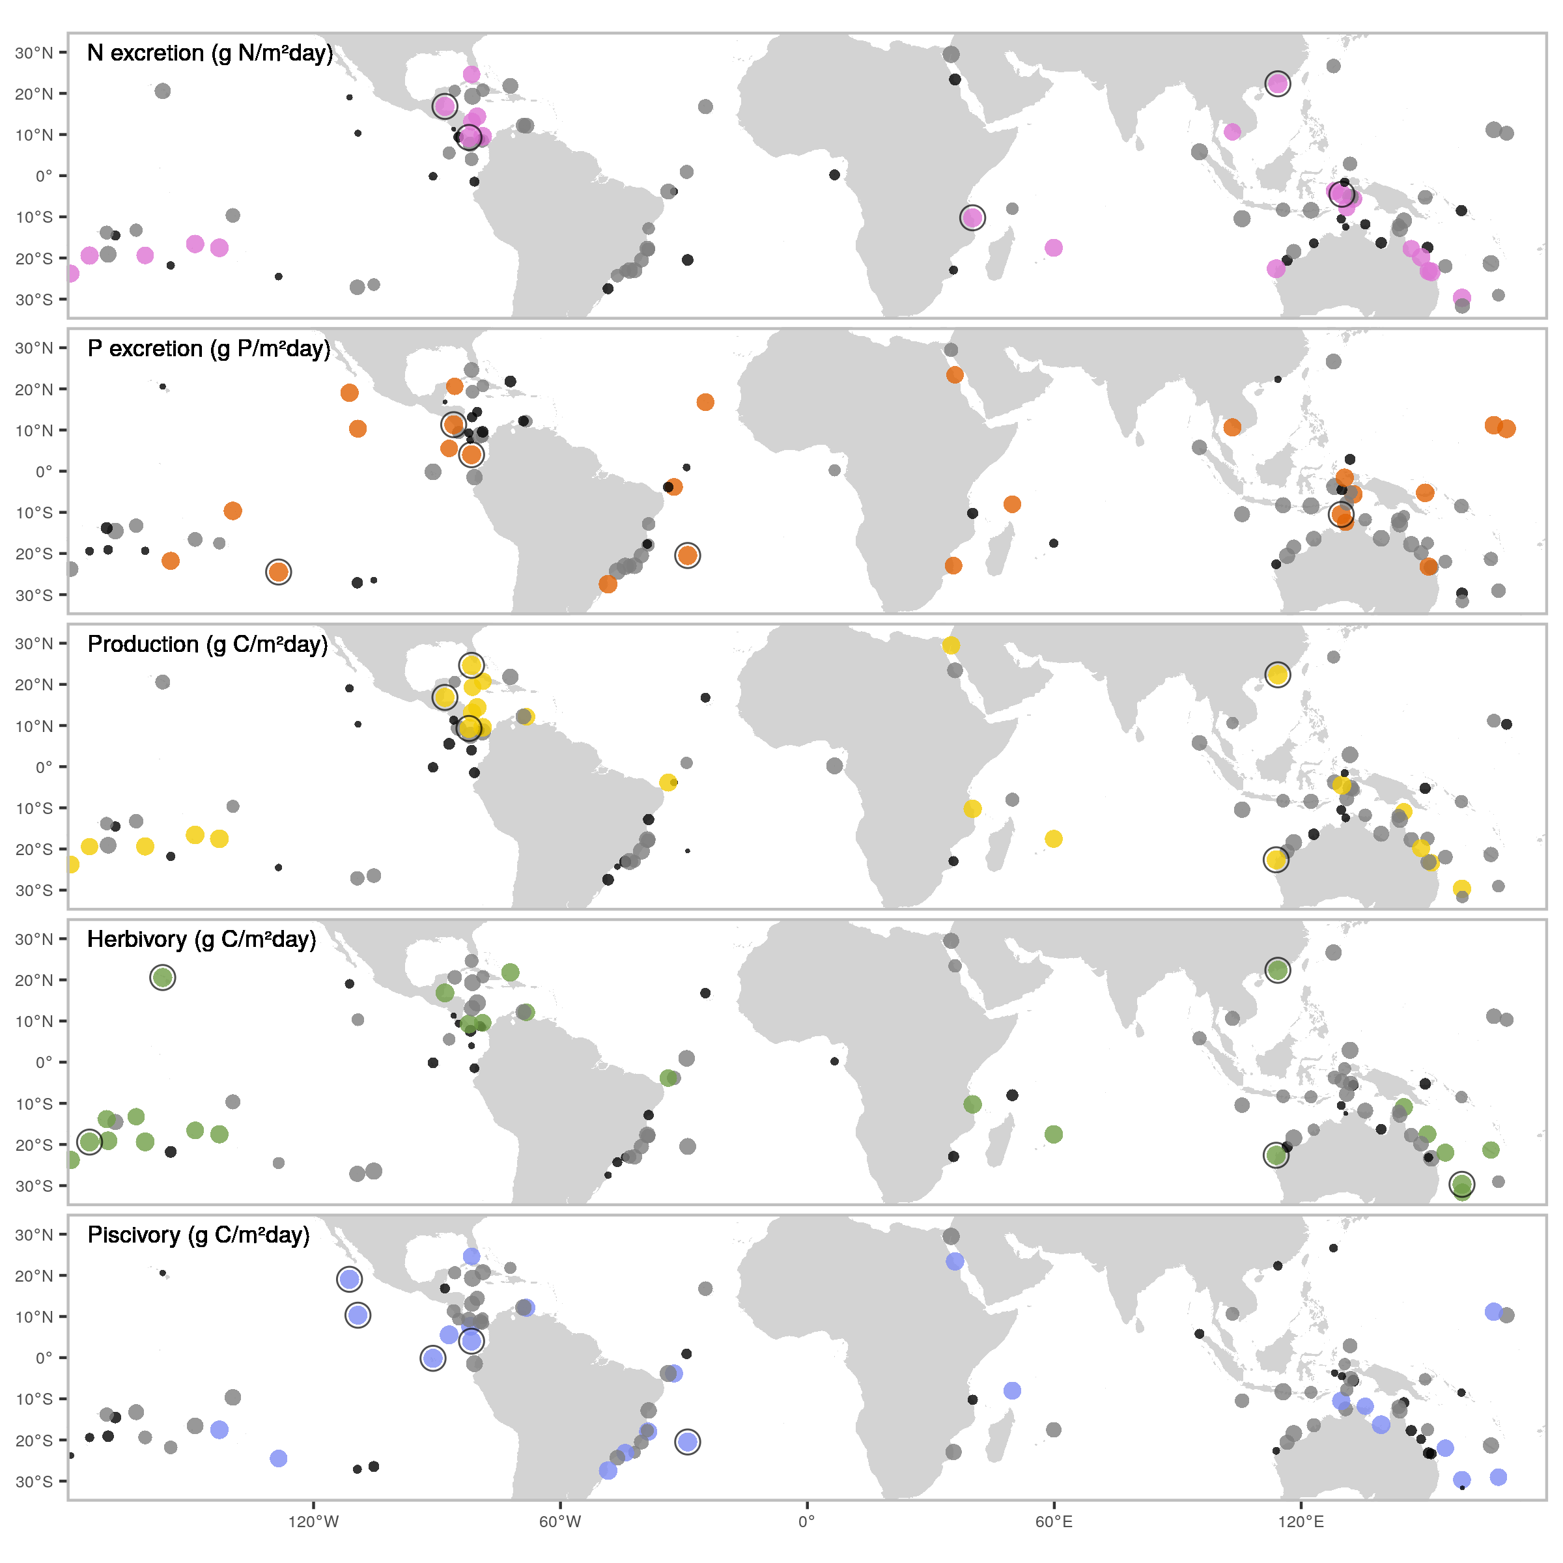

Figure 1: World maps of five key ecosystem functions, biomass-corrected and standardised. Dots indicate the locations that are included in this study. Dot size represents the rank of the biomass-corrected function. Similarly, the color scales show the value of the biomass-corrected function categorically (black = lower 25%, grey = 25-75%, color = >75%). Circles highlight the five locations with the highest value of each biomass-corrected function respectively.

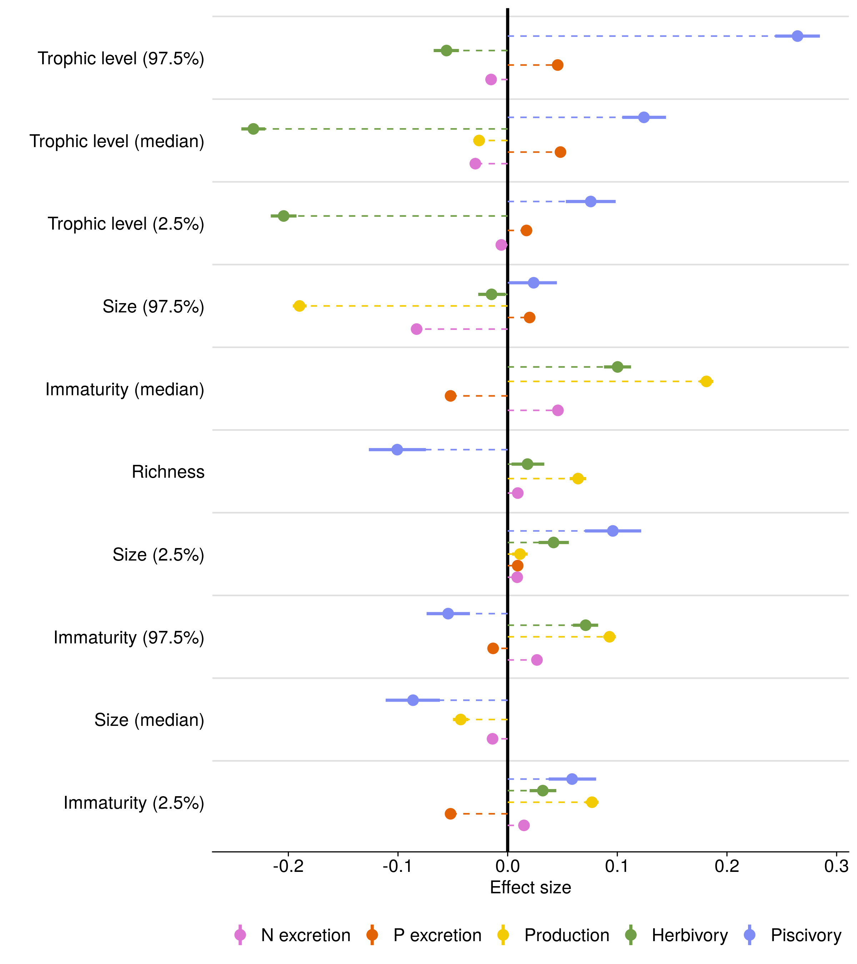

Figure 2: Fixed effect values of the Bayesian linear regression for each function with community variables. Trophic level, size, and immaturity of the community are represented by the median, and lower and upper 95% quantiles of all individuals inside a community. The log-transformed standing biomass was also included as a covariable, but not shown in this figure. All data was standardized to be able to compare across functions and variables. Functions were log-transformed before standardisation. Dots represent the average of the effect, and filled lines indicate the 95% credible interval. Effects are not shown when their 95% CI intersects with zero. Variables are ordered by the maximum absolute effect across the five models.

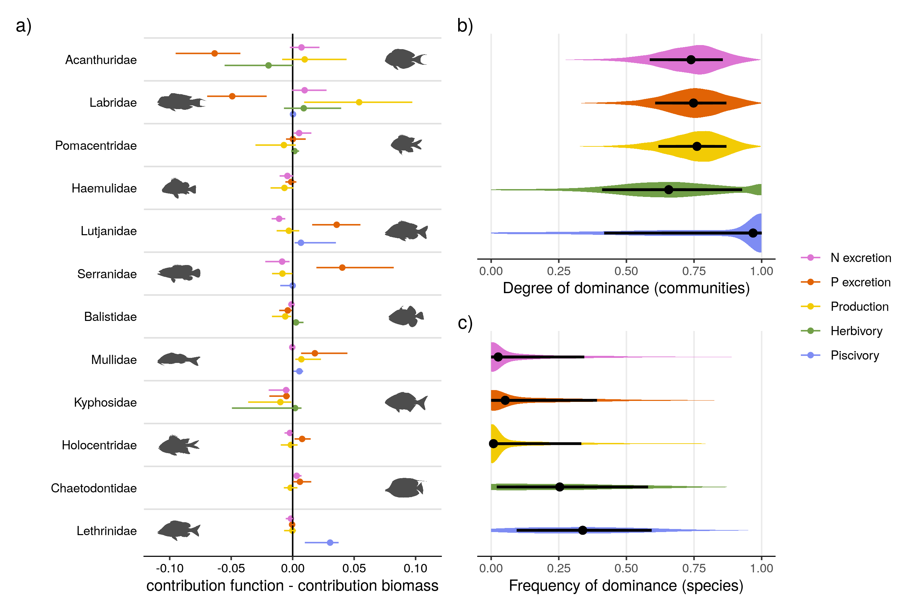

Figure 3: a) Median family-level contributions to each function, relative to their contribution to biomass. Positive values mean that a family contributes more relative to its contribution to total biomass. Only the 12 most important family’s are shown here, and families are ordered by their median contribution to biomass. b) Distribution of the degree of dominance of communities per function. A degree of dominance of 0 means each species contributes equally to a function, 1 means a single species performs a function. c) Distributions of frequency of being dominant to each function of all species across all communities. A value of 1 means that a species is always important whenever present. A species is counted as being dominant in a community if the contribution of that species is higher than the scenario in which all species contribute equally (i.e. 1 divided by the species richness). Shaded areas show the distribution of the values. Dots represent the median value, while lines indicate the interquartile range.

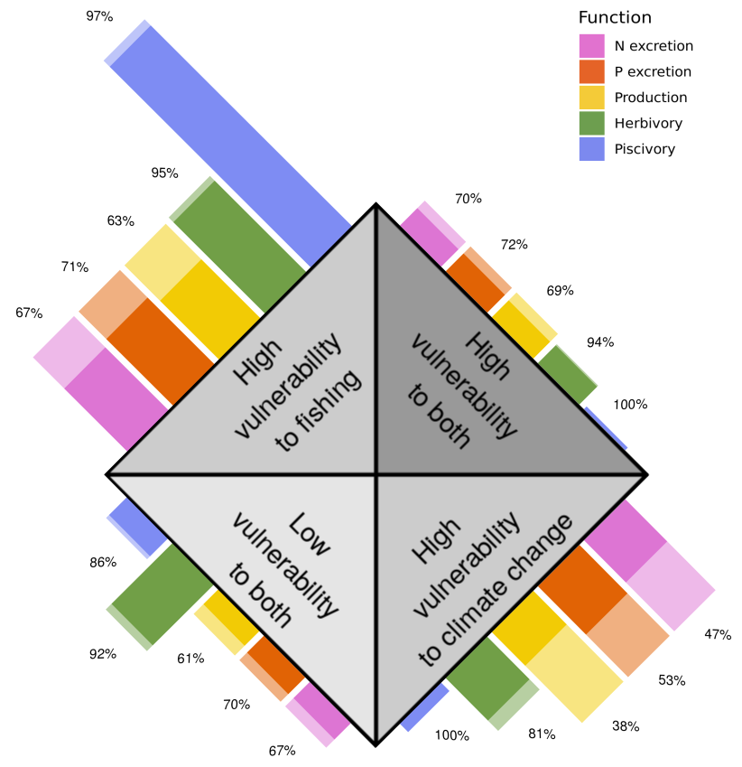

Figure 4: Vulnerability of species included in this study related to local dominance. Transparant bars represent the relative number of species in each category of vulnerability. Filled bars show the proportion of species that are locally dominant. A species is considered locally dominant if in any community, it contributes more to a function than 1 divided by the total number of species.

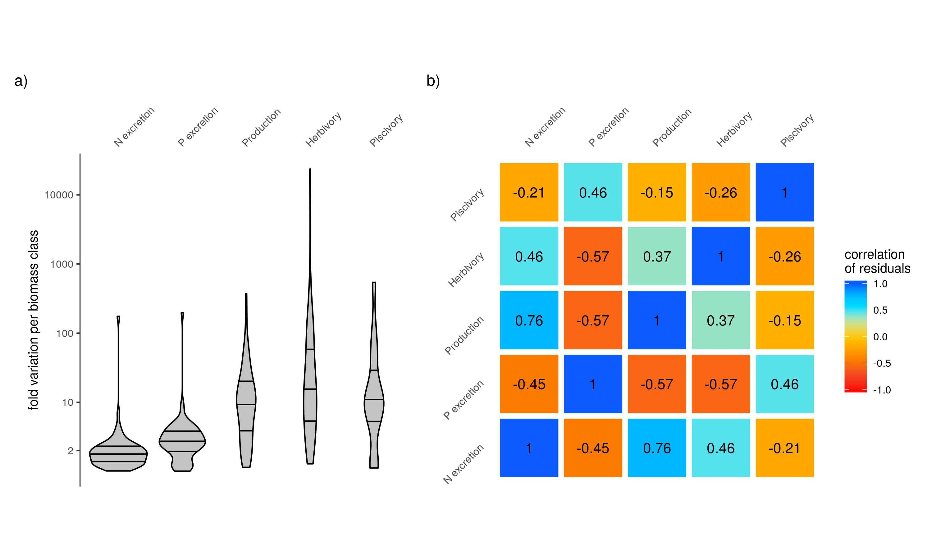

Extended Data Figure 1: a) Fold variation of each function per biomass class of 50g/m2 across fish communities. b) Correlation matrix of the residuals of the five functions. Standard deviations of correlation coefficients did not exceed 0.01.

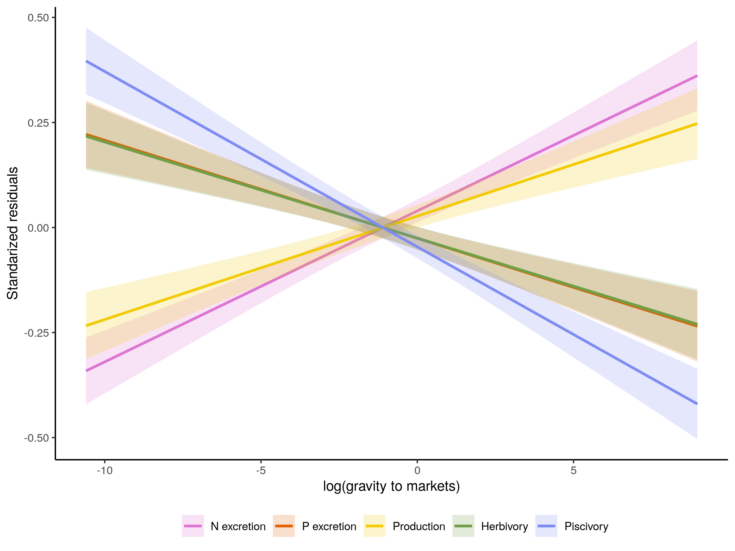

Extended Data Figure 2: Fitted linear regression of each function with the log-transormed gravity to markets. Functions are represented by their residuals, coming from the regression with biomass and sea surface temperature, and are standardized for comparison across functions.

# References

check cinner and rodriguez refs!

1. Welti, N. *et al.* Bridging food webs, ecosystem metabolism, and biogeochemistry using ecological stoichiometry theory. *Frontiers in Microbiology* **8**, 1298 (2017).

2. Teh, L. C. L. A. S., Louise S. L. AND Teh. A global estimate of the number of coral reef fishers. *PLOS ONE* **8**, 1–10 (2013).

3. Graham, N. A. *et al.* Human Disruption of Coral Reef Trophic Structure. *Current Biology* **27**, 231–236 (2017).

4. Ceccarelli, D. M., Emslie, M. J. & Richards, Z. T. Post-Disturbance Stability of Fish Assemblages Measured at Coarse Taxonomic Resolution Masks Change at Finer Scales. *PLOS ONE* **11**, e0156232 (2016).

5. Stuart-Smith, R. D., Brown, C. J., Ceccarelli, D. M. & Edgar, G. J. Ecosystem restructuring along the Great Barrier Reef following mass coral bleaching. *Nature* **560**, 92–96 (2018).

6. Hughes, T. P. *et al.* Global warming and recurrent mass bleaching of corals. *Nature* **543**, 373–377 (2017).

7. Brandl, S. J. *et al.* Coral reef ecosystem functioning: eight core processes and the role of biodiversity. *Frontiers in Ecology and the Environment, Advance online publication.* (2019) doi:[10.1002/fee.2088](https://doi.org/10.1002/fee.2088).

8. Weisser, W. W. *et al.* Biodiversity effects on ecosystem functioning in a 15-year grassland experiment: Patterns, mechanisms, and open questions. *Basic and Applied Ecology* **23**, 1–73 (2017).

9. Tallis, H., Kareiva, P., Marvier, M. & Chang, A. An ecosystem services framework to support both practical conservation and economic development. vol. 105 9457–9464 (2008).

10. Rodríguez, J. P. *et al.* Trade-offs across space, time, and ecosystem services. *Ecology and Society* **11**, (2006).

11. Brandl, S. J. *et al.* Demographic dynamics of the smallest marine vertebrates fuel coral reef ecosystem functioning. *Science* **364**, 1189–1192 (2019).

12. Williams, G. J. *et al.* Coral reef ecology in the Anthropocene. *Functional Ecology* **33**, 1014–1022 (2019).

13. Bellwood, D. R., Streit, R. P., Brandl, S. J. & Tebbett, S. B. The meaning of the term ‘function’ in ecology: A coral reef perspective. vol. 33 948–961 (2019).

14. Mora, C. *et al.* Global Human Footprint on the Linkage between Biodiversity and Ecosystem Functioning in Reef Fishes. *PLoS Biology* **9**, e1000606 (2011).

15. Cinner, J. E. *et al.* Meeting fisheries, ecosystem function, and biodiversity goals in a human-dominated world. *Science* **368**, 307–311 (2020).

16. Mouillot, D. *et al.* Functional over-redundancy and high functional vulnerability in global fish faunas on tropical reefs. *Proceedings of the National Academy of Sciences of the United States of America* **111**, 13757–62 (2014).

17. Allgeier, J. E., Valdivia, A., Cox, C. & Layman, C. A. Fishing down nutrients on coral reefs. *Nature Communications* **7**, (2016).

18. MacNeil, M. A. *et al.* Recovery potential of the world’s coral reef fishes. *Nature* **520**, 341–344 (2015).

19. Allgeier, J. E., Layman, C. A., Mumby, P. J. & Rosemond, A. D. Consistent nutrient storage and supply mediated by diverse fish communities in coral reef ecosystems. *Global Change Biology* **20**, 2459–2472 (2014).

20. Barneche, D. R. & Allen, A. P. The energetics of fish growth and how it constrains food-web trophic structure. *Ecology Letters* **21**, 836–844 (2018).

21. Schiettekatte, N. M. D. *et al.* Nutrient limitation, bioenergetics, and stoichiometry: a new model to predict elemental fluxes mediated by fishes. *Functional Ecology* (2020) doi:[10.1111/1365-2435.13618](https://doi.org/10.1111/1365-2435.13618).

22. Morais, R. A., Connolly, S. R. & Bellwood, D. R. Human exploitation shapes productivity–biomass relationships on coral reefs. *Global Change Biology* **26**, 1295–1305 (2020).

23. Graham, N. A. *et al.* Dynamic fragility of oceanic coral reef ecosystems. *Proceedings of the National Academy of Sciences of the United States of America* **103**, 8425–8429 (2006).

24. Burkepile, D. E. *et al.* Nutrient supply from fishes facilitates macroalgae and suppresses corals in a Caribbean coral reef ecosystem. *Scientific Reports* **3**, 1493 (2013).

25. Allgeier, J. E. *et al.* Rewiring coral: Anthropogenic nutrients shift diverse coral–symbiont nutrient and carbon interactions toward symbiotic algal dominance. *Global Change Biology* **n/a**,

26. Ezzat, L., Maguer, J. F., Grover, R. & Ferrier-Pagès, C. Limited phosphorus availability is the Achilles heel of tropical reef corals in a warming ocean. *Scientific Reports* **6**, 31768 (2016).

27. Ruttenberg, B. I., Adam, T. C., Duran, A. & Burkepile, D. E. Identity of coral reef herbivores drives variation in ecological processes over multiple spatial scales. *Ecological Applications* **29**, e01893 (2019).

28. Topor, Z. M., Rasher, D. B., Duffy, J. E. & Brandl, S. J. Marine protected areas enhance coral reef functioning by promoting fish biodiversity. *Conservation Letters* **12**, e12638 (2019).

29. Bellwood, D. R., Hoey, A. S. & Choat, J. H. Limited functional redundancy in high diversity systems: Resilience and ecosystem function on coral reefs. *Ecology Letters* **6**, 281–285 (2003).

30. Bellwood, D. R., Hughes, T. P. & Hoey, A. S. Sleeping Functional Group Drives Coral-Reef Recovery. *Current Biology* **16**, 2434–2439 (2006).

31. McCauley, D. J. *et al.* Marine defaunation: Animal loss in the global ocean. vol. 347 (2015).

32. Graham, N. A. *et al.* Changing role of coral reef marine reserves in a warming climate. *Nature Communications* **11**, 1–8 (2020).

33. Bruno, J. F., Côté, I. M. & Toth, L. T. Climate Change, Coral Loss, and the Curious Case of the Parrotfish Paradigm: Why Don’t Marine Protected Areas Improve Reef Resilience? *Annual Review of Marine Science* **11**, 307–334 (2019).