# Global drivers and vulnerabilities of coral reef fish functions

**Preserving the integrity of ecosystems – their functioning – is a critical challenge of the 21st century. The world’s coral reefs are highly diverse, productive, and valuable to millions of people1, and protecting their ecosystem functioning under the escalating pressures of fishing2,3 and climate change5 underpins most of today’s coral reef conservation efforts. However, a quantitative assessment of multiple, process-based functions on reefs is lacking. Here, we show that five key functions mediated by fishes —nitrogen and phosphorus cycling, biomass production, herbivory, and piscivory— exhibit critical trade-offs that are driven by diverging community structures and species dominance. Contrary to the concept of maximizing functioning as a single currency, no reef fish community worldwide can simultaneously sustain high values across all functions. Furthermore, functions are locally dominated by few species, but worldwide, 70% of the 1110 species in our dataset contribute disproportionally to functioning in at least one local community. This leads to disparate vulnerabilities of functions to anthropogenic stressors. Our findings reveal a profound challenge in coral reef conservation: there is no clear objective for protecting coral reef functioning and there are no global keystone species to target. Instead, quantitative assessments of multiple functions are necessary to design informed conservation strategies.**

The flow of elements through biological communities fuels all life on Earth6. Preserving these fluxes, often termed ecosystem functions, is critical for the integrity of ecosystems6. For millennia, resources have been managed with an economic mindset to maximize desirable functions such as the production of plant or animal biomass7. Sustaining multiple functions likely requires both high species richness and a variety of species assemblages across a landscape8. However, in agro-ecological settings, efforts to maximize one function negatively impact another (e.g. timber production vs. erosion control), shedding light on the existence of trade-offs between functions8,9. An understanding of such trade-offs is required to make informed management decisions10, but simultaneously quantifying multiple ecosystem functions is challenging. Therefore, trade-offs between functions, their drivers, and functional vulnerability are poorly understood in many ecosystems11.

Coral reefs are among the most diverse and productive ecosystems on Earth and provide essential ecosystem services to humanity1. As coral reefs thrive in nutrient-poor waters, efficient cycling of elements is key to their high productivity12. Yet, the integrity of coral reefs is threatened by a plethora of anthropogenic stressors, such as exploitation and climate change5. Over the past decades, severe declines in coral reef habitat quality and fish biomass as well as shifts in community structure have brought coral reef functioning and services to the forefront of scientific discourse11,13,14. However, our capacity to quantitatively evaluate, monitor, and compare reef functioning primarily relies on static proxies of functions, such as live coral cover, standing stock biomass of reef fishes, or functional richness based on qualitative species traits15–17. Conversely, we know comparatively little about elemental fluxes and their drivers (but see18). This constitutes a severe limitation to effective conservation management of coral reefs11.

Here, we integrate biogeochemistry and community ecology to advance our understanding of the elemental fluxes that underpin reef fish functioning. Using empirically-collected species-specific data on basic organismal processes and Bayesian phylogenetic models to extrapolate to species that lack data, we parameterize individual-level bioenergetic models to estimate five key ecosystem functions: nitrogen (N) excretion, phosphorus (P) excretion, biomass production, herbivory (daily consumption of primary producers, expressed as mass of carbon), and piscivory (daily consumption of fishes, expressed as mass of carbon). We apply these bioenergetic models to all individuals across 9,118 reef fish communities in 585 sites worldwide (Extended Data Table 1) to: (1) quantify community-level reef fish functions and their trade-offs, (2) extract the community- and species-level effects on these functions, and (3) gauge the vulnerability of reef fish functioning in the Anthropocene.

The five key ecosystem functions performed by fishes across the world’s reefs exhibit high variability (Fig. 1). Biomass is the most commonly employed indicator of coral reef functioning11,16,19, and as can be expected from the cumulative nature of community-level ecosystem functioning, we indeed observed a strong relationship between fish standing stock biomass and all five functions (Extended Data Fig. 1a-e, Extended Data Fig. 2). However, our analyses demonstrate that reef fish functions vary remarkably after accounting for biomass, as functions of communities with similar biomass may differ with two orders of magnitude and a two-fold difference in biomass can yield similar levels for functions (i.e. biomass production, Extended Data Fig. 1a-f). Thus, using biomass as a sole proxy for functioning can mask differences in critical community-level functions. Further, we demonstrate strong trade-offs among the five functions, independent of biomass (Fig.1, Extended Data Fig. 1g). For example, high herbivory rates or nitrogen excretion negatively correlate with rates of phosphorus excretion. As a consequence, for a given value of standing stock biomass, no reef can yield above average values across all five functions. In other words, while many reefs may stand out as hotspots for one function, none can maximize functioning as a holistic, multifaceted concept (Fig. 1).

Community structure and species-specific traits clearly impact rates of functioning. First, using community-level ecological predictors known to affect elemental fluxes20 (body size, trophic level, species richness, biomass, temperature, and age structure; Fig. 2), we show that correlations between functions are mediated by contrasting aspects of community structure (Fig. 2; Extended Data Table 2; Extended Data Fig. 2). For example, phosphorus excretion is higher in communities with many large-bodied, mature fishes that occupy high trophic levels, thus creating a positive relationship between phosphorus excretion and piscivory (Extended Fig. 1g; See 21). In contrast, biomass production is highest in communities dominated by small and/or immature fishes at low trophic levels, creating a trade-off between biomass production and phosphorus excretion. Metabolic theory predicts that small-bodied individuals have higher mass-specific metabolic rates, leading to elevated consumption rates and disproportional contributions to functions that rely on rapid energetic turnover12,22,23. Conversely, fishes in early life stages or with a nutrient-poor diet are often limited by phosphorus20, resulting in low contributions of these individuals to phosphorus excretion. Thus, due to variations in organismal physiology and life-history traits18,20, fish community structure can significantly impact ecosystem-wide functioning24.

Secondly, alongside features of community structure, ecosystem functioning may also be influenced by specific high-performing taxa. Certain species or entire families tend to contribute more or less to a particular function, relative to their contribution to standing biomass or due to specific characteristics (Fig. 3a; Extended Data Fig. 3,4). Further, abundant species can impact rates of functioning at the community level25,26. Therefore, we assessed the role of each species by quantifying their relative contributions and the degree to which they disproportionally induce (i.e. dominate) different functions in each community. We show that functions consistently hinge a few dominant species (Fig. 3b). Specifically, more than 50% of a given function, on average, is upheld by only 12% of the species present within a local community. However, the identity of these species varies dramatically (Fig. 3c), despite evidence for some species assuming key functional roles across widely-dispersed locations27. While few high-performing taxa dominate functioning in each location, there are almost no species that are important across their entire range, and most species are locally important in at least one community. Indeed, 70% of all species contributed disproportionally to a specific function in at least one reef fish community. Despite high species richness on coral reefs, researchers often report the existence of functionally-dominant “key species”28. Our results reveal that while functional dominance is indeed prevalent, the identity of local, dominant species vary strongly across different locations, suggesting that maintaining high levels of species richness across coral reef regions is essential to sustain global ecosystem functioning26.

The critical importance of both reef fish community structure and species-specific contributions shines new light on the vulnerability of coral reef functioning in our changing world. Anthropogenic stressors have caused severe changes in reef fish biomass and community structure5,13,15, and our findings suggest that these changes will have strong effects on ecosystem functioning. For example, intensive fishing and associated reductions in biomass of large fishes truncates the size, age, and trophic structure of fish communities2. When accounting for the effect of biomass, these effects can enhance nitrogen excretion and production23, while negatively impacting phosphorus excretion herbivory, and piscivory (Fig. 2). On the other hand, declines in coral cover related to climate change are often associated with a shift toward herbivores, which may help avoid algal domination3,29. However, herbivores have a minor contribution to phosphorus excretion20,21, so a shift to herbivore dominance in fish communities and the subsequent decline of community-level phosphorus excretion may change the balance of nutrient cycling on reefs. Higher N:P ratios may favor algal growth30, and promote algal symbiont dominance within the coral holobiont31. Shifts in elemental ratios may be particularly problematic when considered in concert with climate change since phosphorus starvation in corals reduces their temperature threshold for bleaching32. Thus, considering multiple functions paints a more nuanced, holistic picture of how human-induced shifts in reef fish community structure impact coral reef ecosystems.

Similarly, the species-specific vulnerability of functionally-dominant species heavily affects functioning. By combining species-level vulnerability scores to fishing and climate change induced coral loss33 and the contributions of each species to each function, we demonstrate that the loss of individuals most vulnerable to fishing will have greatest impacts on piscivory, followed by phosphorus excretion (Fig. 4). Conversely, the loss of individuals due to climate change and consequent coral mortality may disproportionally reduce phosphorus excretion, nitrogen excretion, and biomass production. Fishing and the loss of live coral impact species important for phosphorus excretion. Surprisingly, although fishing pressure can negatively impact large herbivores such as parrotfishes34, herbivory is the least vulnerable function. This may be due to the high variability in ecosystem roles within the comparatively large pool of herbivorous fish species. While small herbivores are abundant and not particularly vulnerable to fishing, larger herbivorous species are frequently targeted and prone to functional extinction in areas with high fishing pressure35. While herbivores of all body sizes and functional groups are combined in our assessment, their realized contributions to herbivory are strongly complementary, and it is important to recognize the specific functional roles performed by small subsets of herbivorous species (e.g. bioerosion34,36). Thus, our results reflect the overall vulnerability of functions; yet, this does not consider the distinct roles played by small groups of species nested within a broad function such as herbivory.

Conserving biomass, diversity, and ecosystem functioning are important objectives of most current conservation initiatives16. Even though safeguarding fish biomass enhances coral reef functioning, the strong trade-offs between key ecosystem functions reveals a critical challenge for coral reef conservation, where actions to enhance one function may negatively impact another. For example, the establishment of marine protected areas, which are one of the primary conservation tactics for coral reefs37, may protect herbivorous species and thus provide benefits for herbivory. However, marine protected areas do not protect reefs from the pervasive effects of climate change37, and community shifts towards domination of herbivores may result in the decline of phosphorus excretion. Thus, measuring conservation success with biomass or solely one function (e.g. herbivory) can mask the collapse of other essential functions. It is necessary to gauge the state of reef ecosystems based on multiple, complementary, process-based functions11, as well as making informed decisions on local needs and stressors. Finally, while there is a general consensus on the role of diversity in enhancing functioning8,38, we highlight the overarching importance of community structure and the identity of dominant species at the local scale. While, maintaining the diversity of fishes is critical for coral reef functioning, at local scales, species richness only has a minor impact on individual functions. Rather, dissimilarity between local communities may be the most critical factor in maintaining functioning across the seascape since no species consistently provides high contributions for all functions or across its range8,39,40.

Overall, through coral reef fishes, we demonstrate that the striking variability in processes that govern the cycling of elements presents a critical, unrecognized challenge for coral reef ecosystem functioning. Management strategies that call for the enhancement of coral reef functioning via an economic mindset, where higher functioning is better, are not feasible. Instead, conserving coral reef ecosystem functioning will require a more nuanced approach that considers processes that vary beyond the effect of standing stock biomass and are subject to variable, local trade-offs, drivers, and anthropogenic threats.

# Figures

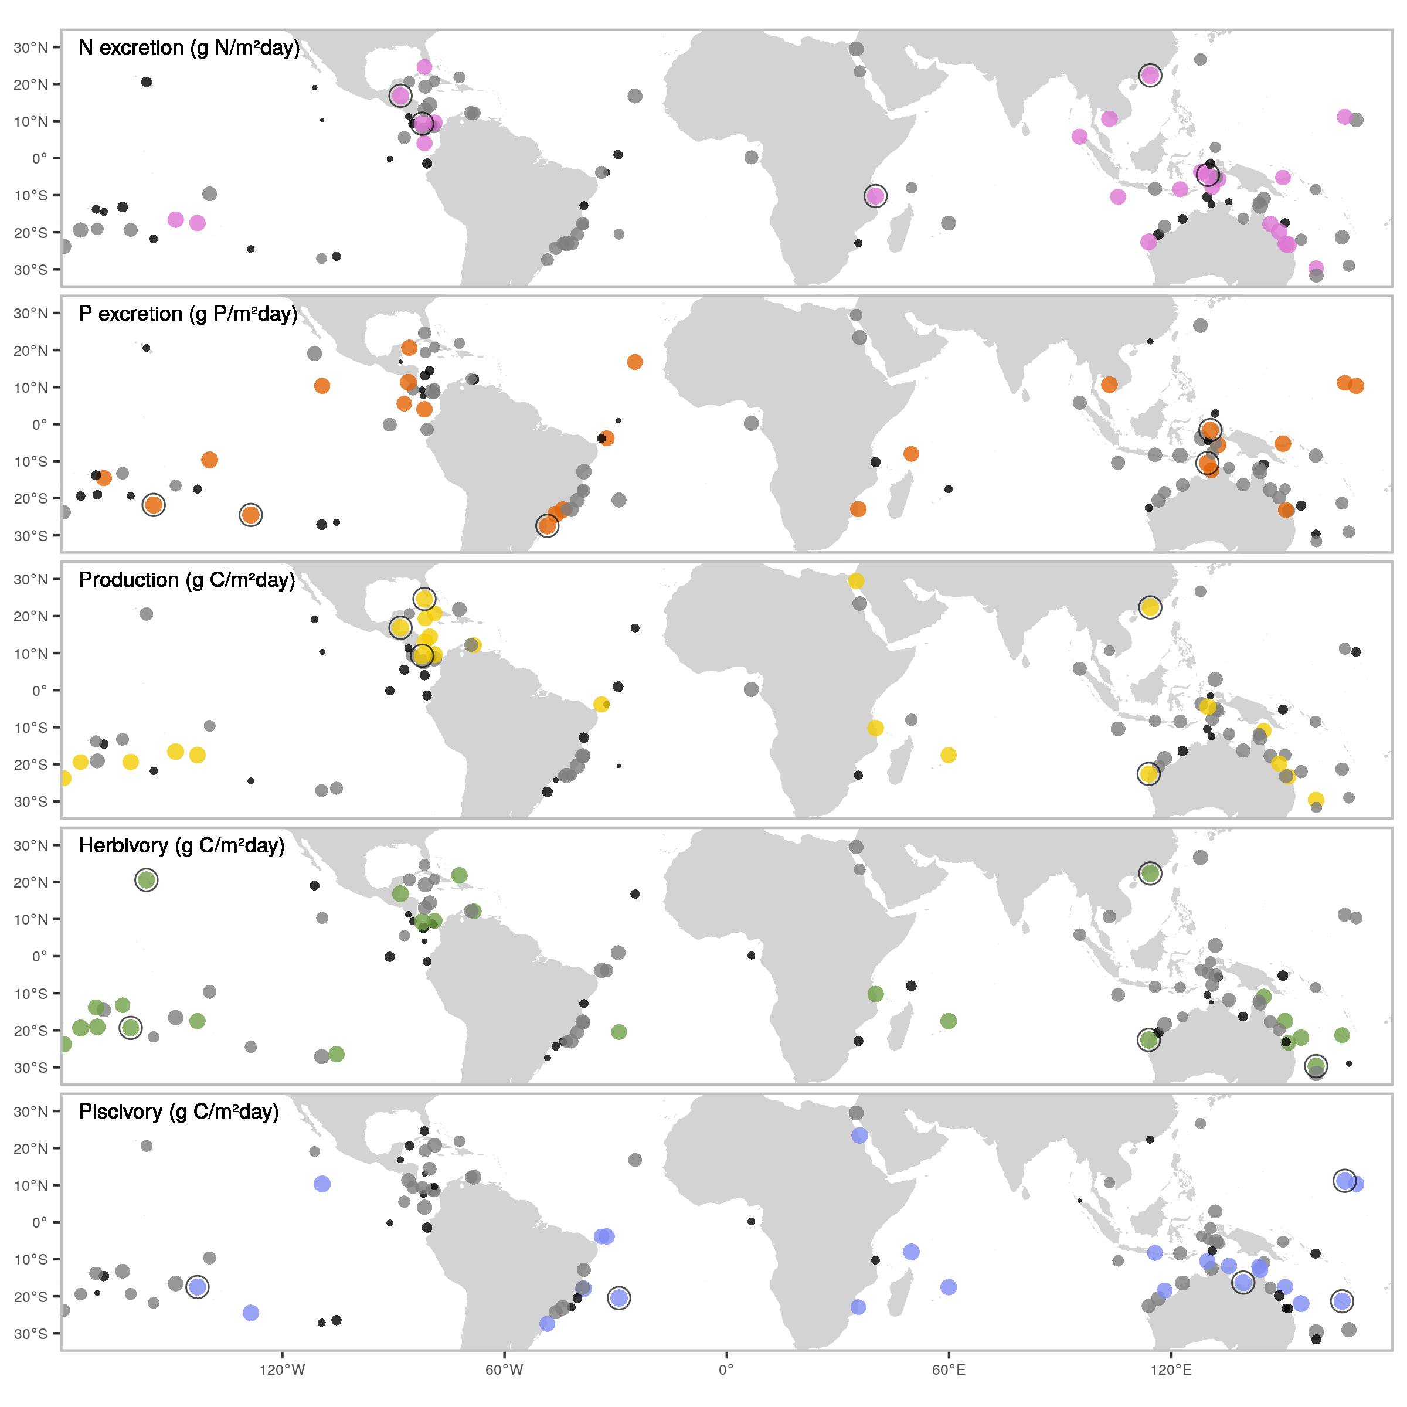

Figure 1: Spatial variation in five key, biomass-corrected ecosystem functions. Dots indicate locations of field surveys, with dot sizes representing the ranked values of biomass-corrected function, and color scales showing categorical assignments (black = lower 25%, grey = 25-75%, color = >75%). Black circular outlines highlight the five locations with the highest values of each biomass-corrected function.

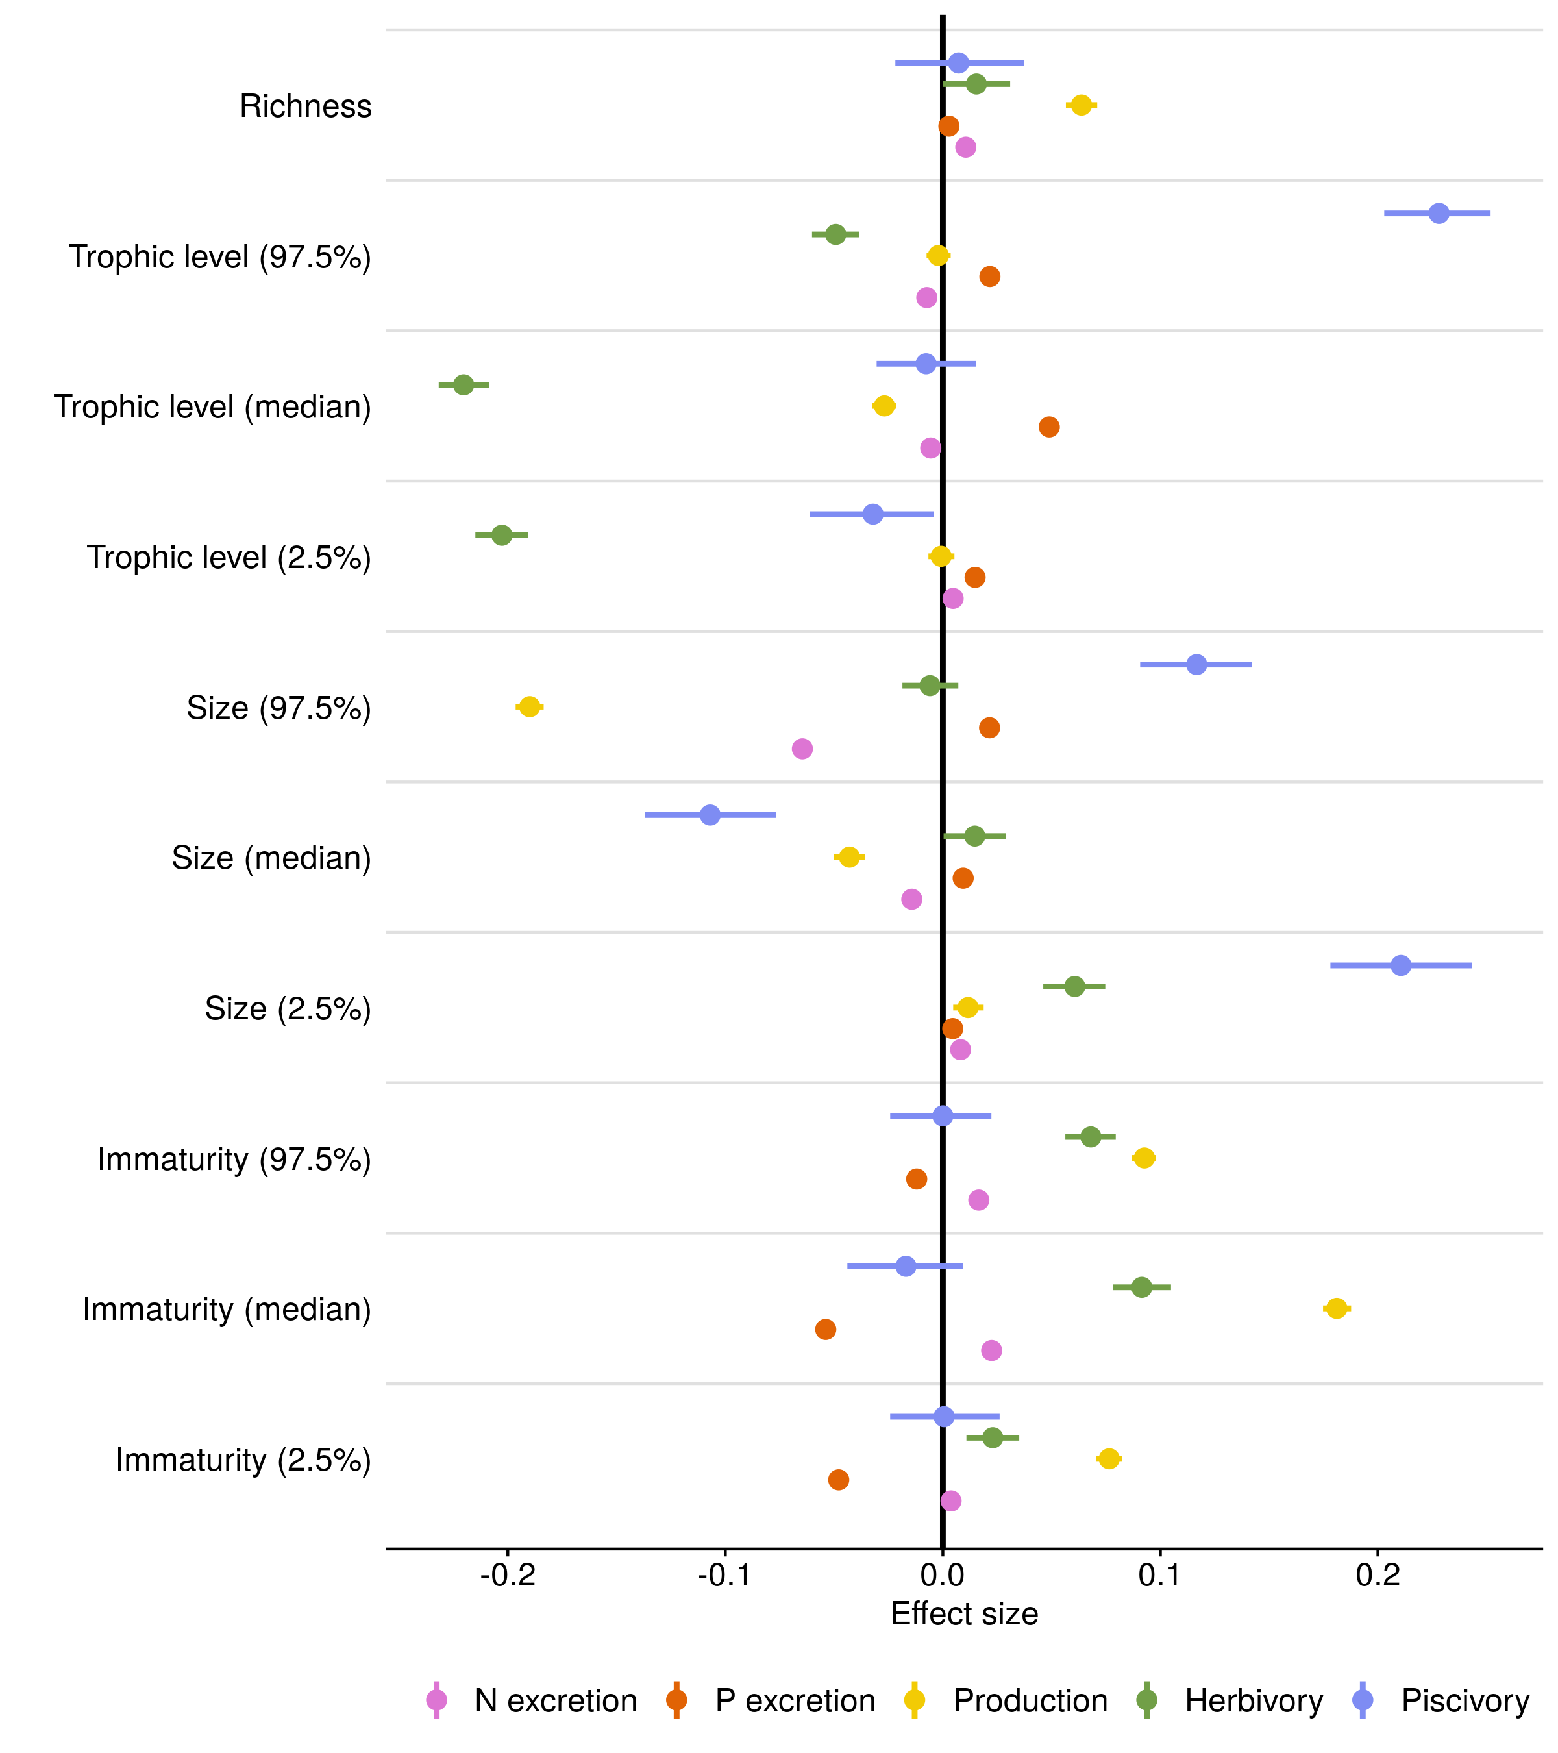

Figure 2: Fixed effect values from Bayesian linear regressions that examine the effects of community variables on five functions. Community variables include species richness, and descriptors of the trophic level, size, and immaturity of fishes. To represent both the median and the spread of trophic level, size, and immaturity across individuals inside a community, we included lower and upper 95% quantile values of these three traits as community variables. All data were log-transformed and standardized to compare across functions and variables (see Extended Data Table 2 for parameter values on non-standardized data). Dots represent the average effect size estimate, and horizontal lines indicate the 95% credible interval.

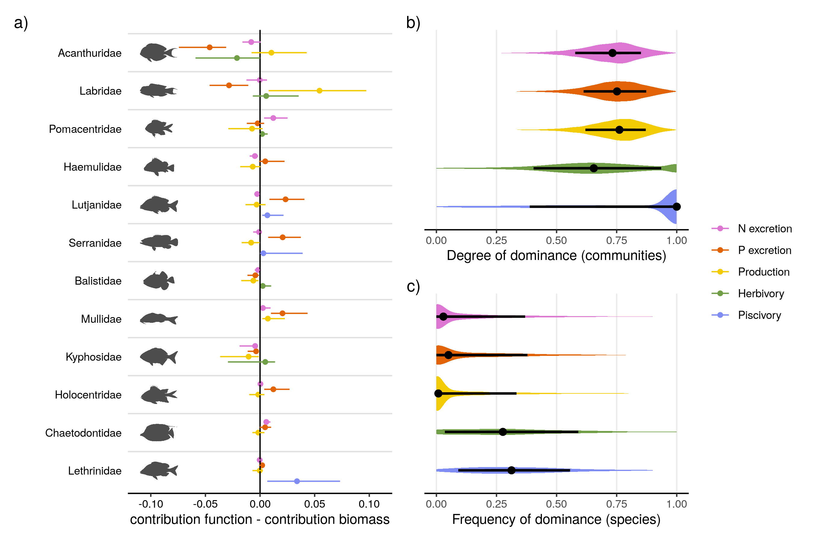

Figure 3: a) The median family-level contributions to each function relative to their contribution to standing stock biomass. The twelve included families are ordered by their median contribution to biomass. b) The distribution of the degree of dominance of communities for each function. Degrees of dominance range between zero (all species contribute equally) and one (a single species is the sole contributor to a given function). c) Species-specific frequencies of dominance in each function across all communities, ranging from zero (species are never dominant) to one (dominant wherever present). A species is categorized as dominant in a community if its contribution to a function is higher than a scenario in which all species are equal (i.e. one divided by the number of species that contribute to the function). Shaded areas show the distribution of the values. Dots represent the median value, and lines indicate the interquartile range.

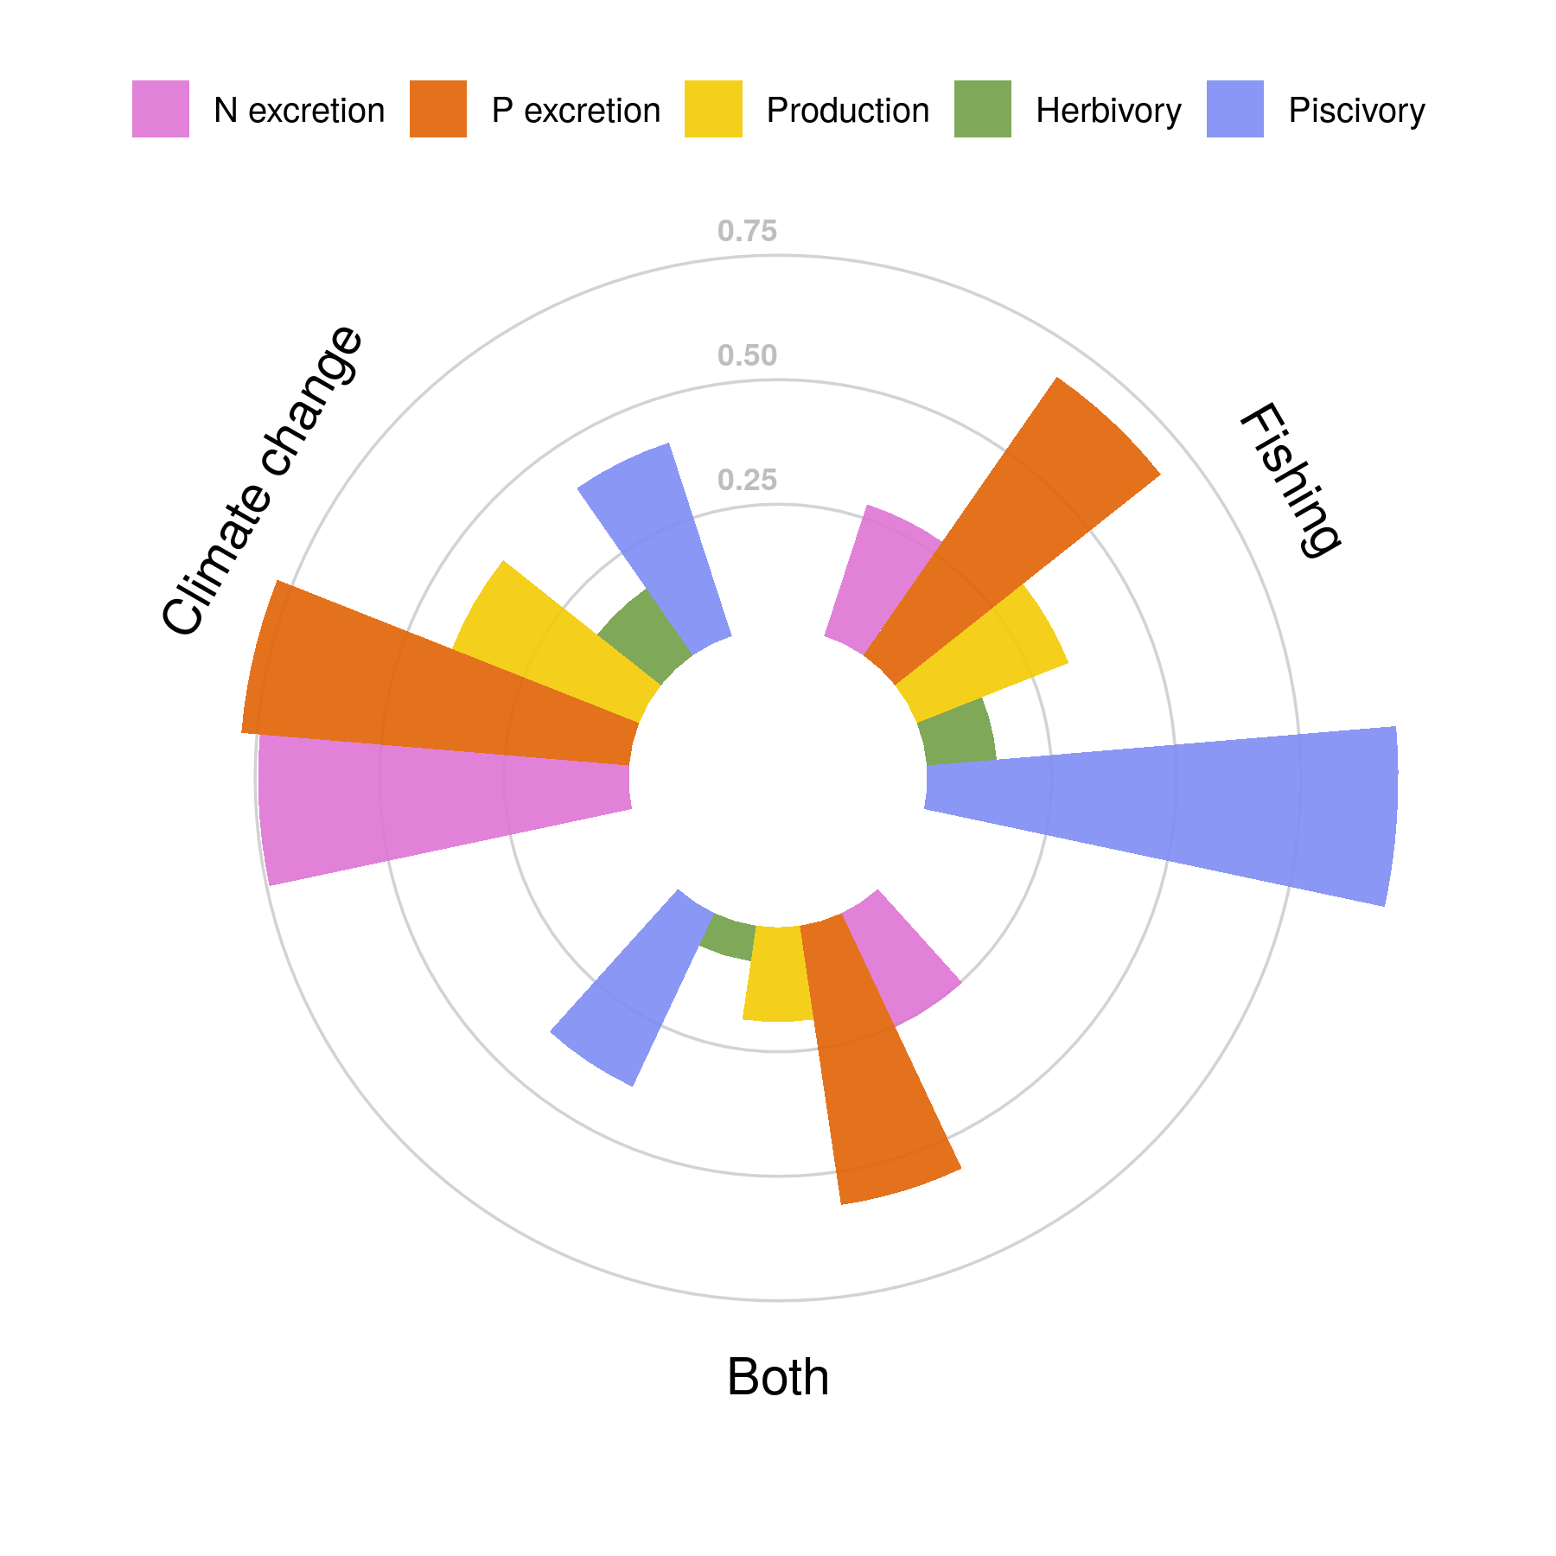

Figure 4: Vulnerability of five critical functions to fishing, climate change-induced coral loss, and both stressors combined. Vulnerability is presented as the proportion of communities (filled bars) in which functional vulnerability is higher than vulnerability based on fish biomass (i.e. not accounting for species contributions to each function).

# References

1. Teh, L. C. L. A. S., Louise S. L. AND Teh. A global estimate of the number of coral reef fishers. *PLOS ONE* **8**, 1–10 (2013).

2. Graham, N. A. *et al.* Human Disruption of Coral Reef Trophic Structure. *Current Biology* **27**, 231–236 (2017).

3. Ceccarelli, D. M., Emslie, M. J. & Richards, Z. T. Post-Disturbance Stability of Fish Assemblages Measured at Coarse Taxonomic Resolution Masks Change at Finer Scales. *PLOS ONE* **11**, e0156232 (2016).

4. Stuart-Smith, R. D., Brown, C. J., Ceccarelli, D. M. & Edgar, G. J. Ecosystem restructuring along the Great Barrier Reef following mass coral bleaching. *Nature* **560**, 92–96 (2018).

5. Hughes, T. P. *et al.* Global warming and recurrent mass bleaching of corals. *Nature* **543**, 373–377 (2017).

6. Welti, N. *et al.* Bridging food webs, ecosystem metabolism, and biogeochemistry using ecological stoichiometry theory. *Frontiers in Microbiology* **8**, 1298 (2017).

7. Weisser, W. W. *et al.* Biodiversity effects on ecosystem functioning in a 15-year grassland experiment: Patterns, mechanisms, and open questions. *Basic and Applied Ecology* **23**, 1–73 (2017).

8. Zavaleta, E. S., Pasari, J. R., Hulvey, K. B. & Tilman, G. D. Sustaining multiple ecosystem functions in grassland communities requires higher biodiversity. *Proceedings of the National Academy of Sciences* **107**, 1443–1446 (2010).

9. Tallis, H., Kareiva, P., Marvier, M. & Chang, A. An ecosystem services framework to support both practical conservation and economic development. vol. 105 9457–9464 (2008).

10. Rodríguez, J. P. *et al.* Trade-offs across space, time, and ecosystem services. *Ecology and Society* **11**, (2006).

11. Brandl, S. J. *et al.* Coral reef ecosystem functioning: Eight core processes and the role of biodiversity. *Frontiers in Ecology and the Environment* **17**, 445–454 (2019).

12. Brandl, S. J. *et al.* Demographic dynamics of the smallest marine vertebrates fuel coral reef ecosystem functioning. *Science* **364**, 1189–1192 (2019).

13. Williams, G. J. *et al.* Coral reef ecology in the Anthropocene. *Functional Ecology* **33**, 1014–1022 (2019).

14. Bellwood, D. R., Streit, R. P., Brandl, S. J. & Tebbett, S. B. The meaning of the term ‘function’ in ecology: A coral reef perspective. vol. 33 948–961 (2019).

15. Mora, C. *et al.* Global Human Footprint on the Linkage between Biodiversity and Ecosystem Functioning in Reef Fishes. *PLoS Biology* **9**, e1000606 (2011).

16. Cinner, J. E. *et al.* Meeting fisheries, ecosystem function, and biodiversity goals in a human-dominated world. *Science* **368**, 307–311 (2020).

17. Mouillot, D. *et al.* Functional over-redundancy and high functional vulnerability in global fish faunas on tropical reefs. *Proceedings of the National Academy of Sciences of the United States of America* **111**, 13757–62 (2014).

18. Allgeier, J. E., Valdivia, A., Cox, C. & Layman, C. A. Fishing down nutrients on coral reefs. *Nature Communications* **7**, (2016).

19. MacNeil, M. A. *et al.* Recovery potential of the world’s coral reef fishes. *Nature* **520**, 341–344 (2015).

20. Schiettekatte, N. M. D. *et al.* Nutrient limitation, bioenergetics and stoichiometry: A new model to predict elemental fluxes mediated by fishes. *Functional Ecology* **34**, 1857–1869 (2020).

21. Allgeier, J. E., Layman, C. A., Mumby, P. J. & Rosemond, A. D. Consistent nutrient storage and supply mediated by diverse fish communities in coral reef ecosystems. *Global Change Biology* **20**, 2459–2472 (2014).

22. Barneche, D. R. & Allen, A. P. The energetics of fish growth and how it constrains food-web trophic structure. *Ecology Letters* **21**, 836–844 (2018).

23. Morais, R. A., Connolly, S. R. & Bellwood, D. R. Human exploitation shapes productivity–biomass relationships on coral reefs. *Global Change Biology* **26**, 1295–1305 (2020).

24. Schramski, J. R., Dell, A. I., Grady, J. M., Sibly, R. M. & Brown, J. H. Metabolic theory predicts whole-ecosystem properties. *Proceedings of the National Academy of Sciences* **112**, 2617–2622 (2015).

25. Ruttenberg, B. I., Adam, T. C., Duran, A. & Burkepile, D. E. Identity of coral reef herbivores drives variation in ecological processes over multiple spatial scales. *Ecological Applications* **29**, e01893 (2019).

26. Topor, Z. M., Rasher, D. B., Duffy, J. E. & Brandl, S. J. Marine protected areas enhance coral reef functioning by promoting fish biodiversity. *Conservation Letters* **12**, e12638 (2019).

27. Bellwood, D. R., Hoey, A. S. & Choat, J. H. Limited functional redundancy in high diversity systems: Resilience and ecosystem function on coral reefs. *Ecology Letters* **6**, 281–285 (2003).

28. Bellwood, D. R., Hughes, T. P. & Hoey, A. S. Sleeping Functional Group Drives Coral-Reef Recovery. *Current Biology* **16**, 2434–2439 (2006).

29. Graham, N. A. *et al.* Dynamic fragility of oceanic coral reef ecosystems. *Proceedings of the National Academy of Sciences of the United States of America* **103**, 8425–8429 (2006).

30. Burkepile, D. E. *et al.* Nutrient supply from fishes facilitates macroalgae and suppresses corals in a Caribbean coral reef ecosystem. *Scientific Reports* **3**, 1493 (2013).

31. Allgeier, J. E. *et al.* Rewiring coral: Anthropogenic nutrients shift diverse coral–symbiont nutrient and carbon interactions toward symbiotic algal dominance. *Global Change Biology* **26**, 5588–5601 (2020).

32. Ezzat, L., Maguer, J. F., Grover, R. & Ferrier-Pagès, C. Limited phosphorus availability is the Achilles heel of tropical reef corals in a warming ocean. *Scientific Reports* **6**, 31768 (2016).

33. Graham, N. A. *et al.* Extinction vulnerability of coral reef fishes. *Ecology Letters* **14**, 341–348 (2011).

34. Bellwood, D. R., Hoey, A. S. & Hughes, T. P. Human activity selectively impacts the ecosystem roles of parrotfishes on coral reefs. *Proceedings of the Royal Society B: Biological Sciences* **279**, 1621–1629 (2012).

35. Bellwood, D. R., Hoey, A. S. & Hughes, T. P. Human activity selectively impacts the ecosystem roles of parrotfishes on coral reefs. *Proceedings of the Royal Society B: Biological Sciences* **279**, 1621–1629 (2012).

36. Green, A. & D.R., B. *Monitoring functional groups of herbivorous reef fishes as indicators of coral reef resilience – A practical guide for coral reef managers in the Asia Pacific region.* 70 (IUCN working group on Climate Change; Coral Reefs. IUCN, Gland, Switzerland., 2009).

37. Graham, N. A. *et al.* Changing role of coral reef marine reserves in a warming climate. *Nature Communications* **11**, 1–8 (2020).

38. Hooper, D. U. *et al.* Effects of biodiversity on ecosystem functioning: A consensus of current knowledge. *Ecological Monographs* **75**, 3–35 (2005).

39. Duffy, J. E. Why biodiversity is important to the functioning of real-world ecosystems. *Frontiers in Ecology and the Environment* **7**, 437–444 (2009).

40. Lefcheck, J. S. *et al.* Tropical fish diversity enhances coral reef functioning across multiple scales. *Science Advances* **5**, (2019).