# Global drivers and vulnerabilities of coral reef fish functions: Extended data figures and tables

## Tables

Extended Data table 2: Overview of localities of UVC transects, used in this study, including number of sites and number of transects

| bioregion | locality | n_sites | n_transects |
| --- | --- | --- | --- |
| c_indopacific | aceh | 4 | 50 |
| c_indopacific | ambon | 1 | 10 |
| c_indopacific | bali | 1 | 18 |
| c_indopacific | cambodia | 1 | 5 |
| c_indopacific | christmas_island | 2 | 17 |
| c_indopacific | dampier_archipelago | 3 | 44 |
| c_indopacific | darwin_(nt) | 1 | 18 |
| c_indopacific | flores | 3 | 13 |
| c_indopacific | hong_kong_island | 1 | 12 |
| c_indopacific | kai_ketjil | 2 | 8 |
| c_indopacific | kimberley | 1 | 11 |
| c_indopacific | mornington_island | 3 | 16 |
| c_indopacific | ningaloo_marine_park | 8 | 250 |
| c_indopacific | northern_territory_(other) | 11 | 76 |
| c_indopacific | north_west_shelf | 26 | 284 |
| c_indopacific | offshore_shoals | 3 | 11 |
| c_indopacific | okinawa | 1 | 8 |
| c_indopacific | palau | 1 | 25 |
| c_indopacific | papua_new_guinea | 1 | 6 |
| c_indopacific | pualu_kaimeer | 1 | 4 |
| c_indopacific | pulau_jamdena | 2 | 8 |
| c_indopacific | pulau_naira | 1 | 12 |
| c_indopacific | raja_ampat | 15 | 259 |
| c_indopacific | solomon | 47 | 322 |
| c_pacific | ailuk_atoll | 3 | 14 |
| c_pacific | austral_islands | 1 | 12 |
| c_pacific | capricorn_group | 6 | 64 |
| c_pacific | central_coral_sea | 22 | 233 |
| c_pacific | central_gbr | 20 | 145 |
| c_pacific | cook_islands | 3 | 14 |
| c_pacific | cook_islands_sp | 1 | 24 |
| c_pacific | elizabeth_and_middleton_reefs | 2 | 66 |
| c_pacific | fiji | 3 | 316 |
| c_pacific | french_polynesia | 18 | 226 |
| c_pacific | hawaii | 12 | 521 |
| c_pacific | lord_howe_island | 2 | 530 |
| c_pacific | marquesas_islands | 2 | 6 |
| c_pacific | minerva_reefs | 2 | 17 |
| c_pacific | new_caledonia | 12 | 884 |
| c_pacific | niue | 1 | 8 |
| c_pacific | norfolk_island | 2 | 38 |
| c_pacific | northern_coral_sea | 10 | 157 |
| c_pacific | northern_gbr | 9 | 97 |
| c_pacific | pitcairn | 4 | 254 |
| c_pacific | queensland_(other) | 10 | 66 |
| c_pacific | rapa_nui | 4 | 65 |
| c_pacific | rongalap_atoll | 2 | 9 |
| c_pacific | rose_atoll | 1 | 16 |
| c_pacific | salaz_y_gomez | 1 | 63 |
| c_pacific | samoa | 8 | 358 |
| c_pacific | society_islands | 5 | 21 |
| c_pacific | southern_coral_sea | 7 | 109 |
| c_pacific | southern_gbr | 1 | 25 |
| c_pacific | tonga | 9 | 293 |
| c_pacific | whitsundays | 1 | 8 |
| e_atlantic | cverde | 1 | 97 |
| e_atlantic | stome | 5 | 38 |
| e_pacific | clipperton | 1 | 80 |
| e_pacific | cocos | 1 | 178 |
| e_pacific | coiba | 15 | 188 |
| e_pacific | costa_rica | 5 | 48 |
| e_pacific | galapagos | 13 | 139 |
| e_pacific | las_perlas | 6 | 47 |
| e_pacific | machalilla | 3 | 19 |
| e_pacific | malpelo | 1 | 70 |
| e_pacific | nicaragua_tep | 5 | 58 |
| e_pacific | panama_pacific | 1 | 6 |
| e_pacific | revillagigedo | 3 | 116 |
| w_atlantic | abrolhos | 1 | 91 |
| w_atlantic | arraial | 1 | 347 |
| w_atlantic | belize | 2 | 37 |
| w_atlantic | bocas_del_toro | 3 | 30 |
| w_atlantic | bonaire | 3 | 14 |
| w_atlantic | cuba | 1 | 3 |
| w_atlantic | curacao | 4 | 117 |
| w_atlantic | florida_keys | 4 | 33 |
| w_atlantic | grand_cayman | 1 | 3 |
| w_atlantic | guarapari | 2 | 114 |
| w_atlantic | ilha_gde | 5 | 25 |
| w_atlantic | l_santos | 1 | 57 |
| w_atlantic | mexico_caribbean | 2 | 31 |
| w_atlantic | neb | 3 | 22 |
| w_atlantic | noronha | 1 | 61 |
| w_atlantic | rio_de_janeiro | 1 | 2 |
| w_atlantic | rocas | 1 | 51 |
| w_atlantic | salvador_bts | 2 | 49 |
| w_atlantic | san_blas | 1 | 13 |
| w_atlantic | santa_catarina | 6 | 253 |
| w_atlantic | seaflower_marine_reserve | 3 | 47 |
| w_atlantic | southwestern_caribbean | 2 | 6 |
| w_atlantic | stpauls_rocks | 1 | 27 |
| w_atlantic | trindade | 2 | 238 |
| w_atlantic | turks_and_caicos_islands | 1 | 4 |
| w_indian | eilat | 1 | 5 |
| w_indian | mozambique | 7 | 30 |
| w_indian | red_sea | 1 | 5 |
| w_indian | seychelles | 6 | 165 |
| w_indian | tanzania | 1 | 8 |

Extended Data table 2: Overview of parameters of the regressions relating the five functions to the community structure variables

| response | term | estimate | std.error | lower | upper |
| --- | --- | --- | --- | --- | --- |
| log(N excretion) | intercept | -8.7502 | 0.0264 | -8.7927 | -8.7061 |
| sst | 0.0290 | 0.0007 | 0.0279 | 0.0301 |
| log(biomass) | 0.9664 | 0.0013 | 0.9643 | 0.9686 |
| richness | 0.0010 | 0.0001 | 0.0008 | 0.0012 |
| size (mean) | -0.0040 | 0.0004 | -0.0046 | -0.0034 |
| trophic level (mean) | -0.0145 | 0.0028 | -0.0190 | -0.0098 |
| immaturity (mean) | 0.0185 | 0.0010 | 0.0169 | 0.0201 |
| size (97.5) | -0.0087 | 0.0002 | -0.0089 | -0.0084 |
| trophic level (97.5%) | -0.0385 | 0.0052 | -0.0471 | -0.0300 |
| immaturity (2.5%) | 0.0055 | 0.0016 | 0.0027 | 0.0081 |
| immaturity (97.5%) | 0.0099 | 0.0006 | 0.0089 | 0.0110 |
| trophic level (2.5%) | 0.0199 | 0.0048 | 0.0121 | 0.0278 |
| size (2.5%) | 0.0034 | 0.0006 | 0.0025 | 0.0044 |
| log(P excretion) | intercept | -12.7600 | 0.0454 | -12.8354 | -12.6861 |
| sst | 0.0265 | 0.0011 | 0.0246 | 0.0284 |
| log(biomass) | 1.0130 | 0.0023 | 1.0092 | 1.0167 |
| richness | 0.0003 | 0.0002 | -0.0001 | 0.0007 |
| size (mean) | 0.0031 | 0.0006 | 0.0020 | 0.0041 |
| trophic level (mean) | 0.1468 | 0.0046 | 0.1393 | 0.1543 |
| immaturity (mean) | -0.0510 | 0.0016 | -0.0536 | -0.0482 |
| size (97.5) | 0.0033 | 0.0003 | 0.0029 | 0.0038 |
| trophic level (97.5%) | 0.1285 | 0.0093 | 0.1129 | 0.1437 |
| immaturity (2.5%) | -0.0810 | 0.0028 | -0.0857 | -0.0765 |
| immaturity (97.5%) | -0.0083 | 0.0011 | -0.0100 | -0.0065 |
| trophic level (2.5%) | 0.0716 | 0.0081 | 0.0583 | 0.0858 |
| size (2.5%) | 0.0022 | 0.0010 | 0.0006 | 0.0037 |
| log(Production) | intercept | -9.2949 | 0.0646 | -9.4005 | -9.1877 |
| sst | 0.0371 | 0.0016 | 0.0344 | 0.0398 |
| log(biomass) | 0.8809 | 0.0033 | 0.8755 | 0.8865 |
| richness | 0.0053 | 0.0003 | 0.0047 | 0.0058 |
| size (mean) | -0.0109 | 0.0009 | -0.0124 | -0.0094 |
| trophic level (mean) | -0.0632 | 0.0064 | -0.0737 | -0.0528 |
| immaturity (mean) | 0.1344 | 0.0024 | 0.1304 | 0.1385 |
| size (97.5) | -0.0230 | 0.0004 | -0.0236 | -0.0223 |
| trophic level (97.5%) | -0.0100 | 0.0131 | -0.0320 | 0.0116 |
| immaturity (2.5%) | 0.1014 | 0.0041 | 0.0946 | 0.1083 |
| immaturity (97.5%) | 0.0501 | 0.0015 | 0.0476 | 0.0526 |
| trophic level (2.5%) | -0.0031 | 0.0116 | -0.0214 | 0.0159 |
| size (2.5%) | 0.0044 | 0.0013 | 0.0022 | 0.0066 |
| log(Herbivory) | intercept | -4.3397 | 0.1756 | -4.6184 | -4.0594 |
| sst | 0.0895 | 0.0045 | 0.0821 | 0.0969 |
| log(biomass) | 0.9258 | 0.0091 | 0.9110 | 0.9407 |
| richness | 0.0017 | 0.0009 | 0.0003 | 0.0031 |
| size (mean) | 0.0050 | 0.0025 | 0.0009 | 0.0092 |
| trophic level (mean) | -0.7042 | 0.0174 | -0.7335 | -0.6762 |
| immaturity (mean) | 0.0922 | 0.0067 | 0.0813 | 0.1032 |
| size (97.5) | -0.0009 | 0.0011 | -0.0027 | 0.0009 |
| trophic level (97.5%) | -0.3129 | 0.0377 | -0.3757 | -0.2511 |
| immaturity (2.5%) | 0.0416 | 0.0115 | 0.0223 | 0.0605 |
| immaturity (97.5%) | 0.0502 | 0.0043 | 0.0433 | 0.0574 |
| trophic level (2.5%) | -1.1401 | 0.0342 | -1.1950 | -1.0836 |
| size (2.5%) | 0.0321 | 0.0038 | 0.0258 | 0.0384 |
| log(Piscivory) | intercept | -13.0583 | 0.4678 | -13.8237 | -12.3086 |
| sst | -0.0807 | 0.0104 | -0.0980 | -0.0635 |
| log(biomass) | 0.7567 | 0.0192 | 0.7253 | 0.7885 |
| richness | 0.0007 | 0.0016 | -0.0019 | 0.0035 |
| size (mean) | -0.0334 | 0.0051 | -0.0416 | -0.0250 |
| trophic level (mean) | -0.0240 | 0.0376 | -0.0867 | 0.0377 |
| immaturity (mean) | -0.0178 | 0.0149 | -0.0420 | 0.0062 |
| size (97.5) | 0.0194 | 0.0022 | 0.0158 | 0.0231 |
| trophic level (97.5%) | 1.5393 | 0.0839 | 1.4012 | 1.6814 |
| immaturity (2.5%) | -0.0003 | 0.0260 | -0.0434 | 0.0428 |
| immaturity (97.5%) | -0.0001 | 0.0093 | -0.0155 | 0.0150 |
| trophic level (2.5%) | -0.1561 | 0.0700 | -0.2705 | -0.0398 |
| size (2.5%) | 0.1072 | 0.0083 | 0.0938 | 0.1210 |

## Figures

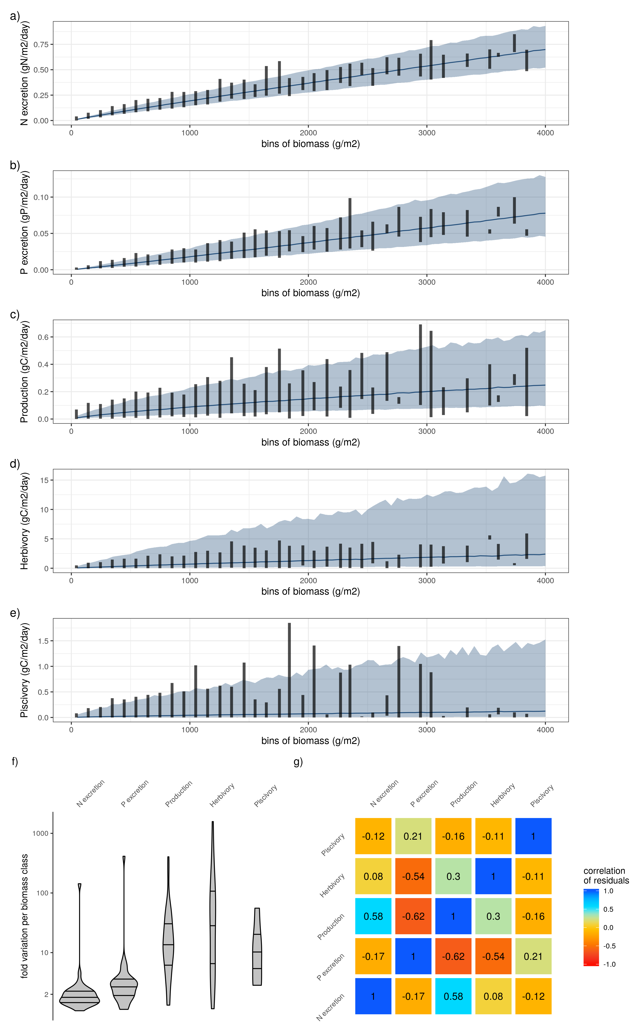

Extended Data Figure 1: a-e) Relationship between biomass and the five functions. Lines and shaded areas show the average and 95% credible interval of the predicted functions respectively, for a constant sea surface temperature of 26°C (the average across all sites). Vertical lines show the range of the estimated functions across fish communities per biomass class of 100g/m2. f) Fold variation of each function per biomass class of 100g/m2 across fish communities. g) Correlation matrix of the residuals of the five functions after regression with biomass and sea surface temperature. Standard deviations of correlation coefficients did not exceed 0.01.

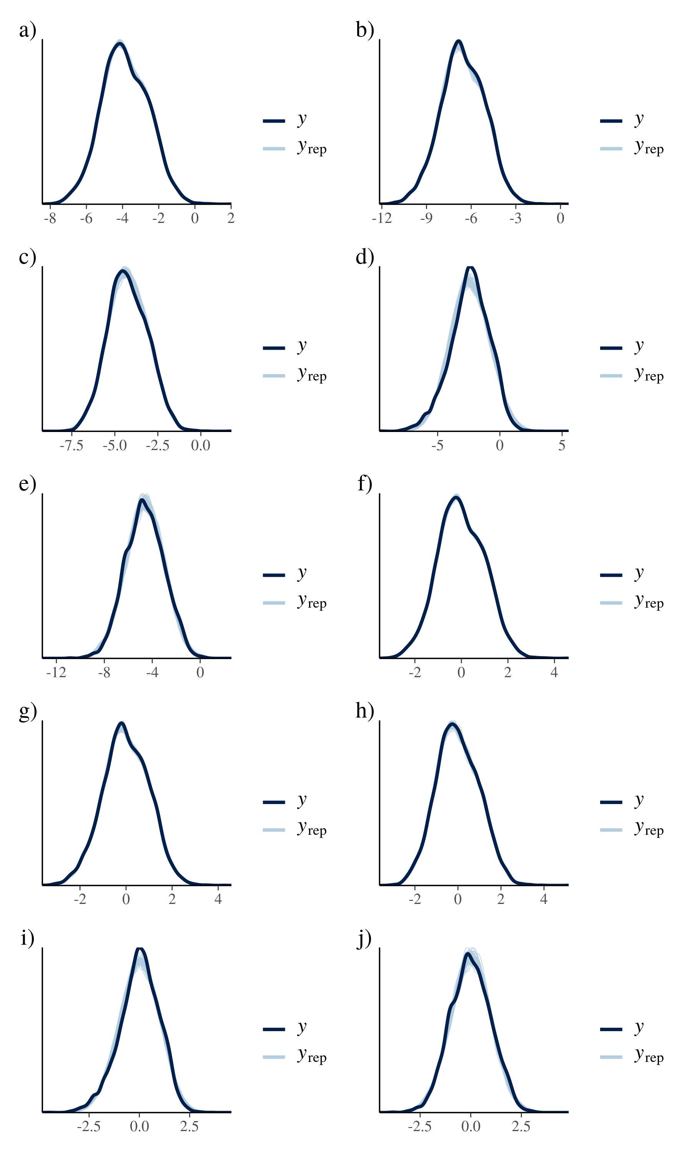

Extended Data Figure 2: Posterior predictive checks of the five models relating functions with biomass and sea surface temperature only (a) N excretion, b) P excretion, c) Production, d) Herbivory, e) Piscivory), and the five models relating functions with community variables (f) N excretion, g) P excretion, h) Production, i) Herbivory, j) Piscivory)

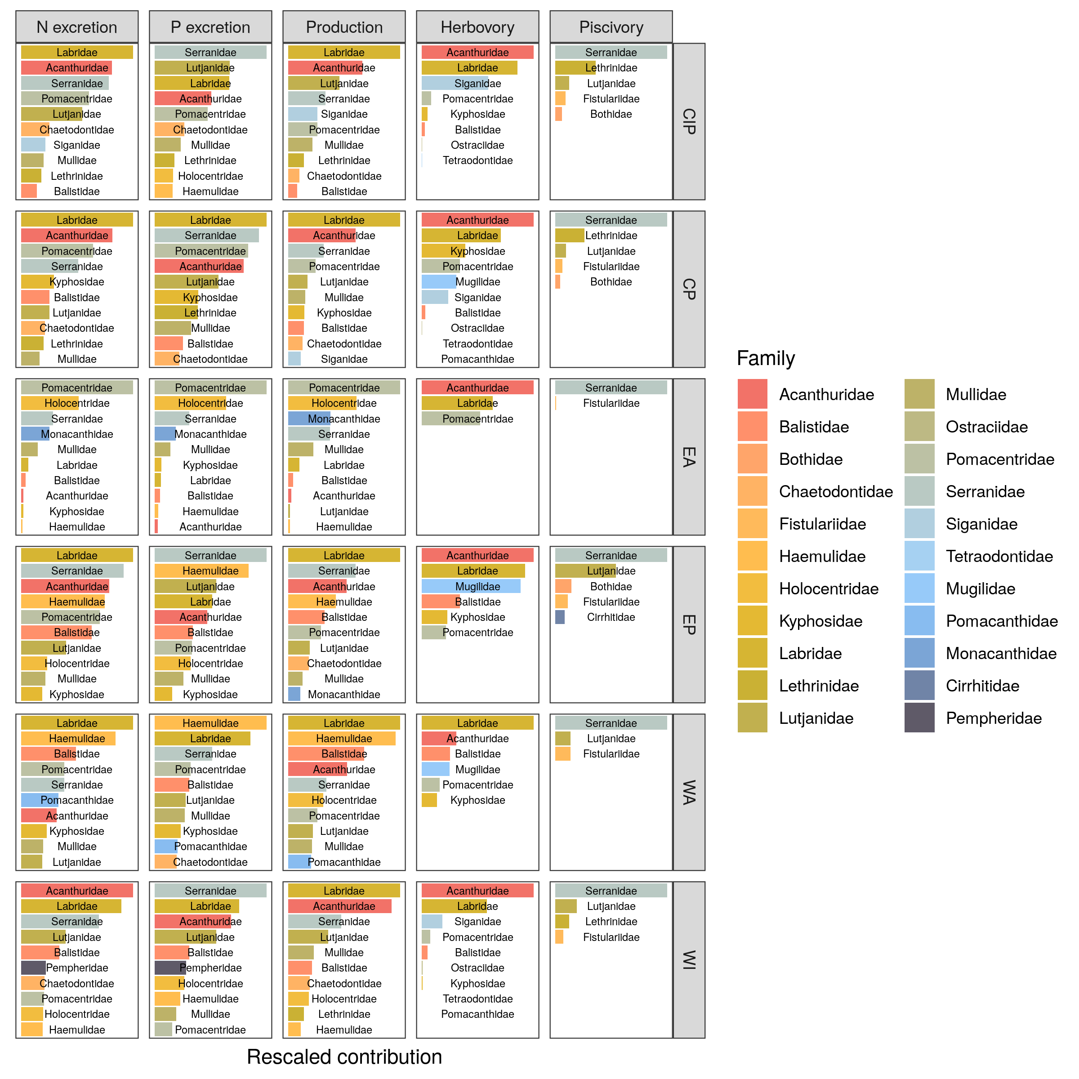  
Extended Data Figure 3: Average relative contribution of fish families to all five functions per biogeographical ocean basin. CIP = Central-Indo-Pacific, CP = Central Pacific, EA = Eastern Atlantic, WA = Western Atlantic, WI = Western Indian

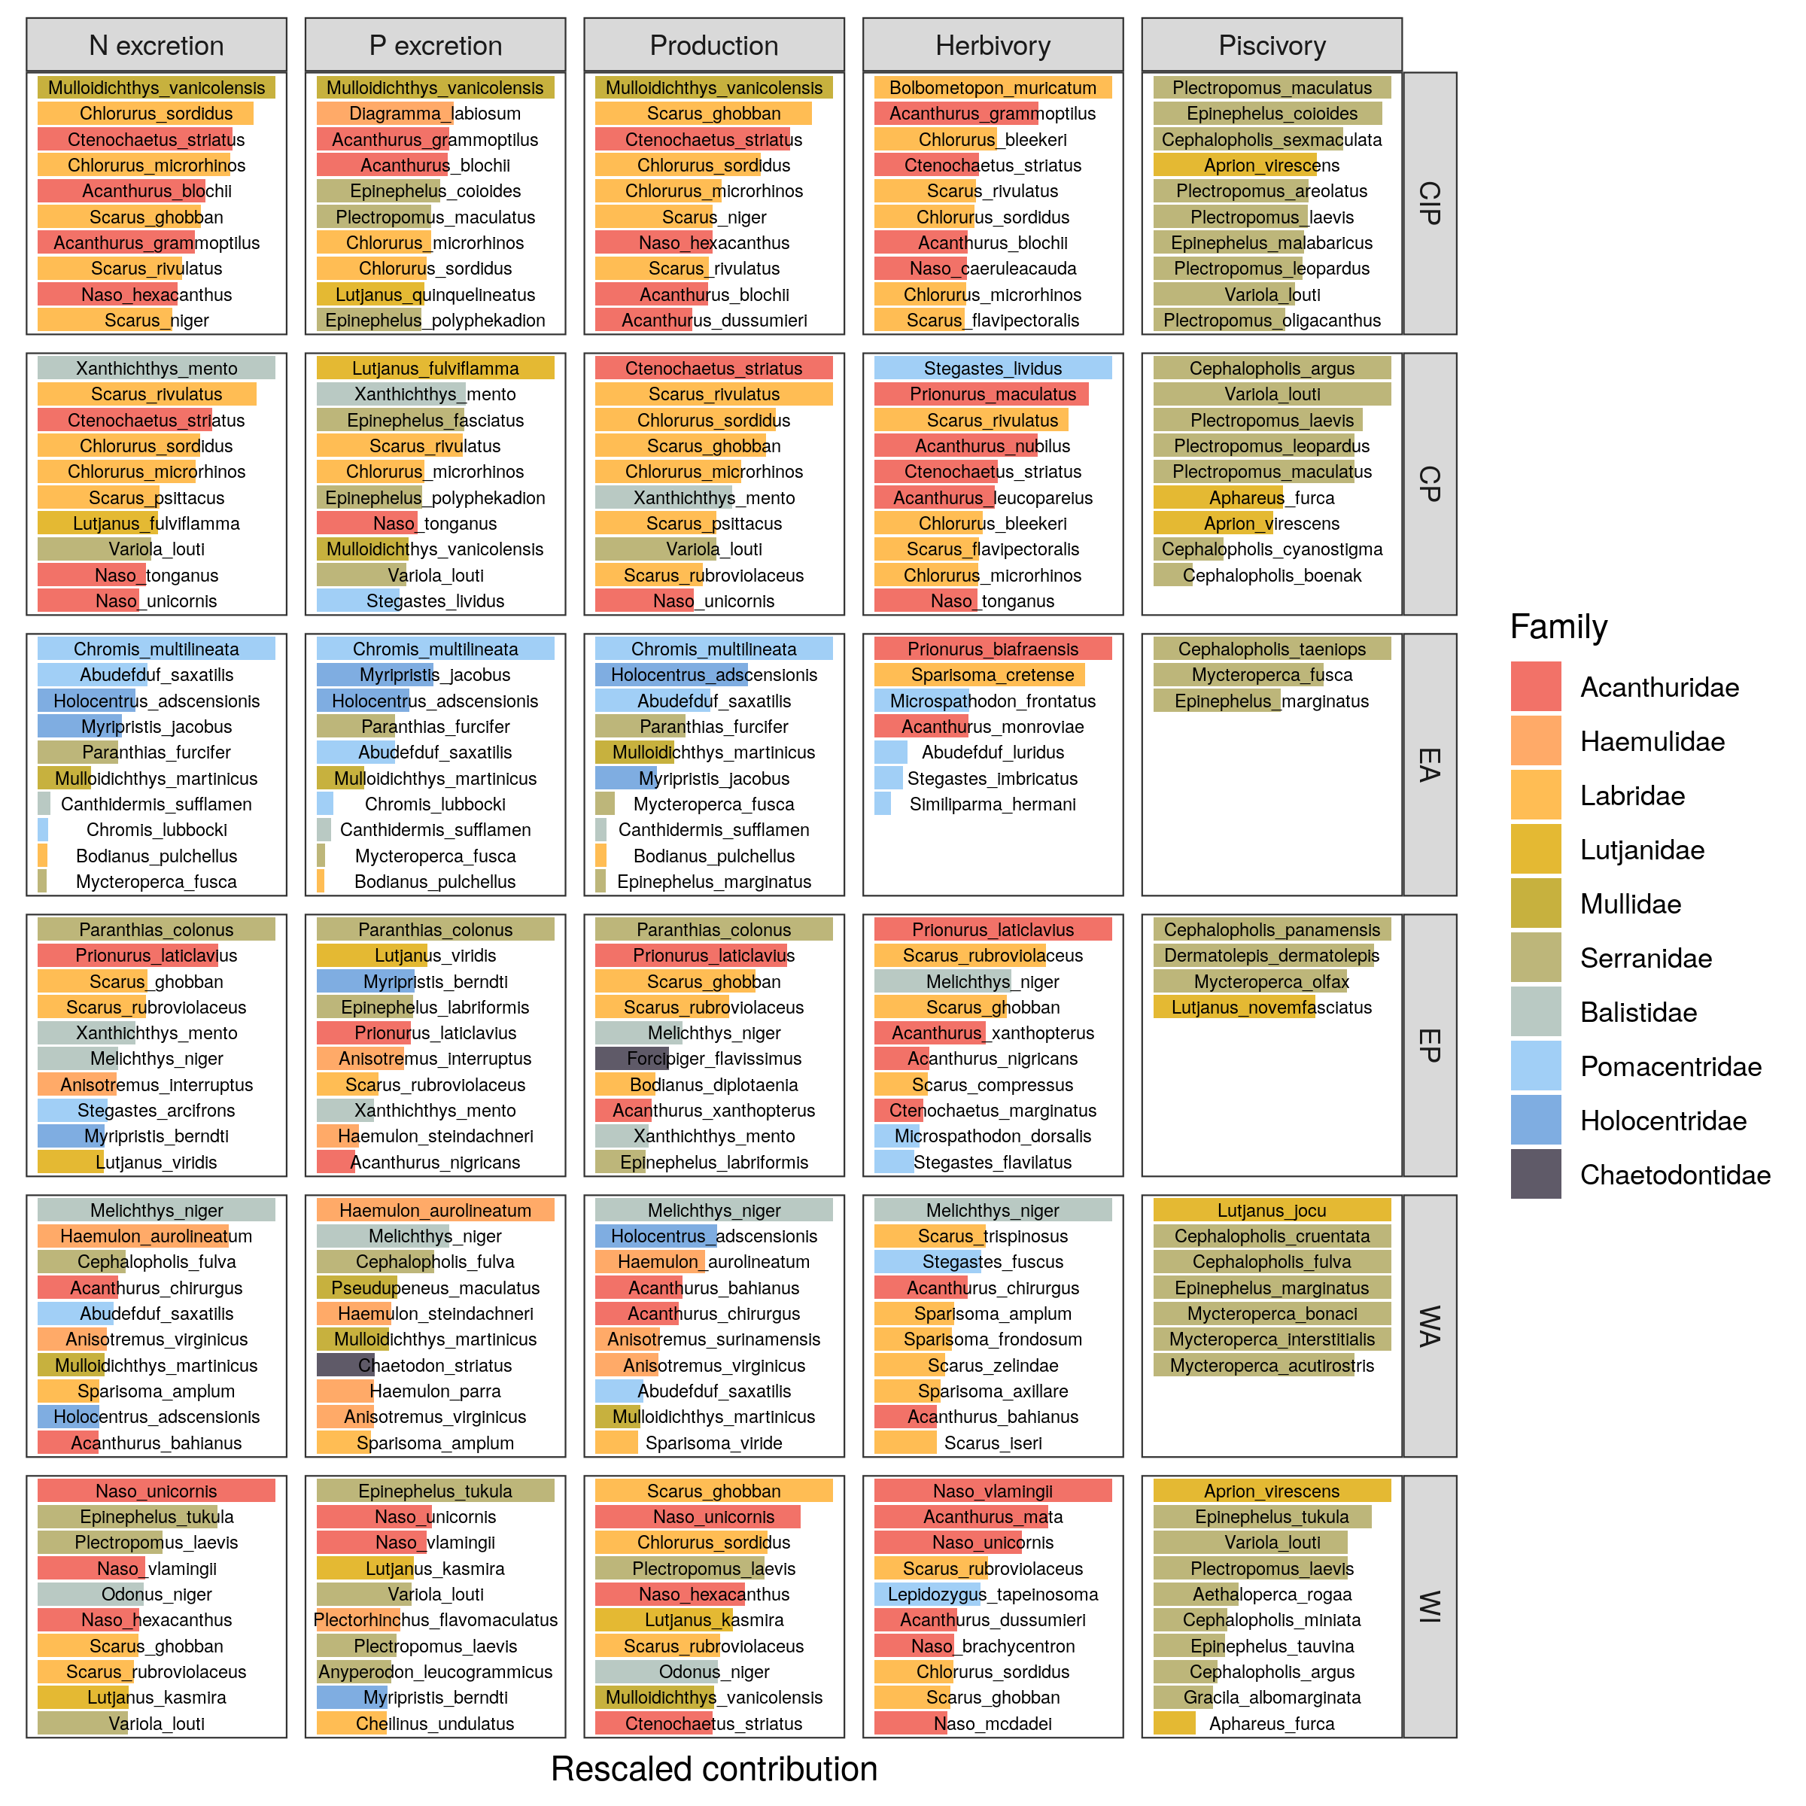Extended Data Figure 4: Average relative contribution of the top ten most contributing species to all five functions per biogeographical ocean basin. CIP = Central-Indo-Pacific, CP = Central Pacific, EA = Eastern Atlantic, WA = Western Atlantic, WI = Western Indian

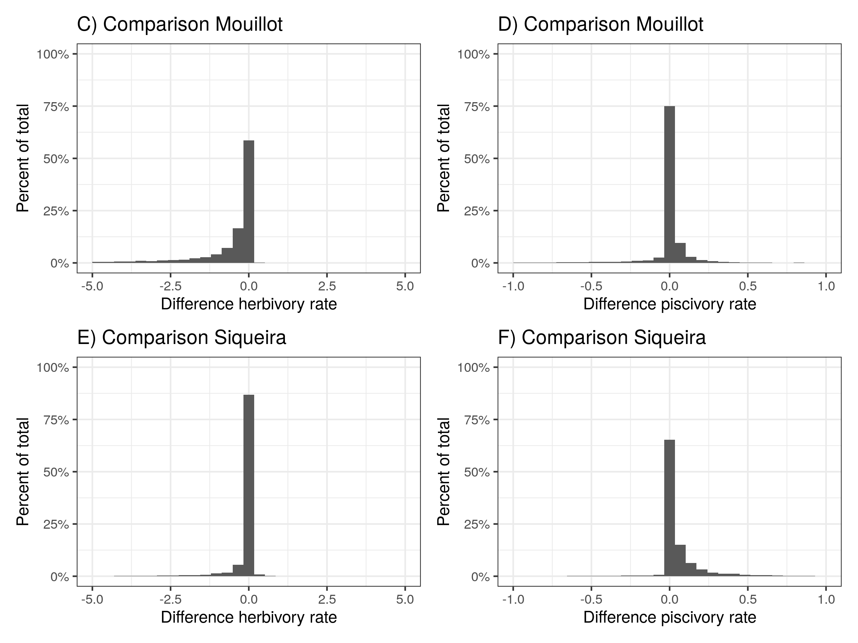

Extended Data Figure 5: Comparison herbivory and piscivory rates when using alternative diet classifications from Mouillot et al. (2014) and Siqueira et al. 2020