I/O Cell Calculations
This document describes the calculations used to fill in the cells of the new COMPASS I/O Tool.

Overview
The CRiSP code off of which COMPASS is derived is capable of generating simple summary statistics for each release at various river segments. These are very simple calculations (e.g. totals) that are used as inputs to the I/O Tool.
Since the I/O Tool selects stocks by location and species, it is possible that there may be more than one release that satisfies the selection made by the user. In this case, multiple releases may be considered and their passage and totals are simply added together as in .
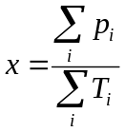
Where:
- 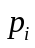 is the number of fish counted for a specific release
- is the maximum number of fish that may be counted for a specific release
The following symbols are used:
- 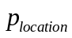 is the total number of fish that exit (i.e. are passed) a location (e.g. dam, pool, turbine) over the season. Note that this is a total, whereas 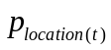 is the number of fish that exit the location at time step .
- 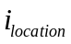 is the total number of fish that enter a location over the season

In-River Survival Estimates

Pool Survival:
Since the pool is defined as the segment before the dam, this is the number of fish exiting the pool out of the number that enter the pool excluding censored fish.

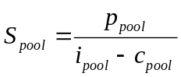
Where
- 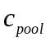 is the number of fish that are censored (i.e. do not exit) in the pool

Dam Survival:
Dam survival does not take into account transported fish, but I believe that this is the correct interpretation.
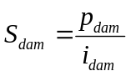

Dam Plus Pool Survival:
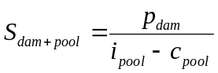

Turbine Survival at Individual Dams:
This is the number of fish surviving and exiting through the turbines out of the total number entering the dam. The SIMPAS document did not describe this cell very clearly, so this may not be the same.
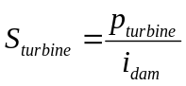

Transport Estimates

Pop. Collected At…:
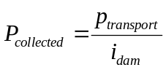

Cumulative Pop Collected:
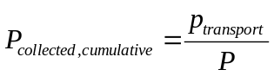
Where
-  is the total number of fish released

Outputs

Fish Passage Efficiency:
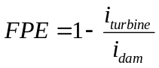

Turbine Passage:
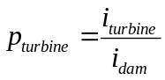

Bypass Passage:
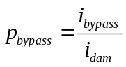

Sluiceway Passage:
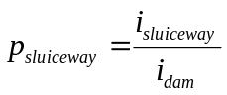

Spill Passage (Normal Bays Only):
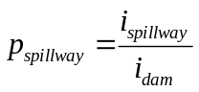

RSW Passage:
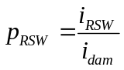

Spill Efficiency:
For each time step, the spill efficiency at time step is calculated as in
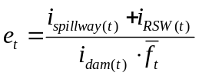
Where
- The spill fraction, 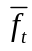, used to calculate spill efficiency for a time step is averaged (as shown in ) since dam time steps are more fine-grained than model time steps:
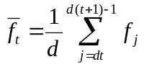
- is the number of dam time steps in each model step
- 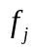 is the spill fraction at dam time step
The final spill efficiency value displayed in the cell is calculated using a weighted average as shown in
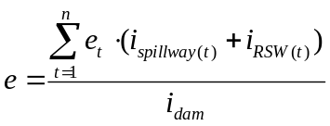

Flow Inputs

Average Spill:
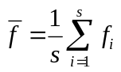
Where
- 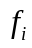 is the spill fraction at a specific time step. Note that only time steps within the specified period (day, night, or either) are used in this calculation
- is the number of steps in the specified period

Passage and Survival Inputs

Diel:
Since the COMPASS model does not natively support setting diel passage, only a drop-down list of options that simulate a specific diel passage value may be selected by the user. These options set the dam delay parameters to species-specific values calculated by Nick in order to achieve the desired diel passage.

