ECOL 620 Lab 1

Natalie Schmer

1/21/2021

ECOL 620 Lab 1

# Load in packages

{  
 library(tidyverse)  
 library(rgdal)  
 library(viridis)  
 library(tidylog)  
 library(ggthemes)  
 library(ggrepel)  
 library(here)  
 library(sp)  
}  
  
#need to download old usmap   
install.packages("/Users/natalieschmer/Desktop/GitHub/ECOL_620/data/usmap_0.5.1.tar", repos = NULL, type="source")

# 1. Briefly describe (1-2 sentences) what each of the following functions achieve.

* c() is for concatenate, and combines the arguments into a list or vector.
* geom_smooth() is in {ggplot2} and draws a line through data to help show the pattern of the data. Need to specify the formula and fit arguments.
* rep() replicates values as specified in the arguments.
* filter in {dplyr} subsets rows using values in columns.
* %>%() is a pipe (from {magrittr})! Moves whatever object is on the left to the operation on the right.
* png() writes an object (like a plot) to a .png file. Need to specify file path as an argument and can also set height, width, other aestheitcs.
* coord_map() is for projection in {ggplot2}.
* plot_grid() from {cowplot} allows for arranging multiple plots in a grid.

# US Maps

## 2. Ploting the contiguous U.S. states colored by area

# Load the data we used earlier, join states to df with areas  
states <- as.data.frame(state.x77)  
states$region <- tolower(rownames(states))  
states_map <- map_data("state")  
fact_join <- left_join(states_map, states, by = "region")  
  
(state_areas <- ggplot(fact_join, aes(long, lat, group = group))+  
 geom_polygon(aes(fill = Area), colour = "white")+  
 scale_fill_viridis_c(option = "D")+  
 ggthemes::theme_clean() +  
 coord_map("bonne", lat0 = 40)+  
 labs(y = "Latitude",   
 x = "Longitude",   
 fill = "Area (sq. miles)",  
 title = "Area of US States")+  
 theme(legend.position = "bottom",  
 legend.text = element_text(angle = 90, vjust = 0.5))  
)

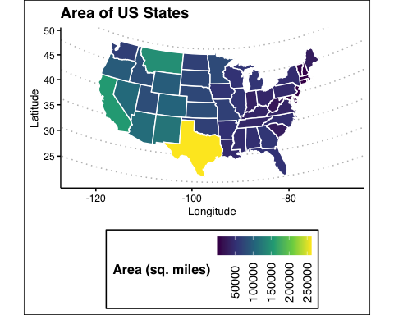

## 3 Three additional plots of the same data, each with different color scale and geographic projection, put together with plot_grid function to make a three-panel horizontal plot.

#1   
(state_areas_1 <- ggplot(fact_join, aes(long, lat, group = group))+  
 geom_polygon(aes(fill = Area), colour = "white")+  
 scale_fill_viridis_c(option = "A")+  
 ggthemes::theme_clean() +  
 coord_map("mercator")+  
 labs(y = "Latitude",   
 x = "Longitude",   
 fill = "Area (sq. miles)",  
 title = "Area of US States, \nMercator Projection")+  
 theme(legend.position = "bottom",  
 legend.text = element_text(angle = 90, vjust = 0.5))  
)

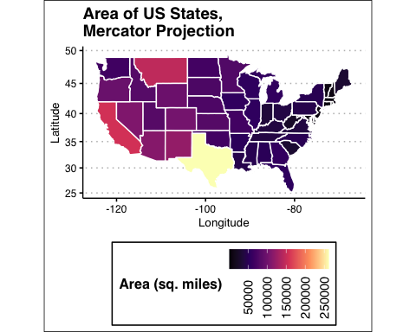

#2  
(state_areas_2 <- ggplot(fact_join, aes(long, lat, group = group))+  
 geom_polygon(aes(fill = Area), colour = "white")+  
 scale_fill_viridis_c(option = "E")+  
 ggthemes::theme_clean() +  
 coord_map("stereographic")+  
 labs(y = "Latitude",   
 x = "Longitude",   
 fill = "Area (sq. miles)",  
 title = "Area of US States, \nStereographic Projection")+  
 theme(legend.position = "bottom",  
 legend.text = element_text(angle = 90, vjust = 0.5))  
)

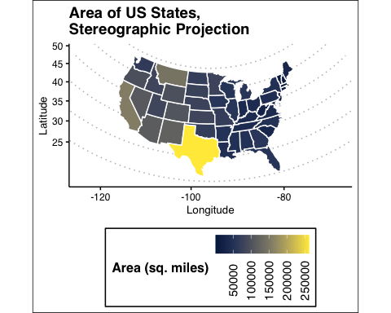

#3  
(state_areas_3 <- ggplot(fact_join, aes(long, lat, group = group))+  
 geom_polygon(aes(fill = Area), colour = "white")+  
 scale_fill_viridis_c(option = "C")+  
 ggthemes::theme_clean() +  
 coord_map("cylequalarea", lat0 = 40)+  
 labs(y = "Latitude",   
 x = "Longitude",   
 fill = "Area (sq. miles)",  
 title = "Area of US States,\nCylequalarea Projection")+  
 theme(legend.position = "bottom",  
 legend.text = element_text(angle = 90, vjust = 0.5))  
)

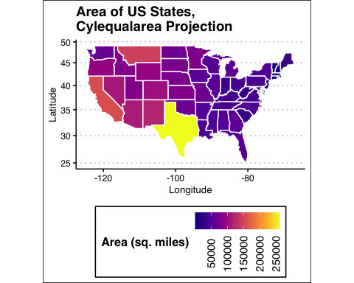

### 3-panel of the different color scales and projections

cowplot::plot_grid(state_areas_1, state_areas_2, state_areas_3, nrow = 1)

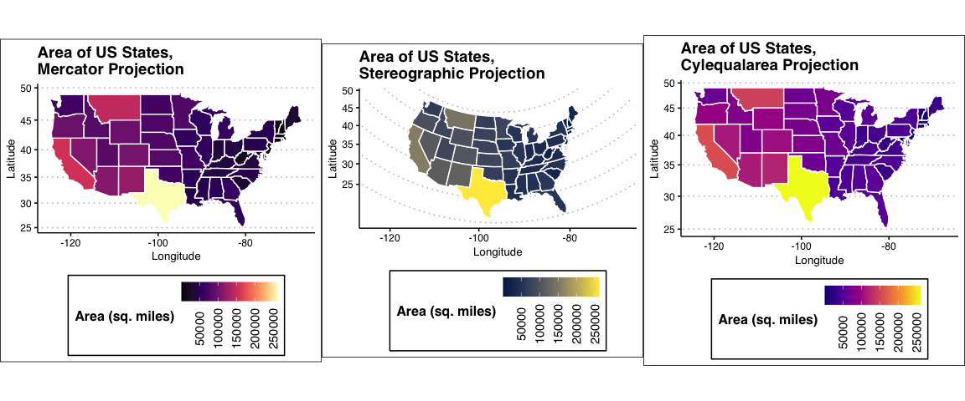

# US University Data

## 4. Plot Colorado colleges and universities within the top 96th quantile of total student enrollment, add in geom_text_repel(data=NAME_OF_YOUR_FILTERED_DATA, aes(label=NAME, x=LON, y = LAT), force=20, size=2)

# Read in the csv of university data   
colo_unis <- read.csv(here::here("data/data_for_lab1/Colleges_and_Universities/colorado_universities.csv"))   
  
# Filter to only CO   
colo_unis <- colo_unis %>%   
 filter(LSTATE == "CO")  
# check   
unique(colo_unis$LSTATE)

## [1] "CO"

# Calculate and filter the 96th quantile universities  
(quan_96 <- quantile(colo_unis$TOT_ENROLL, .96, na.rm = T))

## 96%   
## 16616.8

co_96 <- colo_unis %>%   
 filter(TOT_ENROLL >= quan_96)  
  
# Load in the CO shapefile   
co_counties= readOGR(here::here("data/data_for_lab1/counties/Colorado_County_Boundaries.shp"))

## OGR data source with driver: ESRI Shapefile   
## Source: "/Users/natalieschmer/Desktop/GitHub/ECOL_620/data/data_for_lab1/counties/Colorado_County_Boundaries.shp", layer: "Colorado_County_Boundaries"  
## with 64 features  
## It has 9 fields  
## Integer64 fields read as strings: OBJECTID NUM_FIPS

# Set the min and max enroll  
min_enroll=min(colo_unis$TOT_ENROLL)  
max_enroll=max(colo_unis$TOT_ENROLL)  
  
# Plot   
(CO_MAP_UNI <- ggplot() +  
 geom_polygon(data = co_counties, aes(x=long, y = lat, group = group), fill = NA, color ="black", lwd=.1) +  
 geom_point(data = co_96, aes(x=LON, y = LAT, size=TOT_ENROLL, colour=TOT_ENROLL), alpha=.9) +  
 coord_map("bonne", lat0 = 40)+  
 theme_bw()+  
 theme(panel.grid.minor=element_blank(),panel.grid.major=element_blank())+  
 theme( panel.border=element_blank())+  
 scale_color_viridis(limits=c(min_enroll, max_enroll), breaks=seq(5000, 30000, by=5000), name = "Total\nenrollment")+  
 guides(color= guide_legend(), size=guide_legend())+  
 scale_size_continuous(limits=c(min_enroll, max_enroll), breaks=seq(5000, 30000, by=5000),name = "Total\nenrollment") +  
 geom_text_repel(data = co_96, aes(label=NAME, x=LON, y = LAT), force=20, size=2)+  
 ggthemes::theme_clean()+  
 labs(y = "Latitude",   
 x = "Longitude",  
 title = "CO Universities within the top\n96th quantile of student enrollment")  
)

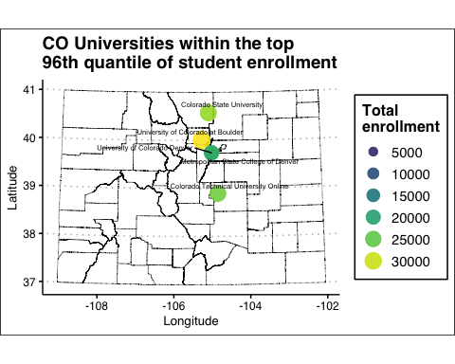

## 5. Other universities: On, Wisconsin!

Wisconsin county boundary shapefile downloaded from <https://data-wi-dnr.opendata.arcgis.com/datasets/county-boundaries-24k>

# load in shapefiles for WI counties and universities  
wi_counties <- readOGR(here::here("data/County_Boundaries_24K-shp/County_Boundaries_24K.shp"))

## OGR data source with driver: ESRI Shapefile   
## Source: "/Users/natalieschmer/Desktop/GitHub/ECOL_620/data/County_Boundaries_24K-shp/County_Boundaries_24K.shp", layer: "County_Boundaries_24K"  
## with 72 features  
## It has 7 fields

us_uni <- readOGR(here::here("data/data_for_lab1/Colleges_and_Universities/CollegesUniversities.shp"))

## OGR data source with driver: ESRI Shapefile   
## Source: "/Users/natalieschmer/Desktop/GitHub/ECOL_620/data/data_for_lab1/Colleges_and_Universities/CollegesUniversities.shp", layer: "CollegesUniversities"  
## with 7126 features  
## It has 38 fields

# Filter out WI schools  
wi_uni <- subset(us_uni, LSTATE=="WI")  
  
# check crs   
proj4string(wi_counties)

## [1] "+proj=tmerc +lat_0=0 +lon_0=-90 +k=0.9996 +x_0=520000 +y_0=-4480000 +ellps=GRS80 +towgs84=0,0,0,0,0,0,0 +units=m +no_defs"

proj4string(wi_uni)

## [1] "+proj=longlat +datum=WGS84 +no_defs"

# reproject counties with the uni projection   
wi_counties_reprj <- spTransform(wi_counties, "+proj=longlat +datum=WGS84 +no_defs")  
  
# make wi unis a df   
wi_unis_df <- as.data.frame(wi_uni)  
  
#remove ins size 0 and lower as those are not reported or not applicable   
wi_unis_df <- wi_unis_df %>%   
 dplyr::filter(INST_SIZE > 0)

ggplot() +  
 geom_polygon(data = wi_counties_reprj, aes(x=long, y = lat, group = group), fill = NA, color ="black", lwd=.1) +  
 geom_point(data = wi_unis_df %>% filter(NAME != "University of Wisconsin-Madison"), aes(x=LON, y = LAT, size=INST_SIZE, colour=INST_SIZE), alpha=.6) +   
 geom_point(data = wi_unis_df %>% filter(NAME == "University of Wisconsin-Madison"), aes(x=LON, y = LAT, size=INST_SIZE), alpha=.6, color = "blue", show.legend = F) +  
 coord_map("bonne", lat0 = 40)+  
 theme_clean()+  
 theme(panel.grid.minor=element_blank(),  
 panel.grid.major=element_blank())+  
 theme( panel.border=element_blank())+  
 scale_color_viridis(limits = c(1, 5),  
 labels = c("Under 1000",  
 "1000 - 4999",  
 "5000 - 9999",  
 "10000 - 19999",  
 "20000 and above"),  
 name = "Institution\nsize") +  
 guides(color= guide_legend(),   
 size=guide_legend()) +  
 scale_size_continuous(limits=c(1, 5),  
 breaks=seq(1, 5, by= 1),  
 labels = c("Under 1000",  
 "1000 - 4999",  
 "5000 - 9999",  
 "10000 - 19999",  
 "20000 and above"),  
 name = "Institution\nsize")+  
 labs(y = "Latitude",   
 x = "Longitude",  
 title = "University of Wisconsin-Madison")

