Assign 11

Natalie Schmer

## 1. Bank Salaries

library(ggplot2)  
library(knitr)  
library(tidyverse)

## ── Attaching packages ────────────────────────────────────────────── tidyverse 1.3.0 ──

## ✓ tibble 3.0.0 ✓ dplyr 0.8.5  
## ✓ tidyr 1.0.2 ✓ stringr 1.4.0  
## ✓ readr 1.3.1 ✓ forcats 0.5.0  
## ✓ purrr 0.3.3

## ── Conflicts ───────────────────────────────────────────────── tidyverse_conflicts() ──  
## x dplyr::filter() masks stats::filter()  
## x dplyr::lag() masks stats::lag()

saldata <- read.csv("/Users/natalieschmer/Desktop/GitHub/stats_511/data/BankSalaries.csv")  
Large <- subset(saldata, Size=="Large")   
Small <- subset(saldata, Size=="Small")

### 1A. Scatter Plot

ggplot(data = saldata, aes(x = LOS, y= Wages, shape = Size))+  
 geom_point(size = 2)+  
 geom_smooth(mapping = aes(LOS, Wages, color = Size), method = "lm", se = T)+  
 theme_bw()

## `geom_smooth()` using formula 'y ~ x'

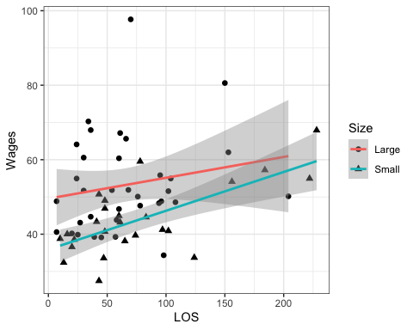

### 1B Regression Models and Equation for line

lm_large <- lm(Wages ~ LOS, data = Large)  
#y = 49.45 + 0.05595(LOS)  
  
lm_small <- lm(Wages ~ LOS, data = Small)  
#y = 35.87192 + 0.10416(LOS)

### 1C. Interpretation

For large banks, wages start higher but for one unit increase in LOS increases by 0.056, whereas for small banks wages start lower but for one unit increase in LOS increase by 0.10.

### 1D.Test for slope

summary(lm_large)

##   
## Call:  
## lm(formula = Wages ~ LOS, data = Large)  
##   
## Residuals:  
## Min 1Q Median 3Q Max   
## -20.688 -8.472 -3.691 5.767 44.218   
##   
## Coefficients:  
## Estimate Std. Error t value Pr(>|t|)   
## (Intercept) 49.54532 4.01305 12.346 6.46e-14 ***  
## LOS 0.05595 0.05116 1.094 0.282   
## ---  
## Signif. codes: 0 '***' 0.001 '**' 0.01 '*' 0.05 '.' 0.1 ' ' 1  
##   
## Residual standard error: 13.02 on 33 degrees of freedom  
## Multiple R-squared: 0.03498, Adjusted R-squared: 0.005741   
## F-statistic: 1.196 on 1 and 33 DF, p-value: 0.282

summary(lm_small)

##   
## Call:  
## lm(formula = Wages ~ LOS, data = Small)  
##   
## Residuals:  
## Min 1Q Median 3Q Max   
## -15.0716 -4.4861 0.3944 2.8101 15.5273   
##   
## Coefficients:  
## Estimate Std. Error t value Pr(>|t|)   
## (Intercept) 35.87192 2.28194 15.720 8.53e-14 ***  
## LOS 0.10416 0.02326 4.478 0.000171 ***  
## ---  
## Signif. codes: 0 '***' 0.001 '**' 0.01 '*' 0.05 '.' 0.1 ' ' 1  
##   
## Residual standard error: 7.021 on 23 degrees of freedom  
## Multiple R-squared: 0.4657, Adjusted R-squared: 0.4425   
## F-statistic: 20.05 on 1 and 23 DF, p-value: 0.0001712

*For large banks, p = 0.282 and for small banks, p = 0.0001712. For, large banks, there is not evidence that LOS is linearly related to wages, but there is evidence this is true for small banks.*

### 1E CI for Intercept

confint(lm_large, level = 0.95)

## 2.5 % 97.5 %  
## (Intercept) 41.38071287 57.7099183  
## LOS -0.04812646 0.1600341

confint(lm_small, level = 0.95)

## 2.5 % 97.5 %  
## (Intercept) 31.15135828 40.5924796  
## LOS 0.05603753 0.1522847

*Ultimately, an employee would be better off at a large bank because the representing the starting wage, starts higher than a smaller bank.*

### 1F. CI for Mean LOS=96

newdata <- data.frame(LOS = 96)  
predict(lm_large, newdata, interval = "predict", level = 0.95)

## fit lwr upr  
## 1 54.91688 27.86905 81.96471

predict(lm_small, newdata, interval = "predict", level = 0.95)

## fit lwr upr  
## 1 45.87139 31.03197 60.7108

predict(lm_large, newdata, interval = "confidence", level = 0.95)

## fit lwr upr  
## 1 54.91688 49.43465 60.39911

predict(lm_small, newdata, interval = "confidence", level = 0.95)

## fit lwr upr  
## 1 45.87139 42.83057 48.91221

*After 8 years, an emplyee would still be better off at a larger bank, as the range of possible wages as represented by the confidence interval is higher than for smaller banks.*

### 1G. Outlier

car::outlierTest(lm_large)

## rstudent unadjusted p-value Bonferroni p  
## 15 4.242492 0.00017638 0.0061735

#row 15 of the large dataset, LOS is 70 and wage is 97.68

### 1H. T-test

boxplot(LOS~Size, data =saldata)

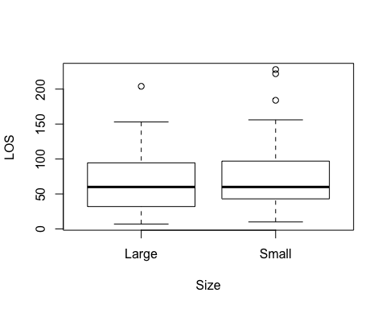

t.test(LOS~Size, data =saldata)

##   
## Welch Two Sample t-test  
##   
## data: LOS by Size  
## t = -0.81609, df = 40.606, p-value = 0.4192  
## alternative hypothesis: true difference in means is not equal to 0  
## 95 percent confidence interval:  
## -40.73149 17.29149  
## sample estimates:  
## mean in group Large mean in group Small   
## 65.60 77.32

*Since the boxplots have a fair amount of overlap and p > 0.05, we cannot conclude that LOS is significantly different between bank sizes.*

## Q2 Steel Quadratic

Steel<-read.csv("/Users/natalieschmer/Desktop/GitHub/stats_511/data/Steel.csv")  
str(Steel)

## 'data.frame': 20 obs. of 2 variables:  
## $ Thick : int 220 220 220 220 370 370 370 370 440 440 ...  
## $ Strength: num 24 22 19.1 15.5 26.3 24.6 23 21.2 25.2 24 ...

### 2A. (**4pts**)

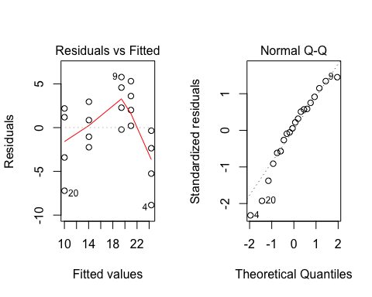 *Based on the plots, the regression assumptions do not seem to be well met. the Residuals vs fitted show deviations away from the 0 line, and the QQ plot is not very linear.*

### 2B. (**4pts**)

regfit2a <- anova(lm_2a)  
  
ANOVA2a <- lm(Strength ~ as.factor(Thick), Steel)  
ANOVAfit2a <- anova(ANOVA2a)  
  
#lack of fit  
anova(lm_2a, ANOVA2a)

## Analysis of Variance Table  
##   
## Model 1: Strength ~ Thick  
## Model 2: Strength ~ as.factor(Thick)  
## Res.Df RSS Df Sum of Sq F Pr(>F)   
## 1 18 301.90   
## 2 15 148.57 3 153.33 5.16 0.01195 *  
## ---  
## Signif. codes: 0 '***' 0.001 '**' 0.01 '*' 0.05 '.' 0.1 ' ' 1

#F   
regfit2a$'Sum Sq'

## [1] 522.0448 301.9007

SSreg = regfit2a$'Sum Sq'[2]  
SSanova = ANOVAfit2a$`Sum Sq`[2]  
DFreg = regfit2a$Df[2]  
DFanova = ANOVAfit2a$Df[2]  
F = ((SSreg-SSanova)/(DFreg-DFanova))/ANOVAfit2a$`Mean Sq`[2]   
  
1-pf(F,(DFreg-DFanova),DFanova) # p-value

## [1] 0.01194633

*Since p< 0.05, there is evidence of a lack of fit.*

### 2C. (4 pts)

ggplot(data = Steel, aes(x = Thick, y = Strength))+  
 geom_point()+  
 geom_smooth(method = "lm", formula = y ~ x + I(x^2))+  
 theme_bw()

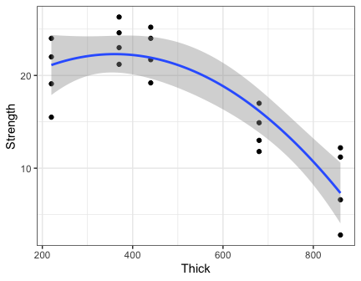

summary(lm(Steel$Strength ~ Steel$Thick + I(Steel$Thick^2)))

##   
## Call:  
## lm(formula = Steel$Strength ~ Steel$Thick + I(Steel$Thick^2))  
##   
## Residuals:  
## Min 1Q Median 3Q Max   
## -5.6222 -2.1960 0.2443 2.4491 4.8763   
##   
## Coefficients:  
## Estimate Std. Error t value Pr(>|t|)   
## (Intercept) 1.452e+01 4.752e+00 3.057 0.00713 **  
## Steel$Thick 4.318e-02 1.980e-02 2.181 0.04354 *   
## I(Steel$Thick^2) -5.994e-05 1.786e-05 -3.357 0.00374 **  
## ---  
## Signif. codes: 0 '***' 0.001 '**' 0.01 '*' 0.05 '.' 0.1 ' ' 1  
##   
## Residual standard error: 3.268 on 17 degrees of freedom  
## Multiple R-squared: 0.7796, Adjusted R-squared: 0.7537   
## F-statistic: 30.07 on 2 and 17 DF, p-value: 2.609e-06

## Q3 SAT Scores

### 3A.

sat_cor <- sat %>%   
 select(-year)  
  
pairs(sat_cor)

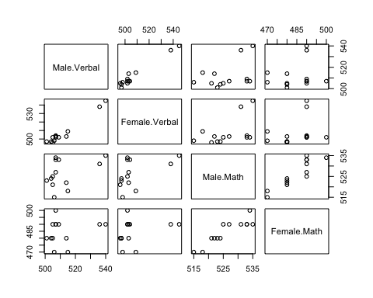{height=200 px}

### 3B.

cor(sat_cor, method = "pearson")

## Male.Verbal Female.Verbal Male.Math Female.Math  
## Male.Verbal 1.0000000 0.9814674 0.4167834 0.1952538  
## Female.Verbal 0.9814674 1.0000000 0.4960357 0.2841566  
## Male.Math 0.4167834 0.4960357 1.0000000 0.8995118  
## Female.Math 0.1952538 0.2841566 0.8995118 1.0000000

*The strongest correlation is between female verbal and male verbal*

### 3C

cor.test(sat_cor$Female.Verbal, sat_cor$Female.Math, method = "pearson")

##   
## Pearson's product-moment correlation  
##   
## data: sat_cor$Female.Verbal and sat_cor$Female.Math  
## t = 0.98296, df = 11, p-value = 0.3468  
## alternative hypothesis: true correlation is not equal to 0  
## 95 percent confidence interval:  
## -0.3163599 0.7220875  
## sample estimates:  
## cor   
## 0.2841566

*Since p > 0.05, and the correlation coefficient is very low, there is little to no correlation bewteen female verbal and female math scores.*