Assign1Template

#1. Use the data described in Problem 3.30 regarding lumber. From the files you downloaded above, you will find the data under CH03, named ex3-30.txt. Use the following commands to import and summarize the data.

#Use path name with R Markdown  
#Laptop  
# lumber <- read.csv("~/Documents/GitHub/CSU/stats_511/data/assignment_1/ASCII-comma/CH03/ex3-30.TXT", quote = "'")  
  
#office  
lumber <- read.csv("/Users/natalieschmer/Desktop/GitHub/stats_511/data/ASCII-comma/CH03/ex3-30.TXT", quote = "'")  
  
#View(lumber) this doesn't work well with R Markdown  
str(lumber)

## 'data.frame': 70 obs. of 1 variable:  
## $ Number: int 7 8 6 4 9 11 9 9 9 10 ...

**A. Include the histogram in your assignment.**

hist(lumber$Number,   
 main = "Histogram of Lumber",  
 xlab = "Lumber",  
 ylab = "Frequency")

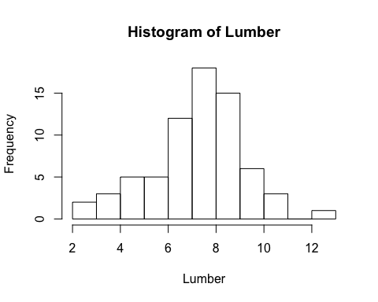 **B. Give the mean and median of the sample.**

(mean(lumber$Number))

## [1] 7.728571

median(lumber$Number)

## [1] 8

**C. Does the data appear to be “normal” (bell-shaped)? Justify your response based on your histogram from above.**

Yes, I think the data could be considred normal due to the fact that the majority of the observations fall in the 7-9 range, which matches the mean (and the median), with decreasing frequency moving away from the middle.

#2 Survival Times

#office  
survival <- read.csv("/Users/natalieschmer/Desktop/GitHub/stats_511/data/ASCII-comma/CH03/ex3-7.TXT", quote = "'")  
str(survival)

## 'data.frame': 28 obs. of 2 variables:  
## $ StandardTherapy: int 4 14 29 6 15 2 6 13 24 16 ...  
## $ NewTherapy : int 5 17 27 9 20 15 14 18 29 19 ...

**A. What is the sample mean and sample standard deviation for each of the therapies?**

#Standard Therapy  
mean(survival$StandardTherapy)

## [1] 15.67857

sd(survival$StandardTherapy)

## [1] 9.630405

#New therapy  
mean(survival$NewTherapy)

## [1] 20.71429

sd(survival$NewTherapy)

## [1] 9.808753

**B. Construct side-by-side boxplots showing the survival times for each therapy.**

boxplot(survival, xlab = "Therapy type", ylab= "Survival Times")

