Exam2 Spring 2020

Natalie Schmer

Signature for honor pledge: Natalie Schmer

## Multiple Choice

(hint: two spaces at end of a line starts new line when knitting to pdf. otherwise numbered lines like below do so automatically.)

### 1 - 7 True/False

1. T
2. F
3. T
4. T
5. F
6. T
7. F

n7 <- 55  
pi7 <- 0.11  
  
3*sqrt(pi7*(1-pi7)/n7)

## [1] 0.1265701

### 8-13 A,B,C,or D

1. B
2. C
3. B
4. B
5. D
6. D

## Matching (place a unique letter next to each)

Scenario1: B  
Scenario2: A  
Scenario3: G  
Scenario4: F  
Scenario5: E  
Scenario6: D  
Scenario7: C

### R Code Questions

## 1. Sleep Data

sleep <- sleep  
str(sleep)

## 'data.frame': 20 obs. of 3 variables:  
## $ extra: num 0.7 -1.6 -0.2 -1.2 -0.1 3.4 3.7 0.8 0 2 ...  
## $ group: Factor w/ 2 levels "1","2": 1 1 1 1 1 1 1 1 1 1 ...  
## $ ID : Factor w/ 10 levels "1","2","3","4",..: 1 2 3 4 5 6 7 8 9 10 ...

?sleep  
summary(sleep)

## extra group ID   
## Min. :-1.600 1:10 1 :2   
## 1st Qu.:-0.025 2:10 2 :2   
## Median : 0.950 3 :2   
## Mean : 1.540 4 :2   
## 3rd Qu.: 3.400 5 :2   
## Max. : 5.500 6 :2   
## (Other):8

### 1A. Hypotheses

**The parameters are the null and alternative hypotheses. The null hypothesis is that there is no difference in how the 2 drugs increase sleep compared to the control– the means of extra sleep in hours for each group are not different. The alternative hypothesis is that one of the drugs increases sleep more than the other as compared to the control– the mean extra sleep in hours for each group are not equal to eachother.**

### 1B. Boxplot

boxplot(extra ~ group, data = sleep, xlab = "Group", ylab = "Extra amount of sleep (hours)")

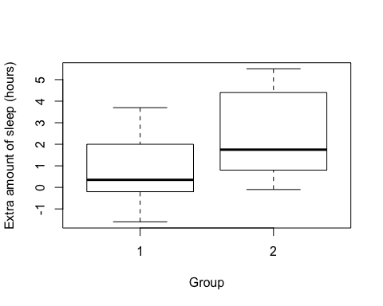

**The boxplot may be misleading because it it showing that the means of the groups are different, when they may not be when tested statistically. Also, the two groups are both compared to a control, with which the sleep in hours is not shown here.**

### 1C. t.test can be done at least 3 different ways

t.test(extra ~ group, data = sleep, paired = T)

##   
## Paired t-test  
##   
## data: extra by group  
## t = -4.0621, df = 9, p-value = 0.002833  
## alternative hypothesis: true difference in means is not equal to 0  
## 95 percent confidence interval:  
## -2.4598858 -0.7001142  
## sample estimates:  
## mean of the differences   
## -1.58

### 1D. Conclusion

**Since p < 0.05, we reject the null hypothesis and conculde that the mean increased sleep is not the same between the 2 groups. Based on the boxplot, it appears that the drug given to the second group increased sleep more than the drug in the first group.**

## 2. Proportion of lefties then and now

### 2A. Hypotheses

**This is a proportion, so the parameters of interest include: number of trials, n = 150, and Y, number of successes = 18, with the main parameter being pi hat, the proportion of successes, in this case being 18/ 150 or 0.12. The null hypothesis is that the proprotion of Americans who are left handed has stayed the same since the 1980’s, and the alternative is that the proprtion of left handed Americans has increased since the 1980’s.**

### 2B. Test Statistic (multiple ways)

#z- score for alpha = 0.05  
qnorm(0.95) #1.645

## [1] 1.644854

#test stat:   
(0.12 - 0.08)/(sqrt((0.08*(1-0.08))/150)) #1.81

## [1] 1.805788

### 2C. p-value (multiple ways)

prop.test(18, 150, p = 0.05, correct = T)

##   
## 1-sample proportions test with continuity correction  
##   
## data: 18 out of 150, null probability 0.05  
## X-squared = 14.035, df = 1, p-value = 0.0001794  
## alternative hypothesis: true p is not equal to 0.05  
## 95 percent confidence interval:  
## 0.0746155 0.1855432  
## sample estimates:  
## p   
## 0.12

### 2D.

**From part b, z=1.81 > z(alpha/2)= 1.96, so part b would say to reject the null hypothesis that the proprotion of americans who are left handed has stayed the same since the 1980’s. From the prop.test in part c, the pvalue is < 0.05, which is also sufficient evidence that the proportion of left handed americans is higher at the time of the study than in the 1980’s.**

## 3 Cuckoos

{   
 library(tidyverse)  
 library(car)  
 library(emmeans)  
}  
  
eggs.wide <- read.csv('/Users/natalieschmer/Desktop/GitHub/stats_511/data/cuckoo.csv')  
  
str(eggs.wide)

## 'data.frame': 45 obs. of 6 variables:  
## $ meadow : num 19.6 20.1 20.6 20.9 21.6 ...  
## $ tree : num 21.1 21.9 22.1 22.4 22.6 ...  
## $ hedge : num 20.9 21.6 22.1 22.9 23.1 ...  
## $ robin : num 21.1 21.9 22.1 22.1 22.1 ...  
## $ wagtail: num 21.1 21.9 21.9 21.9 22.1 ...  
## $ wren : num 19.9 20.1 20.2 20.9 20.9 ...

eggs <- gather(eggs.wide,"HostSpecies","eggsize",na.rm=TRUE) #missing values stacked  
str(eggs)

## 'data.frame': 120 obs. of 2 variables:  
## $ HostSpecies: chr "meadow" "meadow" "meadow" "meadow" ...  
## $ eggsize : num 19.6 20.1 20.6 20.9 21.6 ...

### 3A. boxplot

boxplot(eggsize ~ HostSpecies, data = eggs)

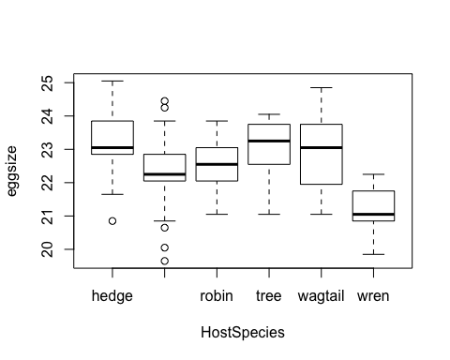

### 3B. Sumstats

eggs %>%   
 group_by(HostSpecies) %>%   
 summarise(n = n(),  
 mean = mean(eggsize),  
 sd = sd(eggsize),  
 se = sd/sqrt(n))

## # A tibble: 6 x 5  
## HostSpecies n mean sd se  
## <chr> <int> <dbl> <dbl> <dbl>  
## 1 hedge 14 23.1 1.07 0.286  
## 2 meadow 45 22.3 0.921 0.137  
## 3 robin 16 22.6 0.685 0.171  
## 4 tree 15 23.1 0.901 0.233  
## 5 wagtail 15 22.9 1.07 0.276  
## 6 wren 15 21.1 0.744 0.192

### 3C. Diagnoatics

Fit_eggs = lm(eggsize ~ HostSpecies, data = eggs)  
  
#Set up plot space and plot  
par(mfrow= c(2, 2))  
plot(Fit_eggs)

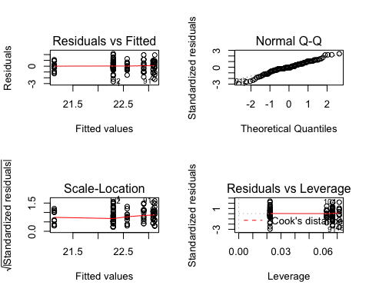

#Levene's test  
car::leveneTest(eggsize ~ HostSpecies, data = eggs, )

## Warning in leveneTest.default(y = y, group = group, ...): group coerced to  
## factor.

## Levene's Test for Homogeneity of Variance (center = median)  
## Df F value Pr(>F)  
## group 5 0.6397 0.6698  
## 114

#Shapiro - Wilk  
(shapiro.test(eggs$eggsize))

##   
## Shapiro-Wilk normality test  
##   
## data: eggs$eggsize  
## W = 0.98241, p-value = 0.1193

**This data appears to be ok for an anova. Residuals are generally very close to 0, except for the last two groups, and the QQ plot has a line that is very close to straight but slightly deviates at the bottom left. Additionally, the Levene p value is > 0.05 so would not be non-normal, and the shapiro-wilk p value= 0.12, also not non-normal. If anything, the differences in sample size where meadow has many more observations could be a problem, but the summary stats are very similar to the other groups.**

### 3D. ANOVA table

anova(Fit_eggs)

## Analysis of Variance Table  
##   
## Response: eggsize  
## Df Sum Sq Mean Sq F value Pr(>F)   
## HostSpecies 5 42.940 8.5879 10.388 3.152e-08 ***  
## Residuals 114 94.248 0.8267   
## ---  
## Signif. codes: 0 '***' 0.001 '**' 0.01 '*' 0.05 '.' 0.1 ' ' 1

### 3E.

**Since F < 0.05, at least one population group mean appears to be different.**

### 3F. CLD

(eggs_cld<- emmeans::emmeans(Fit_eggs, pairwise ~ HostSpecies))

## $emmeans  
## HostSpecies emmean SE df lower.CL upper.CL  
## hedge 23.1 0.243 114 22.6 23.6  
## meadow 22.3 0.136 114 22.0 22.6  
## robin 22.6 0.227 114 22.1 23.0  
## tree 23.1 0.235 114 22.6 23.6  
## wagtail 22.9 0.235 114 22.4 23.4  
## wren 21.1 0.235 114 20.7 21.6  
##   
## Confidence level used: 0.95   
##   
## $contrasts  
## contrast estimate SE df t.ratio p.value  
## hedge - meadow 0.8225 0.278 114 2.956 0.0429   
## hedge - robin 0.5464 0.333 114 1.642 0.5726   
## hedge - tree 0.0314 0.338 114 0.093 1.0000   
## hedge - wagtail 0.2181 0.338 114 0.645 0.9872   
## hedge - wren 1.9914 0.338 114 5.894 <.0001   
## meadow - robin -0.2761 0.265 114 -1.043 0.9022   
## meadow - tree -0.7911 0.271 114 -2.918 0.0475   
## meadow - wagtail -0.6044 0.271 114 -2.230 0.2325   
## meadow - wren 1.1689 0.271 114 4.312 0.0005   
## robin - tree -0.5150 0.327 114 -1.576 0.6160   
## robin - wagtail -0.3283 0.327 114 -1.005 0.9155   
## robin - wren 1.4450 0.327 114 4.422 0.0003   
## tree - wagtail 0.1867 0.332 114 0.562 0.9932   
## tree - wren 1.9600 0.332 114 5.903 <.0001   
## wagtail - wren 1.7733 0.332 114 5.341 <.0001   
##   
## P value adjustment: tukey method for comparing a family of 6 estimates

CLD(eggs_cld)

## HostSpecies emmean SE df lower.CL upper.CL .group  
## wren 21.1 0.235 114 20.7 21.6 1   
## meadow 22.3 0.136 114 22.0 22.6 2   
## robin 22.6 0.227 114 22.1 23.0 23   
## wagtail 22.9 0.235 114 22.4 23.4 23   
## tree 23.1 0.235 114 22.6 23.6 3   
## hedge 23.1 0.243 114 22.6 23.6 3   
##   
## Confidence level used: 0.95   
## P value adjustment: tukey method for comparing a family of 6 estimates   
## significance level used: alpha = 0.05

**Based on the above, it apears that the wren host group tends to have smaller egg sizes than the others.**

### 3G Contrasts

### 3G part i.

**The null hypothesis would be that there is not a significant difference in the mean sizes of wren and meadowlark eggs together as compared to robins and wagtails together.**

### 3G part ii.

eggs_g_model <- lm(eggsize ~ HostSpecies, data = eggs)  
  
eggs_emmeans <- emmeans(eggs_g_model, "HostSpecies")  
  
#find order of factors  
levels(factor(eggs$HostSpecies))

## [1] "hedge" "meadow" "robin" "tree" "wagtail" "wren"

#don't want hedge or tree, positions 1 or 4  
  
contrast(eggs_emmeans, list(partg = c(0, 0.5, -0.5, 0, -0.5, 0.5)))

## contrast estimate SE df t.ratio p.value  
## partg -1.02 0.212 114 -4.827 <.0001