Oakland University

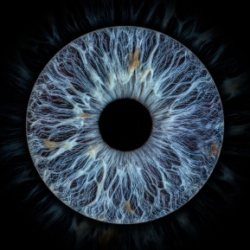

**I of the internet**

Phase 1 report

Nicholas Schultz

CSI2520

Dr. Amartya Sen

10/21/2021

**Problem statement**:

To develop a web-application that will manage and track your **digital identity** using biometrics. The scope of your digital identity are the following items:

- Any computer device that you own that can connect to other devices for the purpose of sharing information.

- Any computer system that you enter personal information into, which then is stored on the system for later use.

- Any digital data that pertains to your person that is being used on the internet.

**System requirements**:

*The system will be able to do the following…*

* Be able to track what apps have your personal information
* Show you an overview of your current overall digital security health.
* Show you the status of the digital health of your personal computer devices.
* Will give you a listing of what computer systems currently have your personal information.
* Will give you a listing of what sites currently have you as a registered user with your email account.
* Teach you about computer security
* Give you the option to remove yourself from any system you are currently enrolled with.
* Show you current common security holes/breaches
* Give suggestions on what you can do to improve your digital security

**Functional requirements:**

* Sign up page
  + User fills out HTML form with the required information and inputs biometric data
  + User data is encrypted and then sent and stored to the database. (The ideal scenario is for this database to be using blockchain technology where the data is split between multiple servers. However, for this assignment, I will stick to one central database that uses standard encryption technology.
  + The user receives either an error or success message depending on the information they entered.
* Home page
  + Display bar representing your overall digital health
  + 3 main panes
    - My devices pane
      * User will be able to click on the links that display a current device that they use and see additional details about best practices for that device, its current security rating, areas that need to be more secure for that device, and be able to remotely control it from the web app.
      * Database requests this information from the application tracking this information that is installed on the device.
      * The data is then sent to the user that is requesting the data
    - My digital accounts pane
      * User will be able to click on the links that display a current account that they use and see additional details about best practices for that account, its current security rating, areas that need to be more secure, such as the password.
      * This will be a web extension that is installed on your web browser to check various account information that you request.
    - Learn pane
      * User will be able to click on the links here to view additional information on general security information and information. This will take them to additional pages with information only.
      * Pages need to have an Href to link content pages to the webapp