**Part A: Components Diagram**

We followed a bottom up testing approach where we tested our individual submodules before committing them into the main branch of the repo to put it all together. Then we each downloaded the new compiled code and did our incremental and regression testing for the entire project. Then we uploaded our website.

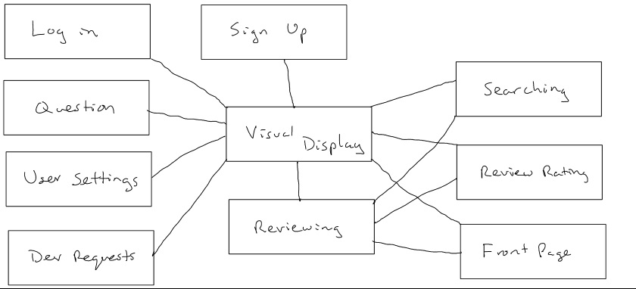

* Sign up Component - Allows users to create an account on the website
  1. input: email, password
  2. output: creates an account for the user
  3. dependent components: Visual Display Component
  4. data: stored in the user database
* Log in Component - allows the users to sign into their account on the website
  1. input: email, password
  2. output: logs the user into the website
  3. dependent components: Visual Display Component
  4. data: stored in the user database
* Front Page Ranking Component
  1. input: courses with reviews
  2. output: displays the list of highest rated courses on the homepage
  3. dependent components: Review Component, Visual Display Component
  4. data: stored in the reviews database (top rated courses)
* Searching Component - Allows users to find a class to review or see reviews
  1. input: course number, department, course name
  2. output: displays a list of relevant search results sorted by rating
  3. dependent components: Review Component, Visual Display Component
  4. data: stored in the courses database
* Reviewing Component - Allows users to write a review for a specific class
  1. input: information relevant to a review (review content, professor name, etc…)
  2. output: the review is published to the course’s page
  3. dependent components: Visual Display Component
  4. data: stored in the reviews database
* Question Component - Allows users to ask and answer questions about a class
  1. input: questions about a class or responses to already published questions
  2. output: the question/answer is published to the course’s page
  3. dependent components: Visual Display Component
  4. data: stored in the questions database
* Review Rating Component - Allows users to rate reviews based off how helpful or funny they are
  1. input: the user will click on a helpful or funny button
  2. output: a counter is incremented on the page and updated in the databases
  3. dependent components: Visual Display Component, Review Component
  4. data: stored in rates database
* Dev requests/contact devs Component - Allows users to contact the developers
  1. input: email, content
  2. output: the developer email account is sent an email with the content and email given
  3. dependent components: Visual Display Component
  4. data: emails pulled from user database when user signed in
* User Settings Component - Allows users to change their password
  1. input: current password, new password
  2. output: the password for the user is updated in the database and an alert is displayed to the user notifying them that the password has been updated
  3. dependent components: Visual Display Component
  4. data: stored in user database
* Visual Display Component - This is the overall display of the website
  1. input: no input required
  2. output: the website content is displayed
  3. dependent components: none

**Part B: Components Incremental and Regression Test Breakdown**

Project Subsections

* Sign up System
* Log in System
* Front Page Ranking System
* Searching System
* Reviewing System
* Question System
* Review Rating System
* Dev requests/contact devs System
* User Settings System (change password)
* Visual Display

|  |  |  |  |
| --- | --- | --- | --- |
| Module | Sign Up System | | |
| Incremental Testing | | | |
| Defect # | Description | Severity | How To Correct |
| N/A | No defects found, this was implemented in the first sprint. | N/A | N/A |
| Regression Testing | | | |
| Defect # | Description | Severity | How To Correct |
| N/A | No defects found, this was implemented in the first sprint. | N/A | N/A |

|  |  |  |  |
| --- | --- | --- | --- |
| Module | Log In System | | |
| Incremental Testing | | | |
| Defect # | Description | Severity | How To Correct |
| N/A | No defects found, this was implemented in the first sprint. | N/A | N/A |
| Regression Testing | | | |
| Defect # | Description | Severity | How To Correct |
| N/A | No defects found, this was implemented in the first sprint. | N/A | N/A |

|  |  |  |  |
| --- | --- | --- | --- |
| Module | Reviews System | | |
| Incremental Testing | | | |
| Defect # | Description | Severity | How To Correct |
| 1 | Review 006 - The stars would not appear at all. | Critical | We needed to import a jquery helper that assured javascript would load before the rest of the page. |
| 2 | Review 011 - The text that states “upload a syllabus” was partially off the screen and was not scaling to different sizes | Workaround | There was a typo in the div container that broke the formatting of the syllabus styling. “dib” needed to be changed to “div” and the formatting now works as anticipated. |
| 3 | Review 013 - There is no admin page link on the front page. | Important | A link has been added to the user dropdown so they can access the admin page if they have admin privileges |
| 4 | Review 012 - The download syllabus link would appear whether or not a syllabus had been uploaded | Workaround | An if statement was added to check if a syllabus has been uploaded. If so, display the download link otherwise, hide it |
| Regression Testing | | | |
| Defect # | Description | Severity | How To Correct |
| 1 | Review 006 - The stars still wouldn’t load on the live website. Though the stars would “show up”, they would not load the image assets. | Critical | Make sure assests are configured to compile that do not fallback to assets pipeline if a precompiled asset is missed. Change the asset compile boolean to true in assests/environments/production.rb |
| 2 | Review 001 - The professor does not show up in the review. | Critical | We removed the instructors database due to a limit in database size for Heroku, this caused the functionality to be messed up on the review page and needed to be touched up again. |

|  |  |  |  |
| --- | --- | --- | --- |
| Module | Dev requests/contact devs System | | |
| Incremental Testing | | | |
| Defect # | Description | Severity | How To Correct |
| N/A | No defects found, this was implemented in the first sprint. | N/A | N/A |
| Regression Testing | | | |
| Defect # | Description | Severity | How To Correct |
| 1 | Contact Devs 002 - When not logged in, if you click the link for ContactUs, it gives an error. | Workaround | There is code that asks for the user’s email, causing the code to break if they’re not logged in. In the code, it’ll be fixed if it is asked first if the user is logged in. |

|  |  |  |  |
| --- | --- | --- | --- |
| Module | Front Page Ranking System | | |
| Incremental Testing | | | |
| Defect # | Description | Severity | How To Correct |
| 1 | Front Page Ranking Test 002 - There is only the top 5 classes being shown currently | Workaround | Merge Conflicts got mixed up so on the Homepage we were only getting the top 5 classes from the database. We changed it to 10 and it displayed the top 10 |
| Regression Testing | | | |
| Defect # | Description | Severity | How To Correct |
| N/A | No defects found, this was implemented in the first sprint. | N/A | N/A |

|  |  |  |  |
| --- | --- | --- | --- |
| Module | Searching System | | |
| Incremental Testing | | | |
| Defect # | Description | Severity | How To Correct |
| 1 | Searching 005 - When searching for “” the website throws an error | Workaround | The results page now checks for empty string searches and returns a “no results” message |
| 2 | Searching 004 - Searching for a course with only 3 digits in the parameters gives no results | Critical | Added code to pad the search parameters with zeros behind the scenes as the search gem requires at least 4 digits to search correctly |
| Regression Testing | | | |
| Defect # | Description | Severity | How To Correct |
| 1 | Searching 005 - After fixing this once and adding pagination, when searching for “” the website throws an error | Workaround | The pagination code needs to be inside the else statement that contains the code that displays the results if there are search results. Leaving pagination with no search results will return nil and break the page. |
| 2 | Searching 004 - the 00 padding would be applied to all parameters | critical | an else statement was added so the original search parameters are used when appropriate |

|  |  |  |  |
| --- | --- | --- | --- |
| Module | Question System | | |
| Incremental Testing | | | |
| Defect # | Description | Severity | How To Correct |
| 1 | Question 003 - You can submit an empty answer | Workaround | A validation check was added to the review form that will not let the review be submitted unless the submit a review. |
| 2 | Question 004 - You can submit an empty Question | Workaround | A validation check was added to the questions form that will not let the question be submitted without unless they actually write a question. |
| Regression Testing | | | |
| Defect # | Description | Severity | How To Correct |
| 1 | Question 006 - The downvote incremented when the flag incremented after fixing the flagging system with questions. | Important | I changed the downvote counting code to the same as the flag code. It counted correctly once I changed the downvote counting function back to the way it used to be. |

|  |  |  |  |
| --- | --- | --- | --- |
| Module | Review Rating System | | |
| Incremental Testing | | | |
| Defect # | Description | Severity | How To Correct |
| N/A | No defects found. | N/A | N/A |
| Regression Testing | | | |
| Defect # | Description | Severity | How To Correct |
| N/A | No defects found. | N/A | N/A |

|  |  |  |  |
| --- | --- | --- | --- |
| Module | Visual System | | |
| Incremental Testing | | | |
| Defect # | Description | Severity | How To Correct |
| 1 | Style 002 - after updating the style of the navbar, the dropdown icon was no longer appearing | Workaround | The icon was switched to an icon compatible with the new bootstrap styles |
| Regression Testing | | | |
| Defect # | Description | Severity | How To Correct |
| 1 | Style 002 - after updating the navbar’s appearance, the search bar’s shape would change unpleasantly | Workaround | The search bar style code was updated to be compatible with the new bootstrap styling |

|  |  |  |  |
| --- | --- | --- | --- |
| Module | User Setting (Change Password) System | | |
| Incremental Testing | | | |
| Defect # | Description | Severity | How To Correct |
| N/A | No defects found. | N/A | N/A |
| Regression Testing | | | |
| Defect # | Description | Severity | How To Correct |
| N/A | No defects found. | N/A | N/A |