
BLACK BOOK PROJECT REPORT ON
FUNDAMENTAL ANALYSIS OF
FEDBANK FINANCIAL SERVICES LIMITED
Submitted in partial fulfilment for the award of the degree of
MASTER OF MANAGEMENT STUDIES
FINANCE
UNIVERSITY OF MUMBAI
Submitted by
DATTAGURU KALLAPA PATIL
ROLL NO: M-16144
ACADEMIC YEAR 2026–2027
Under the Guidance of
DR. RAHUL N. WADEKAR | DR. PRASAD SUPEKAR
DES’S NAVINCHANDRA MEHTA INSTITUTE OF TECHNOLOGY AND DEVELOPMENT
DES MUMBAI CAMPUS, KIRTI COLLEGE ROAD, OFF VEER SAVARKAR MARG, DADAR (W), MUMBAI – 400028

CERTIFICATE
This is to certify that the project report entitled “Fundamental Analysis of Fedbank Financial Services Limited” submitted by Mr. Dattaguru Kallapa Patil (Roll No. M-16144) in partial fulfilment of the requirements for the award of the Master of Management Studies degree in Finance of the University of Mumbai for the academic year 2026–2027 is a record of research work carried out under academic guidance and is submitted for evaluation.
The study is based on the company’s published disclosures and the supporting material identified in the report. The report is subject to the University and Institute’s review and approval.
________________________  DIRECTOR | ________________________  PROJECT GUIDES | ________________________  EXTERNAL EXAMINER
Dr. Rasika Mallya | Dr. Rahul N. Wadekar  Dr. Prasad Supekar

COLLEGE STAMP HERE

INTERNSHIP CERTIFICATE
The following certificate was supplied with the project material and is reproduced as provided.
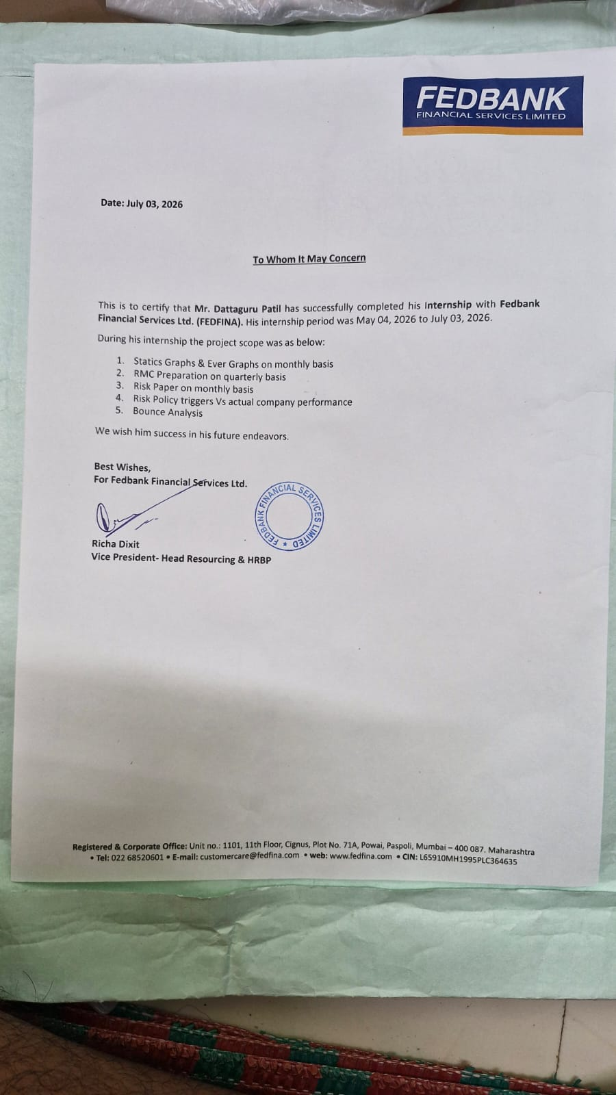

DECLARATION
I hereby declare that this project report entitled “Fundamental Analysis of Fedbank Financial Services Limited”, submitted in partial fulfilment of the requirements for the award of the Master of Management Studies degree in Finance of the University of Mumbai, is my bona fide academic work. It has not been submitted to any other University or Institute for the award of a degree, diploma or certificate.
The analysis is based on publicly available company disclosures and regulatory material identified in the report. Financial information is distinguished from calculations derived from reported data. No survey, interview or borrower-level dataset has been used. Where the supplied disclosures present inconsistent definitions or figures, the difference is identified rather than resolved by assumption.
The report is prepared for academic purposes only. It is not investment advice, an audit, a credit rating or a valuation opinion.
Name: Dattaguru Kallapa Patil
Roll No.: M-16144
Signature: __________________________________________

ACKNOWLEDGEMENT
I express my sincere gratitude to my project guides, Dr. Rahul N. Wadekar and Dr. Prasad Supekar, for their guidance, feedback and encouragement during the preparation of this report. Their emphasis on linking conclusions to disclosed evidence helped shape the analytical approach adopted in the study.
I thank Dr. Rasika Mallya, Director, DES’s Navinchandra Mehta Institute of Technology and Development, and the faculty members of the Finance specialisation for the academic environment and resources provided for this work. I am also grateful to the Institute’s library staff for their assistance with research materials.
I acknowledge Fedbank Financial Services Limited for making its annual reports and corporate disclosures available to the public. The company’s FY 2023–24, FY 2024–25 and FY 2025–26 annual reports form the principal data sources for this project. I also thank my family, classmates and friends for their support throughout the internship and report-writing period.
Dattaguru Kallapa Patil
Roll No. M-16144 | MMS (Finance) 2026–2027

EXECUTIVE SUMMARY
This project examines the fundamental position of Fedbank Financial Services Limited (“Fedfina”), a listed retail-lending non-banking financial company and a majority-owned subsidiary of The Federal Bank Limited. The study follows an Economy–Industry–Company approach and focuses on whether the company’s rapid growth and shift toward secured lending have been accompanied by sustainable profitability, sound asset quality and adequate funding and capital.
The analysis uses the company’s annual reports for FY 2023–24, FY 2024–25 and FY 2025–26. The FY26 annual report supplies audited financial statements and selected five-year indicators; the earlier reports are used to extend time-series analysis. The research is secondary-data based. No questionnaire, respondent sample, interview or borrower-level data was used. Trend and common-size analysis, lender-specific ratios, a DuPont-style return bridge, qualitative risk assessment, PESTLE, Porter’s Five Forces and SWOT are applied. Ratios and figures computed from reported items are identified as derived.
Fedfina reported assets under management of ₹20,153 crore at 31 March 2026, up 27.5% year on year, and profit after tax of ₹343.60 crore for FY26, up 52.6%. Net interest income increased 14.8% to ₹1,229.75 crore, while the reported credit cost declined to 0.8% from 1.8% in FY25. The secured share of AUM was reported at 98.9%. Gold loans represented 51.4% of AUM (₹10,352 crore), while mortgage lending remained a substantial second engine. The company ended the year with 757 branches in 17 states and union territories and reported capital adequacy of 22.4% (Tier I 17.5%).
FY25 was a reset year, with small-ticket mortgage stress and higher provisioning weighing on earnings; FY26 showed a recovery. That improvement was not solely a function of higher revenue: lower impairment charges, lower funding costs and stronger net interest income also contributed. Operating expenses continued to rise as the company invested in branches and employees, and the cost-to-income ratio improved only marginally. AUM growth should therefore be read with credit cost, branch productivity, funding and leverage rather than in isolation.
The analysis also identifies disclosure limitations that affect interpretation. The FY26 report presents GNPA as 1.9% in its highlights and 2.2% in a five-year chart. Note 26 reports ₹101.98 crore of income on direct assignment, while the Corporate Overview presents a narrower ₹7.4 crore measure. Product-level AUM amounts do not fully bridge to total AUM, and the report does not publish a complete AUM-to-on-book-loans reconciliation. These differences are reported transparently; the study does not select an unsupported reconciliation.
The conclusion is balanced. Fedfina has a more secured and diversified funding platform than in the prior year, with improving reported returns and lower credit cost. The durability of the recovery depends on maintaining underwriting and collections discipline in newer mortgage vintages, converting recently opened branches into productive capacity, preserving capital as leverage rises, and managing gold-price, regulatory, cyber and refinancing risks. Recommendations focus on these evidence-based monitoring areas. No live share-price series was supplied, so technical analysis and a current investment recommendation are not made.

CONTENTS
The following consolidated contents field is linked to the report’s chapter and subsection headings.
Update the table of contents in Word to display current headings and page numbers.

LIST OF ABBREVIATIONS
Abbreviation | Meaning
AUM | Assets under management
ALM | Asset-liability management
ARC | Asset reconstruction company
BRSR | Business Responsibility and Sustainability Report
CAGR | Compound annual growth rate
CoB | Cost of borrowings
CRAR | Capital to risk-weighted assets ratio
DA | Direct assignment
D/E | Debt-to-equity
ECL | Expected credit loss
ECB | External commercial borrowing
EPS | Earnings per share
FY | Financial year ending 31 March
GNPA / NNPA | Gross / net non-performing assets
LAP | Loan against property
LTV | Loan-to-value
NBFC | Non-banking financial company
NII / NIM | Net interest income / net interest margin
PAT | Profit after tax
PCR | Provision coverage ratio
PPOP | Pre-provision operating profit
RBI | Reserve Bank of India
RoA / RoE | Return on assets / return on equity
ST / MT LAP | Small-ticket / medium-ticket loan against property

CHAPTER 1

INTRODUCTION

1.1 BACKGROUND OF THE STUDY
Financial intermediaries channel savings into credit for households, entrepreneurs and businesses. In India, banks and non-bank lenders serve different combinations of customers, products and geographies. Non-banking financial companies (NBFCs) commonly specialise in lending models where local distribution, collateral appraisal, smaller ticket sizes or flexible cash-flow assessment are important. Their growth can widen access to formal finance, but it also depends on the quality of underwriting, collections, funding and governance.
Fedbank Financial Services Limited is a listed NBFC whose disclosed portfolio is centred on gold loans and loans against property. It is promoted by The Federal Bank Limited and operates through a branch network across multiple states and union territories. This combination of secured products allows the study to consider a short-tenor, collateral-led product alongside longer-tenor mortgage lending within one company.
The study period includes three distinct reported phases: growth and listing in FY24, portfolio stress and recalibration in FY25, and a profitability recovery with a more secured book in FY26. The contrast is useful for examining how growth, product mix, credit cost, funding and capital interact over a lending cycle.

1.2 NEED OF THE STUDY
A lender cannot be assessed by profit growth alone. Lending is funded with liabilities, while the loan book is the principal earning asset and the main source of credit risk. Asset quality can deteriorate with a lag; a low current non-performing-asset ratio does not remove the need to examine delinquencies, write-offs, provisions, collateral values and collection capability. Conventional industrial ratios such as inventory turnover and operating margin are not appropriate substitutes for lender-specific measures.
Fedfina’s FY25 and FY26 disclosures make the subject particularly relevant. FY25 profitability declined as credit costs rose and the company addressed stress in small-ticket mortgages and legacy unsecured lending. FY26 reported lower credit cost and higher profit alongside a pivot toward secured products. The study therefore asks whether the FY26 improvement reflects a durable change in portfolio and operating quality or a rebound that still requires confirmation over a longer period.
A further need is to assess data consistency. Annual reports provide multiple presentations of certain metrics, and AUM is not identical to on-book loans. Identifying these distinctions is part of responsible financial analysis and prevents a researcher from treating rounded or differently defined indicators as interchangeable.

1.3 PROBLEM STATEMENT / RESEARCH PROBLEM
The research problem is to evaluate whether Fedfina’s growth in AUM and FY26 earnings recovery are supported by a stronger secured portfolio, resilient funding and adequate capital, while recognising the risks associated with leverage, new branch cohorts, mortgage vintages, gold-price movements and regulatory change. The analysis also assesses whether the company’s public disclosures provide a sufficiently consistent basis for interpreting those trends.

1.4 OBJECTIVES OF THE STUDY
- To describe the Indian NBFC environment relevant to gold lending, mortgage lending and secured MSME finance, using sector information as cited in the supplied company reports.
- To profile Fedfina’s ownership, business model, product portfolio, distribution, strategy, governance and operating capabilities.
- To analyse reported trends in AUM, disbursements, profitability, asset quality, capital, funding and returns across the available study period.
- To interpret FY26 financial statements through common-size analysis and NBFC-appropriate ratios, and to compare the reported FY25 and FY26 position.
- To identify material business, credit, liquidity, market, operational, regulatory, cyber, people and ESG risks disclosed in the supplied material.
- To draw findings and practical recommendations that answer the research questions without making an unsupported investment recommendation.

1.5 RESEARCH QUESTIONS
- Has AUM growth been accompanied by improved profitability, and what factors contributed to the FY26 recovery?
- Has the shift toward secured lending strengthened the risk profile, and what residual asset-quality concerns remain?
- Are capital and funding indicators adequate for the company’s stated growth ambitions, taking account of the rise in leverage?
- Which operational, regulatory and external risks could challenge the business model, and what mitigants are disclosed?

1.6 SCOPE OF THE STUDY
The subject is Fedbank Financial Services Limited on a standalone basis. FY26, the year ended 31 March 2026, is the principal reference year. Five-year analysis generally covers FY22–FY26; selected indicators are available for FY19–FY26. FY25 and FY26 financial-statement comparisons use the audited statements and notes in the FY26 annual report, with FY25 and FY24 annual reports used to extend the historical series.
The scope includes the NBFC and secured-lending context, company profile and products, financial performance, cash flow, asset quality, funding and capital, risk management, ESG, SWOT and evidence-based recommendations. Market capitalisation is used only at the date disclosed in the supplied annual report. The study does not include a live market-price analysis, technical indicators, a DCF valuation, borrower interviews, site visits or a survey.

1.7 SIGNIFICANCE OF THE STUDY
Academically, the project applies financial analysis to an NBFC rather than a non-financial company and demonstrates why asset quality, funding cost, liquidity and capital must be analysed with earnings. For management students, it illustrates how a business model can be evaluated using annual reports and how reported metrics must be reconciled before conclusions are drawn. For lenders and investors, it organises the evidence and highlights monitoring variables; it does not replace due diligence or constitute investment advice.

1.8 STRUCTURE OF THE REPORT
Chapter 1 introduces the research problem, objectives, questions and scope. Chapter 2 reviews the sector and macroeconomic context. Chapter 3 profiles the company, its business model and products. Chapter 4 sets out the research methodology and analytical framework. Chapter 5 presents the main data analysis and interpretation. Chapter 6 summarises findings, answers the research questions and provides recommendations. Chapter 7 records study limitations. Chapter 8 lists references, followed by relevant annexures.

CHAPTER 2

INDUSTRY AND SECTOR BACKGROUND

2.1 ROLE OF NBFCS IN THE INDIAN CREDIT SYSTEM
NBFCs complement banks by serving selected retail, self-employed and small-business segments through specialised underwriting and distribution. A lender may use branch-based sourcing, collateral appraisal, cash-flow assessment, digital checks, co-lending or portfolio assignment. These models can extend formal credit, but they also expose the lender to funding-market access, collection performance, asset-liability mismatches and regulatory requirements.
The Fedfina FY26 Management Discussion and Analysis cites sector estimates placing NBFC assets at approximately ₹45 trillion and sector loan-book growth at 15–17% during FY26. It also cites ICRA and CRISIL estimates regarding the share of retail and MSME lending and projected sector growth. These are presented below as company-cited context, not as independently researched findings of this project.
Table 2.1: Selected sector indicators quoted in the FY26 annual report
Indicator | Reported context | Attribution in company report
NBFC sector assets, FY26 | Approximately ₹45 trillion | Industry rankings / press, as cited in MD&A
NBFC loan-book growth through FY26 | 15–17% | Press reports, as cited in MD&A
Projected NBFC AUM in FY27 | Above ₹50 trillion | CRISIL, as cited in MD&A
Retail and MSME share of NBFC loan books | Approximately 60–65% | ICRA, as cited in MD&A
Retail credit growth in FY26 | 19.8% | RBI / PIB, as cited in MD&A
Household credit to GDP | India 42%; China 60%; US 69%; UK 76% | Chairman’s message, FY26 report
Source: Fedbank Financial Services Limited, Annual Report 2025–26, Management Discussion and Analysis and Chairman / MD&CEO messages. Third-party estimates are reproduced as quoted by the company.
The figures describe a large and expanding credit market, but they are not a company-specific forecast. The report uses them to frame potential demand; the company’s ability to convert that demand into risk-adjusted earnings remains a separate question.

2.2 MACROECONOMIC ENVIRONMENT RELEVANT TO FY26
The FY26 annual report describes a supportive but changing macroeconomic backdrop: strong reported GDP growth, lower inflation and a decline in the policy rate, alongside a sharp rise in gold prices during calendar 2025. For a secured retail lender, these variables have different channels. Lower rates can reduce refinancing cost and improve mortgage affordability; gold-price appreciation increases nominal collateral values and can raise the rupee value of AUM without an equivalent increase in gold tonnage. A reversal in either direction can therefore affect margins, collateral buffers and borrower demand.
Table 2.2: Selected FY26 macroeconomic indicators cited by the company
Indicator | FY25 / prior context | FY26 context | Relevance to lender
Real GDP growth | 7.1% (FY25) | 7.7% estimate | Supports formal-credit demand; not a company-specific outcome.
Repo rate | 6.25% after February 2025 cut | 5.25% after cumulative 125 bps cuts | Potentially lowers refinancing cost; repricing speed depends on liability mix.
Inflation | — | Around 2% FY average as cited in report | Can affect real household cash flows and policy settings.
Gold price | US$2,607/oz at end-2024 | US$4,315/oz at end-2025; about 65% increase | Raises nominal collateral value; creates sensitivity to subsequent reversal.
India gold imports | US$57.9 billion | US$72.4 billion, +24% | Context for domestic demand, as cited by the company.
Source: Fedbank Financial Services Limited, Annual Report 2025–26, MD&A and Chairman / MD&CEO messages; underlying providers are identified in that report (including MoSPI, RBI, Economic Survey and Ministry of Commerce).
The FY26 macro environment supported gold-led growth and a lower cost of funds. Neither effect should be extrapolated automatically: loan growth must be separated from price-driven collateral expansion, while future borrowing costs depend on the rate cycle, credit spreads and the company’s funding mix.

2.3 GOLD-LOAN INDUSTRY
Gold-backed lending is secured by a liquid, familiar household asset and can be originated through branch or doorstep channels. The company’s FY26 report, citing ICRA and the World Gold Council, describes an organised gold-loan market exceeding ₹15 lakh crore, a projected market of about ₹18 lakh crore in FY27, and a market in which banks account for a substantial share. The same report notes a rise in gold prices and a decline in gold demand by volume during calendar 2025, while the value of demand increased.
Table 2.3: Gold-loan market context quoted in the FY26 report
Indicator | Value quoted | Analytical relevance
Organised gold-loan market, FY26 | Above ₹15 lakh crore | Large addressable market; estimate is company-cited.
Projected organised market, FY27 | Approximately ₹18 lakh crore | Projection, not an observed outcome.
Banks’ share of organised gold loans | Approximately 82% | Shows that NBFCs compete with banks, not only other NBFCs.
Top-four NBFC share of NBFC gold AUM | 81% in March 2025; 90% in March 2022 | Indicates a concentrated but changing competitive segment.
India gold demand, CY2025 | Approximately 711 tonnes; volume down about 11% | Contrasts volume and rupee-value growth.
Gold price, CY2025 | US$2,607 to US$4,315 per ounce | Price change can materially affect loan size and reported AUM.
Source: Fedbank Financial Services Limited, Annual Report 2025–26, MD&A and sector discussion, quoting ICRA and the World Gold Council.
Gold lending offers speed and collateral cover, but a rising gold price can amplify nominal AUM even when physical gold volumes grow more slowly. Credit quality also depends on appraisal, purity checks, custody, LTV maintenance, renewal practices and fair auction procedures.

2.4 MORTGAGE, HOUSING FINANCE AND MSME CREDIT
Loans against property serve both household and business purposes. Medium-ticket loans can be supported by formal income records and property collateral, while small-ticket LAP and affordable housing products often serve self-employed customers whose income is less formal. These products have longer duration than gold loans and require assessment of repayment capacity, title, valuation, end use and collections performance. Their risk profile therefore differs from short-tenor gold lending even when both are secured.
The FY26 report cites a large MSME base and a substantial estimated credit gap. The data are useful as context, but the supplied material does not provide a borrower-level or independently estimated credit-demand model. For Fedfina, the relevant analytical question is whether underwriting and collections can scale with mortgage growth while maintaining acceptable vintage performance.
Table 2.4: Selected mortgage segments and company disclosures
Segment | Typical customer description | FY26 company metric | Principal risk to monitor
Medium-ticket LAP | Established MSMEs with comparatively formal income records | Average ticket ₹72.4 lakh; origination yield 12.0% | Competition, yield pressure and balance-transfer attrition.
Small-ticket LAP | Self-employed borrowers, often with less formal income | Average ticket ₹16.1 lakh; origination yield 15.1% | Collections intensity and early-vintage delinquency.
Housing loans | First-time or emerging-market home buyers | Included with small-ticket mortgage disclosures in the supplied source | Title, construction, duration and customer repayment risk.
Source: Fedbank Financial Services Limited, Annual Report 2025–26, product disclosures and MD&A; selected MSME context as cited in that report.
The higher reported origination yield for smaller-ticket products does not by itself establish higher profitability. Acquisition and servicing costs, credit losses, tenor and capital consumption must be considered alongside yield.

2.5 REGULATORY ENVIRONMENT
NBFCs operate under Reserve Bank of India (RBI) registration, prudential and conduct requirements, with requirements that vary by regulatory layer and activity. The supplied FY26 report identifies Fedfina as a Middle Layer NBFC under the scale-based framework and reports a minimum CRAR requirement of 15% for the relevant layer. The company’s funding, governance, liquidity and reporting processes are therefore part of the operating model, not administrative matters separate from financial performance.
The report also summarises RBI directions on lending against gold collateral issued in 2025 and effective from 1 April 2026. The directions include tiered LTV ceilings, maintenance of LTV through the tenor, repayment-capacity assessment for larger tickets, revised renewal and top-up conditions, and requirements around valuation, auction and return of collateral. The summary below follows the supplied research material; the exact application should be checked against the official RBI directions for any operational decision.
Table 2.5: Gold-collateral regulatory changes summarised in the supplied material
Area | Direction summarised in the source | Potential relevance to Fedfina
LTV limits | Tiered ceilings are described as 85% for loans up to ₹2.5 lakh, 80% for ₹2.5–5 lakh and 75% above ₹5 lakh. | Portfolio LTV is reported at 60.9%; system monitoring remains necessary through the life of the loan.
LTV maintenance | The ceiling applies through the tenor; bullet-loan LTV uses the amount due at maturity. | Requires ongoing collateral-price and renewal controls.
Credit assessment | Repayment-capacity assessment is required for loans above the specified threshold. | Adds assessment requirements for higher-ticket gold loans.
Renewal and top-up | Renewal and top-up conditions are revised, including servicing interest before renewal. | May change customer rollover behaviour and origination volumes.
Conduct and collateral return | Directions address valuation, customer communication, auction and return of gold after closure. | Customer-protection controls are financially and reputationally material.
Source: Reserve Bank of India, Directions on Lending Against Gold Collateral (June 2025; effective 1 April 2026), as summarised in the supplied Dattaguru research document and Fedfina FY26 report.
The rules affect a product that represented about half of FY26 AUM. The company reports a portfolio LTV below the stated ceilings, but a point-in-time average does not replace loan-level monitoring, operational readiness and customer-conduct controls.

2.6 COMPETITIVE LANDSCAPE AND PORTER’S FIVE FORCES
Competition comes from banks, large gold-loan NBFCs, housing finance companies, other NBFCs and local lenders. Fedfina’s competition is product-specific: gold lending is sensitive to customer proximity, appraisal, turnaround time and LTV; mortgage lending is sensitive to pricing, service and refinancing alternatives. The supplied source contains a numerical peer snapshot based on secondary coverage, but the reported bases differ across standalone and consolidated figures and the AUM definitions are not fully comparable. This report therefore does not calculate peer ratios or use those figures as a like-for-like ranking.
Table 2.6: Porter’s Five Forces: researcher assessment
Force | Assessment | Evidence in supplied material | Implication
Competitive rivalry | High | Banks are cited as holding about 82% of organised gold lending; large NBFCs and mortgage lenders are also active. | Differentiation must come from service, distribution, underwriting and cost discipline, not growth alone.
Threat of new entrants | Moderate | Capital, regulatory compliance, ratings and branch economics are barriers; digital and co-lending channels can lower entry friction. | Scale and governance matter, but technology may widen competition.
Borrower bargaining power | Moderate | Borrowers with limited formal alternatives may have fewer options; prime mortgage customers can refinance. | Retention and transparent pricing are important, particularly in MT LAP.
Supplier / funder power | Moderate to high | The company depends on wholesale funding; it reports 41 lenders and AA+ ratings, but rate and regulatory changes affected funding cost. | Funding diversity mitigates concentration but does not remove refinancing or repricing risk.
Threat of substitutes | Moderate | Alternatives include bank credit, unsecured credit, informal finance, sale of gold and overdrafts. | Product demand can move with household liquidity needs and relative pricing.
Source: Researcher assessment based on Fedbank Financial Services Limited, Annual Reports 2024–25 and 2025–26, and the sector indicators cited therein.
The industry has attractive access-to-credit themes but competitive returns are not guaranteed. The strongest pressures are established bank and NBFC competition, lender funding costs and the operational expense of serving dispersed borrowers.

2.7 PESTLE ANALYSIS
Table 2.7: PESTLE factors relevant to Fedfina
Factor | Evidence or context in supplied reports | Possible business / financial implication
Political / policy | Policy attention to MSMEs, housing and financial inclusion is discussed in company reports. | Can support demand, while public-policy priorities may also bring new compliance expectations.
Economic | FY26 report cites GDP growth, lower repo rates and a sharp rise in gold prices. | May support demand and collateral values; rates and gold prices can reverse.
Social | Gold is a familiar household asset; the company serves self-employed and emerging borrowers. | Supports secured credit access; fair appraisal, collections and customer communication are essential.
Technological | The company reports integrated lending systems, digital servicing and analytics. | Can improve speed and controls, but increases cyber and data-protection exposure.
Legal / regulatory | Scale-based NBFC regulation and gold-lending directions affect capital, governance and product controls. | Compliance capability is a source of cost and resilience.
Environmental | The BRSR reports lower Scope 1 and 2 emission intensity and exploration of green-product lending. | Operational progress is reported; financed-emissions measurement remains a developing area.
Source: Fedbank Financial Services Limited, Annual Report 2025–26, MD&A, Corporate Governance Report and BRSR.
The PESTLE review is not a forecast. It identifies external channels that can alter customer demand, operating cost, risk and compliance. The largest near-term financial sensitivities in the supplied data are funding rates, gold collateral values and the execution of new secured lending.

2.8 INDUSTRY OPPORTUNITIES AND CHALLENGES
The company-cited market data point to under-penetrated formal credit, gold-backed borrowing, secured MSME lending, affordable housing, co-lending and digital distribution as potential opportunities. Fedfina’s reported product and branch strategy is aligned with several of these themes. However, sector growth estimates are not a substitute for company-specific evidence of risk-adjusted returns.
The corresponding challenges are high competition, shifting regulatory requirements, wholesale funding sensitivity, regional concentration, gold-price volatility, long-duration mortgage risk and the cost of branch-led service. These themes inform the company analysis and the risk assessment in Chapters 3 and 5.

CHAPTER 3

COMPANY PROFILE, BUSINESS MODEL AND PRODUCTS

3.1 COMPANY INTRODUCTION AND CORPORATE JOURNEY
Fedbank Financial Services Limited was incorporated in 1995 and is headquartered in Mumbai. It is a listed NBFC and a majority-owned subsidiary of The Federal Bank Limited. The company describes its purpose as providing loans to emerging and underserved customers through a secured retail-lending model. Its shares trade on the NSE under the symbol FEDFINA and on the BSE under scrip code 544027; the company completed its IPO and listing in November 2023.
Table 3.1: Selected corporate milestones
Period | Milestone as reported | Relevance to the study
1995 | Company incorporated. | Establishes the operating history.
2010 | RBI registration to operate as a non-deposit-taking NBFC. | Places the business within the NBFC regulatory framework.
2011–2012 | Gold lending and medium-ticket LAP introduced. | Begins the secured product mix.
2018 | True North investment and development of small-ticket lending products. | Capital and product expansion phase.
2021 | Registered office moved to Mumbai; branch network and AUM continued to expand. | Growth in scale and distribution.
November 2023 | IPO and listing on NSE and BSE. | Public-market disclosure and equity capital.
FY25–FY26 | Portfolio recalibration and exit from new unsecured business lending. | Strategic shift toward a more secured portfolio.
Source: Fedbank Financial Services Limited, Annual Reports 2023–24, 2024–25 and 2025–26, company history and Directors’ Reports.
The company’s development has involved expansion from distribution activity into a scaled, publicly listed lender. The FY25–FY26 pivot is particularly relevant because it changed product mix, asset quality and capital allocation priorities.

3.2 PARENTAGE AND SHAREHOLDING STRUCTURE
The Federal Bank Limited held 60.79% of Fedfina at 31 March 2026, according to the FY26 Corporate Governance Report. The parent relationship provides an institutional connection and is relevant to funding and brand positioning; it does not make Fedfina a bank or remove its standalone credit and liquidity risks. The company also reported that True North exited during FY26, while public, AIF, insurance and mutual-fund holders made up the balance of the share register.
Figure 3.1: Shareholding pattern at 31 March 2026 (%)
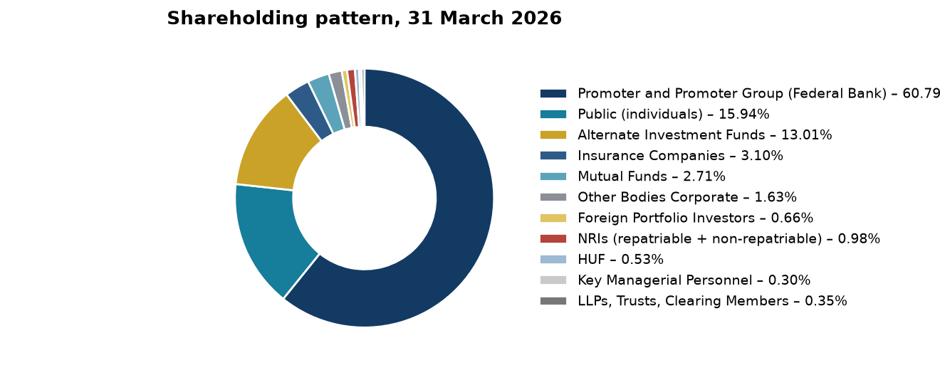
Source: Fedbank Financial Services Limited, Annual Report 2025–26, Report on Corporate Governance.
The promoter holding is stable at about three-fifths of equity. The presence of public and institutional shareholders broadens ownership, while the reported exit of True North is a change to monitor in future disclosures.
Table 3.2: Major shareholder categories
Category | 31 March 2026 | 31 March 2025
Federal Bank / promoter group | 60.79% | 61.03%
Public individuals | 15.94% | 14.34%
Alternate Investment Funds | 13.01% | 14.38%
Insurance companies | 3.10% | 4.04%
Mutual funds | 2.71% | 2.39%
Other holders, combined | 4.45% | 3.82%
Total | 100.00% | 100.00%
Source: Fedbank Financial Services Limited, Annual Report 2025–26, Report on Corporate Governance; figures are reported ownership categories.
The Federal Bank remains the controlling shareholder. Changes in AIF and public holdings should be read as ownership movements, not as direct evidence of a change in operating quality.

3.3 BUSINESS MODEL: SECURED RETAIL LENDING
The company describes a “twin-engine” model built around gold loans and mortgage loans. Gold loans are typically shorter-tenor and collateral-led; mortgage products have longer repayment periods and rely more heavily on income assessment, property title and valuation. Combining the products can diversify borrower needs and loan duration, but each product requires distinct risk controls and collections capability.
The lending process begins with customer acquisition and KYC, followed by product-specific appraisal, credit assessment, approval, documentation, disbursement, servicing, monitoring and recovery. The FY26 report describes a greater use of in-house sourcing, a business-rule engine for mortgage underwriting and digital servicing tools. These are management disclosures; the study assesses outcomes through reported asset-quality, service and cost indicators rather than assuming that technology alone improves performance.

3.4 PRODUCT MIX AND STRATEGIC PRIORITIES
Fedfina’s product mix shifted toward gold loans between FY24 and FY26. Gold rose from 32.6% to 51.4% of AUM, while mortgage lending remained significant and the unsecured business-loan book was run down. The mix change increases the share of secured assets but also makes gold pricing, LTV and custody controls more important.
Figure 3.2: Product mix of AUM, FY24–FY26 (%)
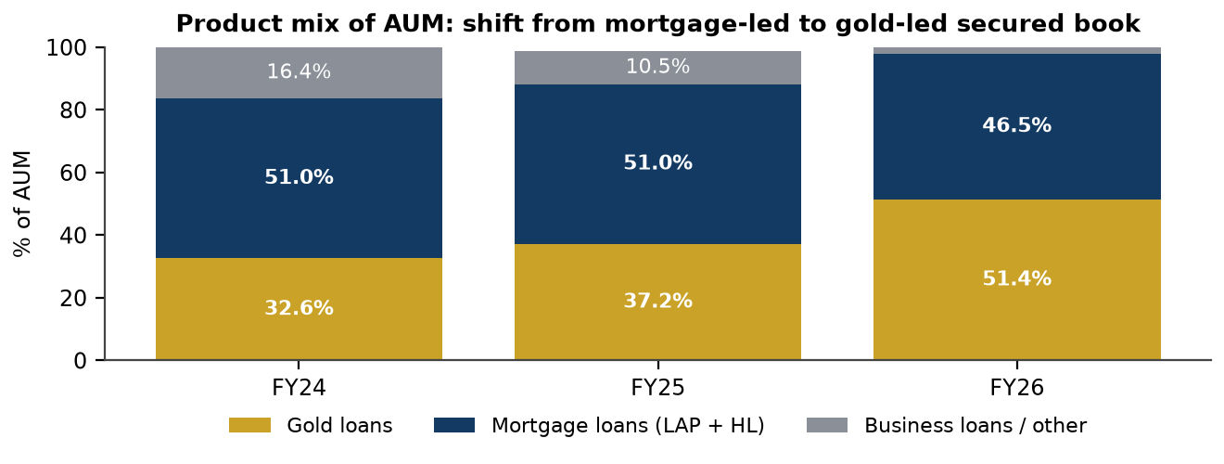
Source: Fedbank Financial Services Limited, Annual Reports 2023–24, 2024–25 and 2025–26, product and MD&A disclosures.
Gold loans became the largest reported product category by FY26. The chart shows the direction of portfolio change; product percentages are company disclosures and are not a substitute for a full AUM-to-balance-sheet reconciliation.
Table 3.3: Reported product mix and FY26 scale
Product | FY24 share | FY25 share | FY26 AUM / share | FY26 disbursements
Gold loans | 32.6% | 37.2% | ₹10,352 crore / 51.4% | ₹28,326 crore
Mortgage loans (LAP + housing) | 51.0% | 51.0% | ₹9,362 crore / 46.5% | Product disbursements reported by type
Business loans / other | 16.4% | 10.5% | Legacy on-book business loans about ₹48 crore; other items not fully bridged | New business-loan originations discontinued / run down
Source: Fedbank Financial Services Limited, Annual Reports 2023–24 to 2025–26, Corporate Overview, MD&A and Directors’ Reports. AUM shares and amounts are company-reported; product data do not fully reconcile to total AUM.
The gold share increased materially, while mortgage AUM remained a second pillar. The supplied product amounts do not fully reconcile to the reported total AUM of ₹20,153 crore; the unallocated difference is not estimated in this report.
Figure 3.3: Disbursements by product, FY22–FY26 (₹ crore)
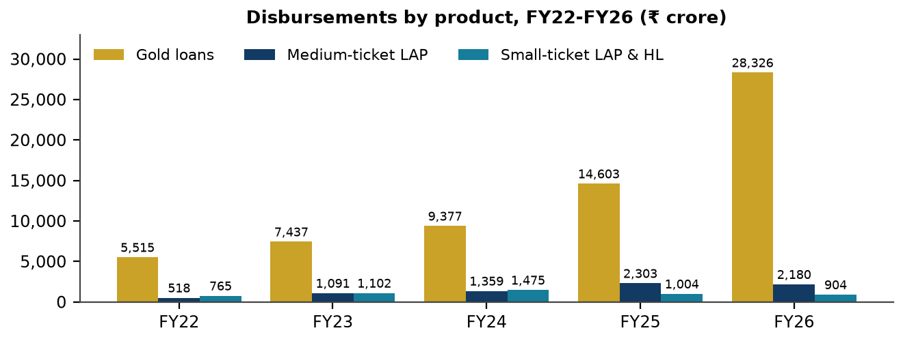
Source: Fedbank Financial Services Limited, Annual Report 2025–26, five-year product disbursement chart; earlier years cross-checked against prior reports.
Gold disbursements accelerated in FY26 and drove the increase in total lending activity. Mortgage disbursements did not follow the same pace, which is consistent with the strategic weighting toward gold and the rebuilding of small-ticket mortgage origination.

3.5 DISTRIBUTION NETWORK AND GEOGRAPHIC PRESENCE
The branch network grew from 359 locations at FY21 to 757 at FY26. At the reporting date, the company disclosed 558 gold-loan branches, 129 MSME hubs and 70 co-located branches. Its network spans 17 states and union territories. The company also reported that 148 branches were opened during FY26; the reported year-end count increased by a net 63 from FY25. Gross openings and net change are different measures, and the supplied report does not provide a complete bridge between them.
Figure 3.4: Branch network by format, FY21–FY26 (number of branches)
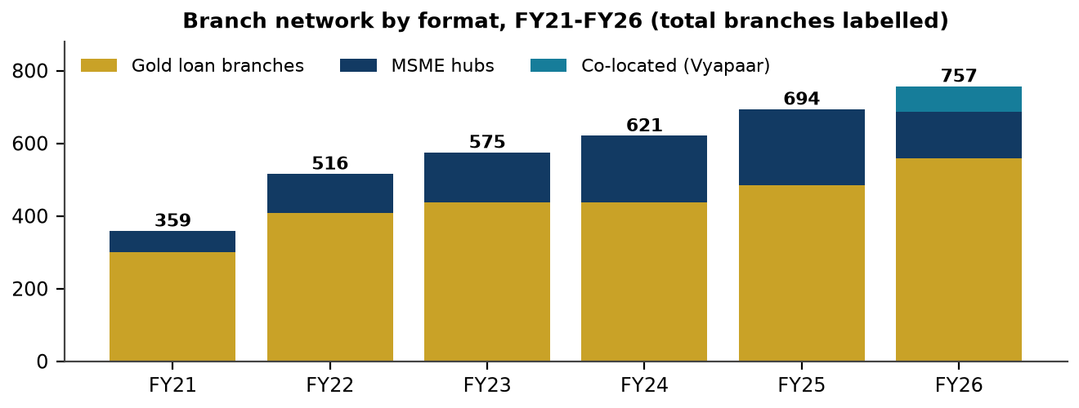
Source: Fedbank Financial Services Limited, Annual Reports 2023–24, 2024–25 and 2025–26, branch-network disclosures.
The network expanded over the period, with gold-loan branches forming the largest format in FY26. The increase supports reach but creates a productivity challenge: costs are incurred before a new branch reaches mature customer and AUM levels.
Table 3.4: Branch network trend and FY26 format
Year-end | Total branches | Gold-loan branches | MSME hubs | Co-located | States / UTs
FY21 | 359 | 301 | 58 | — | —
FY22 | 516 | 407 | 109 | — | —
FY23 | 575 | 437 | 138 | — | —
FY24 | 621 | 438 | 183 | — | 18
FY25 | 694 | 484 | 210 | — | 18
FY26 | 757 | 558 | 129 | 70 | 17
Source: Fedbank Financial Services Limited, Annual Reports 2023–24, 2024–25 and 2025–26, Directors’ Reports and branch-network disclosures.
The network nearly doubled between FY21 and FY26. The FY26 branch-format shift includes co-located outlets; the changes in format definitions should be considered before interpreting the fall in the reported MSME-hub count as a reduction in total reach.

3.6 CUSTOMER SEGMENTS AND SERVICE INDICATORS
Fedfina serves self-employed borrowers, small businesses, households seeking liquidity against gold, and customers seeking property-backed finance. The company reported 3.44 lakh active customers, 455 customers per branch, an 85% positive customer-satisfaction score and 100% resolution of complaints within its stated turnaround time. These service measures are company-reported and are not independently audited customer-survey results in this study.
The company also describes a mix of branch service, doorstep gold loans, digital onboarding and automated customer-service requests. Customer reach is a relevant inclusion indicator, but it should be considered with affordability, transparent pricing, grievance resolution, collateral custody and fair recovery practices.

3.7 HUMAN CAPITAL, TECHNOLOGY AND GOVERNANCE
The FY26 annual report describes investment in staff capability, a lending-system integration, a business-rule engine for mortgage underwriting, digital servicing and cybersecurity controls. It reports 5,303 employees at year end and 735 employees added during FY26, alongside voluntary attrition of 35.85%. The scale-up in staff and branches creates execution benefits only if hiring, training and retention keep pace with portfolio growth.
Governance disclosures include Board and committee oversight, an Audit Committee, a Risk Management Committee, an IT Strategy Committee, internal audit, a whistle-blower mechanism and an Internal Ombudsman. The FY26 report describes an unmodified statutory audit opinion and no audit qualifications. It also reports a proposal to appoint a joint statutory auditor under the regulatory requirement applicable to the company. These controls mitigate but cannot eliminate operational, compliance or cyber risk.
The company disclosed frauds reported to RBI of ₹110 lakh in FY26 and described controls including multi-factor authentication, endpoint protection, vulnerability testing, red-team exercises, vendor-risk management and business continuity planning. The risk relevance rises as digital collections, customer data and doorstep gold lending scale.

3.8 PRODUCT PORTFOLIO
Table 3.5: FY26 product characteristics disclosed by the company
Product | FY26 AUM / share | Disbursement | Average ticket | Selected disclosed feature
Gold loans | ₹10,352 crore / 51.4% | ₹28,326 crore | ₹2.7 lakh | Portfolio LTV 60.9%; gold under custody reported at 12.6 tonnes.
Medium-ticket LAP | ₹5,570 crore / 27.6% | ₹2,180 crore | ₹72.4 lakh | Origination yield 12.0%; 81% of mortgage AUM reported with CIBIL above 700.
Small-ticket LAP and housing | ₹3,792 crore / 18.8% | ₹904 crore | ₹16.1 lakh | Origination yield 15.1%; 68% of the segment reported with CIBIL above 700; 9% new-to-credit.
Legacy unsecured business loans | About ₹48 crore on book | No new originations reported | Not stated | Portfolio assignment / run-down reduced the on-book unsecured exposure.
Source: Fedbank Financial Services Limited, Annual Report 2025–26, product pages, MD&A, Directors’ Report and Note 8. Product AUM rows are not a complete reconciliation to total AUM.
Product-level yields, tickets and bureau indicators are not directly comparable across products. Gold lending is collateral-led; mortgage products rely more on repayment capacity, property security and collections. Product profitability is not separately disclosed in the supplied material.

3.8.1 GOLD LOANS
Gold lending became the largest product line in FY26. The company reported AUM of ₹10,352 crore, average ticket size of ₹2.7 lakh and average portfolio LTV of 60.9%. The short-tenor, collateral-backed structure can support liquidity and reduce loss severity, but does not eliminate risk: purity or valuation errors, custody failures, renewal practices, gold-price declines and auction outcomes remain material.
The company reported 4,633 gold-loan accounts auctioned in FY26 and ₹44.0 crore realised against the disclosed principal and interest due. Auction activity is a recovery mechanism, not proof that all customers were treated fairly or that all collateral losses were avoided. Clear notice, transparent valuation, accurate records and prompt surplus refunds remain essential.

3.8.2 MEDIUM-TICKET LAP
Medium-ticket LAP serves comparatively established borrowers and was reported at ₹5,570 crore of AUM, with an average ticket of ₹72.4 lakh and an origination yield of 12.0%. The company describes competition and yield pressure in this segment. Borrower bureau quality and self-occupied property collateral are useful indicators, but refinancing attrition and loan-to-value discipline must also be monitored.

3.8.3 SMALL-TICKET LAP AND HOUSING LOANS
Small-ticket LAP and housing products serve customers whose income may be informal or less documented. The FY26 report describes a rebuilt underwriting approach and better performance for newer cohorts than the older book, but does not provide a complete vintage delinquency series. Since mortgage arrears can emerge with a lag, expansion should remain linked to observed cohort performance rather than current aggregate AUM alone.

3.8.4 EXIT FROM UNSECURED BUSINESS LENDING
The company reported that it stopped new originations of unsecured business loans and assigned or ran down the legacy portfolio. The on-book unsecured business-loan balance was reported at about ₹48 crore at 31 March 2026, compared with ₹1,232 crore in FY25. This action increased the secured share of the on-book loan portfolio and reduced exposure to unsecured losses, while also changing the yield and earnings mix.

3.8.5 CO-LENDING, DIRECT ASSIGNMENT AND OFF-BOOK AUM
Table 3.6: Selected off-book and capital-light indicators
Indicator | FY24 | FY25 | FY26
Off-book AUM as share of total AUM | 18.7% | 25.1% | 12.1%
Co-lending AUM (₹ crore) | 522 | 1,131 | 2,433
Sell-down / direct assignment during year (₹ crore) | 1,461 | 2,130 | 2,579
Direct-assignment balance (₹ crore) | Not stated | 2,349 | 1,901
Loans at FVOCI / held for sale (₹ crore) | Not stated | 3,444 | 2,982
Source: Fedbank Financial Services Limited, Annual Reports 2023–24, 2024–25 and 2025–26, Directors’ Reports and Note 8.
Co-lending AUM increased while off-book AUM as a share of total AUM declined from the FY25 peak. AUM includes assets beyond the balance-sheet loan line, and the company does not publish a complete bridge; the two measures should not be substituted for one another.
The FY26 Corporate Overview reports a ₹7.4 crore direct-assignment income measure, equal to 1.6% of PBT, while Note 26 reports ₹101.98 crore of interest income on direct assignment. The disclosure definitions appear to differ; this report shows both figures where relevant and does not treat them as the same measure.

CHAPTER 4

RESEARCH METHODOLOGY AND ANALYTICAL FRAMEWORK

4.1 RESEARCH DESIGN
The study is descriptive and analytical. It documents the company, products and sector context from published information, then interprets the disclosed financial and operating data. The design is a single-company longitudinal case study, with selected FY26 comparisons to prior years. It is not an experimental study and does not establish causal relationships between strategy changes and financial outcomes.
The conceptual structure follows Economy–Industry–Company analysis. Economy-level factors include interest rates, inflation, gold prices and borrower demand. Industry-level factors include competition, regulation, credit penetration and funding conditions. Company-level analysis covers strategy, product mix, governance, funding, capital, asset quality, profitability and operational execution.

4.2 NATURE AND SOURCES OF DATA
Only secondary data were used. The principal sources are the supplied Fedbank Financial Services Limited annual reports for FY 2023–24, FY 2024–25 and FY 2025–26, including the Corporate Overview, MD&A, Directors’ Reports, Corporate Governance Reports, BRSR and audited Ind AS financial statements and notes. Regulatory provisions and sector statistics are used as described in those reports.
Table 4.1: Data sources and treatment
Source | Use in this report | Treatment
Annual Report 2025–26 | FY26 financial statements, notes, product, risk, governance and ESG data; FY25 comparatives. | Primary source for FY26 and FY25 audited financial figures.
Annual Report 2024–25 | FY25 business narrative, asset-quality reset, product mix and historical indicators. | Used to interpret the FY25 reset and extend trends.
Annual Report 2023–24 | Company history, FY24 statements, IPO and historical KPIs. | Used for history and selected series through FY24.
RBI regulatory material cited in company reports | NBFC scale-based requirements and gold-collateral directions. | Summarised for academic context; official directions govern operational application.
Sector statistics cited in the company reports | NBFC, gold-loan, MSME and macro context. | Quoted as company-referenced estimates; not independently re-sourced here.
Source: Supplied annual reports of Fedbank Financial Services Limited and regulatory material identified therein.
Audited financial statements are preferred for financial amounts. Corporate Overview and management commentary provide useful context but may use rounded, re-based or differently defined KPIs; differences are flagged where material.

4.3 PERIOD OF STUDY AND UNIT OF ANALYSIS
The principal reporting date is 31 March 2026. Trend analysis generally covers FY22–FY26, with FY19–FY26 AUM and PAT series where disclosed. Detailed statement analysis compares FY26 with FY25. All amounts are in Indian rupees; analytical tables generally use ₹ crore, while selected annexure tables retain ₹ lakh to follow the audited statement presentation. One crore equals 100 lakh.

4.4 DATA COLLECTION AND PROCESSING
Reported values were extracted from the company’s annual reports and organised by year, metric, unit and source section. Amounts reported in lakh were divided by 100 when converted into crore. Financial years are aligned to the year ended 31 March. The report distinguishes a company-reported figure from a derived calculation and states the basis for derived ratios where practical.
The data were checked for arithmetic consistency, including growth rates, common-size percentages, totals and ratio calculations. Where a company report contains inconsistent values or definitions, both disclosures are identified and no unsupported reconciliation is made. Missing or incomparable data are described as not available or not comparable rather than estimated.

4.5 SAMPLING AND PRIMARY RESEARCH
Sampling is not applicable because this study does not involve a respondent population. No questionnaire, survey, interview, branch visit, customer record or borrower-level dataset was supplied or used. The project is based on public secondary disclosures and therefore does not make claims about customer experience beyond the indicators reported by the company.

4.6 ANALYTICAL TOOLS AND TECHNIQUES
Table 4.2: Tools applied and their purpose
Technique | Application | Interpretive caution
Year-on-year and trend analysis | AUM, disbursements, income, costs, PAT, asset quality, capital and returns. | Growth is not sufficient evidence of quality or sustainability.
CAGR | Selected multi-year AUM and PAT series. | CAGR smooths volatility and does not describe the path between endpoints.
Common-size analysis | FY26 income statement as a proportion of revenue; balance-sheet composition. | Classification and company definitions govern comparability.
NBFC ratio analysis | NIM, yield, cost of borrowings, credit cost, GNPA/NNPA, PCR, CRAR, D/E, RoA and RoE. | Company methodologies may differ from peer methodologies.
DuPont-style return bridge | Margin, asset utilisation and leverage components of return on equity. | Financial-company definitions differ from industrial-company DuPont analysis.
Qualitative frameworks | PESTLE, Porter’s Five Forces, SWOT, risk matrix and balanced scorecard. | Ratings are researcher judgements based on disclosed evidence.
Cash-flow and ALM review | Operating / investing / financing cash flows and maturity buckets. | Lending growth creates operating cash outflows; interpretation differs from a manufacturer.
Source: Researcher’s application of methods to the supplied annual reports; company-reported metrics are distinguished from derived calculations.
The tools are used to explain what changed and why it matters. They are not used to generate unsupported forecasts, target prices or causal claims.

4.7 FINANCIAL RATIOS AND FORMULAE
Table 4.3: Selected lender-specific measures
Measure | Formula / basis used | Purpose
AUM growth | (Current AUM ÷ prior-year AUM − 1) × 100 | Measures portfolio scale change.
CAGR | [(Ending value ÷ beginning value)^(1/n) − 1] × 100 | Measures compound annual growth over n years.
Cost-to-income | Operating expenses ÷ net operating income, using company presentation | Measures operating efficiency.
Yield on advances | Interest on loans ÷ average advances, company basis | Measures asset yield.
Spread | Yield on advances − cost of borrowings, company basis | Indicates lending spread before other costs.
Credit cost | Company-reported impairment measure relative to average assets | Captures credit-loss charge; methodology is company-defined.
GNPA / NNPA | Gross / net non-performing loans as reported by company | Measures impaired-asset levels.
PCR | Stage 3 provisions ÷ gross Stage 3 loans, company basis | Indicates provision coverage.
CRAR | Regulatory capital ÷ risk-weighted assets | Measures prudential capital adequacy.
Debt-to-equity | Total borrowings ÷ net worth | Measures balance-sheet leverage.
RoA / RoE | PAT ÷ average assets / average equity, company basis | Measures return on assets and shareholder capital.
P/E and P/B | Market price ÷ EPS; market price ÷ book value per share | Valuation multiples, only when a dated price is available.
Source: Fedbank Financial Services Limited, Annual Report 2025–26, Key Ratios, Directors’ Report and audited financial statements; derived calculations are identified in the relevant section.
Current ratio, inventory turnover, industrial operating margin and industrial interest-coverage measures are not applied as generic tests to an NBFC. The measures above are more relevant to a lending company, but remain subject to the company’s definitions.

4.8 CALCULATION EXAMPLES
AUM CAGR, FY22–FY26 (derived): [(₹20,153 crore ÷ ₹6,187 crore)^(1/4) − 1] × 100 = approximately 34.3%. The period contains four annual intervals, from the FY22 closing AUM to FY26 closing AUM.
PAT growth in FY26 (derived from reported figures): [(₹343.60 crore − ₹225.18 crore) ÷ ₹225.18 crore] × 100 = approximately 52.6%. This agrees with the reported rounded growth rate.
Illustrative FY26 valuation multiples (derived, dated 31 March 2026): implied price = ₹4,642 crore market capitalisation ÷ 37.4206 crore shares = approximately ₹124.05 per share; P/E = ₹124.05 ÷ ₹9.20 basic EPS = approximately 13.5 times; P/B = ₹124.05 ÷ ₹78.19 book value per share = approximately 1.59 times. The implied price is a calculation from reported market capitalisation and closing share count, not a substitute for an exchange closing-price record.

4.9 RELIABILITY, VERIFICATION AND ETHICS
The annual reports are statutory company documents; the FY26 financial statements include an unmodified audit opinion in the supplied report. The project does not re-audit or independently verify the company’s disclosures. Management commentary and third-party sector statistics quoted within the annual report are treated as context, not as audited findings of this study.
The report does not fabricate data, survey results, references or market prices. Calculated figures are labelled derived. Forward-looking company targets are presented as management statements, not as the researcher’s forecast. The report is for academic analysis and not investment advice.

4.10 METHODOLOGICAL LIMITATIONS
- The analysis depends on company definitions and reported classifications; AUM includes off-book or managed exposures that are not identical to balance-sheet loans.
- The FY26 report restates selected historical yield, spread and cost-of-borrowings indicators on a different basis from prior reports; this report uses the FY26 basis for the comparable series and flags the change.
- The company reports differing values for selected measures, including FY26 GNPA and direct-assignment income; the supplied public data do not provide a complete reconciliation.
- Some ratios are not comparable across lenders because product mix, consolidation basis, average-balance methods and definitions differ.
- There are no borrower-level data, interviews, market-price histories or proprietary databases in the supplied material.

CHAPTER 5

DATA ANALYSIS AND INTERPRETATION

5.1 ANALYTICAL FRAMEWORK AND CONVENTIONS
The analysis begins with the FY25–FY26 financial snapshot, then examines growth, margins, expenses, balance-sheet funding, cash flow, capital, asset quality, returns and valuation. Risk and ESG observations are linked to the financial evidence. Amounts are in ₹ crore unless otherwise stated. Historical yields and funding costs use the FY26 annual report’s restated basis for consistency; reported company ratios are distinguished from researcher-derived calculations.

5.2 FY25–FY26 FINANCIAL SNAPSHOT
Table 5.1: Selected financial and operating indicators
Metric | FY25 | FY26 | Change / note
AUM at year end (₹ crore) | 15,812 | 20,153 | +27.5%
Disbursements during year (₹ crore) | 18,787 | 31,410 | About +67%
Net interest income (₹ crore) | 1,070.80 | 1,229.75 | +14.8%
Total revenue (₹ crore) | 2,079.82 | 2,226.61 | +7.1%
Profit before tax (₹ crore) | 303.75 | 461.01 | +51.8%
Profit after tax (₹ crore) | 225.18 | 343.60 | +52.6%
Credit cost | 1.8% | 0.8% | Company-reported
RoA / RoE | 1.82% / 9.39% | 2.44% / 12.62% | Company-reported
CRAR / Tier I | 21.92% / 18.92% | 22.40% / 17.52% | Total capital up; Tier I down
Debt-to-equity | 4.03x derived | 4.61x derived | Leverage increased
Source: Fedbank Financial Services Limited, Annual Report 2025–26, Key Financial Highlights, Directors’ Report and audited financial statements. Derived debt-to-equity equals borrowings divided by net worth.
FY26 combined higher AUM, NII and lower impairment with a sharp rise in PAT. Total revenue grew more slowly than profit, showing that expense and credit-cost movements were important contributors. The higher debt-to-equity ratio is a counterweight to the stronger reported returns.

5.3 AUM, DISBURSEMENTS AND SCALE
AUM increased each year from FY22 through FY26. It rose from ₹6,187 crore in FY22 to ₹20,153 crore in FY26, a derived four-year CAGR of 34.3%. The FY26 year-on-year increase was 27.5%, below FY25’s 29.7%, but the absolute addition was larger because the starting base was higher. Disbursements reached ₹31,410 crore in FY26, up about 67% as reported by the company.
Table 5.2: Five-year AUM and branch trend
Financial year | AUM (₹ crore) | YoY AUM growth | Branches
FY22 | 6,187 | 27.2% | 516
FY23 | 9,070 | 46.6% | 575
FY24 | 12,192 | 34.4% | 621
FY25 | 15,812 | 29.7% | 694
FY26 | 20,153 | 27.5% | 757
Source: Fedbank Financial Services Limited, Annual Reports 2023–24, 2024–25 and 2025–26, KPI charts and Directors’ Reports; growth rates are derived from reported AUM.
AUM scaled rapidly over the five-year period. The declining growth rate after FY23 is not a contraction; the nominal portfolio continued to expand. The key analytical question is whether the growth is supported by stable asset quality, productive branches and adequate capital.
Figure 5.1: Assets under management, FY19–FY26 (₹ crore)
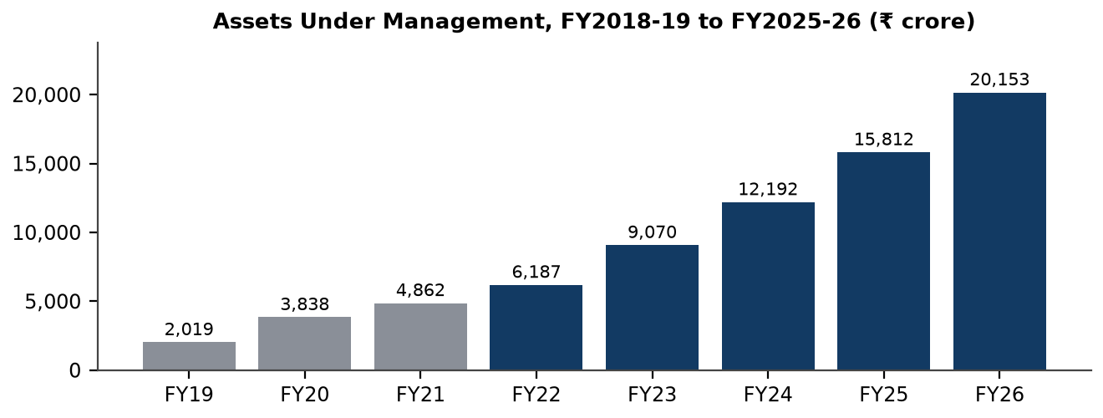
Source: Fedbank Financial Services Limited, Annual Reports 2023–24, 2024–25 and 2025–26, KPI pages.
The eight-year series shows substantial scale expansion, including through the pandemic and subsequent recalibration. The longer view supports the conclusion that FY26 growth sits within a longer expansion trajectory, but does not establish that future growth will earn comparable returns.
The FY22–FY26 AUM CAGR calculation is: [(20,153 ÷ 6,187)^(1/4) − 1] × 100 = 34.3% (derived). AUM per year-end branch increased from approximately ₹12.0 crore in FY22 to ₹26.6 crore in FY26 (derived); this aggregate measure does not adjust for branch maturity, co-location or product mix.

5.4 PROFITABILITY TREND
PAT increased from ₹103.5 crore in FY22 to ₹343.6 crore in FY26. FY25 was the interruption in this trend: PAT fell to ₹225.2 crore as credit cost rose. FY26 PAT growth of 52.6% recovered the decline and exceeded FY24’s reported level. The derived FY22–FY26 PAT CAGR is approximately 35.0%, but the FY25 drop demonstrates that profit growth is sensitive to impairment and portfolio performance.
Table 5.3: Reported PAT trend
Financial year | PAT (₹ crore) | Year-on-year movement
FY22 | 103.5 | —
FY23 | 180.1 | +74.0% derived
FY24 | 244.7 | +35.9% derived
FY25 | 225.2 | −8.0% reported, rounded
FY26 | 343.6 | +52.6% reported
Source: Fedbank Financial Services Limited, Annual Reports 2023–24, 2024–25 and 2025–26, KPI pages and Directors’ Reports; selected growth rates derived.
PAT growth was uneven. FY26 is a recovery year following the FY25 reset; the two-year comparison should be interpreted alongside impairment, funding cost, AUM mix and operating expenses rather than as a simple continuation of a smooth earnings trend.
Figure 5.2: Profit after tax, FY19–FY26 (₹ crore)
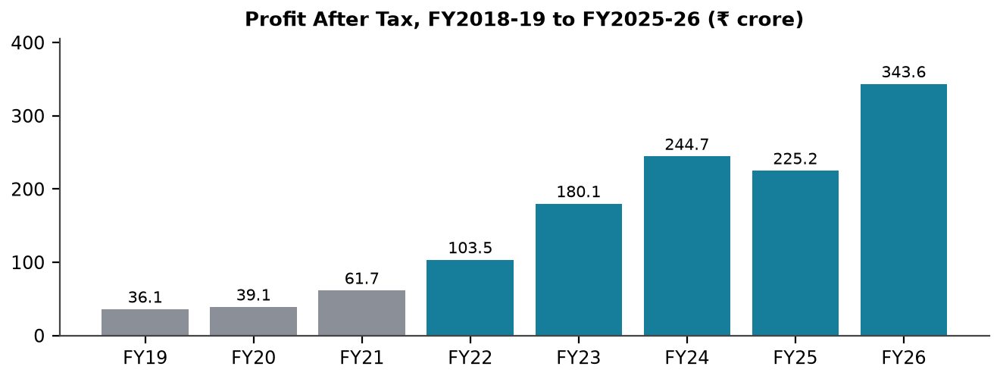
Source: Fedbank Financial Services Limited, Annual Reports 2023–24, 2024–25 and 2025–26, KPI pages and Directors’ Reports.
The chart shows the FY25 decline and FY26 rebound against the longer series. The movement is consistent with a credit-cost cycle and reinforces the need to evaluate recurring income and provisioning together.

5.5 YIELD, COST OF BORROWINGS AND SPREAD
On the FY26 annual report’s basis, yield on advances was 16.7%, cost of borrowings 8.1% and spread 8.6% in FY26. Cost of borrowings rose through FY25 and declined in FY26, while yield eased slightly from its FY25 high. The reported spread was the highest in the five-year series shown in the supplied source. Because the FY26 report restates several prior-year values, the table below follows that report’s common basis rather than combining figures from earlier presentations.
Table 5.4: Five-year yield, cost of borrowings and spread (FY26 report basis)
Year | Yield | Cost of borrowings | Spread | Cost-to-income
FY22 | 16.0% | 7.8% | 8.2% | 58.4%
FY23 | 16.1% | 7.8% | 8.3% | 58.6%
FY24 | 16.7% | 8.6% | 8.1% | 58.2%
FY25 | 17.1% | 9.0% | 8.2% | 57.6%
FY26 | 16.7% | 8.1% | 8.6% | 57.2%
Source: Fedbank Financial Services Limited, Annual Report 2025–26, five-year KPI charts; company-reported ratios.
The FY26 improvement in spread reflects lower reported funding cost while yield remained high. A spread measure excludes operating expense, credit cost and capital consumption; it should not be treated as a net profitability measure.
Figure 5.3: Yield on advances, cost of borrowings and spread, FY22–FY26 (%)
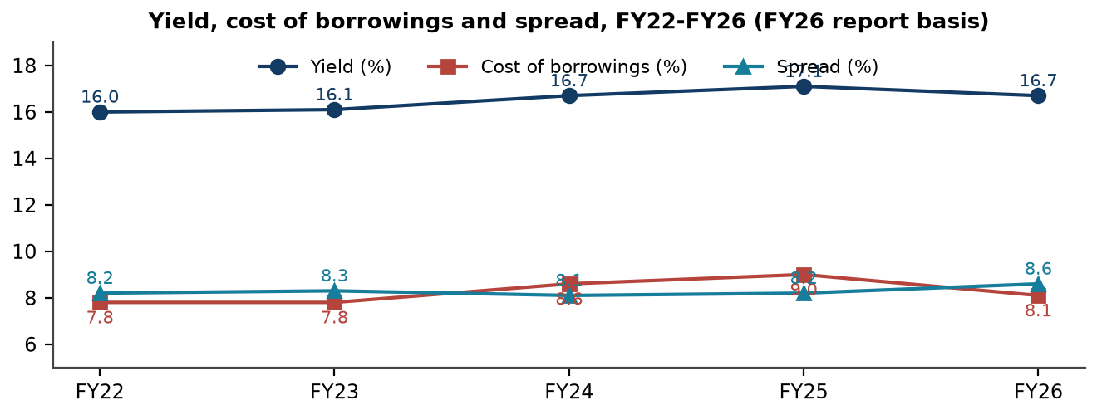
Source: Fedbank Financial Services Limited, Annual Report 2025–26, five-year KPI charts; FY26-report basis.
The narrowing of the funding-cost line in FY26 helped widen the spread. The sensitivity of this result to future funding repricing, liability mix and asset yield remains a key monitorable.

5.6 INCOME STATEMENT ANALYSIS
Total revenue increased 7.1% to ₹2,226.61 crore in FY26, while NII grew 14.8% to ₹1,229.75 crore. Interest income on loans increased, but fee and commission income and fair-value gains declined. PAT grew faster than revenue because impairment expense fell by 46.7%, finance costs rose by only 3.0%, and total expenses were slightly lower than FY25. This composition indicates a meaningful recovery in credit charges; it should not be interpreted as a recurring 52.6% earnings-growth rate.
Table 5.5: Selected income statement items (₹ crore)
Item | FY25 | FY26 | Change
Interest income | 1,924.58 | 2,109.07 | +9.6%
Net interest income | 1,070.80 | 1,229.75 | +14.8%
Fee and other income | 155.24 | 117.54 | −24.3%
Total revenue | 2,079.82 | 2,226.61 | +7.1%
Finance costs | 853.78 | 879.32 | +3.0%
Impairment on financial instruments | 216.36 | 115.27 | −46.7%
Operating expenses (employee + D&A + other) | 687.43 | 771.21 | +12.2%
Profit before tax | 303.75 | 461.01 | +51.8%
Profit after tax | 225.18 | 343.60 | +52.6%
Source: Fedbank Financial Services Limited, Annual Report 2025–26, audited Statement of Profit and Loss and Notes 26, 32–34; ₹ lakh amounts converted to ₹ crore.
Net interest income was the strongest recurring revenue driver in the selected lines, while non-interest income declined. The largest favourable P&L movement was lower impairment. Operating expenses increased as the company invested in people and distribution, so future operating leverage remains unproven.
Table 5.6: Interest income by source (₹ crore)
Source | FY25 | FY26 | Change
Interest on loans | 1,735.17 | 1,967.62 | +13.4%
Income on direct assignment (Note 26) | 152.31 | 101.98 | −33.0%
Interest on investments | 19.57 | 21.75 | +11.1%
Interest on fixed deposits | 15.55 | 16.24 | +4.4%
Interest on security deposit | 1.98 | 1.48 | −25.3%
Total interest income | 1,924.58 | 2,109.07 | +9.6%
Source: Fedbank Financial Services Limited, Annual Report 2025–26, Note 26; lakh amounts converted to crore.
Interest on loans represented approximately 93.3% of FY26 interest income (derived). Note 26 still records material income on direct assignment, so the narrower Corporate Overview measure of ₹7.4 crore should not be read as the total Note 26 line.

5.7 EXPENSE STRUCTURE AND OPERATING EFFICIENCY
Operating expenses, defined here as employee benefits, depreciation and other operating expenses, increased 12.2% to ₹771.21 crore. AUM grew faster, but branch and staff investment is front-loaded and does not guarantee operating leverage. The reported cost-to-income ratio moved only from 57.58% to 57.23%. AUM per employee rose to ₹3.8 crore as reported, while voluntary attrition remained high at 35.85%.
Figure 5.4: Expense structure, FY25 versus FY26 (₹ crore)
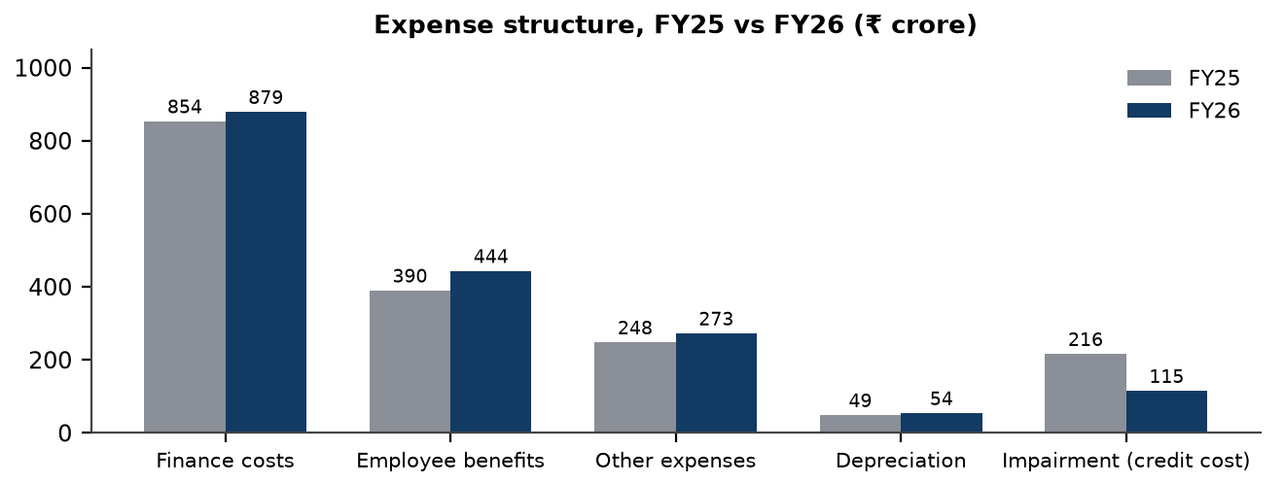
Source: Fedbank Financial Services Limited, Annual Report 2025–26, Statement of Profit and Loss.
Finance costs remain the largest expense line; impairment declined markedly while employee and other expenses rose. This pattern explains why earnings recovered quickly in FY26 but also shows that the cost base continues to expand.
Table 5.7: Operating efficiency indicators
Measure | FY25 | FY26 | Basis / interpretation
Operating expenses (₹ crore) | 687.43 | 771.21 | Employee + depreciation + other expenses.
Cost-to-income | 57.58% | 57.23% | Company-reported; 0.35 percentage-point improvement.
Opex / average total assets | 5.64% | 5.12% | Derived using two-point average total assets.
Pre-provision operating profit (₹ crore) | Not comparable on one basis | 576.1 derived | FY26 NII + fee and other income less operating expenses.
AUM per employee (₹ crore) | About 3.5 derived | 3.8 reported | Aggregate productivity proxy; not adjusted for role or tenure.
Voluntary attrition | Not stated in selected source | 35.85% | Company-reported people indicator.
Source: Fedbank Financial Services Limited, Annual Report 2025–26, Directors’ Report, Notes 33–34 and company KPI disclosures; derived ratios are identified.
The cost-to-income ratio improved only modestly despite scale growth. This indicates that expansion costs have not yet been fully absorbed by operating leverage. A fair assessment requires branch-vintage productivity and employee-retention data, not only a consolidated ratio.

5.8 BALANCE SHEET ANALYSIS
Total assets increased 27.4% to ₹16,874.78 crore. Net loans were ₹14,318.85 crore and represented about 84.9% of total assets. Cash and cash equivalents rose to ₹1,339.73 crore. Borrowings increased 31.3% to ₹13,484.13 crore, faster than net worth, which grew 14.9% to ₹2,926.10 crore. The balance sheet therefore expanded with a higher contribution from debt funding.
Table 5.8: Selected balance-sheet items (₹ crore)
Item | 31 March 2025 | 31 March 2026 | Change
Cash and cash equivalents | 724.60 | 1,339.73 | +84.9%
Loans, net | 11,646.37 | 14,318.85 | +22.9%
Investments | 404.19 | 401.67 | −0.6%
Total assets | 13,249.70 | 16,874.78 | +27.4%
Debt securities | 500.22 | 1,730.31 | +245.9%
Borrowings other than debt securities | 9,292.37 | 10,837.47 | +16.6%
Subordinated liabilities | 476.07 | 916.35 | +92.5%
Total borrowings, company disclosure | 10,268.66 | 13,484.13 | +31.3%
Net worth / equity | 2,547.36 | 2,926.10 | +14.9%
Source: Fedbank Financial Services Limited, Annual Report 2025–26, audited Balance Sheet and Notes 16–18; ₹ lakh amounts converted to ₹ crore.
Loans remain the dominant earning asset. Cash grew substantially, providing a liquidity buffer, but leverage rose because borrowings expanded faster than net worth. Balance-sheet analysis should therefore consider ALM and capital together rather than treating cash alone as a complete liquidity measure.

5.9 CASH FLOW ANALYSIS
Cash flow from operating activities was negative in FY25 and FY26. For a lender, loan disbursements and changes in the loan book are classified within operating cash flows; the FY26 cash-flow statement shows a ₹2,811.61 crore increase in loans as a major cash use. The negative operating cash flow should therefore not be interpreted using the same “profit-to-cash” test applied to a manufacturer. Funding inflows and the maturity structure of assets and liabilities are central to interpreting the statement.
Table 5.9: Cash flow summary (₹ crore)
Cash-flow item | FY25 | FY26 | Interpretation
Net cash from / (used in) operating activities | (977.52) | (1,664.16) | Loan growth and working-capital movements dominate.
Net cash from / (used in) investing activities | 329.16 | (30.60) | Includes investment and redemption activity.
Net cash from financing activities | 1,187.42 | 2,309.89 | Debt securities and borrowings funded asset growth.
Net increase in cash | 539.06 | 615.13 | Cash balance increased in both years.
Closing cash and cash equivalents | 724.60 | 1,339.73 | Reported balance at year end.
Source: Fedbank Financial Services Limited, Annual Report 2025–26, Statement of Cash Flow for FY26 and FY25 comparatives; ₹ lakh converted to crore.
Operating cash outflow reflects the cash-intensive nature of loan-book expansion and was offset by financing inflows. This does not by itself indicate weak earnings quality; the more relevant questions are funding availability, asset collections, maturity matching and the cost of refinancing.

5.10 FUNDING PROFILE AND ASSET-LIABILITY MANAGEMENT
At 31 March 2026, the company reported 41 lenders, AA+/Stable long-term ratings from four agencies and A1+ short-term ratings. Its funding included bank and financial-institution loans, external commercial borrowings, non-convertible debentures, commercial paper and subordinated debt. The USD 250 million ECB programme was reported as fully hedged through cross-currency swaps. Funding diversity reduces reliance on a single source, but it does not remove market-access, maturity or currency-hedging risk.
Table 5.10: Borrowings by instrument group at 31 March 2026
Funding group | Amount (₹ crore) | Share of borrowings | Risk / note
Bank and financial-institution loans, including demand loans | 8,455.11 | 62.7% | Includes Federal Bank and other lenders.
External commercial borrowings | 2,382.36 | 17.7% | USD facility; fully hedged as reported.
Secured NCDs | 565.88 | 4.2% | Market borrowing.
Commercial paper | 1,164.43 | 8.6% | Short-tenor refinancing exposure.
Subordinated NCDs | 916.35 | 6.8% | Includes instruments eligible as Tier II capital, subject to terms.
Total borrowings | 13,484.13 | 100.0% | As reported in notes; grouped amounts are derived sums.
Source: Fedbank Financial Services Limited, Annual Report 2025–26, Notes 16–18 and Directors’ Report; grouped categories and percentages are derived from reported instruments.
Bank and financial-institution loans form the majority of funding, while ECB and commercial-paper balances increased substantially. The company reports hedging the ECB exposure; continued hedge effectiveness and refinancing access remain important.
Figure 5.5: Borrowings by instrument at 31 March 2026 (₹ crore)
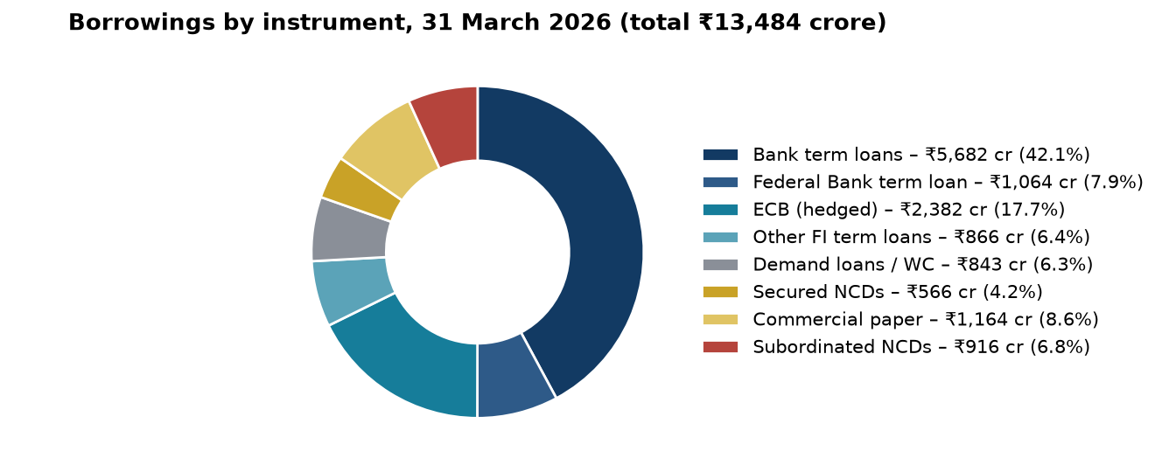
Source: Fedbank Financial Services Limited, Annual Report 2025–26, Notes 16–18 and funding disclosures.
The chart illustrates a diversified funding stack but also a material wholesale-funding dependence. Commercial paper is short-dated and should be assessed with liquidity buffers, lender commitments and maturity management.
Table 5.11: Selected structural liquidity buckets at 31 March 2026 (₹ crore)
Maturity bucket | Advances | Borrowings | Gap
1–7 days | 83 | 330 | (247)
8–14 days | 16 | 13 | 2
15–31 days | 142 | 249 | (107)
1–2 months | 217 | 445 | (229)
2–3 months | 180 | 601 | (421)
3–6 months | 653 | 1,369 | (716)
6–12 months | 7,721 | 2,253 | 5,468
1–3 years | 1,984 | 6,409 | (4,425)
3–5 years | 1,982 | 1,325 | 657
Over 5 years | 1,341 | 488 | 852
Total | 14,319 | 13,484 | 835
Source: Fedbank Financial Services Limited, Annual Report 2025–26, Note 48, structural liquidity statement. Figures may differ slightly due to rounding.
The maturity profile shows negative gaps in the shortest buckets and a large inflow gap in 6–12 months, followed by a negative 1–3 year bucket. The cumulative profile is reported as positive by one year, but individual short-term and medium-term mismatches require continued ALCO monitoring and stress testing.
Figure 5.6: Cumulative maturity of advances and borrowings, 31 March 2026 (₹ crore)
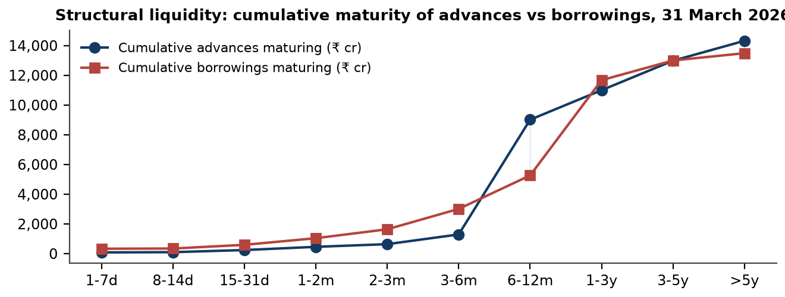
Source: Fedbank Financial Services Limited, Annual Report 2025–26, Note 48, maturity profile.
The chart makes the timing mismatch visible: the portfolio has substantial advance maturities within 6–12 months, while liabilities are concentrated in the 1–3 year bucket. The reported liquidity position should be assessed under behavioural and stress assumptions as well as contractual maturities.

5.11 CAPITAL ADEQUACY AND LEVERAGE
CRAR increased from 21.92% in FY25 to 22.40% in FY26, above the 15% minimum stated for the relevant NBFC layer. The composition changed: Tier I fell from 18.92% to 17.52%, while Tier II rose from 3.00% to 4.88%, supported by subordinated borrowing. Debt-to-equity increased from about 4.03x to 4.61x on the derived borrowings-to-net-worth basis. Total capital remains above the regulatory minimum, but the falling Tier I ratio and higher leverage warrant monitoring as the balance sheet grows.
Table 5.12: Capital and leverage indicators
Indicator | FY25 | FY26 | Interpretation
CRAR | 21.92% | 22.40% | Above 15% stated minimum.
Tier I capital ratio | 18.92% | 17.52% | Declined by 1.40 percentage points.
Tier II capital ratio | 3.00% | 4.88% | Increased with subordinated debt.
Net worth (₹ crore) | 2,547.36 | 2,926.10 | +14.9%.
Borrowings (₹ crore) | 10,268.66 | 13,484.13 | +31.3%.
Debt-to-equity, derived | 4.03x | 4.61x | Borrowings ÷ net worth.
Source: Fedbank Financial Services Limited, Annual Report 2025–26, Directors’ Report, Note 48 and audited financial statements; D/E derived.
Total capital adequacy strengthened modestly, but this was accompanied by a lower Tier I share and rising leverage. Capital planning should consider the pace of AUM growth, retained earnings, risk weights, asset quality and the availability and cost of future funding.
Figure 5.7: Capital adequacy (%) and book value per share (₹), FY22–FY26
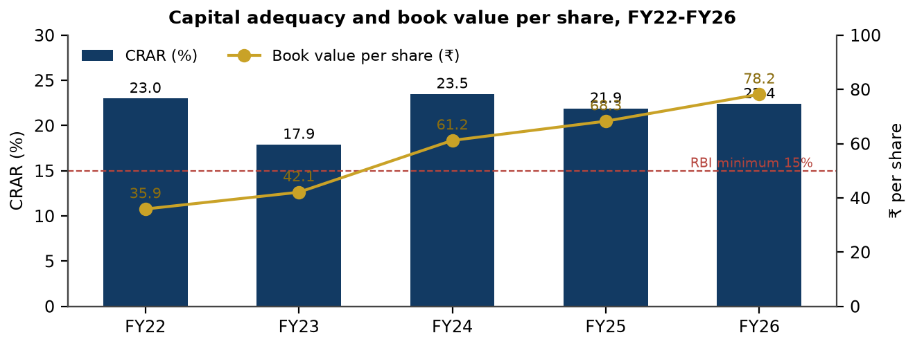
Source: Fedbank Financial Services Limited, Annual Reports 2023–24, 2024–25 and 2025–26, KPI charts and Directors’ Reports.
CRAR remained above the reported minimum across the series, while book value per share increased. The capital measure is a regulatory ratio; book-value growth does not remove the need to monitor risk-weighted assets and leverage.

5.12 ASSET QUALITY AND EXPECTED CREDIT LOSS
The FY26 report shows improvement in Stage 2 and Stage 3 loans at amortised cost: their combined share declined from 7.4% of the book in FY25 to 3.5% in FY26. The company reported credit cost of 0.8% for FY26 against 1.8% in FY25. Provision coverage declined from 40.0% to 32.3%, partly in the context of write-offs and ARC sales. New mortgage cohorts remain relatively unseasoned, so the aggregate improvement should be tested against vintage performance in subsequent reporting periods.
Figure 5.8: Asset quality: GNPA, NNPA and provision coverage, FY22–FY26 (%)
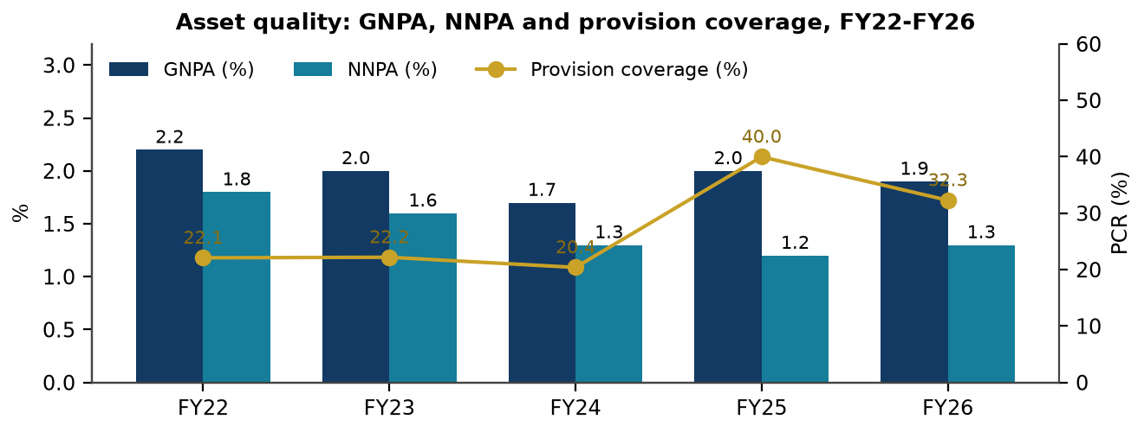
Source: Fedbank Financial Services Limited, Annual Reports 2023–24, 2024–25 and 2025–26, KPI charts and FY26 Key Highlights.
The reported series shows a FY25 rise in stress and a lower credit-cost result in FY26. The FY26 GNPA measure differs across sections of the same annual report: 1.9% in highlights and 2.2% in the five-year chart. Both are disclosed in this report without an assumed reconciliation.
Table 5.13: Stage-wise loans at amortised cost (₹ crore)
Stage | 31 Mar 2025 | Share of book | 31 Mar 2026 | Share of book
Stage 1 – performing | 7,772.98 | 92.6% | 11,122.45 | 96.5%
Stage 2 – significant increase in credit risk | 426.37 | 5.1% | 222.25 | 1.9%
Stage 3 – credit-impaired | 194.75 | 2.3% | 178.78 | 1.6%
Total amortised-cost loans | 8,394.10 | 100.0% | 11,523.48 | 100.0%
Loans at FVOCI / held for sale | 3,444.32 | Not in above denominator | 2,982.00 | Not in above denominator
Source: Fedbank Financial Services Limited, Annual Report 2025–26, Note 8; ₹ lakh converted to ₹ crore and percentages reported / derived.
Stage 2 loans fell from 5.1% to 1.9% of amortised-cost loans and Stage 3 from 2.3% to 1.6%. FVOCI loans are disclosed separately and should not be included in the amortised-cost denominator without an explicit reconciliation.
Figure 5.9: Stage classification of loans at amortised cost, 31 March 2025 vs 31 March 2026 (% of loans)
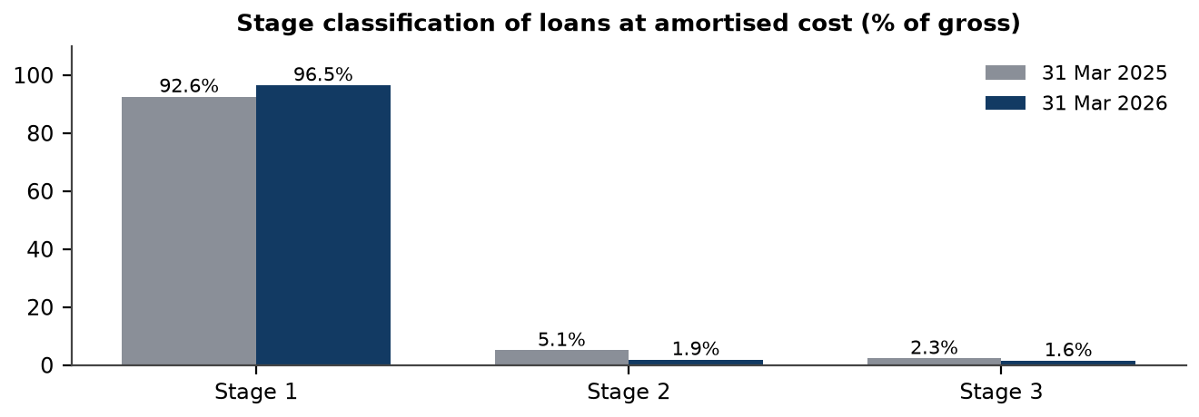
Source: Fedbank Financial Services Limited, Annual Report 2025–26, Note 8; shares derived from reported balances.
The chart shows a larger Stage 1 share and smaller Stage 2 and Stage 3 shares in FY26. Because the portfolio grew, absolute balances and cohort-level movement should also be considered; a lower share does not mean all underlying risk has disappeared.
Table 5.14: Selected credit-impaired-loan movements (₹ crore)
Movement | FY25 | FY26
Gross credit-impaired loans, opening | 164.57 | 238.88
Additions during the year | 195.23 | 227.13
Reductions: upgrades, recoveries and sales | 114.09 | 105.90
Write-offs | 6.83 | 88.17
Gross credit-impaired loans, closing | 238.88 | 271.94
NPA accounts sold to ARCs: principal | 16.90 | 104.90
Source: Fedbank Financial Services Limited, Annual Report 2025–26, Note 48.09 and related impairment notes; lakh amounts converted to crore.
Despite lower stage ratios and reported credit cost, additions to impaired loans remained material and write-offs and ARC sales increased. These movements underline why reported NPA ratios should be interpreted alongside recoveries, write-offs and additions.

5.13 DUPONT-STYLE RETURN DECOMPOSITION
For a lender, return on equity is shaped by profit generation, asset utilisation and leverage. A simple two-point average calculation gives FY26 average assets of approximately ₹15,062 crore and average equity of approximately ₹2,737 crore. Using total revenue of ₹2,226.61 crore, PAT of ₹343.60 crore and those average balances, the derived relationship is: net margin of about 15.4% × asset turnover of about 0.148 × leverage of about 5.50 = approximately 12.6% RoE.
Table 5.15: FY26 return bridge using two-point average balances
Component | Calculation | FY26 result
Net profit margin | PAT ÷ total revenue | 15.4% derived
Asset turnover | Total revenue ÷ average total assets | 0.148x derived
Financial leverage | Average total assets ÷ average equity | 5.50x derived
DuPont-style RoE | Margin × asset turnover × leverage | 12.6% derived
Company-reported RoE | Company methodology | 12.62%
Company-reported RoA | Company methodology | 2.44%
Source: Researcher calculation from Fedbank Financial Services Limited, Annual Report 2025–26, audited Statement of Profit and Loss and Balance Sheets; the company reports RoA/RoE using its own methodology.
The derived RoE is close to the reported RoE. Leverage materially magnifies shareholder returns, so a higher RoE is not unambiguously positive unless asset quality and funding remain controlled. The derived two-point RoA differs from the reported figure because the company’s averaging and ratio methodology are not identical.
Figure 5.10: Return on assets and return on equity, FY22–FY26 (%)
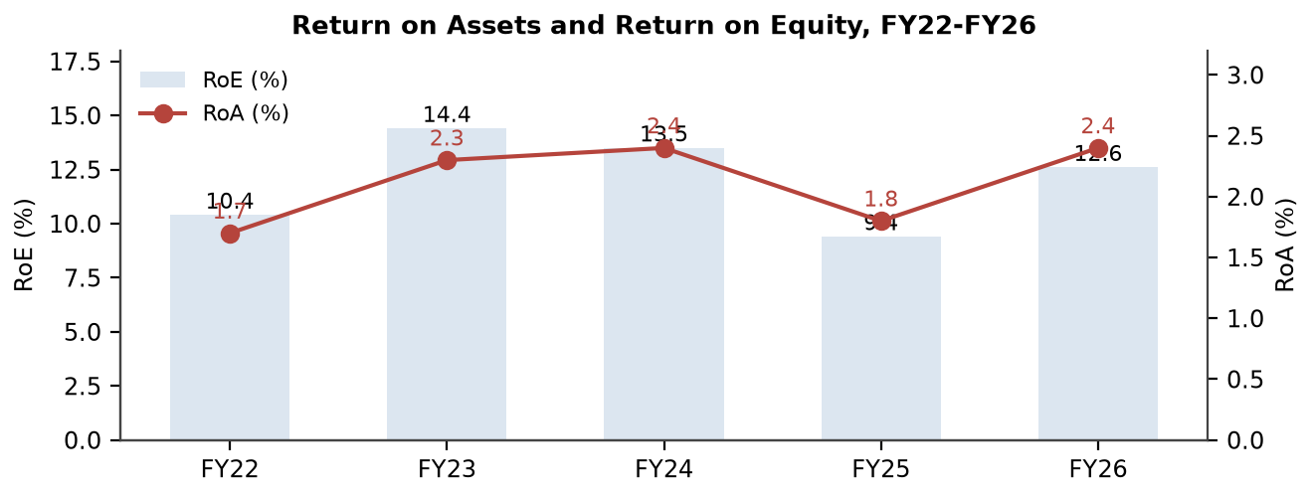
Source: Fedbank Financial Services Limited, Annual Reports 2023–24, 2024–25 and 2025–26, KPI charts.
Reported returns fell in FY25 and recovered in FY26. RoE remains below the FY23 peak in the supplied series; the recovery should be sustained through subsequent credit and funding cycles before being treated as a normalised level.

5.14 PER-SHARE INDICATORS AND DATED VALUATION PERSPECTIVE
FY26 basic EPS was ₹9.20 and book value per share was ₹78.19. The annual report disclosed market capitalisation of ₹4,642 crore at 31 March 2026. Using closing shares of 37.4206 crore gives a derived implied price of approximately ₹124.05 per share and illustrative P/E and P/B ratios of approximately 13.5x and 1.59x respectively. This is a dated calculation based on reported market capitalisation and shares, not a live market quotation or a target valuation.
Table 5.16: Per-share and valuation indicators as at 31 March 2026
Measure | Value | Basis
Equity shares outstanding | 37.4206 crore | Reported at year end.
Basic EPS | ₹9.20 | Reported.
Book value per share | ₹78.19 | Reported.
Market capitalisation | ₹4,642 crore | Reported by company as at 31 March 2026.
Implied price per share | About ₹124.05 | Market capitalisation ÷ shares; derived.
P/E | About 13.5x | Implied price ÷ basic EPS; derived.
P/B | About 1.59x | Implied price ÷ book value per share; derived.
Source: Fedbank Financial Services Limited, Annual Report 2025–26, inside cover, Directors’ Report and Corporate Governance Report; implied price and multiples derived.
The multiples are tied to one historical date and are not a recommendation. The supplied material does not include a verified price series, peer valuation basis or explicit forecast assumptions; a target price and technical analysis are therefore not presented.

5.15 DISCLOSURE RECONCILIATION AND DATA INTEGRITY
Table 5.17: Material differences in supplied disclosures
Metric | Disclosure A | Disclosure B | Treatment in this report
FY26 GNPA | 1.9% in Key Highlights | 2.2% in the five-year KPI chart | Both values are noted; no unsupported reconciliation is made.
Direct-assignment income | ₹7.4 crore / 1.6% of PBT in Corporate Overview | ₹101.98 crore in Note 26 | Likely different definitions; both are distinguished.
AUM vs on-book loans | AUM ₹20,153 crore | Net loans ₹14,318.85 crore; gross on-book loans differ from AUM | No full bridge is published in the supplied reports; measures are not equated.
Product AUM sum | Reported product amounts / shares | Do not fully sum to total AUM / 100% | Residual is not estimated or allocated.
Branch openings | Company reports 148 new branches opened in FY26 | Year-end network moved from 694 to 757, a net increase of 63 | Gross openings and net count change are treated as separate measures.
Historical yield series | FY26 report restates earlier years | FY24 / FY25 reports show differing values | FY26 report basis is used for the comparable five-year series.
Source: Fedbank Financial Services Limited, Annual Report 2025–26, Corporate Overview, Key Highlights, KPI charts, Note 26, Note 8 and Directors’ Report; prior-year annual reports for restated comparisons.
The identified differences do not invalidate the audited financial statements, but they limit precise cross-section comparisons. Transparent disclosure of definitions and reconciliations would improve the usability of future company reporting.

5.16 CONSOLIDATED RISK ANALYSIS
The risk assessment combines the company’s disclosed risk architecture with financial and operating indicators. Likelihood and impact ratings below are the researcher’s qualitative judgements based on the supplied FY26 evidence; they are not probability estimates issued by management.
Table 5.18: Researcher-assessed risk matrix
Risk | Likelihood | Impact | Evidence in FY26 disclosures | Mitigants / monitorables
Gold-price and collateral risk | Medium | High | Gold was 51.4% of AUM; gold price rose sharply in CY2025; LTV reported at 60.9%. | Daily price monitoring, LTV distribution, auction outcomes and tonnage growth.
Small-ticket mortgage vintage risk | Medium | High | FY25 stress was followed by rebuilding; new cohorts are not fully seasoned. | Vintage delinquency, early-bucket collections and product-level credit cost.
Leverage and Tier I pressure | Medium | High | D/E derived at 4.61x; Tier I 17.52%, down from 18.92%. | Capital planning, risk-weighted growth and retained-earnings trajectory.
Liquidity / refinancing risk | Low to medium | High | Wholesale funding, short-term borrowing and maturity mismatches; cash ₹1,339.73 crore. | ALCO stress tests, committed facilities, maturity diversification and cash buffers.
Cyber and data-protection risk | Medium | High | Digital channels and customer-data systems are scaling; frauds reported at ₹110 lakh. | MFA, endpoint controls, testing, vendor-risk and incident reporting.
Regulatory / conduct risk | Medium | High | Gold directions effective from 1 April 2026; auctions and collateral custody are conduct-sensitive. | LTV monitoring, customer notices, grievance resolution and audit testing.
Branch productivity and people risk | Medium | Medium | 148 new branches reported; voluntary attrition 35.85%; C/I 57.23%. | Cohort productivity, training, retention and incentive alignment.
Geographic concentration | Medium | Medium | Top five states represented 75.1% of AUM in FY26. | Regional limits, state-level early-warning indicators and diversified growth.
Source: Researcher assessment based on Fedbank Financial Services Limited, Annual Report 2025–26, MD&A, Notes 8 and 48, Corporate Governance Report and BRSR.
The most material downside channels are a combination of gold-price movement, new-vintage credit performance and leverage. The company reports several mitigants, but their effectiveness should be assessed through subsequent data rather than assumed from policy existence alone.

5.17 ENVIRONMENTAL, SOCIAL AND GOVERNANCE PROFILE
Table 5.19: Selected ESG and stakeholder indicators
Dimension | FY25 | FY26 | Financial / business relevance
Scope 1 and 2 emission intensity (tCO₂e per ₹ crore turnover) | 3.93 | 2.96 | Reported reduction of about 25%; operational efficiency and disclosure relevance.
Third-party water withdrawal (kilolitres) | 77,509 | 89,432 | Operational resource measure; intensity and context should accompany totals.
Women in workforce | 15.7% | 16.4% | Workforce representation; company target for women in senior management is described in BRSR.
Voluntary attrition | Not stated in selected FY25 figure | 35.85% | Retention risk in branch, collections and credit functions.
CSR expenditure (₹ crore) | 4.73 | 5.84 | Community programmes; outcome reporting is relevant.
Customer satisfaction / complaints | Not stated on the same basis | 85% positive / 100% resolved within TAT | Customer conduct and reputation; company-reported measures.
Audit / regulatory qualifications | Nil reported | Nil reported | Governance indicator; three BSE filing fines are separately disclosed.
Source: Fedbank Financial Services Limited, Annual Report 2024–25 and Annual Report 2025–26, BRSR, Corporate Governance Report and Directors’ Report.
The company reports progress in operational emissions and customer-service measures, alongside high voluntary attrition and material cyber and customer-conduct exposure. ESG is financially relevant through operational resilience, compliance, employee capability and reputational risk.

5.18 SWOT ANALYSIS
Table 5.20: SWOT summary
Strengths | Weaknesses | Opportunities | Threats
• Federal Bank promoter holding of 60.79%.  • 98.9% secured AUM as reported.  • AA+/Stable ratings from four agencies and 41 lenders.  • Gold and mortgage lending provide different product tenors.  • FY26 recovery in PAT and reported credit cost. | • D/E increased to about 4.61x derived.  • Tier I ratio declined to 17.52%.  • Cost-to-income remained about 57%.  • FY25 exposed collection weakness.  • High voluntary attrition and unseasoned branches. | • Formal-credit and secured MSME demand.  • Gold-loan market and co-lending channels.  • Digital underwriting and servicing.  • Cross-sell across the customer base.  • Branch productivity as new cohorts mature. | • Gold-price reversal and auction loss.  • Bank and NBFC competition.  • New mortgage vintage stress.  • Refinancing, rates and regulatory change.  • Cyber, data privacy, employee and conduct risk.
Source: Researcher synthesis of the FY26 annual report, prior-year annual reports and the analysis in this report.
The strengths and opportunities align around secured retail lending and institutional funding. The weaknesses and threats cluster around operating leverage, gold concentration, new-vintage credit performance and increasing leverage; recommendations therefore focus on measurable control and disclosure rather than generic expansion.

5.19 QUALITATIVE SCENARIO AND MONITORING FRAMEWORK
The following scenarios are qualitative stress paths, not forecasts. No projected PAT, AUM or share price is calculated because the supplied material does not establish a forecast model or the assumptions necessary to produce one.
Table 5.21: Scenario drivers and indicators to monitor
Scenario | Potential transmission channel | Evidence-based monitor
Stable conditions | Gold prices and funding costs remain broadly supportive; branch cohorts mature. | AUM growth alongside gold tonnage, credit cost, cost-to-income and branch productivity.
Gold-price correction | Collateral coverage tightens; new borrowing demand may slow; auction recovery becomes more sensitive. | LTV distribution, top-up / renewal trends, auction volumes, shortfalls and gold tonnage.
Mortgage stress re-emerges | Small-ticket arrears rise with a lag; collections costs and provisions increase. | Vintage 30+ / 90+ days past due, Stage 2 share, cure rates and product credit cost.
Funding-cost reversal | Floating liabilities reprice; spreads can narrow and refinancing costs rise. | Cost of borrowings, fixed/floating mix, lender concentration and ALM gaps.
Operational or cyber event | Service disruption, fraud, data loss or regulatory response may create financial and reputational costs. | Fraud incidents, cyber events, recovery time, complaint rates and audit closure.
Source: Researcher-constructed qualitative scenarios based on reported FY26 exposures; not company guidance or financial forecasts.
The framework converts the principal risks into observable indicators without inventing future financial figures. It can be updated when the company publishes FY27 operating and financial disclosures.

CHAPTER 6

FINDINGS, CONCLUSION AND SUGGESTIONS

6.1 MAJOR FINDINGS
Finding 1. Fedfina achieved sustained scale growth: AUM increased from ₹6,187 crore in FY22 to ₹20,153 crore in FY26, a derived CAGR of 34.3%.
Finding 2. FY26 was a recovery year after the FY25 reset. PAT increased 52.6% to ₹343.60 crore, supported by higher NII and lower impairment; the pace of profit growth exceeded revenue growth.
Finding 3. The portfolio became more secured. The company reported secured AUM of 98.9%, gold loans at 51.4% of AUM and a substantial reduction in on-book unsecured business loans.
Finding 4. Asset-quality measures improved in FY26, including lower Stage 2 and Stage 3 shares and reported credit cost of 0.8%; however, additions to impaired loans remained material and the GNPA disclosure differs across report sections.
Finding 5. Capital adequacy was 22.4%, above the stated 15% minimum, but Tier I fell to 17.52% and derived debt-to-equity rose to 4.61x.
Finding 6. The cost of borrowings declined on the company’s reported basis and spread widened to 8.6%, while cost-to-income improved only marginally to 57.23%.
Finding 7. Funding sources were diversified, and cash increased, but operating cash flow remained negative because loan growth is a major operating cash use; the maturity profile includes negative short buckets and a 1–3 year gap.
Finding 8. The company reports improvements in technology, collections and customer-service controls, but high attrition, cyber exposure, gold concentration and the productivity of new branches remain important monitoring issues.
Finding 9. Selected company disclosures are not fully reconciled, especially AUM versus on-book loans, GNPA and direct-assignment income. These issues limit exact cross-section comparisons.

6.2 ANSWERS TO RESEARCH QUESTIONS AND WORKING HYPOTHESIS
Table 6.1: Research questions and answers
Research question | Answer based on the analysis
Has growth been accompanied by improved profitability? | In FY26, yes: PAT, NII, RoA and RoE rose from FY25. The recovery was supported by lower impairment and funding costs as well as NII growth; sustainability is not yet proven.
Has the secured shift strengthened the risk profile? | The reported secured share increased and on-book unsecured lending fell sharply. This lowers unsecured exposure but does not remove gold-price, collateral-custody, mortgage-vintage or collection risk.
Are capital and funding adequate for growth? | CRAR is above the stated regulatory minimum and multiple funding channels are reported. Rising leverage and a lower Tier I ratio create a reason to monitor capital headroom and maturity management.
What risks could challenge the plan? | Gold-price reversal, mortgage-vintage stress, funding repricing, cyber incidents, regulation, attrition and branch productivity are the principal risks identified.
Source: Researcher synthesis of Chapters 2–5 and the supplied FY24–FY26 annual reports.
The answers are conditional and reflect information available through FY26 disclosures. The project does not establish causal effects or make a forward-looking investment call.
Working hypothesis: A higher secured share of AUM, combined with stronger operating discipline, supports more sustainable profitability, subject to credit-cost and funding-cost control. The FY26 evidence is consistent with this hypothesis: the secured share rose, credit cost declined and profitability improved. It is supported with qualifications rather than proven. The FY26 observation period is short, newer loan vintages remain unseasoned, leverage increased, and some disclosures require reconciliation.

6.3 CONCLUSION
The fundamental analysis indicates that Fedfina entered FY26 with a larger, more secured portfolio and reported a material recovery in earnings after the FY25 reset. AUM and PAT have grown substantially over the available multi-year period. The gold-and-mortgage model provides two secured lending engines, and the company reports multiple funding sources, AA+/Stable ratings and CRAR above the stated regulatory minimum.
The findings do not support an unconditional conclusion that the FY26 level of profitability is permanent. PAT grew faster than revenue largely in a year when impairment declined, while operating costs continued to rise and cost-to-income moved only slightly. Leverage increased and Tier I capital declined. The book also became more exposed to gold prices, and the quality of newer mortgage cohorts will only be observable with time.
Accordingly, the research problem is answered as follows: FY26 performance reflects a credible recovery and a strategic shift toward secured lending, but the sustainability of growth and returns depends on disciplined collections, branch productivity, risk-sensitive capital planning, resilient funding and consistent public disclosure. Future results should be assessed against these conditions rather than extrapolated from one year.

6.4 SUGGESTIONS AND RECOMMENDATIONS
Table 6.2: Evidence-based recommendations
Recommendation | Evidence from this study | Expected benefit / monitoring indicator
Track productivity by branch cohort, format and vintage before prioritising additional expansion. | 757 branches at FY26; 148 openings reported; cost-to-income 57.23%; year-end network grew by a net 63. | Identify branch break-even and AUM productivity; distinguish gross openings, closures and co-locations.
Publish product- and vintage-level delinquency data, especially for small-ticket LAP. | FY25 collections stress; FY26 improvement with unseasoned newer cohorts. | Earlier identification of credit deterioration; track Stage 2, 30+/90+ delinquency and cure rates.
Report gold tonnage, AUM per gram and LTV distribution alongside rupee AUM growth. | Gold AUM grew sharply as the gold price rose; average LTV is not a distribution. | Separate volume from price effects and monitor collateral headroom and auction outcomes.
Reconcile AUM, on-book loans, off-book balances and product-level totals in investor disclosures. | AUM, net loans and product-level figures do not fully bridge in the supplied reports. | Improve comparability and support a more reliable assessment of capital and earnings.
Standardise GNPA and direct-assignment definitions across report sections. | FY26 GNPA is stated as 1.9% and 2.2%; Note 26 DA income differs from the Corporate Overview measure. | Reduce interpretation risk; disclose scope, denominator, inclusion/exclusion and reconciliation.
Maintain forward-looking capital and funding stress tests as leverage rises. | CRAR 22.40%; Tier I 17.52%; D/E 4.61x derived; ALM bucket mismatches. | Preserve resilience under growth, rate, gold-price and refinancing stress.
Align branch and sales incentives with loan-vintage quality and customer conduct. | In-house sourcing and branch expansion are growing; FY25 highlighted collection weakness. | Support responsible growth by linking incentives to portfolio performance and complaint outcomes.
Continue cyber, fraud and employee-retention controls with measurable reporting. | ₹110 lakh frauds reported; digital channels scale; voluntary attrition 35.85%. | Improve operational resilience, staff continuity and stakeholder confidence.
Report ESG and inclusion outcomes, not only activity counts. | Emission intensity declined; customer, CSR and workforce indicators are reported. | Connect sustainability activity to customer, employee and operating outcomes.
Source: Recommendations are the researcher’s synthesis of findings from the supplied FY24–FY26 annual reports; no external forecast is assumed.
Each recommendation responds to a disclosed issue or an analytical limitation. The expected benefit is improved monitoring, transparency or risk control, not a guaranteed financial outcome.

6.5 LEARNING OUTCOMES
- Applied lender-specific analysis rather than relying on industrial-company ratios that are not meaningful for an NBFC.
- Practised extracting and reconciling multi-year financial and operating information from annual reports and audited notes.
- Linked AUM growth, profit, cash flow, asset quality, funding and capital to strategic and operational decisions.
- Distinguished reported facts from derived calculations, company statements, researcher judgements and unavailable information.

CHAPTER 7

LIMITATIONS OF THE STUDY

7.1 LIMITATIONS
The findings should be read within the following genuine limitations:
- The study is based on secondary information in three company annual reports and material identified within them. There are no interviews, borrower-level records, branch visits, survey results or proprietary databases.
- AUM is company-defined and includes managed or off-book activity. It is not identical to the balance-sheet loan line; a complete bridge was not available in the supplied material.
- The FY26 report restates selected historical KPIs on a revised basis. This report uses the FY26 basis for the comparable yield, spread and borrowing-cost series and flags the change.
- The company presents differing values for FY26 GNPA and direct-assignment income in separate sections. The project reports those differences without an unsupported reconciliation.
- Sector estimates are quoted through the company’s MD&A and were not independently re-sourced. They provide context, not an independent industry forecast.
- The peer data in the supplied working material are not fully comparable across standalone / consolidated bases and definitions. No peer valuation or peer-ratio conclusion is drawn.
- Market capitalisation is available only at 31 March 2026 in the supplied material. No live price history, technical indicators, target price or current valuation recommendation is provided.
- The research period ends with FY26 disclosures. Later operating developments may change the assessment; company targets and scenarios are not treated as guaranteed outcomes.
These limitations do not prevent the report from assessing disclosed multi-year trends and strategic changes. They do require the conclusion to remain conditional and to avoid precision beyond the data supplied.

CHAPTER 8

REFERENCE AND BIBLIOGRAPHY

8.1 COMPANY ANNUAL REPORTS
- Fedbank Financial Services Limited. Annual Report 2023–24. Mumbai: Fedbank Financial Services Limited.
- Fedbank Financial Services Limited. Annual Report 2024–25. Mumbai: Fedbank Financial Services Limited.
- Fedbank Financial Services Limited. Annual Report 2025–26. Mumbai: Fedbank Financial Services Limited.

8.2 REGULATORY AND OFFICIAL MATERIAL
- Reserve Bank of India. Directions on Lending Against Gold Collateral, issued June 2025 and effective 1 April 2026, as identified in the supplied research material.
- Reserve Bank of India. Scale-based regulatory framework and directions applicable to NBFCs, as referenced in Fedbank Financial Services Limited, Annual Report 2025–26.
- Reserve Bank of India regulatory provisions on NBFCs, digital lending, co-lending and fraud-risk management, as cited in the company annual reports and supplied research material.

8.3 INDUSTRY AND MARKET DATA
Sector, macroeconomic, gold-demand, MSME and credit-market estimates in this report are cited through the relevant sections of Fedbank Financial Services Limited, Annual Report 2025–26. The company report attributes selected figures to MoSPI, RBI / PIB, the Economic Survey, Ministry of Commerce, ICRA, CRISIL and the World Gold Council. These underlying publications were not separately supplied for independent page-by-page verification and are therefore not presented as independently re-sourced findings here.

8.4 CITATION CONVENTION
Table and figure source lines identify the annual report section, financial statement or note used. Amounts converted from lakh to crore are stated as converted; author calculations are labelled derived. Where the company’s own sections disclose different values or definitions, the report cites both and explains the treatment. No unverified URL, publication page number or market quotation has been added.

ANNEXURE A – SUMMARISED BALANCE SHEET
Amounts are in ₹ crore unless otherwise stated. The summary retains selected audited statement lines to support the analysis in Chapter 5.
Table A.1: Selected balance-sheet lines at 31 March 2025 and 31 March 2026
Particulars | 31 Mar 2025 | 31 Mar 2026
Cash and cash equivalents | 724.60 | 1,339.73
Other bank balances | 110.09 | 51.22
Loans, net | 11,646.37 | 14,318.85
Investments | 404.19 | 401.67
Other financial assets | 86.71 | 207.36
Total financial assets | 12,991.85 | 16,563.52
Total non-financial assets | 257.85 | 311.26
Total assets | 13,249.70 | 16,874.78
Debt securities | 500.22 | 1,730.31
Borrowings other than debt securities | 9,292.37 | 10,837.47
Subordinated liabilities | 476.07 | 916.35
Total financial liabilities | 10,651.02 | 13,900.35
Total equity / net worth | 2,547.36 | 2,926.10
Total liabilities and equity | 13,249.70 | 16,874.78
Source: Fedbank Financial Services Limited, Annual Report 2025–26, audited Balance Sheet and Notes; ₹ lakh converted to crore.
Loans remain the principal asset, while total borrowings expanded faster than equity. Totals are stated as reported, subject to rounding in conversion.

ANNEXURE B – SUMMARISED STATEMENT OF PROFIT AND LOSS
Amounts are in ₹ crore. This annexure provides a more detailed view than the selected analytical table in Chapter 5.
Table B.1: Statement of Profit and Loss, FY25 and FY26
Particulars | FY25 | FY26
Interest income | 1,924.58 | 2,109.07
Fee and commission income | 111.71 | 96.69
Net gain on fair-value changes | 25.58 | 17.84
Revenue from operations | 2,061.87 | 2,223.60
Other income | 17.95 | 3.01
Total income | 2,079.82 | 2,226.61
Finance costs | 853.78 | 879.32
Fee and commission expense | 18.50 | (0.20)
Impairment on financial instruments | 216.36 | 115.27
Employee benefits expense | 390.30 | 443.93
Depreciation and amortisation | 48.85 | 54.47
Other expenses | 248.28 | 272.81
Total expenses | 1,776.07 | 1,765.60
Profit before tax | 303.75 | 461.01
Current tax | 101.69 | 121.07
Deferred tax credit | (23.12) | (3.66)
Profit after tax | 225.18 | 343.60
Other comprehensive income, net | 41.59 | 15.02
Total comprehensive income | 266.77 | 358.62
Source: Fedbank Financial Services Limited, Annual Report 2025–26, audited Statement of Profit and Loss; ₹ lakh converted to crore.
The recovery in profit after tax is larger than the increase in revenue and reflects lower impairment as well as operating movements. The statement is presented for support; interpretations are in Chapter 5.

ANNEXURE C – BRANCH NETWORK BY STATE / UNION TERRITORY
Table C.1: Branch network by location at 31 March 2026
State / Union Territory | MSME hubs | Gold branches | Co-located | Total | Share
Maharashtra | 31 | 102 | 8 | 141 | 18.6%
Gujarat | 11 | 110 | 15 | 136 | 18.0%
Karnataka | 9 | 77 | 9 | 95 | 12.5%
Tamil Nadu | 26 | 57 | 7 | 90 | 11.9%
Andhra Pradesh | 9 | 42 | 6 | 57 | 7.5%
Delhi NCR | 1 | 45 | 0 | 46 | 6.1%
Telangana | 4 | 27 | 11 | 42 | 5.5%
Rajasthan | 10 | 19 | 5 | 34 | 4.5%
Haryana | 7 | 25 | 0 | 32 | 4.2%
Uttar Pradesh | 9 | 21 | 2 | 32 | 4.2%
Madhya Pradesh | 7 | 8 | 5 | 20 | 2.6%
Punjab | 1 | 12 | 0 | 13 | 1.7%
Uttarakhand | 1 | 5 | 2 | 8 | 1.1%
Goa | 0 | 5 | 0 | 5 | 0.7%
Pondicherry | 2 | 1 | 0 | 3 | 0.4%
Dadra & Nagar Haveli (UT) | 0 | 2 | 0 | 2 | 0.3%
Chandigarh | 1 | 0 | 0 | 1 | 0.1%
Total | 129 | 558 | 70 | 757 | 100.0%
Source: Fedbank Financial Services Limited, Annual Report 2025–26, Directors’ Report, branch-network table; state shares are company-reported / rounded.
Maharashtra and Gujarat together account for over one-third of the reported network. The source reports the geographic mix; the analysis of AUM concentration is separately shown in Figure C.1.
Figure C.1: Share of AUM in top five states, FY21–FY26 (%)
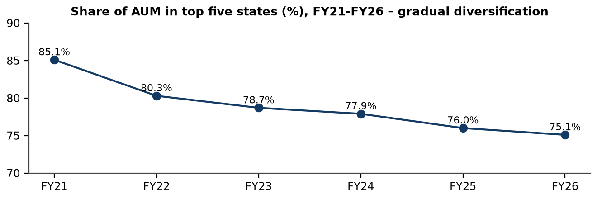
Source: Fedbank Financial Services Limited, Annual Reports 2023–24, 2024–25 and 2025–26, geographic concentration disclosures.
The top-five-state share declined from 85.1% in FY21 to 75.1% in FY26, indicating gradual diversification. A three-quarter concentration in five states still leaves performance exposed to regional economic conditions.

ANNEXURE D – FUNDING AND DEBT INSTRUMENTS
Table D.1: Borrowings by instrument at 31 March 2026 (₹ crore)
Instrument | Amount | Share
Bank term loans, non-related parties | 5,682.11 | 42.1%
Term loan from Federal Bank | 1,064.13 | 7.9%
External commercial borrowings | 2,382.36 | 17.7%
Loans from other financial institutions | 865.57 | 6.4%
Loans repayable on demand – banks | 783.30 | 5.8%
Loans repayable on demand – Federal Bank | 60.00 | 0.4%
Secured NCDs | 565.88 | 4.2%
Commercial paper | 1,164.43 | 8.6%
Subordinated NCDs – Federal Bank | 246.12 | 1.8%
Subordinated NCDs – other holders | 670.23 | 5.0%
Total borrowings | 13,484.13 | 100.0%
Source: Fedbank Financial Services Limited, Annual Report 2025–26, Notes 16–18; amounts converted from ₹ lakh to ₹ crore.
The instrument mix is diversified across bank and institutional loans, ECB, NCDs and commercial paper. ECB hedging and CP rollover remain important treasury controls.
Table D.2: Selected debt and rating disclosures
Item | FY26 disclosure
Commercial paper | ₹1,164 crore outstanding (net of discount); A1+ short-term rating reported.
External commercial borrowing | USD 250 million programme; carrying amount ₹2,382 crore; fully hedged as reported.
NCDs issued in FY26 | ₹200 crore secured reset-rate NCD and ₹450 crore subordinated Tier II NCDs, as reported.
Shareholder borrowing limit | ₹18,000 crore; total borrowings of ₹13,484 crore at year end.
Credit ratings | AA+/Stable long-term and A1+ short-term ratings from CARE, CRISIL, ICRA and India Ratings.
Source: Fedbank Financial Services Limited, Annual Report 2025–26, Directors’ Report, Notes 16–18 and Corporate Governance Report.
These disclosures support the funding analysis but do not substitute for maturity, covenant and hedge-note review by a lender or investor.

ANNEXURE E – SHAREHOLDING AND SELECTED COMPANY FACTS
Table E.1: Shareholding categories
Category | 31 March 2025 | 31 March 2026
Federal Bank / promoter group | 61.03% | 60.79%
Public individuals | 14.34% | 15.94%
Alternate Investment Funds | 14.38% | 13.01%
Insurance companies | 4.04% | 3.10%
Mutual funds | 2.39% | 2.71%
Other categories combined | 3.82% | 4.45%
Total | 100.00% | 100.00%
Source: Fedbank Financial Services Limited, Annual Report 2025–26, Report on Corporate Governance.
The promoter remains the majority shareholder. This table aggregates smaller categories for readability; the detailed corporate-governance filing contains the full category list.
Table E.2: Selected company facts as at / during FY26
Particular | Disclosure
NSE symbol / BSE code | FEDFINA / 544027
Promoter | The Federal Bank Limited; 60.79% at 31 March 2026.
AUM / secured share | ₹20,153 crore / 98.9% as reported.
PAT / EPS | ₹343.60 crore / ₹9.20 basic EPS.
Branches / states and UTs | 757 / 17.
Market capitalisation | ₹4,642 crore at 31 March 2026.
Dividend | No dividend recommended for FY26, as reported.
Source: Fedbank Financial Services Limited, Annual Report 2025–26, inside cover, Key Highlights, Directors’ Report and Corporate Governance Report.
These facts are included for identification. They should not be interpreted as current market data after the stated reporting date.

ANNEXURE F – FORMULA SHEET AND GLOSSARY
Table F.1: Formula sheet
Metric | Formula / explanation
AUM growth | (Current-year AUM ÷ prior-year AUM − 1) × 100.
CAGR | [(Ending value ÷ beginning value)^(1 ÷ number of years) − 1] × 100.
Net interest income | Interest income less interest / finance expense as defined in the company statement.
Spread | Yield on advances less cost of borrowings, using company methodology.
Cost-to-income | Operating expenses divided by net operating income, as disclosed / defined by company.
Credit cost | Company-defined impairment charge relative to average assets.
Provision coverage ratio | Stage 3 provisions divided by gross Stage 3 loans, company basis.
Debt-to-equity | Total borrowings divided by net worth; derived ratio in this report.
CRAR | Eligible regulatory capital divided by risk-weighted assets.
RoA / RoE | PAT divided by average total assets / average equity, subject to company methodology.
P/E / P/B | Market price divided by EPS / book value per share. A dated price is required.
Source: Definitions are based on Fedbank Financial Services Limited, Annual Report 2025–26, Key Ratios, Directors’ Report and this report’s calculation conventions.
The formula sheet distinguishes lender-specific measures from conventional industrial ratios. Definitions should be checked against the relevant company report before comparing with another lender.
Table F.2: Selected glossary
Term | Meaning
AUM | Assets under management; a company-defined measure that may include on-book and off-book exposures.
ALM | Asset-liability management; monitoring cash-flow and maturity mismatches.
Co-lending | A lending arrangement in which an NBFC and a bank jointly fund eligible loans, subject to applicable RBI requirements.
Direct assignment | Transfer of a pool of loans to an assignee, with servicing and income recognition governed by transaction terms.
ECL | Expected credit loss provision under the applicable accounting framework.
FVOCI | Fair value through other comprehensive income classification for eligible financial assets.
GNPA / NNPA | Gross / net non-performing assets, as defined by the company and applicable regulatory norms.
LTV | Loan-to-value ratio; loan exposure relative to the assessed collateral value.
NCD / CP | Non-convertible debenture / commercial paper.
PCR | Provision coverage ratio.
Stage 1 / 2 / 3 | Performing / significant increase in credit risk / credit-impaired categories under the expected-credit-loss framework.
SARFAESI | Securitisation and Reconstruction of Financial Assets and Enforcement of Security Interest Act.
Source: Definitions follow terms used in the supplied company reports and applicable Indian financial reporting / regulatory usage.
The glossary is intended to support reading of the analytical chapters; it does not replace formal statutory or regulatory definitions.

