BLACK BOOK PROJECT REPORT ON
A Study of Equity Dealing, the Futures and Options Market and Trading Terminals at Rosy Blue Securities Pvt. Ltd.:
WITH A COMPANY ANALYSIS OF PINE LABS LIMITED
Submitted in partial fulfilment for the award of the degree of
MASTER OF MANAGEMENT STUDIES
FINANCE
UNIVERSITY OF MUMBAI
Submitted by
[ADD: STUDENT NAME]
ROLL NO: [ADD: ROLL NO]
[ADD: ACADEMIC YEARS, e.g. 2025-2027]
Under The Guidance of
[ADD: NAME OF PROJECT GUIDE]
[ADD: COLLEGE LOGO IMAGE HERE — 2.08 in wide × 1.49 in high]
[ADD: NAME OF INSTITUTE]
[ADD: CITY AND PIN CODE]
[ADD: COLLEGE LETTERHEAD IMAGE HERE — 5.3 in wide × 1.18 in high]
CERTIFICATE
This is to certify that the summer internship project report titled “A Study of Equity Dealing, the Futures and Options Market and Trading Terminals at Rosy Blue Securities Pvt. Ltd.: with a Company Analysis of Pine Labs Limited” submitted in partial fulfilment of the requirements for the Master of Management Studies degree examination of the University of Mumbai by [ADD: STUDENT NAME], Roll No. [ADD: ROLL NO], is a record of bonafide research work carried out by the student during the period from [ADD: INTERNSHIP START DATE] to [ADD: INTERNSHIP END DATE] under my guidance and supervision, and has been found satisfactory. The work presented in this report is original and has not been submitted earlier for the award of any degree, diploma or associateship of any other university or institute.
COLLEGE STAMP HERE

------------------------------  [ADD: NAME OF DIRECTOR]  DIRECTOR | ------------------------------  [ADD: NAME OF PROJECT GUIDE]  PROJECT GUIDE
------------------------------
EXTERNAL EXAMINER

EXPERIENCE CERTIFICATE
[ADD: FULL-PAGE SCANNED IMAGE OF THE INTERNSHIP COMPLETION / EXPERIENCE CERTIFICATE ISSUED BY ROSY BLUE SECURITIES PVT. LTD. — if the firm has not issued one, delete this page and renumber the Contents.]

DECLARATION
I, [ADD: STUDENT NAME], Roll No. [ADD: ROLL NO], a student of the Master of Management Studies (Finance) programme of the University of Mumbai, hereby declare that the project report titled “A Study of Equity Dealing, the Futures and Options Market and Trading Terminals at Rosy Blue Securities Pvt. Ltd.: with a Company Analysis of Pine Labs Limited” has been prepared by me as part of the academic requirements of the programme. The report is based on my own learning, observation and practical exposure during the internship undertaken at Rosy Blue Securities Pvt. Ltd. in the capacity of an Equity Dealer, together with information drawn from publicly available documents of the exchanges, the Securities and Exchange Board of India and Pine Labs Limited. Confidential information such as client names, client codes, permanent account numbers, unique client codes, internal ticket numbers, terminal identifiers, internet protocol addresses, proprietary configurations and the firm's internal financial data has not been disclosed; all trading examples given in this report are illustrative and are identified as such. I further declare that this report has not been submitted earlier to any other institution or university for the award of any degree, diploma or other qualification.
Name : [ADD: STUDENT NAME] Signature
Roll No. [ADD: ROLL NO] [ADD: STUDENT NAME]

ACKNOWLEDGEMENT
I wish to record my sincere gratitude to my project guide, [ADD: NAME OF PROJECT GUIDE], for the patient supervision, academic direction and constructive criticism that shaped this report. The guide's insistence that every figure be traced to a verifiable source, and that every table be followed by an interpretation rather than a restatement, has improved both the discipline and the usefulness of this work.
I am grateful to my family and friends for their encouragement and forbearance during the internship and the writing of this report. Their support made it possible to combine the demands of a live dealing desk, which begins well before the market opens, with the equally demanding requirements of academic study.
I thank the management of Rosy Blue Securities Pvt. Ltd. for granting me the opportunity to work in the Equity Dealing function, and the dealing-desk seniors, risk management colleagues and back-office staff who explained processes, corrected my errors and allowed me to observe live operations. I also thank [ADD: NAME OF DIRECTOR], Director of the Institute, the faculty members of the Finance specialisation and the library staff for the academic and infrastructural support extended throughout the programme.
[ADD: STUDENT NAME]

EXECUTIVE SUMMARY
The Indian secondary market has widened very rapidly over the last five years, and the operational layer that carries this growth — the stock broker's dealing desk — has received far less academic attention than the valuation and portfolio topics that dominate finance curricula. As on 31 August 2026 the two depositories together serviced about 23.77 crore demat accounts, and the National Stock Exchange reported about 13.4 crore unique registered investors as of July 2026. Every one of those accounts reaches the market through an order that must be keyed, risk-checked, routed, matched, cleared and settled within a defined time cycle. This study examines that process from inside the function, and pairs it with a fundamental analysis of a recently listed company so that the operational and analytical sides of a finance role are treated together rather than separately.
The study was carried out during an internship at Rosy Blue Securities Pvt. Ltd. in the capacity of an Equity Dealer. The intern observed and, under supervision, participated in the pre-market routine, order entry and modification on the exchange-provided terminal and on the member's Computer-to-Computer Link facility, client-wise limit and margin verification, response to risk-management alerts, square-off discipline and post-trade reconciliation. The theoretical chapter documents the structure of the Indian capital market, the trading mechanism, the settlement cycle, the margining framework in both segments, the regulatory obligations attaching to Computer-to-Computer Link terminals and the ladder of statutory charges on every executed trade.
The analytical chapter converts that description into computed evidence. A futures contract priced by cost of carry on an illustrative underlying at Rs. 1,250.00 gives a fair value of Rs. 1,257.21, a basis of 0.577 per cent over thirty days. A five-day mark-to-market sequence on one lot produces daily cash flows summing to Rs. 9,000, exactly the difference between the entry and the final settlement price, showing that daily settlement redistributes but does not alter the total result. A thirty-day call struck at Rs. 1,260 prices at Rs. 38.69 under the Black-Scholes model, with a theta of Rs. -0.7808 per day, and loses roughly two-thirds of its value in the final ten days if the underlying does not move. A delivery round trip of Rs. 1,00,000 attracts Rs. 340.25 of total cost. The company analysis finds that Pine Labs Limited, listed on 14 November 2025, recorded its first full year of profit in FY2025-26 with revenue of Rs. 2,710.60 crore, up 19.19 per cent, and a profit after tax of Rs. 112.50 crore against a loss of Rs. 145.49 crore, a swing of Rs. 257.99 crore.
The study concludes that competence on a dealing desk rests on three things learned only by doing: speed and accuracy in order entry, an instinct for a client's margin position before the risk system raises an alert, and an understanding of the cost ladder that determines whether a nominally profitable trade is in fact profitable. It further concludes that the separation of expiry days between the exchanges, the upfront margin regime and the compressed settlement cycle have collectively made the role more procedural and less discretionary than a decade ago. Pine Labs demonstrates genuine operating leverage but trades at a multiple of earnings that leaves little tolerance for disappointment; the analysis is academic and is not investment advice.

CONTENTS
 |  | CONTENT | PAGE NO.
Chapter 1 |  | INTRODUCTION | 9
 | 1.1-1.6 | Need, objectives, scope, market overview, challenges, structure
Chapter 2 |  | ORGANISATIONAL BACKGROUND | 13
 | 2.1-2.3 | The firm, its registrations and its services
 | 2.4-2.6 | Organisation structure, the dealing desk and the intern's role
Chapter 3 |  | THEORETICAL FRAMEWORK | 18
 | 3.1-3.6 | Financial system, markets, exchanges, participants and regulation
 | 3.7-3.9 | Trading mechanism, clearing and settlement, cash-market risk
 | 3.10-3.14 | Derivatives, futures, options, margining and strategies
 | 3.15-3.17 | NEAT PLUS, CTCL and the back office
 | 3.18-3.20 | Transaction costs, investor protection and fintech
Chapter 4 |  | RESEARCH METHODOLOGY | 36
 | 4.1-4.6 | Design, data, period, tools, mapping and ethics
Chapter 5 |  | ANALYSIS AND INTERPRETATION | 39
 | 5.1-5.3 | The dealing day and the market snapshot
 | 5.4-5.5 | Order life cycle on NEAT PLUS and CTCL in practice
 | 5.6-5.9 | Futures, options, margin and charges worked examples
 | 5.10 | Company analysis: Pine Labs Limited
 | 5.11-5.13 | Dealer's view, learning outcomes and summary of findings
Chapter 6 |  | CONCLUSION AND SUGGESTIONS | 63
 | 6.1-6.3 | Conclusion, suggestions and learning outcomes
Chapter 7 |  | LIMITATIONS OF THE STUDY | 66
Chapter 8 |  | BIBLIOGRAPHY | 67
 | 8.1-8.3 | Books, regulations and circulars, websites and filings
Annexure A |  | GLOSSARY OF TERMS | 69
Annexure B |  | FORMULA SHEET | 71
Annexure C |  | LIST OF ABBREVIATIONS | 72
Source: Compiled by the author. Page numbers are computed from a layout model and must be refreshed in Word after the logo, letterhead and experience-certificate images have been inserted.

CHAPTER 1

INTRODUCTION

1.1 NEED OF THE STUDY
Finance education in India devotes considerable attention to valuation, portfolio theory and corporate finance, and comparatively little to the operational machinery through which a securities transaction actually occurs. A student may be able to construct a discounted cash-flow model and yet be unable to explain what happens between the moment a client telephones an order and the moment the shares appear in that client's demat account. That gap matters, because most entry-level positions in broking, wealth management and market operations are concerned with exactly this process. The equity dealer sits where client instruction, regulatory obligation and market microstructure meet, and the role therefore offers an unusually compressed view of how the secondary market functions in practice.
The need also arises from the pace of regulatory change. In the last few years the settlement cycle has been shortened, an upfront margin regime has replaced informal intraday leverage, the pledge and re-pledge mechanism has altered how client collateral is held, and the weekly expiry days of the two principal exchanges have been separated by regulatory direction. Material written even three years ago is therefore unreliable as a description of current practice. The specific needs addressed are set out below.
• To connect theory to procedure: to show how price-time priority, cost of carry, option time value and value-at-risk margining appear in the concrete form of a screen, a limit or an obligation.
• To quantify the cost of trading: to compute the full statutory and transactional cost ladder on illustrative trades, so that the difference between gross and net outcome is made explicit rather than assumed.
• To understand trading technology: to examine the exchange-provided terminal and the member's Computer-to-Computer Link facility, and the pre-trade risk controls and audit obligations attaching to each.
• To apply fundamental analysis to a recent listing: to analyse Pine Labs Limited, a company that listed in November 2025 and reported its first full year of profit in FY2025-26, as a test of whether standard analytical tools work on a company with a short listed history.

1.2 OBJECTIVES OF THE STUDY
• To study the Indian equity market: its structure, participants, trading mechanism, settlement cycle and the regulatory framework administered by the Securities and Exchange Board of India and the exchanges.
• To study the futures and options market: contract design, lot size and expiry conventions, pricing by cost of carry, option payoff and premium decomposition, and the computation of option sensitivities.
• To examine the NEAT PLUS trading terminal: its market watch, order-entry, order-book and trade-book functions, and the order modification and cancellation facilities used by a dealer during market hours.
• To examine the Computer-to-Computer Link facility: its architecture, approval requirements, order routing, user and terminal identification, pre-trade risk controls and audit trail, and how it differs from the exchange-provided terminal.
• To study risk management on a dealing desk: margin computation in both segments, exposure and client-wise limits, margin-shortfall identification, square-off discipline and post-trade reconciliation.
• To conduct a fundamental analysis of Pine Labs Limited: covering its business model, industry, four-year financial record, ratio analysis, shareholding, market data, peer position, strengths and risks, without arriving at any buy or sell recommendation.

1.3 SCOPE OF THE STUDY
The study covers the cash and equity-derivatives segments of the Indian secondary market as they operated during the internship period and as the rules stood on 9 October 2026. Geographically the scope is the two principal domestic exchanges, their clearing corporations and the two depositories. Functionally it is the dealing desk and the processes immediately adjacent to it, namely risk management, back-office settlement and compliance. The currency, commodity and debt segments are outside the scope, as are portfolio management and investment advisory.
The company analysis is confined to Pine Labs Limited and a small set of comparable listed entities. The financial period covered is FY2022-23 to FY2025-26 together with the quarter ended 30 June 2026, the latest reported period at the time of writing. Because the company listed only in November 2025, the earlier years are drawn from restated consolidated information in the offer document rather than from statutory accounts of a listed entity, and the two bases are not strictly identical. All firm-specific operational detail has been generalised in accordance with the confidentiality undertaking described in Section 4.6, and every trading example in Chapter 5 is illustrative.

1.4 OVERVIEW OF THE INDIAN EQUITY AND DERIVATIVES MARKET
The Indian secondary market is an order-driven, fully electronic market operating through two principal exchanges. Price discovery takes place by anonymous matching on price-time priority, with no designated market maker in the cash segment for most securities. Benchmark levels at the end of September 2026 illustrate the current state of the market: the Nifty 50 closed at 22,620.45 and the S&P BSE Sensex at 72,480.29 on 30 September 2026, after monthly declines of 6.03 per cent and 5.82 per cent respectively. A dealing desk experiences such a month as a period of elevated call volume, more frequent margin alerts and a higher incidence of square-off instructions, which is precisely why the operational discipline described in this report matters most when the market is least comfortable.
Participation has broadened substantially. The two depositories together serviced about 23.77 crore demat accounts as on 31 August 2026, while the National Stock Exchange reported about 13.4 crore unique registered investors, measured by distinct permanent account numbers, as of July 2026. The gap arises because one investor may hold accounts with several depository participants, a distinction a dealer learns quickly, because limits and margins attach to the client code rather than to the person. The derivatives segment has grown faster than the cash segment and now dominates turnover, which has drawn sustained regulatory attention. Contract sizes have been raised, weekly expiries restricted, and the expiry days of the two exchanges separated, with National Stock Exchange equity derivatives expiring on Tuesday and BSE equity derivatives on Thursday from 1 September 2025. A dealer handling clients active on both exchanges therefore manages two distinct expiry routines in the same week.

1.5 CHALLENGES FACED DURING THE INTERNSHIP
The following difficulties were encountered and are recorded because they shaped both the learning and the limitations of this study.
• Speed of the live environment: order entry during volatile periods allows no time for deliberation, and the transition from classroom pace to market pace required several weeks of supervised practice before accuracy became reliable.
• Volume of regulatory detail: margin rules, surveillance categories, price bands and charge rates are numerous, interlocking and periodically revised, and an error in any one of them produces a real consequence rather than a lost mark.
• Confidentiality constraints: client-identifying data, internal limits and the firm's own financial information could not be recorded or reproduced, which required every example in this report to be reconstructed in illustrative form.
• Reconciling theory with practice: textbook descriptions of margining and settlement proved to be simplified, and the actual sequence of upfront margin collection, peak margin reporting and collateral pledging had to be learned from circulars and from colleagues.

1.6 STRUCTURE OF THE REPORT
The report is organised into eight chapters and three annexures. Chapter 1 sets out the need, objectives and scope of the study and records the challenges faced. Chapter 2 describes Rosy Blue Securities Pvt. Ltd. and the intern's role as an Equity Dealer. Chapter 3 is the theoretical framework and the longest chapter; it proceeds from the structure of the financial system through the trading mechanism, clearing and settlement, risk management, derivatives and margining to the NEAT PLUS terminal, the Computer-to-Computer Link facility, transaction costs and surveillance. Chapter 4 states the research design, data, tools and ethical safeguards. Chapter 5 contains the analysis, including the dealing-desk day, the life of an order, worked examples on futures, options, margin and charges, and the company analysis of Pine Labs Limited. Chapters 6, 7 and 8 present the conclusion and suggestions, the limitations and the bibliography, and the three annexures give a glossary, a formula sheet and a list of abbreviations.

CHAPTER 2

ORGANISATIONAL BACKGROUND

2.1 INTRODUCTION TO ROSY BLUE SECURITIES PVT. LTD.
Rosy Blue Securities Pvt. Ltd. is the organisation at which the internship was undertaken. The firm operates as a stock broker in the Indian securities market, which means it is registered with the Securities and Exchange Board of India, holds membership of a recognised stock exchange and executes transactions in securities on behalf of clients for a brokerage commission. The specific corporate particulars are a matter of record with the Registrar of Companies and the exchanges, and have been left for completion from the firm's own documents rather than reconstructed: [ADD: year of incorporation], [ADD: registered office address], [ADD: approximate number of branches, dealing desks and employees], [ADD: names and designations of key management personnel], and [ADD: group affiliation, if any — note that no relationship between Rosy Blue Securities Pvt. Ltd. and any similarly named group has been assumed or stated].
A broking firm of this type performs four functions that are separated for regulatory and control reasons. The dealing function receives and executes client orders; the risk management function sets and monitors client-wise exposure against collateral; the back-office function computes obligations, issues contract notes and reconciles against exchange and depository records; and the compliance function maintains client registration documents, unique client code mappings and regulatory filings. The intern was attached to the first but interacted with the other three daily, because an instruction that fails a risk check or produces an unreconciled trade becomes an immediate problem for the desk.

2.2 REGISTRATIONS, MEMBERSHIPS AND SEGMENTS
The firm's regulatory identity is summarised in Table 2.1. Every entry in this table is a matter of public record and should be reproduced exactly from the firm's own registration certificates and the exchange member directory; none of the identifiers has been inferred.
Table 2.1: Registrations, exchange memberships and segments of the firm
Particular | Entry to be confirmed from the firm's records
Name of the entity | Rosy Blue Securities Pvt. Ltd.
Constitution | Private limited company incorporated under the Companies Act
Year of incorporation | [ADD: year of incorporation]
Registered office | [ADD: registered office address]
SEBI stock-broker registration no. | [ADD: SEBI registration number, INZ format]
Other SEBI registrations | [ADD: research analyst / investment adviser / DP, if held]
Exchange membership — NSE | [ADD: member code and segments, if a member]
Exchange membership — BSE | [ADD: member code and segments, if a member]
Other exchange memberships | [ADD: MCX / NCDEX / MSE, if applicable]
Segments active | [ADD: cash / equity derivatives / currency / commodity]
Clearing arrangement | [ADD: self-clearing or through a clearing member — name]
Depository participation | [ADD: CDSL / NSDL DP registration, or 'not a DP']
Investor-grievance channel | [ADD: e-mail and SCORES registration details]
Source: To be completed from the firm's registration certificates and the exchange member directory. No identifier in this table has been assumed by the author.
Interpretation. The registration and membership profile determines the boundary of everything a dealer may lawfully do. A member registered only in the cash segment cannot accept a derivatives order however insistent the client; a firm that is not a depository participant must route demat instructions through a separate entity, which lengthens the settlement chain; and a firm clearing through another member rather than self-clearing faces an additional layer in the margin and collateral process described in Section 3.9. The table is therefore not an administrative formality but the first thing a new dealer should read, because it defines the permissible universe of instructions.

2.3 SERVICES OFFERED
The service range of an Indian retail-facing broking firm typically comprises the following, and the firm's own brochure should be used to confirm which of these it actually provides: [ADD: confirm the services offered by the firm].
• Secondary-market broking: execution of buy and sell orders in the cash segment on behalf of registered clients, against a brokerage charged on turnover or on a per-order basis.
• Derivatives broking: execution in equity futures and options, subject to the client having satisfied the additional documentation and margin requirements attaching to that segment.
• Depository services: holding of client securities in dematerialised form, where the firm is a depository participant, together with pledge, re-pledge and transfer instructions.
• Research and advisory: dissemination of research output, which may be undertaken only to the extent permitted by the firm's separate registration as a research analyst or investment adviser.

2.4 ORGANISATION STRUCTURE AND THE DEALING DESK
The functional organisation of a broking firm and the position of the dealing desk within it are shown in Figure 2.1, and the responsibilities of each department are set out in Table 2.2.
Figure 2.1: Organisation structure and the position of the dealing desk
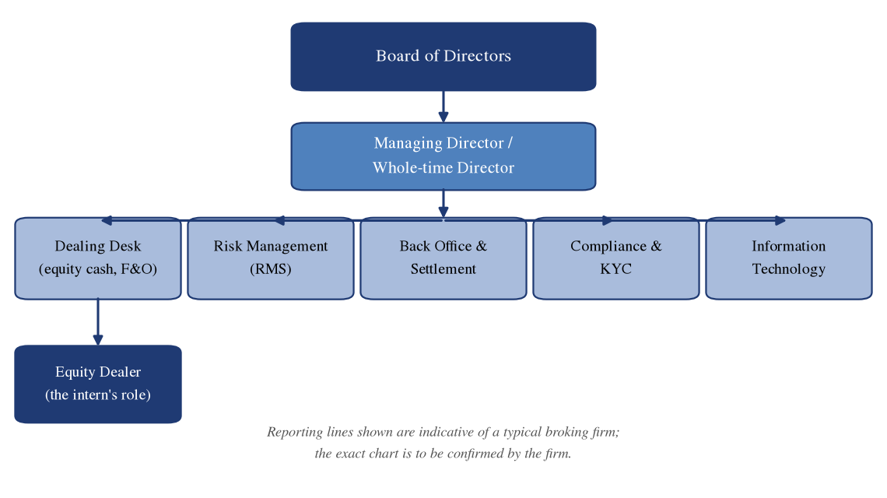
Source: Compiled by the author; the exact structure of the firm is to be confirmed.
Table 2.2: Departments of a broking firm and their principal functions
Department | Principal functions | Interaction with the dealing desk
Dealing desk | Receives client instructions, enters and modifies orders, confirms executions, communicates fills to clients | The function itself
Risk management (RMS) | Sets client-wise limits, monitors margin utilisation, raises shortfall alerts, authorises square-off | Releases or blocks limits in real time during market hours
Back office and settlement | Computes obligations, generates contract notes, maintains client ledgers, handles pay-in and pay-out | Supplies opening ledger balances and resolves trade mismatches
Compliance | Client registration, unique client code mapping, surveillance responses, regulatory filings and reporting | Confirms that a client code is active and permitted in a segment
Information technology | Terminal provisioning, connectivity, user and terminal identifiers, business-continuity arrangements | Restores terminal access and connectivity when a session fails
Accounts and treasury | Client fund transfers, bank reconciliation, settlement funding and collateral placement | Confirms receipt of client funds that release additional limit
Source: Compiled by the author.
Interpretation. The separation of the dealing function from the risk-management function is the single most important control in the structure, because it prevents the person with an incentive to execute from also being the person who decides whether execution is affordable. A dealer therefore cannot increase a client's limit, and an instruction that exceeds it must be refused at the desk and escalated. During the internship this separation was the most frequent source of friction with clients and simultaneously the most frequent source of protection for the firm, which is consistent with the margin-shortfall scenario computed in Section 5.8.

2.5 MISSION, VISION AND VALUES
[ADD: reproduce the firm's published mission, vision and values statement here. If the firm does not publish one, delete this section entirely and renumber Section 2.6 as Section 2.5 together with the corresponding Contents entry.]

2.6 THE INTERN'S ROLE AS AN EQUITY DEALER
The intern was attached to the equity dealing desk in the capacity of an Equity Dealer for the period [ADD: internship start date] to [ADD: internship end date], working [ADD: working hours] and reporting to [ADD: designation of the reporting senior, role only, no names]. The segments handled were [ADD: cash / equity derivatives / both] and the client categories dealt with were [ADD: retail / high net-worth / sub-broker / institutional — categories only]. All order entry was carried out under the supervision of a registered dealer, and no instruction was executed without a verified client instruction and a confirmed limit.
The responsibilities fell into three time bands, corresponding to the periods before, during and after the continuous trading session, and are set out in Table 2.3.
Table 2.3: Indicative working day of an equity dealer
Time | Activity | Purpose
08:45 – 09:00 | Review of overnight news, corporate actions, the exchange ban list and pending client instructions | To identify scrips that require special handling before the session opens
09:00 – 09:07 | Verification of client-wise limits and collateral uploaded by the risk-management system | To confirm the tradable limit available to each client for the day
09:07 – 09:15 | Observation of the pre-open session and the indicative equilibrium price | To assess the likely opening level
09:15 – 12:30 | Continuous trading: order entry, modification and cancellation; confirmation of fills to clients | Execution of client instructions within the limits available
12:30 – 14:30 | Mid-session monitoring, response to risk alerts, margin top-up follow-up | To prevent a margin shortfall from becoming a forced square-off
14:30 – 15:30 | Intraday square-off discipline, closing instructions, end-of-session order review | To close positions that cannot be carried forward under the client's limit
15:30 – 17:30 | Verification of the day's executions against the trade book, post-trade reconciliation with the back office and contract-note verification | To ensure the client's records and the firm's records agree
Source: Author's observation during the internship; timings are indicative of a normal trading day and exclude special sessions.
Interpretation. The shape of the day shows that only about six of the nine working hours fall inside the continuous trading session, and that much of a dealer's effort is expended before the market opens and after it closes. The pre-market block determines how much can safely be executed; the post-market block determines whether what was executed has been recorded correctly. Order entry is thus the visible part of a process that is predominantly preparation and verification, consistent with the reconciliation emphasis described in Section 3.17.
The principal tools used during the internship were the following.
• The exchange-provided trading terminal: used for market watch, order entry, order-book and trade-book review, as described in Section 3.15.
• The member's Computer-to-Computer Link terminal: used for order routing through the firm's own server with pre-trade risk controls applied, as described in Section 3.16. [ADD: name of the CTCL software used by the firm].
• The risk-management system console: used to read client-wise limit utilisation, available margin and shortfall alerts.
• The telephone recording system: used for the receipt of client instructions, retained as evidence of the instruction in accordance with the firm's compliance policy.

CHAPTER 3

THEORETICAL FRAMEWORK

3.1 INTRODUCTION
This chapter sets out the conceptual and regulatory framework within which an equity dealer operates, in the order in which the subject matter becomes relevant to a person joining a dealing desk: the structure of the market, the rules that govern it, the mechanics of trading and settlement, risk management, derivatives and their margining, the two trading technologies used on the desk, and the costs and controls attaching to every transaction. Each regulatory statement carries a source line identifying the authority relied upon and the date checked; where verification against a primary source could not be completed, the statement is marked to be verified.

3.2 THE FINANCIAL SYSTEM AND THE CAPITAL MARKET IN INDIA
The financial system is the arrangement of markets, institutions, instruments and services through which savings are transferred to productive use. The financial markets component divides into the money market, which deals in instruments of original maturity up to one year, and the capital market, which deals in longer-dated instruments including equity. The capital market in turn divides into the primary market, in which securities are issued for the first time, and the secondary market, in which existing securities change hands. A stock broker's dealing desk operates almost entirely in the secondary segment of the capital market, which is why that is the focus of this report.
The distinction matters operationally. In the primary market the broker is a distribution channel and the applicant's funds are blocked rather than debited; in the secondary market the broker is an execution intermediary with settlement obligations to the clearing corporation that arise within a fixed number of days regardless of whether the client pays. That asymmetry is the origin of the margin framework described in Sections 3.9 and 3.13.

3.3 PRIMARY MARKET AND SECONDARY MARKET
Table 3.1: Primary market and secondary market compared
Basis | Primary market | Secondary market
Nature of transaction | Issue of new securities | Transfer of existing securities
Recipient of funds | The issuing company | The selling investor
Effect on company capital | Capital is raised | No change in company capital
Price determination | Book-building or fixed price | Continuous order matching
Frequency | Occasional, issue by issue | Continuous on every trading day
Role of the broker | Distribution and application support | Execution of orders
Principal document | Prospectus or offer document | Contract note
Typical settlement | On allotment and listing | Rolling settlement cycle
Source: Compiled by the author.
Interpretation. The comparison indicates why a dealer's risk exposure is concentrated in the secondary market. In the primary market the intermediary's obligation ends when the application is forwarded, whereas an executed secondary-market trade creates an irrevocable obligation to deliver securities or funds on a fixed date. A client who does not pay does not cancel that obligation; the member must settle and then recover. This explains why the pre-trade limit check in Section 3.16 is applied before an order is released rather than after it is executed.

3.4 STOCK EXCHANGES, INDICES AND MARKET SEGMENTS
A stock exchange is a recognised body that provides the trading platform, the rules of trading and the framework of surveillance for securities transactions. India's two principal exchanges are the National Stock Exchange of India Limited and BSE Limited. Both operate fully electronic, order-driven markets with anonymous order matching. Each exchange supports several segments, of which the capital market segment, dealing in equity shares, and the equity derivatives segment, dealing in futures and options on indices and individual securities, are relevant to this report.
An index is a statistical measure of the aggregate price movement of a defined basket of securities, computed on a free-float market-capitalisation basis for the principal Indian benchmarks. The Nifty 50 comprises fifty companies on the National Stock Exchange and the S&P BSE Sensex thirty on the BSE. For a dealer, indices matter in three ways: they are the underlying for the most liquid derivative contracts, they are the benchmark against which a client judges performance, and index levels define the market-wide circuit breakers that halt trading after specified falls.

3.5 MARKET PARTICIPANTS
Table 3.2: Market participants and their roles
Participant | Role in the market | Point of contact with the dealing desk
Retail investor | Buys and sells securities for personal account in modest size | Places orders by telephone or through the firm's platform
Stock broker | Executes orders as an intermediary and is a member of the exchange | The employer of the dealer
Clearing member | Assumes responsibility for settlement of trades with the clearing corporation | Determines the collateral the broker must place
Clearing corporation | Acts as central counterparty, computes obligations and margins | Sets the margin that constrains every client limit
Depository and DP | Holds securities in electronic form and effects transfers | Delivers pay-out and processes pledge instructions
Institutional investor | Foreign portfolio investors and mutual funds investing under registered categories and stated mandates | Rarely a retail desk's client; drives market direction and volume
Source: Compiled by the author.
Interpretation. The table shows that a dealer deals directly with only two of the categories listed and indirectly with the rest through the constraints they impose. The clearing corporation is the most consequential participant the dealer never speaks to, because its margin computation determines the limit the risk-management system will grant, which determines what the dealer may execute. This chain is worked through numerically in Section 5.8, where an illustrative position of Rs. 12,57,000 requires margin of Rs. 1,63,410, or 13.00 per cent of contract value.

3.6 THE REGULATORY FRAMEWORK
Table 3.3: Principal statutes and regulations governing stock broking
Instrument | Principal subject matter | Relevance to the dealing desk
Securities Contracts (Regulation) Act, 1956 | Recognition of stock exchanges and regulation of contracts in securities | Establishes that trades must occur on a recognised exchange
SEBI Act, 1992 | Constitution and powers of the Securities and Exchange Board of India | Source of the regulator's authority over brokers
Depositories Act, 1996 | Dematerialisation and electronic transfer of securities | Underlies demat delivery and pledge of collateral
SEBI (Stock Brokers) Regulations, 1992 | Registration, conduct, records and obligations of stock brokers | Governs client registration, contract notes and records
Exchange byelaws, rules and regulations | Trading parameters, member obligations, discipline | Day-to-day operating rules of the terminal
Clearing corporation regulations | Margining, settlement, default and close-out | Determines margin rates and settlement timelines
Source: SEBI circulars and master circulars; checked 9 October 2026.
Interpretation. The structure is hierarchical: statute confers power on the regulator, the regulator makes regulations and issues circulars, and the exchanges and clearing corporations issue operating rules consistent with them. For a dealer the binding instruction on any given day is usually the most recent circular rather than the parent regulation, and circulars change frequently. The expiry-day change described in Section 3.11 is an example: the statutory framework was unaltered, but a single circular changed the operating routine of every derivatives desk in the country.

3.7 THE EQUITY TRADING MECHANISM
The Indian cash market is an order-driven market. Buyers and sellers submit orders to a central electronic order book and the exchange's matching engine pairs them according to price-time priority: the order offering the best price is matched first, and among orders at the same price the one entered earlier is matched first. There is no obligation on any participant to provide a two-way quote in most securities, which means liquidity is a function of participation rather than of designated market making. Figure 3.1 illustrates the principle on an order book.
Figure 3.1: Price-time priority in an order-driven market
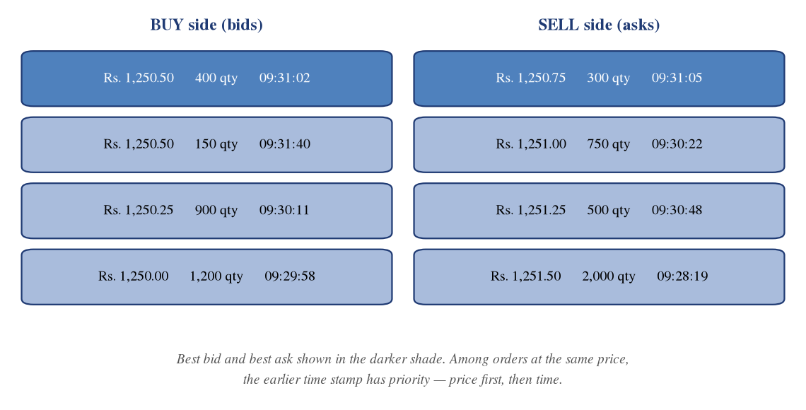
Source: Compiled by the author.
The trading day is divided into defined sessions. The pre-open session collects orders without matching them, determines a single equilibrium price at which the maximum quantity can trade, and executes at that price; it exists to reduce the volatility that follows an overnight accumulation of information. The continuous trading session then operates on price-time priority until the close, followed by a closing session in which the closing price is computed. Indicative timings are set out in Table 3.4.
Table 3.4: Equity trading sessions and indicative timings
Session | Indicative timing | What happens
Pre-open order collection | 09:00 – 09:08 | Orders entered, modified and cancelled; no matching
Pre-open price determination | 09:08 – 09:12 | Equilibrium price computed and orders matched at that price
Continuous trading | 09:15 – 15:30 | Order-driven matching on price-time priority
Closing price computation | 15:30 – 15:40 | Weighted average of the last half hour used as the closing price
Post-closing session | 15:40 – 16:00 | Limited trading at the closing price, where offered
Source: NSE and BSE trading-hours pages; checked 9 October 2026. Exact session boundaries are to be verified against the exchange notice in force on the date of submission.
Price bands, also called circuit filters, limit the movement permitted in a security during a day. Securities in the derivatives segment generally carry a wider operating range, while others are placed in fixed bands. In addition, market-wide circuit breakers linked to index movement halt trading across the market for specified durations. Table 3.5 sets out the order types a dealer uses and Table 3.6 the band categories.
Table 3.5: Order types, validity conditions and typical use
Order type | Definition | When a dealer uses it
Market order | Executes at the best available price in the book | When certainty of execution matters more than price
Limit order | Executes only at the stated price or better | The default for client orders with a price instruction
Stop-loss limit (SL) | Becomes a limit order once the trigger price is reached | To cap loss on an open position at a defined level
Stop-loss market (SL-M) | Becomes a market order once the trigger is reached | Where exit is required even at an unfavourable price
Immediate or cancel (IOC) | Executes immediately in whole or part; the rest lapses | To avoid leaving a resting order in a fast market
Disclosed quantity | Reveals only part of the total quantity to the market | To reduce market impact on a large order
Source: NSE India, circulars and market-statistics pages; checked 9 October 2026.
Table 3.6: Price-band and circuit-filter categories
Category | Indicative band | Comment
Securities in the derivatives segment | Dynamic operating range | Wider range with a flexing mechanism rather than a hard daily band
Other securities — band 1 | 20 per cent | Most actively traded non-F&O scrips
Other securities — band 2 | 10 per cent | Lower-liquidity scrips
Other securities — band 3 | 5 per cent | Scrips under closer monitoring
Surveillance categories | 2 per cent or lower | Scrips placed under additional surveillance measures
Market-wide circuit breaker | 10, 15 and 20 per cent index movement | Trading halted market-wide for a specified duration
Source: NSE and BSE price-band circulars; checked 9 October 2026. Scrip-wise band assignment changes periodically and is to be verified on the date of submission.
Interpretation. Order type and price band interact in a way that is not obvious until observed live. A market order entered in a scrip approaching its upper band may execute at the band itself rather than near the prevailing price, producing an execution the client regards as an error. The standing instruction on the desk was therefore to avoid market orders in scrips with a narrow band or thin depth and to use an aggressively priced limit order instead — a practical application of the price-time priority principle shown in Figure 3.1.

3.8 CLEARING, SETTLEMENT AND THE DEPOSITORIES
Clearing is the computation of what each party owes after a trading day; settlement is the exchange of securities and funds. Both are performed by a clearing corporation acting as central counterparty, which interposes itself between buyer and seller so neither is exposed to the other's default. Obligations are netted at clearing-member level and settled on a rolling settlement basis. The standard cycle for equities is T+1, with an optional same-day T+0 facility for a specified list of securities. The sequence is shown in Figure 3.2 and the timeline in Table 3.7.
Figure 3.2: Clearing and settlement flow
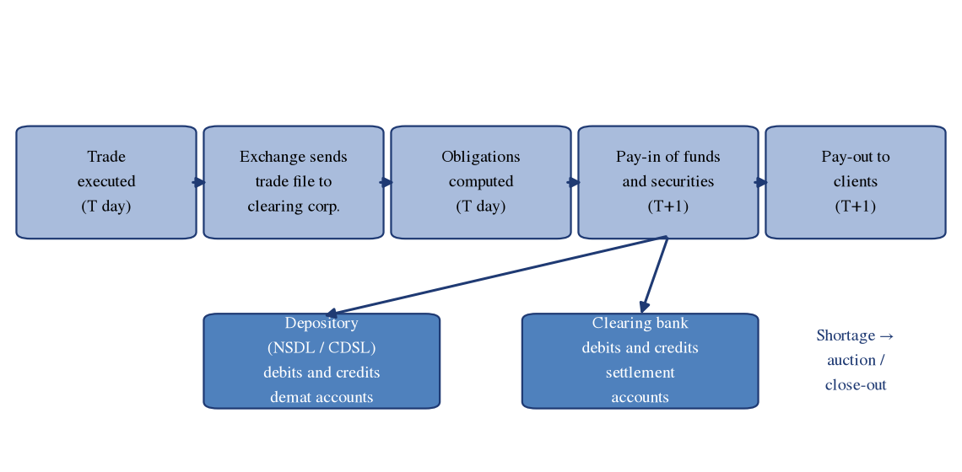
Source: Compiled by the author.
Table 3.7: Rolling settlement timeline under the T+1 cycle
Stage | Day | Action
Trade | T | Order matched on the exchange; contract note issued to the client
Securities pay-in | T+1 | Selling member delivers securities to the clearing corporation through the depository
Funds pay-in | T+1 | Buying member transfers funds through the clearing bank
Pay-out | T+1 | Securities and funds released to the entitled members and credited to client accounts
Shortage handling | T+1 onward | Undelivered securities met through auction or close-out at a prescribed rate
Source: Clearing corporation settlement-cycle documents and SEBI circulars; checked 9 October 2026. The scope of the optional T+0 facility is to be verified.
Interpretation. The compression of the cycle to T+1 has had a direct effect on the dealing desk. Under a longer cycle a client had time to arrange funds after executing a purchase; under T+1 the funds must effectively be in place at the time of the trade, which is why upfront margin collection became unavoidable rather than merely prudent. The consequence observed on the desk was a shift of effort from post-trade collection to pre-trade verification, the same shift visible in Table 2.3.

3.9 RISK MANAGEMENT IN THE CASH MARKET
Margin in the cash market covers the risk that a client fails to meet an obligation between trade and settlement; the components appear in Table 3.8. The value-at-risk margin is a statistical estimate of the loss not exceeded on a given proportion of days, scrip by scrip; the extreme loss margin covers losses outside that interval; and mark-to-market margin covers the notional loss on an unsettled position at the close. Under the upfront margin framework the first two must be collected before the trade, and compliance is tested against snapshots taken at random during the day, which is the peak margin concept.
Table 3.8: Margins applicable in the cash market
Margin | What it covers | Timing of collection
Value-at-risk (VaR) margin | Statistical estimate of a one-day adverse price move | Upfront, before the order is released
Extreme loss margin (ELM) | Losses beyond the VaR confidence interval | Upfront, together with VaR margin
Mark-to-market (MTM) margin | Notional loss on an unsettled position at the close | Collected after the close for the next day
Delivery margin | Risk on positions moving into the delivery cycle | Levied in stages approaching settlement
Peak margin obligation | Highest intraday margin requirement across random snapshots | Tested intraday; shortfall attracts penalty
Source: SEBI margin-framework circulars and clearing corporation documents; checked 9 October 2026. Current rates are scrip-specific and to be verified.
Client collateral may be furnished in cash or in securities. Securities are furnished through the margin pledge mechanism, under which they remain in the client's own demat account and a pledge is created in favour of the broker, who may re-pledge them to the clearing member and clearing corporation. This replaced the earlier practice of transferring client securities into a broker-controlled account. For the dealer the effect is that a client who holds shares but has not pledged them has no additional limit, however large the holding.
Interpretation. The upfront margin regime converted a credit decision into a systems decision. A dealer can no longer extend informal accommodation to a reliable client, because the limit is computed by the risk system from collateral actually pledged and the order is rejected at entry if it is insufficient. This is the largest practical difference between the desk described in older study material and the desk observed during this internship, and it is quantified in Section 5.8, where a price fall of Rs. 25.00 on one lot converts an adequately margined position into a shortfall of Rs. 10,160.

3.10 DERIVATIVES: CONCEPT, HISTORY AND TYPES
A derivative is a contract whose value is derived from an underlying asset, rate or index. Derivatives serve three economic functions: hedging, the transfer of an unwanted price risk; speculation, the assumption of price risk in search of profit; and arbitrage, the exploitation of price differences between related instruments, which keeps prices consistent. Exchange-traded derivatives in India began with index futures in 2000, followed by index options, stock options and stock futures over the next two years.
Table 3.9: Types of derivative contracts
Type | Obligation of the buyer | Obligation of the seller | Traded in India
Forward | To buy at a fixed price on a future date | To sell at that price | Over the counter only
Future | To buy at a fixed price on expiry, settled daily | To sell at that price, settled daily | On exchange, index and stock
Call option | Right, not obligation, to buy at the strike | Obligation to sell if exercised | On exchange, index and stock
Put option | Right, not obligation, to sell at the strike | Obligation to buy if exercised | On exchange, index and stock
Source: Compiled by the author.
Interpretation. The asymmetry between futures and options is the point a new dealer must internalise first. In a futures contract both parties carry an obligation and both post margin; in an option only the seller carries an obligation, so only the seller posts margin while the buyer pays a premium and can lose no more than that premium. Clients frequently assume an option purchase carries the same margin consequence as a futures position. Section 5.7 shows a call premium outlay of Rs. 38,690 for one lot, against margin of Rs. 1,63,410 for a comparable futures position in Section 5.8.

3.11 FUTURES: SPECIFICATION, PRICING AND SETTLEMENT
A futures contract is a standardised agreement to buy or sell a specified quantity of an underlying at a price agreed today for settlement on a specified future date. Standardisation extends to the lot size, the expiry date, the tick size and the settlement method. Lot sizes are revised periodically and the minimum contract value has been raised in recent years, so any lot size quoted must carry the contract month and the date checked.
Expiry conventions changed materially with effect from 1 September 2025. Following a regulatory direction limiting equity-derivative expiries to two days of the week, the National Stock Exchange moved its weekly and monthly equity-derivative expiries to Tuesday and the BSE to Thursday. In addition, each exchange retains only one weekly benchmark index option contract, and all other equity-derivative contracts carry a minimum tenor of one month expiring in the last week of the month on the exchange's chosen day. Any description of a universal Thursday expiry is therefore obsolete.
The theoretical price of a futures contract is given by the cost-of-carry relationship, under which the futures price equals the spot price compounded at the financing rate over the remaining life of the contract, adjusted for any income forgone.
F = S × e^(r × t)
where F is the futures price, S the spot price, r the continuously compounded risk-free rate and t the time to expiry in years. The difference between futures and spot is the basis, which converges to zero at expiry; the worked computation appears in Section 5.6. Futures are settled daily by mark to market, so the accumulated exposure never exceeds one day's movement. Figure 3.3 shows the payoff profile.
Figure 3.3: Payoff of long and short futures positions
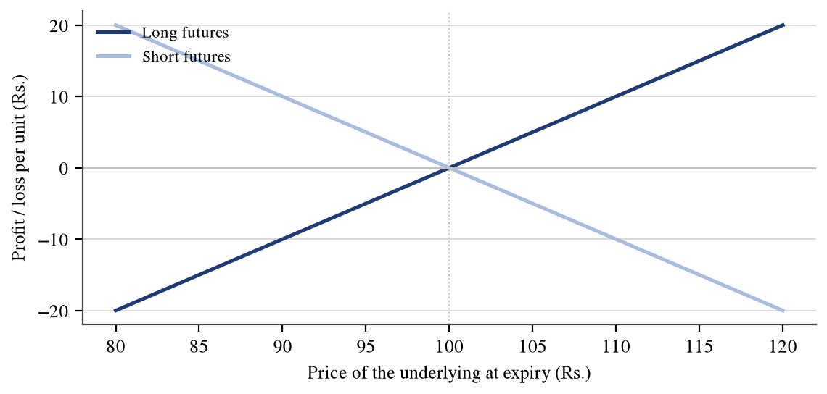
Source: Author's computation; illustrative figures.
Table 3.10: Illustrative equity-futures contract specification
Parameter | Illustrative specification
Underlying | An illustrative listed equity security
Contract size (lot) | 1,000 units
Tick size | Rs. 0.05
Expiry day | Last Tuesday of the contract month on the NSE; Thursday on the BSE
Settlement basis | Daily mark to market; final settlement in cash on expiry
Final settlement price | Closing price of the underlying on the expiry day
Daily price limit | Operating range with a flexing mechanism
Source: NSE contract specification pages; checked 9 October 2026. Lot size shown is illustrative; the actual lot size for any contract is to be verified.

3.12 OPTIONS: PAYOFF, PREMIUM AND THE GREEKS
An option confers a right without an obligation. A call option gives its holder the right to buy the underlying at the strike price; a put option gives the right to sell. The buyer pays a premium to the seller, or writer, and that premium is the buyer's maximum loss. Moneyness describes the relationship between the underlying price and the strike: a call is in the money when the underlying exceeds the strike, at the money when they are equal and out of the money below it, with the reverse applying to puts.
Premium = Intrinsic value + Time value
Intrinsic value of a call = max(S − K, 0); of a put = max(K − S, 0)
Table 3.11: Option moneyness, intrinsic value and time value
Condition | Call option | Put option | Intrinsic value
Underlying above strike | In the money | Out of the money | Positive for the call
Underlying equal to strike | At the money | At the money | Nil for both
Underlying below strike | Out of the money | In the money | Positive for the put
At expiry | Premium equals intrinsic value | Premium equals intrinsic value | Time value is nil
Source: Compiled by the author.
Figure 3.4: Payoff of a long call and a long put
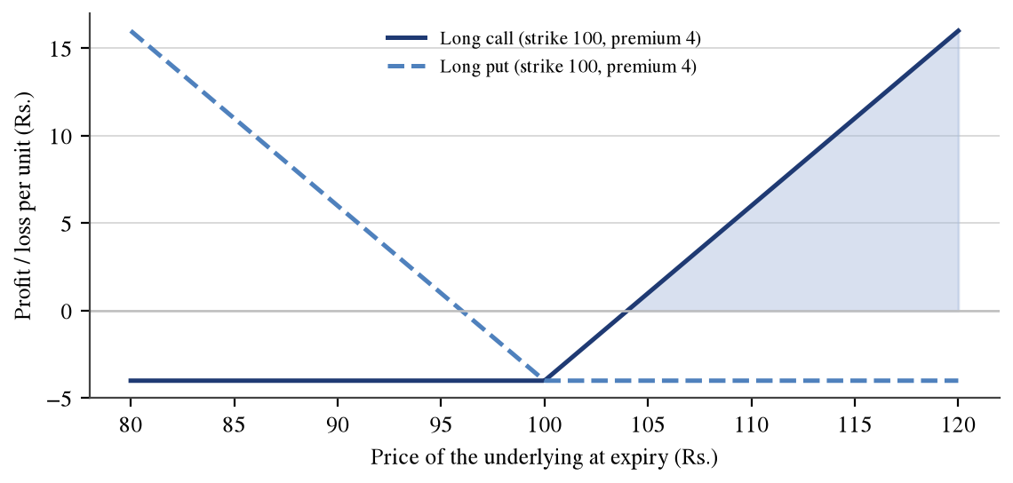
Source: Author's computation; illustrative figures.
The theoretical value of a European option is given by the Black-Scholes-Merton model, which expresses the option price as a function of the underlying price, the strike, the time to expiry, the risk-free rate and the volatility of the underlying.
C = S × N(d₁) − K × e^(−rt) × N(d₂)
d₁ = [ln(S/K) + (r + σ²/2)t] ÷ (σ√t); d₂ = d₁ − σ√t
The partial derivatives of the option price with respect to its inputs are called the Greeks. Delta measures the change in option value for a unit change in the underlying; gamma measures the rate of change of delta; theta measures the loss of value from the passage of one day; vega measures sensitivity to a one-point change in volatility; and rho measures sensitivity to interest rates. A worked computation for an illustrative contract appears in Section 5.7.

3.13 MARGINING IN THE FUTURES AND OPTIONS SEGMENT
Margin in the derivatives segment is computed by a portfolio-based system commonly referred to as SPAN, which revalues the client's portfolio under scenarios combining movements in the underlying price and in volatility and takes the worst outcome as the requirement. To this is added an exposure margin on contract value and, for option buyers, the premium margin. Spread positions across contract months attract a calendar spread concession because the legs offset. Table 3.12 summarises the components.
Table 3.12: Components of margin in the derivatives segment
Component | Basis of computation | Who pays it
SPAN or initial margin | Worst-case portfolio loss across prescribed scenarios | Futures buyers and sellers; option sellers
Exposure margin | A percentage of notional contract value | Futures buyers and sellers; option sellers
Premium margin | Premium payable on purchased options until pay-in | Option buyers, until the premium is settled
Calendar spread benefit | Concession for offsetting positions in different months | Reduces the requirement for spread positions
Delivery margin | Levied on stock derivatives approaching physical settlement | Both parties in the expiry week
Source: Clearing corporation margin documents; checked 9 October 2026. Scenario parameters and exposure-margin percentages are to be verified.
Interpretation. Two features matter on the desk. First, because SPAN is portfolio-based, adding a hedging leg can reduce total margin rather than increase it, which is counter-intuitive to clients who assume more positions require more money. Second, margin is recomputed continuously, so a position adequately margined at entry can fall into shortfall purely because the underlying moved. Section 5.8 demonstrates this: the requirement falls from Rs. 1,63,410 to Rs. 1,60,160 while available collateral falls faster, from Rs. 1,75,000 to Rs. 1,50,000.

3.14 TRADING STRATEGIES OBSERVED ON A DEALING DESK
A dealing desk does not devise strategies, but it must recognise them, because the margin consequence and the order sequence differ by strategy. The principal structures encountered are summarised in Table 3.13.
Table 3.13: Common strategies and their payoff characteristics
Strategy | Construction | Maximum profit | Maximum loss | View
Protective put | Long stock plus long put | Unlimited | Limited to put strike | Bullish with protection
Covered call | Long stock plus short call | Limited to strike plus premium | Substantial if stock falls | Mildly bullish
Long straddle | Long call and long put at the same strike | Unlimited | Total premium paid | Large move, direction unknown
Bull call spread | Long lower-strike call, short higher-strike call | Difference in strikes less net premium | Net premium paid | Moderately bullish
Bear put spread | Long higher-strike put, short lower-strike put | Difference in strikes less net premium | Net premium paid | Moderately bearish
Source: Compiled by the author.

3.15 THE NEAT PLUS TRADING TERMINAL
NEAT, the National Exchange for Automated Trading system, is the front-end application supplied by the National Stock Exchange to its trading members for order entry in the capital-market segment; NEAT PLUS is the multi-segment variant allowing a single terminal to access more than one segment. The terminal is keyboard-driven, with function keys mapped to the most frequent operations, and is organised around a small number of windows.
Table 3.14: Principal screens of the terminal and their use
Screen | Content | Use by the dealer
Market watch | User-selected list of securities with best bid, best ask and last traded price | Continuous monitoring of the scrips in which clients are active
Market by price | Aggregated depth at each price level on both sides | Assessment of liquidity before entering a large order
Order entry | Entry of client code, quantity, price, order type and validity | The principal working screen during market hours
Outstanding order book | All orders entered and not yet executed or cancelled | Modification and cancellation of resting orders
Trade book | All executions of the day with price, quantity and time | Confirmation of fills and end-of-day verification
Limits and margin | Available limit and utilisation against collateral | Pre-entry check that the order will not be rejected
Source: NSE trading-system documentation and the intern's observation; checked 9 October 2026. [ADD: confirm which of these screens were used, and list the specific function keys and shortcuts used on the desk.]
Interpretation. The organisation of the terminal reflects the sequence of a dealer's decision rather than the structure of the data. Verification of the security, assessment of depth, confirmation of limit, entry and confirmation each has its own window, and a competent dealer moves between them by keystroke. The learning curve observed during the internship was concentrated almost entirely in this motor skill rather than in conceptual understanding, consistent with the challenge recorded in Section 1.5.

3.16 THE COMPUTER-TO-COMPUTER LINK FACILITY
CTCL, the Computer-to-Computer Link, is an arrangement under which a trading member connects its own front-end application and server to the exchange trading system, instead of using only the exchange-supplied terminal. The member's server receives orders from dealer workstations, applies the member's own pre-trade risk controls and then transmits the order to the exchange. The architecture is shown in Figure 3.5.
Figure 3.5: Computer-to-Computer Link architecture
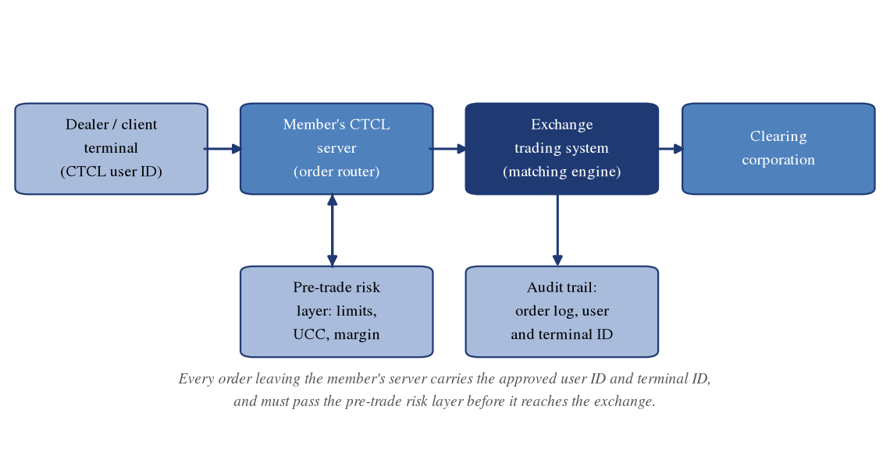
Source: Compiled by the author.
The facility is subject to a defined regulatory discipline. The software used must be of a version approved by the exchange; every terminal must be registered with a unique terminal identifier mapped to a location; every operator must hold a unique user identifier and the prescribed certification; and the member must maintain a complete audit trail of every order, modification and cancellation, identifying the user and terminal that originated it. Pre-trade risk controls must be applied at the member's server and cannot be bypassed by the operator. Where orders are generated by software, the separate framework governing algorithmic trading applies.
Table 3.15: NEAT PLUS and CTCL compared
Basis | Exchange terminal (NEAT PLUS) | Member CTCL facility
Software owner | The exchange | The trading member or its vendor
Point of risk control | Exchange-level validations only | Member's own pre-trade risk layer in addition
Customisation | Limited to user settings | Substantial; screens and controls vary
User identification | Exchange-allotted user ID | Member-allotted user ID mapped to a registered terminal ID
Audit trail | Maintained at the exchange | Maintained by the member and inspected
Approval requirement | Terminal allotment by the exchange | Software version approval plus terminal registration
Source: Exchange CTCL circulars and member compliance documents; checked 9 October 2026. [ADD: name of the CTCL software used by the firm.]
Interpretation. The essential difference is the location of the risk control rather than the appearance of the screen. On an exchange terminal the validations are those the exchange applies to every member; on a CTCL terminal the member interposes its own, invariably tighter, limits. An order may therefore be rejected by the firm's own server without ever reaching the exchange. Recognising which layer has rejected an order is a practical diagnostic skill, because the remedy differs: an internal rejection requires a limit discussion with risk management, while an exchange rejection usually indicates a parameter error such as a price outside the band.

3.17 THE BACK OFFICE AND THE RISK-MANAGEMENT SYSTEM
The back office maintains the records that convert executions into enforceable entitlements. Every client is identified by a unique client code registered with the exchange, and an order entered against an incorrect code is a reportable irregularity rather than a clerical error. At the close the back office receives the exchange trade file, computes client-wise obligations, generates contract notes within the prescribed time, posts entries to the client ledger and reconciles holdings against depository records. Table 3.16 lists the principal records.
Table 3.16: Records maintained against each client
Record | Content | Why the dealer needs it
Client registration file | KYC documents, agreements, risk-disclosure acknowledgement | Confirms the client may trade in the segment
Unique client code mapping | Exchange-registered code against the client | Every order must carry a valid code
Client ledger | Running record of funds due to and from the client | Determines free balance available as limit
Holding statement | Securities held, pledged and free | Determines deliverable quantity and collateral
Margin statement | Daily margin required, collected and shortfall | Basis of the shortfall alert and square-off decision
Contract note | Trade-wise price, quantity, brokerage and statutory charges | The client's primary evidence of the transaction
Source: Compiled by the author.

3.18 TRANSACTION COSTS AND STATUTORY CHARGES
Six distinct charges attach to an executed equity transaction, only one of which accrues to the broker. Brokerage is the member's own fee; exchange transaction charges are levied on turnover; the Securities Transaction Tax is a central levy on specified securities transactions; stamp duty is a state levy collected on the buy side; the SEBI turnover fee is a small regulatory charge on traded value; and goods and services tax is charged at eighteen per cent on the sum of brokerage, exchange charges and the regulator's fee, but not on the statutory levies. Depository charges apply additionally on delivery-based sales. The rates are set out in Table 3.17 and applied in Section 5.9.
Table 3.17: Statutory charges and transaction costs
Charge | Equity delivery | Equity intraday | Equity futures | Equity options
Securities Transaction Tax | 0.10% buy and sell | 0.025% sell only | 0.05% sell only | 0.15% on premium, sell
Stamp duty (buy side only) | 0.015% | 0.003% | 0.002% | 0.003%
NSE transaction charges | 0.00297% | 0.00297% | 0.00173% | 0.03503% on premium
SEBI turnover fee | 0.0001% | 0.0001% | 0.0001% | 0.0001%
Goods and services tax | 18% on brokerage, exchange and SEBI charges | 18% on the same base | 18% on the same base | 18% on the same base
Brokerage | As per the firm's tariff | As per the firm's tariff | As per the firm's tariff | As per the firm's tariff
Depository charges | On delivery-based sale | Not applicable | Not applicable | Not applicable
Source: Rates compiled from the Securities Transaction Tax schedule as revised with effect from 1 April 2026, state stamp-duty notifications, NSE transaction-charge circulars and SEBI fee regulations; checked 9 October 2026. Rates are revised periodically and must be reconfirmed on the date of submission.
Interpretation. The composition of the charge is as important as its size. Because the Securities Transaction Tax falls on turnover rather than profit, it is payable on a losing trade as readily as on a winning one, and because goods and services tax applies to brokerage but not to the statutory levies, a reduction in brokerage reduces the tax base as well as the fee. On the delivery round trip in Section 5.9 the tax alone accounts for Rs. 200.00 of the Rs. 340.25 total, or 58.78 per cent, which indicates that negotiating brokerage addresses only a minority of the cost.

3.19 INVESTOR PROTECTION, COMPLIANCE AND SURVEILLANCE
Client onboarding requires know your customer verification, execution of the prescribed agreements and acknowledgement of the risk-disclosure document, after which the client is allotted a unique client code. Orders must be placed only against a verified instruction, which is why telephone instructions are recorded. Surveillance measures are applied by the exchanges to securities exhibiting unusual price or volume behaviour, as summarised in Table 3.18.
Table 3.18: Surveillance frameworks and their effect on trading
Framework | Purpose | Effect on the dealing desk
Graded Surveillance Measure (GSM) | Applied to securities with weak fundamentals and sharp price rises | Periodic call auction, higher margin, restricted trading
Additional Surveillance Measure (ASM) | Applied to securities with unusual volatility or volume | Elevated margin, often 100 per cent of value
Ban period in derivatives | Applied when market-wide open interest exceeds a threshold | Only position-reducing orders permitted
Trade-for-trade segment | Compulsory delivery-based settlement | No intraday squaring-off permitted
Investor grievance redressal | SCORES and the exchange investor-services cell | Complaints routed away from the desk to compliance
Source: Exchange surveillance circulars; checked 9 October 2026. The scrip-wise list under each framework changes daily and is to be verified.

3.20 DIGITAL PAYMENTS AND FINANCIAL TECHNOLOGY IN THE CAPITAL MARKET
This section provides the bridge to the company analysed in Chapter 5. The capital market now depends on digital payment infrastructure at several points: client funds move by electronic transfer and increasingly through the unified payments interface; public-issue applications rely on a blocked-amount mechanism using the same rails; and the compression of the settlement cycle to T+1 would not have been feasible without near-real-time funds movement. A dealer experiences this directly, because a transfer that clears within minutes releases limit within minutes.
The companies that build this infrastructure have themselves become listed securities, and are therefore both the plumbing of the market and objects traded within it. Pine Labs Limited, a merchant-commerce and payments platform that listed on both principal exchanges on 14 November 2025, is analysed in Section 5.10 for that reason.

CHAPTER 4

RESEARCH METHODOLOGY

4.1 RESEARCH DESIGN
The study adopts a descriptive research design combined with work-based learning, or participant observation. A descriptive design is appropriate because the objective is to document and explain an existing process rather than to test a causal hypothesis. The work-based element arises because the author was placed within the function studied and the observations were generated by performing the work rather than by interviewing those who perform it. The design has a recognised strength and weakness: it produces detail an external observer could not obtain, and a single-site account that cannot be generalised without further evidence.

4.2 DATA COLLECTION
Primary data consists of the author's own structured observation of the dealing desk during the internship, including the sequence of the working day, the screens and functions used, the categories of client instruction received, the nature of the risk alerts generated and the reconciliation procedure followed at the close. No client record, internal limit or firm financial figure was copied, and no screenshot is reproduced unless it has been anonymised. [ADD: state whether masked terminal screenshots are attached; if yes, insert them in Sections 5.4 and 5.5 with the prescribed caption and source line.]
Secondary data consists of publicly available documents: circulars of the Securities and Exchange Board of India; circulars, contract specifications and statistics of the National Stock Exchange and BSE Limited; settlement and margin documentation of the clearing corporations; depository statistics; and, for the company analysis, the financial results, offer document, shareholding-pattern filings and investor material of Pine Labs Limited together with exchange price data. Aggregator websites were used only to locate primary documents and are not relied upon as the source of any figure.

4.3 PERIOD OF THE STUDY
The internship was undertaken from [ADD: internship start date] to [ADD: internship end date]. Market and regulatory facts are stated as they stood on 9 October 2026, which is the date of writing. Market price data for Pine Labs Limited is stated as on 25 September 2026. The financial period covered in the company analysis is the four financial years FY2022-23 to FY2025-26 together with the quarter ended 30 June 2026.

4.4 TOOLS AND TECHNIQUES
• Trend analysis: year-on-year growth and compound annual growth rate applied to the revenue and profit series of the company analysed, to separate the level of performance from its direction.
• Ratio analysis: profitability, return, efficiency and capital-structure ratios, each shown with the formula applied and the computed value, so that the derivation is auditable.
• Option pricing: the Black-Scholes-Merton model used to value an illustrative contract and to compute its delta, gamma, theta, vega and rho.
• Cost-of-carry and mark-to-market computation: derivation of a theoretical futures price and simulation of a five-day daily settlement sequence, with a cross-check that daily flows sum to the total price change.
• Charge computation: line-by-line application of the current statutory rate card to illustrative delivery and intraday transactions.
All arithmetic in this report was performed in code rather than by hand, and the computations were cross-checked where an independent check exists. The mark-to-market sequence in Section 5.6, for example, was verified by confirming that the sum of the five daily flows, Rs. 9,000, equals the product of the total price change and the lot size, Rs. 9,000.

4.5 MAPPING OF OBJECTIVES TO METHODS
Table 4.1: Mapping of objectives to methods and report sections
Objective | Method used | Section
To study the Indian equity market | Review of statute, circulars and exchange documents; observation of the trading day | 3.2 – 3.9, 5.2, 5.3
To study the futures and options market | Cost-of-carry computation, mark-to-market simulation, Black-Scholes valuation, payoff analysis | 3.10 – 3.14, 5.6, 5.7
To examine the NEAT PLUS terminal | Direct use under supervision; documentation of screens and order states | 3.15, 5.4
To examine the CTCL facility | Observation of routing and risk checks; review of exchange requirements | 3.16, 5.5
To study risk management | SPAN and exposure illustration; shortfall and square-off scenario | 3.9, 3.13, 5.8
To analyse Pine Labs Limited | Trend analysis, ratio analysis, shareholding and peer comparison from filings | 5.10, 5.11
Source: Compiled by the author.

4.6 DATA COVERAGE AND ETHICAL SAFEGUARDS
Four safeguards were adopted. First, no client-identifying information appears in this report; where an example requires a client, the designation Client A or Client B is used. Second, no internal figure of the firm is disclosed; all monetary examples are constructed by the author and labelled illustrative. Third, no fact about the firm has been invented: where a particular was not available from the firm's own documents, a marked placeholder has been left rather than an assumed value. Fourth, every regulatory statement carries a source and a date of checking, and where verification could not be completed the statement is marked to be verified rather than presented as established.

CHAPTER 5

ANALYSIS AND INTERPRETATION

5.1 INTRODUCTION
This chapter converts the description in Chapter 3 into computed evidence. It begins with the shape of the dealing day and a snapshot of the market, follows an order through the exchange terminal and the member's Computer-to-Computer Link facility, works through four quantitative demonstrations — futures pricing and settlement, option valuation and payoff, margin and shortfall, and transaction charges — and applies fundamental analysis to Pine Labs Limited. All trading examples are illustrative and constructed by the author; no figure is taken from the firm's records.

5.2 A DAY ON THE EQUITY DEALING DESK
The flow of a dealer's working day is shown in Figure 5.1 and set out task by task in Table 5.1.
Figure 5.1: Flow of a dealer's day from pre-open to post-close
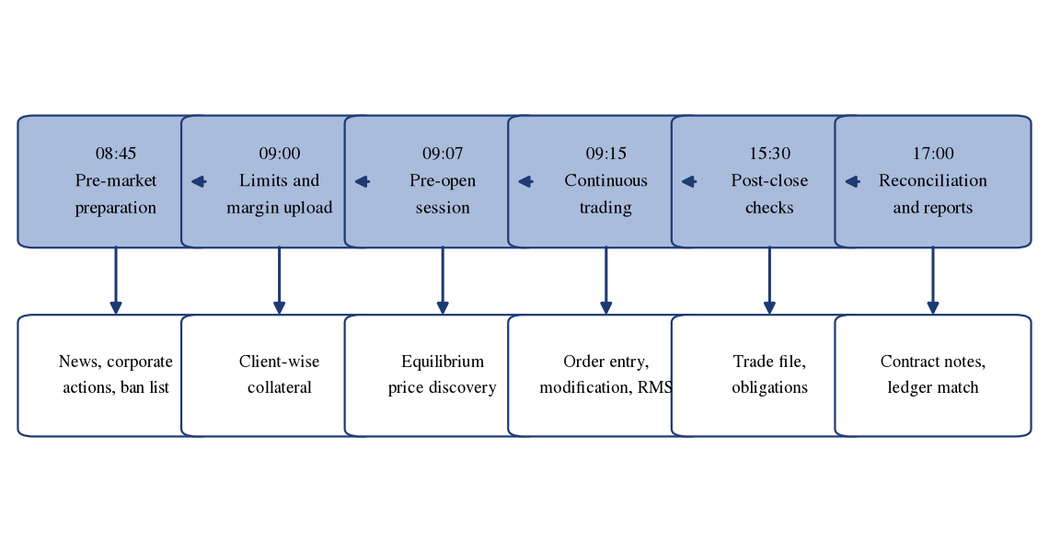
Source: Compiled by the author.
Table 5.1: Timeline of a dealing-desk day, task by task
Phase | Task performed | Control applied | Output
Pre-market | Review of news, corporate actions and the derivatives ban list | Cross-check against the exchange circular of the morning | List of restricted scrips
Pre-market | Verification of client-wise limits released by the risk system | Limit must be read before, not after, an instruction is accepted | Tradable limit per client
Continuous | Order entry against verified client instruction | Client code, quantity, price and segment confirmed before release | Order number
Continuous | Response to margin-shortfall alerts | Escalation to risk management; no limit granted at the desk | Top-up or square-off
Pre-close | Intraday square-off of positions that cannot be carried | Executed before the cut-off time set by the firm | Flat intraday book
Post-close | Verification of executions against the trade book | Every fill matched to an instruction | Confirmed trade list
Post-close | Reconciliation with the back office and contract-note check | Discrepancy reported the same evening | Reconciled client position
Source: Author's observation during the internship; no client or firm data is included.
Interpretation. Nine distinct tasks appear in the day, of which only two — order entry and modification — involve execution; the remaining seven are preparation, control or verification. The dealing function is therefore better understood as a controlled process with an execution step embedded in it than as an execution function with controls attached. This explains why the most common cause of an escalated problem observed during the internship was an omission in the pre-market block rather than an error during trading.

5.3 INDIAN EQUITY MARKET SNAPSHOT
The market in which the internship took place is described in Table 5.2 and the participation data in Table 5.3 and Figure 5.2.
Table 5.2: Benchmark index levels, as on 30 September 2026
Index | Closing level | Change during September 2026 (%) | Comment
Nifty 50 | 22,620.45 | -6.03 | Second consecutive monthly decline
S&P BSE Sensex | 72,480.29 | -5.82 | Broadly parallel movement to the Nifty 50
Source: Exchange index data for the month ended 30 September 2026; checked 9 October 2026.
Table 5.3: Investor participation and demat accounts
Measure | Figure | As on | Source basis
Demat accounts — CDSL | 19.10 crore | 31 August 2026 | Depository published count
Demat accounts — NSDL | 4.67 crore | 31 August 2026 | Depository published count
Demat accounts — total | 23.77 crore | 31 August 2026 | Author's computation, sum of the above
CDSL accounts | 18.01 crore | 31 March 2026 | Depository disclosure
CDSL accounts added in FY26 | 2.71 crore | FY2025-26 | Author's computation
NSE unique registered investors | 13.4 crore | July 2026 | Unique permanent account numbers
Cash-market turnover | [ADD: verify from NSE and BSE statistics] | FY2025-26 | to be verified
Equity-derivatives turnover | [ADD: verify from NSE and BSE statistics] | FY2025-26 | to be verified
Source: CDSL and NSDL published statistics and NSE investor data; checked 9 October 2026. Turnover figures could not be verified against a primary exchange document in the time available and are marked to be verified.
Figure 5.2: Growth in demat accounts
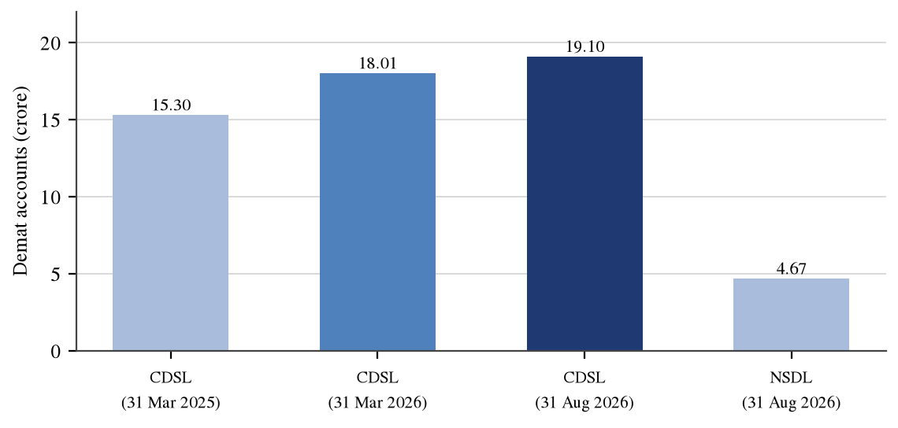
Source: CDSL and NSDL published statistics; checked 9 October 2026.
Interpretation. Demat accounts at the Central Depository Services (India) Limited rose from 15.30 crore at the end of FY2024-25 to 18.01 crore at the end of FY2025-26, an addition of 2.71 crore accounts or 17.71 per cent in a single year. The gap between the 23.77 crore total accounts and the 13.4 crore unique registered investors indicates that the average investor holds more than one account. For the dealing desk this growth is visible as a rise in the number of small, frequent instructions rather than in average order size, which places the burden on the speed of order entry rather than on depth assessment.

5.4 LIFE OF AN ORDER ON THE EXCHANGE TERMINAL
The states through which an order passes are shown in Figure 5.3 and listed in Table 5.4; the order types a dealer selects between are set out in Table 5.5.
Figure 5.3: Life of an order from instruction to settlement
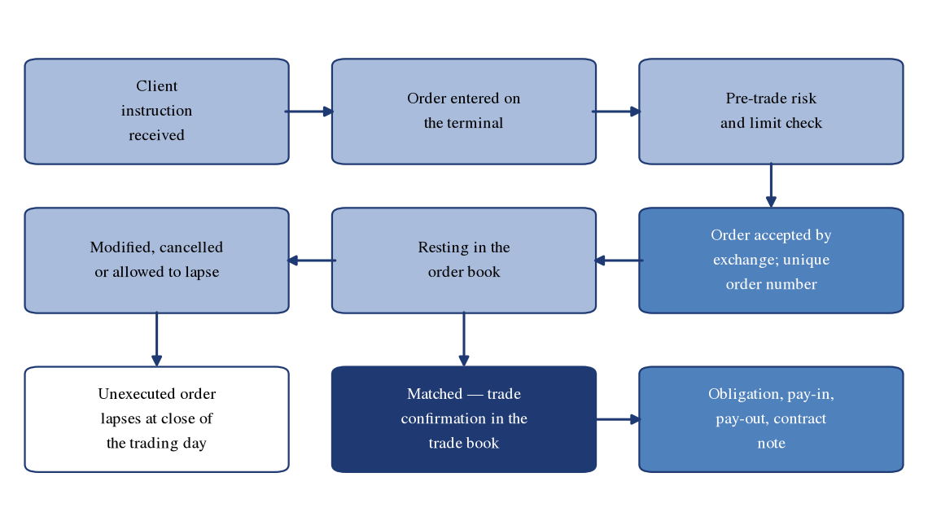
Source: Compiled by the author.
Table 5.4: Order states from entry to trade confirmation
State | What has happened | What the dealer can still do
Instruction received | Client instruction captured and recorded | Clarify quantity, price and validity before entry
Risk-checked | Member's pre-trade controls applied at the server | Escalate to risk management if rejected
Accepted | Exchange has acknowledged and allotted an order number | Modify or cancel
Open | Resting in the order book awaiting a counterparty | Modify price or quantity, or cancel
Executed | Full quantity traded; appears in the trade book | Nothing; the trade is irrevocable
Cancelled | Withdrawn before execution | Re-enter if the client so instructs
Rejected | Failed a validation at the member or exchange level | Correct the parameter or obtain limit
Source: Compiled by the author.
Table 5.5: Order types used during the internship and the situation calling for each
Order type | Validity | Situation in which it was used
Limit | Day | The standard instruction where the client specifies a price
Market | Immediate | Only in liquid scrips where execution certainty was required
Stop-loss limit | Day | To cap the loss on a carried position at a defined level
Stop-loss market | Day | Where exit was required irrespective of the price obtained
Immediate or cancel | Immediate | To avoid leaving a resting order in a fast market
Disclosed quantity | Day | On larger orders, to limit visible size and market impact
Source: Author's observation during the internship. [ADD: confirm the order types actually used and delete any that were not.]
Interpretation. The sequence shows that a dealer's discretion is confined to a narrow window between acceptance and execution. Before acceptance the order is governed by validation rules and after execution it is irrevocable, so the whole of a dealer's judgement lies in deciding what to enter and whether to modify a resting order. This is why the order-type decision in Table 5.5 is treated on the desk as a risk decision rather than a convenience.

5.5 THE COMPUTER-TO-COMPUTER LINK FACILITY IN PRACTICE
The routing of an order through the member's own infrastructure is shown in Figure 5.4, the pre-trade checks applied in Table 5.6 and the operational comparison with the exchange terminal in Table 5.7.
Figure 5.4: CTCL order routing and pre-trade risk checks
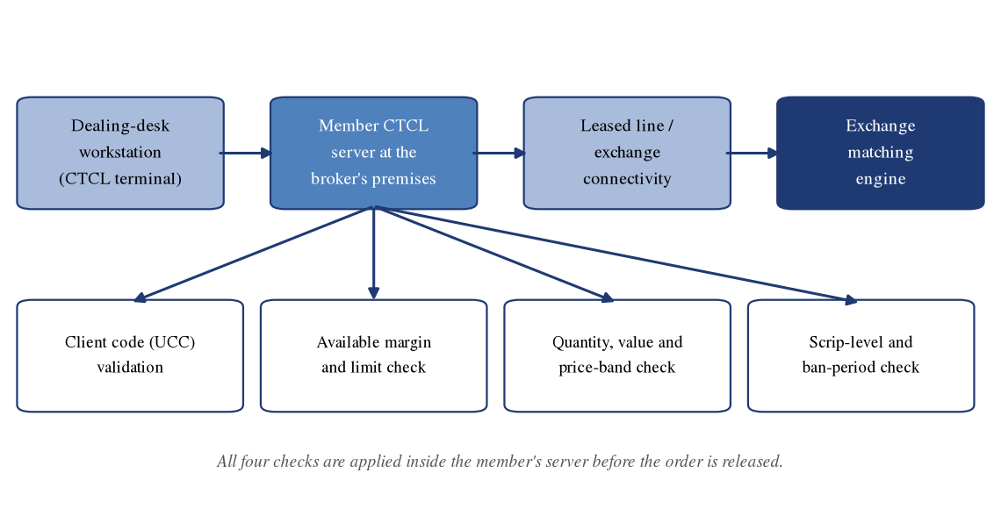
Source: Compiled by the author.
Table 5.6: Pre-trade risk checks applied to an order at the member's server
Check | What is tested | Consequence of failure
Client code validity | Code is registered, active and permitted in the segment | Order rejected; compliance consulted
Available margin | Collateral and free balance cover the margin requirement | Order rejected; client asked to fund or pledge
Order value limit | Single-order value within the client's ceiling | Order rejected; may be split only with authority
Price reasonability | Price within a band around the last traded price | Order rejected; protects against a keying error
Scrip permission | Scrip not restricted, suspended or in a ban period | Order rejected or permitted only to reduce a position
Segment permission | Client authorised for the cash or derivatives segment | Order rejected
Terminal and user validity | Order originates from a registered terminal and user | Order rejected and the attempt logged
Source: Exchange CTCL requirements and the intern's observation; checked 9 October 2026.
Table 5.7: Exchange terminal and CTCL compared on the desk
Operational aspect | Exchange terminal | Member CTCL terminal
Where the order is first validated | At the exchange | At the member's server, before the exchange
Who sets the limits | Exchange-level parameters | The member's risk-management team
Source of a rejection message | Exchange | Member's server, in most cases
Remedy for a rejection | Correct the order parameter | Usually a limit discussion with risk management
Number of workstations | One per allotted user | Many behind a single server
Customisation of the screen | Minimal | Extensive, vendor dependent
Source: Author's observation and exchange CTCL circulars; checked 9 October 2026. [ADD: name of the CTCL software used by the firm and any firm-specific difference in the routing described above.]
Interpretation. Eight checks are applied before an order reaches the exchange, of which only two relate to the order itself and six to the client's standing, permission or capacity. The weighting indicates that the primary purpose of the pre-trade layer is credit control rather than error prevention, which follows from the settlement obligation in Section 3.8: the member must settle whether or not the client pays. The practical skill the intern acquired was diagnostic — identifying from the rejection message whether the obstacle was internal and negotiable, or external and not.

5.6 FUTURES: PRICING AND DAILY SETTLEMENT
The contract used for the worked example is specified in Table 3.10. Applying the cost-of-carry relationship to an illustrative spot price of Rs. 1,250.00 at a financing rate of 7 per cent for 30 days gives the fair value computed in Table 5.8.
Table 5.8: Cost-of-carry fair value of a futures contract (illustrative)
Input or output | Symbol | Value | Basis
Spot price | S | Rs. 1,250.00 | illustrative
Risk-free rate, continuously compounded | r | 7.00 per cent | illustrative
Days to expiry | t | 30 days | illustrative
Time in years | t | 0.0822 | Author's computation
Theoretical futures price | F | Rs. 1,257.21 | Author's computation
Basis | F − S | Rs. 7.21 | Author's computation
Basis as a percentage of spot |  | 0.577 per cent | Author's computation
Source: Author's computation using F = S × e^(r × t); illustrative figures.
A long position of one lot is assumed to be opened at Rs. 1,257.00. Table 5.9 traces the daily settlement over the following five trading days.
Table 5.9: Five-day mark-to-market settlement on one long lot (illustrative)
Day | Previous settlement price | Settlement price | Price change | Daily MTM (1,000 units) | Cumulative MTM
Day 1 | Rs. 1,257.00 | Rs. 1,262.00 | Rs. 5.00 | Rs. 5,000 | Rs. 5,000
Day 2 | Rs. 1,262.00 | Rs. 1,255.50 | Rs. -6.50 | Rs. -6,500 | Rs. -1,500
Day 3 | Rs. 1,255.50 | Rs. 1,248.00 | Rs. -7.50 | Rs. -7,500 | Rs. -9,000
Day 4 | Rs. 1,248.00 | Rs. 1,259.25 | Rs. 11.25 | Rs. 11,250 | Rs. 2,250
Day 5 | Rs. 1,259.25 | Rs. 1,266.00 | Rs. 6.75 | Rs. 6,750 | Rs. 9,000
Total |  |  | Rs. 9.00 | Rs. 9,000 | Rs. 9,000
Source: Author's computation; illustrative figures.
Figure 5.5: Daily mark-to-market cash flow on the illustrative position
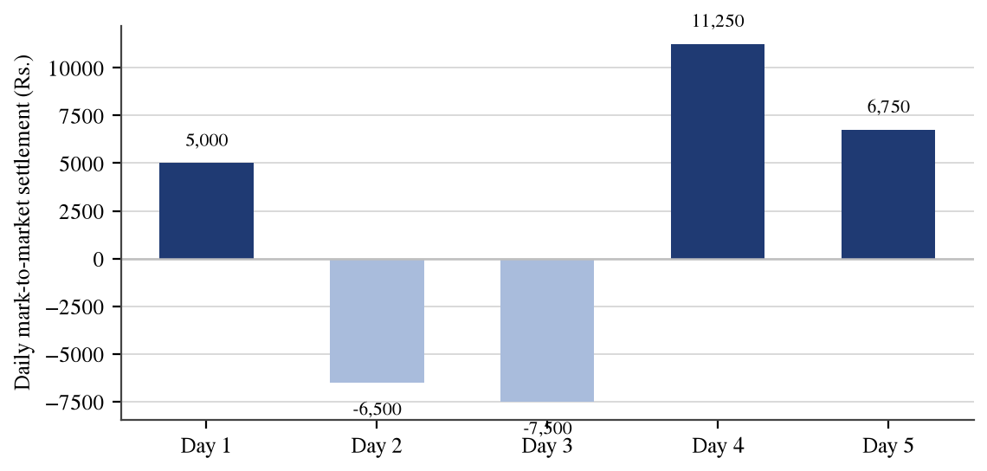
Source: Author's computation; illustrative figures.
Interpretation. The theoretical futures price of Rs. 1,257.21 exceeds spot by Rs. 7.21, or 0.577 per cent over thirty days, which is simply the cost of financing the underlying for that period. The five daily flows sum to Rs. 9,000, exactly equal to the price change of Rs. 9.00 multiplied by the lot size of 1,000 units, so daily settlement redistributes the result across days without altering it. The practical significance is that the client must fund two adverse days of Rs. 6,500 and Rs. 7,500 in cash even though the position ends profitably — the mechanism behind the shortfall scenario in Section 5.8.

5.7 OPTIONS: VALUATION, SENSITIVITIES AND PAYOFF
An illustrative thirty-day call option on the same underlying, struck at Rs. 1,260 with the spot at Rs. 1,250, is valued in Table 5.10 using the Black-Scholes-Merton model. Volatility is assumed at 28 per cent per annum and the risk-free rate at 7 per cent; both are illustrative assumptions and not market observations.
Table 5.10: Black-Scholes inputs, computed price and Greeks (illustrative)
Item | Symbol | Value | Label
Spot price | S | Rs. 1,250.00 | illustrative
Strike price | K | Rs. 1,260.00 | illustrative
Time to expiry | t | 0.0822 years (30 days) | illustrative
Risk-free rate | r | 7.00 per cent | illustrative
Volatility | σ | 28.00 per cent | illustrative
d₁ | d₁ | 0.0125 | Author's computation
d₂ | d₂ | -0.0677 | Author's computation
Call price | C | Rs. 38.69 | Author's computation
Put price at the same strike | P | Rs. 41.47 | Author's computation
Delta of the call | Δ | 0.5050 | Author's computation
Gamma | Γ | 0.003976 | Author's computation
Theta of the call, per day | Θ | Rs. -0.7808 | Author's computation
Vega, per one point of volatility | ν | Rs. 1.4296 | Author's computation
Premium outlay on one lot of 1,000 |  | Rs. 38,690 | illustrative
Break-even at expiry | K + C | Rs. 1,298.69 | Author's computation
Source: Author's computation using the Black-Scholes-Merton model with no dividend; illustrative inputs.
The payoff of the position at expiry across a range of underlying prices is set out in Table 5.11 and plotted in Figure 5.6.
Table 5.11: Payoff of the long call at expiry (illustrative, one lot of 1,000)
Underlying at expiry (Rs.) | Intrinsic value per unit (Rs.) | Premium paid per unit (Rs.) | Net profit or loss on one lot (Rs.)
1,150 | 0.00 | 38.69 | -38,690
1,200 | 0.00 | 38.69 | -38,690
1,250 | 0.00 | 38.69 | -38,690
1,260 | 0.00 | 38.69 | -38,690
1,280 | 20.00 | 38.69 | -18,690
1,301 | 41.00 | 38.69 | 2,310
1,320 | 60.00 | 38.69 | 21,310
1,360 | 100.00 | 38.69 | 61,310
1,400 | 140.00 | 38.69 | 1,01,310
Source: Author's computation; illustrative figures.
Figure 5.6: Payoff of the long call with break-even marked
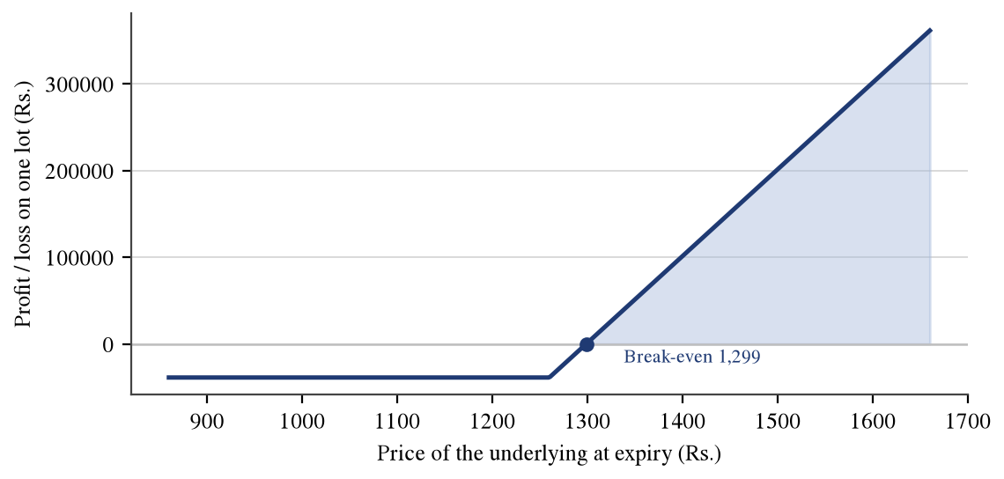
Source: Author's computation; illustrative figures.
Premium decomposition is shown next. If the same option were quoted in the market at Rs. 41.00 while the spot stood at Rs. 1,250.00, the entire premium would be time value, because the option is out of the money and its intrinsic value is nil.
Table 5.12: Premium decomposition of the illustrative call
Component | Formula | Value (Rs. per unit)
Market premium | Observed quote | 41.00
Intrinsic value | max(S − K, 0) = max(1,250 − 1,260, 0) | 0.00
Time value | Premium − intrinsic value | 41.00
Source: Author's computation; illustrative figures.
Figure 5.7: Decay of the call premium as expiry approaches, spot held constant
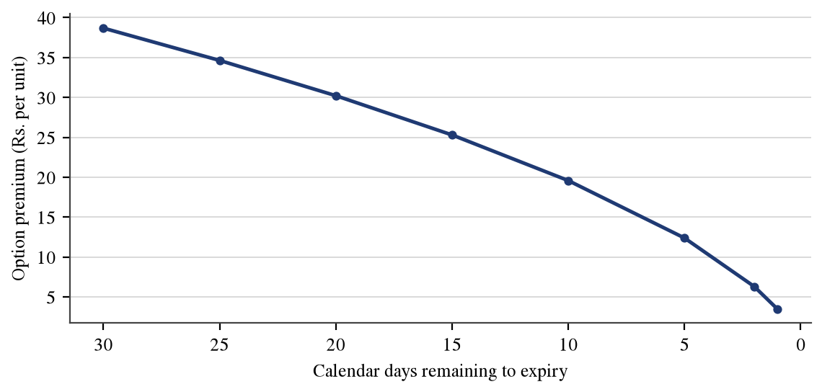
Source: Author's computation using the Black-Scholes model with the spot price and volatility held constant; illustrative.
Finally, a long straddle is constructed at the money by buying both a call and a put struck at Rs. 1,250. The combined premium is Rs. 80.01 per unit, producing two break-even points.
Table 5.13: Payoff of a long at-the-money straddle (illustrative, one lot)
Underlying at expiry (Rs.) | Net profit or loss on one lot (Rs.)
1,100.00 | 69,990
1,150.00 | 19,990
1,169.99 | 0
1,250.00 | -80,010
1,330.01 | 0
1,350.00 | 19,990
1,400.00 | 69,990
Source: Author's computation; illustrative figures.
Interpretation. The computed call price of Rs. 38.69 carries a delta of 0.5050, so the option behaves like roughly half a unit of the underlying, and a theta of Rs. 0.7808 per day, the amount lost for each day that passes without movement. The decay path in Figure 5.7 shows the consequence: the premium falls from Rs. 38.69 with thirty days remaining to Rs. 12.38 with five days remaining, so about 68 per cent of the value is lost in the last five days alone. The straddle requires a move of 6.40 per cent in either direction merely to break even, which makes strategies of this kind considerably less forgiving than clients commonly assume.

5.8 MARGIN AND THE MECHANICS OF A SHORTFALL
The margin requirement on the futures position opened in Section 5.6 is built up in Table 5.14 using illustrative percentages; the actual scenario parameters used by the clearing corporation are proprietary and vary daily.
Table 5.14: Margin build-up on one long futures lot (illustrative)
Component | Basis | Rate | Amount (Rs.)
Contract value | Entry price 1,257.00 × lot 1,000 |  | 12,57,000
SPAN / initial margin | Contract value × rate | 9.50% | 1,19,415
Exposure margin | Contract value × rate | 3.50% | 43,995
Total margin required | SPAN + exposure | 13.00% | 1,63,410
Margin as a percentage of contract value | Total margin / contract value |  | 13.00%
Source: Author's computation; illustrative figures.
The client is assumed to have placed collateral of Rs. 1,75,000, comfortably above the requirement at entry. Table 5.15 shows what happens when the underlying falls to Rs. 1,232.00.
Table 5.15: Margin shortfall and square-off scenario (illustrative)
Step | Computation | Amount (Rs.)
Collateral placed by the client | Given | 1,75,000
Margin required at entry | From Table 5.14 | 1,63,410
Surplus at entry | 1,75,000 − 1,63,410 | 11,590
Mark-to-market loss on the fall to 1,232.00 | (1,232.00 − 1,257.00) × 1,000 | -25,000
Collateral after the loss is debited | 1,75,000 − 25,000 | 1,50,000
Margin required at the lower price | 1,232.00 × 1,000 × 13.00% | 1,60,160
Shortfall | 1,60,160 − 1,50,000 | 10,160
Source: Author's computation; illustrative figures.
Interpretation. At entry the client held a surplus of Rs. 11,590 over the requirement of Rs. 1,63,410, an apparently comfortable position. A fall of 1.99 per cent converts that surplus into a shortfall of Rs. 10,160. The mark-to-market loss of Rs. 25,000 is debited from collateral while the requirement falls only slightly, from Rs. 1,63,410 to Rs. 1,60,160, because it is computed on a contract value that has itself fallen. Collateral therefore declines faster than the requirement. This asymmetry is the single most important thing a new dealer must understand, and it is why the margin-alert response in Table 5.1 is treated as time-critical.

5.9 CONTRACT NOTE AND TRANSACTION CHARGES
The rates set out in Table 3.17 are applied here to two illustrative transactions. The first is a delivery-based round trip of 100 shares bought and sold at Rs. 1,000, at a brokerage of 0.05 per cent on each side.
Table 5.16: Charge computation on an illustrative delivery round trip
Charge | Rate applied | Base | Amount (Rs.)
Buy value | 100 shares × Rs. 1,000 |  | 1,00,000
Sell value | 100 shares × Rs. 1,000 |  | 1,00,000
Brokerage | 0.05% each side | Buy + sell value | 100.00
Securities Transaction Tax | 0.10% each side | Buy + sell value | 200.00
NSE transaction charges | 0.00297% | Buy + sell value | 5.94
SEBI turnover fee | 0.0001% | Buy + sell value | 0.20
Stamp duty | 0.015% | Buy value only | 15.00
Goods and services tax | 18% | Brokerage + exchange + SEBI | 19.11
Total charges |  |  | 340.25
Break-even move required per share | Total charges / 100 shares |  | 3.40
Source: Author's computation applying the rates in Table 3.17; illustrative figures.
Figure 5.8: Composition of total charges on the delivery round trip
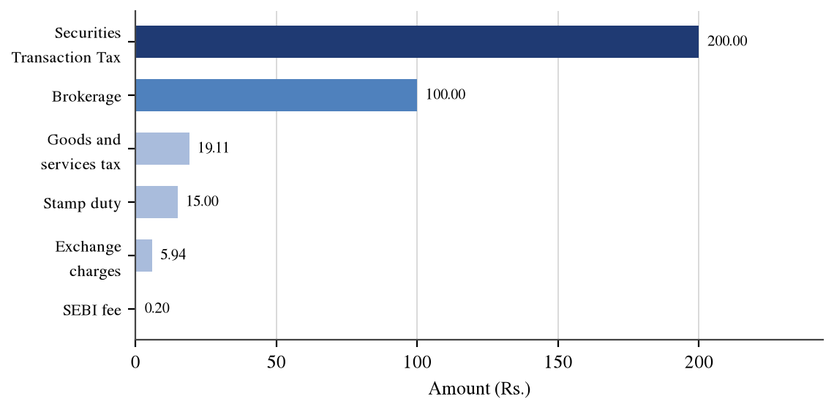
Source: Author's computation; illustrative figures.
The second transaction is an intraday trade of Rs. 5,00,000 bought and Rs. 5,02,500 sold on the same day at a flat brokerage of Rs. 20 per executed order.
Table 5.17: Charge computation on an illustrative intraday trade
Charge | Rate applied | Base | Amount (Rs.)
Brokerage | Rs. 20 per order, two orders |  | 40.00
Securities Transaction Tax | 0.025% | Sell value only | 125.62
NSE transaction charges | 0.00297% | Buy + sell value | 29.77
SEBI turnover fee | 0.0001% | Buy + sell value | 1.00
Stamp duty | 0.003% | Buy value only | 15.00
Goods and services tax | 18% | Brokerage + exchange + SEBI | 12.74
Total charges |  |  | 224.14
Gross profit on the trade | 5,02,500 − 5,00,000 |  | 2,500
Net profit after charges | 2,500.00 − total charges |  | 2,275.86
Charges as a percentage of gross profit |  |  | 8.97%
Source: Author's computation applying the rates in Table 3.17; illustrative figures.
Interpretation. On the delivery round trip the total cost of Rs. 340.25 requires the share to move Rs. 3.40, or about 0.34 per cent, before the client is even. The Securities Transaction Tax contributes Rs. 200.00 of that total against brokerage of only Rs. 100.00, so the statutory component is the larger constraint. On the intraday trade the charges of Rs. 224.14 absorb 8.97 per cent of a gross profit of Rs. 2,500, leaving Rs. 2,275.86. Frequency of trading, rather than size, is therefore the dominant determinant of total cost.

5.10 COMPANY ANALYSIS: PINE LABS LIMITED

5.10.1 Company overview
Pine Labs Limited, formerly Pine Labs Private Limited, is a merchant-commerce and payments technology company. It provides digital checkout infrastructure to merchants, affordability and value-added services at the point of sale, online payment acceptance, and issuing and processing services covering prepaid instruments, gift cards and card-related infrastructure for banks and consumer brands. The company states that it operates in more than twenty-two countries. Its identification details are set out in Table 5.18.
Table 5.18: Pine Labs Limited — company identification
Particular | Detail
Name | Pine Labs Limited (formerly Pine Labs Private Limited)
NSE symbol | PINELABS
BSE scrip code | 544606
ISIN | INE15B701018
Date of listing | 14 November 2025, on both the NSE and the BSE
Initial public offer size | Rs. 3,899.91 crore
Price band and issue price | Rs. 210 to Rs. 221; issued at Rs. 221
Listing-day opening price | Rs. 242 on both exchanges
Overall subscription and face value | About 2.46 times; Rs. 1 per equity share
Shares outstanding after the issue | 1,14,82,76,377 equity shares
Managing Director and CEO | Amrish Rau
Group Chief Financial Officer | Sameer Kamath
Book-running lead manager and registrar | Axis Capital Limited; KFin Technologies Limited
Source: Pine Labs Limited offer documents and exchange listing records; checked 9 October 2026.

5.10.2 Industry background
The company operates in the Indian digital payments and merchant-commerce industry, which has expanded rapidly on the back of the unified payments interface and the migration of small retailers from cash to electronic acceptance. Three characteristics bear on the analysis that follows. First, the economics are volume-driven and take-rate-thin: providers process very large transaction value and retain a small fraction of it, so profitability depends on operating leverage rather than margin per transaction. Second, the highest-volume rail carries no merchant discount rate on most person-to-merchant transactions, forcing providers to monetise through subscriptions, devices, credit distribution and value-added services. Third, the industry is closely regulated by the Reserve Bank of India in respect of payment aggregation, prepaid instruments and card data, so a regulatory change can alter a revenue line directly. [ADD: insert verified industry-size and transaction-volume data from RBI payment-system statistics or NPCI monthly data, with the month and the date checked.]

5.10.3 Business model and revenue streams
Table 5.19: Pine Labs Limited — reported segments and revenue streams
Segment | What it comprises | How it is monetised | FY26 revenue (Rs. crore) | Share of segment revenue (%)
Digital Infrastructure and Transaction Platform | Checkout infrastructure, affordability and value-added services, transaction processing, online payments | Device subscriptions, transaction fees, platform fees from merchants, brands and lenders | 1,836.82 | 67.76
Issuing and Acquiring Platform | Issuing and processing services, prepaid cards, gift cards, interest on float, breakage income | Processing fees, distribution margin, float income and unredeemed balances | 873.77 | 32.24
Total |  |  | 2,710.60 | 100.00
Source: Pine Labs Limited, audited consolidated financial results for the year ended 31 March 2026 (board meeting of 25 May 2026); checked 9 October 2026.
Figure 5.9: Segment revenue mix
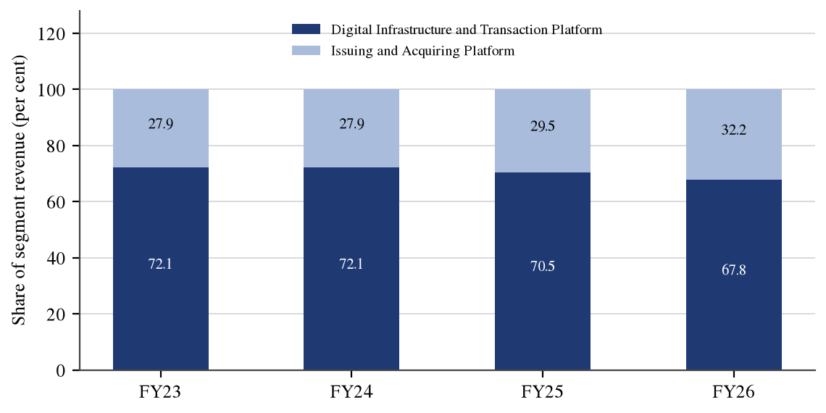
Source: Pine Labs Limited, audited consolidated financial results for the year ended 31 March 2026 (board meeting of 25 May 2026); checked 9 October 2026. FY23 to FY25 from the Red Herring Prospectus.
Interpretation. The Digital Infrastructure and Transaction Platform segment contributed Rs. 1,836.82 crore, or 67.76 per cent of segment revenue in FY2025-26, and remains the core of the business. The Issuing and Acquiring Platform grew faster, at 30.21 per cent against 14.57 per cent, and its share has risen steadily across the four years in Figure 5.9. The mix shift matters because the issuing business includes float income and breakage on unredeemed prepaid balances, which are high-margin but more exposed to regulatory change than a subscription fee, as discussed in Section 5.10.10.

5.10.4 Financial performance, FY2022-23 to FY2025-26
Table 5.20: Pine Labs Limited — consolidated financial performance
Financial year | Revenue from operations (Rs. crore) | Revenue growth (%) | Profit / (loss) after tax (Rs. crore) | Net profit margin (%)
FY23 | 1,597.66 | — | -265.15 | -16.60
FY24 | 1,769.55 | 10.76 | -341.90 | -19.32
FY25 | 2,274.27 | 28.52 | -145.49 | -6.40
FY26 | 2,710.60 | 19.19 | 112.50 | 4.15
Source: FY23 to FY25 from the Red Herring Prospectus, restated consolidated financial information; FY26 from the audited consolidated results for the year ended 31 March 2026. Growth and margin are the author's computation. Checked 9 October 2026.
Figure 5.10: Revenue and profit after tax, FY2022-23 to FY2025-26
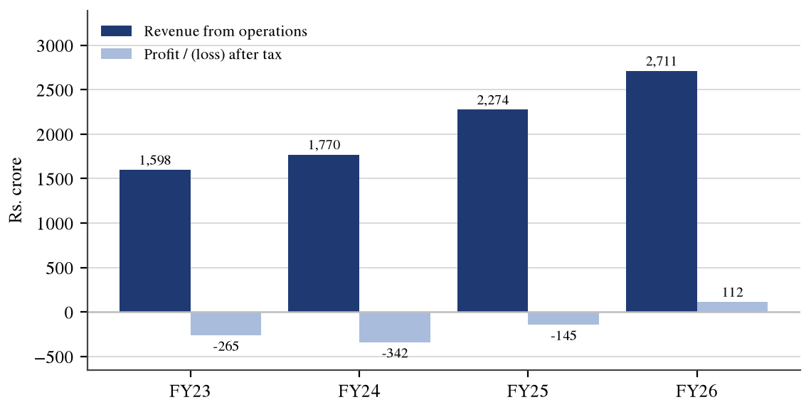
Source: Pine Labs Limited, audited consolidated financial results for the year ended 31 March 2026 (board meeting of 25 May 2026); checked 9 October 2026. Earlier years from the Red Herring Prospectus.
Table 5.21: Other consolidated financial indicators
Indicator | FY2024-25 | FY2025-26 | Change
Total income (Rs. crore) | 2,327.10 | 2,847.20 | +22.35%
Adjusted EBITDA (Rs. crore) | 356.00 | 559.00 | +57.02%
Adjusted EBITDA margin (%) | 15.65 | 20.62 | +4.97 pp
Contribution margin (%) | 76.00 | 75.00 | -1.00 pp
Operating cash flow (Rs. crore) | 49.70 | 395.40 | ×8.0
Total equity (Rs. crore) | [ADD: verify] | 5,895.00 | —
Cash and cash equivalents (Rs. crore) | 245.20 | 1,273.90 | ×5.2
Source: Pine Labs Limited, audited consolidated financial results for the year ended 31 March 2026 (board meeting of 25 May 2026); checked 9 October 2026. Percentage changes are the author's computation. Adjusted EBITDA is a measure defined by the company and is not a measure prescribed by accounting standards.
Interpretation. Revenue rose from Rs. 1,597.66 crore in FY2022-23 to Rs. 2,710.60 crore in FY2025-26, a compound annual growth rate of 19.27 per cent, while the result moved from a loss of Rs. 265.15 crore to a profit of Rs. 112.50 crore. The decisive year was FY2025-26: revenue grew 19.19 per cent but adjusted EBITDA grew 57.02 per cent. Profit growing far faster than revenue while contribution margin edged down from 76.00 to 75.00 per cent indicates that the improvement came from operating leverage on fixed costs rather than from better unit economics. The cash evidence supports the reported profit: operating cash flow of Rs. 395.40 crore is 3.51 times profit after tax, the opposite of the divergence that would warrant concern.
The most recent reported period is the quarter ended 30 June 2026, set out in Table 5.22.
Table 5.22: Pine Labs Limited — Q1 FY2026-27 against Q1 FY2025-26
Particular (Rs. crore unless stated) | Q1 FY2026-27 | Q1 FY2025-26 | Change (%)
Revenue from operations | 736.92 | 615.91 | 19.65
Total income | 765.87 | 653.08 | 17.27
Profit / (loss) before tax | 37.73 | -4.84 | not meaningful
Profit after tax | 19.57 | 4.79 | 308.56
Contribution margin (%) | 72.28 | 77.90 | -5.62 pp
Adjusted EBITDA | 126.00 | 121.00 | 4.13
Adjusted EBITDA margin (%) | 17.10 | 19.65 | -2.55 pp
Segment — digital infrastructure | 499.12 | 434.37 | 14.91
Segment — issuing and acquiring | 237.80 | 181.54 | 30.99
Basic earnings per share (Rs.) | 0.17 | 0.05 | —
Source: Pine Labs Limited, unaudited consolidated financial results for the quarter ended 30 June 2026 (board meeting of 28 July 2026); checked 9 October 2026. Percentage changes are the author's computation.
Interpretation. Revenue grew 19.65 per cent to Rs. 736.92 crore and profit after tax rose 308.56 per cent to Rs. 19.57 crore, with profit before tax turning positive. The figure that deserves attention, however, is the contribution margin, which fell 5.62 percentage points to 72.28 per cent, and the adjusted EBITDA margin, which fell from 19.65 to 17.10 per cent despite the revenue growth. Management attributes this to deliberate investment in salesforce, cloud and network capacity. The quarter therefore shows continued top-line momentum with a pause in margin expansion, and the full-year outcome will test whether the pause is seasonal or structural.

5.10.5 Ratio analysis
Table 5.23: Pine Labs Limited — ratio analysis, FY2025-26
Ratio | Formula applied | Computation | Value
Net profit margin | PAT / revenue × 100 | 112.50 / 2,710.60 × 100 | 4.15%
Net profit margin, FY2024-25 | PAT / revenue × 100 | −145.49 / 2,274.27 × 100 | -6.40%
Adjusted EBITDA margin | Adjusted EBITDA / revenue × 100 | 559 / 2,710.60 × 100 | 20.62%
Return on equity | PAT / total equity × 100 | 112.50 / 5,895 × 100 | 1.91%
Return on assets | PAT / total assets × 100 | 112.50 / 13,297 × 100 | 0.85%
Asset turnover | Revenue / average total assets | 2,710.60 / 12,006.50 | 0.226
Cash conversion | Operating cash flow / PAT | 395.40 / 112.50 | 3.51×
Revenue CAGR, FY23 to FY26 | ((2,710.60/1,597.66)^(1/3) − 1) × 100 | three-year compounding | 19.27%
Earnings per share, FY2025-26 | PAT / shares outstanding | 112.50 crore / 114.83 crore shares | Rs. 0.98
Source: Author's computation from the audited consolidated results for FY2025-26 and the Red Herring Prospectus; checked 9 October 2026.
Interpretation. The ratios describe a company at the very beginning of profitability rather than a mature one. A net profit margin of 4.15 per cent and a return on equity of 1.91 per cent are low in absolute terms, but they follow a margin of -6.40 per cent in the preceding year, so the direction is more informative than the level. Asset turnover of 0.226 is strikingly low for a technology business and reflects the float and settlement balances a payments processor carries; it should not be read as inefficiency. Cash conversion of 3.51 times profit indicates that reported earnings are supported by cash. The weakest number is the return on equity, and its improvement depends on whether the operating leverage of FY2025-26 continues, which the Q1 margin compression leaves open.

5.10.6 Shareholding pattern
Table 5.24: Pine Labs Limited — shareholding pattern, quarter ended June 2026
Category | Holding (%)
Promoter and promoter group | 0.00
Domestic institutional investors | 24.82
Foreign portfolio investors | 9.49
Public and others | 65.69
Total | 100.00
Source: Shareholding-pattern filing for the quarter ended 30 June 2026; checked 9 October 2026.
Figure 5.11: Shareholding pattern
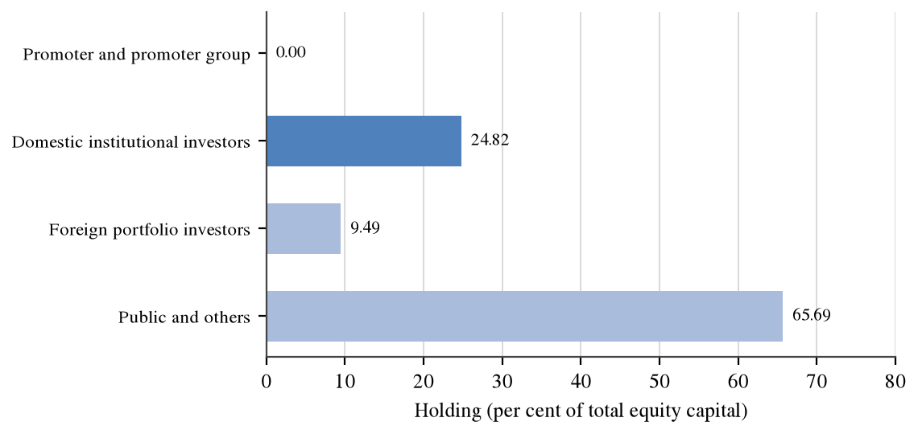
Source: Shareholding-pattern filing for the quarter ended 30 June 2026.
Interpretation. The most significant feature of the pattern is that promoter holding is nil, which is characteristic of a venture-funded technology company that has listed after several private rounds and in which no single shareholder exercises control. Domestic institutions hold 24.82 per cent and foreign portfolio investors 9.49 per cent, with 65.69 per cent in public and other hands, a category that here includes directors and individual pre-listing shareholders. The absence of a promoter removes the pledge and related-party concerns that dominate governance analysis of family-controlled Indian companies, but replaces them with another: there is no controlling shareholder with a long-term capital commitment, so the free float is more exposed to institutional repositioning.

5.10.7 Market data and valuation
Table 5.25: Pine Labs Limited — market data and valuation, as on 25 September 2026
Measure | Value | Basis
Closing price | Rs. 176.57 | Exchange close
Market capitalisation | Rs. 20,389 crore | Exchange data
52-week high | Rs. 284.00 | Exchange data
52-week low | Rs. 134.73 | Exchange data
Issue price | Rs. 221.00 | Offer document
Listing-day premium over issue price | 9.50% | Author's computation
Current price against issue price | -20.10% | Author's computation
Current price against the 52-week high | -37.83% | Author's computation
Earnings per share, FY2025-26 | Rs. 0.98 | Author's computation
Price to earnings, on FY2025-26 earnings | 180.2× | Author's computation
Price to book | 3.46× | Author's computation
Price to sales, on FY2025-26 revenue | 7.52× | Author's computation
Dividend | Nil declared since listing | Company disclosure
Source: Exchange market data as on 25 September 2026 and the company's audited FY2025-26 results; ratios are the author's computation. Checked 9 October 2026.
Interpretation. The valuation picture is dominated by the shortness of the listed history and by the fact that the company only just became profitable. At Rs. 176.57 the share trades 20.10 per cent below its issue price and 37.83 per cent below its 52-week high, while standing 31.05 per cent above its low; a range of 110.79 per cent of the low in under a year indicates considerable volatility. The price-to-earnings multiple of about 180 times is arithmetically correct but of limited analytical use, because it divides by a first-year profit of Rs. 0.98 per share; the price-to-sales multiple of 7.52 times and the price-to-book of 3.46 times are more stable reference points at this stage. No multi-year price chart is presented, because the company has been listed for under eleven months.

5.10.8 Peer comparison
Four listed comparators have been selected: One97 Communications Limited (Paytm), the closest listed analogue in merchant payments and distribution; Infibeam Avenues Limited, which operates a payment gateway and is comparable in online acceptance; One MobiKwik Systems Limited, comparable in consumer and merchant payments at a smaller scale; and Zaggle Prepaid Ocean Services Limited, comparable to the issuing and prepaid side. Razorpay, PhonePe and BharatPe are excluded because they were not listed entities with comparable public disclosure at the time of writing.
Table 5.26: Pine Labs Limited and listed peers
Company | Principal business | Latest full-year revenue (Rs. crore) | Latest full-year PAT (Rs. crore) | Comment
Pine Labs Limited | Merchant commerce, payments and issuing | 2,710.60 | 112.50 | First full year of profit in FY2025-26
One97 Communications (Paytm) | Merchant payments, distribution of credit | [ADD: verify] | [ADD: verify] | Largest listed comparator by scale
Infibeam Avenues | Online payment gateway and platforms | [ADD: verify] | [ADD: verify] | Comparable in online acceptance
One MobiKwik Systems | Consumer and merchant digital payments | [ADD: verify] | [ADD: verify] | Smaller scale, consumer-weighted
Zaggle Prepaid Ocean Services | Prepaid instruments and spend management | [ADD: verify] | [ADD: verify] | Comparable to the issuing segment
Source: Pine Labs figures from the audited FY2025-26 consolidated results. Peer figures could not be verified against the respective companies' own filings in the time available and are marked for completion; they must be taken from each company's annual report or results filing before submission.

5.10.9 SWOT analysis
Table 5.27: Pine Labs Limited — SWOT analysis
Strengths | Weaknesses
• Large installed base of digital checkout points and a long-standing merchant relationship base.  • Two distinct revenue engines, with the issuing platform growing at 30.21 per cent against 14.57 per cent for the core.  • Demonstrated operating leverage: adjusted EBITDA grew 57.02 per cent on revenue growth of 19.19 per cent in FY2025-26.  • Strong cash generation, with operating cash flow at 3.51 times profit after tax, and a substantial net cash position. | • Profitability is very thin: a net margin of 4.15 per cent and a return on equity of 1.91 per cent.  • Contribution margin declined in FY2025-26 and again in Q1 FY2026-27, to 72.28 per cent.  • Dependence on a company-defined adjusted EBITDA measure to present profitability.  • Short listed history limits the reliability of market-based valuation.
Opportunities | Threats
• International business growing from a small base across more than twenty-two markets.  • Continued migration of small and mid-market merchants from cash to electronic acceptance.  • Cross-sell of credit, affordability and value-added services over an installed device base.  • Operating leverage has further room if indirect costs continue to grow more slowly than revenue. | • Regulatory change affecting prepaid instruments, float income or unredeemed balances, which are high-margin revenue lines.  • Intense competition from both listed and large unlisted payment providers, several of which are better capitalised.  • Zero or near-zero merchant discount on the fastest-growing payment rail.  • Valuation risk: a high multiple of a very small first-year profit leaves limited tolerance for disappointment.
Source: Author's analysis based on the company's FY2025-26 and Q1 FY2026-27 filings; checked 9 October 2026.

5.10.10 Risks and outlook
• Regulatory risk: the issuing and prepaid business derives part of its margin from float income and from balances that are never redeemed; a change in the treatment of either would affect a disproportionately profitable revenue line.
• Margin risk: contribution margin fell in FY2025-26 and again in the first quarter of FY2026-27, to 72.28 per cent, and the company attributes this to investment rather than pricing; if the explanation proves incomplete, the operating leverage thesis weakens.
• Competitive risk: merchant payments in India is contested by very large unlisted competitors whose pricing is not constrained by the need to report quarterly profit.
• Concentration and mix risk: 67.76 per cent of segment revenue still comes from the digital infrastructure platform, and that segment grew at only 14.57 per cent in FY2025-26.
• Valuation risk: at about 180 times FY2025-26 earnings the share price embeds a sustained improvement in profitability; the stock already trades 20.10 per cent below its issue price, which indicates that the market has been repricing that expectation.

5.10.11 Overall view
Taken together, the evidence describes a company that has completed the transition from funded growth to self-funded operation but has not yet shown that the transition is durable. The positive findings are substantial: revenue compounding at 19.27 per cent over three years, a first full-year profit of Rs. 112.50 crore after a loss of Rs. 145.49 crore, and operating cash flow of Rs. 395.40 crore that comfortably exceeds reported profit. The reservations are equally identifiable: profitability remains thin in absolute terms, contribution margin is moving in the wrong direction, part of the most profitable revenue is exposed to regulatory treatment, and the market multiple rests on a first-year profit small enough to make it unstable. The decisive question is not whether the company can grow, which it has shown, but whether the operating leverage of FY2025-26 survives the investment phase of the first quarter of FY2026-27. This analysis has been prepared for academic purposes as part of an MMS project and is not investment advice; no recommendation to buy, hold or sell any security is made or intended.

5.11 THE DEALING-DESK VIEW OF THE SCRIP
The preceding analysis is the view an analyst takes. A dealer looks at the same security through an entirely different set of attributes, which are set out in Table 5.28.
Table 5.28: How a dealer would assess the PINELABS scrip
Attribute | Position | Consequence for the desk
Exchange and symbol | NSE: PINELABS; BSE: 544606 | Orders routable on either exchange
Market capitalisation | Rs. 20,389 crore, small-capitalisation | Depth thinner than in large-capitalisation names
Volatility | 52-week range of 110.79 per cent of the low | Market orders avoided; limit orders preferred
Price band | [ADD: verify the applicable band for PINELABS] | Determines the maximum intraday move
Surveillance status | [ADD: verify whether under GSM, ASM or short-term ASM] | Would raise the margin and may restrict intraday trading
F&O eligibility | [ADD: verify whether in the derivatives segment] | If not eligible, no hedging or leverage through futures or options
Settlement | Rolling T+1 | Pay-in obligation on the next business day
Typical client interest | Retail and small high net-worth, post-listing | Frequent small orders rather than block interest
Source: Exchange data as on 25 September 2026 and the author's assessment; items marked for completion are to be verified on the date of submission.
Interpretation. The comparison is instructive because the two perspectives disagree about what matters. The analyst's conclusion in Section 5.10.11 turns on operating leverage and margin direction, neither of which affects how an order should be entered. The dealer's conclusion turns on depth, volatility and band, and would be identical whether the company were profitable or not. A volatility range of 110.79 per cent of the low in under a year is the single most relevant fact on the desk. A competent finance professional must be able to hold both views at once, which is the central learning of this internship.

5.12 SKILLS AND LEARNING OUTCOMES MAPPED TO TASKS
Table 5.29: Tasks performed, skills acquired and evidence in this report
Task performed | Skill or knowledge gained | Evidence in this report
Pre-market review of news, corporate actions and the ban list | Identification of scrips requiring restricted handling | Table 5.1; Section 3.19
Reading client-wise limits released by the risk system | Understanding of how collateral converts into tradable limit | Section 3.9; Table 5.14
Order entry on the exchange terminal under supervision | Accurate use of client code, quantity, price, type and validity | Table 5.4; Table 5.5
Observing order routing through the member's CTCL server | Understanding of where pre-trade risk control is applied | Figure 5.4; Table 5.6
Responding to margin-shortfall alerts | Recognition that collateral falls faster than the requirement | Table 5.15
Explaining charges to clients | Ability to decompose a contract note into its six components | Table 5.16; Table 5.17
Observing futures and option positions on client accounts | Cost-of-carry pricing, mark-to-market settlement, premium decomposition | Tables 5.8, 5.9, 5.10, 5.12
Reading company filings for the project | Extraction of segment, margin and cash data from primary filings | Tables 5.20 to 5.25
Source: Author's record of the internship.

5.13 SUMMARY OF FINDINGS
Table 5.30: Summary of findings
Area | Finding
Shape of the dealing function | Of nine tasks in the dealing day, only two involve execution; the function is a controlled process with an execution step embedded in it.
Market participation | Demat accounts reached about 23.77 crore by 31 August 2026 against about 13.4 crore unique investors, indicating multiple accounts per investor and a rise in order count rather than order size.
Pre-trade risk control | Six of the eight checks applied at the member's server relate to client standing rather than to the order, confirming that the layer exists for credit control.
Futures pricing and settlement | Fair value of Rs. 1,257.21 against spot of Rs. 1,250.00; five daily settlements summing to Rs. 9,000 exactly reproduce the total price change.
Option behaviour | The illustrative call priced at Rs. 38.69 loses about 68 per cent of its value in the final five days if the underlying does not move.
Margin dynamics | A fall of 1.99 per cent converts a surplus of Rs. 11,590 into a shortfall of Rs. 10,160, because collateral falls faster than the requirement.
Transaction costs | A delivery round trip costs Rs. 340.25 on Rs. 1,00,000 each way, of which Securities Transaction Tax is Rs. 200.00; an intraday trade loses 8.97 per cent of gross profit to charges.
Pine Labs — growth | Revenue compounded at 19.27 per cent over three years to Rs. 2,710.60 crore in FY2025-26.
Pine Labs — profitability | First full-year profit of Rs. 112.50 crore, a swing of Rs. 257.99 crore, driven by operating leverage rather than unit economics.
Pine Labs — market position | The share trades 20.10 per cent below its issue price at about 180 times a thin first-year profit.
Source: Compiled by the author from Sections 5.2 to 5.11.

CHAPTER 6

CONCLUSION AND SUGGESTIONS

6.1 CONCLUSION

6.1.1 The equity market and the dealing function
• The dealing role is predominantly procedural: of the nine tasks identified in Table 5.1, seven are preparation, control or verification and only two involve execution, which indicates that competence is demonstrated by the absence of error rather than by the presence of skill in trading.
• Discretion is narrow and bounded: a dealer's judgement operates only between acceptance and execution, because validation precedes the first and irrevocability follows the second.
• Credit control has displaced credit judgement: the upfront margin framework computes the limit from pledged collateral, so a dealer can no longer accommodate a reliable client informally, as described in Section 3.9.

6.1.2 Futures, options and risk
• Daily settlement redistributes rather than alters the result: the five daily flows in Table 5.9 sum to Rs. 9,000, exactly equal to the total price change multiplied by the lot size, but the client must fund the adverse days in cash along the way.
• Collateral falls faster than the margin requirement: a price fall of 1.99 per cent converted a surplus of Rs. 11,590 into a shortfall of Rs. 10,160 in the illustration at Table 5.15.
• Time decay is non-linear and dominates the final week: the illustrative call lost about 68 per cent of its value in the final five days with the underlying unchanged.

6.1.3 Trading terminals and technology
• The terminal is organised around the decision, not the data: verification, depth assessment, limit confirmation, entry and confirmation each occupy a separate window, and competence is largely a motor skill acquired by practice.
• The CTCL layer is a credit control before it is a convenience: six of the eight pre-trade checks in Table 5.6 test the client's standing rather than the order's parameters.
• Diagnosing the source of a rejection is a distinct skill: an internal rejection is negotiable through risk management while an exchange rejection is not, and the remedy differs accordingly.

6.1.4 Findings on Pine Labs Limited
• The turnaround is real and cash-backed: revenue of Rs. 2,710.60 crore in FY2025-26 with a profit of Rs. 112.50 crore, a swing of Rs. 257.99 crore, and operating cash flow at 3.51 times profit.
• The improvement came from operating leverage, not unit economics: adjusted EBITDA grew 57.02 per cent on revenue growth of 19.19 per cent while contribution margin edged down.
• The margin direction is the open question: contribution margin fell again in Q1 FY2026-27 to 72.28 per cent and adjusted EBITDA margin to 17.10 per cent.
Overall, the internship shows that the competence expected of an equity dealer is not the ability to form a view on a security but the ability to execute an instruction correctly within a dense framework of limits, timings and statutory obligations, and to recognise immediately when that framework has been breached. Chapter 5 shows the complementary point: the attributes that determine how a security should be traded — depth, volatility, band, segment eligibility — are almost entirely disjoint from those that determine whether it is a sound business. The principal value of a dealing-desk internship to a student of finance is that it supplies the frame the classroom does not.

6.2 SUGGESTIONS
• Formalise a written pre-market checklist for the desk: the most frequent escalations observed arose from an omission in the pre-market block rather than from an error during trading; a signed checklist covering corporate actions, the ban list, surveillance changes and limit confirmation would address the largest single source of avoidable problems.
• Introduce a structured terminal-simulation period for new dealers: because the learning curve is a motor skill rather than a conceptual one, supervised practice on a simulated order book before live access would shorten the period during which a new entrant is a net risk.
• Provide clients with a pre-trade cost illustration: Table 5.16 shows that a delivery round trip requires a move of Rs. 3.40 per share merely to break even; a standard one-page illustration would reduce the disputes that arise when a client sees the contract note for the first time.
• Issue a plain-language note on margin asymmetry to derivative clients: the finding that collateral falls faster than the requirement is counter-intuitive and is the root of most shortfall disputes; the scenario in Table 5.15 could be reproduced as a client-facing example.

6.3 LEARNING OUTCOMES
The internship produced four durable outcomes. First, an operational understanding of the Indian secondary market that extends from a client instruction to a settled demat credit, including the points at which the process can fail. Second, the ability to compute, rather than describe, the quantities that govern a dealing decision: a futures fair value, a mark-to-market obligation, an option premium and its sensitivities, a margin requirement and the ladder of statutory charges. Third, familiarity with the two trading technologies in use on an Indian dealing desk. Fourth, the discipline of sourcing: every regulatory statement carries the authority relied upon and the date checked, and every figure is labelled as reported, computed or illustrative.

CHAPTER 7

LIMITATIONS OF THE STUDY
The findings of this report should be read subject to the following limitations.
• Short duration of the internship: the period of attachment covered only a small number of trading cycles and did not include a full expiry cycle in every contract month, a quarterly results season or a period of market-wide circuit-breaker activity, so observations about behaviour under stress are necessarily limited.
• Limited segments handled: the work was confined to the cash and equity-derivatives segments of a retail-facing desk; the currency, commodity and debt segments, institutional dealing and algorithmic order flow were not observed and no conclusion is offered about them.
• Confidentiality constraints on firm data: no client record, internal limit, brokerage tariff or financial figure of Rosy Blue Securities Pvt. Ltd. could be recorded or reproduced, which means that the quantitative work in Chapter 5 rests on constructed examples rather than on the firm's actual order flow.
• Illustrative nature of the worked examples: the prices, lot size, volatility, interest rate and margin percentages used in Sections 5.6 to 5.9 are assumptions chosen to demonstrate a mechanism and must not be read as market observations or as parameters applied by any clearing corporation.
• Regulatory change after the date of writing: expiry conventions, margin rules, lot sizes, price bands, surveillance categories and charge rates are revised frequently; every such statement in this report is dated 9 October 2026 and several are expressly marked to be verified, and all should be reconfirmed against the exchange and regulator websites before the report is submitted.
• Reliance on secondary data for the company analysis: the analysis of Pine Labs Limited rests on the company's own published filings and on exchange market data; no management access, site visit or independent verification of the underlying records was possible, and the peer figures in Table 5.26 could not be verified within the time available and are marked for completion.
• No forecasting or recommendation: the study does not project future revenue, earnings or share price, does not apply a discounted cash-flow or other intrinsic valuation, and makes no recommendation to buy, hold or sell any security; the analysis is academic in purpose.

CHAPTER 8

BIBLIOGRAPHY

8.1 BOOKS AND STUDY MATERIAL
• Hull, J. C., *Options, Futures and Other Derivatives*, Pearson.
• Bhole, L. M. and Mahakud, J., *Financial Institutions and Markets*, McGraw Hill Education.
• Pathak, B. V., *The Indian Financial System: Markets, Institutions and Services*, Pearson.
• NSE Academy certification workbooks on the capital market and the derivatives market (current editions).
• [ADD: any additional textbook or study material prescribed by the institute.]

8.2 REGULATIONS, CIRCULARS AND RULE BOOKS
• Securities and Exchange Board of India Act, 1992.
• SEBI (Stock Brokers) Regulations, 1992, as amended.
• SEBI circular dated 26 May 2025 on the standardisation of expiry days for equity derivative contracts; accessed 9 October 2026.
• NSE and BSE circulars on the shift of equity-derivative expiry to Tuesday and Thursday respectively with effect from 1 September 2025; accessed 9 October 2026.
• Exchange circulars on Computer-to-Computer Link software approval, terminal registration and user identification; accessed 9 October 2026.
• Exchange circulars on transaction charges for the capital market and equity-derivatives segments; accessed 9 October 2026.
• Finance Act provisions prescribing Securities Transaction Tax rates applicable from 1 April 2026; accessed 9 October 2026.

8.3 WEBSITES AND FILINGS
• National Stock Exchange of India Limited, www.nseindia.com; accessed 9 October 2026.
• Securities and Exchange Board of India, www.sebi.gov.in; accessed 9 October 2026.
• Central Depository Services (India) Limited, www.cdslindia.com; depository statistics as on 31 August 2026; accessed 9 October 2026.
• National Securities Depository Limited, www.nsdl.co.in; depository statistics as on 31 August 2026; accessed 9 October 2026.
• Pine Labs Limited, audited consolidated financial results for the year ended 31 March 2026, approved by the board on 25 May 2026; accessed 9 October 2026.
• Pine Labs Limited, unaudited consolidated financial results for the quarter ended 30 June 2026, approved by the board on 28 July 2026; accessed 9 October 2026.
• Pine Labs Limited, Red Herring Prospectus, October 2025, restated consolidated financial information; accessed 9 October 2026.
• Rosy Blue Securities Pvt. Ltd., [ADD: website address, if any]; accessed [ADD: date of access].

ANNEXURE A

GLOSSARY OF TERMS
Table A.1: Glossary of terms used in this report
Term | Meaning
Arbitrage | Simultaneous purchase and sale of related instruments to profit from a price difference.
Assignment | Allocation of an exercise obligation to an option seller.
Audit trail | Time-stamped record of every order, modification and cancellation, identifying user and terminal.
Basis | Difference between the futures price and the spot price of the underlying.
CTCL | Computer-to-Computer Link; a member's own front end and server connected to the exchange.
Circuit filter | Price band beyond which a security may not trade during a session.
Clearing corporation | Entity that acts as central counterparty and computes settlement obligations.
Contract note | Document issued by a broker recording the price, quantity and charges on a trade.
Cost of carry | Financing and holding cost reflected in the difference between futures and spot prices.
Delta | Change in an option's value for a unit change in the price of the underlying.
Depository participant | Agent of a depository through which an investor holds a demat account.
ELM | Extreme loss margin; margin covering losses beyond the value-at-risk confidence interval.
Expiry | Date on which a derivative contract ceases to exist and is finally settled.
Exposure margin | Margin levied as a percentage of notional contract value.
GSM | Graded Surveillance Measure; framework restricting trading in specified securities.
Gamma | Rate of change of an option's delta for a unit change in the underlying.
Intrinsic value | The in-the-money amount of an option, never less than zero.
Lot size | Number of units of the underlying in one derivative contract.
MTM | Mark to market; daily revaluation of an open position and settlement of the change.
Margin pledge | Creation of a charge over client securities held in the client's own demat account.
Moneyness | Relationship between the price of the underlying and the strike price of an option.
NEAT PLUS | Multi-segment variant of the exchange-supplied trading front end.
Open interest | Total number of derivative contracts outstanding and not yet closed or settled.
Peak margin | Highest intraday margin requirement measured across random snapshots.
Premium | Amount paid by an option buyer to an option seller.
Price-time priority | Matching rule under which the best price, and then the earliest order, is matched first.
Rolling settlement | Settlement of each day's trades a fixed number of business days later.
SPAN | Portfolio-based margining system that revalues positions across prescribed scenarios.
Square-off | Closing of an open position by an equal and opposite transaction.
Strike price | Price at which an option holder may buy or sell the underlying.
Theta | Loss of option value attributable to the passage of one day.
Time value | The part of an option premium in excess of its intrinsic value.
UCC | Unique client code; the exchange-registered identifier for a client.
VaR margin | Value-at-risk margin; statistical estimate of a one-day adverse price move.
Vega | Change in an option's value for a one-point change in volatility.
Source: Compiled by the author.

ANNEXURE B

FORMULA SHEET
Table B.1: Formulae applied in this report
Quantity | Formula as applied
Futures fair value | F = S x e^(r x t)
Basis | Basis = F - S
Daily mark to market | MTM = (today's settlement price - previous settlement price) x lot size
Intrinsic value, call | max(S - K, 0)
Premium decomposition | Premium = intrinsic value + time value
Long call payoff at expiry | (max(S - K, 0) - premium) x lot size
Long call break-even | Break-even = K + premium
Long straddle break-even | Lower = K - total premium; Upper = K + total premium
Black-Scholes call | C = S x N(d1) - K x e^(-rt) x N(d2)
d1 and d2 | d1 = [ln(S/K) + (r + sigma^2/2)t] / (sigma x sqrt(t)); d2 = d1 - sigma x sqrt(t)
Delta of a call | Delta = N(d1)
Gamma | Gamma = n(d1) / (S x sigma x sqrt(t))
Theta of a call, per day | Theta = [-S x n(d1) x sigma / (2 sqrt(t)) - r K e^(-rt) N(d2)] / 365
Vega, per one point | Vega = S x n(d1) x sqrt(t) / 100
Total derivatives margin | Margin = SPAN margin + exposure margin
Margin shortfall | Shortfall = margin required - collateral available after MTM debit
Goods and services tax | GST = 18% x (brokerage + exchange transaction charges + SEBI fee)
Total charges | Total = brokerage + STT + exchange charges + SEBI fee + stamp duty + GST
Break-even move per share | Break-even = total charges / quantity
Year-on-year growth | Growth = (current - previous) / previous x 100
Compound annual growth rate | CAGR = ((ending value / beginning value)^(1/n) - 1) x 100
Net profit margin | NPM = profit after tax / revenue from operations x 100
Adjusted EBITDA margin | Margin = adjusted EBITDA / revenue from operations x 100
Contribution margin | Margin = contribution profit / revenue from operations x 100
Return on equity | ROE = profit after tax / total equity x 100
Return on assets | ROA = profit after tax / total assets x 100
Asset turnover | Asset turnover = revenue / average total assets
Cash conversion | Cash conversion = operating cash flow / profit after tax
Earnings per share | EPS = profit after tax / number of equity shares outstanding
Price to earnings | P/E = market price per share / earnings per share
Price to book | P/B = market price per share / book value per share
Source: Compiled by the author.

ANNEXURE C

LIST OF ABBREVIATIONS
Table C.1: Abbreviations used in this report
Abbreviation | Expansion
ASM | Additional Surveillance Measure
BSE | BSE Limited, formerly the Bombay Stock Exchange
CAGR | Compound annual growth rate
CDSL | Central Depository Services (India) Limited
CTCL | Computer-to-Computer Link
DII | Domestic institutional investor
DITP | Digital Infrastructure and Transaction Platform
DP | Depository participant
EBITDA | Earnings before interest, tax, depreciation and amortisation
ELM | Extreme loss margin
EPS | Earnings per share
F&O | Futures and options
FPI | Foreign portfolio investor
FY | Financial year
GSM | Graded Surveillance Measure
GST | Goods and services tax
GTV | Gross transaction value
IAP | Issuing and Acquiring Platform
IPO | Initial public offering
ISIN | International Securities Identification Number
KYC | Know your customer
LODR | Listing Obligations and Disclosure Requirements
MTM | Mark to market
NEAT | National Exchange for Automated Trading
NPCI | National Payments Corporation of India
NSDL | National Securities Depository Limited
NSE | National Stock Exchange of India Limited
OFS | Offer for sale
P/B | Price to book
P/E | Price to earnings
PAT | Profit after tax
RBI | Reserve Bank of India
RHP | Red Herring Prospectus
RMS | Risk management system
ROA | Return on assets
ROE | Return on equity
SCORES | SEBI Complaints Redress System
SEBI | Securities and Exchange Board of India
SPAN | Standard Portfolio Analysis of Risk
STT | Securities Transaction Tax
SWOT | Strengths, weaknesses, opportunities and threats
UCC | Unique client code
UPI | Unified Payments Interface
VaR | Value at risk
Source: Compiled by the author.

