SUMMER INTERNSHIP PROJECT REPORT
COMPANY RESEARCH & FUNDAMENTAL ANALYSIS REPORT
MMS – FINANCE SPECIALISATION
on
“A STUDY OF FINANCIAL PRODUCTS AND PERFORMANCE OF
FEDBANK FINANCIAL SERVICES LIMITED (FEDFINA)”
Submitted in partial fulfilment of the requirements for the degree of
Master of Management Studies (MMS) – Finance
Academic Year: 2026–27
Student Name: ______________________________
Roll No.: __________ Division: __________
Faculty Guide: ______________________________
Company Guide: ______________________________
Institute: _________________________________
University: ________________________________
Study period: FY2023–24 to FY2025–26 (with Q1 FY2026–27 update)
Market data as on 1 October 2026

CERTIFICATE FROM THE INSTITUTE
This is to certify that the project report titled “A Study of Financial Products and Performance of Fedbank Financial Services Limited” is a bonafide work carried out by Mr./Ms. ____________________________, Roll No. ________, a student of Master of Management Studies (Finance), ______________________________ (Institute), during the academic year 2026–27.
The project has been completed under my guidance and supervision. To the best of my knowledge, the work presented in this report is original and has not been submitted earlier to any other university or institute for the award of any degree or diploma.

Faculty Guide: ____________________ Director / Principal: ____________________
Signature: ________________________ Signature: ________________________
Date: ____________ Place: ____________

CERTIFICATE FROM THE ORGANISATION
[To be printed on the company letterhead]
This is to certify that Mr./Ms. ____________________________, a student of MMS (Finance) from ______________________________, has successfully completed the summer internship at Fedbank Financial Services Limited, ____________ Branch/Office, from ____/____/2026 to ____/____/2026.
During the internship, the student studied the financial products of the company and carried out the project titled “A Study of Financial Products and Performance of Fedbank Financial Services Limited”. We found the student sincere, hard-working and regular. We wish the student all the best for the future.

Authorised Signatory: ____________________
Designation: ____________________ Company Seal

DECLARATION
I, ____________________________, student of MMS (Finance), ______________________________, hereby declare that the project report titled “A Study of Financial Products and Performance of Fedbank Financial Services Limited” is my original work, prepared during my summer internship.
The information and data used in this report are taken from the company’s annual reports, investor presentations, stock exchange filings, credit rating reports and other published sources, which are acknowledged in the bibliography. The analysis, interpretation and opinions are my own. This report has not been submitted to any other university or institute for any degree, diploma or other purpose.

Place: ____________
Date: ____________ Signature of Student

ACKNOWLEDGEMENT
Completing this summer internship project has been a valuable learning experience, and it would not have been possible without the support of many people.
First, I would like to thank Fedbank Financial Services Limited (Fedfina) for giving me the opportunity to do my internship with the organisation. I am thankful to my company guide, Mr./Ms. ____________________, for sharing practical knowledge about gold loans, loan against property and branch operations, and for guiding me throughout the internship.
I express my sincere gratitude to my faculty guide, Prof. ____________________, for valuable guidance, regular feedback and encouragement at every stage of this project.
I am also thankful to the Director, ______________________________, and all faculty members of the Finance department for their support. I thank the branch staff of Fedfina who patiently answered my questions and explained how products are sold and serviced.
Finally, I thank my parents and friends for their constant motivation and support.

Student Name: ____________________

TABLE OF CONTENTS
(Right-click → Update Field in MS Word to refresh page numbers)

LIST OF TABLES
Table 1: Basic terms used in this report
Table 2: Research methodology at a glance
Table 3: Chapter plan of the report
Table 4: Summary of literature reviewed
Table 5: Hypotheses of the study
Table 6: Company identification sheet
Table 7: Executive summary – key findings
Table 8: Main types of NBFCs in India
Table 9: Industry analysis
Table 10: Peer set – qualitative comparison
Table 11: Illustration – how leverage changes ROE
Table 12: Stages in the lending cycle
Table 13: Key milestones of Fedfina
Table 14: Key management roles
Table 15: Organisation levels
Table 16: Product families
Table 17: Product-wise AUM (₹ crore)
Table 18: Branch and employee growth
Table 19: Sources of income
Table 20: Business model flow
Table 21: Relationship between Federal Bank and Fedfina
Table 22: Important recent developments
Table 23: Gold loan – key features
Table 24: Gold loan eligibility calculation
Table 25: Interest on a ₹1,50,000 gold loan at 18% p.a.
Table 26: Gold price fall and effective LTV
Table 27: Branch gold loan vs Doorstep gold loan
Table 28: LAP – key features
Table 29: LAP EMI calculation
Table 30: EMI on ₹20 lakh LAP at 13% for different tenures
Table 31: EMI on ₹20 lakh LAP for 10 years at different rates
Table 32: Housing loan – key features
Table 33: Housing loan of ₹15 lakh at 11% p.a.
Table 34: Comparison of a ₹5 lakh loan default
Table 35: Comparison of Fedfina products
Table 36: Comparison of gold loan repayment options (₹1,50,000, 18%, 12 months)
Table 37: Effect of a ₹2 lakh prepayment after 2 years (same EMI)
Table 38: Which product fits which customer
Table 39: Comparison of borrowing options for ₹1,00,000 for 6 months
Table 40: Suresh’s loan journey
Table 41: PESTLE analysis of Fedfina
Table 42: Porter’s Five Forces – gold loan and LAP lending
Table 43: SWOT analysis of Fedfina
Table 44: Management and governance checklist
Table 45: Income statement summary (₹ crore)
Table 46: Five-year financial trend (₹ crore)
Table 47: YoY growth and CAGR
Table 48: Quarterly results (₹ crore)
Table 49: Q1 FY27 vs Q1 FY26 – key highlights
Table 50: Balance sheet summary (₹ crore)
Table 51: Capital and funding indicators
Table 52: Cash flow summary (₹ crore)
Table 53: Illustration – a lender’s cash flow in one year
Table 54: Comparative income statement FY25 vs FY26 (₹ crore)
Table 55: Comparative balance sheet FY25 vs FY26 (₹ crore)
Table 56: Common-size income statement (% of revenue)
Table 57: Common-size balance sheet (% of total assets)
Table 58: Trend index (FY22 = 100)
Table 59: Ratio formula sheet
Table 60: Ratio worksheet
Table 61: Worked ratio calculations for FY26
Table 62: Key operating indicators
Table 63: Asset quality trend
Table 64: Simple profitability tree (FY26, as % of average total assets)
Table 65: Product-wise AUM growth
Table 66: Gold loan AUM through FY26 (₹ crore)
Table 67: DuPont analysis of Fedfina
Table 68: FY26 peer comparison (consolidated for peers, standalone for Fedfina)
Table 69: Fedfina valuation snapshot (as on 1 October 2026)
Table 70: Sensitivity of justified P/B (Ke = 13.5%)
Table 71: Price snapshot (as on 1 October 2026)
Table 72: Technical indicator worksheet
Table 73: Risk matrix
Table 74: ESG review
Table 75: Learning outcomes
Table 76: Investment thesis
Table 77: Abbreviations used
Table 78: Five-year data sheet (₹ crore, standalone)
Table 79: Worked ratio calculations – FY24
Table 80: Worked ratio calculations – FY25
Table 81: Glossary
Table 82: Useful Excel formulas
LIST OF FIGURES
Figure 1: Product-wise AUM, FY24 to FY26 (₹ crore)
Figure 2: AUM mix as on 31 March 2026
Figure 3: Growth in branch network, FY23 to FY26
Figure 4: How FY26 total income was used (₹ crore)
Figure 5: Example – loan available on 20 g of gold at different LTV levels
Figure 6: Example – effect of fall in gold price on effective LTV
Figure 7: Example – yearly principal and interest paid on a ₹20 lakh LAP
Figure 8: Annual disbursements, FY24 to FY26 (₹ crore)
Figure 9: Example – cost of borrowing ₹1 lakh for 6 months
Figure 10: Shareholding pattern – June 2026
Figure 11: Revenue from operations, FY22 to FY26 (₹ crore)
Figure 12: Profit after tax, FY22 to FY26 (₹ crore)
Figure 13: Quarterly PAT, Q1 FY25 to Q1 FY27 (₹ crore)
Figure 14: Net profit margin and financing margin, FY22 to FY26
Figure 15: Quarterly revenue, finance cost and net total income (₹ crore)
Figure 16: Borrowings vs net worth, FY22 to FY26 (₹ crore)
Figure 17: Cash flow summary, FY24 to FY26 (₹ crore)
Figure 18: ROE and ROA, FY24 to FY26 (%)
Figure 19: Earnings per share, FY22 to FY26 (₹)
Figure 20: Assets under management, FY24 to Q1 FY27 (₹ crore)
Figure 21: Gross and net NPA, Q1 FY25 to Q1 FY27 (%)
Figure 22: DuPont components, FY24 to FY26
Figure 23: FY26 AUM and PAT growth – Fedfina vs gold-loan peers (%)

1. Introduction and Research Design

1.1 Introduction to the Study
Finance is the lifeblood of every economy. Individuals need money to start a business, build a house, pay for education or meet a medical emergency. Banks are the main source of such money, but banks alone cannot reach every customer in a large country like India. Many small business owners, self-employed people and families in smaller towns do not have the formal income proof that banks ask for. This gap is filled by Non-Banking Financial Companies (NBFCs).
An NBFC is a company registered under the Companies Act that is engaged in lending, investment or other financial activities, and is regulated by the Reserve Bank of India (RBI). Unlike banks, most NBFCs cannot accept demand deposits (such as savings account money) and they are not part of the cheque payment system. They raise money through bank loans, debentures, commercial papers and equity, and lend it to customers who need credit.
This project studies one such NBFC – Fedbank Financial Services Limited, popularly known as Fedfina. Fedfina is a subsidiary of The Federal Bank Limited, one of India’s leading private sector banks. The company mainly offers gold loans, loan against property (LAP), housing loans and (earlier) business loans. The project looks at two things: first, the financial products that the company offers and how they work for a customer; and second, the financial performance of the company over the last three to five years.
The report follows the MMS Finance Company Research & Fundamental Analysis format. Every table and chart is followed by a simple interpretation, and examples are given wherever possible so that the reader can understand how each product and each ratio works in real life.

1.2 Meaning of Key Terms Used
Table 1: Basic terms used in this report
Term | Simple meaning
NBFC | A finance company registered with RBI that gives loans but is not a bank.
AUM (Assets Under Management) | Total value of loans the company is managing, including loans sold to banks but still serviced by the company.
Disbursement | The amount of new loans actually paid out to customers during a period.
Gold loan | A loan given against gold jewellery kept with the lender as security.
LAP | Loan Against Property – a loan given against a house, shop or other property.
LTV (Loan-to-Value) | Loan amount divided by value of security. LTV of 75% means ₹75 loan for every ₹100 of gold or property.
NII (Net Interest Income) | Interest earned on loans minus interest paid on borrowings.
GNPA / NNPA | Gross / Net Non-Performing Assets – loans where the customer has not paid for more than 90 days (net NPA is after provisions).
CRAR | Capital to Risk-weighted Assets Ratio – shows how much own capital supports the loan book.
Co-lending | A loan given jointly by a bank and an NBFC, where the bank usually funds the larger share.
Direct Assignment (DA) | Selling a pool of loans to a bank or another lender.

1.3 Need and Importance of the Study
- Gold loans and loans against property are among the fastest growing retail loan products in India. Understanding them is useful for any finance student who wants to work in banking or NBFCs.
- Fedfina went through an important change between FY24 and FY26. It stopped unsecured business loans, sold that book and moved almost fully to secured lending. Studying this change shows how a lender reacts to rising credit risk.
- The company was listed on the stock exchanges in November 2023. A study of its performance after listing helps investors judge whether the company is creating value.
- The study helps the student connect classroom concepts such as ratio analysis, DuPont analysis, risk analysis and valuation with a real company.
- For the company, the findings and suggestions may give an outside view of customer needs and areas of improvement.

1.4 Objectives of the Study
- To study the business profile, history and organisation structure of Fedbank Financial Services Limited.
- To understand the different financial products offered by Fedfina – gold loan, doorstep gold loan, loan against property, housing loan and business loan – with practical examples.
- To analyse the financial performance of the company for FY2024 to FY2026 using income statement, balance sheet and cash flow data.
- To evaluate profitability, leverage, efficiency and asset quality through ratio analysis and DuPont analysis.
- To compare Fedfina with selected gold-loan peers and to form an academic view on its valuation.
- To identify key risks and to give suggestions for improvement.

1.5 Research Question
Research question
Is Fedbank Financial Services Limited financially strong, competitively positioned in gold loans and loans against property, and reasonably valued for a medium-to-long-term investor?

1.6 Scope of the Study
The study covers the products and financial results of Fedbank Financial Services Limited at the company level (standalone figures, as the company has no material subsidiaries). The main study period is three financial years – FY2023-24 (FY24), FY2024-25 (FY25) and FY2025-26 (FY26). Where useful, five-year data (FY22 to FY26) and the latest quarter, Q1 FY27 (April–June 2026), are also shown. Market price data is taken as on 1 October 2026.

1.7 Research Methodology
Table 2: Research methodology at a glance
Element | Details
Type of research | Descriptive and analytical research
Nature of data | Mainly secondary data; product knowledge gained during the internship
Sources of data | Annual reports, investor presentations, quarterly press releases, NSE/BSE filings, credit rating reports (CARE, ICRA), Screener.in data, Federal Bank disclosures, RBI publications, news articles
Period of study | FY2023-24 to FY2025-26 (3 years); trend data FY2021-22 to FY2025-26; latest quarter Q1 FY2026-27
Tools of analysis | Comparative statements, trend analysis, YoY growth, CAGR, ratio analysis, DuPont analysis, peer comparison, PESTLE, Porter’s Five Forces, SWOT, risk matrix
Presentation | Tables, bar charts, line charts and pie charts made in MS Excel / Python

Formulae used
- YoY Growth (%) = (Current Year – Previous Year) ÷ Previous Year × 100
- CAGR (%) = [(Ending Value ÷ Beginning Value)^(1/n) – 1] × 100, where n = number of years
- Average of a balance sheet item = (Opening balance + Closing balance) ÷ 2

1.8 Limitations of the Study
- The study is mainly based on secondary data published by the company and other sources. Any error in those sources may affect the analysis.
- Figures from different sources (for example, company presentation and data aggregators) may differ slightly due to rounding or classification. Where this happens, the source used is mentioned.
- The internship period was short (about eight weeks), so a large customer survey could not be carried out.
- Market prices change daily. The valuation section is valid only for the date mentioned.
- The views given in this report are for academic purposes only and are not investment advice.

1.9 Chapter Plan
Table 3: Chapter plan of the report
Chapter | Contents
1 | Introduction and research design
2 | Company identification sheet and executive summary
3 | Industry profile and competitive analysis
4 | Company profile and business model
5 | Financial products of Fedfina (with examples)
6 | PESTLE and Porter’s Five Forces
7 | SWOT and management analysis
8–9 | Income statement, balance sheet and cash flow analysis
10–12 | Ratio analysis, NBFC-specific ratios and DuPont analysis
13–14 | Peer comparison, valuation and technical view
15–16 | Risk analysis and ESG
17–19 | Internship learning, findings, suggestions, investment thesis and conclusion
Annexures | Bibliography, glossary, quarterly data, questionnaire format

1.10 Review of Literature
A review of earlier studies and reports helps to understand what is already known about NBFCs, gold loans and financial performance analysis, and where this study adds value. Important works referred to are summarised below.
Table 4: Summary of literature reviewed
Author / Source (Year) | Area | Key idea relevant to this study
Beaver, W. H. (1966), Journal of Accounting Research | Financial ratios | Showed that financial ratios can signal financial trouble years before failure; supports the use of ratio analysis.
Altman, E. I. (1968), Journal of Finance | Ratio-based prediction | Combined several ratios into the Z-score model; shows ratios should be read together, not in isolation.
Berger, A. N. & DeYoung, R. (1997), Journal of Banking & Finance | Bank efficiency and bad loans | Found links between poor cost efficiency and later problem loans; supports tracking both cost and NPA.
Soliman, M. T. (2008), The Accounting Review | DuPont analysis | Showed that DuPont components (margin and turnover) carry useful information for investors.
Damodaran, A. (2009), NYU Stern working paper “Valuing Financial Service Firms” | Valuation of lenders | Explains why book value, ROE and equity-based models suit banks and NBFCs better than FCFF models.
RBI Working Group (Usha Thorat) (2011) | NBFC regulation | Recommended stronger capital, asset classification and governance norms for NBFCs.
RBI Working Group on Gold Loans by NBFCs (K. U. B. Rao) (2013) | Gold loans | Studied rapid growth of gold-loan NBFCs, LTV and auction practices; led to tighter LTV and disclosure rules.
RBI (2021), Scale-Based Regulation framework | NBFC regulation | Introduced layered regulation of NBFCs by size and risk, effective October 2022.
World Gold Council – India gold market reports | Household gold | Highlight India’s large household gold stock and growth of organised gold loans.
Mishkin, F. S. & Eakins, S. G., Financial Markets and Institutions | Financial intermediation | Explains how intermediaries earn spreads and manage credit, liquidity and interest rate risk.

Discussion of literature
Studies by Beaver and Altman established that financial ratios are useful tools to judge the health of a firm. Later studies such as Soliman showed that breaking return on equity into margin, turnover and leverage (DuPont analysis) gives deeper insight than looking at ROE alone. These ideas form the base for Chapters 10 to 12 of this report.
Literature on banks, such as Berger and DeYoung, shows that cost efficiency and loan quality are linked: weak cost control often comes before rising bad loans. This supports the focus of this study on both operating cost and NPA trends. Damodaran’s work explains that lenders should be valued using equity-based measures such as P/B and ROE, which is the approach used in Chapter 13.
Regulatory reports by RBI working groups show that gold loans are useful for financial inclusion but need careful rules on LTV, valuation and auctions. The 2013 working group on gold loans and later RBI directions were a response to very fast growth in the sector – a situation similar to the strong growth seen again in 2024–2026.

1.11 Research Gap
Most available studies focus on large banks or on the biggest gold-loan NBFCs such as Muthoot Finance and Manappuram Finance. Very few academic studies look at a mid-sized, bank-promoted NBFC that offers both gold loans and loans against property, especially one that has recently changed its business mix. Also, earlier studies do not cover the period after FY2024, when gold prices rose sharply and NBFCs reduced unsecured lending. This study tries to fill this gap by studying Fedfina’s products and performance from FY24 to Q1 FY27.

1.12 Hypotheses (for discussion)
Although this is mainly a descriptive study, the following simple hypotheses guide the analysis. They are tested through trend and ratio analysis rather than statistical tests.
Table 5: Hypotheses of the study
No. | Hypothesis | Result (see chapters)
H1 | The shift to secured lending has improved Fedfina’s asset quality. | Supported – GNPA fell to 1.55% and credit cost fell to 0.8% (Ch. 11)
H2 | Profit growth in FY26 is driven mainly by lower credit cost rather than higher leverage. | Supported – DuPont shows margin as the main driver (Ch. 12)
H3 | Fedfina’s profitability is lower than that of the leading gold-loan NBFC. | Supported – ROE 12.6% vs ~30% for Muthoot (Ch. 13)
H4 | Growth in AUM has been funded more by debt than by equity. | Supported – D/E rose from 3.7x to 4.7x (Ch. 9–10)

2. Company Identification Sheet and Executive Summary

2.1 Standard Company Identification Sheet
Table 6: Company identification sheet
Particular | Details
Company Name | Fedbank Financial Services Limited (Fedfina)
NSE Symbol / BSE Code | FEDFINA / 544027
Sector / Industry | Financial Services – Non-Banking Financial Company (NBFC), retail lending
RBI classification | NBFC – Investment and Credit Company (Middle Layer under Scale-Based Regulation)
Corporate Website | www.fedfina.com
Registered Office | Kerala (CIN: U65910KL1995PLC008910); corporate office in Mumbai
Year Established | 1995 (NBFC licence for lending business received in 2010)
Promoter / Parent Group | The Federal Bank Limited (holds about 60.7%)
MD & CEO | Mr. Parvez Mulla
Face Value | ₹10 per share
Listing date | November 2023 (Initial Public Offer)
Market Capitalisation (as on 01-Oct-2026) | About ₹5,628 crore
Market Price (as on 01-Oct-2026) | About ₹150 per share
52-week High / Low | ₹178 / ₹119
Book value per share (Mar-2026) | ₹78.2
Study Period | FY24 to FY26 (trend FY22–FY26; update Q1 FY27)
Sources Used | Annual report / NSE / BSE / company filings / rating reports / Screener.in

Source: Company filings, Screener.in (price data as on 1 October 2026), company website.

2.2 Executive Summary
Fedbank Financial Services Limited is a retail NBFC promoted by Federal Bank. It gives gold loans and loans against property to small business owners, self-employed people and salaried customers, mainly in South and West India. At the end of March 2026 its loan book (AUM) was ₹20,153 crore, up 27.5% over the year, and it worked from 757 branches.
The biggest story of the last two years is the change in product mix. In FY25, unsecured business loans and small-ticket LAP showed stress, and profit fell. Management stopped unsecured lending, sold the remaining book in May 2025 and pushed gold loans hard. Gold loans grew 76% in FY26 to ₹10,352 crore and became more than half of the AUM. Today about 99% of the loan book is secured.
This change has improved results. Profit after tax rose 52.6% to ₹343.6 crore in FY26, ROE recovered to 12.6% and Gross NPA fell to 1.87%. The improvement continued in Q1 FY27, with PAT of ₹114.4 crore (up 52.5%) and AUM of ₹21,136 crore. The main concerns are rising leverage (debt-equity about 4.7 times), dependence on gold prices, tough competition from banks and large gold-loan NBFCs, and a return on equity that is still lower than leaders like Muthoot Finance.
Table 7: Executive summary – key findings
Area | Key finding
Business | Secured retail lender: gold loans (51%) and mortgage loans (47%) of AUM in March 2026
Industry | Gold loan and small-business LAP markets growing fast; strong competition from banks and gold-loan NBFCs
Revenue / PAT trend | Revenue CAGR FY22–26: 26.5%; PAT CAGR: 35.2%; FY25 dip, sharp recovery in FY26
Profitability | ROE 13.5% → 9.4% → 12.6% (FY24→FY26); ROA about 2.3% in FY26
Balance-sheet strength | Net worth ₹2,926 crore; CRAR 22.4% (well above 15% minimum); D/E rising to ~4.7x
Cash-flow quality | Operating cash flow negative because loan book is growing – normal for a growing lender; funded by borrowings
Valuation | P/E about 14.7x (TTM) and P/B about 1.9x at ₹150 – moderate compared with the sector leader
Key risks | Gold price fall, competition, funding cost, regulatory changes on gold loans, execution in new branches
Overall research view | HOLD / ACCUMULATE on dips (academic view, NOT investment advice)
Valuation range (illustrative) | ₹150–₹180 (1.7x–2.0x estimated FY27 book value of about ₹90 per share)
Investment horizon | 2–3 years

Interpretation box
The strongest positive factor is the successful shift to secured lending, which has lifted profit and reduced NPAs. The biggest concern is that growth now depends heavily on gold loans, where gold price and competition can hurt margins. At around 1.9 times book value, the stock is neither very cheap nor very expensive for an ROE of 12–15%. If the company can keep ROE above 14% while growing AUM at 20–25%, the view could turn more positive; a sharp fall in gold prices or a rise in NPAs would make it negative.

3. Industry Profile and Competitive Analysis

3.1 Indian Financial System – A Brief Overview
The Indian financial system has four main parts: financial institutions (banks, NBFCs, insurance companies, mutual funds), financial markets (money market and capital market), financial instruments (loans, shares, bonds) and financial services. Banks are the largest lenders. However, NBFCs have become very important because they reach customers in small towns and serve customers who may not meet strict bank rules.
NBFCs now account for roughly one-fourth of total credit given by banks and NBFCs together in India. They are especially strong in vehicle finance, gold loans, microfinance, small business loans and consumer durable loans.

3.2 Types of NBFCs
Table 8: Main types of NBFCs in India
Type | Main activity | Examples
Investment and Credit Company (NBFC-ICC) | General lending and investment | Fedbank Financial Services, Bajaj Finance, Muthoot Finance
Housing Finance Company (HFC) | Home loans | LIC Housing Finance, Aavas Financiers
NBFC – Microfinance Institution | Small loans to low-income women groups | CreditAccess Grameen
Infrastructure Finance Company | Loans to infrastructure projects | REC, PFC
Core Investment Company | Holds shares of group companies | Group holding companies

3.3 Scale-Based Regulation of NBFCs
Since October 2022, RBI regulates NBFCs according to their size and risk under a Scale-Based Regulation (SBR) framework. NBFCs are placed in four layers – Base Layer, Middle Layer, Upper Layer and Top Layer. The larger the NBFC, the stricter the rules on capital, governance and disclosure. Fedfina, being a deposit-not-taking NBFC with assets of more than ₹1,000 crore, falls in the Middle Layer. It must keep a minimum CRAR of 15%, follow rules on asset classification, and have a strong board and risk management system.

3.4 The Gold Loan Market in India
Indian households hold one of the largest stocks of gold in the world. Gold is seen as a safe saving and as family wealth. A gold loan allows a family to use this idle gold to raise money quickly without selling it. The loan is approved in minutes, needs very little paperwork and does not depend strongly on the borrower’s credit score. This makes gold loans popular among small traders, farmers and households with emergency needs.
The organised gold loan market is shared by banks (such as Federal Bank, SBI and Indian Bank) and gold-loan NBFCs (such as Muthoot Finance, Manappuram Finance and Fedfina). Rising gold prices in 2024–2026 increased the value of jewellery and allowed customers to borrow more against the same gold, which pushed strong growth across the sector. In FY26, Muthoot Finance’s consolidated gold loan AUM grew 54% and Manappuram’s consolidated gold loans reached 80% of its AUM.

RBI rules on gold loans
In 2025 RBI issued new directions on lending against gold to bring the same rules to banks and NBFCs. Important points include a tiered LTV limit (higher LTV allowed for small loans and lower LTV for bigger loans), clear rules for valuing gold, standard procedures for auction, and better disclosure to customers. These rules aim to protect small borrowers while allowing lenders to grow responsibly.

3.5 The Loan Against Property (LAP) and Housing Market
Small businesses in India such as kirana shops, small manufacturers and service providers often own their home or shop but may not have audited financial statements. A loan against property helps them raise larger and longer-term money at lower interest than unsecured loans. The LAP market is served by banks, housing finance companies and NBFCs. NBFCs focus on the small-ticket (₹5–30 lakh) segment where they can assess customers by visiting their business and checking cash flows.

3.6 Industry and Competitive Analysis
Table 9: Industry analysis
Factor | Finding | Evidence / Source | Implication
Industry size / growth | Retail NBFC credit growing in high teens; gold loans growing much faster | RBI reports; FY26 results of gold-loan NBFCs | Large room for growth for focused players
Growth drivers | Rising gold prices, credit demand from MSMEs, digital processes | Peer and company results | Supports AUM growth of 20–25%
Demand trends | Customers prefer quick, secured, small-ticket loans | Rise of doorstep and digital gold loans | Branch + doorstep model is relevant
Technology | Apps, online renewals, digital payments, e-KYC | Over 65% of Fedfina gold payments are digital (AR FY25) | Lower cost and better service
Regulation | Scale-based regulation; new gold loan directions | RBI circulars | Higher compliance cost; level playing field
Competition | Banks, Muthoot, Manappuram, IIFL and fintech partners | Market data | Pressure on yields; need for low funding cost
Major threats | Gold price correction, rate hikes, NPA cycle in MSME loans | FY25 stress in unsecured business loans | Need strong risk controls

3.7 Peer Set
Table 10: Peer set – qualitative comparison
Company | Market position | Key strength | Key weakness
Muthoot Finance | Largest gold-loan NBFC; AUM ₹1.82 lakh crore (FY26, cons.) | Huge branch network, brand, very high ROE | Highly concentrated in gold
Manappuram Finance | Second-largest gold-loan NBFC; AUM ₹63,798 crore (FY26, cons.) | Strong gold franchise, diversified | Stress in microfinance and vehicle finance subsidiaries
IIFL Finance | Large diversified NBFC with gold loans and MSME loans | Diversified products, scale | Regulatory action in 2024 on gold loans hurt growth
Fedbank Financial Services | Mid-sized NBFC; AUM ₹20,153 crore (FY26) | Federal Bank parentage, low cost of funds, balanced gold + LAP mix | Smaller scale, lower ROE than leaders, rising leverage

Source: Company results and investor presentations for FY26.

3.8 Conceptual Framework – How a Lending Business Works
Before analysing Fedfina, it is useful to understand the basic economics of a lending business in simple terms.

a) Spread business
A lender borrows money at one rate and lends at a higher rate. The difference is called the spread. For example, if Fedfina borrows at 9% and lends a gold loan at 18%, the gross spread is 9%. Out of this, it must pay operating costs and absorb loan losses.

b) Leverage
Lenders use a lot of borrowed money. If a company has ₹100 of its own capital and borrows ₹450, it can lend about ₹550. A small profit on each rupee of loan becomes a large profit on the ₹100 of capital. This is why leverage increases ROE – but it also increases risk, because losses are also multiplied.
Table 11: Illustration – how leverage changes ROE
Item | Lender A (low leverage) | Lender B (high leverage)
Own capital (₹ crore) | 100 | 100
Borrowings (₹ crore) | 200 | 500
Total loans (₹ crore) | 300 | 600
ROA (profit ÷ loans) | 2.5% | 2.5%
Profit (₹ crore) | 7.5 | 15
ROE (profit ÷ capital) | 7.5% | 15%
Loss if 5% of loans go bad (₹ crore) | 15 (15% of capital) | 30 (30% of capital)

Both lenders earn the same ROA, but Lender B earns double the ROE because it uses more borrowed money. However, if 5% of loans go bad, Lender B loses 30% of its capital. This example explains why RBI requires NBFCs to keep a minimum CRAR and why investors watch leverage closely.

c) Credit risk and collateral
Credit risk is the risk that the borrower does not repay. Lenders reduce this risk by taking collateral (security) like gold or property. The lower the LTV, the bigger the cushion. Secured loans usually have lower interest rates and lower losses than unsecured loans.

d) Liquidity and asset-liability management (ALM)
If a lender gives 15-year loans using 3-year borrowings, it must keep refinancing its debt. If markets freeze (as in the 2018 NBFC crisis), it can face a liquidity problem. Lenders therefore try to match the tenure of their assets and liabilities. Fedfina’s short-term gold book helps here because money comes back within months.

e) The lending cycle
Table 12: Stages in the lending cycle
Stage | Activity | Key risk controlled
1. Sourcing | Customer walks in, is referred, or is reached through doorstep/digital channels | Fraud, wrong customer profile
2. Assessment | KYC, gold appraisal or property valuation, income and cash-flow check | Credit risk, valuation risk
3. Sanction & disbursement | Loan approved, agreement signed, money paid | Operational and legal risk
4. Monitoring | Tracking repayments, gold prices, property status | Early warning of default
5. Collection & closure | EMI/interest collection, renewal, release of gold or property papers | Collection risk
6. Recovery (if needed) | Notices, auction of gold (as per rules), SARFAESI action for property | Loss given default

4. Company Profile and Business Model

4.1 About Fedbank Financial Services Limited
Fedbank Financial Services Limited (Fedfina) is a Mumbai-based, retail-focused Non-Banking Financial Company. It was incorporated in Kerala in 1995 as a subsidiary of The Federal Bank Limited and received its NBFC licence to start the lending business in 2010. Over the last fifteen years, it has grown from a small gold loan company into a mid-sized NBFC with a loan book of more than ₹20,000 crore.
The company’s focus customers are small business owners, self-employed individuals and salaried people in semi-urban and urban areas – people who are often called “emerging” or “under-served” customers. These customers need quick, simple and secured loans. Fedfina meets their needs mainly through gold loans and loans against property.
Being part of the Federal Bank group gives Fedfina three important benefits: (1) a trusted brand name, especially in South India; (2) a lower cost of borrowing, because lenders see strong parent support; and (3) access to the bank’s experience in risk management and governance. Fedfina’s shares were listed on NSE and BSE in November 2023 after its Initial Public Offer (IPO).

4.2 History and Milestones
Table 13: Key milestones of Fedfina
Year | Milestone
1995 | Company incorporated in Kerala as a subsidiary of Federal Bank
2010 | Received NBFC licence from RBI; started lending business
2018 | True North (private equity fund) invested in the company; AUM about ₹1,429 crore
2018–2022 | Expanded gold loan branches in South and West India; grew LAP and housing loans
FY23 | AUM crossed ₹9,000 crore; 575 branches
November 2023 | IPO and listing on NSE and BSE (symbol FEDFINA)
FY24 | AUM ₹12,192 crore; PAT ₹245 crore; 621 branches
FY25 (Q3) | Stopped disbursing unsecured business loans due to rising stress
May 2025 | Sold (100% direct assignment) unsecured business loan book of about ₹770 crore
FY26 | AUM ₹20,153 crore; gold AUM crossed ₹10,000 crore; PAT ₹343.6 crore; 757 branches
Q1 FY27 | Highest-ever quarterly PAT of ₹114.4 crore; AUM ₹21,136 crore; 99.2% secured book

Source: Company press releases, investor presentations, ICRA and CARE rating reports.

4.3 Vision, Mission and Values
Fedfina describes itself as a retail lender that wants to make credit simple and accessible for emerging India. Its broad aims can be summarised as follows:
- Vision: To be a trusted and leading retail finance company for emerging customers of India.
- Mission: To provide quick, transparent and secured credit to individuals and small businesses through a wide branch network and digital tools, while maintaining strong governance.
- Values: Customer focus, integrity, prudence in risk, teamwork and respect for every customer.
(Note: The above statements summarise the company’s public communication in simple words. The student may replace them with the exact wording from the company’s latest annual report.)

4.4 Board and Key Management
The company is managed by a professional team under the supervision of a Board of Directors that includes nominee directors from Federal Bank and independent directors. Important management roles are listed below.
Table 14: Key management roles
Role | Responsibility
MD & CEO (Mr. Parvez Mulla) | Overall strategy, growth and performance of the company
Chief Financial Officer | Accounts, borrowing, treasury, investor relations
Chief Risk Officer | Credit policy, risk limits, portfolio quality
Chief Business Officers – Gold, Mortgage | Sales, branch expansion and product performance
Chief Human Resource Officer | Hiring, training and employee engagement
Company Secretary & Compliance | Board meetings, legal and RBI compliance

4.5 Organisation Structure
Fedfina follows a hub-and-spoke structure. The corporate office in Mumbai handles policy, finance, risk, technology and HR. Zonal and regional offices supervise clusters of branches. Gold loan branches serve walk-in customers, while MSME hubs handle loan against property and housing loans that need field visits, legal checks and technical valuation of property.
Table 15: Organisation levels
Level | Main role
Board of Directors | Approves strategy, policies and results
MD & CEO and Senior Management | Runs the business and reports to the Board
Corporate functions (Finance, Risk, Credit, IT, HR, Legal, Audit) | Support and control functions
Zonal / Regional Heads | Supervise branches in a region
Branch Managers | Daily operations, sales, customer service
Gold appraisers, Relationship / Sales officers, Credit officers | Customer-facing work

4.6 Products and Services (Overview)
Fedfina’s products can be grouped into three families. Each product is explained in detail with examples in Chapter 5.
Table 16: Product families
Product family | Products | Typical customer
Gold loans | Branch gold loan, Doorstep Gold Loan (DSGL), gold loan co-lending | Small traders, farmers, households, self-employed
Mortgage loans | Small-ticket LAP, Medium-ticket LAP, Housing loans | Small business owners, self-employed and salaried
Business loans | Unsecured business loans (discontinued from Q3 FY25) | Small and medium enterprises

4.7 Revenue Segments
Fedfina is a single-segment business for accounting purposes – financing. However, it is useful to look at the loan book by product, because each product earns a different yield and carries a different risk.
Table 17: Product-wise AUM (₹ crore)
Product | FY24 | FY25 | FY26 | FY26 share
Gold loans | 3,970 | 5,880 | 10,352 | 51.4%
Mortgage loans (LAP + Housing) | 6,216 | 8,062 | 9,362 | 46.5%
Business loans & others | 2,006 | 1,870 | 439 | 2.2%
Total AUM | 12,192 | 15,812 | 20,153 | 100%

Source: Company investor presentations. FY24 gold and mortgage values derived from reported FY25 values and growth rates; others are the balancing figure.
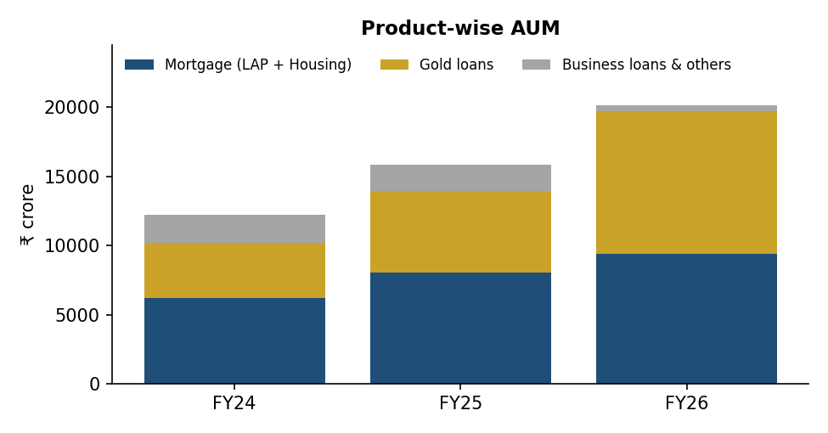
Figure 1: Product-wise AUM, FY24 to FY26 (₹ crore)
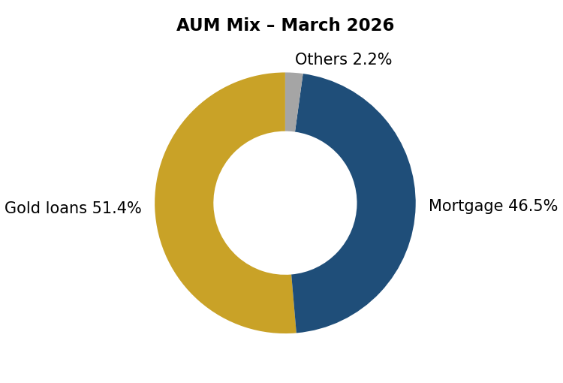
Figure 2: AUM mix as on 31 March 2026
Interpretation
In two years the business has changed shape. Gold loans grew from about one-third of AUM to more than half, while business loans almost disappeared. Mortgage loans continued to grow steadily. The new mix is safer because almost all loans are backed by gold or property, but it also makes the company more dependent on the gold loan market.

4.8 Geography and Distribution
Fedfina’s branches are mainly located in Southern and Western India – states such as Kerala, Tamil Nadu, Karnataka, Andhra Pradesh, Telangana, Maharashtra and Gujarat – with presence across about 17–18 states and union territories. Gold loan branches are spread in semi-urban and urban markets, while MSME hubs are in larger towns. In FY26 the company opened 148 new gold loan branches and also co-located some LAP branches with gold branches to save cost.
Table 18: Branch and employee growth
Particular | FY23 | FY24 | FY25 | FY26
Total branches | 575 | 621 | 694 | 757
Employees | 3,570 | 4,298 | 4,568 | n.a.
AUM per branch (₹ crore) | – | 19.6 | 22.8 | 26.6

Source: Company press releases. AUM per branch = AUM ÷ branches (student calculation).
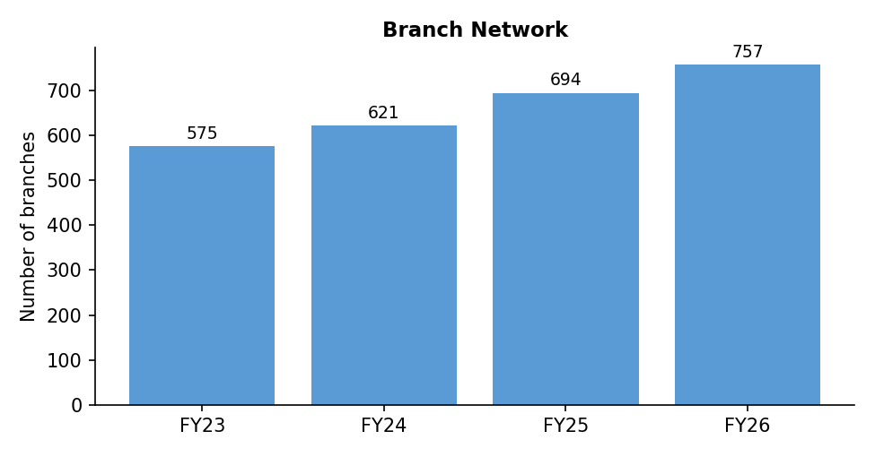
Figure 3: Growth in branch network, FY23 to FY26
The branch network grew by about 32% from FY23 to FY26, while AUM grew much faster. This means each branch is handling more business, which improves productivity and helps profitability.

4.9 How the Company Makes Money
Like any lender, Fedfina earns money mainly from the difference between the interest it charges customers and the interest it pays on its borrowings. It borrows from banks, through non-convertible debentures (NCDs) and commercial papers, and also uses its own capital. It then lends this money at higher rates. After paying for staff, branches, technology and loan losses, the balance is profit.
Table 19: Sources of income
Source | Explanation
Interest income | Interest from gold loans, LAP and housing loans – the biggest source
Fees and charges | Processing fees, valuation charges, late payment charges
Gain on assignment / co-lending | Income earned when loans are sold to banks or co-lent; the company keeps a spread
Other income | Interest on investments and bank deposits

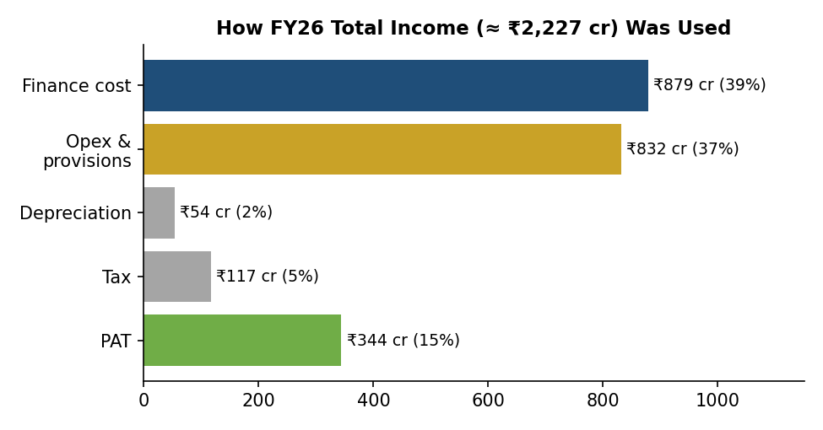
Figure 4: How FY26 total income was used (₹ crore)
Example – where ₹100 of income goes
Out of every ₹100 earned in FY26, about ₹39 was paid as interest to lenders, about ₹37 went for employee costs, branch expenses and loan-loss provisions, ₹2 for depreciation, ₹5 for income tax, and about ₹15 remained as net profit for shareholders.

4.10 Business Model Diagram
Table 20: Business model flow
Inputs | Operations | Products | Customers | Revenue → Profit → Cash
Equity capital, bank loans, NCDs, co-lending partners, employees, branches, technology | Sourcing, gold appraisal, credit assessment, property valuation, disbursement, collection | Gold loans, Doorstep gold loans, LAP, Housing loans | Small businesses, self-employed, salaried, households in semi-urban and urban India | Interest + fees → minus finance cost, opex, credit cost, tax → PAT → retained to grow loan book

In simple words: Money comes in (borrowings + equity) → is lent out as secured loans → customers pay interest and repay → the company pays its lenders and costs → the profit is kept in the business to lend more.

4.11 Profile of the Parent – The Federal Bank Limited
The Federal Bank Limited, headquartered in Aluva, Kerala, is one of India’s leading private sector banks with a large presence in South India and a strong franchise among Non-Resident Indians (NRIs). It is also a major gold lender itself. In FY26 Federal Bank reported its best-ever annual profit of about ₹4,117 crore, and in Q1 FY27 its own gold loan book was about ₹41,476 crore.
Table 21: Relationship between Federal Bank and Fedfina
Area | How Fedfina benefits
Ownership | Federal Bank holds about 60.7% – Fedfina is its key NBFC subsidiary
Brand | Use of the “Fed” name builds trust with customers pledging gold
Funding | Lenders give better rates to a bank-promoted NBFC; Fedfina has one of the lowest borrowing costs among peers
Governance | Bank nominee directors on the board; strong risk and compliance culture
Business | Co-lending and sourcing partnerships possible within the group

At the same time, Fedfina competes with its own parent in gold loans in some markets. The two entities serve slightly different customers – Fedfina focuses more on customers who prefer the speed and flexibility of an NBFC.

4.12 Recent Developments (2025–2026)
Table 22: Important recent developments
Period | Development | Significance
May 2025 | 100% direct assignment of unsecured business loan book (~₹770 crore) | Removed the riskiest part of the book
FY26 | 148 new gold loan branches; some LAP branches co-located with gold branches | Faster gold growth at lower cost
Dec 2025 – Apr 2026 | Credit ratings reaffirmed by CRISIL, ICRA, CARE and India Ratings | Confirms stable credit profile and access to funds
Q4 FY26 | Quarterly PAT crossed ₹100 crore; AUM crossed ₹20,000 crore; gold AUM crossed ₹10,000 crore | Key scale milestones
June 2026 quarter | Change in institutional holding – FII share rose to 9.3% while DII share fell to 10.9% | Change in investor base (as per exchange filings)
July 2026 | Q1 FY27: PAT ₹114.4 crore (+52.5%), AUM ₹21,136 crore (+34.7%); FY27 growth guidance of 20–25% | Momentum continuing
August 2026 | Board to consider raising up to ₹2,500 crore through debt | Funding for growth
September 2026 | 31st AGM held on 29 September 2026; resolutions on borrowings, NCDs and ESOPs | Routine governance approvals

Source: BSE announcements, company press releases and news reports.

5. Financial Products of Fedfina – Explained with Examples
This chapter explains each product in simple language, gives its main features and shows how it works through a practical example with tables and graphs. Interest rates and terms used in examples are illustrative – actual rates depend on the scheme, customer profile and the company’s rate card on the date of the loan.

5.1 Gold Loan
A gold loan is a secured loan where the customer pledges gold jewellery with the company and receives money. The gold is kept safely in the branch strong room. When the customer repays the loan with interest, the gold is returned. Because the loan is fully backed by gold, approval is fast – often within 30 minutes – and documentation is minimal.
Table 23: Gold loan – key features
Feature | Details
Security | Gold ornaments of 18 to 22 carat purity (coins as per RBI limits)
Loan amount | From a few thousand rupees to several lakhs, based on gold weight and purity
LTV | As per RBI directions – up to 85% for small loans (up to ₹2.5 lakh), lower for bigger loans
Tenure | Usually 3 to 12 months; can be renewed
Interest | Varies by scheme – lower rate for lower LTV; monthly, quarterly or bullet payment options
Documents | KYC (Aadhaar, PAN), photograph; no income proof needed for small loans
Repayment options | Pay interest monthly and principal at end; EMI; or bullet (principal + interest at end)
Channels | Branch, Doorstep Gold Loan, mobile app for payments and renewals

Steps in a gold loan
- Customer visits the branch with gold jewellery and KYC documents.
- Gold appraiser checks purity (touchstone / karat meter) and weighs the jewellery, excluding stones.
- Value of gold is calculated using the approved gold rate; eligible loan is calculated as per LTV.
- Customer selects a scheme; loan agreement is signed.
- Money is paid to the bank account (or in cash within legal limits); gold is sealed and stored.
- Customer pays interest/principal; on full repayment, gold is returned. If the loan is not repaid, after notice the gold may be auctioned as per rules.

Example 1: How much loan can a customer get?
Ramesh, a small grocery shop owner, needs money to buy stock before Diwali. He brings 20 grams of 22-carat jewellery (net weight after removing stones). Assume the company’s rate for 22-carat gold is ₹10,000 per gram (illustrative).
Table 24: Gold loan eligibility calculation
Step | Calculation | Amount (₹)
Net weight of gold | 20 grams | –
Value of gold | 20 g × ₹10,000 | 2,00,000
Eligible loan at 75% LTV | ₹2,00,000 × 75% | 1,50,000
Eligible loan at 85% LTV (maximum, small loans) | ₹2,00,000 × 85% | 1,70,000
Loan taken by Ramesh (75% LTV scheme) | – | 1,50,000

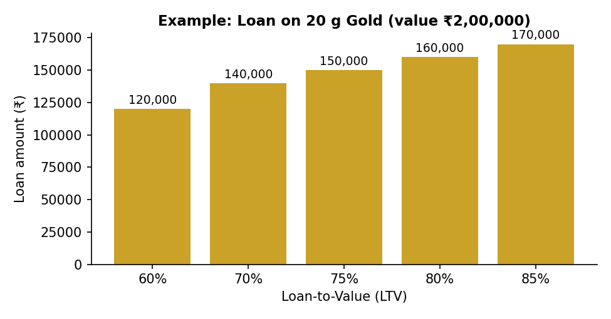
Figure 5: Example – loan available on 20 g of gold at different LTV levels
The graph shows that the higher the LTV, the more money the customer gets. However, schemes with a higher LTV usually carry a higher interest rate because the safety margin for the lender is smaller.

Example 2: Interest cost for different periods
Assume Ramesh’s scheme charges 18% per annum, simple interest, paid at the time of closure.
Table 25: Interest on a ₹1,50,000 gold loan at 18% p.a.
Period | Formula | Interest (₹) | Total repayment (₹)
1 month | 1,50,000 × 18% × 1/12 | 2,250 | 1,52,250
3 months | 1,50,000 × 18% × 3/12 | 6,750 | 1,56,750
6 months | 1,50,000 × 18% × 6/12 | 13,500 | 1,63,500
12 months | 1,50,000 × 18% × 12/12 | 27,000 | 1,77,000

If Ramesh sells his stock during the festival season and repays in three months, he pays only ₹6,750 as interest. This is why gold loans are popular for short-term business needs.

Example 3: Why lenders care about gold prices
If gold prices fall, the value of the security falls but the loan stays the same. This increases the effective LTV. The chart below shows what happens to a loan given at 75% LTV if the gold price falls.
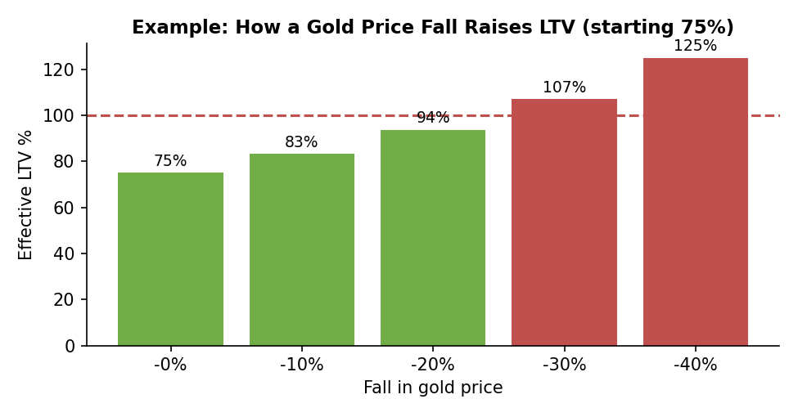
Figure 6: Example – effect of fall in gold price on effective LTV
Table 26: Gold price fall and effective LTV
Fall in gold price | New gold value (₹) | Loan (₹) | Effective LTV
0% | 2,00,000 | 1,50,000 | 75%
10% | 1,80,000 | 1,50,000 | 83%
20% | 1,60,000 | 1,50,000 | 94%
30% | 1,40,000 | 1,50,000 | 107%

After a 30% fall, the gold is worth less than the loan plus interest, and the customer may not want to repay. That is why Fedfina keeps its average portfolio LTV at about 61% (March 2026), much lower than the maximum allowed, and uses short tenures so it can react quickly to price changes.

5.2 Doorstep Gold Loan (DSGL)
Doorstep Gold Loan is a service where a trained Fedfina officer visits the customer’s home or shop with a secure kit, checks the gold, completes the paperwork and transfers money to the customer’s account. The gold is then carried safely to the branch. This product is useful for customers who value privacy or cannot visit a branch, such as busy shopkeepers or elderly people.
Table 27: Branch gold loan vs Doorstep gold loan
Point | Branch gold loan | Doorstep gold loan
Where | At the branch | At customer’s home or shop
Time for customer | Travel + waiting | Saves travel time
Privacy | Customer is seen at a gold loan branch | High privacy
Cost for company | Lower | Higher (staff travel, security) – but higher ticket size
Growth | Main channel | AUM more than doubled in FY26; about 15–17% of gold AUM

5.3 Loan Against Property (LAP)
A loan against property is given against residential or commercial property owned by the customer. Fedfina offers Small-Ticket LAP (generally up to about ₹30 lakh, for small businesses with informal income) and Medium-Ticket LAP (larger loans for established self-employed customers). Over 80% of the mortgage book is backed by self-occupied residential or commercial property, which reduces risk because customers are emotionally and practically attached to the property they live or work in.
Table 28: LAP – key features
Feature | Details
Purpose | Business expansion, working capital, debt consolidation, education, marriage
Security | Residential / commercial property, mostly self-occupied
LTV | Usually 40%–60% of market value of property
Tenure | Up to 15 years
Repayment | Monthly EMI
Assessment | Personal discussion, business visit, cash-flow assessment, legal & technical check of property
Documents | KYC, property papers, bank statements, business proof, ITR (if available)

Example 4: EMI on a loan against property
Mrs. Lakshmi runs a tailoring unit and owns a house worth ₹45 lakh. She takes a LAP of ₹20 lakh (LTV 44%) at 13% per annum for 10 years to buy new machines.
EMI formula: EMI = P × r × (1 + r)^n ÷ [(1 + r)^n – 1], where P = loan amount, r = monthly interest rate, n = number of months.
Table 29: LAP EMI calculation
Item | Value
Loan amount (P) | ₹20,00,000
Interest rate | 13% p.a. → r = 13 ÷ 12 ÷ 100 = 0.010833
Tenure (n) | 10 years = 120 months
Monthly EMI | ₹29,862
Total amount paid (EMI × 120) | ₹35,83,458
Total interest paid | ₹15,83,458

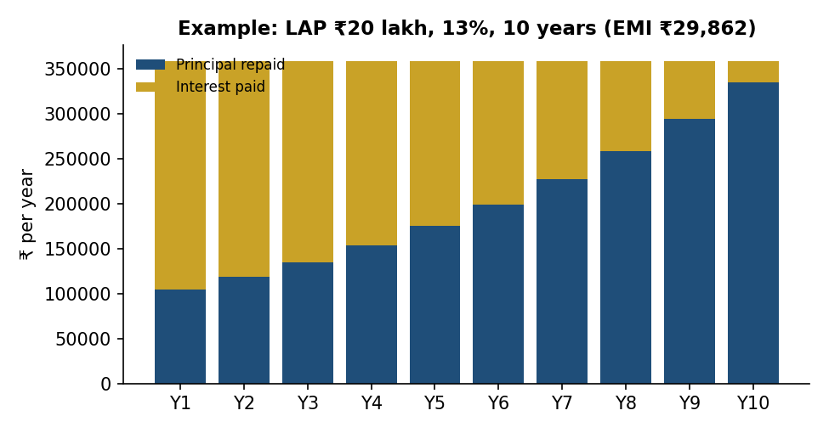
Figure 7: Example – yearly principal and interest paid on a ₹20 lakh LAP
In the early years most of the EMI goes towards interest; in later years more goes towards principal. This is why prepaying a loan in the early years saves a large amount of interest.

Example 5: Effect of tenure and interest rate on EMI
Table 30: EMI on ₹20 lakh LAP at 13% for different tenures
Tenure | Monthly EMI (₹) | Total interest (₹)
5 years | 45,506 | 7,30,369
7 years | 36,384 | 10,56,250
10 years | 29,862 | 15,83,458
15 years | 25,305 | 25,54,872

Table 31: EMI on ₹20 lakh LAP for 10 years at different rates
Interest rate | Monthly EMI (₹) | Total interest (₹)
11% | 27,550 | 13,06,000
13% | 29,862 | 15,83,458
15% | 32,267 | 18,72,039
17% | 34,760 | 21,71,144

A longer tenure reduces the EMI but increases total interest a lot. A 2% higher rate increases the EMI by about ₹2,300–2,500 per month. Customers should therefore compare rates and choose the shortest tenure they can comfortably afford.

5.4 Housing Loan
Fedfina also offers housing loans for buying, building or extending a house, mainly to self-employed and salaried customers in smaller towns who may find it difficult to get a loan from a large bank. Housing loans are part of the mortgage book.
Table 32: Housing loan – key features
Feature | Details
Purpose | Purchase of flat/house, construction, extension, renovation
Tenure | Up to 20 years
LTV | As per RBI/NHB norms, generally up to 75–90% depending on loan size
Repayment | Monthly EMI
Benefits | Tax benefits under Income-tax Act (as applicable); possible PMAY interest subsidy for eligible customers

Example 6: Housing loan EMI
Table 33: Housing loan of ₹15 lakh at 11% p.a.
Tenure | Monthly EMI (₹) | Total interest (₹)
15 years | 17,049 | 15,68,812
20 years | 15,483 | 22,15,878

Increasing the tenure by five years reduces the EMI by only about ₹1,566 per month but adds more than ₹6.4 lakh of interest.

5.5 Business Loan (Unsecured) – Discontinued
Earlier, Fedfina gave unsecured business loans to small and medium enterprises for working capital. These loans did not have collateral and depended only on the business cash flow. In FY25, many small borrowers across the industry were over-borrowed, and stress rose. Fedfina stopped new unsecured disbursements from Q3 FY25 and in May 2025 sold its remaining book of about ₹770 crore through a 100% direct assignment. As a result, business loans fell to about 2% of AUM.

Example 7: Why unsecured loans are riskier
Table 34: Comparison of a ₹5 lakh loan default
Point | Gold loan ₹5 lakh | Unsecured business loan ₹5 lakh
Security held | Gold worth about ₹6.7–8 lakh | None
If customer stops paying | Gold can be auctioned to recover dues | Recovery depends on legal action and follow-up
Likely recovery | Close to 100% | Often low
Interest rate needed | Lower | Higher (often 18–24%) to cover risk

This example explains why the company’s decision to exit unsecured lending reduced its credit costs and improved profits in FY26.

5.6 Co-lending and Direct Assignment
Fedfina also partners with banks through co-lending, where the bank funds most of the loan and Fedfina sources and services it, and through direct assignment, where Fedfina sells loan pools to banks. These off-book arrangements allow the company to grow AUM without using too much of its own capital. In Q1 FY26, off-book AUM was about ₹4,370 crore. During FY26, gold co-lending AUM increased by over ₹1,100 crore.

5.7 Product Comparison Summary
Table 35: Comparison of Fedfina products
Feature | Gold loan | LAP | Housing loan | Business loan
Security | Gold | Property | House being bought/built | None
Ticket size | Small | Medium | Medium | Small–medium
Tenure | 3–12 months | Up to 15 years | Up to 20 years | 1–3 years
Approval time | Minutes | 1–3 weeks | 1–3 weeks | Days
Interest rate | Medium | Medium | Lower | High
Risk to lender | Low | Low–medium | Low | High
Status (2026) | Main growth engine | Core product | Part of mortgage | Discontinued

5.8 Disbursement Trend
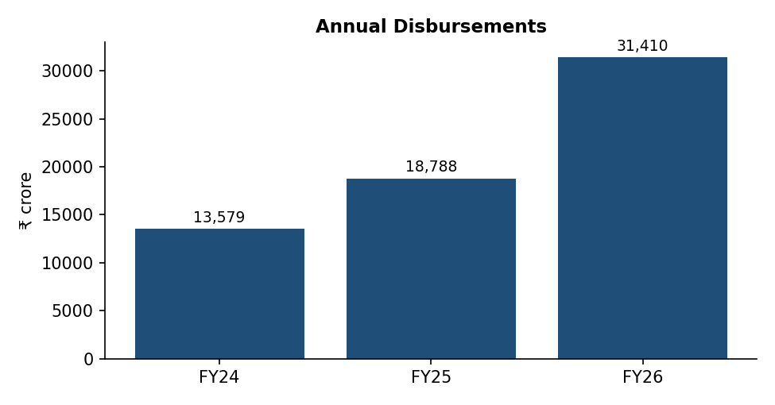
Figure 8: Annual disbursements, FY24 to FY26 (₹ crore)
Disbursements jumped 67% in FY26 to ₹31,410 crore, mainly because gold loans are short-term and are disbursed and repaid several times a year. Q4 FY26 alone saw disbursements of ₹11,664 crore, up 109% year-on-year.

5.9 Gold Loan Repayment Options – Example
Gold loan customers can usually choose how to repay. Taking Ramesh’s loan of ₹1,50,000 at 18% p.a. for 12 months, the three common options compare as follows:
Table 36: Comparison of gold loan repayment options (₹1,50,000, 18%, 12 months)
Option | How it works | Monthly outgo (₹) | Total interest (₹)
Bullet repayment | Pay principal + interest at the end | Nil | 27,000 (simple)
Monthly interest + principal at end | Pay interest every month; principal at end | 2,250 | 27,000
EMI | Fixed monthly amount covering interest and principal | 13,752 | 15,024

The EMI option has the lowest total interest because principal reduces every month. Bullet repayment suits customers who expect a lump sum (for example, after a harvest or festival sale), while monthly interest payments keep the account regular and avoid a large interest build-up. Paying interest on time also protects the customer from auction if gold prices fall.

5.10 Prepayment Example for LAP
Suppose Mrs. Lakshmi (₹20 lakh LAP, 13%, 10 years, EMI ₹29,862) receives a business profit of ₹2 lakh at the end of year 2 and prepays it, keeping the same EMI.
Table 37: Effect of a ₹2 lakh prepayment after 2 years (same EMI)
Particular | Without prepayment | With prepayment
Outstanding after 2 years (₹) | ≈ 17,77,000 | ≈ 15,77,000
Remaining tenure | 96 months | ≈ 79 months
Months saved | – | ≈ 17 months
Approximate interest saved (₹) | – | ≈ 3.1 lakh

A one-time prepayment of ₹2 lakh saves more interest than the amount prepaid. (Figures are approximate. For floating-rate loans to individuals, RBI does not allow prepayment penalties.)

5.11 Customer Profile Examples
Table 38: Which product fits which customer
Customer | Need | Suitable product | Reason
Farmer before sowing season | ₹60,000 for 4 months | Gold loan (bullet) | Quick money, repay after harvest
Kirana shop owner | ₹1.5 lakh stock for festival | Gold loan | Short-term, fast approval
Busy jeweller / trader | ₹5 lakh, privacy needed | Doorstep gold loan | No branch visit, high privacy
Small manufacturer with own factory | ₹25 lakh for machinery | Small/medium-ticket LAP | Long tenure, lower EMI
Self-employed tailor buying first house | ₹15 lakh home | Housing loan | Long tenure; possible tax and subsidy benefits

5.12 Gold Loan Compared with Other Borrowing Options
Many customers who take gold loans could also use a personal loan or a credit card. The example below compares the cost of borrowing ₹1,00,000 for six months, repaid in equal monthly instalments. Rates are illustrative.
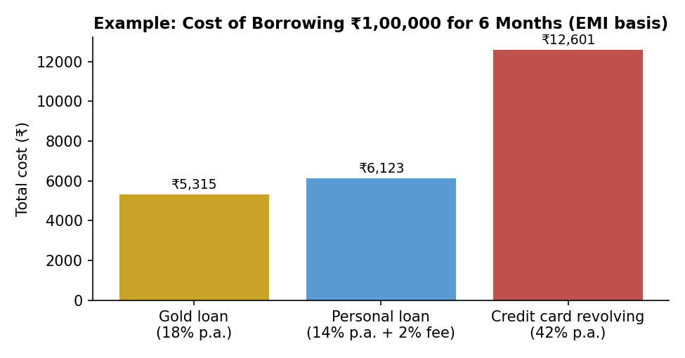
Figure 9: Example – cost of borrowing ₹1 lakh for 6 months
Table 39: Comparison of borrowing options for ₹1,00,000 for 6 months
Option | Assumed rate | Total cost (₹) | Approval time | Documents / credit score
Gold loan | 18% p.a. | 5,315 | 30–60 minutes | KYC only; credit score not critical
Personal loan | 14% p.a. + 2% fee | 6,123 | 1–7 days | Income proof and good credit score needed
Credit card (revolving) | 42% p.a. | 12,601 | Already available (if card held) | Needs existing card and limit

For a customer who owns gold, a gold loan is usually cheaper than revolving credit card debt and comparable to a personal loan, while being much faster and easier to obtain. A personal loan may be cheaper for salaried customers with very good credit scores, but many of Fedfina’s customers are self-employed and may not qualify easily.

5.13 Case Study – A Customer’s Complete Journey
Background: Suresh (name changed for illustration) runs a small electrical goods shop in a town in Maharashtra. In March he gets a large order from a local builder and needs ₹2,50,000 to buy stock. His bank asks for audited accounts, which he does not have.
Table 40: Suresh’s loan journey
Step | What happened
Day 1 – Enquiry | Suresh calls Fedfina’s doorstep gold loan number after seeing an advertisement.
Day 1 – Visit | An officer visits his shop, checks 40 g of 22-carat jewellery and values it at ₹4,00,000 (illustrative rate ₹10,000/g).
Day 1 – Sanction | Suresh chooses a scheme with LTV of about 62.5% (₹2,50,000) at a lower interest rate. KYC is done digitally.
Day 1 – Disbursement | Money is transferred to his bank account within hours; gold is sealed and taken to the branch.
Months 1–3 | Suresh pays interest monthly through the Fedfina app (₹3,750 per month at 18% p.a.).
Month 4 | Builder pays Suresh. He repays ₹2,50,000 and his gold is returned at his shop.

Total cost to Suresh: about ₹15,000 interest for four months (₹3,750 × 4). The order gave him a profit of about ₹60,000. The gold loan helped him earn money he would otherwise have lost. For Fedfina, the loan was fully secured (LTV 62.5%), short-term and profitable – an example of why gold loans are attractive for both sides.

6. PESTLE Analysis and Porter’s Five Forces

6.1 PESTLE Analysis
PESTLE analysis studies the outside (macro) environment in which a company works – Political, Economic, Social, Technological, Legal and Environmental factors.
Table 41: PESTLE analysis of Fedfina
PESTLE factor | Impact on Fedfina | Low / Medium / High | Evidence
Political | Government push for MSME credit, financial inclusion and digital India supports retail lending | Medium | MSME credit schemes, Jan Dhan, Digital India
Economic | Interest rate changes affect borrowing cost; gold price changes affect gold loan size; GDP growth affects MSME demand | High | 89% floating-rate borrowings; gold price rise lifted gold AUM 76% in FY26
Social | Indians hold large amounts of gold and accept gold loans more easily than before; rising aspirations of small-town customers | High | Strong demand for doorstep gold loans
Technological | Digital payments, apps, e-KYC, AI-based credit tools lower cost and improve service | Medium | Fedfina app downloaded over 1.2 million times; 65%+ digital gold payments
Legal | RBI Scale-Based Regulation, gold loan directions, fair practices code, data protection law | High | RBI gold loan directions (2025); DPDP Act
Environmental | Low direct impact; climate events can hurt borrowers in rural areas; ESG expectations of investors rising | Low | BRSR disclosures

6.2 Porter’s Five Forces
Porter’s Five Forces model explains how competitive an industry is and how much profit a company can earn in it.
Table 42: Porter’s Five Forces – gold loan and LAP lending
Force | Assessment | Reason
Threat of new entrants | Medium | Gold loans need trust, strong-rooms, trained appraisers and RBI licence – entry is not easy. But banks and fintech partners are entering actively.
Supplier power (lenders/investors) | Medium | NBFCs depend on banks and bond investors for money. Fedfina’s Federal Bank parentage and good ratings (AA category) reduce this power.
Buyer power (borrowers) | Medium–High | Customers can easily compare gold loan rates and switch at renewal. Large LAP customers bargain hard on rates.
Threat of substitutes | Medium | Personal loans, credit cards, Kisan Credit Cards, selling gold, borrowing from relatives or moneylenders.
Competitive rivalry | High | Muthoot, Manappuram, IIFL, banks (including Federal Bank itself) and many regional players fight for the same customers.

Interpretation
The industry structure allows reasonable but not very high returns for a mid-sized player. Gold loans have strong demand and low credit risk, but rivalry and customer bargaining power put pressure on interest rates. A lender with a low cost of funds and efficient branches can still earn good returns. Fedfina’s advantage is its lower borrowing cost due to its parent; its challenge is to build scale and brand against much larger rivals.

7. SWOT and Management Analysis

7.1 SWOT Analysis
Table 43: SWOT analysis of Fedfina
Strengths | Weaknesses | Opportunities | Threats
Promoted by Federal Bank – trust and low funding cost | Smaller scale than Muthoot and Manappuram | Large untapped gold held by Indian households | Sharp fall in gold prices
99% secured loan book | ROE (12–15%) lower than gold-loan leaders | Expansion into North and East India | Aggressive competition from banks
Balanced mix of gold (short-term) and LAP (long-term) | Rising leverage (D/E ~4.7x) | Doorstep and digital gold loans | Regulatory changes on LTV, auctions, interest
Good capital adequacy (CRAR 22.4%) | Concentration in South and West India | Co-lending partnerships with banks | Rise in MSME stress affecting LAP
Improving asset quality (GNPA 1.55% in Q1 FY27) | No dividend so far | Cross-selling insurance and other products | Interest rate increases raising cost of funds

7.2 Explanation of SWOT
Strengths: The Federal Bank parentage is the single biggest strength. It gives customers confidence to pledge their gold and gives lenders confidence to lend at lower rates. After exiting unsecured loans, almost the entire book is secured, so losses are limited even in bad times.
Weaknesses: Fedfina’s AUM is about one-ninth of Muthoot Finance. Its ROE has improved but is still lower than the gold-loan leaders. Borrowings have grown faster than equity, so leverage is rising.
Opportunities: A large part of gold in India is still not used as collateral. New branches, doorstep service and digital renewals can bring many new customers. Co-lending with banks allows growth without much extra capital.
Threats: Gold loan profits depend on gold prices. A sudden fall can increase LTV and auctions. Many banks have become aggressive in gold loans, and RBI may tighten rules further.

7.3 Management and Governance Checklist
Table 44: Management and governance checklist
Item | Finding
Promoter holding | Federal Bank holds about 60.7% (June 2026) – stable, slight dilution only from ESOPs
Institutional ownership | FIIs 9.3% and DIIs 10.9% (June 2026); total institutions about 20%
Pledge of promoter shares | Nil – promoter is a regulated bank
Board independence | Board includes independent directors and Federal Bank nominees, as required by RBI and SEBI
Related-party transactions | Mainly with Federal Bank (borrowings, co-lending, deposits) – disclosed in the annual report; done at arm’s length
Capital allocation | Profits fully retained (no dividend) to fund loan growth; IPO money used for capital adequacy
Major acquisitions / divestments | Divested unsecured business loan book (~₹770 crore) in May 2025
Auditor observations | No major qualification reported in recent annual reports (to be re-checked in AR FY26)
Credit ratings | Rated in AA category for long-term debt and A1+ for short-term by leading agencies; reaffirmed in Dec 2025–Apr 2026

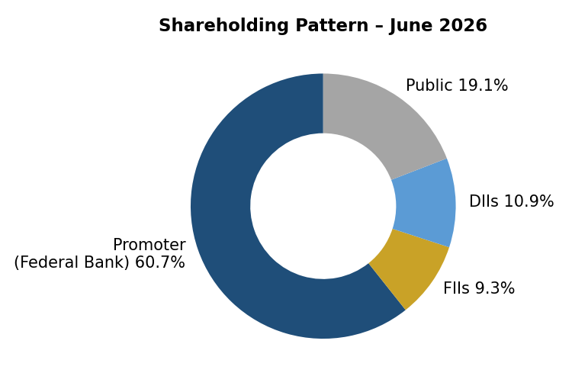
Figure 10: Shareholding pattern – June 2026
Source: BSE shareholding filings via Screener.in.
Researcher’s view
Management appears to allocate capital sensibly. The quick decision to stop unsecured lending when stress appeared, and to sell the book, protected shareholders from larger losses. Strong promoter holding by a regulated bank, no pledge, and good ratings support minority shareholder confidence. The main question is whether the company will start paying dividends once growth stabilises.

8. Financial Performance – Income Statement
All figures are standalone and in ₹ crore unless stated otherwise. For an NBFC, “revenue” is mainly interest income, and “finance cost” is the interest paid on borrowings. Hence the usual EBIT concept is replaced with Financing profit (profit before depreciation, other income and tax) and Pre-provision operating profit.

8.1 Three-Year Income Statement
Table 45: Income statement summary (₹ crore)
Metric | FY24 | FY25 | FY26
Revenue from operations | 1,577 | 2,063 | 2,224
Less: Finance cost | 680 | 854 | 879
Net total income (Revenue – Finance cost) | 897 | 1,209 | 1,345
Less: Operating expenses & provisions | 578 | 873 | 832
Financing profit | 320 | 336 | 513
Add: Other income | 46 | 17 | 3
Less: Depreciation | 37 | 49 | 54
Profit before tax (PBT) | 328 | 304 | 461
Tax | 83 | 79 | 117
Profit after tax (PAT) | 245 | 225 | 344
EPS (₹) | 6.62 | 6.04 | 9.18
EBIT (PBT + Finance cost) | 1,008 | 1,158 | 1,340

Source: Annual reports / Screener.in (standalone). Company-reported FY26 PAT: ₹343.6 crore; FY25: ₹225.2 crore.

8.2 Five-Year Trend
Table 46: Five-year financial trend (₹ crore)
Metric | FY22 | FY23 | FY24 | FY25 | FY26
Revenue | 869 | 1,180 | 1,577 | 2,063 | 2,224
Finance cost | 348 | 472 | 680 | 854 | 879
PBT | 139 | 243 | 328 | 304 | 461
PAT | 103 | 180 | 245 | 225 | 344
EPS (₹) | 3.22 | 5.60 | 6.62 | 6.04 | 9.18
Net worth | 1,154 | 1,356 | 2,260 | 2,548 | 2,926

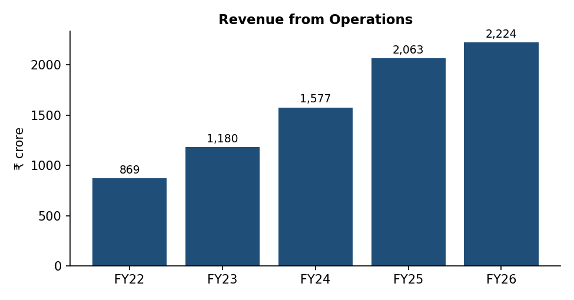
Figure 11: Revenue from operations, FY22 to FY26 (₹ crore)
Revenue grew every year, from ₹869 crore in FY22 to ₹2,224 crore in FY26 – more than 2.5 times. Growth was fastest in FY24 and FY25. In FY26 revenue growth slowed to about 8% because the high-yield unsecured book was sold and gold loans, which earn lower yields than unsecured loans, became the main product.
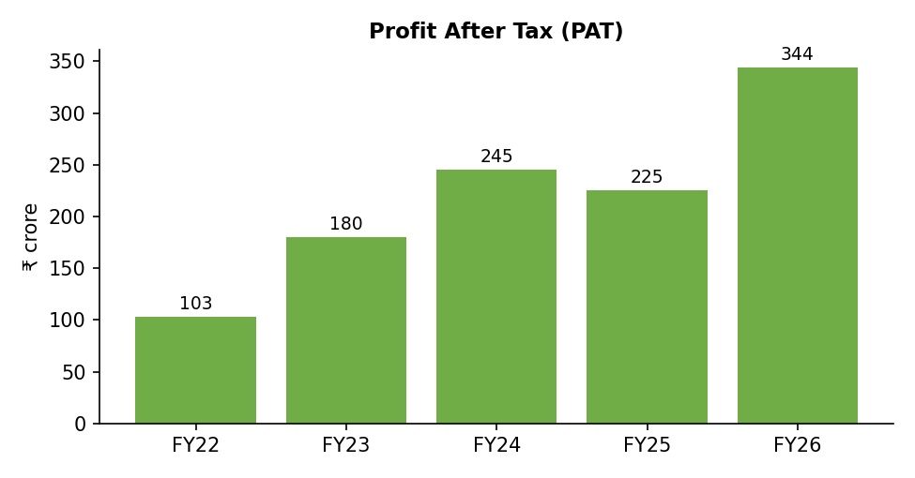
Figure 12: Profit after tax, FY22 to FY26 (₹ crore)
PAT rose strongly till FY24, fell by 8% in FY25 because of higher credit costs in unsecured business loans and small-ticket LAP, and then jumped 52.6% in FY26 to a record ₹343.6 crore as credit costs fell and the gold book grew.

8.3 Growth Calculations
Table 47: YoY growth and CAGR
Metric | FY25 YoY | FY26 YoY | CAGR FY22–26 (4 years)
Revenue | 30.8% | 7.8% | 26.5%
Finance cost | 25.6% | 2.9% | 26.1%
PBT | -7.3% | 51.6% | 35.0%
PAT | -8.0% | 52.6% | 35.2%
EPS | -8.8% | 52.0% | 29.9%
AUM | 29.7% | 27.5% | 28.6% (FY24–26)

Worked example – CAGR of PAT
PAT FY22 = ₹103 crore; PAT FY26 = ₹344 crore; n = 4 years.
CAGR = [(344 ÷ 103)^(1/4) – 1] × 100 = [(3.34)^0.25 – 1] × 100 = (1.352 – 1) × 100 = 35.2%.
This means profit grew, on average, by about 35% every year for four years.

8.4 Quarterly Trend
Table 48: Quarterly results (₹ crore)
Quarter | Revenue | PBT | PAT | GNPA %
Q1 FY25 | 477 | 94 | 70 | 1.97
Q2 FY25 | 513 | 86 | 65 | 1.87
Q3 FY25 | 530 | 25 | 19 | 1.80
Q4 FY25 | 536 | 99 | 72 | 2.02
Q1 FY26 | 517 | 100 | 75 | 1.99
Q2 FY26 | 535 | 107 | 80 | 1.90
Q3 FY26 | 555 | 118 | 88 | 2.06
Q4 FY26 | 616 | 135 | 101 | 1.87
Q1 FY27 | 670 | 153 | 114 | 1.55

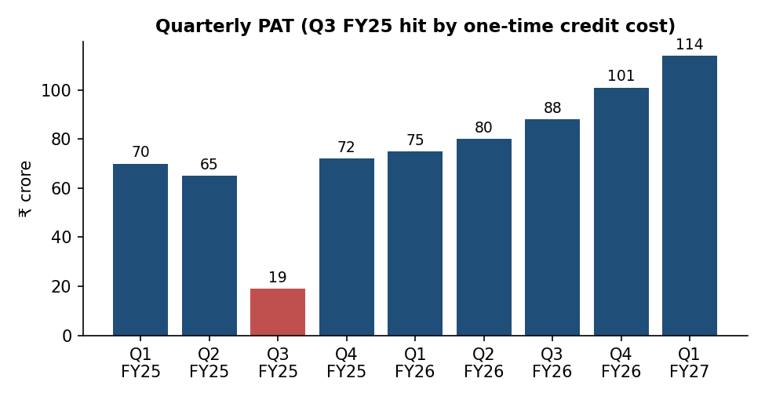
Figure 13: Quarterly PAT, Q1 FY25 to Q1 FY27 (₹ crore)
Q3 FY25 was the weakest quarter, with PAT of only ₹19 crore, due to a one-time increase in provisions on unsecured loans. Since then, profit has increased in every quarter. Q4 FY26 crossed ₹100 crore for the first time and Q1 FY27 reached ₹114 crore – about six times the Q3 FY25 level.
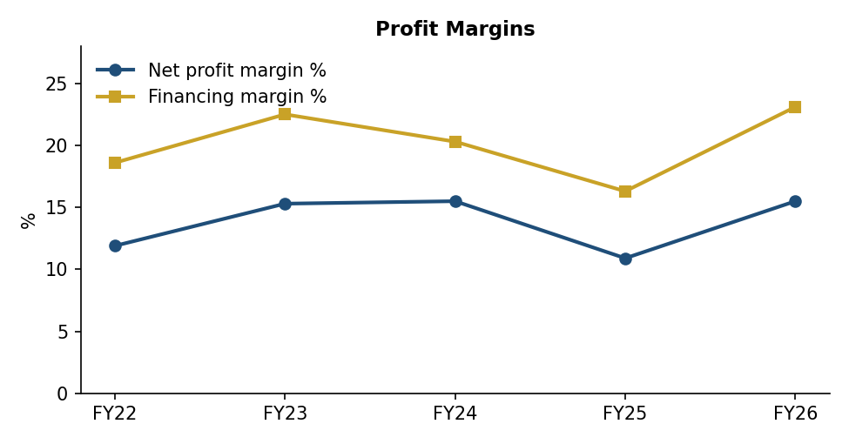
Figure 14: Net profit margin and financing margin, FY22 to FY26
Interpretation
Over FY22–FY26 revenue grew at a CAGR of 26.5% and PAT at 35.2%, so profit grew faster than revenue. Margins fell in FY25 (net margin 10.9%) but recovered to 15.5% in FY26, the same as FY24. The recovery came mainly from lower credit costs and stable finance cost (finance cost grew only 2.9% in FY26 because the company repaid costly borrowings and benefited from falling interest rates). Profit growth is now driven by better asset quality and scale, which appears more sustainable than growth driven by high-yield risky loans.

8.5 Quarterly Deep-Dive
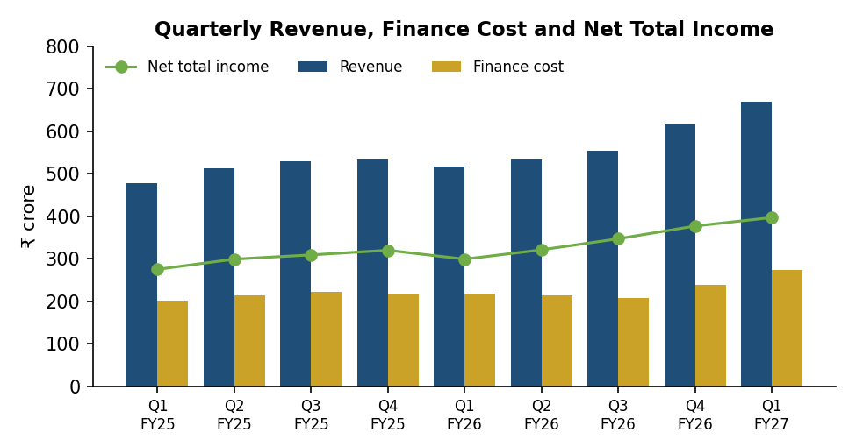
Figure 15: Quarterly revenue, finance cost and net total income (₹ crore)
Quarterly revenue was nearly flat between Q4 FY25 and Q2 FY26 because the high-yield business loan book was being run down and sold. From Q3 FY26 revenue started rising again as gold loans grew rapidly. Finance cost actually fell during FY26 (from ₹218 crore in Q1 to ₹208 crore in Q3) because of lower interest rates and better borrowing terms, before rising in Q4 FY26 and Q1 FY27 with the larger book. As a result, net total income rose from about ₹299 crore in Q1 FY26 to ₹397 crore in Q1 FY27.
Table 49: Q1 FY27 vs Q1 FY26 – key highlights
Metric | Q1 FY26 | Q1 FY27 | Growth
AUM (₹ crore) | 15,697 | 21,136 | 34.7%
Disbursements (₹ crore) | 5,933 | 6,760 | 13.9%
Net interest income (₹ crore) | 268.2 | 371.9 | 38.7%
Operating profit (₹ crore) | ~125 | 187.5 | 49.9%
PAT (₹ crore) | 75.0 | 114.4 | 52.5%
Gross NPA | 1.99% | 1.55% | -44 bps
Net NPA | 1.24% | 0.96% | -28 bps

Source: Company press releases for Q1 FY26 and Q1 FY27. Q1 FY26 operating profit derived from reported growth.
Interpretation
The first quarter of FY27 confirms that the improvement seen in FY26 is not a one-off. Profit grew faster than AUM, and NPAs fell further. If the company can keep quarterly PAT above ₹110–115 crore for the rest of the year, FY27 PAT could be around ₹450–480 crore (student estimate), which would mean an ROE of about 15%.

9. Balance Sheet and Cash Flow Analysis

9.1 Balance Sheet Summary
Table 50: Balance sheet summary (₹ crore)
Metric | FY24 | FY25 | FY26
Equity share capital | 369 | 373 | 374
Reserves and surplus | 1,891 | 2,175 | 2,552
Net worth | 2,260 | 2,548 | 2,926
Borrowings (total debt) | 8,340 | 10,437 | 13,675
Other liabilities | 537 | 265 | 274
Total liabilities & equity | 11,138 | 13,250 | 16,875
Fixed assets (incl. CWIP) | 146 | 190 | 222
Investments | 751 | 404 | 402
Loans and other assets | 10,241 | 12,656 | 16,251
Total assets | 11,138 | 13,250 | 16,875

Source: Annual reports / Screener.in (standalone).
Total assets grew 51% in two years, from ₹11,138 crore to ₹16,875 crore. Almost all assets are loans to customers. Net worth grew from ₹2,260 crore to ₹2,926 crore, entirely from retained profits. Borrowings grew faster (64%), which means the company is using more debt to fund each rupee of loans.
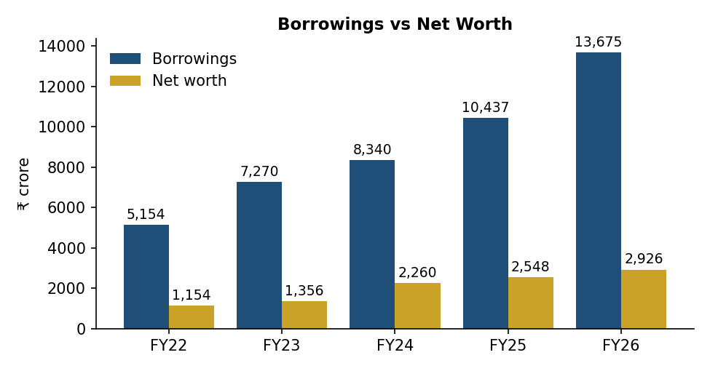
Figure 16: Borrowings vs net worth, FY22 to FY26 (₹ crore)

9.2 Capital Adequacy and Liquidity
Table 51: Capital and funding indicators
Indicator | FY25 | FY26 | Comment
CRAR (%) | 21.9 | 22.4 | Well above RBI minimum of 15%
Borrowings as per company (₹ cr) | 10,269 | 13,484 | Grew 31%
Debt-Equity (x) | 4.10 | 4.67 | Rising but within comfortable range for a secured NBFC
Book value per share (₹) | 68.3 | 78.2 | Up 14.5%
Floating-rate borrowings | – | ~89% | Benefits when rates fall, hurts when rates rise

Gold loans are short-term (3–12 months) and give the company a natural liquidity cushion, because a large part of the book is repaid within a year. This makes asset-liability management easier than for a pure long-term lender.

9.3 Cash Flow Analysis
Table 52: Cash flow summary (₹ crore)
Cash-flow item | FY24 | FY25 | FY26
Operating cash flow | -776 | -978 | -1,664
Investing cash flow | -100 | 329 | -31
Financing cash flow | 967 | 1,187 | 2,310
Net change in cash | 92 | 539 | 615
PAT (for comparison) | 245 | 225 | 344

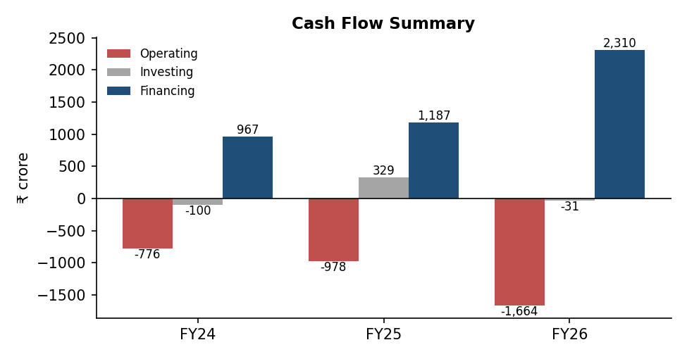
Figure 17: Cash flow summary, FY24 to FY26 (₹ crore)
Interpretation – why operating cash flow is negative
For a manufacturing company, negative operating cash flow is a warning sign. For a growing lender, it is normal. Giving a new loan is an operating activity, so when the loan book grows, cash goes out of operations. In FY26 the loan book grew by about ₹3,600 crore, so operating cash flow was –₹1,664 crore even though PAT was ₹344 crore.
This gap was funded by new borrowings (financing cash flow +₹2,310 crore). The key point for investors is that the growth must be in good-quality loans, otherwise the cash may not come back. The low NPA levels suggest that, so far, loan quality is good.

Example: Simple cash flow of a lender
Table 53: Illustration – a lender’s cash flow in one year
Item | ₹ crore
Interest collected from customers | +200
Interest paid to banks | -80
Staff and other expenses | -60
New loans given (net of repayments) | -400
Operating cash flow | -340
New borrowings from banks | +350
Net cash flow | +10

Even though this lender is profitable (₹200 – ₹80 – ₹60 = ₹60 profit before provisions), its operating cash flow is negative because it gave out ₹400 crore of new loans. This is exactly what happens in Fedfina’s cash flow statement.

9.4 Horizontal (Comparative) Analysis
Horizontal analysis compares each item with the previous year to show the change in rupees and percentage.
Table 54: Comparative income statement FY25 vs FY26 (₹ crore)
Item | FY25 | FY26 | Change (₹) | Change (%)
Revenue | 2,063 | 2,224 | 161 | 7.8%
Finance cost | 854 | 879 | 25 | 2.9%
Net total income | 1,209 | 1,345 | 136 | 11.2%
Opex & provisions | 873 | 832 | -41 | -4.7%
Depreciation | 49 | 54 | 5 | 10.2%
PBT | 304 | 461 | 157 | 51.6%
PAT | 225 | 344 | 119 | 52.9%

Table 55: Comparative balance sheet FY25 vs FY26 (₹ crore)
Item | FY25 | FY26 | Change (₹) | Change (%)
Net worth | 2,548 | 2,926 | 378 | 14.8%
Borrowings | 10,437 | 13,675 | 3,238 | 31.0%
Other liabilities | 265 | 274 | 9 | 3.4%
Total assets | 13,250 | 16,875 | 3,625 | 27.4%
Loans & other assets | 12,656 | 16,251 | 3,595 | 28.4%
Investments | 404 | 402 | -2 | -0.5%

Revenue grew only 7.8%, but profit grew 52.9% because finance cost grew slowly and operating expenses with provisions actually fell. On the balance sheet, loans grew 28.4%, funded mostly by a 31% rise in borrowings.

9.5 Vertical (Common-Size) Analysis
In common-size analysis, each item of the income statement is shown as a percentage of revenue, and each item of the balance sheet as a percentage of total assets. This makes it easy to compare years.
Table 56: Common-size income statement (% of revenue)
Item | FY24 | FY25 | FY26
Revenue | 100.0 | 100.0 | 100.0
Finance cost | 43.1 | 41.4 | 39.5
Opex & provisions | 36.7 | 42.3 | 37.4
Depreciation | 2.3 | 2.4 | 2.4
Other income | 2.9 | 0.8 | 0.1
PBT | 20.8 | 14.7 | 20.7
Tax | 5.3 | 3.8 | 5.3
PAT | 15.5 | 10.9 | 15.5

Table 57: Common-size balance sheet (% of total assets)
Item | FY24 | FY25 | FY26
Net worth | 20.3 | 19.2 | 17.3
Borrowings | 74.9 | 78.8 | 81.0
Other liabilities | 4.8 | 2.0 | 1.6
Total | 100.0 | 100.0 | 100.0
Loans & other assets | 91.9 | 95.5 | 96.3
Investments | 6.7 | 3.0 | 2.4
Fixed assets | 1.3 | 1.4 | 1.3

Interpretation
Finance cost as a share of revenue fell from 43.1% to 39.5% over two years, showing that the company’s borrowing cost has become more favourable. Operating expenses and provisions jumped to 42.3% of revenue in FY25 (because of loan losses) and came back to 37.4% in FY26. On the balance sheet, the share of net worth fell from 20.3% to 17.3% of assets, while borrowings rose to 81% – another way of seeing the rising leverage.

9.6 Trend Analysis Using Index Numbers (FY22 = 100)
Table 58: Trend index (FY22 = 100)
Item | FY22 | FY23 | FY24 | FY25 | FY26
Revenue | 100 | 136 | 181 | 237 | 256
Finance cost | 100 | 136 | 195 | 245 | 253
PAT | 100 | 175 | 238 | 218 | 334
Net worth | 100 | 118 | 196 | 221 | 254
Borrowings | 100 | 141 | 162 | 203 | 265
Total assets | 100 | 138 | 170 | 202 | 257

Index numbers show that over four years PAT grew 3.3 times while revenue grew 2.6 times and total assets 2.6 times. Net worth (2.5 times) has grown a little slower than borrowings (2.7 times). Profit growing faster than assets is a positive sign of improving efficiency.

10. Ratio Analysis

10.1 Ratio Formula Sheet
Table 59: Ratio formula sheet
Ratio | Formula | What it tells you
Debt–Equity | Total Debt ÷ Shareholders’ Equity | Financial leverage
Net Profit Margin | PAT ÷ Revenue × 100 | Profit earned per ₹ of revenue
Operating (EBIT) Margin | EBIT ÷ Revenue × 100 | Core operating profitability
ROE | PAT ÷ Average Equity × 100 | Return on shareholder capital
ROA | PAT ÷ Average Total Assets × 100 | Return on all assets – key for lenders
ROCE | EBIT ÷ Average Capital Employed × 100 | Return on long-term capital (equity + debt)
Asset Turnover | Revenue ÷ Average Total Assets | Asset-use efficiency
Interest Coverage | EBIT ÷ Finance Cost | Ability to service interest
EPS | PAT ÷ Weighted average shares | Earnings per share
P/E | Market Price ÷ EPS | Price paid per ₹ of earnings
P/B | Market Price ÷ Book Value per Share | Price relative to book value
Dividend Yield | DPS ÷ Market Price × 100 | Cash income yield

Important
For banks and NBFCs, the current ratio is not meaningful because their main assets (loans) and liabilities (borrowings) are financial. More useful ratios are capital adequacy (CRAR), NIM, cost of funds, credit cost, GNPA/NNPA, ROA and ROE. These are covered in Chapter 11.

10.2 Ratio Worksheet – Fedfina
Table 60: Ratio worksheet
Ratio | FY24 | FY25 | FY26 | Trend
Operating (EBIT) Margin | 63.9% | 56.1% | 60.3% | Dipped in FY25, recovered
Net Profit Margin | 15.5% | 10.9% | 15.5% | Back to FY24 level
ROE | 13.5% | 9.4% | 12.6% | Recovering
ROA | 2.4% | 1.9% | 2.3% | Recovering
ROCE | 10.5% | 9.8% | 9.1% | Slightly lower
Debt–Equity (x) | 3.69 | 4.10 | 4.67 | Rising
Interest Coverage (x) | 1.48 | 1.36 | 1.52 | Improved
Asset Turnover (x) | 0.156 | 0.169 | 0.148 | Lower (gold yields lower)
EPS (₹) | 6.62 | 6.04 | 9.18 | Strong rise
P/E (x) at ₹150 | – | – | 16.3 (FY26) / 14.7 (TTM) | Moderate
P/B (x) at ₹150 | – | – | 1.92 | Moderate
Dividend yield | 0% | 0% | 0% | No dividend

Source: Student calculations based on standalone annual data. Averages use opening and closing balances.

10.3 Worked Calculations (FY26)
Table 61: Worked ratio calculations for FY26
Ratio | Calculation | Result
Net profit margin | 344 ÷ 2,224 × 100 | 15.5%
EBIT | PBT 461 + Finance cost 879 | ₹1,340 cr
Operating margin | 1,340 ÷ 2,224 × 100 | 60.3%
Average equity | (2,548 + 2,926) ÷ 2 | ₹2,737 cr
ROE | 344 ÷ 2,737 × 100 | 12.6%
Average total assets | (13,250 + 16,875) ÷ 2 | ₹15,063 cr
ROA | 344 ÷ 15,063 × 100 | 2.3%
Capital employed (Mar-26) | 2,926 + 13,675 | ₹16,601 cr
ROCE | 1,340 ÷ avg(12,985, 16,601) × 100 | 9.1%
Debt-equity | 13,675 ÷ 2,926 | 4.67x
Interest coverage | 1,340 ÷ 879 | 1.52x
P/B | 150 ÷ 78.2 | 1.92x

10.4 Interpretation of Key Ratios
1. Net profit margin: Fedfina keeps about ₹15.5 of every ₹100 of revenue as profit in FY26, up from ₹10.9 in FY25. The improvement came from lower loan losses after exiting unsecured loans.
2. Return on equity (ROE): ROE fell to 9.4% in FY25 but recovered to 12.6% in FY26, and the company reported an exit ROE of about 14% in Q4 FY26 and about 15% in Q1 FY27. This is close to the cost of equity for a mid-sized NBFC (around 13–14%), so the company is now beginning to create value for shareholders.
3. Return on assets (ROA): For lenders, an ROA of 2% or more is considered good. Fedfina’s ROA of 2.3–2.5% is healthy for a secured lender, although lower than Muthoot Finance, which earns much higher yields on gold loans with very low operating costs per rupee.
4. Debt-equity: Leverage has risen from 3.7x to 4.7x. This helps ROE (more loans per rupee of capital) but also increases risk. For a secured NBFC with CRAR above 22%, this level is still comfortable, but further increase will need fresh capital or slower growth.
5. Interest coverage: EBIT covers finance cost about 1.5 times. For lenders, this ratio is naturally low because interest is their main cost. The improvement in FY26 shows that earnings grew faster than interest cost.
6. Asset turnover: This fell in FY26 because gold loans earn lower yields than the unsecured loans that were exited. The company has accepted lower yields in exchange for much lower risk.
7. EPS: EPS rose 52% to ₹9.18 in FY26 and annualised Q1 FY27 EPS is above ₹12, showing strong earnings momentum.
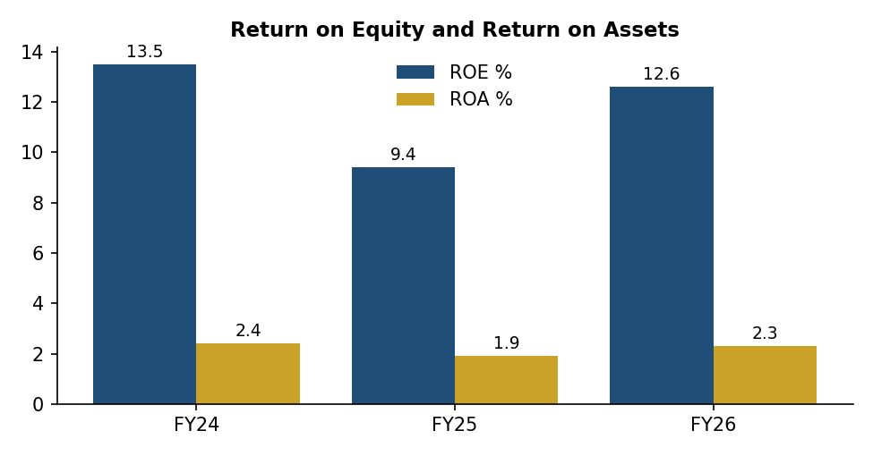
Figure 18: ROE and ROA, FY24 to FY26 (%)
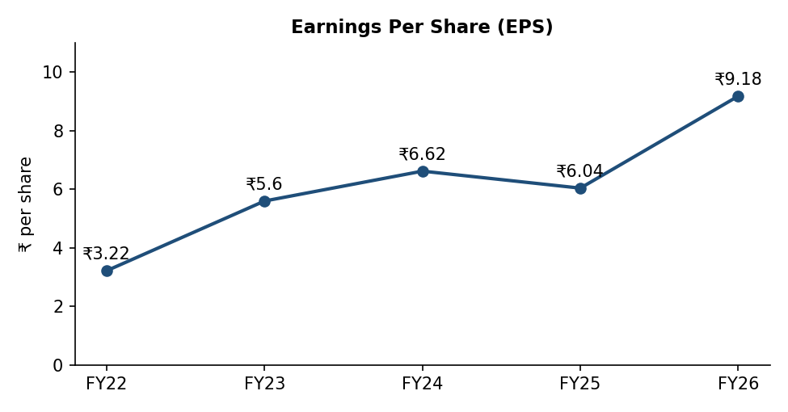
Figure 19: Earnings per share, FY22 to FY26 (₹)

11. NBFC-Specific Performance Indicators
As the template notes, lenders should be judged on industry-specific ratios. This chapter looks at the business, asset quality and capital indicators that RBI, rating agencies and analysts track for NBFCs.

11.1 Key Operating Indicators
Table 62: Key operating indicators
Indicator | FY24 | FY25 | FY26 | Q1 FY27
AUM (₹ crore) | 12,192 | 15,812 | 20,153 | 21,136
AUM growth (YoY) | – | 29.7% | 27.5% | 34.7%
Gold loan AUM (₹ crore) | 3,970 | 5,880 | 10,352 | 11,191
Mortgage AUM (₹ crore) | 6,216 | 8,062 | 9,362 | 9,777
Disbursements (₹ crore) | 13,579 | 18,788 | 31,410 | 6,760 (qtr)
Secured share of AUM | ~85% | 89.5% | ~98% | 99.2%
Branches | 621 | 694 | 757 | –
CRAR | – | 21.9% | 22.4% | –

Source: Company press releases and investor presentations; Q1 FY27 press release (15 July 2026).
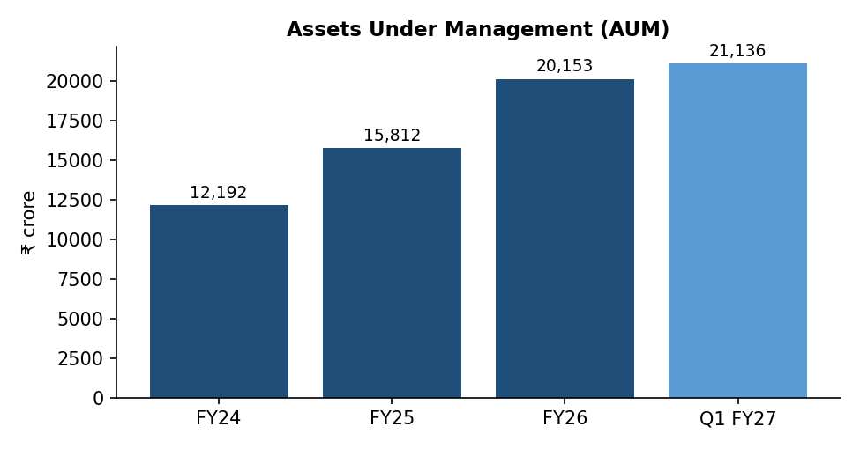
Figure 20: Assets under management, FY24 to Q1 FY27 (₹ crore)
AUM grew at a CAGR of 28.6% between FY24 and FY26. Growth continued strongly into FY27, with AUM up 34.7% year-on-year in June 2026. Management has guided for AUM growth of 20–25% in FY27.

11.2 Asset Quality
Asset quality shows how many loans are not being repaid on time. A loan becomes a Non-Performing Asset (NPA) if interest or principal is overdue for more than 90 days. Gross NPA (GNPA) is the total value of such loans as a percentage of total loans; Net NPA (NNPA) is GNPA minus the provisions kept aside for those loans.
Table 63: Asset quality trend
Indicator | FY24 | FY25 | FY26 | Q1 FY27
Gross NPA (%) | 1.70 | 2.02 | 1.87 | 1.55
Net NPA (%) | 1.30 | 1.22 | 1.28 | 0.96
Credit cost (% of avg. assets) | – | 1.8 | 0.8 | <1

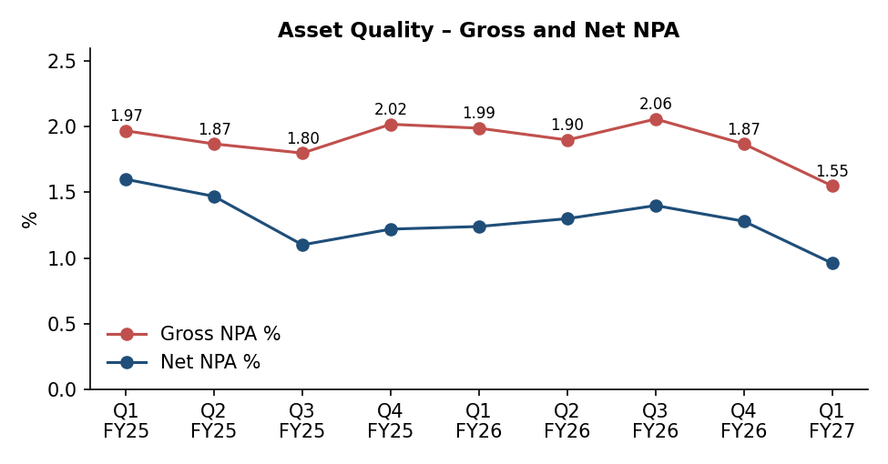
Figure 21: Gross and net NPA, Q1 FY25 to Q1 FY27 (%)
Example – understanding GNPA and NNPA
Suppose a lender has total loans of ₹1,000 crore and loans worth ₹20 crore are overdue by more than 90 days. GNPA = 20 ÷ 1,000 = 2.0%.
If the lender has already set aside ₹8 crore as provision for these bad loans, NNPA = (20 – 8) ÷ (1,000 – 8) = about 1.2%. This is very close to Fedfina’s position in FY25.

Fedfina’s GNPA has stayed around 2% and fell to 1.55% in Q1 FY27 – the lowest in the study period. Credit cost (loan losses as a share of assets) fell from 1.8% in FY25 to 0.8% in FY26. This is the main reason why profit rose so sharply in FY26.

11.3 Profitability Tree
Table 64: Simple profitability tree (FY26, as % of average total assets)
Item | % of average assets | Comment
Revenue (yield on assets) | 14.8% | 2,224 ÷ 15,063
Less: Finance cost | 5.8% | 879 ÷ 15,063
Net total income | 8.9% | Similar to NIM
Less: Opex + credit cost | 5.5% | 832 ÷ 15,063
Less: Depreciation (net of other income) | 0.3% | (54 – 3) ÷ 15,063
PBT | 3.1% | 461 ÷ 15,063
Less: Tax | 0.8% | 117 ÷ 15,063
ROA (PAT) | 2.3% | 344 ÷ 15,063

This tree shows that out of a gross yield of about 14.8% on assets, Fedfina pays about 5.8% to its lenders and spends about 5.5% on operations and loan losses, leaving an ROA of about 2.3%. The biggest lever to improve ROA is to reduce operating cost per rupee of AUM as new branches mature.

11.4 Product-wise Performance Analysis
Table 65: Product-wise AUM growth
Product | FY25 growth | FY26 growth | Q1 FY27 growth (YoY) | Comment
Gold loans | 48.1% | 76.0% | 76.7% | Main growth driver; helped by gold prices and new branches
Mortgage loans | 29.7% | 16.1% | 14.5% | Steady growth with tighter underwriting
Business loans | Run-down | -76.5% | – | Exited; book sold in May 2025
Total AUM | 29.7% | 27.5% | 34.7% | Strong overall growth

Gold loan business
Gold AUM crossed ₹10,000 crore in FY26 and reached ₹11,191 crore in June 2026. Growth came both from higher gold prices (customers get larger loans on the same gold) and from more gold under pledge (tonnage). The company opened 148 gold branches in FY26, and its AUM per branch still improved to about ₹16.5 crore, showing that new branches are ramping up well. Portfolio LTV of about 61% leaves a comfortable cushion.

Mortgage business
Mortgage AUM grew to ₹9,362 crore in FY26 and ₹9,777 crore in June 2026. Medium-ticket LAP grew faster than small-ticket LAP, because the company tightened lending in the small-ticket segment after stress in FY25. Over 80% of mortgage loans are against self-occupied property, which lowers the chance of default.

Quarterly gold AUM build-up in FY26
Table 66: Gold loan AUM through FY26 (₹ crore)
Quarter-end | Gold AUM | Share of total AUM
Mar-25 (Q4 FY25) | 5,880 | 37.2%
Dec-25 (Q3 FY26) | 7,905 | 45.2%
Mar-26 (Q4 FY26) | 10,352 | 51.4%
Jun-26 (Q1 FY27) | 11,191 | ~53%

In Q4 FY26 alone, gold AUM increased by about ₹2,447 crore – the highest quarterly addition in the company’s history.

12. DuPont Analysis
DuPont analysis breaks ROE into three parts so that we can see what is really driving shareholder returns.
DuPont formula
ROE = Net Profit Margin × Asset Turnover × Financial Leverage, where Net Profit Margin = PAT ÷ Revenue; Asset Turnover = Revenue ÷ Average Assets; Financial Leverage = Average Assets ÷ Average Equity.

Table 67: DuPont analysis of Fedfina
Component | Formula | FY24 | FY25 | FY26 | Interpretation
Net Profit Margin | PAT ÷ Revenue | 15.5% | 10.9% | 15.5% | Fell in FY25 due to credit cost; recovered
Asset Turnover | Revenue ÷ Avg Assets | 0.156 | 0.169 | 0.148 | Lower in FY26 as gold yields are lower
Financial Leverage | Avg Assets ÷ Avg Equity | 5.59 | 5.07 | 5.50 | Fell after IPO capital, rising again
ROE | Product of above | 13.5% | 9.4% | 12.6% | Recovery led by margin

Check calculation – FY26
ROE = 15.47% × 0.1477 × 5.50 = 12.6%, which matches the direct calculation of PAT ÷ average equity (344 ÷ 2,737 = 12.6%).
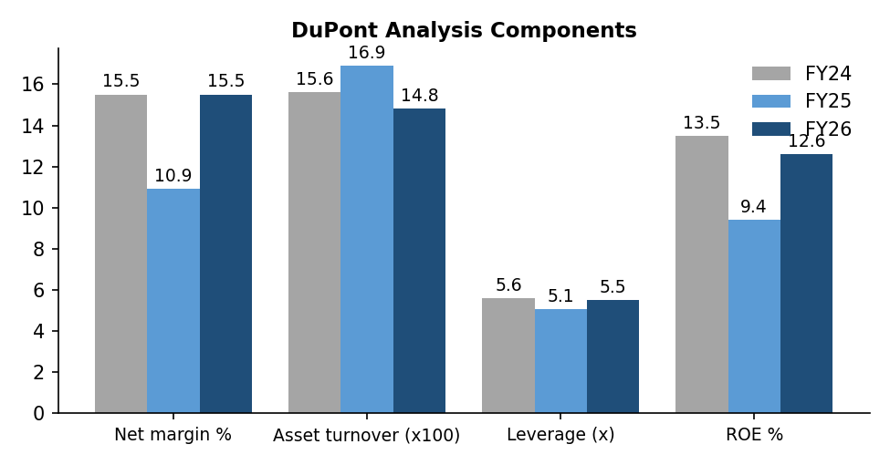
Figure 22: DuPont components, FY24 to FY26
Interpretation
The fall in ROE in FY25 was mainly due to lower profit margin (higher loan losses), not due to lower efficiency or leverage. In FY26, ROE recovered mainly because margin went back to 15.5%. Asset turnover fell slightly because the company moved to lower-yield, lower-risk gold loans. Leverage rose again to 5.5x. So the recovery is driven by better profitability rather than just more debt, which is a healthy sign. However, future ROE gains will need either better cost efficiency or higher leverage – and too much leverage would deserve caution.

13. Peer Comparison and Valuation

13.1 Peer Comparison
Table 68: FY26 peer comparison (consolidated for peers, standalone for Fedfina)
Metric | Fedfina | Muthoot Finance | Manappuram Finance
AUM (₹ crore) | 20,153 | 1,81,916 | 63,798
AUM growth (YoY) | 27.5% | 49% | 48.3%
Gold share of AUM | ~51% | ~91% | ~80%
PAT (₹ crore) | 343.6 | 10,607 | 993
PAT growth (YoY) | 52.6% | 98% | -17.5%
ROE | 12.6% | ~30% | n.a.
Gross NPA | 1.87% | n.a. | n.a.

Source: Company results and earnings call disclosures for FY26; IDBI Capital research note for Muthoot ROE. n.a. = not compared due to non-comparable data.
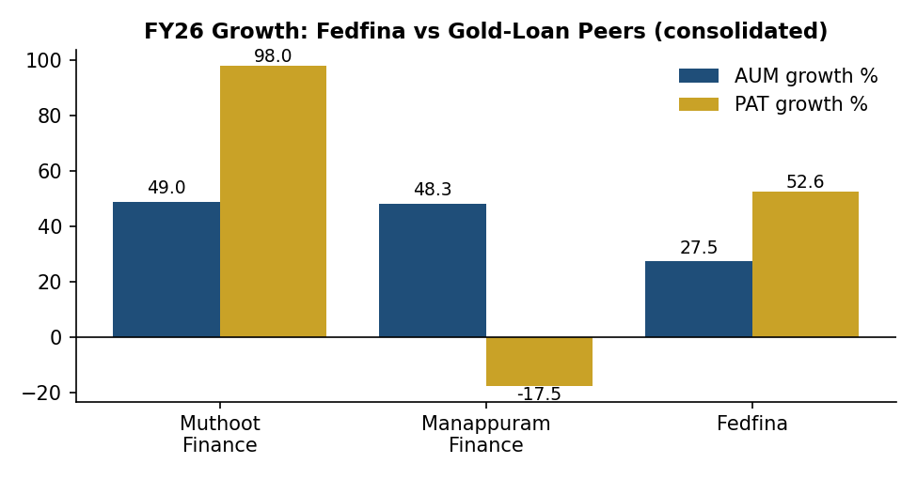
Figure 23: FY26 AUM and PAT growth – Fedfina vs gold-loan peers (%)
Muthoot Finance is in a different league in size and profitability – its consolidated AUM is about nine times Fedfina’s and its ROE is more than double. Manappuram grew AUM fast in FY26 but its profit fell because of losses in its microfinance and vehicle finance businesses. Fedfina sits in the middle: slower AUM growth than the gold-loan leaders (because half its book is mortgage loans that grow more slowly), but strong profit growth and a cleaner, almost fully secured book.

13.2 Relative Valuation
Table 69: Fedfina valuation snapshot (as on 1 October 2026)
Metric | Value | Calculation
Market price | ₹150 | NSE closing
Market capitalisation | ≈ ₹5,628 crore | ₹150 × ~37.5 crore shares
EPS FY26 | ₹9.18 | Annual report
EPS TTM (Jul-25 to Jun-26) | ₹10.23 | Sum of 4 quarters
P/E (FY26) | 16.3x | 150 ÷ 9.18
P/E (TTM) | 14.7x | 150 ÷ 10.23
Book value per share | ₹78.2 | March 2026
P/B | 1.92x | 150 ÷ 78.2
Dividend yield | 0% | No dividend paid

Relative valuation questions
- Premium or discount to peers? Fedfina trades at a lower P/B than Muthoot Finance, which has historically traded at well above 2.5–3x book because of its much higher ROE. A discount is reasonable given the ROE gap.
- Is the valuation justified by growth/profitability? At ~1.9x book with ROE moving towards 14–15% and AUM growth guidance of 20–25%, the valuation looks fair.
- Is it expensive after adjusting for quality? Not expensive, but not deep value either. The market seems to be waiting for consistent ROE above 15%.
- Which metric fits best? For lenders, P/B along with ROE is the most suitable metric, because book value (capital) is the raw material of a lending business. P/E is useful as a secondary check.

13.3 Justified P/B Method (Illustrative)
A simple way to value a lender is the Justified P/B formula: P/B = (ROE – g) ÷ (Ke – g), where ROE = sustainable return on equity, g = long-term growth rate and Ke = cost of equity.
Table 70: Sensitivity of justified P/B (Ke = 13.5%)
Sustainable ROE | g = 9% | g = 10% | g = 11%
13% | 0.89x | 0.86x | 0.80x
15% | 1.33x | 1.43x | 1.60x
17% | 1.78x | 2.00x | 2.40x
18% | 2.00x | 2.29x | 2.80x

The table shows that the current P/B of 1.9x is justified only if the market believes Fedfina can reach a sustainable ROE of about 16–17%. This is above the FY26 ROE but in line with the Q1 FY27 exit ROE of about 15% and management’s aim of further improvement. In other words, the current price already factors in a good part of the expected improvement.
Optional DCF note
DCF (FCFF) is not suitable for lenders because borrowings are part of their raw material, not just financing. Analysts instead use dividend discount models or residual income (excess return) models, which are linked to the P/B–ROE approach used above.

14. Technical Analysis (Price Behaviour)
Technical analysis studies past price and volume to understand the current trend. It should be used only as a supporting tool and never as a guaranteed prediction.
Table 71: Price snapshot (as on 1 October 2026)
Particular | Value
Current price | ₹150
52-week high | ₹178
52-week low | ₹119
Distance from 52-week high | –15.7%
Distance from 52-week low | +26.1%
1-year price return | About –2%

Source: Screener.in / NSE.
Table 72: Technical indicator worksheet
Indicator | Current observation | Interpretation
Price vs 50-DMA | Student to check on NSE/TradingView as on date | Price above 50-DMA = short-term strength
Price vs 200-DMA | Student to check as on date | Price above 200-DMA = long-term uptrend
RSI (14) | Student to check as on date | Above 70 overbought; below 30 oversold
MACD | Student to check as on date | MACD above signal line = positive momentum
Support | ≈ ₹119–125 (52-week low zone) | Buyers have appeared near this level
Resistance | ≈ ₹175–178 (52-week high zone) | Selling pressure seen near this level
Volume trend | Check average volume on result days | Rising volume on up-days is positive

Technical conclusion
The stock is trading roughly in the middle of its 52-week range and is almost flat over one year, even though profit rose more than 50%. Price has been range-bound between about ₹119 and ₹178. A sustained move above ₹178 would signal a breakout; a fall below ₹119 would signal weakness. Fundamentals have improved faster than the share price, which means valuation has become more reasonable over the year.

15. Risk Analysis
Table 73: Risk matrix
Risk | Probability | Impact | Evidence | Mitigation / response
Business risk (gold price) | Medium | High | Gold now >50% of AUM; prices at record highs | Low average LTV (~61%), short tenures, daily price monitoring
Competition | High | Medium | Banks and Muthoot/Manappuram growing gold loans 50%+ | Doorstep service, faster TAT, parent brand
Credit risk (MSME / LAP) | Medium | Medium | FY25 stress in unsecured and ST-LAP | Exit from unsecured; self-occupied property focus
Financial / liquidity risk | Medium | Medium | D/E up to 4.7x; NBFC funding can dry up in crises | CRAR 22.4%; parent support; diversified borrowing; short-term gold book
Interest rate risk | Medium | Medium | ~89% floating-rate borrowings | Reprice loans; match asset-liability tenures
Regulatory risk | Medium | High | RBI gold loan directions 2025; past action on peers | Strong compliance, audit and process standardisation
Currency risk | Low | Low | Domestic business; no major foreign borrowings | Not material
Technology / cyber risk | Medium | Medium | Rising digital transactions | IT security, audits, backup systems
Operational risk (fraud, theft) | Low | Medium | Gold stored in hundreds of branches | Strong-rooms, insurance, dual control, CCTV, audits
ESG / reputational risk | Low | Medium | Auction practices and collection behaviour are sensitive | Fair practices code, grievance redressal
Valuation risk | Medium | Medium | P/B ~1.9x already prices in ROE improvement | Investor should buy on dips

15.1 Risk Conclusion
The two risks most capable of changing the investment thesis are:
- A sharp fall in gold prices – with more than half the book in gold loans, a 20–30% fall in gold prices would slow AUM growth, reduce loan sizes and may increase auctions and losses.
- Regulatory tightening on gold loans – stricter LTV, valuation or auction rules, or a regulatory action like the one faced by a peer in 2024, could hurt growth and profits quickly.

16. ESG and Sustainability
Table 74: ESG review
Dimension | What to examine | Finding | Implication
Environment | Energy, emissions, waste, water | Low direct footprint (offices and branches); digital processes reduce paper use | Low financial risk; scope to finance green housing
Social | Employees, customers, community, diversity | 4,500+ employees; credit to small businesses and under-served customers; CSR activities | Supports financial inclusion and brand trust
Governance | Board, ethics, related parties, transparency | Regulated-bank promoter; independent directors; regular disclosures; good ratings | Reduces governance risk and funding cost

As a listed company, Fedfina publishes a Business Responsibility and Sustainability Report (BRSR) as part of its annual report. For a lender, the most important ESG issues are responsible lending (not over-lending to borrowers), fair recovery and auction practices, data privacy and governance. These are directly linked to reputational and regulatory risk, so they matter financially, not just as a “good to have”.

17. Internship Experience and Learning
[The student should edit this chapter to reflect the actual department, branch and tasks handled during the internship.]

17.1 Work Done During the Internship
- Studied the company’s product brochures, rate cards and credit policies for gold loans and loans against property.
- Observed the gold loan process at the branch – customer KYC, gold appraisal, weighing, purity testing, valuation and sanction.
- Observed the LAP process – lead generation, personal discussion, document collection, legal and technical verification, and credit approval.
- Prepared comparison sheets of gold loan schemes and EMI calculators for LAP and housing loans in MS Excel.
- Collected and analysed the company’s financial statements and investor presentations for FY24–FY26.
- Assisted in customer follow-ups for interest payment reminders and renewals (as allowed by the branch).

17.2 Key Learnings
Table 75: Learning outcomes
Area | Learning
Product knowledge | How gold loans, LAP and housing loans are structured, priced and serviced
Credit assessment | How lenders judge customers without formal income proof – through cash-flow assessment and collateral
Risk management | Why LTV, tenure and collateral type are key to controlling losses
Financial analysis | How to read an NBFC’s financial statements and use NBFC-specific ratios
Soft skills | Customer communication, teamwork, discipline and time management

18. Findings, Suggestions and Conclusion

18.1 Findings
- Fedfina has grown its AUM from ₹12,192 crore (FY24) to ₹20,153 crore (FY26), a CAGR of 28.6%, and to ₹21,136 crore by June 2026.
- The product mix changed sharply: gold loans rose from about 33% to 51% of AUM, while unsecured business loans were almost fully exited. About 99% of the book is now secured.
- PAT fell 8% in FY25 because of stress in unsecured business loans, but rose 52.6% to a record ₹343.6 crore in FY26. Quarterly PAT has risen for seven quarters in a row.
- Revenue CAGR (FY22–26) was 26.5% while PAT CAGR was 35.2%, showing operating leverage and better cost control.
- Asset quality is stable and improving: GNPA 1.87% (FY26) and 1.55% (Q1 FY27); credit cost fell from 1.8% to 0.8%.
- ROE recovered from 9.4% (FY25) to 12.6% (FY26), with exit ROE of about 14–15%. DuPont analysis shows that the recovery came mainly from better margins.
- Leverage is rising (D/E from 3.7x to 4.7x), but capital adequacy is strong at 22.4%.
- Operating cash flow is negative because the loan book is growing; this is normal for a lender and is funded by borrowings.
- Compared with peers, Fedfina is smaller and less profitable than Muthoot Finance but has a cleaner balance sheet than Manappuram (which had subsidiary losses).
- At ₹150 the stock trades at about 1.9x book and 14.7x TTM earnings – fair value for an ROE of 15–17%.

18.2 Suggestions
- Control operating costs: As the 148 new gold branches mature, the company should track cost-to-AUM closely to lift ROA towards 3%.
- Keep LTV discipline: Gold prices are at record levels. The company should maintain conservative LTV and avoid chasing growth through high-LTV schemes.
- Grow mortgage loans steadily: Mortgage loans provide long-term stable income and balance the short-term gold book. Moderate growth with strict underwriting is advisable.
- Expand geographically: Opening branches in under-served states of North and East India can reduce concentration risk.
- Increase digital adoption: More online renewals, part-payments and top-ups through the app can reduce branch visits and cost.
- Diversify funding: Increase long-term NCDs and co-lending to manage the rising debt-equity ratio and interest rate risk.
- Cross-sell: Offer insurance and other fee-based products to existing gold and LAP customers to increase non-interest income.
- Shareholder returns: Once ROE stabilises above 15%, the company may consider a modest dividend policy to reward shareholders.
- Customer awareness: Educate customers on gold price risk, auction rules and EMI planning to build trust and reduce defaults.

19. Investment Thesis and Final View
Table 76: Investment thesis
Question | Response
Strongest reason to own the stock? | Clean, secured book with strong profit momentum and Federal Bank parentage
Biggest reason not to own it? | High dependence on gold prices and intense competition; ROE still below leaders
What could drive earnings higher? | Maturing new branches, lower credit cost, co-lending fee income, rate cuts
What could cause earnings to disappoint? | Gold price fall, regulatory changes, rise in LAP delinquencies, funding cost rise
Is valuation attractive? Why? | Fair – P/B 1.9x requires sustainable ROE of 16–17%
Appropriate investment horizon | 2–3 years
BUY / HOLD / SELL / NOT RATED | HOLD / ACCUMULATE ON DIPS (academic view only)
Valuation range (illustrative) | ₹150–₹180 (1.7x–2.0x estimated FY27 book of ~₹90)
Catalysts | Quarterly PAT above ₹120 crore, ROE above 15%, dividend initiation, inclusion in larger indices
Triggers for thesis failure | GNPA above 3%, gold price crash, regulatory action, CRAR below 18%

19.1 Final Researcher’s View
Fedbank Financial Services Limited has come out of a difficult FY25 as a stronger and safer company. By exiting unsecured business loans and building its gold loan franchise, it has transformed its balance sheet into an almost fully secured loan book. The results are visible: record profit of ₹343.6 crore in FY26, falling NPAs and rising return ratios. The first quarter of FY27 confirms that this improvement is continuing.
The company’s biggest advantage is its relationship with Federal Bank, which gives it trust among customers and lower borrowing costs. Its main challenges are its smaller size compared with market leaders, rising leverage and a growing dependence on gold prices.
From a research point of view, the stock appears fairly valued at around ₹150. A long-term investor may consider accumulating on price dips, while tracking quarterly ROE, asset quality and gold price trends. This view is purely academic and is not an investment recommendation.

19.2 Conclusion
This study set out to understand the financial products and the performance of Fedbank Financial Services Limited. The study found that the company offers simple, secured and customer-friendly products – gold loans, doorstep gold loans, loans against property and housing loans – that meet the needs of small businesses and households in emerging India. Practical examples showed how loan eligibility, interest cost and EMIs work for the customer, and why collateral and LTV are important for the lender.
The financial analysis showed strong growth in AUM, revenue and profit over five years, a temporary setback in FY25 and a sharp recovery in FY26. Ratio and DuPont analysis showed that profitability has improved mainly due to better margins and lower credit costs, while leverage has risen moderately. Overall, Fedfina is a financially sound, well-capitalised NBFC with good growth prospects, provided it maintains risk discipline in its gold loan and mortgage businesses.

Bibliography

Company and Exchange Sources
- Fedbank Financial Services Ltd – Annual Reports FY2023-24, FY2024-25 and FY2025-26.
- Fedbank Financial Services Ltd – Investor Presentations: Q4 FY25, Q3 FY26, Q4 FY26 (www.fedfina.com).
- Fedbank Financial Services Ltd – Press Releases: Q2 FY25, Q1 FY26, Q1 FY27; Q4 FY26 earnings call transcript.
- BSE / NSE corporate filings – shareholding pattern and financial results (symbol FEDFINA, code 544027).
- Screener.in – Fedbank Financial Services Ltd company page (data as on 1 October 2026).

Rating Agency and Research Reports
- CARE Ratings – Press release on Fedbank Financial Services Ltd (October 2025).
- ICRA – Rating rationale on Fedbank Financial Services Ltd (December 2025).
- ICICI Securities – Fedbank Financial Services Results Update (15 July 2026).
- IDBI Capital – Muthoot Finance Q4 FY26 Result Review.

Peer and Industry Sources
- Muthoot Finance Ltd – Q4 FY26 results and earnings call.
- Manappuram Finance Ltd – Q4 FY26 investor presentation and earnings call.
- Reserve Bank of India – Scale-Based Regulation framework for NBFCs; Directions on lending against gold (2025); Financial Stability Reports.
- Federal Bank Ltd – Q1 FY27 investor presentation.

Books
- Khan, M.Y. and Jain, P.K. – Financial Management, McGraw Hill.
- Bhole, L.M. and Mahakud, J. – Financial Institutions and Markets, McGraw Hill.
- Damodaran, A. – Investment Valuation, Wiley.

Annexure I: Glossary and Abbreviations
Table 77: Abbreviations used
Abbreviation | Full form
AUM | Assets Under Management
BRSR | Business Responsibility and Sustainability Report
CAGR | Compound Annual Growth Rate
CRAR | Capital to Risk-weighted Assets Ratio
DA | Direct Assignment
DMA | Daily Moving Average
DSGL | Doorstep Gold Loan
EMI | Equated Monthly Instalment
EPS | Earnings Per Share
GNPA / NNPA | Gross / Net Non-Performing Assets
IPO | Initial Public Offer
KYC | Know Your Customer
LAP | Loan Against Property
LTV | Loan to Value
MSME | Micro, Small and Medium Enterprises
NBFC | Non-Banking Financial Company
NCD | Non-Convertible Debenture
NII | Net Interest Income
NIM | Net Interest Margin
PAT / PBT | Profit After Tax / Profit Before Tax
P/B, P/E | Price to Book, Price to Earnings
RBI | Reserve Bank of India
ROA / ROE / ROCE | Return on Assets / Equity / Capital Employed
SBR | Scale-Based Regulation
TTM | Trailing Twelve Months
YoY / QoQ | Year-on-Year / Quarter-on-Quarter

Annexure II: Five-Year Data Sheet
Table 78: Five-year data sheet (₹ crore, standalone)
Item | FY22 | FY23 | FY24 | FY25 | FY26
Revenue | 869 | 1,180 | 1,577 | 2,063 | 2,224
Finance cost | 348 | 472 | 680 | 854 | 879
Opex & provisions | 359 | 442 | 578 | 873 | 832
Financing profit | 162 | 266 | 320 | 336 | 513
Other income | 14 | 19 | 46 | 17 | 3
Depreciation | 37 | 42 | 37 | 49 | 54
PBT | 139 | 243 | 328 | 304 | 461
PAT | 103 | 180 | 245 | 225 | 344
Equity capital | 322 | 322 | 369 | 373 | 374
Reserves | 832 | 1,034 | 1,891 | 2,175 | 2,552
Borrowings | 5,154 | 7,270 | 8,340 | 10,437 | 13,675
Total assets | 6,556 | 9,071 | 11,138 | 13,250 | 16,875
Operating cash flow | -578 | -1,474 | -776 | -978 | -1,664
Financing cash flow | 535 | 1,632 | 967 | 1,187 | 2,310

Source: Screener.in (standalone data from annual reports).

Annexure III: Customer Feedback Questionnaire (Format)
[This questionnaire format may be used if the student collects primary data from branch customers. Results should be added only if the survey is actually conducted.]
- Name (optional): ____________ Age group: □ Below 25 □ 25–40 □ 41–60 □ Above 60
- Occupation: □ Business □ Self-employed □ Salaried □ Farmer □ Homemaker □ Other
- Which Fedfina product do you use? □ Gold loan □ Doorstep gold loan □ LAP □ Housing loan
- Purpose of loan: □ Business □ Medical □ Education □ Agriculture □ Family function □ Other
- How did you come to know about Fedfina? □ Branch □ Friends/relatives □ Advertisement □ Federal Bank □ Online
- Rate the time taken to approve your loan: □ Very fast □ Fast □ Average □ Slow
- Rate the interest rate compared with other lenders: □ Lower □ Same □ Higher □ Don’t know
- Rate the behaviour of staff: □ Excellent □ Good □ Average □ Poor
- Do you use the Fedfina mobile app for payments? □ Yes □ No
- Would you recommend Fedfina to others? □ Yes □ No □ Maybe
- Overall satisfaction (1 = very poor, 5 = excellent): □1 □2 □3 □4 □5
- Suggestions for improvement: ______________________________________________

Annexure IV: Ratio Workings for FY24 and FY25
Table 79: Worked ratio calculations – FY24
Ratio | Calculation | Result
Net profit margin | 245 ÷ 1,577 × 100 | 15.5%
EBIT | PBT 328 + Finance cost 680 | ₹1,008 cr
Operating margin | 1,008 ÷ 1,577 × 100 | 63.9%
Average equity | (1,356 + 2,260) ÷ 2 | ₹1,808 cr
ROE | 245 ÷ 1,808 × 100 | 13.5%
Average total assets | (9,071 + 11,138) ÷ 2 | ₹10,105 cr
ROA | 245 ÷ 10,105 × 100 | 2.4%
Average capital employed | [(1,356 + 7,270) + (2,260 + 8,340)] ÷ 2 | ₹9,613 cr
ROCE | 1,008 ÷ 9,613 × 100 | 10.5%
Debt-equity | 8,340 ÷ 2,260 | 3.69x
Interest coverage | 1,008 ÷ 680 | 1.48x
Asset turnover | 1,577 ÷ 10,105 | 0.156x

Table 80: Worked ratio calculations – FY25
Ratio | Calculation | Result
Net profit margin | 225 ÷ 2,063 × 100 | 10.9%
EBIT | PBT 304 + Finance cost 854 | ₹1,158 cr
Operating margin | 1,158 ÷ 2,063 × 100 | 56.1%
Average equity | (2,260 + 2,548) ÷ 2 | ₹2,404 cr
ROE | 225 ÷ 2,404 × 100 | 9.4%
Average total assets | (11,138 + 13,250) ÷ 2 | ₹12,194 cr
ROA | 225 ÷ 12,194 × 100 | 1.8%
Average capital employed | [(2,260 + 8,340) + (2,548 + 10,437)] ÷ 2 | ₹11,793 cr
ROCE | 1,158 ÷ 11,793 × 100 | 9.8%
Debt-equity | 10,437 ÷ 2,548 | 4.10x
Interest coverage | 1,158 ÷ 854 | 1.36x
Asset turnover | 2,063 ÷ 12,194 | 0.169x

Note: ROA for FY25 is 1.85%, shown as 1.9% in the ratio worksheet after rounding; the company reported 1.8%.

Annexure V: Glossary of Important Terms
Table 81: Glossary
Term | Explanation in simple words
Appraiser | A trained staff member who checks the purity and weight of gold.
Auction | Sale of pledged gold by the lender when the loan is not repaid even after notices, as per RBI rules.
Book value per share | Net worth divided by number of shares – what each share is worth as per the balance sheet.
Co-lending | A partnership where a bank and NBFC jointly give a loan; usually the bank funds 80% and the NBFC 20%.
Cost of funds | Average interest rate the company pays on its borrowings.
Credit cost | Loan losses and provisions as a percentage of loans or assets.
Disbursement | Money actually paid out as new loans during a period.
ECL (Expected Credit Loss) | Ind-AS method under which lenders set aside provisions for expected future losses.
Karat | Measure of gold purity; 24 karat is pure gold, 22 karat is about 91.6% pure.
Net interest margin | Net interest income as a percentage of average loans – a measure of lending spread.
Off-book AUM | Loans sourced and serviced by the company but sold or co-lent, so they are not fully on its balance sheet.
Provision | Money set aside from profit to cover possible loan losses.
SARFAESI Act | Law that allows lenders to take possession of and sell secured property without going to court, subject to conditions.
Self-occupied property | A house or shop that the borrower lives in or works from.
Stage 3 assets | Ind-AS term for credit-impaired loans – broadly equal to NPAs.
Tonnage | Total weight of gold held as security by the lender.
Yield | Interest earned as a percentage of loans.

Annexure VI: Excel Formulas Used in the Report
The following MS Excel formulas can be used to reproduce the calculations in this report.
Table 82: Useful Excel formulas
Purpose | Excel formula | Example used in report
EMI | =PMT(rate/12, months, -loan) | =PMT(13%/12,120,-2000000) → ₹29,862
Total interest | =PMT(...)*months – loan | =29862*120-2000000 → ₹15,83,458
Simple interest | =Principal*Rate*Months/12 | =150000*18%*6/12 → ₹13,500
YoY growth | =(Current/Previous)-1 | =(2224/2063)-1 → 7.8%
CAGR | =(End/Start)^(1/n)-1 | =(344/103)^(1/4)-1 → 35.2%
Average balance | =AVERAGE(Opening, Closing) | =AVERAGE(2548,2926) → 2,737
ROE | =PAT/Average equity | =344/2737 → 12.6%
Loan eligibility (gold) | =Weight*Rate per gram*LTV | =20*10000*75% → ₹1,50,000
Justified P/B | =(ROE-g)/(Ke-g) | =(17%-10%)/(13.5%-10%) → 2.0x

