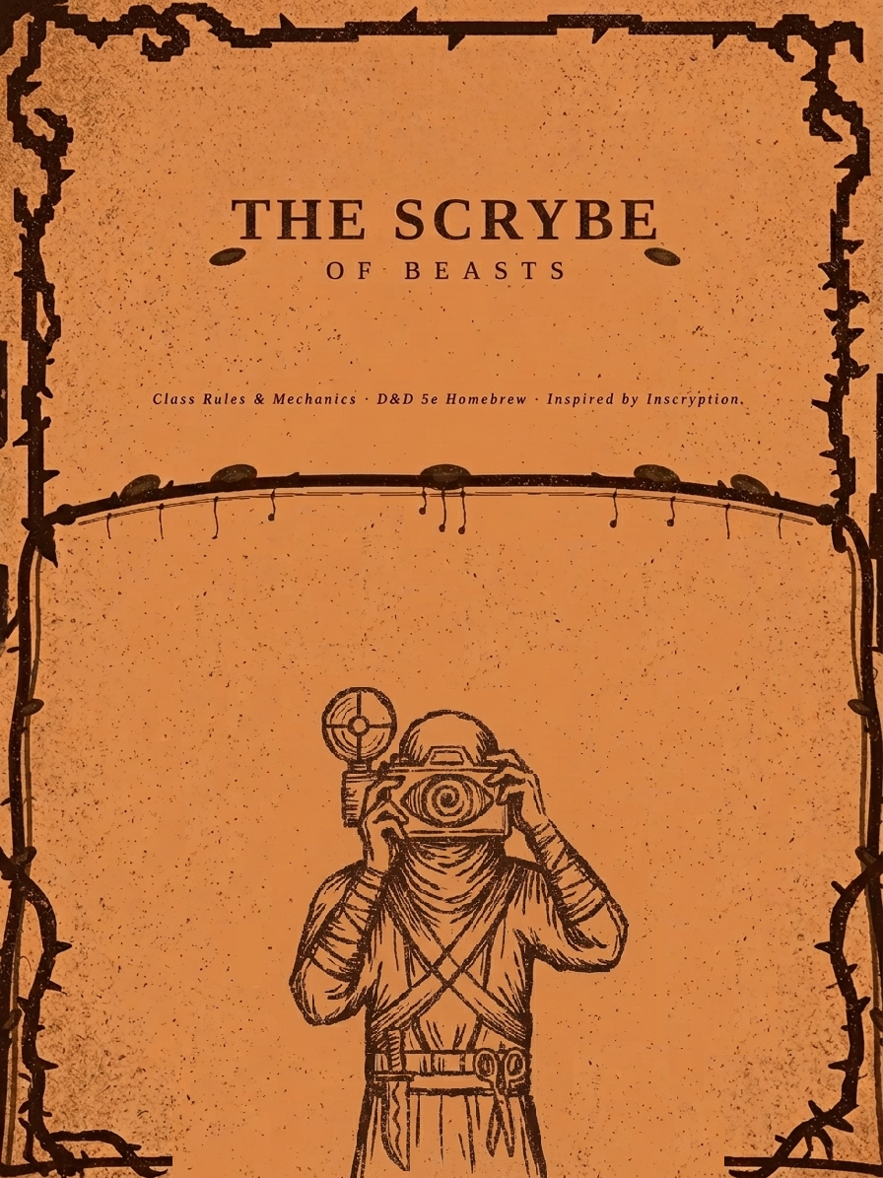
THE SCRYBE OF BEAST
Class Rules & Mechanics
Inspired by Inscryption • D&D 5e Homebrew • Standalone Class

Overview
"There never seems to be enough time to do the things you want to do... once you've found them."
— Leshy

The Scrybe is a D&D 5e standalone class inspired by the game Inscryption. Where wizards study spells and fighters perfect their sword arm, the Scrybe inscribes and collects cards. Armed with a magical Camera, they rip living entities from reality and bind their essence into Inscription Cards and growing deck of creatures they can summon, sacrifice, and evolve in combat.

The Scrybe has no spells. Their power comes entirely from their deck: playing cards by spending Blood, gained by sacrificing their own creatures with a ritual knife, and Bones collected when their summons fall. Between encounters, the Scrybe grows stronger through Sigil Altars, Campfires, Scissors, and the favor of gods, with each carrying risk as well as reward.

Core Class Statistics

Hit Die | d8 per Scrybe level
Hit Points at 1st Level | 8 + your Constitution modifier
Hit Points at Higher Levels | 1d8 (or 5) + your Constitution modifier per Scrybe level after 1st
Primary Ability | Wisdom
Saving Throw Proficiencies | Wisdom and Intelligence

Proficiencies
Armour | Light armour, medium armour. The Scrybe can wear metal armor, but it is not recommended, as camera shots will take 1 turn longer
Weapons | Daggers, darts, javelins, quarterstaffs, slings, spears, bows
Tools | Herbalism Kit.
Skills | Choose two from: Animal Handling, Arcana, Insight, Nature, Perception, Stealth, Survival.

Starting Equipment
You begin play with the following:

The Camera (see below)
The Sacrificial Knife (see below)
Blowgun, 20 darts
Leather armour
Explorer's Pack (backpack, bedroll, mess kit, tinderbox, 10 torches, 10 days rations, waterskin, 50 ft rope)
Herbalism Kit
A pair of scissors
Card Deck Holder

Level Progression

Level | Prof. Bonus | Hit Die | Bone Limit | Features Gained
1 | +2 | d8 | 10 | The Camera, Inscription Cards, Blood & Bones, Sacrificial Knife
2 | +2 | d8 | 12 | Keen Eye (advantage on Camera checks if target is unaware)
3 | +2 | d8 | 14 | Steady Hand (Camera concentration saves: advantage)
4 | +2 | d8 | 16 | Ability Score Improvement
5 | +3 | d8 | 18 | Extra Capture (Camera takes 4 turns instead of 5)
6 | +3 | d8 | 20 | Blood Ritual (Knife grants 2 Blood on a roll of 5+ on d6)
7 | +3 | d8 | 22 | Instynct (+1 to all Camera WIS checks)
8 | +3 | d8 | 24 | Ability Score Improvement
9 | +4 | d8 | 26 | Bone Hoard (Bones reset after Short Rest, not only Long Rest)
10 | +4 | d8 | 28 | Sigil Mastery (Sigil Cap increases from 3 to 5 per card)
11 | +4 | d8 | 30 | Swift Capture (Camera takes 3 turns instead of 4)
12 | +4 | d8 | 32 | Ability Score Improvement
13 | +5 | d8 | 34 | Deeper Focus (Camera concentration DC drops from 14 to 11)
14 | +5 | d8 | 36 | Bone Lord’s Boon (once per Long Rest, gain 3 Bones as a free action)
15 | +5 | d8 | 38 | Ambidextrous (draw 2 cards per turn instead of 1)
16 | +5 | d8 | 40 | Ability Score Improvement
17 | +6 | d8 | 42 | Snap-Shot (Camera takes 2 turns instead of 3)
18 | +6 | d8 | 44 | Unyielding Deck (cards destroyed by Campfire are instead merely Smoked — see feature)
19 | +6 | d8 | 46 | Ability Score Improvement
20 | +6 | d8 | No limit | No Shot (Be able to capture any inanimate entity)

The Camera
"Another challenger... it has been ages. Perhaps you have forgotten how this game is played. Allow me to remind you."
— Leshy

The Camera is the Scrybe's defining tool. It can rip any living entity from reality and bind its essence into an Inscription Card.

How Capture Works
Range | You must be within 30 feet of the target.
Time | Taking the photo requires 30 seconds of uninterrupted focus. In combat this costs your full Action each turn for 5 consecutive turns (reduced by class features at higher levels).
The Roll | At the end of the process, make a Wisdom (Perception) check vs. DC 12 + the target's CR (minimum DC 12).
On a Success | The entity instantly vanishes and becomes an Inscription Card. All stats, abilities, attacks, immunities, and traits are preserved. When summoned it appears as a full black-and-white version of its true shape and features, all color bleached away like a living photograph. You can only capture one entity per photo. The camera has unlimited film
On a Failure | The shutter clicks. The card is either completely blank or has accidentally framed something else. Blank and blurred cards do nothing — they cannot be played, used, combined, or sacrificed in any way. The time is spent regardless.

Capturing in Combat
You may attempt to capture a target mid-combat. Each of the required turns costs your full Action. If you take damage during any of those turns, make a DC 14 Constitution saving throw or the process resets and you must start from turn 1 again. (This DC drops to 11 at level 13.)

Inscription Cards — Core Rules

Property | Rule
Stats | Identical to the original creature in every way.
Appearance | Full black-and-white version of the creature — same shape and features, all colour removed.
Starting Deck | You begin play with 0 cards. Your DM may allow 1—3 starter cards (CR 1/4 or lower) at session zero.
Deck Limit | No limit. Your deck can grow indefinitely.
Draw Per Turn | Draw 1 card per turn at the start of your turn (free, no Action cost). At level 15 you draw 2 cards per turn.
Hand Limit | Maximum 6 cards in hand at any time. If full, you cannot draw.
Playing Cards | Play as many cards per turn as you can afford (Blood and/or Bone cost). Paying the cost IS the action — no extra Action required unless stated. Summoned cards appears in a 5 meter radius. They do no disappear until killed
Bone Limit | Bones accumulate to a maximum determined by your level (see progression table). Excess Bones are lost.
On Destruction | When a card reaches 0 HP it dissolves and returns to your deck after the encounter ends.

Blood & Bones
"Fear not... the beast is sacrificed, but not removed from your deck. Its suffering was real. But you will see it again."
— Leshy

Cards are not free to play. Each Inscription Card has a Blood and/or Bone cost assigned by your DM when the card is created.

Blood
Gaining Blood. You gain 1 Blood each time you use the Sacrificial Knife to destroy one of your own currently-summoned beast cards.
The Sacrificial Knife. On your Action, strike one of your summoned beasts. It is instantly removed from the battlefield. You gain 1 Blood. The Knife always yields exactly 1 Blood per beast unless a card property states otherwise.
At Level 6 — Blood Ritual. When you use the Sacrificial Knife, roll a d6. On a 5 or 6, you gain 2 Blood instead of 1.
Sacrificed Beasts Return. Any beast killed by the Knife is out of play for the rest of combat, then returns to your deck after the encounter ends.
Blood is Temporary. Unspent Blood is lost at the end of your turn.

Bones
Gaining Bones. You gain 1 Bone whenever any of your summoned beast cards is destroyed by any cause whether slain by an enemy, killed by your Knife, or any other means.
Tracking Bones. Bones accumulate across the encounter up to your Bone Limit (see progression table). Bones reset to 0 after a Long Rest. At level 9 (Bone Hoard), Bones reset after a Short Rest instead.
Spending Bones. Bones are spent when playing cards with a Bone cost. You may spend Bones on the same turn you receive them.
At Level 14, Bone Lord’s Boon. Once per Long Rest, as a free action on your turn, you may gain 3 Bones immediately.
At Level 18, Unyielding Deck, smoked cards will grant 4 bones on death.

Suggested Cost by CR
Creature CR | Suggested Cost
CR 0 — 1/4 | Free or 1 Bone
CR 1/2 — 1 | 1 Blood or 2 Bones
CR 2 — 3 | 2 Blood or 4 Bones
CR 4 — 5 | 3 Blood or 6 Bones
CR 6 — 10 | 4 Blood or 8 Bones
CR 11+ | 5+ Blood or 10+ Bones (DM decides)

Note: Your DM assigns the final cost when the card is inscribed. The table above is a guide, not a rule.

Class Features
Level 1 — The Camera, Inscription Cards, Blood & Bones, Sacrificial Knife
You gain the Camera, the Sacrificial Knife, and all the core mechanics described in this document. These are your class abilities.
Level 2 — Keen Eye
You have learned to approach targets before they have any reason to flee. When you attempt to capture a creature that is not aware of your hostile intent (it is not in combat, has not been attacked, and does not consider you a threat), you have advantage on the Wisdom (Perception) check to capture it.
Level 3 — Steady Hand
You have learned to hold your focus through pain. When you take damage during a Camera capture attempt and must make a Constitution saving throw to maintain concentration, you do so with advantage.
Level 5 — Extra Capture
The Camera responds faster to your will. A combat capture now takes 4 consecutive turns instead of 5.
Level 6 — Blood Ritual
Your bond with the Knife deepens. When you use the Sacrificial Knife, roll a d6. On a result of 5 or 6, you gain 2 Blood from the sacrifice instead of 1.
Level 7 — Instynct
Years of capture have sharpened your eye. You gain a +1 bonus to all Wisdom (Perception) checks made for Camera captures.
Level 9 — Bone Hoard
You have learned to carry the remnants of fallen beasts with you. Your Bones now reset to 0 after a Short Rest rather than only a Long Rest.
Level 10 — Sigil Mastery
Your skill with the Sigil Altar has grown. A card may now hold a maximum of 5 added sigils instead of 3, not counting its base abilities.
Level 11 — Swift Capture
The Camera shutter is an extension of your intent. A combat capture now takes 3 consecutive turns instead of 4.
Level 13 — Deeper Focus
Your concentration under fire is extraordinary. The DC of the Constitution saving throw to maintain a Camera capture when you take damage drops from 14 to 11.
Level 14 — Bone Lord’s Boon
Once per Long Rest, as a free action on your turn, you may immediately gain 3 Bones.
Level 15 — Ambidextrous
Your instincts have grown sharp enough to read the deck at a glance. At the start of each of your turns, you draw 2 cards instead of 1.
Level 17 — Snap-Shot
You can capture even mid-battle enemies in the time it takes to blink. A combat capture now takes only 3 consecutive turns.
Level 18 — Unyielding Deck
The fire that once destroyed your cards now merely chars them. When a card would be permanently destroyed by a Campfire roll of 1—2, it is instead Smoked: it survives, but its Maximum HP is permanently reduced by half (rounded down). A Smoked card cannot be Campfire-buffed again. Upon death, a smoked card will always grant 4 bones. All other sources of permanent destruction (Sigil Altars, Combining failures, God sacrifices) are unaffected — only Campfire burns are mitigated by this feature.
Level 20 — No Shot
You have learned that not all beasts are alive with claws and fur. Be able to capture any object, regardless of size.

Sigil Altar
"You placed the creature upon the altar. Its form twisted and changed as a new power was inscribed upon it."
— Leshy

A Sigil Altar lets you extract an ability from one card and permanently graft it onto another. The price is the card itself.

How to Obtain a Sigil Altar
Sigil Altars are made with two altars, one with the sacrifice symbol on it. They must be crafted, which takes 3 minutes.

Ritual of the Sigil Altar
Requirement | Out of combat only.
The Altar | You must first build a small altar from 2 available stones and carve the Sacrifice Symbol into it. This takes 3 minutes. The altar is permanent so you may return to any altar you have built and use it again, as long as it physically stands.
The Sacrifice | Choose one card and place it on the altar. That card is permanently destroyed. There is no recovery.
Extract | You extract one ability, attack, passive trait, or special feature from the sacrificed card.
Transfer | Apply that sigil to any other card in your deck. That card now possesses the transferred ability in addition to its own.
Sigil Cap | A card may hold a maximum of 3 added sigils (5 at level 10), not counting its base abilities.

Example: You sacrifice your Giant Rat card (gone forever) to extract Pack Tactics. You transfer it to your Brown Bear. The Bear now has Pack Tactics on top of all its own abilities.

Campfire Buffing
"You came across... a campfire."
— Leshy

At any campfire or open flame during a Short or Long Rest, you may hold a card to the flames and attempt to strengthen it.

Campfire Roll (d6)
d6 Roll | Outcome
1 — 2 | The card burns. Destroyed permanently, gone forever. (At level 18, the card survives as a Smoked card instead — see Unyielding Deck.)
3 — 4 | Roll on the Stat Table. That stat increases by +1.
5 | Roll on the Stat Table. That stat increases by +2.
6 | Roll on the Stat Table. That stat increases by +3.

Stat Table (d6)
d6 | Stat Increased
1 | Maximum HP
2 | Armour Class (AC)
3 | Attack bonus on all attacks
4 | Damage on all attacks
5 | Movement speed (+5 ft per point of buff value)
6 | All saving throws

A card may be campfire-buffed multiple times across different rests. Each attempt is a fresh roll.

Combining Cards
"We will experiment on your flock, yes? We need 2 of the same creatures?"
— Leshy, as the Mycologist

If you hold two identical Cards of the same creature, you may attempt to merge them into one stronger version using a pair of scissors.

Requirement | Two cards of the exact same creature. Out of combat. Takes 10 minutes. Requires a pair of scissors.
The Process | Using the scissors, carefully cut and overlap the two cards together, aligning them precisely. Then make a Wisdom (Arcana) check, DC 15.
On Success | The cards fuse into one. The merged card has its Maximum HP doubled, gains +2 to all attack rolls, and +2 to AC. All original abilities are retained.
On Failure | Both cards are destroyed permanently. The essence shatters. Both are gone with no recovery.
No Retry | You may not re-attempt the same pair after a failure. The essences have been spent.

Sacrificing to Gods
"The Bone Lord was immensely pleased with your offering."
— Leshy

At shrines, places of power, or in the presence of a divine being, you may offer Cards as a sacrifice. The card is permanently destroyed.

The Offer | Choose one or more cards from your deck. Present them at the shrine or to the deity. The cards are permanently destroyed.
The Boon | Your DM decides what is granted based on the cards, the god's nature, and the story. Boons may include stat bonuses, new abilities, narrative favor, or stranger gifts.
No Guarantees | Gods are not merchants. A generous offering to an indifferent deity may yield nothing. Roleplay the encounter.
Suggested Scale | CR 1/4 beast: minor, single-use boon. CR 5+ creature: significant boon. CR 10+ creature: permanent or powerful boon.
Deathcards
"I would like a memento…"
— Leshy
If any sentient entity, fellow player, or the scrybe falls in combat, and fails their saving and death throws, you can make a deathcard out of them. The scrybe chooses three sets of three cards. If the scrybe does not have enough cards, the dm will choose the cards and reuse cards if needed. In the first set of cards, the individual chooses one card’s to be the stats of the deathcard. In the next set of cards, the individual chooses one card to be the cost of the deathcard. In the last set of cards, the individual chooses the one card to be the abilities of the deathcard. If the entity or player is the subject of the death card but is already dead, the scrybe can choose the cards for the deathcard, if the scrybe is dead, another player can do this but cannot use the cards ad such. If the player using the scrybe wishes, they can make a new character which is also the scrybe of beast and use the deathcard and the deck of their last character in that campaign.

Combat Quick Reference

Phase | What You Can Do
Start of your turn | Draw 1 card (or 2 at level 15) from your deck into your hand (free, no Action). Max 6 cards in hand — if full, you do not draw.
Your Action | Play any number of cards (paying Blood or Bone cost each) — OR — use the Camera (1 of your required turns) — OR — use the Sacrificial Knife — OR — take any standard action (Dash, Dodge, Help, etc.)
Your Bonus Action | Use any item or feature that specifies a Bonus Action.
When any beast card dies | Add 1 to your Bone counter (up to your Bone Limit).
End of your turn | Unspent Blood is lost.
End of combat | All destroyed cards (any cause, including Knife) return to your deck. Hand resets.

Resource Summary
Blood — Gained by Knife-killing your own summoned beasts. Spent on Blood-cost cards. Lost at end of your turn.
Bones — Gained when any of your beasts die (any cause). Accumulate up to your Bone Limit. Reset after Short Rest (level 9+) or Long Rest.
Hand — Max 6 cards. Draw 1 per turn (2 at level 15). Play as many as you can afford.
Combat-destroyed cards — Always return to your deck after the encounter ends.
Permanently destroyed cards — Campfire burns, Sigil Altar sacrifices, Combining failures, and God sacrifices. Gone forever (except Campfire burns at level 18).
Camera — 5 consecutive turns in combat (reduced by class features). Wisdom check vs DC 12 + CR. Failure burns the turns. Blank/blurred cards do nothing.
Scissors — Required for combining. Out of combat. DC 15 Wisdom (Arcana). Both cards destroyed on failure.
Sigil Altars — Found as loot or rewards. Used out of combat at a built altar (3 min to build, permanent). Each use costs 1 Altar and 1 card permanently.

Notes for Your DM
Hand this section to your Dungeon Master.

Card costs. Assign Blood/Bone costs when a card is inscribed. Use the CR table as a baseline and adjust for narrative fit.
Starter deck. Consider giving the player 1—3 cards at session zero (CR 1/4 or lower) so they are not helpless in their first combat. These can be creatures they encountered or captured before the campaign began.
Failed photo cards. Blank and blurred cards do nothing at all. The player may keep them as flavor objects.
Sigil Altars. Treat built altars as permanent landmarks in your world. NPCs might notice them. Old altars may carry narrative weight.
Campfire access. Campfires should appear regularly: campsites, tavern hearths, forge rooms, ruins. They are a core progression mechanic the player needs access to.
God boons. Scale rewards to the offering and the deity's domain. Use this as a roleplay opportunity, not a transaction.
Card appearance. When a card is summoned, describe it as a fully recognizable black-and-white version of the creature with the same size, shape, and features, just drained of all color. Like a living photograph.
Lore: The Scrybes are the source of their own power. Each are a representation of the four horsemen and reincarnate as an individual with the same mind, though devoid of the memory that they are a Scrybe. The Scrybe of Beast is the Black Horseman of Hunger, generally chaotic neutral or true neutral, and has the main goal of just surviving. Only one of each Scrybe can exist in one campaign. The Scrybes hate each other and will always be enemies, even if they never met each other, they will be hostile.
Other stuff. Beast cards when summoned can be stolen, used, and kept if struck by a fishing hook. Cards can also be killed instantly with scissors. And as for Scybes in general, only can exist at a time, one of each. This Scrybe can only have natural cards, if a picture of an undead or robot, the photo will be null and unusable. If a being which can cast spells, then it will be limited to its natural abilities, as the dm, you can make exceptions.

