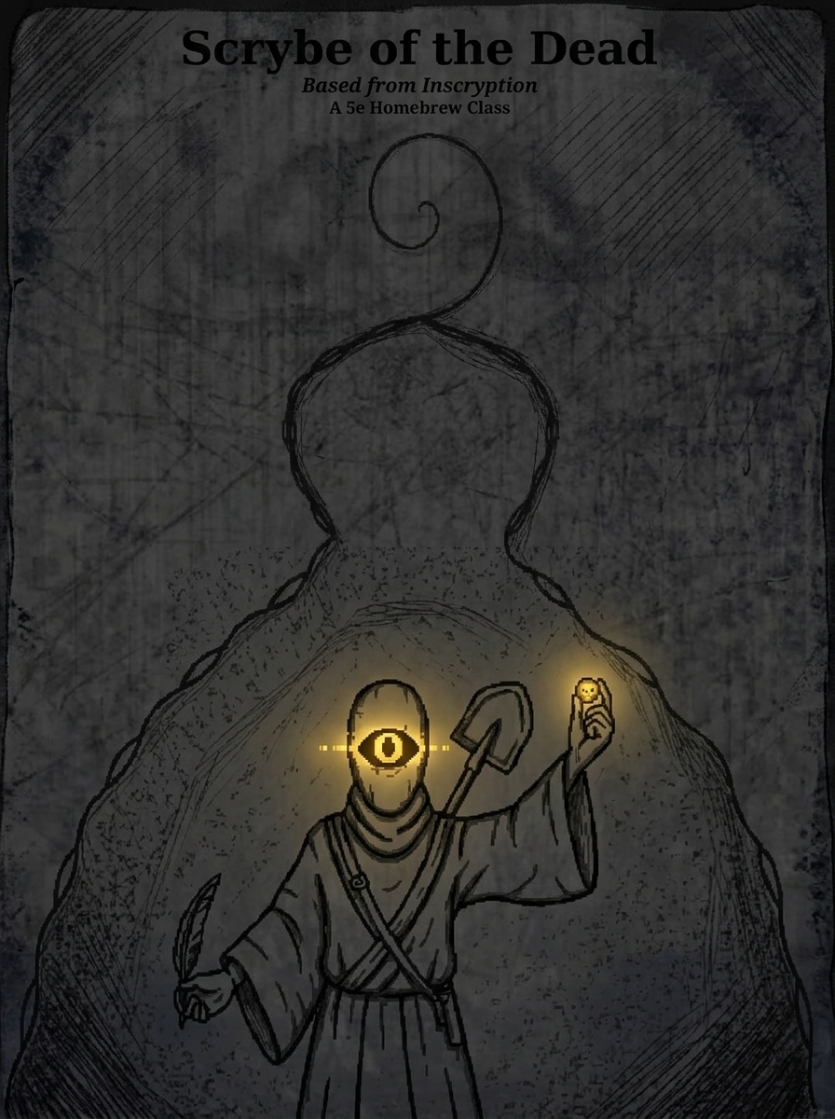
THE SCRYBE OF THE DEAD
Class Rules & Mechanics
Inspired by Inscryption (Grimora) · D&D 5e Homebrew
Overview

The Scrybe of the Dead wanders graveyards and battlefields, binding the fallen into gravestone-shaped Inscription Cards rendered as haunting ink-wash paintings.
Your power flows from death itself. You raise undead echoes that fuel an engine of Bones and Souls. Some summonses are brittle and fleeting, others more enduring. Through risky rituals like lightning-struck trees, obol flips, burials, and digging up the dead you grow your deck.

Core Class Statistics

Hit Die. d8 per Scrybe level
HP at 1st Level. 8 + Constitution modifier
HP at Higher Levels. 1d8 (or 5) + Constitution modifier per level after 1st
Primary Ability. Wisdom
Saving Throws. Wisdom and Intelligence
Armour. Light and medium armour
Weapons. Daggers, darts, javelins, quarterstaffs, slings, spears
Tools. Herbalism Kit
Skills. Choose two from: Arcana, Insight, Medicine, Perception, Religion, Survival

Starting Equipment
- The Grim Quill
- An Obol
- Leather armour
- Explorer’s Pack
- Herbalism Kit
- Shovel

Level Progression

Level | Features Gained
1 | Grim Quill, Inscription Cards, Bones & Souls, Fleeting Undead, Obol Flip, Rusted Nail Ritual, Burial Ritual, Gravedigging
2 | Early Grave
3 | Death’s Whisper
4 | Ability Score Improvement
5 | All Roads
6 | Bone Hoard
7 | Collective Grave
8 | Ability Score Improvement
9 | Burial Ritual Mastery
10 | Dead Mass Mastery
11 | Recurring Dead
12 | Ability Score Improvement
13 | By Daylight
14 | Bone Lord’s Tithe
15 | Ambidextrous Drawing
16 | Ability Score Improvement
17 | Undying Resilience
18 | Obol Mastery
19 | Ability Score Improvement
20 | The Bone Lord

Core Mechanics

Grim Quill
You inscribe corpses or gravesites (out of combat only, 1-minute ritual). The resulting card is always an undead counterpart of the original. You choose whether it manifests as a Zombie/Rotting or Skeletal version.

Inscription Cards
Shape. All cards are tall gravestone-shaped with ink-wash painting artwork and an epitaph plaque.
Deck. No deck limit. You draw 3 cards on your first turn of combat, then draw 1 card per turn thereafter (2 cards per turn at level 15). Hand limit: 6.
Destruction. Cards that reach 0 HP return to your deck after the encounter ends.

Fleeting Undead
Creatures of CR 3 or lower become Fleeting Undead: very low HP (30–50% of original), act once or twice in their turn, then die automatically, granting Bones.
Creatures of CR 4+ become Enduring Undead with more reasonable HP with three, four action or until destroyed.

Bones & Souls
Bones. Gained whenever any of your cards dies (1 per death by default). Level-based maximum. Reset after a Short Rest at level 6.
Souls. You automatically gain the turn number in Soul at the start of your turn. Unused Souls carry over. (max 6).

Dead Mass
A grotesque pile of fused undead. Cannot attack initially (gains this at level 10). Moves and defends using its size. Size is determined by how many cards were sacrificed to create it. When a Dead Mass dies, it grants Bones equal to roughly 1 per card used to make it. You cannot use dead masses in obol flips

Class Features

Level 1 — All Core Features
You gain the Grim Quill, Inscription Cards, Bones & Souls, Fleeting Undead, Obol Flip, Rusted Nail Ritual, Burial Ritual, and Gravedigging.

Obol Flip
Max 5 times per day, resets on Long Rest. Choose 1 or 2 cards and flip the Obol.
Heads. Both chosen cards are duplicated.
Tails (2 cards). The two cards are fused into a Dead Mass.
Tails (1 card). The card is destroyed permanently.

Rusted Nail Ritual
During storms or heavy clouds (requires trees). Place a card on or beside a tree. Lightning strikes it.
d6 Roll | Result
1–2 | Card becomes Brittle (gains Fleeting Undead trait permanently). If already Brittle, it gains an additional negative effect (DM’s choice).
3–4 | +1 to one random stat and Brittle
5–6 | +2 or +3 to one random stat, plus a minor beneficial death trigger

Burial Ritual
In this event, you will bury a card for it to decrease in cost but debuffed. Roll a d4, if one the buried card will have its bone cost halved, but become fleeting. If 2 the cost will be decreased by two but the card will always be poisoned. If three, health is rounded down to the nearest ten, damage is rounded up to the nearest ten. If a four, then it will cost one less bone but also cost 2 soul.

Gravedigging
Spend 10–30 minutes digging at any graveyard or corpse site. On a successful check, create 1–3 new undead cards.

Level 2 — Early Grave
When inscribing a fresh corpse (died within the last 24 hours), roll a d6 after the check.
d6 | Outcome
1–3 | Normal undead card
4–5 | +1 to two random stats
6 | +2 to one stat, +1 to another, plus a minor beneficial death trigger

Level 3 — Death’s Whisper
Whenever one of your cards dies, you can roll a d6. On a 5 or 6, gain 1 Soul immediately.

Level 5 — All Roads
If an enemy dies in combat within ten feet (excluding plants, constructs, and objects), roll a d6, if 5 or 6, gain one soul and one bone

Level 6 — Bone Hoard
Your Bones now reset after a Short Rest instead of a Long Rest.

Level 7 — Collective Grave
Whenever any creature (excluding plants, constructs, and objects) dies within 60 feet of you, you gain +1 Bone. This includes enemy creatures, allied creatures, and neutral creatures.

Level 9 — Boner
Use 10 bones to temporarily buff any chosen stat of a card
Level 10 — Dead Masstery
Dead Masses you create can now attack, using the half-combined strength of the sacrificed cards. Attack rolls and damage scale with the number of cards used to form the mass.

Level 11 — Recurring Dead
As a bonus action, spend 2 Souls to return any card from your Dead zone to your hand.

Level 13 — By Daylight
At the start of combat, roll a d20. Whatever number you get, that is called you “Due Date”. On the same turn as the number you got on the roll, all of your played cards give you the number of bone of their cost.

Level 14 — Bone Lord’s Tithe
Once per Long Rest, you can convert all your current Souls into Bones at a 1:2 ratio (each Soul becomes 2 Bones).

Level 15 — Oversoul
When at max soul amount, roll a d 20. If below 10 the check is failed but can be performed again next turn. If 10 or above, you can gain soul up to that number. Once you reach that number, you can expend 6 souls to heal cards enduring cards or postpone fleeting cards death by one turn.

Level 17 — Undying Resilience
When one of your cards would be permanently destroyed by the lightning ritual, it instead becomes Undying: its stats are permanently halved, but when reduced to 0 HP it returns to your hand rather than dying.

Level 18 — The Snake Itself Eats
Use 20 bones to heal a card on your turn.
Level 20 — The Bone Lord
Once at any time in combat, tally up the damage all your cards dealt and all the hp they lost, these numbers will be the damage and health of the Bone Lord. For add the number of fleeting cards to its health, and the number of enduring cards to its damage. The amount of souls you have is the amount of abilities you may give the Bone Lord, chosen from the played cards. The Bone Lord card will be created in your hand and requires a full board wipe to play.

Combat Quick Reference

Phase | Action
Start of turn | Gain 1 Soul (scales with level). Draw 3 cards on the first turn of combat, then 1 card per turn (2 at level 15). Hand maximum: 6.
Your Action | Play cards (paying Bone/Soul costs)
Bonus Action | Use Recurring Dead (level 11) or any standard bonus action.
When any card dies | Gain 1 Bone (up to Bone Limit). Level 3: roll d6; on 5–6 gain 1 Soul.
End of combat | All destroyed cards return to deck. Hand resets.

Resource Summary
- Bones — Gained when your cards die. Level-based max. Reset after Long Rest (Short Rest at level 6).
- Souls You gain the turn number in Soul at the start of your turn. Carry over (max 6). Spend to play cards or use abilities.

Notes for Your DM

DM Notes: Running the Scrybe of the Dead
Corpse access. The Grim Quill requires actual corpses or gravesites. Make them available regularly — battlefields, graveyards, dungeons.
Fleeting Undead. Treat them as brief explosive summons. They die on the Scrybe’s turn; no need to track their initiative separately.
Dead Mass size. Use the number of cards (Small: 1–2, Medium: 3–4, Large: 5–6, Huge: 7+). Scale HP and defenses accordingly.
Card appearance. All cards should be described as ink-wash gravestone portraits — haunting, monochrome, slightly decayed.
Starter Deck. Most cards should be cheap or free, preferably free, with stronger cards being high cost and few medium cost cards
Lore. The Scrybes are the source of their own power. Each are a representation of the four horsemen and reincarnate as an individual with the same mind, though devoid of the memory that they are a Scrybe. The Scrybe of The Dead is the Pale Green Horseman of Death, generally evil neutral or true neutral, and has the main goal of ending all life or any life in general. Only one of each Scrybe can exist in one campaign. The Scrybes hate each other and will always be enemies, even if they never met each other, they will be hostile.

