**Prerequisites**

Before running any git clone commands, run the following commands:

git config **--global** core**.**autocrlf false

git config **--global** core**.**longpaths true

You can check the setting of these parameters with the following commands:

git config **--**get core**.**autocrlf

git config **--**get core**.**longpaths

These need to be false and true respectively.

For Node.js you also need the necessary Visual Studio C++ Build Tools

npm install **--global** windows**-**build**-**tools

npm install **--global** grpc

*(It takes few minutes, so have patience)*

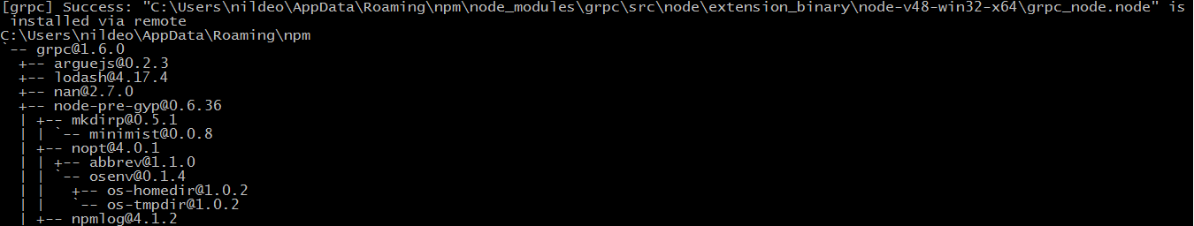

**Install cUrl:**

**Usages document can be found** [**here**](https://curl.haxx.se/docs/manual.html)