

**Block Chain**

**Hyper ledger Fabric Development Environment Setup in Windows**

# Document History

|  |  |  |  |
| --- | --- | --- | --- |
| Date | Author | Version | Comment |
|  |  |  |  |
|  |  |  |  |
|  |  |  |  |
|  |  |  |  |

# Hyperledger in windows([**Docker**](https://www.docker.com/products/docker-toolbox))

For installation in windows download and run Docker Toolbox.

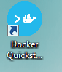 run this shortcut on the desktop.

Don’t get panic if you find a pop up like this after installing docker toolbox and running the shortcut on the desktop.

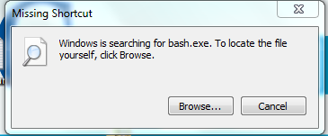

Go to the folder where you installed Docker Toolbox.

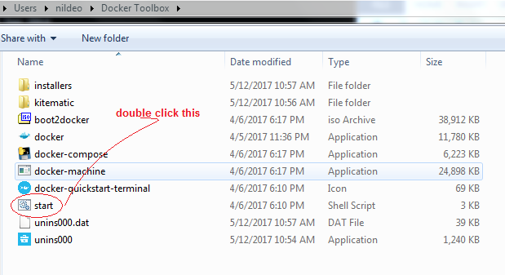

Or open it using git bash

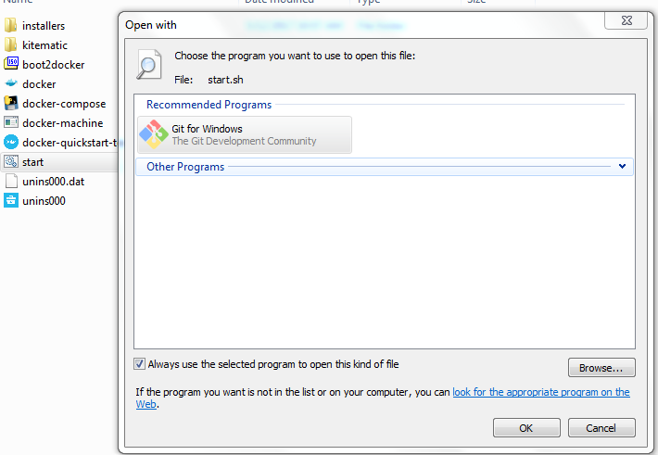

Or git bash in the above folder and type

***./start.sh***

The above step will open a git bash prompt as below

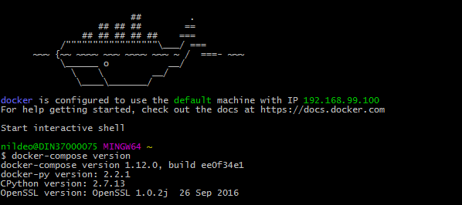

Here ***git clone https://github.com/IBM-Blockchain/fabric-images.git***

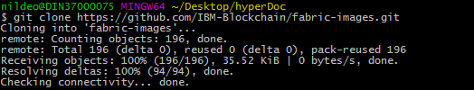

Go inside docker-compose

***cd fabric-images/docker-compose***

Run the following

***. setenv.sh***

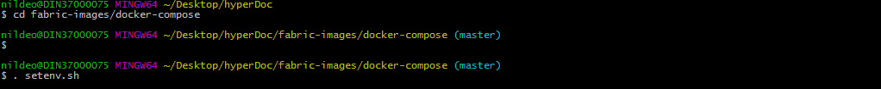

To run four peers type the following command

***docker-compose -f four-peer-ca.yaml up***

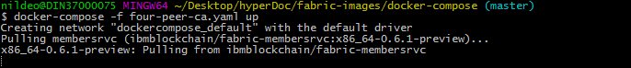

If you find any error make sure you have double clicked the docker quickstart shortcut on the desktop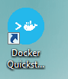

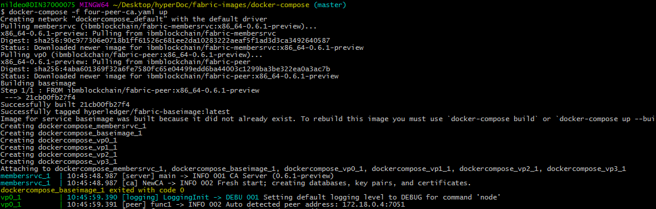

Open a new terminal or git bash and run the docker prompt by using

***./start.sh***

Then open a peer by typing

***docker exec -it dockercompose_vp0_1 bash***

prefix ***winpty*** with the above command if found error.



Enroll an user using the following command

***peer network login test_user0 -p MS9qrN8hFjlE***

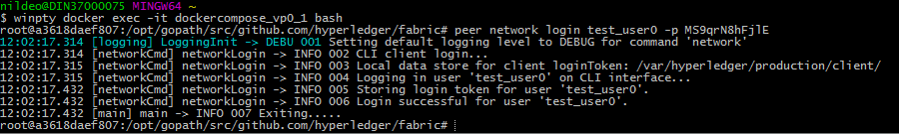

Deploy a chaincode using the following

***peer chaincode deploy -u test_user0 -p github.com/hyperledger/fabric/examples/chaincode/go/chaincode_example02 -c '{"Args": ["init","a", "100", "b", "200"]}'***

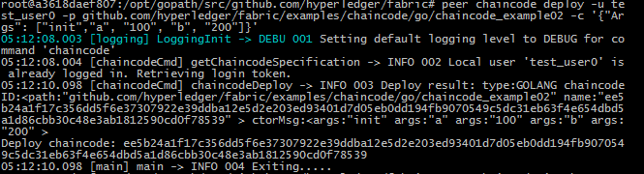

Invoke the chain code using the following

***peer chaincode invoke -u test_user0 -n ee5b24a1f17c356dd5f6e37307922e39ddba12e5d2e203ed93401d7d05eb0dd194fb9070549c5dc31eb63f4e654dbd5a1d86cbb30c48e3ab1812590cd0f78539 -c '{"Args": ["invoke", "a", "b", "10"]}'***

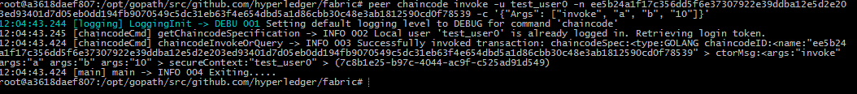

Query the chaincode with the following command

***peer chaincode query -u test_user0 -n ee5b24a1f17c356dd5f6e37307922e39ddba12e5d2e203ed93401d7d05eb0dd194fb9070549c5dc31eb63f4e654dbd5a1d86cbb30c48e3ab1812590cd0f78539 -c '{"Args": ["query", "a"]}'***

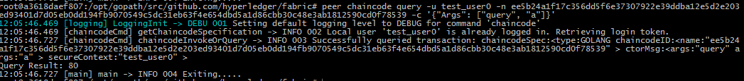

In other terminal …

# TO SEE USERS AND PEER CONFIGURATION

Go to the path ***cd opt/gopath/src/github.com/hyperledger/fabric/membersrvc***

Then type :

cat membersrvc.yaml

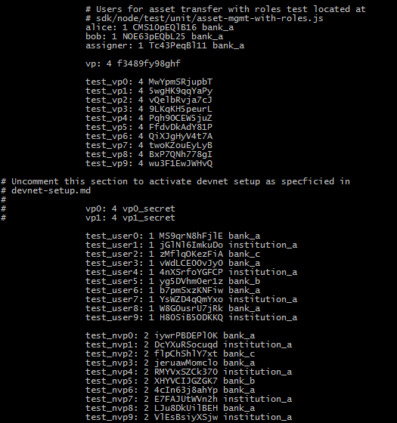

To get into a Docker container running vp1:

***docker exec -it dockercompose_vp1_1 bash***

To enroll a different user say test1

***peer network login test_user1 -p jGlNl6ImkuDo***

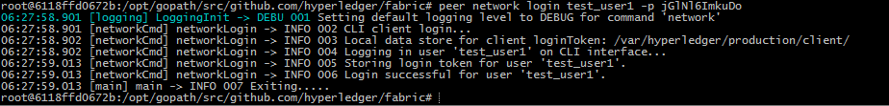

**Deploying a Sample Chaincode:**

* To deploy a chaincode firstly we need to execute the docker container.

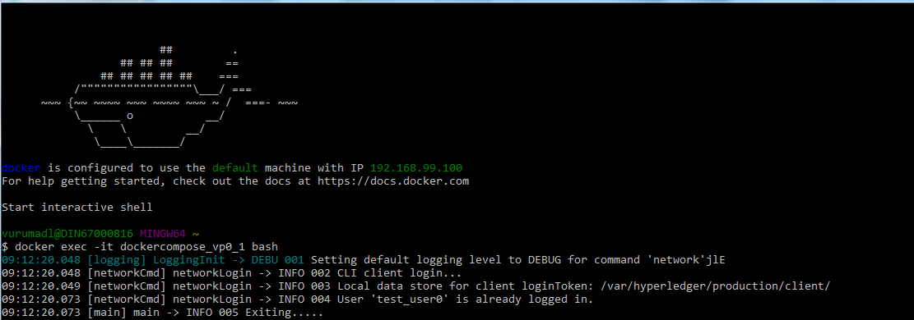

* After getting into the container create a folder anywhere within the fabric folder as below.



* In other terminal get into the folder where your chaincode is presnt in your local machine. In my it is **( c/Users/vurumadl/source-files ).**

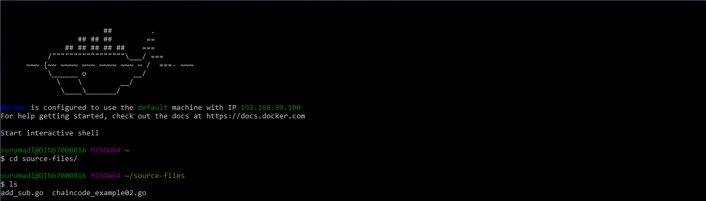

* **NOTE:**  Now follow the below command to copy the file into the container.



* The command format is shown below
* docker cp [OPTIONS] CONTAINER:SRC_PATH DEST_PATH|-
* docker cp [OPTIONS] SRC_PATH|- CONTAINER:DEST_PATH
* Now go to the previous terminal and check whether it is moved to container or not. Check it by doing ls.



* Build the chaincode and check whether it is built or not as below.



* Now you can do the init, invoke and query operations from the command prompt as below.

**Init:**



**Invoke:**

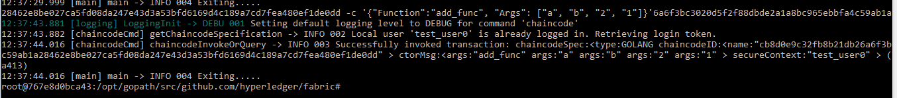

**Query:**

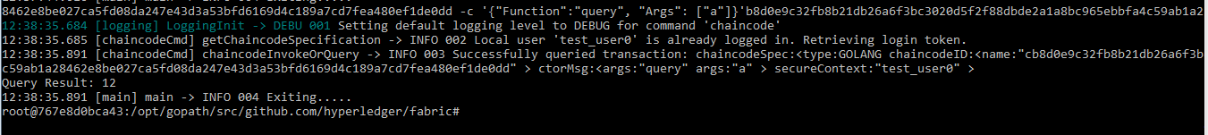

**Accessing from postman:**

**Init:**

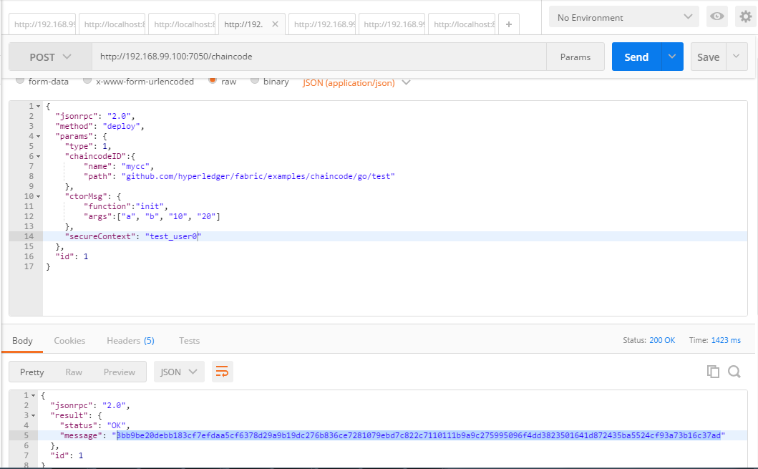

**Invoke:**

Here copy the hash from the response in the message and paste it in invoke as below.

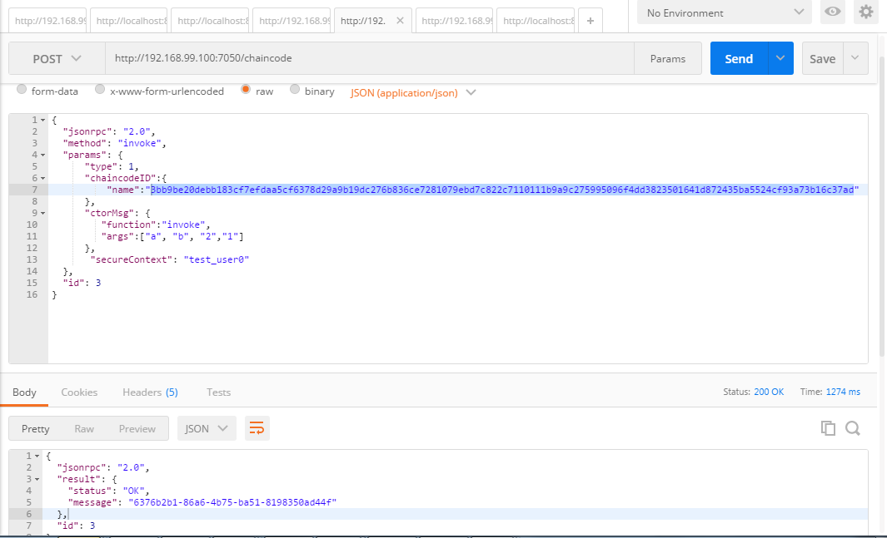

**Query:**

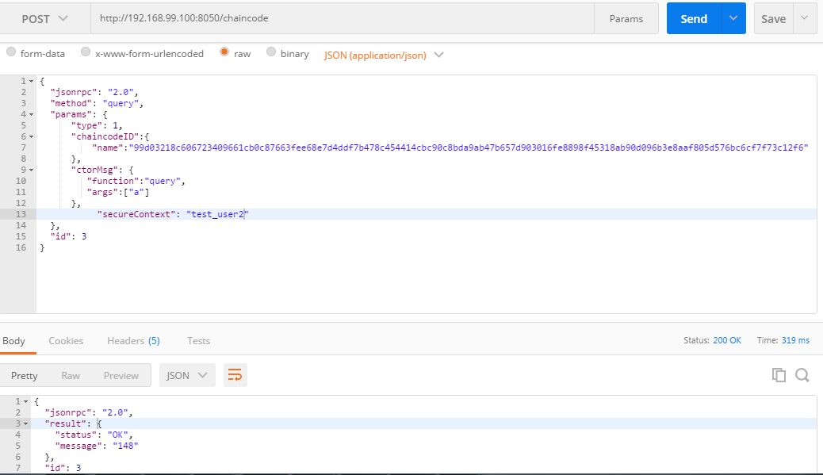

**Queryall:**

