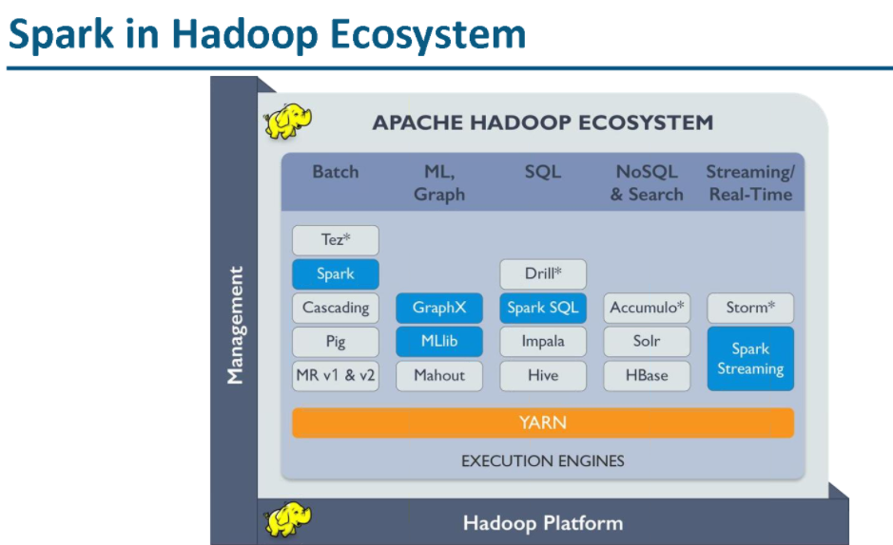

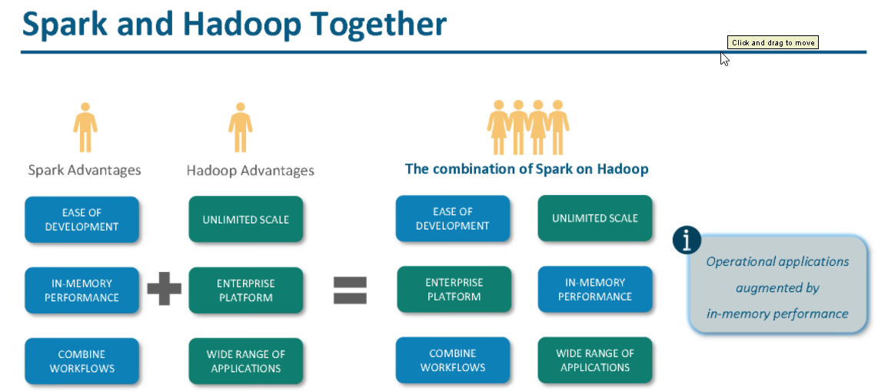

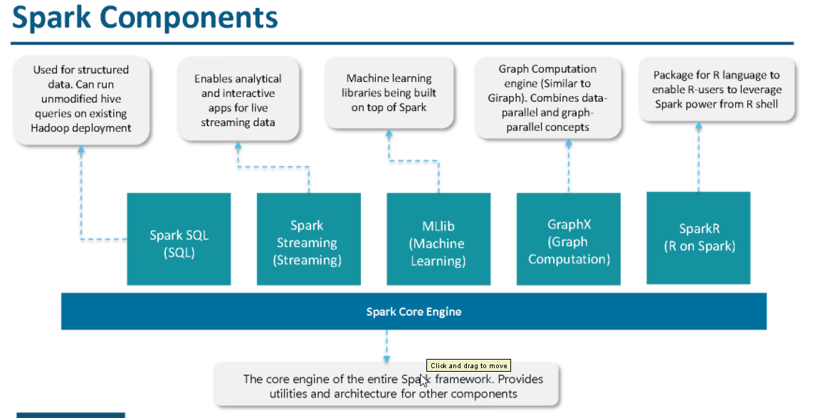

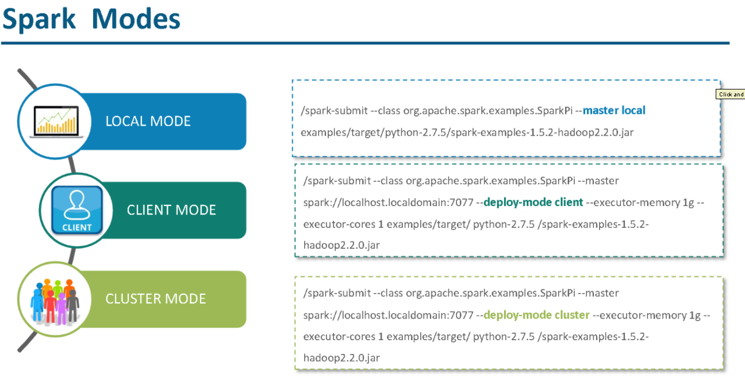

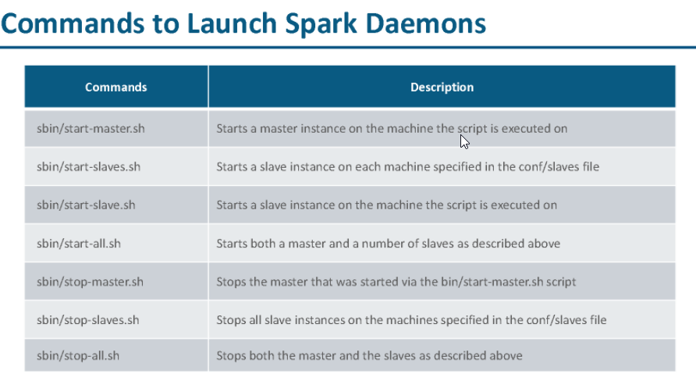

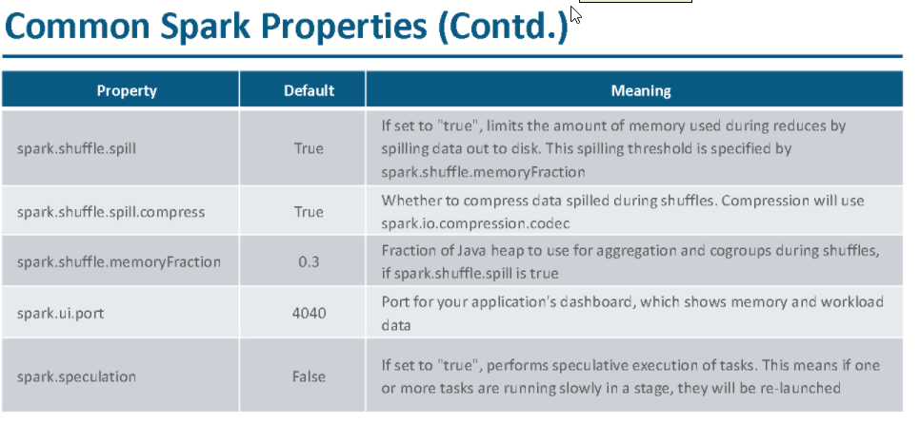

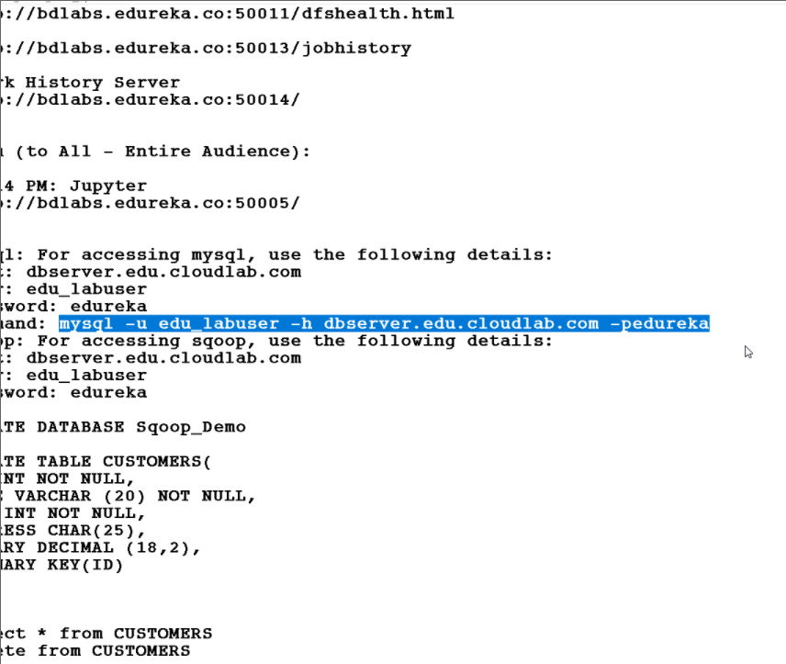

**mysql -u edu_labuser -h dbserver.edu.cloudlab.com –pedureka**

9:55 AM: sqoop import --connect jdbc:mysql://dbserver.edu.cloudlab.com/labuser_database --table CUSTOMERS --username edu_labuser --password edureka -m 1 --target-dir '/user/edureka_633681/sqoop2/'  
  
  
sqoop export --connect jdbc:mysql://dbserver.edu.cloudlab.com/labuser_database --table CUSTOMERS --username edu_labuser --password edureka -m 1 --export-dir '/user/edureka_633681/sqoop2'  
  
sqoop list-databases --connect jdbc:mysql://dbserver.edu.cloudlab.com/labuser_database --username edu_labuser --password edureka  
  
sqoop list-tables --connect jdbc:mysql://dbserver.edu.cloudlab.com/labuser_database --username edu_labuser --password edureka  
  
sqoop codegen --connect jdbc:mysql://dbserver.edu.cloudlab.com/labuser_database --username edu_labuser --password edureka  --table CUSTOMERS  
  
sqoop eval  --connect jdbc:mysql://dbserver.edu.cloudlab.com/labuser_database --username edu_labuser --password edureka  --query "SELECT * FROM CUSTOMERS"