PRACTICAL FILE
MBA 106: MICROSOFT OFFICE FOR MANAGERS


\

SUBMITTED TO
DR. MANMINDER KAUR ASSOCIATE PROFESSOR MMIM, MMDU
SUBMITTED BY:
PRAVINDER SINGH MBA 1A
12258037

Maharishi Markandeshwar Institute of Management Maharishi Markandeshwar (Deemed to be University) NAAC Accredited Grade 'A++' University
Mullana, Ambala (Haryana),133207

TABLE OF CONTENTS

CONTENTS | PAGE NO
UNIT I:MS Word-Document Creation and Formatting | 02
PRACTICAL 1.1-Creating a Professional Business Proposal and Template | 02
PRACTICAL 1.2-Drafting a Standard Operating Procedure (SOP) with Advanced Formatting: | 08
PRACTICAL 1.3-Automating a Customer Communication Letter (Mail Merge) | 14
UNIT II:MS PowerPoint-Business Presentation and Multimedia | 17
PRACTICAL 2.1-Developing a Business Deck Pitch: | 18
UNIT III-MS Excel: Data Management and Formulas: | 24
PRACTICAL 3.1-Setting up and Formatting a Sales Data Spreadsheet: | 24
PRACTICAL 3.2-Sales Performance Analysis using Key Functions: | 31
PRACTICAL 3.3-Employee Lookup System using VLOOKUP | 35
UNIT IV:MS Excel: Data Management, Formulas and Visualization | 39
PRACTICAL 4.1-Data Visualization and Interpretation of Charts | 39
PRACTICAL 4.2-Advanced Reporting with PivotTables and Grouping | 45
PRACTICAL 4.3-Creating a Dynamic Executive Dashboard | 53

UNIT I:MS Word-Document Creation and Formatting
Introduction to MS Word: MS Word is a word-processing application used to create professional documents such as letters, reports, projects, and essays. It allows users to type, edit, format, add images, create tables, check spelling and grammar, and design the overall layout of a document. MS Word is mainly focused on text and document preparation. It is different from MS PowerPoint (PPT), which is used for making visual presentations with slides that include images, animations, charts, and bullet points. PowerPoint is designed for presenting information to an audience. On the other hand, MS Excel is used for managing and analyzing data in the form of spreadsheets. It includes rows, columns, formulas, and functions to perform calculations, create charts, and analyse large sets of data. While Word is best for writing, PowerPoint is best for presenting, and Excel is best for calculating and analyzing data.
PRACTICAL 1.1-Creating a Professional Business Proposal and Template

Objective:
Apply document creation, formatting, and table features to produce a professional template.

Task:
Create a two-page Business Proposal Template for a consulting firm. The template should include:

- A cover page with a large, centre-aligned, bold title and a watermarked company logo (simulate using an image).
- Use different font styles and sizes for headings (e.g., Arial 14pt Bold) and body text (e.g., Calibri 11pt).
- Apply bullets and numbering for a "Scope of Work" section.
- Insert a simple table (3 columns, 4 rows) to list project phases and estimated timelines. Apply borders and shading to the table header row.

Procedure:

- Creating a New Document:

  - Open MS Word.
  - Click on File > New to open a new blank document.

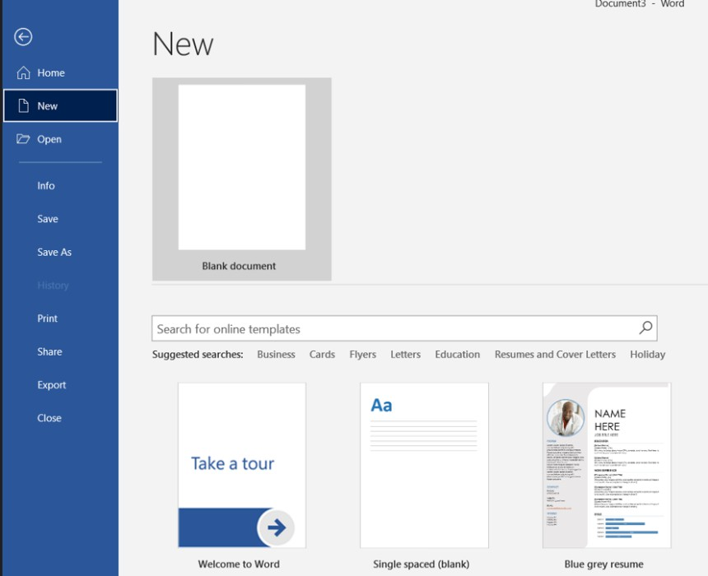

Set Margin:

Go to Layout → Margins → Normal (1 inch).
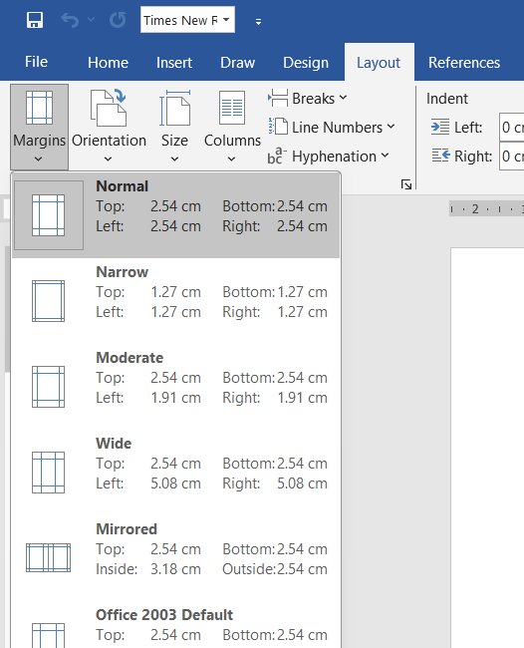

Insert Watermark:

Create the Cover Page:

- Move to the first page.
- Press Ctrl + E to center-align the cursor.
- Type a large, bold title (e.g., Business Proposal).
- Increase the font size to around 28–36 pt.
- To add a watermarked logo:

- Go to Design → Watermark → Custom Watermark.

- Select Picture Watermark, upload any image to simulate a company logo, and apply it with appropriate transparency.
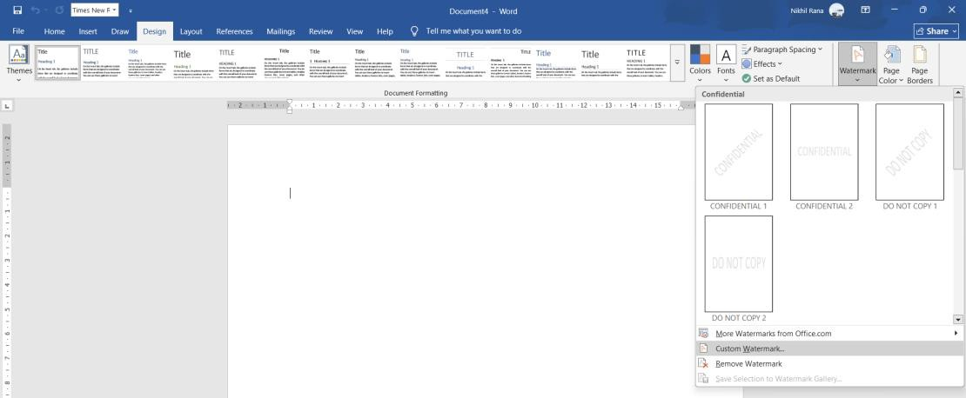



Set Font Styles for Headings and Body Text:
For main headings:

- Font: Arial
- Size: 14 pt
- Style: Bold
For body text:
  - Font: Calibri
  - Size: 11 pt

Add Important Sections:
- Insert a new page using Ctrl + Enter.
- Add headings such as Introduction, Scope of Work, Project Timeline, etc.
- Apply the predefined heading style (Arial 14pt Bold).

Create the “Scope of Work” Section with Bullets and Numbering:
- Type the heading “Scope of Work.”
- Write the key points under it.
- Select the points and apply either:
- Bullets, or
- Numbering, depending on the required format.

Insert a Table for Project Phases and Timelines:
- Type the heading “Project Timeline.”
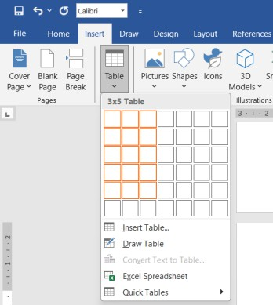
- Go to Insert → Table and choose 3 columns × 5 rows.
- In the first row, enter header labels such as:

- Phase

- Description
- Timeline
- Select the first row and apply:
- Shading (a light fill colour)
- Borders → All Borders
- Fill the remaining rows with project phases and time estimates.

7. Save the Document:
Go to File > Save As, choose a location, name your document, and click Save.

Final Output:



BUSINESS PROPOSAL

Cost Reduction & Operations Optimisation
Prepared for: Boston Consulting group Company Ltd.
Prepared by: XYZ Consulting Services — Pravinder Singh
Date: 13 November 2025

Introduction
This Business Proposal outlines a structured approach by XYZ Consulting Services to support Global Manufacturing Company Ltd. in reducing operating costs and improving manufacturing efficiency. The recommended engagement will diagnose operational inefficiencies, develop targeted strategies, and support implementation to achieve measurable cost savings.

Objective
Objective: Apply a focused diagnostic and implementation approach to reduce total manufacturing costs by up to 15% through supply chain optimisation, process redesign, and overhead rationalization.

Scope of Work

Project Analysis
    - Conduct data collection across production lines and supply chain.
    - Perform cost driver analysis and identify inefficiencies.

Strategy Development
    - Design cost reduction initiatives (process changes, sourcing strategies).
    - Model financial impact and prioritize initiatives.

Implementation Support
    - Pilot key initiatives on selected lines.
    - Provide training and change management support.

Reporting & Handover
    - Deliver final report documenting savings and recommendations.
    - Transition to client team with monitoring metrics.

Project Phases and Estimated Timeline

Phase | Description | Estimated Timeline
Phase 1 | Diagnostic & data collection: review production, supply chain, overheads. | Weeks 1-3
Phase 2 | Strategy development: design and prioritize initiatives. | Weeks 4-6
Phase 3 | Implementation: pilot and rollout selected changes. | Weeks 7-12
Phase 4 | Review & handover: measure savings and transition to client. | Weeks 13-14

PRACTICAL 1.2-Drafting a Standard Operating Procedure (SOP) with Advanced Formatting:

Objective:
Use advanced text and paragraph formatting, including headers/footers, indentation, and alignment.
Task: Draft a brief Standard Operating Procedure (SOP) for "Employee Onboarding." The document must demonstrate:
- Use of different text alignments (left, center, justified).
- Proper use of paragraph indentation (first-line or hanging indent).
- Correct application of Spell Check and use the Thesaurus to find a synonym for a key word.
- Setup a Header (Document Title) and Footer (Page Number).

Procedure:

Creating a New Document:

  - Open MS Word.
  - Click on File > New to open a new blank document.

Set up the Header and Footer:

- Go to Insert → Header and choose a simple header style.
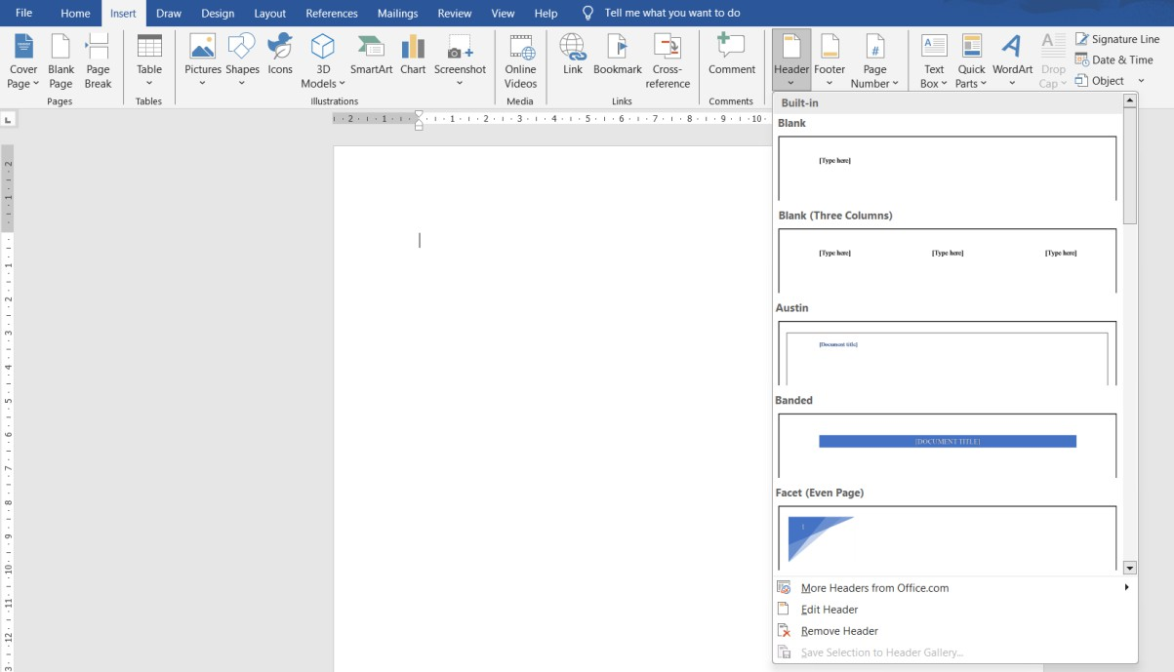
- Type the document title, e.g., STANDARD OPERATING PROCEDURE (SOP) — Employee Onboarding
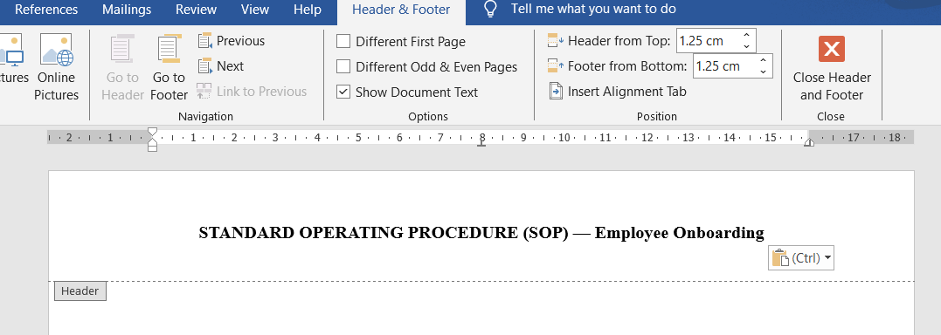
Then go to Insert → Footer → Page Number and select a page number format (e.g., bottom-center).

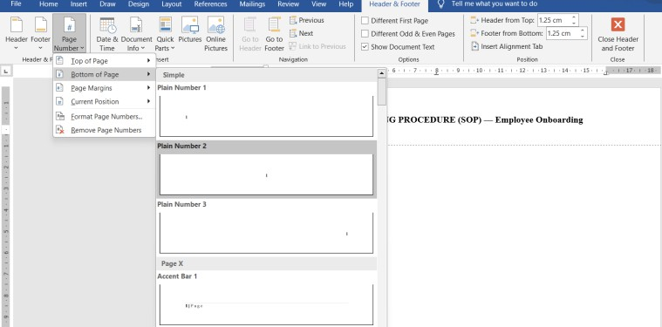

- Double-click outside the header/footer area to return to the main document.

Insert the SOP Title and Apply Alignment
- Type the main title: Standard Operating Procedure – Employee Onboarding.
- Select the title and press Ctrl + E to center-align it.
- Press Enter and start the content with left alignment (Ctrl + L).
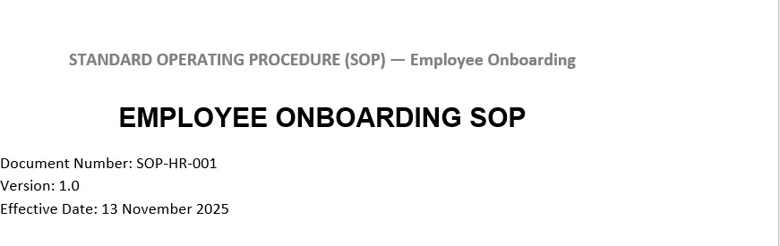
- Draft the Introduction Paragraph (Justified Alignment):

  - Write a short introduction about the purpose of the Employee Onboarding SOP.
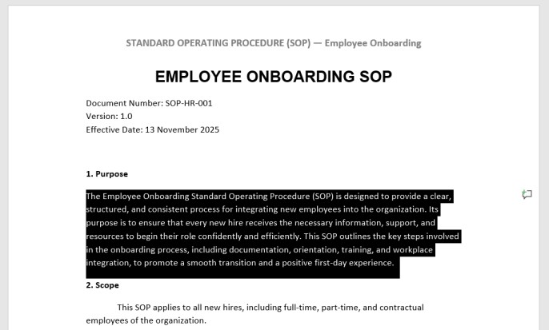

  - Select the paragraph and apply Justify alignment (Ctrl + J).

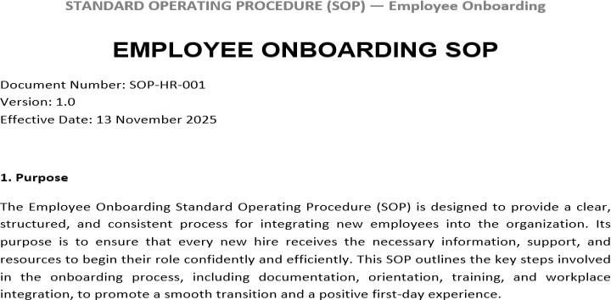

  - This makes the text clean and evenly aligned on both sides.

- Apply Paragraph Indentation:
- For the first paragraph, apply First-Line Indent:
- Go to Home → Paragraph Settings (small arrow) → Indentation → First Line.
- For the list of onboarding steps, apply a Hanging Indent:
- Same menu → Indentation → Special → Hanging.
- Type your onboarding steps (e.g., Document Verification, Orientation, Training Schedule, IT Setup).
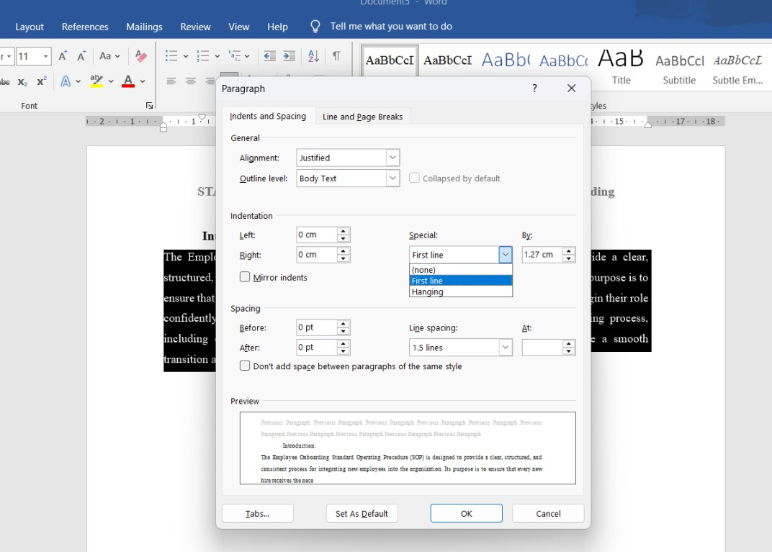

Use Spell Check:

  - Press F7 to run Spell Check.

  - Correct any spelling or grammar suggestions provided by Word.

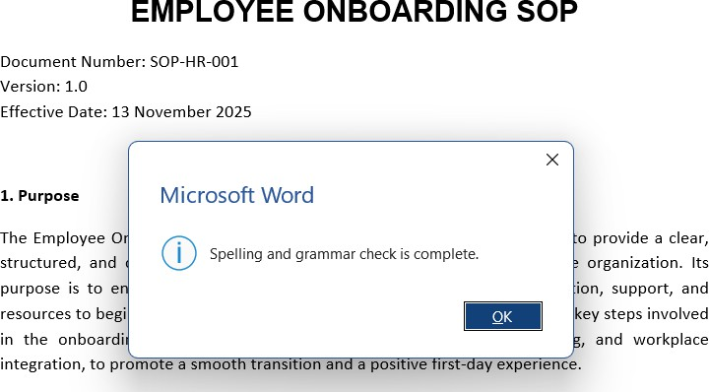

Use the Thesaurus for a Synonym:
  - Select a word that you want to replace (e.g., “important”).
  - Press Shift + F7 to open the Thesaurus.
  - Choose a suitable synonym (e.g., “essential”) and insert it into the document.

Save the Document:
  - Go to File → Save As, choose a location, and save the final SOP document.

Final Output:

EMPLOYEE ONBOARDING SOP
Document Number: SOP-HR-001 Version: 1.0
Effective Date: 13 November 2025

Purpose
The Employee Onboarding Standard Operating Procedure (SOP) is designed to provide a clear, structured, and consistent process for integrating new employees into the organization. Its

purpose is to ensure that every new hire receives the necessary information, support, and resources to begin their role confidently and efficiently. This SOP outlines the key steps involved in the onboarding process, including documentation, orientation, training, and workplace integration, to promote a smooth transition and a positive first-day experience.

Scope
This SOP applies to all new hires, including full-time, part-time, and contractual employees of the organization.

Responsibilities
  - HR Manager: Coordinate onboarding schedule, documentation, and orientation sessions.
  - Hiring Manager: Prepare role-specific training and introduce team responsibilities.
  - IT Support: Provision workstation, email, and system accesses before Day 1.

Procedure
- Pre-Start (Week before Day 1)
  - HR sends offer letter and collects signed documents.
  - IT provisions equipment and system access.

Day 1 — Induction
  - Welcome meeting with HR (Company overview, policies).
  - Facility tour and team introductions.

Week 1 — Role Onboarding
  - Hiring manager assigns training plan and initial tasks.
  - Daily check-ins for first week.

Month 1 — Performance Check
  - 30-day review to address questions and measure performance.

Records
All onboarding documents (offer letters, signed forms, ID proofs, and training logs) will be stored in the employee file and HR digital repository.

Revision History

Version | Date | Description | Author
1.0 | 13 Nov 2025 | Initial issue | HR Department

Note: The word 'Onboarding' was checked with Thesaurus and synonym 'Induction' was used in Section 4.

PRACTICAL 1.3-Automating a Customer Communication Letter (Mail Merge)

Objective:
Master the Mail Merge feature for personalized mass communication.
Task: Prepare a personalized Customer Welcome Letter.
  - Create a simple data source (like a small Excel sheet or a Word table) containing at least five customer records with fields: Name, Address, and Product Purchased.
  - Write a short generic welcome letter in MS Word.
  - Use Mail Merge to insert the customer-specific fields (Name, Address, Product) into the letter.
  - Generate the final merged letters. (Screenshots of the data source, the merged document, and the Mail Merge setup wizard steps are required.)
Procedure:

Create the Data Source:

  - Open Excel (or create a table in Word).

  - Make a small table with the following column headers:

    - Name
    - Address
    - Product Purchased
  - Enter at least five customer records below these fields.

  - Save the file as CustomerData.xlsx .

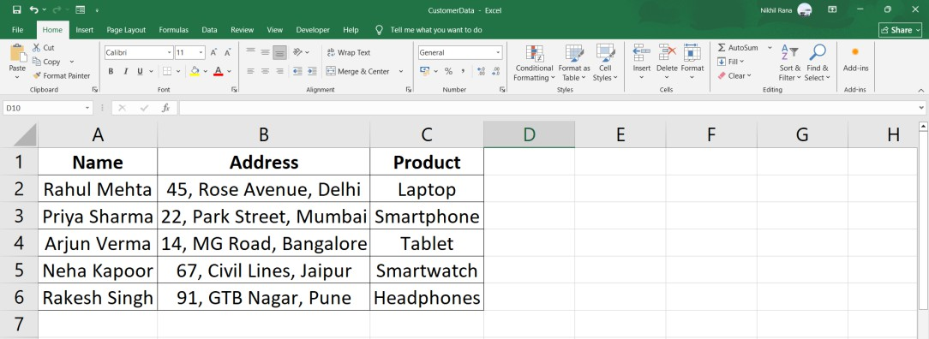

Write the Generic Welcome Letter in MS Word

- Open MS Word and start a Blank Document.
- Type a short welcome letter.

Start the Mail Merge Process:
- Go to Mailings → Start Mail Merge → Letters.
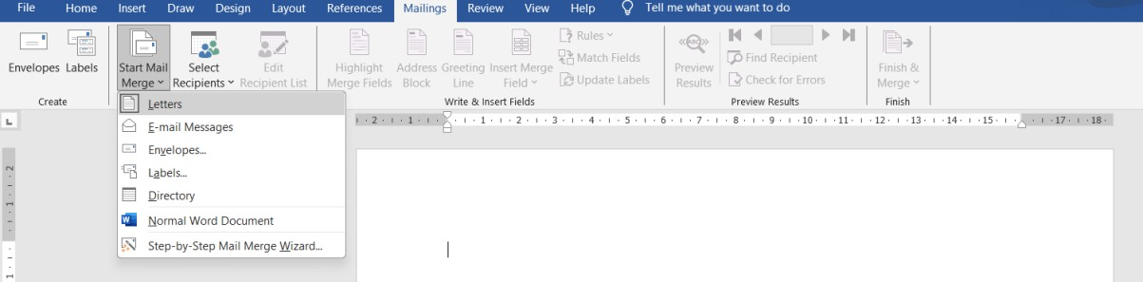
- Click Select Recipients → Use an Existing List.
- Locate and select your Excel data source (CustomerData.xlsx).
- Choose the sheet containing your records and click OK.
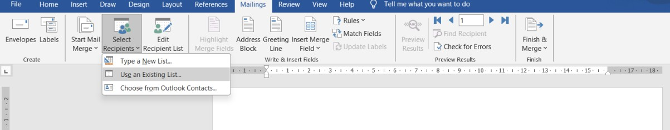

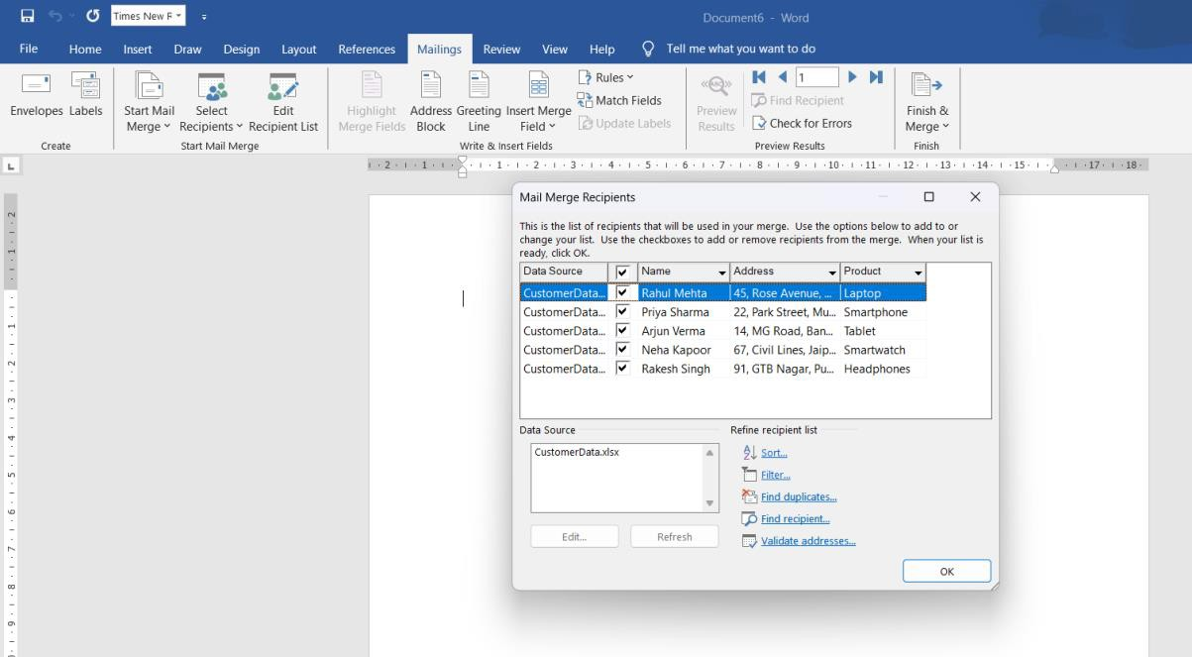

Insert the Merge Fields

  - Place your cursor where the Name should appear.
  - Go to Mailings → Insert Merge Field → Name.
  - Insert the remaining fields in the correct places:
- Address
- Product Purchased
  - Preview the letter using Mailings → Preview Results to confirm customer details appear correctly.

Complete the Mail Merge
  - Once everything looks correct, go to:
Mailings → Finish & Merge → Edit Individual Documents.
  - Select All to generate personalized letters for every customer.
  - A new document will open containing all the merged letters.

Save the Document:
Go to File > Save As, choose a location, name your document, and click Save.

Final Output:
Global Electronics Pvt. Ltd.
New Delhi
Dear Rahul Mehta

Welcome to the Global Electronics family! We are delighted to have you as our valued customer. We appreciate your recent purchase of Laptop 45, Rose Avenue, Delhi

We assure you of our continued support and service.
If you have any queries, feel free to contact us at support@globalelectronics.com.

Warm regards,
Customer Relations Team Global Electronics Pvt. Ltd.

UNIT II:MS PowerPoint-Business Presentation and Multimedia

Introduction to MS PowerPoint:

Microsoft PowerPoint is a presentation software used to create visual slideshows that combine text, images, charts, audio, videos, and animations for effective communication in classrooms, meetings, and business presentations. Unlike MS Word, which is mainly used for creating text-based documents such as reports, letters, and assignments, PowerPoint focuses on delivering information through visually designed slides. It is also different from MS Excel, which is primarily used for data entry, calculations, formulas, and data analysis using rows and columns. While Word manages written content and Excel manages numerical data, PowerPoint is designed to present information visually and interactively.

PRACTICAL 2.1-Developing a Business Deck Pitch:
Objective:

Create a structured presentation using a template, applying text editing and slide manipulation.

Task:
Create a 5-slide "Startup Funding Pitch Deck.
- Start with a pre-designed template.
- The presentation must include a Title Slide, a Problem/Solution Slide, a Market Size Slide, a Team Slide, and a Financial Summary Slide.
- Practice inserting and deleting slides to refine the structure.
- Ensure consistent and well-edited text across all slides.

Open PowerPoint and Choose a Pre-Designed Template
  - Open MS PowerPoint.
  - Click New and browse through available templates.
  - Select a professional startup or business template.
  - The template will open with its default slide designs.
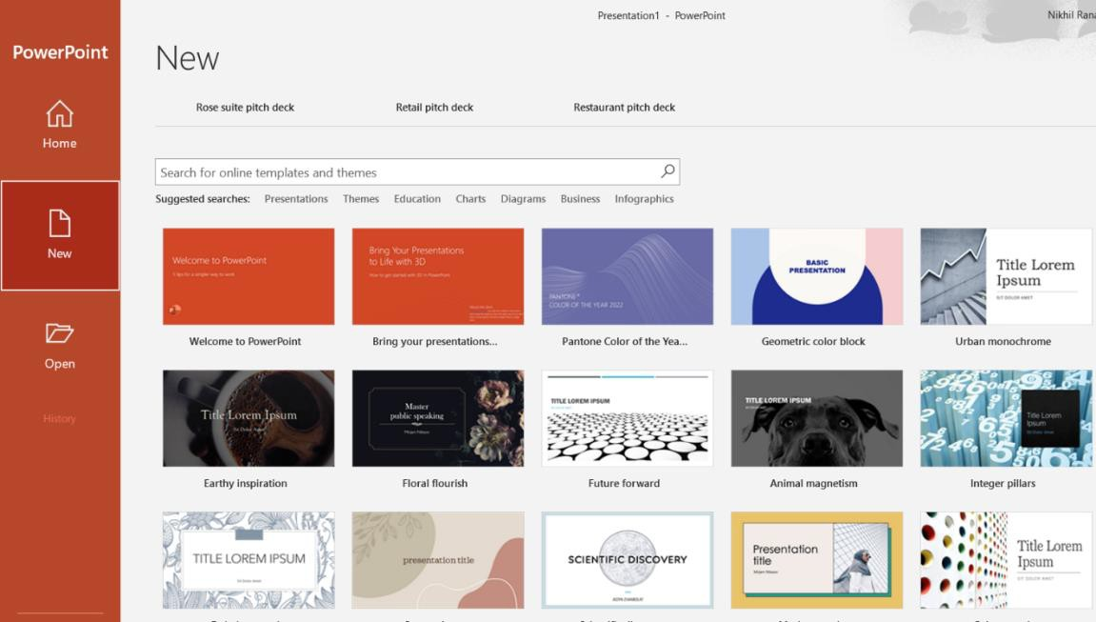

Create the Required 5 Slides:

Slide 1 – Title Slide:
  - Insert your startup name, tagline, and presenter name.


Slide 2 – Problem/Solution Slide:
  - Go to New Slide in Home tab and select the “problem” slide.
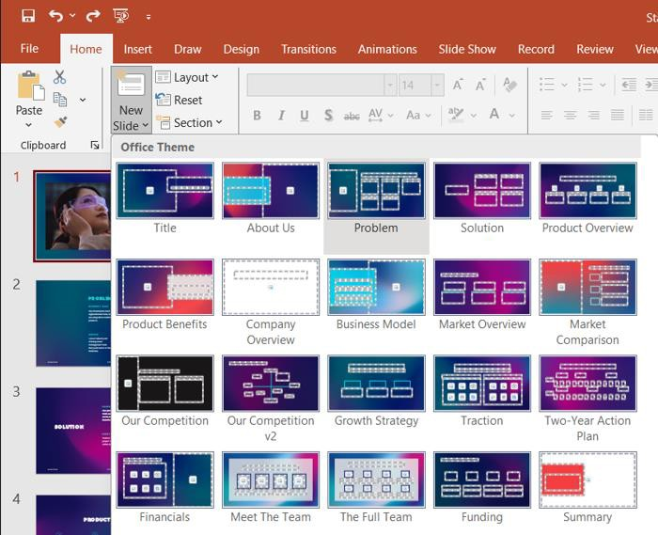

  - Add your content in the slide.
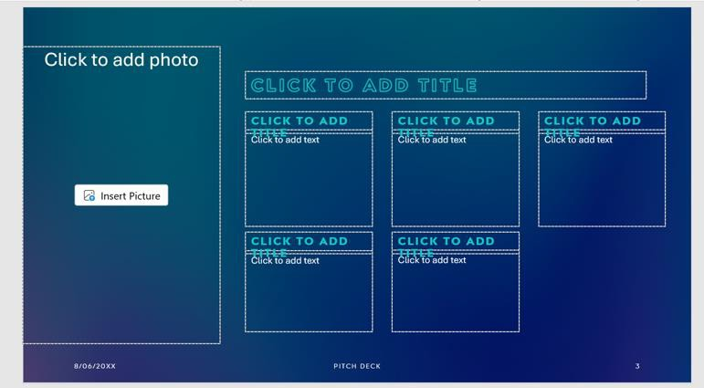

Slide 3 – Market Size Slide:
  - Add basic data, charts, or bullet points showing your target market size.

Slide 4 – Team Slide:
  - Introduce founders and key team members.
  - Add photos if needed.

Slide 5 – Financial Summary Slide:
  - Present projected revenue, costs, or funding requirement in short points.

Insert and Delete Slides to Refine the Structure

- To insert a slide:
  - Go to Home → New Slide and choose a layout.
- To delete a slide:
  - Right-click the slide in the left panel and select Delete Slide.
- Rearrange slides by dragging them in the left slide pane.

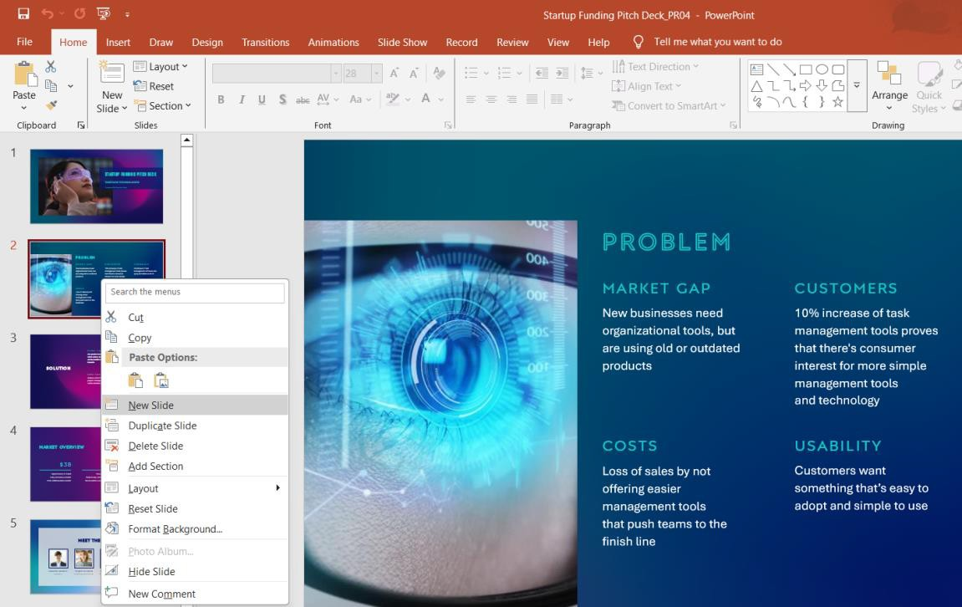

Edit Text and Maintain Consistency

  - Make sure all slides use the same font style (e.g., Calibri or Arial).
  - Keep headings clear and bold.
  - Use bullet points for short and readable content.
  - Ensure that spacing, alignment, and text size are consistent across the slides.

Final Output:

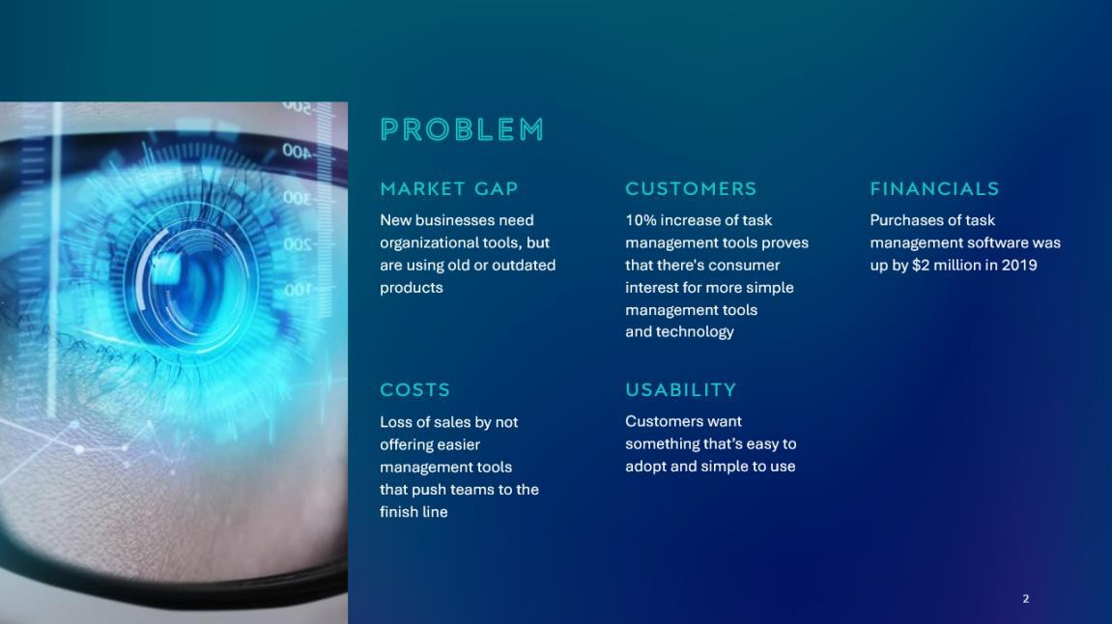

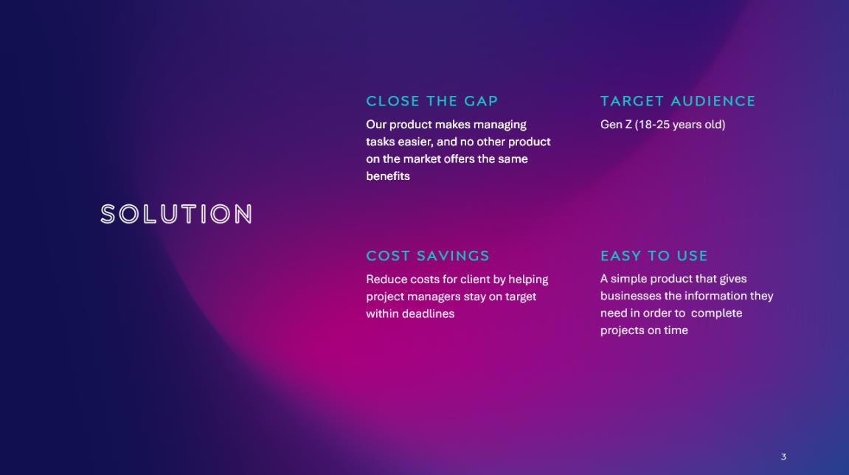




UNIT III-MS Excel: Data Management and Formulas:

Introduction to MS Excel:

Microsoft Excel is a versatile spreadsheet software used for organizing, analyzing, and presenting data. It allows users to work with information in rows and columns, perform calculations using formulas and functions, and create charts for visual understanding. Excel is widely used in fields like business, finance, education, and data analysis because it helps manage large amounts of data efficiently. With features such as sorting, filtering, conditional formatting, and pivot tables, Excel makes it easy to interpret data and make informed decisions.

PRACTICAL 3.1-Setting up and Formatting a Sales Data Spreadsheet:

Objective:
Master basic spreadsheet creation, cell manipulation, and effective formatting. Task: Create a spreadsheet named "Q3 Regional Sales Data."
- Enter text, numbers, and dates (e.g., Region, Sales Rep, Date, Units Sold, Revenue). Ensure proper data type formatting for dates and currency.
- Insert and delete a column and a row to correct initial data entry.
- Adjust cell height and width for optimal display.

- Apply Conditional Formatting to highlight all Revenue figures that are above a specific target value (e.g., $50,000).
- Sort the data table by "Revenue" in descending order.
Procedure:

Create a New Spreadsheet
  - Open Microsoft Excel.
  - Click Blank Workbook.
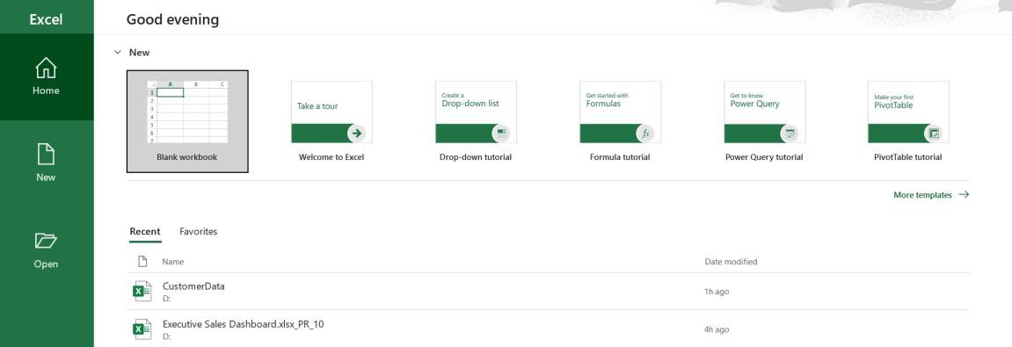
  - Go to File → Save As, and name the file “Q3 Regional Sales Data”.

Enter Text, Numbers, and Dates with Proper Formatting
  - In Row 1, enter the following headers:
    - A1: Region
    - B1: Sales Rep
    - C1: Date
    - D1: Units Sold
    - E1: Revenue

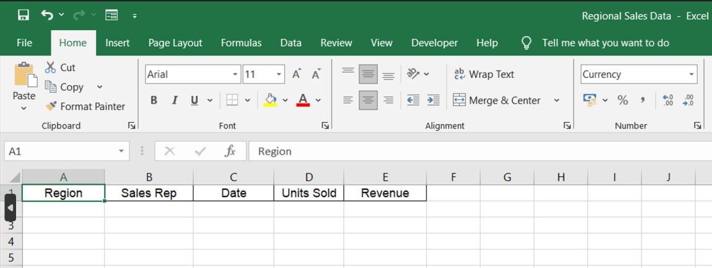
  - Enter sample data under each column (any names, regions, dates, and numbers).

Format the Date column:
    - Select all cells under the Date column → Format Cells box → Choose Date.

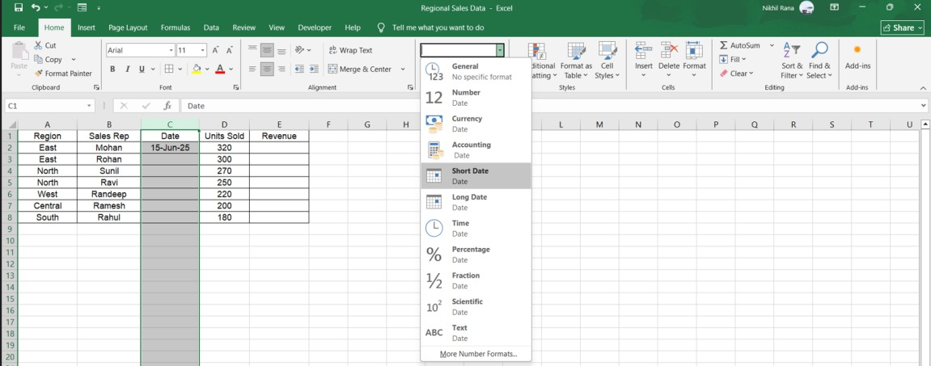

Format the Revenue column as Currency:
    - Select all Revenue cells → Right-click → Format Cells box → Select Currency → OK.

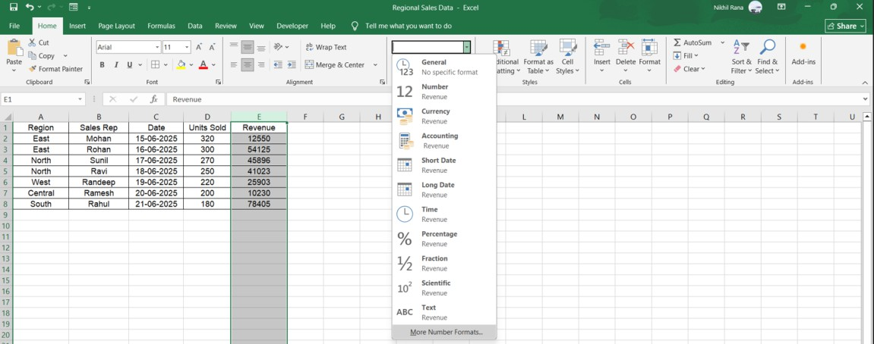
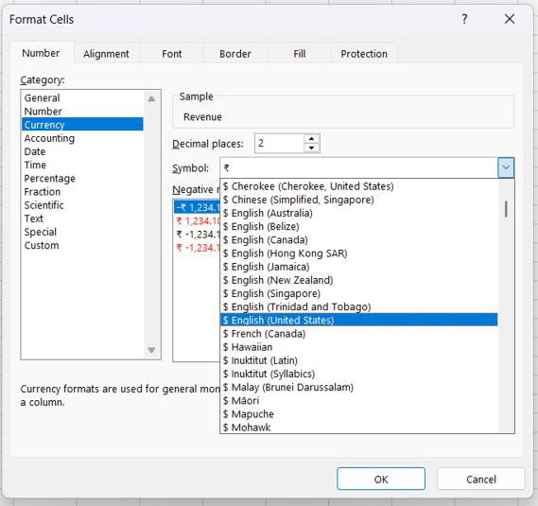
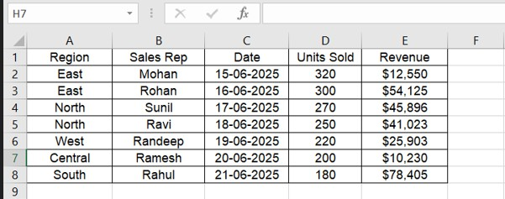

Insert and Delete a Row and Column Insert a Column
  - Select the column where you want the new column (e.g., click on column F).
  - Right-click → Insert → A new column will appear to the left.

Delete a Column
- Select the column you want to remove.

- Right-click → Delete.
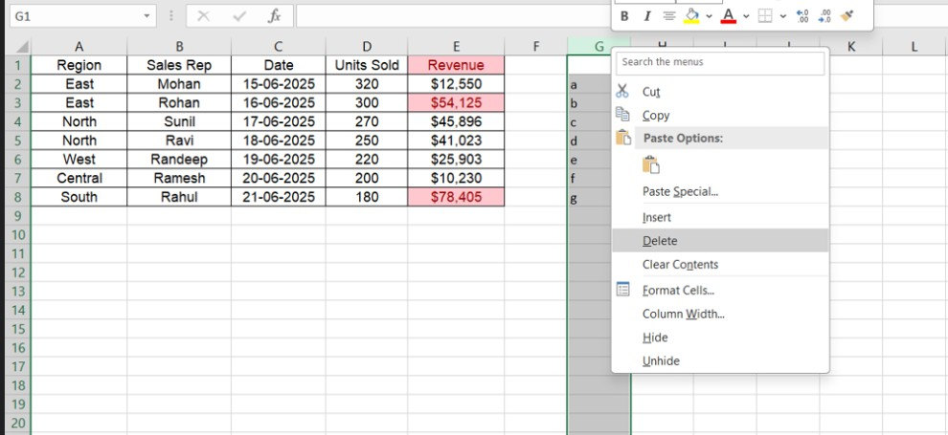

Insert a Row
- Select any row number (e.g., Row 4).
- Right-click → Insert → A new row appears above.

Delete a Row
- Select the row you want to delete.
- Right-click → Delete.

Adjust Cell Height and Width
  - To change column width: Goto→ Format→ Autofit column width
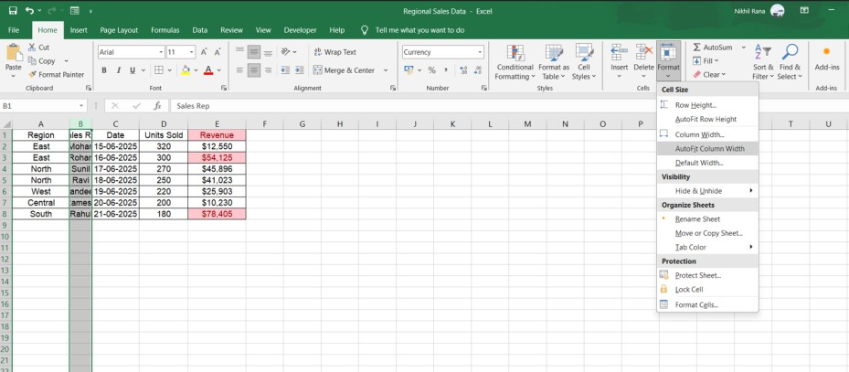
  - To change row height:
    - Move the cursor between row numbers until the double arrow appears.
    - Drag to adjust height.
- Apply Conditional Formatting (Revenue > $50,000)
  - Select all revenue cells (E2:E8 or as needed).

  - Go to Home → Conditional Formatting → Highlight Cell Rules → Greater Than…
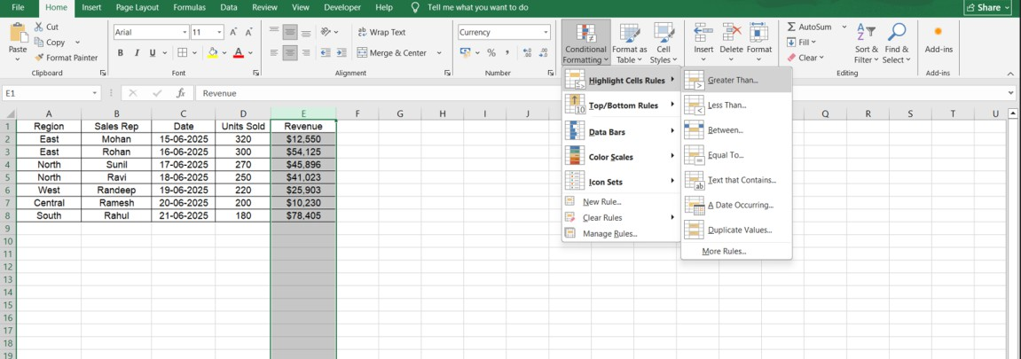
  - Enter 50000 in the value box.
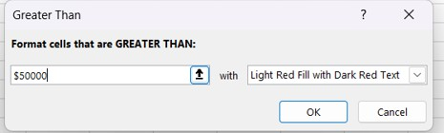
  - Choose a formatting style (green fill, bold text, etc.).
  - Click OK.
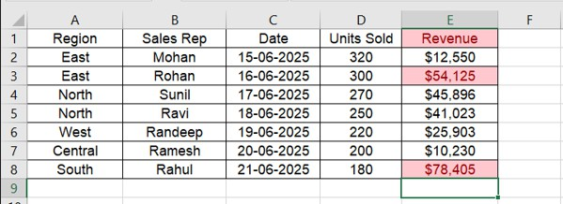

Sort Data by Revenue (Descending Order)
  - Click anywhere inside the data table.
  - Go to Data tab → Sort.

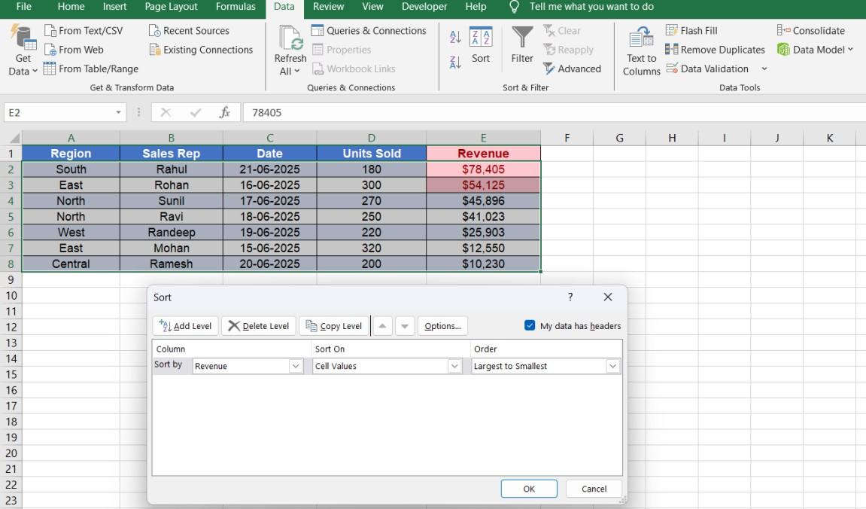
  - In the Sort box:
    - Column: Revenue
    - Sort On: Values
    - Order: Largest to Smallest
  - Click OK — the revenue will now be sorted from highest to lowest.

7. Save the Workbook:
  - Go to File → Save, to keep your updated and formatted spreadsheet.

Final Output:
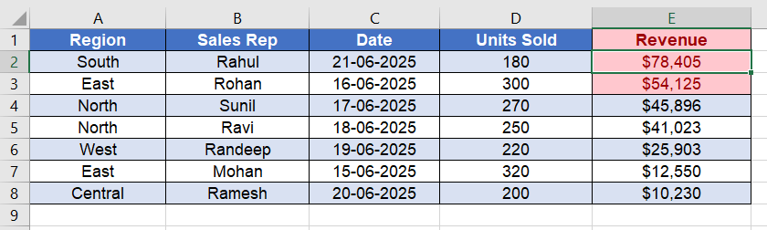

PRACTICAL 3.2-Sales Performance Analysis using Key Functions:

Objective:
Practice fundamental business calculation formulas/functions in Excel.

Task: Using the data from Practical III.1, perform the following calculations in a summary section:

- Calculate the Total Revenue using the function.
- Calculate the Average Revenue per Transaction using the function.
- Calculate the Number of Sales Transactions using the function.
- Use the IF function to create a new column, "Performance Status," those labels transactions with Revenue as "Achieved Target" and others as "Below Target."

Procedure:
- Open the File:
a) Open the previously saved Excel sheet named “ Regional Sales Data.”
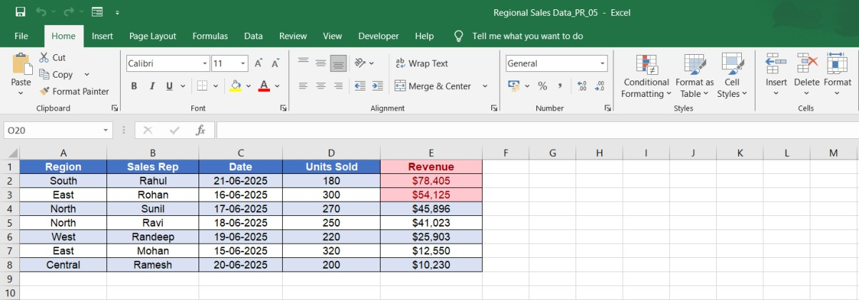

Create the Summary Section:

Scroll below the table and type labels in Column C or D:

  - Total Revenue
  - Average Revenue per Transaction
  - Number of Sales Transactions

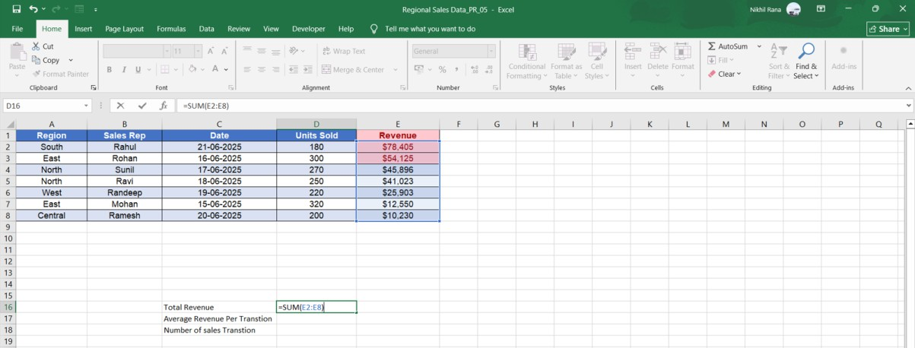

Calculate Total Revenue
- Click the cell next to Total Revenue
- Type the formula:
3. =SUM(E2:E8)
4. Press Enter.
This adds all values in the Revenue column.
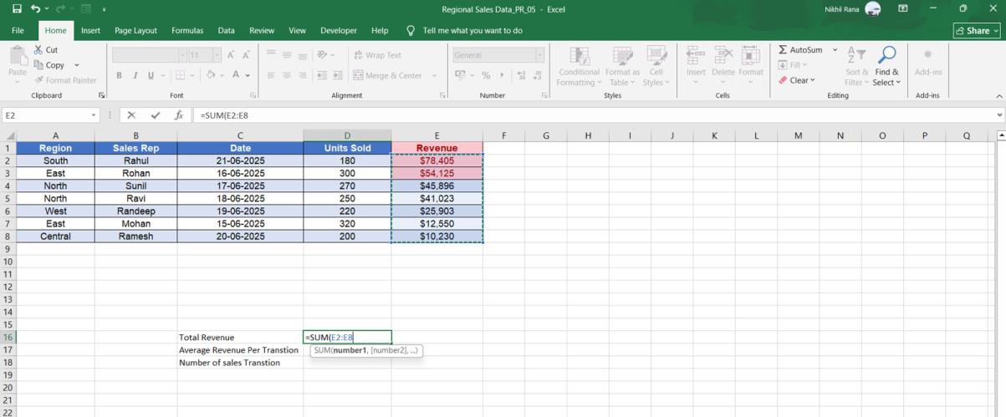


4: Calculate Average Revenue per Transaction
- Select the cell next to Average Revenue Per Transaction (D17, based on screenshot).
- Type the formula:

3. =AVERAGE(E2:E8)
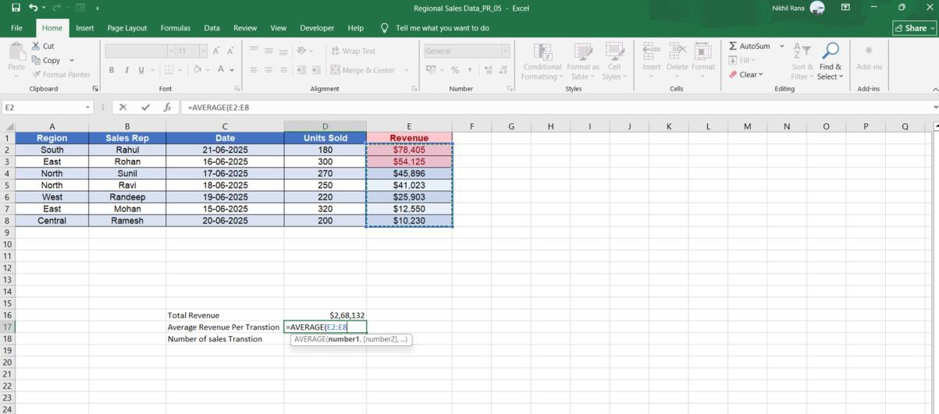
4. Press Enter.
This gives the average of all revenues.
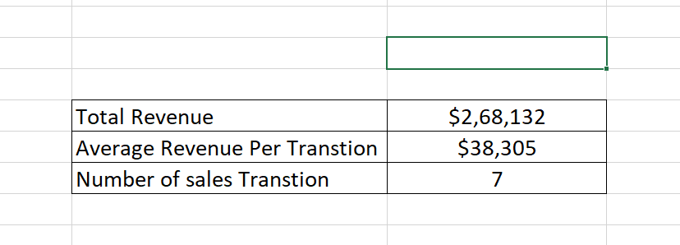

5: Calculate the Number of Sales Transactions
- Click the cell next to Number of Sales Transaction (C18).
- Type the formula:
3. =COUNTA(A2:A8)

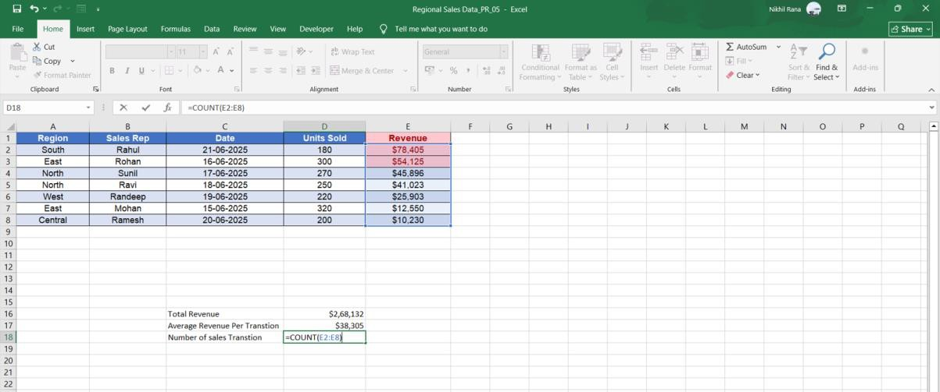
4. Press Enter.
This counts the number of records in the table.
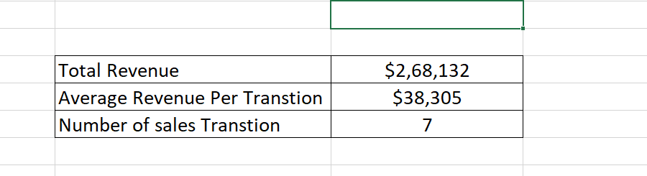

6: Create “Performance Status” Column Using IF Function
- Go to cell F2 (first row under Performance Status).
- Enter:
3. =IF(E2:E8>=50000,"Achieved Target","Below Target")
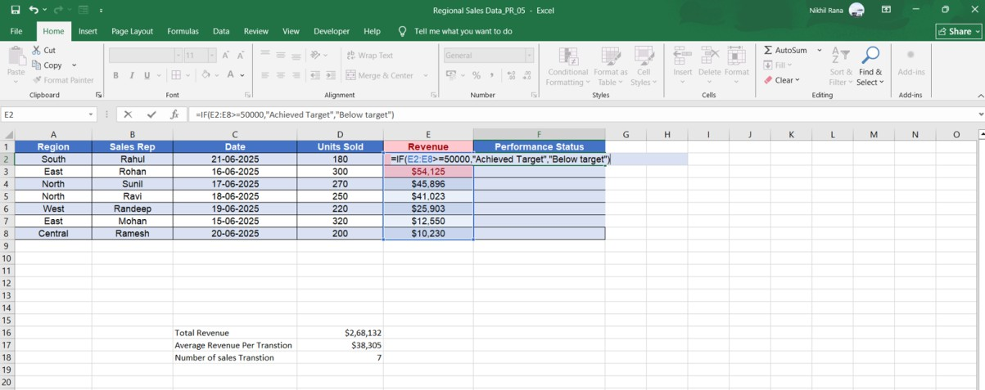
- Press Enter.

- Drag the fill handle down to F8 to apply the formula to all rows.
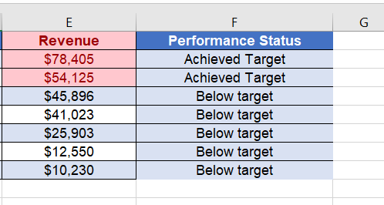

Final Output:
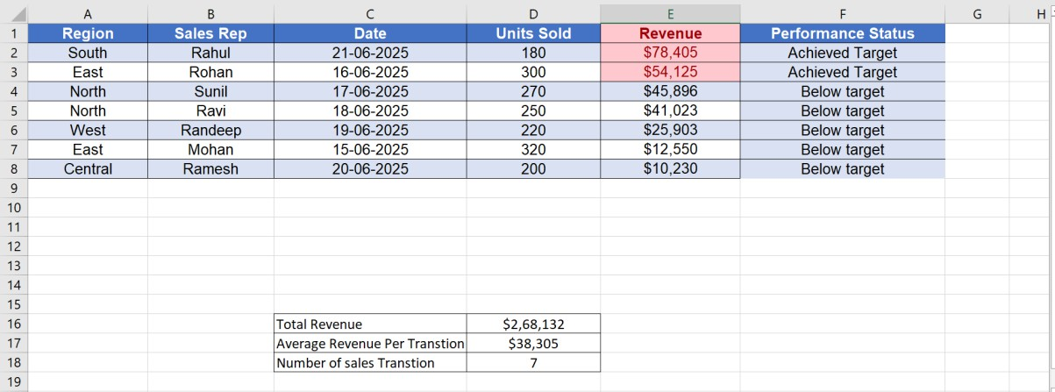

PRACTICAL 3.3-Employee Lookup System using VLOOKUP

Objective:
Implement the function to retrieve specific data, simulating a mini-database query. Task: Create two small tables:
- Table 1 (Employee Master): Employee ID, Name, Department, Salary.
- Table 2 (Lookup Tool): A single cell for entering the Employee ID and adjacent cells where will automatically populate the Name, Department, and Salary. (Students should demonstrate that changing the Employee ID in the lookup cell correctly updates the other details.)

Step 1: Create Table 1 – Employee Master:
  - Open Microsoft Excel. In Row 1, enter the following headers: Employee ID | Name | Department | Salary
  - Enter the details of employees under each column. This table will act as the “database.”
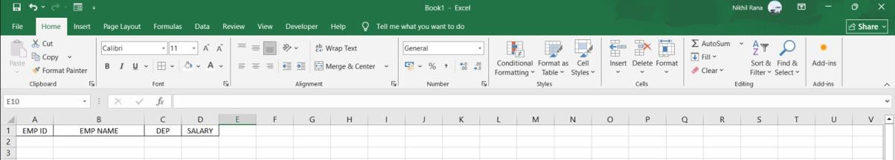
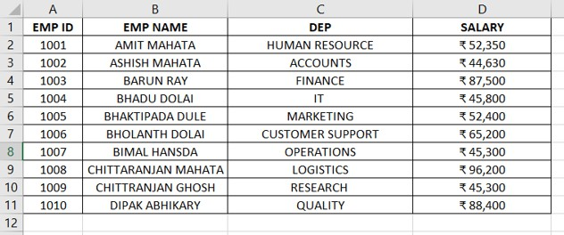

Step 2: Create Table 2 – Lookup Tool
- Scroll down below the master table
- Create small labels for the lookup section:
  - EMP ID
  - EMP NAME
  - DEP
  - SALARY

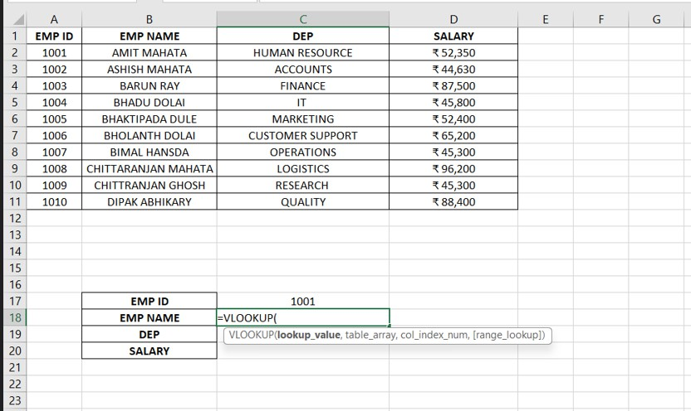

Step 3: Use a Dynamic VLOOKUP Formula With ROW()
Instead of writing separate VLOOKUP formulas for each field, we used one formula that automatically adjusts the column index.
Formula Used:
In cell C18, enter:
=VLOOKUP($C$17,$A$1:$D$11,ROW()-16,0)
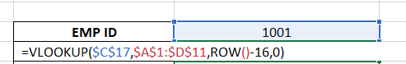

Step-by-step explanation:
- $C$17 → The input Employee ID
- $A$1:$D$11 → Employee Master Table
- ROW()–16 automatically calculates which column to return:
  - In Row 18 → ROW()=18 → 18–16=2 → EMP NAME
  - In Row 19 → ROW()=19 → 3 → DEP
  - In Row 20 → ROW()=20 → 4 → SALARY
- The 0 (FALSE) ensures an exact match

Step 4: Copy the Formula Down

- After entering the formula in C18, drag it down from C18 to C20.
- Excel automatically changes:
  - Row 18 → returns EMP NAME
  - Row 19 → returns DEP
  - Row 20 → returns SALARY
This happens because ROW() changes with each row.
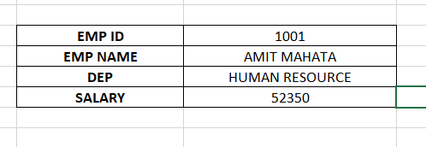

Step 5: Test the Lookup
- Go to cell C17.
- Type any employee ID from the master table (e.g., 1001, 1005, 1008).
- The EMP NAME, DEP, and SALARY will automatically refresh.
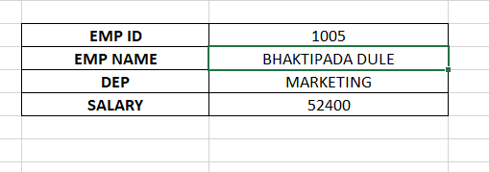

Final Output:
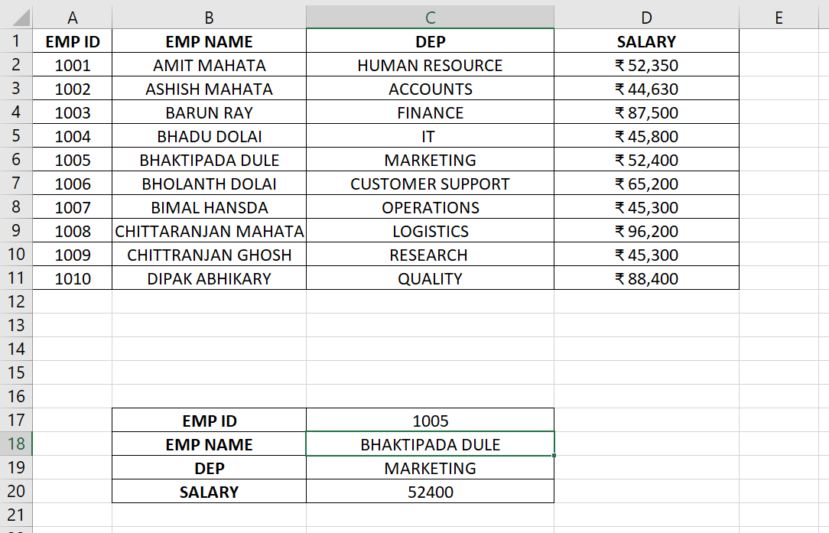

UNIT IV:MS Excel: Data Management, Formulas and Visualization
MS Excel helps in managing and organizing large amounts of data easily using rows and columns. It provides various formulas and functions like SUM, AVERAGE, and IF to perform quick and accurate calculations. Excel also allows users to create charts, graphs, and pivot tables for data visualization. These tools help in analyzing information, finding trends, and making better decisions. Overall, Excel makes data handling, computation, and presentation more efficient and effective.
PRACTICAL 4.1-Data Visualization and Interpretation of Charts

Objective:
Create and customize a relevant chart to visualize business data.

Task: Using the Revenue and Region data from Practical III.1:
1. Create a Bar Chart or Column Chart to visually compare the total revenue across different regions. 2. Customize the chart with a clear title, appropriate axis labels, and change the chart style to a professional, easily readable design.

3. Insert a SmartArt graphic on the side to illustrate the company's organizational structure (e.g., a Hierarchy layout).

Open a New Spreadsheet:
  - Open MS Excel.
  - Click File > New to start a new blank workbook.

Creating the Column Chart

- Selected the Region and Revenue columns.
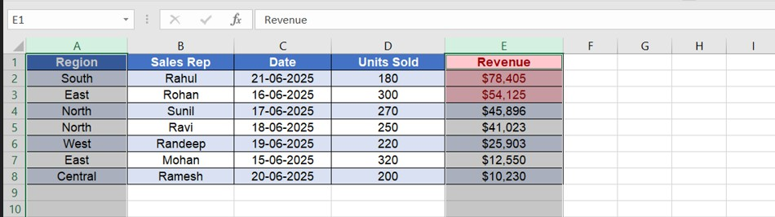
- Went to the Insert tab on the Ribbon.
- In the Charts group, clicked on Column Chart and selected Clustered Column.
- Excel automatically inserted a column chart on the worksheet.
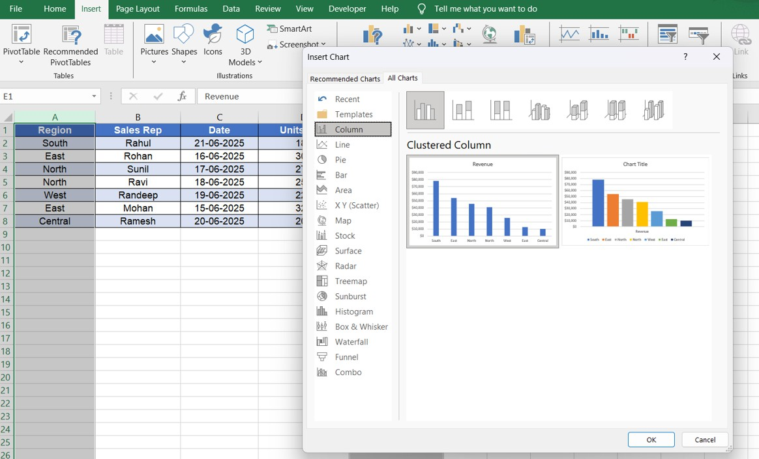

Customizing the Chart:

- Changing the Chart Title
  - Clicked on the existing chart title.
  - Renamed it to “Revenue Comparison by Region” to clearly represent the data.
  - 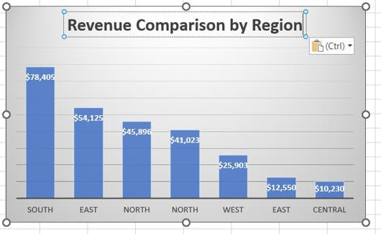

Adding Axis Titles:
- Selected the chart → clicked the Chart Elements (+) button.
- Enabled Axis Titles.
- Labelled the:
- Horizontal Axis as Regions
- Vertical Axis as Revenue ($)

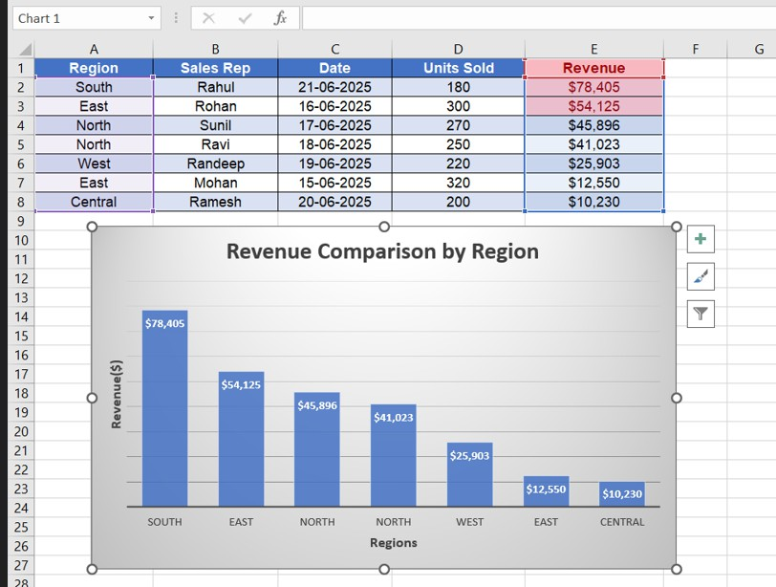

Adding Data Labels
  - Right-clicked on the chart bars → chose Add Data Labels.
  - The revenue values were displayed on top of each bar (as seen in the output).

Inserting the SmartArt Organizational Hierarchy:
Clicked on the Insert tab. Selected SmartArt → Hierarchy.
Chose the Organization Chart layout.
Entered the following hierarchy exactly as in the output:

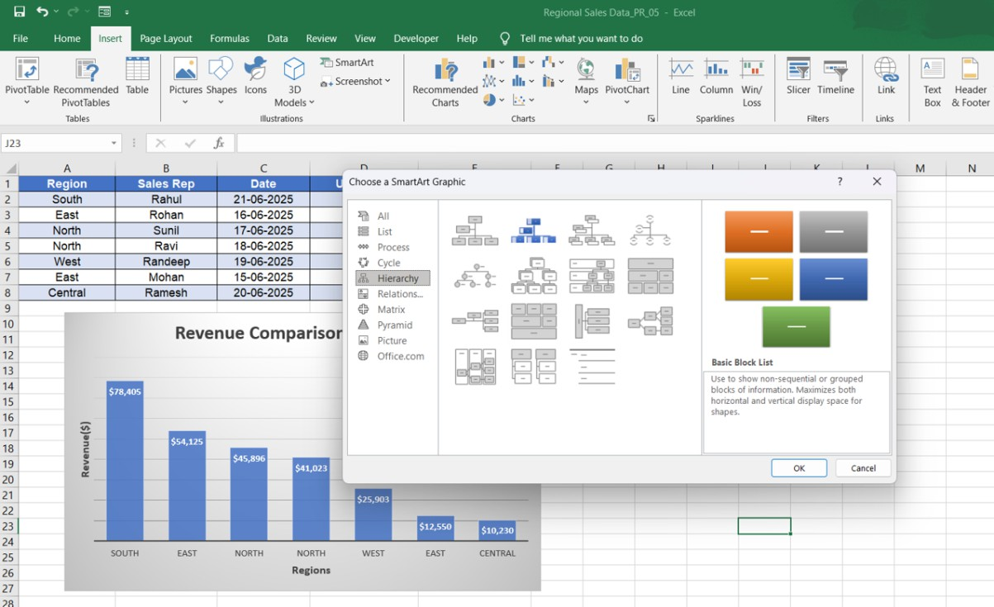

Formatting the SmartArt
- Used SmartArt Design → Change Colors to apply the colorful gradient theme (orange, green, blue).
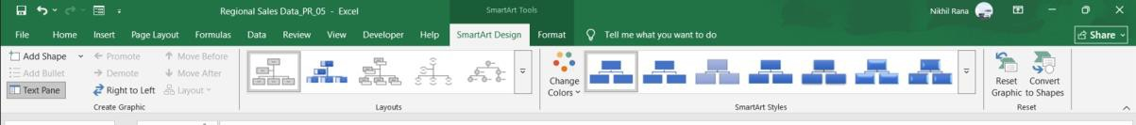
- Adjusted the shape sizes and spacing to match the alignment shown in the output.
- Resized the entire SmartArt graphic and placed it on the right side of the worksheet.

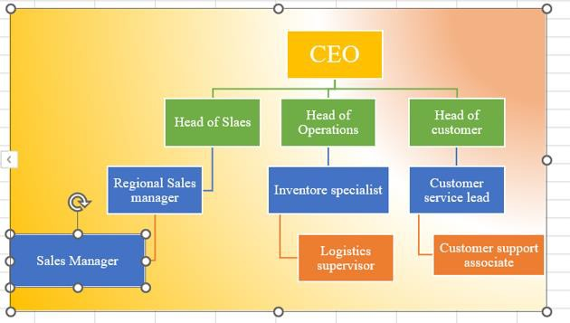

Final Output:
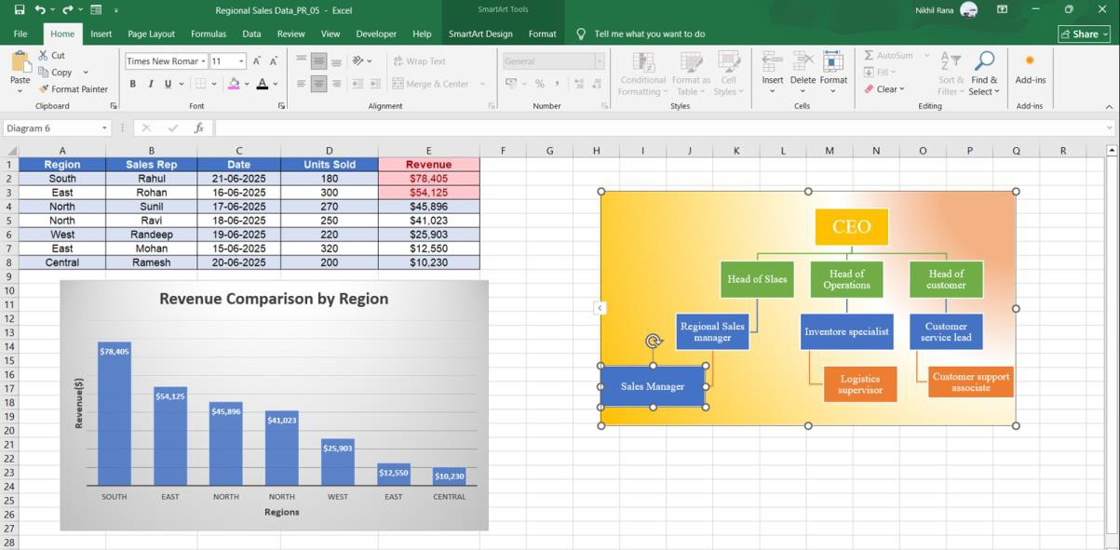

PRACTICAL 4.2-Advanced Reporting with PivotTables and Grouping
Objective:

Use PivotTables for aggregating and analyzing data and apply grouping/sorting.

Task: Create a PivotTable from the full sales data (Practical III.1).
- Structure the PivotTable to show Total Revenue (Values) by Sales Rep (Rows) and by Region (Columns).
- Group the "Date" field (if available) by Quarter to show quarterly revenue totals.
- Apply a professional PivotTable Style.
- Use the Filtering feature to display data for only two specific regions.

Procedure:
- Selecting the Sales Data
  - Opened Microsoft Excel and selected the complete sales dataset, including the columns:

Region, Sales Rep, Date, Units Sold, Revenue.
  - Ensured the entire table (A1:E8) was highlighted.
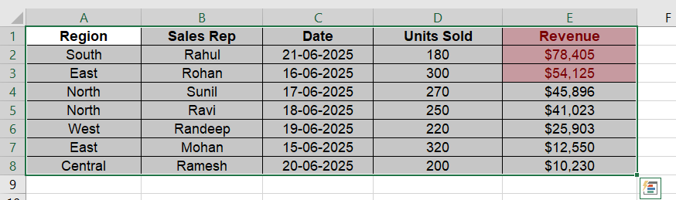

Inserting the PivotTable
  - Went to the Insert tab.
  - Clicked PivotTable.

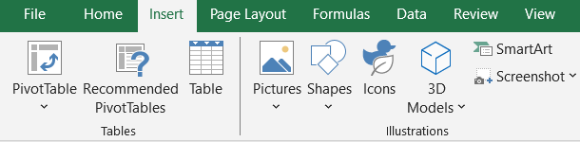
  - Chose New Worksheet (or existing sheet where the output appears).
  - Clicked OK to create a blank PivotTable layout.
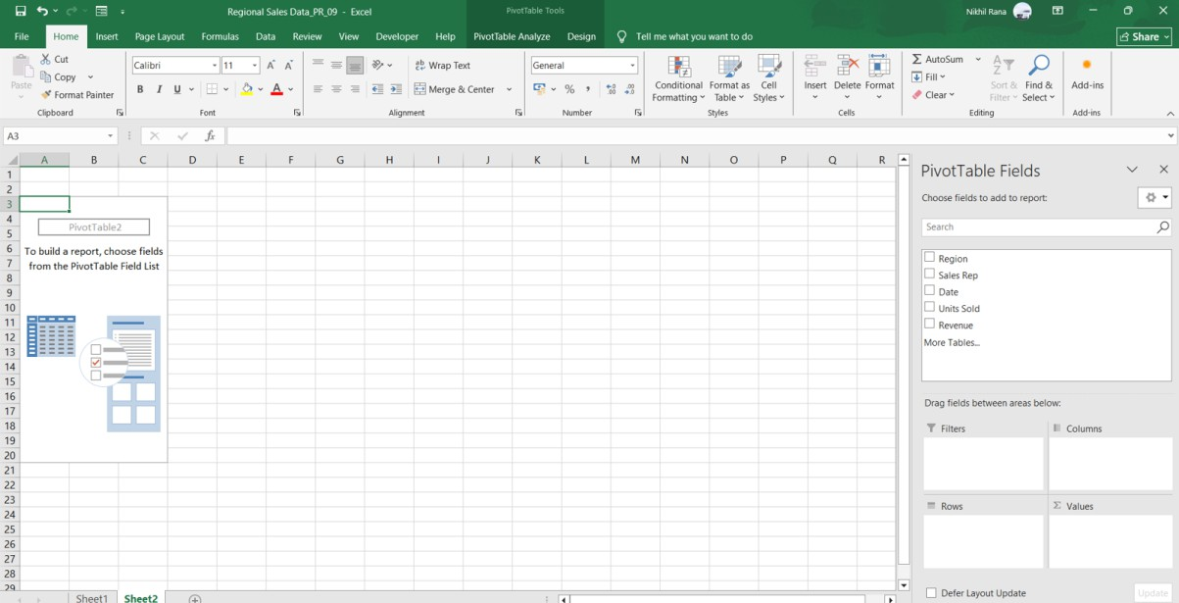

Setting Up the PivotTable Fields
- Adding Region as Columns
  - Dragged Region into the Columns area.
  - The column headings (East, West, etc.) appeared at the top of the PivotTable.
- Adding Sales Rep as Rows
  - Dragged Sales Rep into the Rows area.
  - Later an additional grouping was added (Years and Quarters), but Sales Rep remains under them.
- Adding Revenue to Values
  - Dragged Revenue into the Values area.
  - Excel automatically displayed Sum of Revenue.

  - 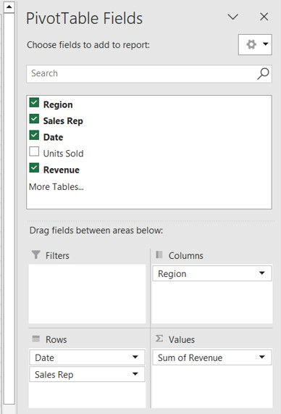

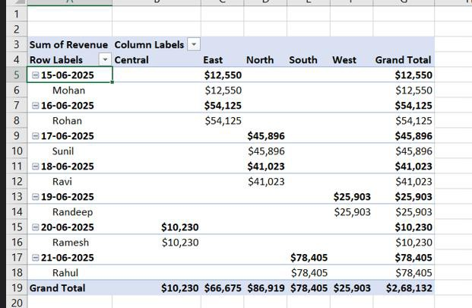

Grouping the Date Field by Quarter
  - Dragged Date into the Rows area (initially).
  - Right-clicked any date inside the PivotTable.
  - Selected Group.

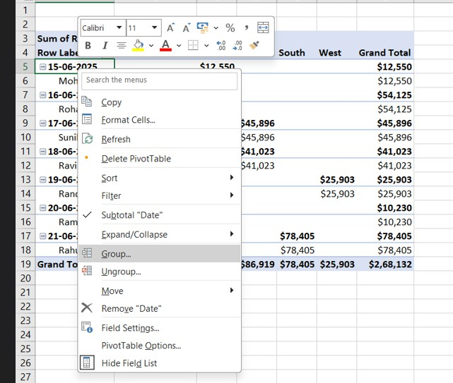
  - Chose Years and Quarters from the grouping options.
  - Clicked OK.
  - Excel created hierarchical levels:
Years → Quarters → Sales Rep, exactly as shown in your output.

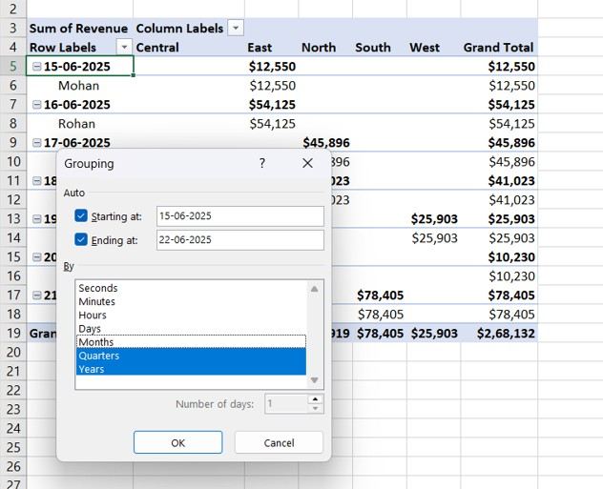
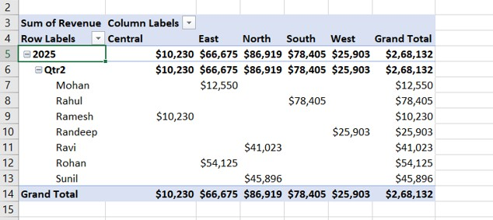

Applying the PivotTable Style
  - Clicked anywhere inside the PivotTable.
  - Opened the PivotTable Design tab.

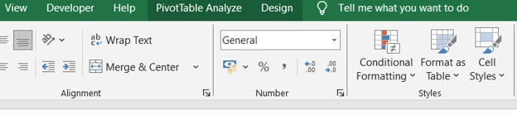
  - Selected a professional dark-header style.
  - Ensured the colour formatting matched the default PivotTable style used.
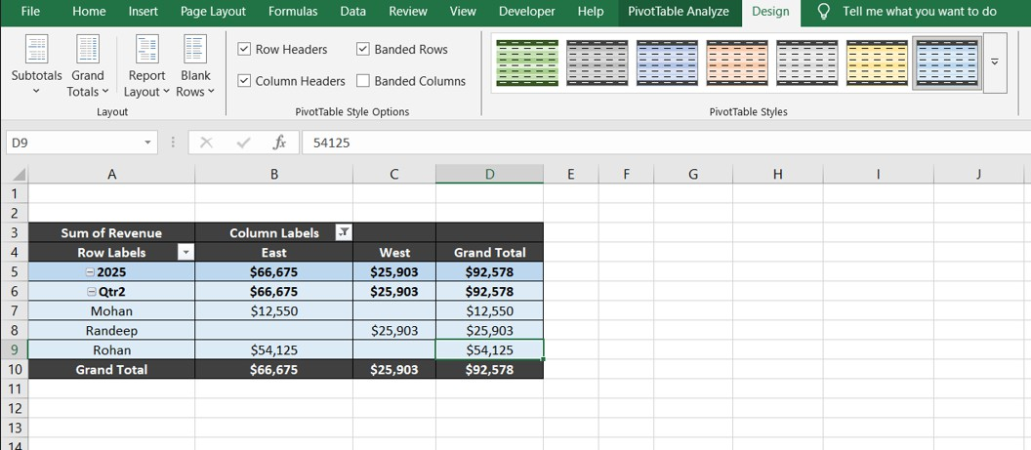

Filtering the PivotTable to Show Only Two Regions
  - Clicked the drop-down arrow on the Column Labels field.
  - Unchecked all regions except East and West.

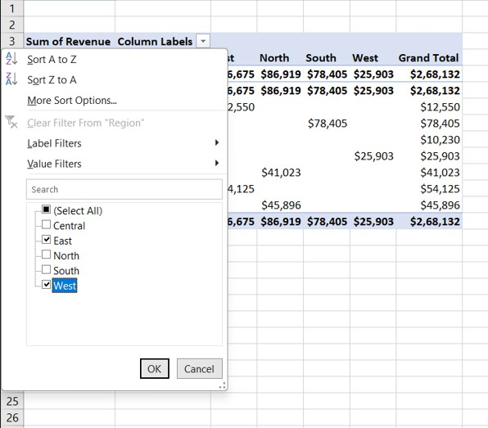
  - Clicked OK.
  - The PivotTable updated to display only the revenue data for East and West, matching the output.

Final Output:
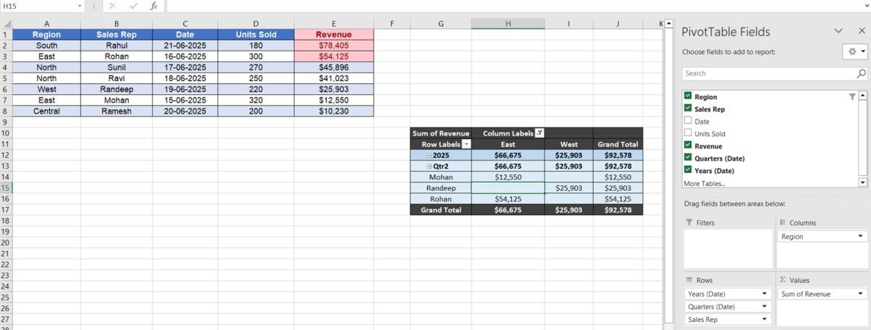

PRACTICAL 4.3-Creating a Dynamic Executive Dashboard

Objective:
Combine data summarization (PivotTable/Charts) and create a simple and dynamic reporting tool.
Task: Based on the PivotTable created in Practical IV.2:
- Create a Pivot Chart that visualizes the total revenue by sales rep.
- Insert a Slicer linked to the PivotTable for the "Region" field.
- The file should be saved as an "Executive Sales Dashboard" demonstrating how clicking different regions in the Slicer dynamically updates both the PivotTable and the Pivot Chart.

Procedure:
  - Preparing the PivotTable:
    - Opened the Excel file containing the complete sales data.
    - Used the PivotTable from Practical IV.2, which already had:
      - Sales Rep in the Rows
      - Region in the Columns
      - Revenue in the Values
      - Date grouped into Years and Quarters

Creating the Pivot Chart
- Clicked anywhere inside the existing PivotTable.
- Went to the PivotTable Analyse tab.

- Selected PivotChart.
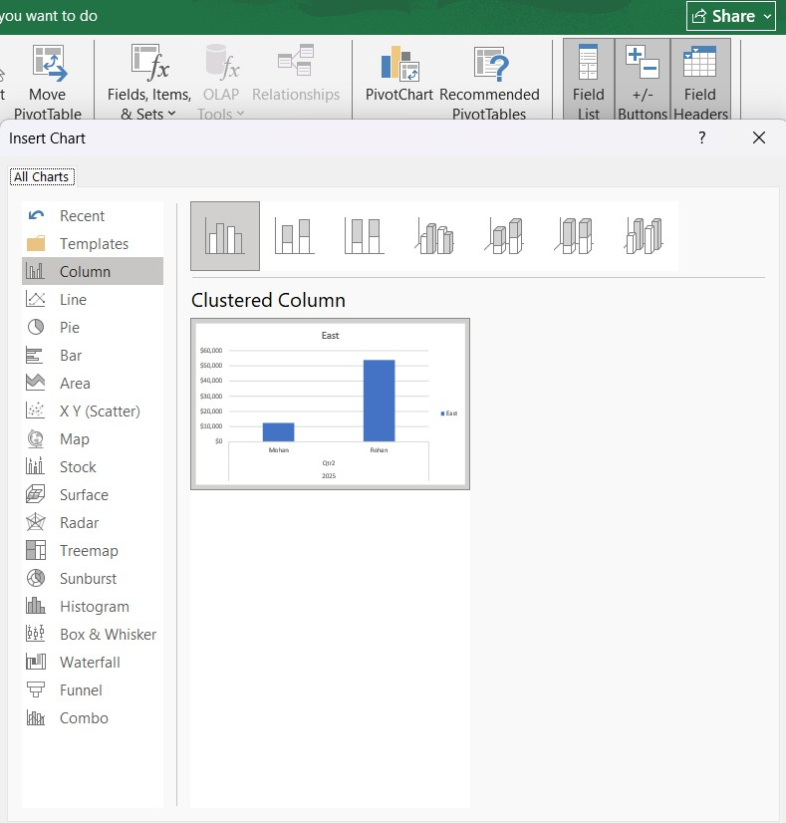
- Chose a Clustered Column Chart (same style as in the output).
- Clicked OK, and the Pivot Chart was inserted below the PivotTable.

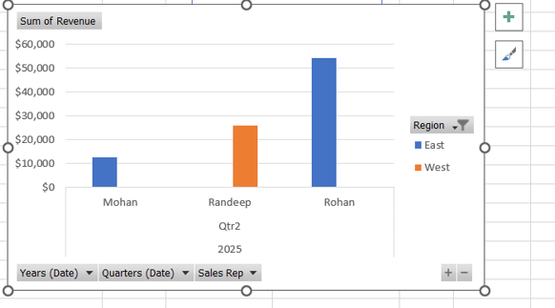

- Changed the chart title to “Total Revenue by Sales Representative.
- Verified that the chart shows only the Sales Rep names on the x-axis and their corresponding Revenue
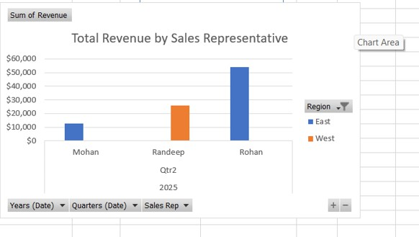

Formatting the Pivot Chart:

    - Went to the Design tab under PivotChart Tools.

    - Applied a clean, professional orange-coloured chart style matching the output.

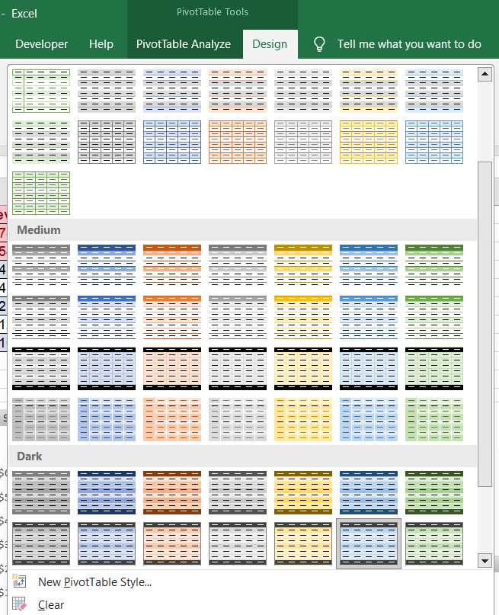

    - Adjusted the chart size and positioned it neatly on the sheet.

Inserting a Slicer for Region

    - Clicked inside the PivotTable.

    - Went to PivotTable Analyse → Insert Slicer.

    - Checked the box for region.

    - Clicked OK, and a Slicer appeared on the sheet.
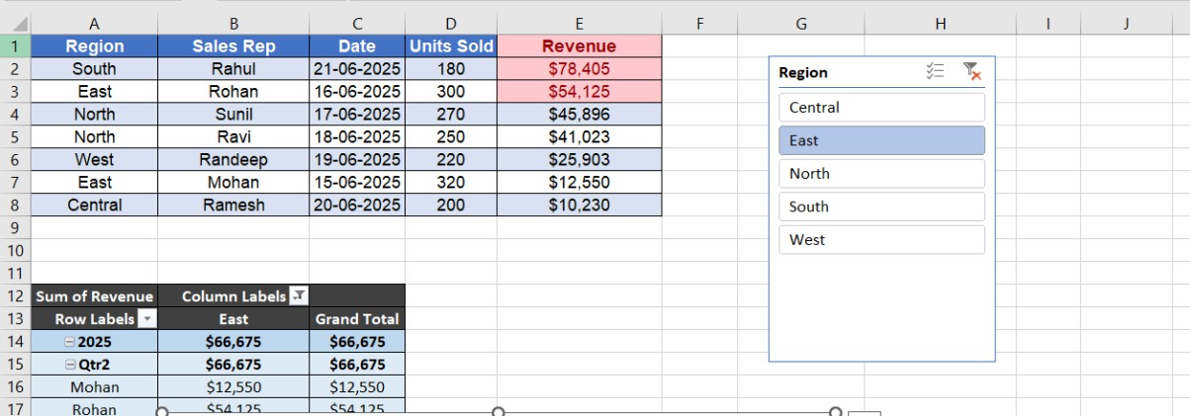

    - Positioned the Slicer to the right side of the data.

Connecting the Slicer to the Pivot Chart

    - Right-clicked the Slicer.

    - Selected Report Connections

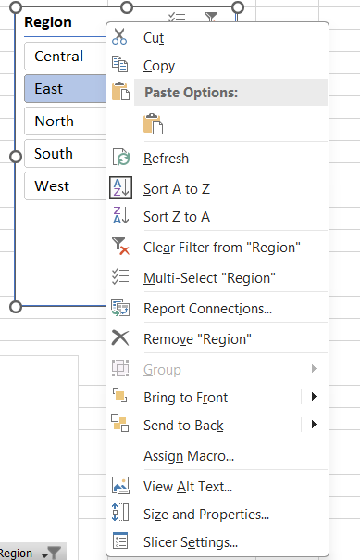

    - Checked the box for the PivotTable (ensuring the Pivot Chart is linked as well).

    - Now the Slicer controls both the PivotTable and the Pivot Chart.

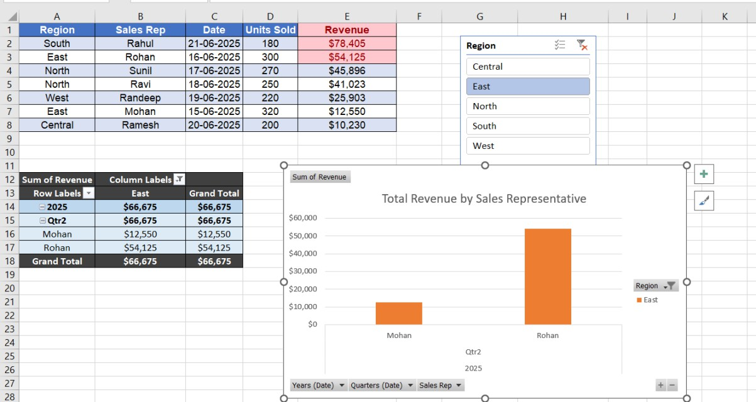

Testing the Dynamic Dashboard

    - Clicked on different regions in the Slicer (East, West, North, etc.).

    - Observed that:

      - The PivotTable updates instantly.

      - The Pivot Chart also updates instantly to show only the selected region’s revenue.

    - Verified the dashboard works dynamically exactly as required.
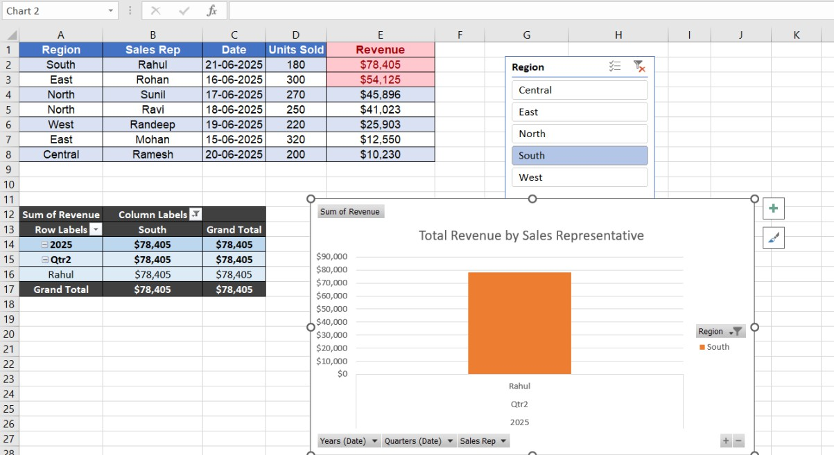

Renaming and Saving the File

    - Went to File → Save As.

    - Named the file “Executive Sales Dashboard.xlsx.

    - Saved the file as the final submission.

Final Output:




