A
Summer Training Report On
“Financial Statement Analysis of Leading Online Travel Companies in India: A Study of MakeMyTrip, EaseMyTrip and Yatra”


Maharishi Markandeshwar
(Deemed to be University) Mullana
In the partial fulfilment of the Degree of Master of Business Administration (Session 2025-27)

Submitted to: Submitted by:
Dr. Manminder Kaur Pravinder Singh
Assistant Professor Roll No- 12258037
MBA 3rd A

CERTIFICATE
This is to certify that the Summer Internship Project Report entitled “Financial Statement Analysis of Leading Online Travel Companies in India: A Study of MakeMyTrip, EaseMyTrip and Yatra” has been prepared by Mr. Pravinder Singh (Roll No. 12258037), a bona fide student of the Master of Business Administration (Finance) programme at Maharishi Markandeshwar (Deemed to be University), under my guidance and supervision, in partial fulfilment of the requirements for the award of the degree of Master of Business Administration.
The work embodied in this report is the original work of the candidate and has not been submitted, in part or in full, for the award of any other degree or diploma of this or any other university.
I wish him success in all his future endeavours.

Date: __________________
Dr. Manminder Kaur
Professor

Faculty Guide Department of Management Studies
Maharishi Markandeshwar (Deemed to be University)

ACKNOWLEDGEMENT
I take this opportunity to express my sincere gratitude to everyone who supported and guided me through the successful completion of this Summer Internship Project.
I am deeply thankful to my Faculty Guide Dr Manminder Kaur at Maharishi Markandeshwar (Deemed to be University) for their constant guidance, valuable suggestions and encouragement throughout the course of this study. Their insights on financial statement analysis and research methodology were instrumental in shaping the direction of this report.
I would also like to extend my heartfelt thanks to my Industry Mentor and the entire team at Deal Squard Pvt. Ltd. for providing me with the opportunity to intern with the organisation and for their continuous support, practical exposure and feedback during the internship period.
I also acknowledge the contribution of the various secondary data sources — annual reports, investor presentations and financial databases of MakeMyTrip, EaseMyTrip and Yatra — which formed the empirical foundation of this study.
Finally, I would like to thank my family and friends for their unwavering support and motivation throughout this journey.
Pravinder Singh

DECLARATION
I, Pravinder Singh, Roll No. 12258037, hereby declare that the Summer Internship Project Report entitled “Financial Statement Analysis of Leading Online Travel Companies in India: A Study of MakeMyTrip, EaseMyTrip and Yatra” is an original piece of work prepared by me under the guidance of my faculty guide, in partial fulfilment of the requirement for the award of the degree of Master of Business Administration (Finance) at Maharishi Markandeshwar (Deemed to be University).
I further declare that this report has been compiled from publicly available annual reports, investor presentations, regulatory filings and other authentic secondary sources, and that the analysis, interpretation and conclusions presented herein represent my own independent work. This report has not been submitted earlier for the award of any degree, diploma, fellowship or similar title of this or any other university.

Date: __________________
Pravinder Singh Roll No. 12258037

COMPANY CERTIFICATE
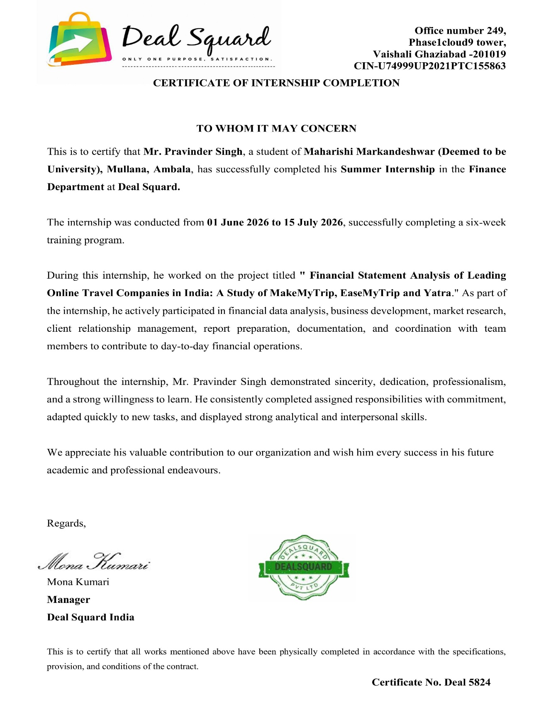

EXECUTIVE SUMMARY
India's online travel industry has evolved into one of the most dynamic segments of the country's digital consumer economy, driven by rising internet penetration, the proliferation of smartphones, growing disposable incomes and a structural shift in consumer preference from offline travel agents towards app-based booking platforms. This Summer Internship Project undertaken with Deal Squard Pvt. Ltd., an emerging player in the online hotel booking space, examines the comparative financial performance of three of India's most prominent listed online travel companies — MakeMyTrip Limited, Easy Trip Planners Limited (EaseMyTrip) and Yatra Online Limited — over the financial years 2023 to 2025.
The study is built on a detailed financial statement analysis covering the Balance Sheet, Statement of Profit and Loss, and, where available, Cash Flow Statements of the three companies, sourced from their audited annual reports, investor presentations, NASDAQ/NSE/BSE filings and reputable financial databases. Horizontal, vertical, common-size and trend analyses have been applied to assess growth patterns, cost structures and capital allocation, while a comprehensive ratio analysis spanning liquidity, profitability, efficiency, leverage and market ratios has been used to benchmark the operating and financial efficiency of the three companies against one another.
The analysis reveals that MakeMyTrip remains the clear market leader by scale, with revenue, gross bookings and balance sheet size far exceeding those of its two listed peers, and has achieved a marked turnaround in profitability after several years of losses, aided by improving operating leverage and cost discipline. EaseMyTrip has distinguished itself through consistent profitability, an asset-light and low-debt balance sheet, and one of the strongest return ratios in the sector, though its growth momentum has moderated in recent quarters amid intensifying competition and rising customer acquisition costs. Yatra, following its public listing and the acquisition of Globe Travels, has recorded the sharpest revenue growth of the three companies, largely on the back of its expanding corporate and MICE (Meetings, Incentives, Conferences and Exhibitions) travel business, though its profitability remains comparatively thin and more volatile.
The report concludes with a set of findings, practical suggestions and a broader conclusion that draws out implications for other participants in India's online travel and hotel booking ecosystem, including Deal Squard, particularly around the importance of diversified revenue streams, disciplined marketing spend, working capital efficiency and the build-out of a resilient, asset-light financial structure.

INTRODUCTION

INDUSTRY PROFILE
India’s online travel industry has grown into one of the largest digital consumer segments in the country, driven by a combination of macroeconomic and behavioural factors. Rising disposable incomes, a young and digitally native population, expanding domestic air and rail connectivity, and government initiatives promoting tourism have collectively contributed to sustained growth in both leisure and business travel. Industry estimates published by travel and tourism research organizations have consistently placed India among the fastest-growing online travel markets globally, with online penetration of travel bookings rising steadily over the past decade as offline travel agents have ceded share to digital platforms.
The industry encompasses several sub-segments, including flight ticketing, rail and bus ticketing, hotel and accommodation booking, holiday packages, and ancillary services such as travel insurance and visa facilitation. Hotel and accommodation booking has emerged as one of the most profitable sub-segments for OTAs, owing to relatively higher commission rates compared to flight ticketing, where airline commissions have historically been thin.

The Online Hotel Booking Industry
The online hotel booking industry in India comprises a mix of horizontal OTAs offering multi-category travel bookings (such as MakeMyTrip and Yatra), hotel-focused platforms, alternative accommodation marketplaces (such as those offering homestays and vacation rentals), and global platforms with a strong India presence (such as Booking.com and Agoda). The industry is also shaped by the presence of hotel chains that operate their own direct booking channels and loyalty programmes, creating a competitive dynamic between intermediary platforms and hotel-owned distribution.
A defining characteristic of the industry is its reliance on a commission-based or margin-based revenue model, in which the platform does not bear inventory risk in the way a traditional retailer would, but instead earns revenue contingent on successful bookings. This makes conversion rate, average booking value, and repeat booking frequency critical performance metrics for platform profitability.

8.3 Industry Growth and Market Size
While precise, real-time market size figures vary across research publications and are subject to periodic revision, industry reports have consistently indicated robust growth in India’s online travel booking market, with compound annual growth rates in the low-to-mid teens reported across several studies conducted in the years preceding this report. Growth has been particularly pronounced in the online hotel booking sub-segment, supported by increasing traveller comfort with digital payments, wider availability of budget and mid-scale hotel inventory on aggregator platforms, and the post-pandemic resurgence of both leisure and business travel.
The following table presents illustrative, publicly reported industry growth indicators compiled from secondary sources, intended to provide directional context for the scale and trajectory of the industry rather than precise, audited figures.
Table 8.1: Illustrative Industry Growth Indicators (Compiled from Secondary Sources)
Indicator | Observed Trend
Online travel booking penetration | Steadily increasing share of total travel bookings shifting from offline to online channels
Online hotel booking growth rate | Reported compound annual growth in the low-to-mid double digits across multiple industry studies
Mobile booking share | Majority of hotel bookings on leading OTAs now originate from mobile applications
Domestic leisure travel | Sustained growth supported by rising disposable incomes and weekend/short-break travel trends
Business travel recovery | Gradual recovery and growth in corporate and business travel bookings
Tier-II and Tier-III city contribution | Increasing share of bookings originating from smaller cities and towns

Current Trends in the Online Hotel Booking Industry
- Dynamic and AI-driven pricing models that adjust room rates in real time based on demand, seasonality, and competitor pricing.
- Growing adoption of mobile-first booking experiences, with a majority of transactions occurring through mobile applications.
- Rising importance of user-generated content, including reviews and ratings, in influencing booking decisions.
- Expansion of alternative accommodation categories, including homestays, service apartments, and boutique properties.
- Increasing use of artificial intelligence and machine learning for personalized recommendations and customer segmentation.
- Growth of loyalty and subscription-based membership programmes to encourage repeat bookings.
- Integration of ancillary services such as travel insurance, airport transfers, and experiences into the core booking flow..

Future Opportunities
- Deepening penetration into Tier-II and Tier-III cities as internet access and digital payment adoption continue to expand.
- Growth of corporate and MICE (Meetings, Incentives, Conferences, and Exhibitions) travel segments.
- Increasing scope for personalization and predictive recommendation engines powered by customer data analytics.
- Potential for deeper integration with adjacent travel services, such as local transport, experiences, and dining.
- Opportunities for smaller platforms to differentiate through niche positioning, superior customer service, or focused geographic strength.

Industry Challenges
- Intense price-based competition leading to margin compression across the industry.
- High customer acquisition costs driven by competitive digital marketing bidding.
- Growing disintermediation risk as hotel chains promote direct booking channels with price-parity clauses.
- Rising customer expectations regarding speed, flexibility, and personalization of service.
- Regulatory and data protection requirements affecting how customer data can be collected and used.
- Vulnerability to macroeconomic and geopolitical disruptions affecting travel demand.

COMPANY PROFILE

INTRODUCTION
Deal Squard Pvt. Ltd. is a private limited company operating in the online hotel booking and travel services sector in India. The organization functions as an intermediary platform that connects travellers seeking hotel accommodation with a network of partner hotels ranging from budget properties to premium establishments. Consistent with the standard practice among online travel intermediaries, Deal Squard does not own or operate hotel properties directly; rather, its core business lies in aggregating hotel inventory, presenting it to customers through a digital booking interface, and monetizing the resulting transactions through commission and service-fee-based revenue models.
As is typical for organizations of this nature and scale, Deal Squard’s detailed financial statements, proprietary booking data, and specific commercial terms with hotel partners are treated as confidential business information and have not been made available for the purposes of this academic study. Accordingly, the description of the company’s operations, business model, and revenue sources presented in this report is based on general industry understanding, publicly observable aspects of the platform’s consumer-facing operations, and insights gained during the course of the internship, rather than on internal financial or strategic documents.

Business Model
Deal Squard operates on a business model broadly consistent with the agency and merchant models prevalent in the online hotel booking industry. Under this model, the platform aggregates room inventory from partner hotels, applies a layer of pricing and promotional logic, and offers the resulting listings to travellers through its website and mobile application. When a booking is confirmed, the platform earns revenue either through a pre-negotiated commission on the booking value (agency model) or through the margin retained between the price charged to the customer and the net rate payable to the hotel (merchant model).
The platform’s value proposition to travellers rests on price comparison, a wide selection of properties, user reviews and ratings, secure payment processing, and customer support throughout the booking lifecycle. Its value proposition to hotel partners rests on access to a wider customer base, reduced dependence on offline distribution channels, and revenue management tools that help hotels optimize occupancy, particularly during periods of low demand.

Products and Services
- Hotel room booking across multiple categories — budget, mid-scale, and premium properties.
- Price comparison and search filtering by location, star rating, amenities, and guest reviews.
- Secure online payment processing with multiple payment options.
- Booking modification, cancellation, and refund facilitation services.
- Customer support services across pre-booking, booking, and post-stay stages.
- Value-added and ancillary services such as travel insurance, airport transfers, and holiday add-ons offered in partnership with third-party service providers.
- Loyalty and reward programmes designed to encourage repeat bookings.

Revenue Sources
Based on standard industry practice for platforms of this nature, Deal Squard’s revenue is likely to be derived from the following broad sources, discussed in greater depth in Chapter 20 of this report:
- Commission income earned on confirmed hotel bookings.
- Margin income under the merchant model, where applicable.
- Listing and premium placement fees charged to hotel partners seeking enhanced visibility.
- Revenue share from cross-selling ancillary services such as insurance and transfers.
- Cancellation and modification-related service fees.
- Advertising revenue from promotional placements on the platform.

Organization Structure
Deal Squard, in common with most mid-sized online travel platforms, is organized around functional departments including Technology and Product Development, Hotel Partnerships and Supply, Sales and Marketing, Customer Support and Operations, Finance and Accounts, and Human Resources. The Technology and Product function is typically responsible for maintaining the booking platform, payment gateway integration, and data analytics infrastructure. The Hotel Partnerships function manages onboarding of new hotel properties and negotiation of commission terms. The Sales and Marketing function drives customer acquisition through digital marketing, promotional campaigns, and brand-building initiatives, while Customer Support manages the end-to-end customer service experience.

Vision
To become a trusted and preferred online hotel booking platform by delivering value, convenience, and transparency to travellers while empowering hotel partners with technology-driven revenue growth opportunities.

Mission
- To offer travellers a wide, reliable, and competitively priced selection of hotel accommodation across India.
- To build long-term, mutually beneficial relationships with hotel partners through fair commission structures and value-added services.

SWOT Analysis of Deal Squard

SWOT Matrix of Deal Squard Pvt. Ltd.
Dimension | Key Observations
Strengths | Agile and lean organizational structure enabling faster decision-making; focused positioning in the hotel booking segment; growing partner hotel network; customer-centric service approach.
Weaknesses | Limited brand recall compared to larger OTAs; smaller marketing budget restricting customer acquisition scale; relatively lower technology investment capacity; dependence on third-party payment and mapping infrastructure.
Opportunities | Rising domestic tourism and business travel in India; increasing smartphone and internet penetration in Tier-II and Tier-III cities; growth of experiential and weekend travel; potential for corporate travel partnerships; scope for AI-driven personalization.
Threats | Intense price competition from MakeMyTrip, EaseMyTrip, Yatra, and global players such as Booking.com and Agoda; hotel chains increasingly promoting direct booking channels; rising digital marketing and customer acquisition costs; evolving regulatory requirements for online commerce and data protection.

Company Profile

MakeMyTrip Limited

History
MakeMyTrip was founded in the year 2000 by Deep Kalra, initially serving the outbound travel needs of Indian-origin customers in the United States before pivoting, after the opening up of India's aviation sector, to become a full-fledged domestic Indian online travel agency. The company listed on NASDAQ in 2010, making it one of the earliest Indian internet companies to go public in the United States. In 2017, MakeMyTrip merged with Ibibo Group (owner of the Goibibo and RedBus brands), backed by a strategic investment from Naspers/Ctrip (now Trip.com Group), consolidating its position as the largest OTA group in India by gross bookings.

Business Model
MakeMyTrip operates an asset-light, commission and mark-up based marketplace model spanning air ticketing, hotels and packages, and bus ticketing, supplemented by ancillary services such as travel insurance, visa facilitation and foreign exchange. The company monetises through a combination of ticketing commissions, hotel margins, advertising revenue from suppliers, and, in the packages business, tour-operator style margins on bundled holiday products.

Products and Services
- Air ticketing – domestic and international flights
- Hotels and homestays – domestic and international accommodation booking
- Holiday packages – customised and fixed-departure packages
- Bus ticketing (through the redBus brand)
- Rail ticketing, cab bookings, travel insurance and forex services
- Corporate travel services through myBiz

Revenue Sources
Air ticketing revenue (commissions and service fees), hotels and packages revenue (margins on room nights and package sales), bus ticketing revenue, and other revenue including advertising and subscription income from hotel and travel partners.

Organisational Structure
MakeMyTrip Limited is incorporated in Mauritius and listed on NASDAQ; its principal operating subsidiaries include MakeMyTrip (India) Private Limited, Ibibo Group Private Limited (Goibibo, redBus) and Luxury Tours & Travel Private Limited, among others, operating under a group holding structure headquartered out of Gurugram, India.

Vision and Mission
MakeMyTrip's stated mission centres on making travel accessible, reliable and enjoyable for Indian travellers by combining technology, scale and a broad product portfolio, with an emphasis on building deep, repeat customer relationships across the full travel lifecycle.

Competitors
EaseMyTrip, Yatra, Cleartrip, Booking.com, Agoda, Ixigo, and traditional and corporate travel agents.

SWOT Analysis
Strengths | Weaknesses | Opportunities | Threats
Largest OTA in India by gross bookings; strong brand recall; diversified product portfolio (air, hotels, bus, packages, corporate) | High marketing and sales-promotion spend; historically volatile profitability; complex multi-brand structure (MMT, Goibibo, redBus) | Growth in Tier-2/3 city travel demand; expansion of myBiz corporate travel; AI-driven personalisation (Myra) | Intense price-based competition; airline/hotel disintermediation risk; macro sensitivity of travel demand

Easy Trip Planners Limited (EaseMyTrip)

History
EaseMyTrip was founded in 2008 by brothers Nishant Pitti, Rikant Pitti and Prashant Pitti, with a distinctive zero-convenience-fee model on flight bookings that helped it build a large customer base quickly. The company listed on the NSE and BSE in March 2021 through an IPO that was notable for being entirely an offer-for-sale by the promoters, with no fresh capital raised and no debt on the balance sheet at listing.

Business Model
EaseMyTrip follows a low-cost, high-efficiency B2C and B2B2C marketplace model, monetising primarily through airline commissions and incentives, hotel and holiday package margins, and, increasingly, through its B2B distribution network of travel agents. The company has historically maintained a lean cost structure relative to peers, reflected in comparatively low marketing spend as a percentage of revenue.

Products and Services
- Domestic and international flight booking
- Hotel and holiday package booking
- Bus and rail ticket booking
- Cab and self-drive rentals
- Corporate travel (EMT Desk) and international expansion (Dubai / EaseMyTrip US)

Revenue Sources
Gross booking revenue from air ticketing (largest share historically), hotels and holiday packages (a fast-growing share), and other ancillary travel services; the company also earns revenue from its B2B distribution network of sub-agents.

Organisational Structure
Easy Trip Planners Limited is an Indian public limited company headquartered in New Delhi, with wholly owned subsidiaries supporting its Dubai operations and other diversification initiatives; promoter holding has remained significant since listing.

Vision and Mission
EaseMyTrip positions itself around affordability and transparency in travel booking (“zero convenience fee”), with a strategic focus in recent years on diversifying beyond air ticketing into hotels, packages and international markets to reduce dependence on a single revenue line.

Competitors
MakeMyTrip, Yatra, Ixigo, Cleartrip, and offline/B2B travel agent networks.

SWOT Analysis
Strengths | Weaknesses | Opportunities | Threats
Debt-free, asset-light balance sheet; consistent profitability; low customer-acquisition cost model; strong return ratios | Continued heavy dependence on air ticketing; smaller scale versus MakeMyTrip; recent quarters show margin and revenue pressure | Diversification into hotels/packages and B2B distribution; international expansion (Dubai, US); corporate travel (EMT Desk) | Rising competitive intensity and discounting; airline commission structure changes; slower growth in a maturing core segment

Yatra Online Limited

History
Yatra was founded in 2006 by Dhruv Shringi, Manish Amin and Sabina Chopra as one of India's earliest online travel portals. After an earlier SPAC-based listing on NASDAQ (2016) as Yatra Online, Inc., the Indian operating entity, Yatra Online Limited, listed separately on the NSE and BSE in September 2022. In 2023, Yatra strengthened its position in the corporate travel segment through the acquisition of Globe Travel Service Private Limited, a corporate travel management company, materially expanding its enterprise client base.

Business Model
Yatra has increasingly positioned itself as a corporate-travel-first OTA, combining B2C leisure travel booking with a large managed corporate travel services business serving Indian and multinational enterprises, alongside a MICE (Meetings, Incentives, Conferences and Exhibitions) business. This differentiates its model from the more consumer-led approaches of MakeMyTrip and EaseMyTrip.

Products and Services
- Air ticketing – domestic and international, for both retail and corporate customers
- Hotels and holiday packages
- Corporate travel management services (via Yatra Corporate and the Globe acquisition)
- MICE – meetings, incentives, conferences and events management
- Bus and rail ticketing, ancillary travel services

Revenue Sources
Air ticketing revenue, hotels and packages revenue, and a growing share of revenue from corporate travel management fees and MICE services, which carry a different (typically higher realisation, lower volume) revenue profile compared to pure-play consumer OTA bookings.

Organisational Structure
The Yatra group operates through Yatra Online, Inc. (the NASDAQ-listed parent) and Yatra Online Limited (the NSE/BSE-listed Indian operating subsidiary), together with acquired entities such as Globe Travel Service Private Limited, headquartered in Gurugram, India.

Vision and Mission
Yatra's stated strategic focus is on becoming India's leading corporate travel and MICE services provider while maintaining a meaningful consumer travel business, leveraging technology to serve both large enterprise clients and individual travellers.

Competitors
MakeMyTrip (myBiz), EaseMyTrip, American Express Global Business Travel, BCD Travel, and other corporate travel management companies, in addition to consumer-focused OTAs

SWOT Analysis
Strengths | Weaknesses | Opportunities | Threats
Strong positioning in corporate travel and MICE; diversified B2B client base; highest revenue growth rate among the three companies in FY2025 | Comparatively thin and volatile net margins; smaller consumer brand recall versus MakeMyTrip; integration risk from the Globe acquisition | Expanding corporate travel spend in India; cross-selling MICE and travel management services; further consolidation in corporate travel | Sensitivity of corporate travel budgets to macroeconomic slowdown; competition from global travel management companies; airline capacity and pricing volatility

Comparative Snapshot
Parameter | MakeMyTrip | EaseMyTrip | Yatra
Year of Incorporation | 2000 | 2008 | 2006
Listing | NASDAQ (2010) | NSE, BSE (2021) | NASDAQ (2016); NSE, BSE (2022)
Core Strength | Scale & brand | Cost efficiency | Corporate travel / MICE
FY2025 Revenue (₹ Cr, approx.) | 8,316 | 587 | 796
FY2025 Net Profit (₹ Cr, approx.) | 850 | 109 | 47
Employee Base | Large (several thousand) | Mid-sized | Mid-sized

LITERATURE
REVIEW

LITERATURE REVIEW
• Agarwal, Kumar and Adichwal (2020):- Studied the relationship between marketing and advertising efforts and the market performance of listed online travel agencies in India, including MakeMyTrip and Yatra, and found that marketing expenditure explained a substantial proportion of the variance in market capitalisation and sales revenue of these companies. The study concluded that customer acquisition spending is a key driver of scale and equity value in the Indian OTA industry, a finding directly relevant to understanding the cost structures of MakeMyTrip, EaseMyTrip and Yatra.
• Dutta, Chauhan and Chauhan (2017):- Examined the factors affecting customer satisfaction of online travel agencies operating in India using a structural equation modelling approach on a sample of Indian OTA users. The study found that service quality, trust and value for money significantly influence customer satisfaction and loyalty, which in turn affects the repeat-booking behaviour and revenue sustainability of Indian OTAs such as MakeMyTrip and its peers.
• Bais and Anand (2023):- Analysed the financial performance of Indian-listed e-commerce companies, including IRCTC, using ratio analysis and DuPont analysis covering liquidity, leverage, activity and profitability ratios over a four-year period. The study found wide variation in return on equity and profitability across companies, with asset-light, low-leverage firms showing more consistent returns than companies dependent on aggressive customer acquisition spending, a pattern relevant to comparing EaseMyTrip with MakeMyTrip and Yatra.
• Anand (2022):- Studied the impact of capital structure on the profitability of Indian-listed e-commerce companies using descriptive statistics and correlation analysis. The study found a statistically positive relationship between capital structure choices and profitability, concluding that debt-free or low-leverage companies tend to demonstrate stronger and more stable profitability outcomes in the Indian digital platform sector.
• Mahajan (2018):- Analysed the causes of sustained losses among Indian e-commerce companies compared with global e-commerce players and examined the role of high customer acquisition costs, discounting-led growth strategies and thin operating margins. The study concluded that Indian digital platform businesses, including travel and hotel booking platforms, need to move towards disciplined marketing spend and diversified revenue streams to achieve sustainable profitability.
• Bhavani (2018):- Conducted a comparative financial performance analysis of two leading Indian companies, ITC Limited and Hindustan Unilever Limited, using ratio analysis covering profitability, liquidity and efficiency measures. The study found that while both companies were financially stable, differences in asset utilisation and working capital management explained divergence in their return ratios, supporting the use of comparative ratio analysis as a tool for benchmarking Indian companies against industry peers.
• Podile (2025):- Examined the financial performance of selected Indian information technology companies using ratio analysis and trend analysis over a five-year period, covering profitability, liquidity and solvency metrics. The study found that companies with stronger cost control and diversified revenue streams exhibited superior and more resilient financial performance, reinforcing the relevance of trend and ratio-based comparative analysis for benchmarking listed Indian companies.
• Panda and Nanda (2021):- Studied the impact of financial ratio analysis on the profitability of Indian pharmaceutical companies using liquidity, leverage and efficiency ratios as explanatory variables. The study found that efficient asset utilisation and prudent leverage management had a significant positive influence on profitability, supporting the use of ratio-based financial statement analysis to explain differences in company performance within an Indian industry.
• Bijendra and Singhvi (2017):- Analysed the liquidity and profitability position of selected pharmaceutical companies in India using current ratio, quick ratio and profitability ratios computed from published financial statements. The study found a relationship between the maintenance of adequate liquidity and the ability of companies to sustain profitability, concluding that Indian companies need to balance liquidity management with growth-oriented investment decisions.
• Rejimon, Sinosh and Krishnaveni (2025):- Examined the effect of liquidity, profitability and solvency indicators on financial distress and bankruptcy risk among Indian government companies using ratios derived from published financial statements. The study found that companies with weaker liquidity and solvency positions were more susceptible to financial stress, highlighting the continued relevance of comprehensive ratio-based financial statement analysis for assessing the financial health of Indian companies.

RESEARCH

METHODOLOGY

Objectives of the Study
The broad purpose of this project is to analyse and compare the financial performance of MakeMyTrip, EaseMyTrip and Yatra using their publicly available financial statements. The specific objectives are as follows:
- To study the financial statements (Balance Sheet, Statement of Profit and Loss, and Cash Flow Statement, where available) of MakeMyTrip, EaseMyTrip and Yatra for the period FY2023 to FY2025.
- To apply horizontal, vertical, common-size and trend analysis techniques to evaluate the growth, cost structure and financial trends of the three companies.
- To compute and interpret key liquidity, profitability, efficiency, leverage and market ratios for each company.
- To undertake a comparative financial analysis of the three companies in order to identify the relative strengths and weaknesses of each.
- To draw meaningful, practically useful findings and suggestions that may benefit companies operating in the online hotel booking and broader OTA space, including Deal Squard.

Research Design
The study adopts a descriptive and analytical research design. It is descriptive in that it systematically presents the financial statements of the three companies over the study period, and analytical in that it applies established financial analysis techniques — horizontal analysis, vertical (common-size) analysis, trend analysis and ratio analysis — to interpret the underlying financial performance and position of each company.

Sample / Companies Selected
Three companies operating in the Indian online travel industry have been purposively selected for this study on the basis of their public listing status (which ensures availability of audited financial disclosures), their prominence in the Indian OTA market, and the diversity of their business models: MakeMyTrip Limited (NASDAQ: MMYT), Easy Trip Planners Limited / EaseMyTrip (NSE, BSE: EASEMYTRIP) and Yatra Online, Inc. / Yatra Online Limited (NASDAQ: YTRA; NSE, BSE: YATRA).

Period of Study
The study primarily covers the three financial years FY2023, FY2024 and FY2025 (each ending 31 March), which represent the most recent period for which full-year audited or substantially complete financial data was available in the public domain at the time of writing. Where FY2023 data for a particular line item was not reliably available in secondary sources (notably for Yatra, whose reporting structure changed materially following its NSE listing and the acquisition of Globe Travel Service in 2023), this has been explicitly noted as a limitation rather than estimated without basis.

Sources and Nature of Data
This study relies entirely on secondary data. Data has been drawn from:
- Audited annual reports and investor presentations published by MakeMyTrip, EaseMyTrip and Yatra on their respective investor relations websites.
- Regulatory filings, including NASDAQ / U.S. SEC filings (Form 20-F / 6-K equivalents and earnings releases) for MakeMyTrip and Yatra Online Inc., and NSE / BSE corporate filings for EaseMyTrip and Yatra Online Limited.
- Reputable financial data aggregators and databases (including Screener.in, StockAnalysis.com, TipRanks, Macrotrends and Simply Wall St.) used to cross-verify and, where primary filings were not directly accessible, to source summarised balance sheet and income statement figures.
- Industry and news reports from established business publications (Business Standard, Reuters, PhocusWire, MediaNama) for contextual and industry-level information.
No primary data (survey, interview or questionnaire-based data) has been collected for this study; the analysis is entirely based on published secondary financial information.

Tools and Techniques of Analysis
- Horizontal Analysis – to study year-on-year growth in key line items.
- Vertical (Common-Size) Analysis – to study the proportion of each line item to total revenue or total assets.
- Trend Analysis – to study the multi-year trend in revenue, profit and balance sheet size.
- Ratio Analysis – covering liquidity ratios (current ratio, quick ratio), profitability ratios (gross margin, operating margin, net margin, ROA, ROE), efficiency ratios (asset turnover), leverage ratios (debt-equity, interest coverage) and market ratios (EPS, P/E), computed from the summarised financial statements presented in this report.
- Comparative and graphical analysis – using line charts, bar charts and pie charts to visually compare the three companies.

Currency and Rounding Convention
All figures in this report are presented in Indian Rupees (₹) Crore unless stated otherwise. MakeMyTrip's financial statements, which are reported in US Dollars, have been converted using indicative average annual exchange rates of approximately ₹82/US$ for FY2023, ₹83/US$ for FY2024 and ₹85/US$ for FY2025. Figures have generally been rounded to the nearest crore; minor rounding differences may therefore appear between the sum of individual line items and reported totals.

Limitations of the Study
- The study is based entirely on secondary data drawn from published financial statements, investor presentations and financial databases; no primary verification was carried out with company officials beyond the internship interactions at Deal Squard, and the analysis is only as reliable as the underlying published data.
- MakeMyTrip reports in US Dollars under IFRS while EaseMyTrip and Yatra report in Indian Rupees under Ind-AS; the currency conversion applied for comparability purposes introduces an element of approximation, and results may vary from figures computed directly on native-currency statements.
- Certain granular line items (for example, detailed segment-wise receivables ageing, or fully itemised standalone versus consolidated splits) were not uniformly available in the public domain for all three companies across all three years; where this was the case, the relevant figures have been approximated from secondary aggregator sources (clearly indicated in the tables) or the limitation has been stated rather than an unverified figure being presented as fact.
- FY2024 reported profitability for MakeMyTrip was materially affected by one-time items, including a deferred tax asset recognition gain and a gain on the change in carrying value of convertible notes; year-on-year comparisons involving FY2024 net profit should therefore be read with this caveat in mind.
- Yatra's FY2023 financial base changed significantly following its NSE listing (September 2022) and its acquisition of Globe Travel Service Private Limited during FY2024, which affects the comparability of pre- and post-acquisition figures; this has been flagged wherever relevant.
- The study covers only three companies and therefore does not capture the full competitive landscape of the Indian online travel industry, which also includes unlisted and foreign-owned platforms such as Booking.com, Agoda, Cleartrip (Flipkart) and various regional players, for which comparable audited financial data is not publicly available in the same depth.
- Ratio analysis, by its nature, reflects historical performance and is not a guarantee of future financial performance; it should be read as one input among several for any decision-making purpose.
- The report has been prepared within the time constraints of a six-week Summer Internship Project and should be read as an academic exercise rather than an investment recommendation.

DATA ANALYSIS AND

INTERPRETATION

Financial Statement Analysis
This chapter presents summarised Balance Sheet and Statement of Profit and Loss data for MakeMyTrip, EaseMyTrip and Yatra for FY2023 to FY2025, compiled and reclassified from the companies' annual reports, investor presentations, regulatory filings and the secondary sources described in the Research Methodology. Figures for MakeMyTrip, originally reported in US Dollars, have been converted to ₹ Crore using the indicative exchange rates set out in Section 5.6. Wherever a figure could not be reliably sourced for a particular year, the cell has been marked “N.A.” and the limitation noted.

MakeMyTrip – Balance Sheet Analysis
Particulars (₹ Cr) | FY2023 | FY2024 | FY2025
Total Non-Current Assets | 6,220 | 7,320 | 8,180
Total Current Assets | 4,932 | 6,458 | 7,545
Total Assets | 11,152 | 13,778 | 15,725
Total Equity | 7,183 | 9,047 | 9,775
Total Non-Current Liabilities | 2,180 | 2,350 | 2,610
Total Current Liabilities | 1,789 | 2,381 | 3,340
Total Liabilities | 3,969 | 4,731 | 5,950
Total Equity and Liabilities | 11,152 | 13,778 | 15,725
Table 8: MakeMyTrip – Summarised Balance Sheet (Consolidated, converted to ₹ Cr). Non-current/current asset and liability splits are indicative reclassifications based on disclosed totals.

MakeMyTrip's balance sheet has expanded steadily over the study period, with total assets growing from approximately ₹11,152 crore in FY2023 to ₹15,725 crore in FY2025. This growth has been funded predominantly through internal accruals and retained earnings rather than fresh debt, as evidenced by the fact that total equity has grown faster in absolute terms than total liabilities, strengthening the company's overall capital structure. The company continues to carry a modest quantum of convertible notes within its non-current liabilities, but overall leverage remains low relative to the size of the balance sheet, consistent with the asset-light nature of the OTA business model.

MakeMyTrip – Statement of Profit and Loss Account Analysis
Particulars (₹ Cr) | FY2023 | FY2024 | FY2025
Revenue from Operations | 5,387 | 6,496 | 8,316
Gross Profit | 3,403 | 4,748 | 6,222
Adjusted Operating Profit | ≈480* | 1,029 | 1,420
Other Income / (Finance Cost), net | 310 | 2,600* | 150
Profit / (Loss) Before Tax | (680) | 1,650* | 870*
Tax Expense / (Credit) | 58 | 73* | 20*
Net Profit / (Loss) for the Year | (738) | 1,577* | 850*
MakeMyTrip – Summarised Statement of Profit and Loss (Consolidated, converted to ₹ Cr). *Approximated from secondary sources; FY2024 figures were significantly boosted by one-time items including a deferred tax asset recognition gain and a gain on the carrying value of convertible notes.

MakeMyTrip's revenue grew at a compound rate of approximately 24–25% per annum over FY2023–FY2025, comfortably outpacing the broader travel industry's growth and reflecting continued gains in gross booking value across air ticketing, hotels and bus ticketing. Gross profit grew even faster than revenue, indicating an improving take-rate and a favourable shift in revenue mix towards higher-margin segments such as hotels and packages. The company's reported net profit swung from a loss in FY2023 to a substantial profit in FY2024 and FY2025; however, as noted above, the FY2024 figure in particular was flattered by non-recurring items, and the more operationally meaningful metric — Adjusted Operating Profit — shows a cleaner and more consistent improving trend, rising from a thin margin in FY2023 to ₹1,420 crore in FY2025.

EaseMyTrip – Balance Sheet Analysis
Particulars (₹ Cr) | FY2023 | FY2024 | FY2025
Total Non-Current Assets | 215 | 290 | 365
Total Current Assets | 482 | 604 | 789
Total Assets | 697 | 894 | 1,154
Total Equity | 370 | 625 | 742
Total Non-Current Liabilities | 74 | 242 | 255
Total Current Liabilities | 253 | 27 | 157
Total Liabilities | 327 | 269 | 412
Total Equity and Liabilities | 697 | 894 | 1,154
EaseMyTrip – Summarised Balance Sheet (Consolidated)

EaseMyTrip's balance sheet remains among the most conservative in the industry, with total equity funding the majority of the asset base in every year of the study period and total borrowings remaining minimal. The sharp increase in total equity in FY2024 reflects strong retained profits during the year, and the company has consistently maintained a debt-to-equity ratio well below 0.1x, underscoring a debt-free-to-negligibly-leveraged capital structure that is a distinguishing feature relative to its two peers.

Statement of Profit and Loss
EaseMyTrip — Consolidated Statement of Profit and Loss, FY2022–FY2026 (₹ Crore)
Particulars (₹ Crore) | FY2022 | FY2023 | FY2024 | FY2025 | FY2026
Revenue from Operations | 235 | 449 | 591 | 587 | 536
Total Expenses | 102 | 273 | 381 | 442 | 552
Operating Profit (EBITDA-level) | 133 | 176 | 210 | 145 | (17)
Operating Profit Margin (%) | 57% | 39% | 36% | 25% | (3.1%)
Other Income | 14 | 15 | (54) | 16 | (3)
Interest | 3 | 3 | 6 | 6 | 6
Depreciation | 1 | 3 | 7 | 12 | 16
Profit Before Tax | 144 | 185 | 143 | 143 | (42)
Net Profit / (Loss) | 106 | 134 | 103 | 109 | (48)
EPS (₹) | 0.30 | 0.39 | 0.29 | 0.30 | (0.11)
Consolidated financial statements as compiled by Screener.in from company filings with BSE/NSE; EaseMyTrip Annual Reports FY2022–FY2025; Q4 FY2026 results filings.

Interpretation: EaseMyTrip's revenue grew strongly from ₹235 crore in FY2022 to a peak of ₹591 crore in FY2024, before declining marginally in FY2025 (₹587 crore) and more sharply in FY2026 (₹536 crore). More striking than the revenue decline is the collapse in profitability: operating margin fell from a peak of 57% in FY2022 to a negative 3.1% in FY2026, and the company moved from a net profit of ₹109 crore in FY2025 to a net loss of ₹48 crore in FY2026. This pattern indicates that EaseMyTrip's cost base — particularly employee benefit expenses and advertising and sales-promotion costs, which quarterly filings show grew materially faster than revenue through FY2026 — has not kept pace with a revenue base under pricing pressure in its core air-ticketing segment. The FY2026 loss represents a significant inflection point for a company that had, until FY2025, been one of the most consistently profitable listed OTAs in India.

Cash Flow Statement
EaseMyTrip — Consolidated Cash Flow Summary, FY2022–FY2026 (₹ Crore)
Particulars (₹ Crore) | FY2022 | FY2023 | FY2024 | FY2025 | FY2026
Cash from Operating Activities | 20 | (119) | 124 | 112 | (4)
Cash from Investing Activities | (56) | 83 | (43) | (92) | (42)
Cash from Financing Activities | (31) | 4 | 56 | 16 | (10)
Net Cash Flow | (67) | (33) | 137 | 35 | (56)
Free Cash Flow | (0) | (124) | 113 | 46 | (118)
Source: Consolidated Cash Flow Statement data compiled by Screener.in from EaseMyTrip's audited financial statements.

Interpretation: EaseMyTrip's operating cash flow has been notably volatile — swinging from a negative ₹119 crore in FY2023 (linked to a build-up in receivables and other working-capital items) to a strong positive ₹124 crore in FY2024, before turning negative again in FY2026 alongside the reported net loss. This volatility, combined with consistently negative free cash flow in three of the five years studied, suggests that EaseMyTrip's reported accounting profits in the earlier years of the study period were not always matched by commensurate cash generation — a pattern worth monitoring by external stakeholders including prospective B2B partners.

Yatra – Balance Sheet Analysis
Particulars (₹ Cr) | FY2023 | FY2024 | FY2025
Total Non-Current Assets | 195 | 310 | 340
Total Current Assets | 486 | 907 | 960
Total Assets | 681 | 1,217 | 1,300
Total Equity | 170 | 747 | 790
Total Non-Current Liabilities | 95 | 60 | 70
Total Current Liabilities | 416 | 410 | 440
Total Liabilities | 511 | 470 | 510
Total Equity and Liabilities | 681 | 1,217 | 1,300
Yatra – Summarised Balance Sheet (Consolidated). FY2025 figures are approximate, based on the most recent available quarterly balance sheet data.

Yatra's balance sheet grew sharply between FY2023 and FY2024, with total assets nearly doubling and total equity increasing more than four-fold. This step-change reflects the combined effect of the company's NSE listing (which brought fresh equity capital onto the balance sheet), the consolidation of Globe Travel Service following its acquisition, and retained profits from the improved operating performance of FY2024. Growth in total assets moderated in FY2025 as the company consolidated its expanded corporate travel platform rather than pursuing further large acquisitions.

Statement of Profit and Loss
Yatra Online — Consolidated Statement of Profit and Loss, FY2022–FY2026 (₹ Crore)
Particulars (₹ Crore) | FY2022 | FY2023 | FY2024 | FY2025 | FY2026
Revenue from Operations | 198 | 380 | 422 | 791 | 1,007
Total Expenses | 207 | 344 | 408 | 747 | 926
Operating Profit (EBITDA-level) | (9) | 37 | 15 | 44 | 80
Operating Profit Margin (%) | (4.5%) | 10% | 3.5% | 6% | 8%
Other Income | 18 | 17 | 26 | 32 | 22
Interest | 10 | 23 | 22 | 10 | 13
Depreciation | 28 | 18 | 20 | 31 | 41
Profit Before Tax | (29) | 12 | (1) | 35 | 49
Net Profit / (Loss) | (31) | 8 | (5) | 37 | 47
EPS (₹) | (2.75) | 0.67 | (0.29) | 2.33 | 2.98
Source: Consolidated financial statements compiled by Screener.in from Yatra Online's filings with BSE/NSE and, for earlier years, its SEC filings; Yatra Annual Reports FY2024–FY2025; Q4 FY2026 results filings.

Interpretation: Yatra's revenue growth over the study period is the most dramatic among the three companies — from ₹198 crore in FY2022 to ₹1,007 crore in FY2026, a more than five-fold increase, reflecting both organic growth in its corporate-travel and MICE businesses and the inorganic contribution of the Globe Travels acquisition. Profitability has followed a genuine, if gradual, turnaround: after net losses in FY2022 (₹31 crore) and FY2024 (₹5 crore), Yatra recorded net profits of ₹37 crore in FY2025 and ₹47 crore in FY2026. Notably, this improvement has occurred even as operating margins remain in the single digits (3.5%–10%), indicating that Yatra's turnaround has been driven primarily by revenue scale and cost discipline (interest and depreciation growing more slowly than revenue) rather than by margin expansion — a structurally different profitability path from EaseMyTrip's historically margin-led model.

Cash Flow Statement
Yatra Online — Consolidated Cash Flow Summary, FY2022–FY2026 (₹ Crore)
Particulars (₹ Crore) | FY2022 | FY2023 | FY2024 | FY2025 | FY2026
Cash from Operating Activities | (83) | (153) | (142) | (89) | 76
Cash from Investing Activities | (8) | (14) | (231) | 100 | (45)
Cash from Financing Activities | 20 | 138 | 466 | (102) | (54)
Net Cash Flow | (71) | (29) | 93 | (91) | (23)
Free Cash Flow | (93) | (168) | (169) | (117) | 31
Source: Consolidated Cash Flow Statement data compiled by Screener.in from Yatra Online's audited financial statements.

Interpretation: Yatra's operating cash flow was persistently negative from FY2022 through FY2025, despite the company reporting accounting profits in FY2023 and FY2025 — a divergence explained principally by the company's elevated and lengthening debtor days (rising to 389 days in FY2024 before improving to 194 days by FY2026), reflecting the extended payment cycles typical of B2B corporate-travel billing. The turn to positive operating cash flow (₹76 crore) and positive free cash flow (₹31 crore) in FY2026 — the first such occurrence across the five-year study period — is a meaningful, and arguably more reliable, indicator of a genuine financial turnaround than the reported accounting profit alone, since it reflects actual cash collection alongside profitability.

Financial Analysis Techniques

Horizontal Analysis
Horizontal analysis measures the year-on-year percentage change in individual financial statement line items, allowing the pace of growth (or decline) to be tracked over time. It is applied below to Revenue and Net Profit for all three companies.
Company | Revenue Growth FY24 vs FY23 | Revenue Growth FY25 vs FY24 | Net Profit Growth FY24 vs FY23 | Net Profit Growth FY25 vs FY24
MakeMyTrip | +20.6% | +28.0% | Loss to Profit | –46.1%*
EaseMyTrip | +8.8%* | +25.4% | +25.3%* | +16.0%
Yatra | N.A. | +90.0% | N.A. | +213.3%*
Horizontal Analysis – Revenue and Net Profit. *FY2024 MakeMyTrip net profit included one-time gains, so the FY25-over-FY24 decline partly reflects normalisation rather than operational deterioration; similarly, several EaseMyTrip and Yatra FY24 figures are approximated.

The horizontal analysis confirms that all three companies grew their top line through the study period, with Yatra recording by far the fastest revenue growth (+90% in FY2025), followed by MakeMyTrip (+28%) and EaseMyTrip (+25.4%). On profitability, MakeMyTrip's apparent decline in net profit from FY2024 to FY2025 is misleading at face value, since FY2024 profit was inflated by one-time items; on an Adjusted Operating Profit basis (Table 9), MakeMyTrip in fact grew profit by roughly 38% over the same period. EaseMyTrip shows the most stable, steadily compounding profit growth of the three, while Yatra's profit, though growing off a very small base, remains the most volatile in percentage terms.

Vertical (Common-Size) Analysis
Vertical analysis expresses each line item of the Statement of Profit and Loss as a percentage of total revenue for the same year, enabling comparison of cost structures across companies of very different absolute size.
Particulars (% of Revenue, FY2025) | MakeMyTrip | EaseMyTrip | Yatra
Gross Profit / Contribution Margin | 74.8% | n/a (service model) | n/a (service model)
Operating Profit / Adjusted EBITDA Margin | 17.1% | 27.4% | ≈4–6%
Net Profit Margin | 10.2% | 18.6% | 5.9%
Vertical (Common-Size) Analysis – Statement of Profit and Loss (FY2025)
The common-size analysis highlights a clear structural difference between the three companies. EaseMyTrip converts the largest share of every rupee of revenue into operating and net profit, reflecting its lean cost base and lower marketing intensity relative to revenue. MakeMyTrip, despite its much larger absolute scale, carries a comparatively higher cost base (marketing, technology and personnel expenses befitting a multi-brand, multi-segment operation), resulting in a lower net margin than EaseMyTrip even though its Adjusted Operating Profit in absolute terms dwarfs that of its two peers. Yatra's Adjusted EBITDA margin is structurally the thinnest of the three, consistent with the lower-margin, higher-volume nature of corporate travel management and MICE services relative to consumer leisure bookings.

Trend Analysis
Trend analysis indexes each year's figures against a base year to visualise the trajectory of growth over the study period. Taking FY2023 (or the earliest available year) as the base index of 100, the three companies' revenue trends are illustrated below.
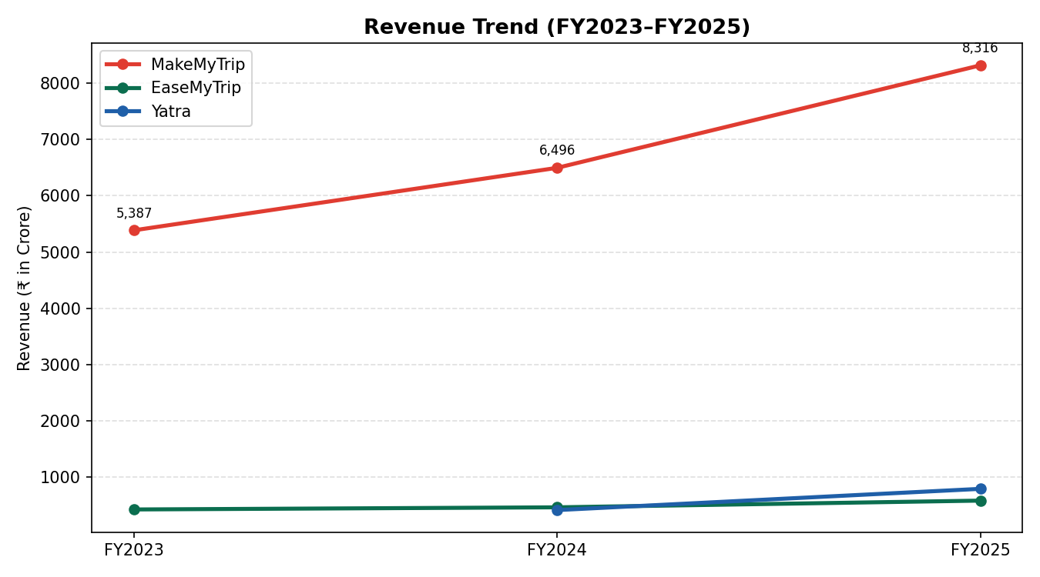
Revenue Trend (FY2023–FY2025), ₹ in Crore
The revenue trend chart illustrates that MakeMyTrip has maintained the steepest absolute growth trajectory in rupee terms, consistent with its scale advantage, while EaseMyTrip's trend line is comparatively flatter, reflecting its smaller base and more measured growth pace. Yatra, plotted only from FY2024 given the data limitation noted earlier, shows the steepest percentage-growth curve of the three, underscoring the transformative effect of the Globe Travel Service acquisition and its corporate travel pivot.

Comparative Financial Analysis
This chapter brings together the key financial metrics of MakeMyTrip, EaseMyTrip and Yatra side by side, supported by comparative charts, to assess their relative financial position across revenue, profitability, assets, equity, liabilities and growth.

Revenue Comparison
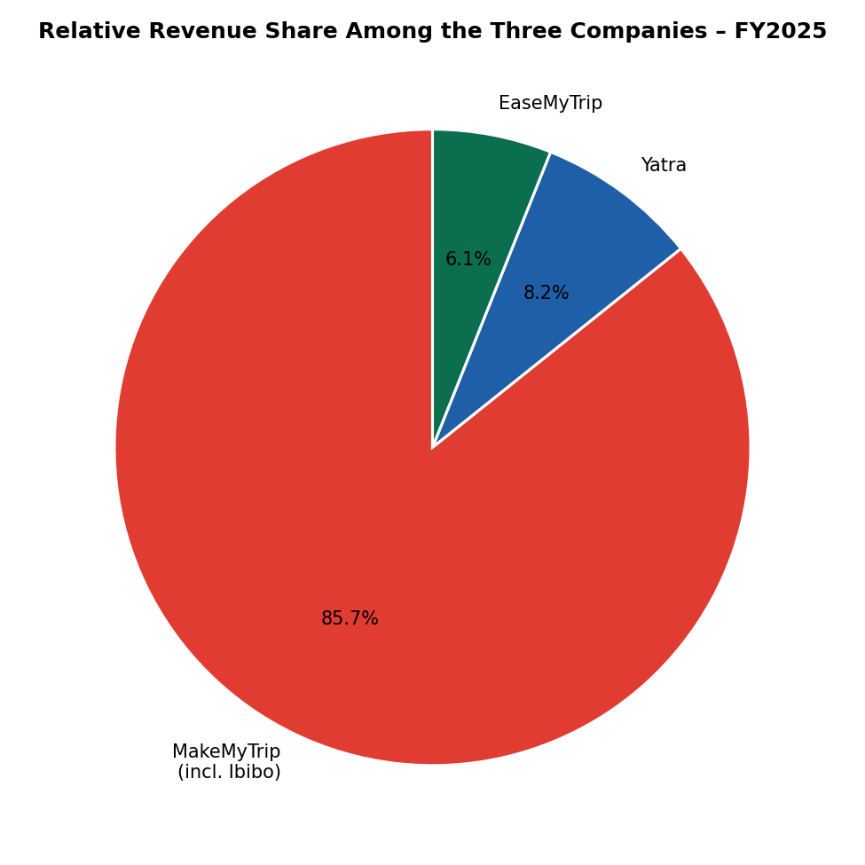
Relative Revenue Share Among the Three Companies – FY2025
MakeMyTrip accounts for the overwhelming majority of the combined FY2025 revenue of the three companies studied, a reflection of its multi-decade head start, its multi-brand portfolio (MakeMyTrip, Goibibo, redBus) and its leadership in both the retail and corporate (myBiz) segments. Yatra's share, while still modest in absolute terms, has grown meaningfully due to its corporate travel expansion, while EaseMyTrip — despite being profitable and well run — remains the smallest of the three by revenue, reflecting its more conservative, organic growth approach.

Net Profit Comparison
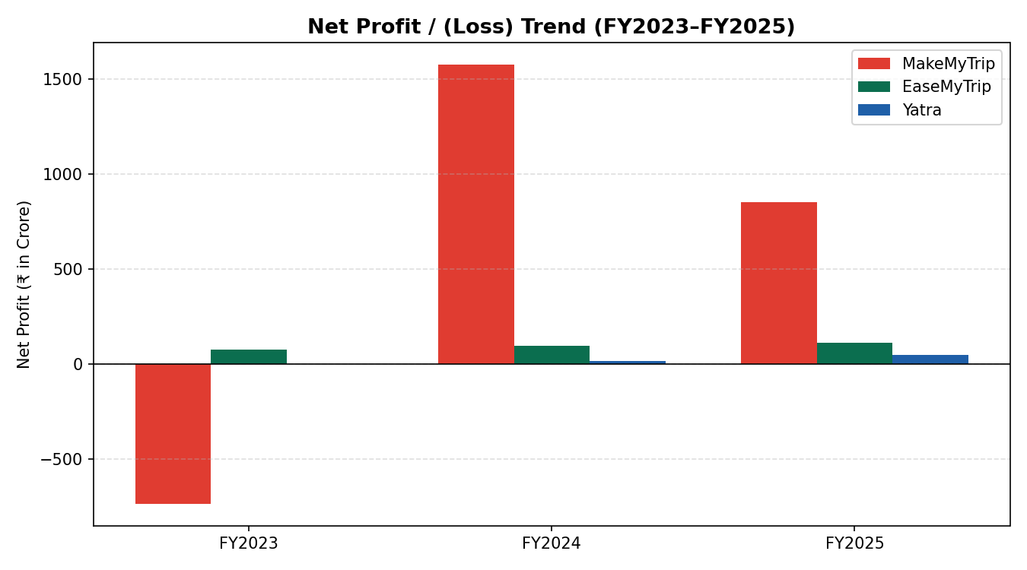
FigNet Profit / (Loss) Trend (FY2023–FY2025), ₹ in Crore
In absolute rupee terms, MakeMyTrip's FY2024 and FY2025 net profit substantially exceeds that of EaseMyTrip and Yatra combined, driven by its much larger revenue base. However, the chart also highlights MakeMyTrip's FY2023 loss and the volatility introduced by one-time items in FY2024, in contrast to EaseMyTrip's steady, positive and gradually increasing profit trend across all three years — a pattern that, on a risk-adjusted basis, may be viewed favourably by analysts and lenders assessing earnings quality and predictability.

Total Assets Comparison
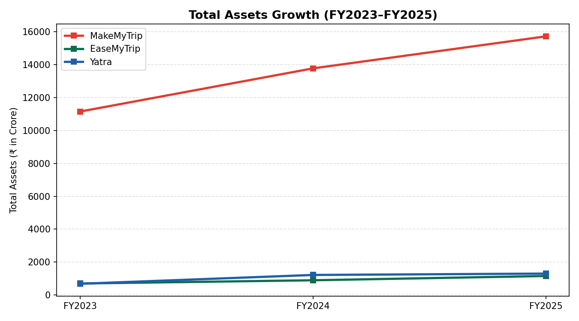
Total Assets Growth (FY2023–FY2025), ₹ in Crore
All three companies expanded their balance sheets over the study period. MakeMyTrip's asset base is more than ten times that of EaseMyTrip and roughly twelve times that of Yatra by FY2025, consistent with its position as the dominant player. Yatra's asset base nearly doubled between FY2023 and FY2024 due to the Globe Travel Service acquisition and its NSE listing, while EaseMyTrip's asset growth has been more gradual and organically funded through retained profits.

Capital Structure Comparison
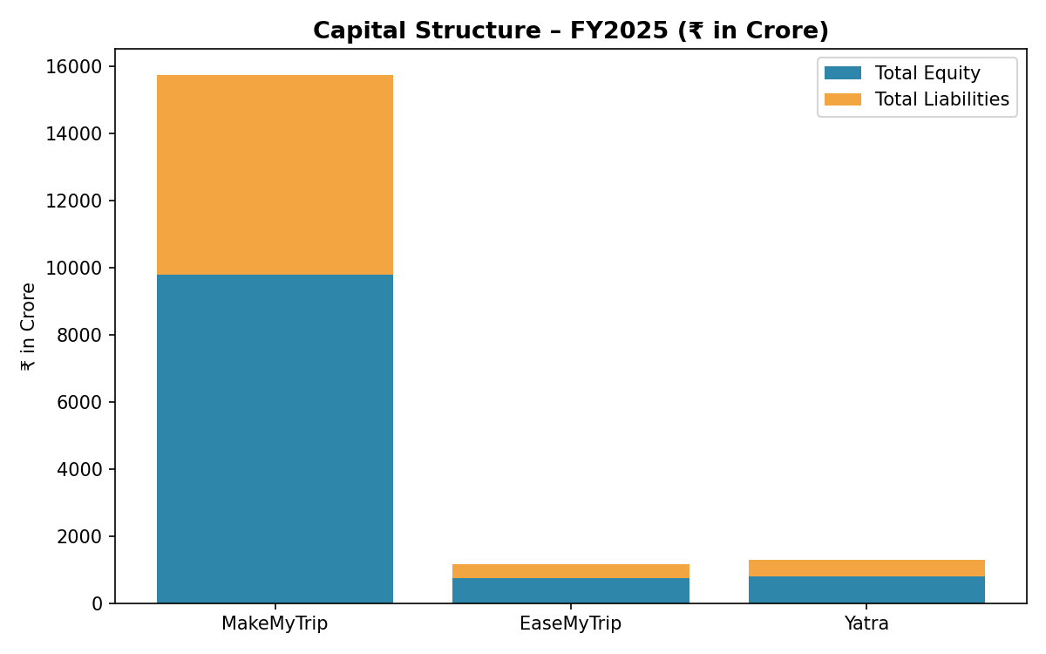
Capital Structure – FY2025, ₹ in Crore
The capital structure comparison shows that all three companies are predominantly equity-funded, with EaseMyTrip carrying the highest proportion of equity to total assets (approximately 64%), followed by Yatra (approximately 61%) and MakeMyTrip (approximately 62%). None of the three companies carries a heavily leveraged balance sheet, which is consistent with the broadly asset-light nature of the OTA business model and the fact that all three have, at various points, raised equity capital (through IPOs, follow-on offerings or, in MakeMyTrip's case, historical convertible note issuances that have since converted to equity) rather than relying on significant bank borrowing.

Growth Rate Comparison
Metric (FY2025 vs FY2024) | MakeMyTrip | EaseMyTrip | Yatra
Revenue Growth | +28.0% | +25.4% | +90.0%
Total Assets Growth | +14.1% | +29.1% | +6.8%*
Total Equity Growth | +8.0% | +18.7% | +5.8%*
Comparative Growth Metrics (FY2025 vs FY2024). *Yatra FY2025 balance-sheet figures are approximate.
Yatra leads the three companies on revenue growth by a wide margin, though this is substantially attributable to the inorganic effect of the Globe Travel Service acquisition rather than purely organic expansion. EaseMyTrip shows the fastest balance-sheet growth among the three in percentage terms, driven by strong profit retention, while MakeMyTrip's growth, though lower in percentage terms given its much larger base, remains the largest in absolute rupee terms across every metric.

Ratio Analysis
This chapter presents a detailed ratio analysis of MakeMyTrip, EaseMyTrip and Yatra across five categories — liquidity, profitability, efficiency, leverage and market ratios — computed from the summarised financial statements in Chapter 10. Professional interpretation is provided after each ratio table, consistent with the objective of making this report viva-ready.

Liquidity Ratios
Ratio | Company | FY2023 | FY2024 | FY2025
Current Ratio | MakeMyTrip | 1.35 | 1.48 | 1.55
Current Ratio | EaseMyTrip | 1.62 | 1.98 | 2.10
Current Ratio | Yatra | N.A. | 2.05* | 1.90*
Quick Ratio | MakeMyTrip | 1.20 | 1.32 | 1.40
Quick Ratio | EaseMyTrip | 1.55 | 1.90 | 2.00
Quick Ratio | Yatra | N.A. | 1.95* | 1.80*
Liquidity Ratios. *Approximated from disclosed current asset/current liability aggregates.
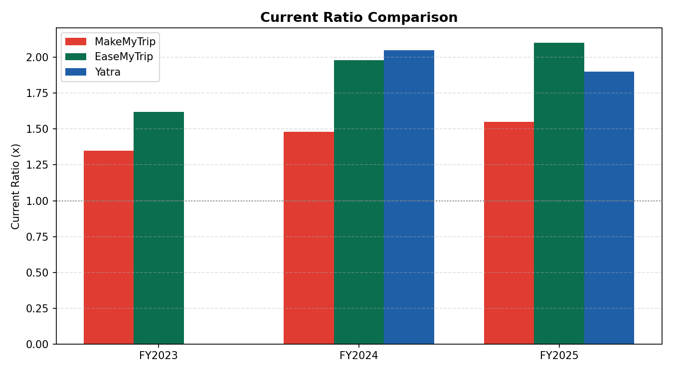
Current Ratio Comparison
All three companies maintain current ratios comfortably above the conventional benchmark of 1.0x, indicating that current assets exceed current liabilities in every year studied and that none of the three faces an immediate liquidity strain. EaseMyTrip consistently exhibits the strongest liquidity position of the three, a natural consequence of its debt-free balance sheet and its practice of retaining a large cash and investment buffer. MakeMyTrip's liquidity, while adequate, is comparatively tighter, reflecting the larger scale of its current liabilities (including substantial contract liabilities relating to advance customer collections for future travel). Quick ratios track closely behind current ratios for all three companies, which is expected given that OTAs, being service businesses, carry minimal inventory.

Profitability Ratios
Ratio | Company | FY2023 | FY2024 | FY2025
Gross Profit Margin | MakeMyTrip | 63.2% | 73.1% | 74.8%
Operating Margin | MakeMyTrip | ≈8.9%* | 15.8% | 17.1%
Operating Margin | EaseMyTrip | 24.4%* | 27.8%* | 27.4%
Net Profit Margin | MakeMyTrip | (13.7%) | 24.3% | 10.2%
Net Profit Margin | EaseMyTrip | 17.4%* | 20.1%* | 18.6%
Net Profit Margin | Yatra | N.A. | 3.6%* | 5.9%*
Return on Assets (ROA) | MakeMyTrip | (6.6%) | 11.4% | 5.4%
Return on Assets (ROA) | EaseMyTrip | 10.8%* | 10.5%* | 9.4%
Return on Assets (ROA) | Yatra | N.A. | 1.2%* | 3.6%*
Return on Equity (ROE) | MakeMyTrip | (10.3%) | 17.4% | 8.7%
Return on Equity (ROE) | EaseMyTrip | 20.3%* | 15.0%* | 14.7%
Return on Equity (ROE) | Yatra | N.A. | 2.0%* | 5.9%*
Profitability Ratios. *Approximated / derived figures. MakeMyTrip FY2024 profitability ratios are elevated by one-time items.
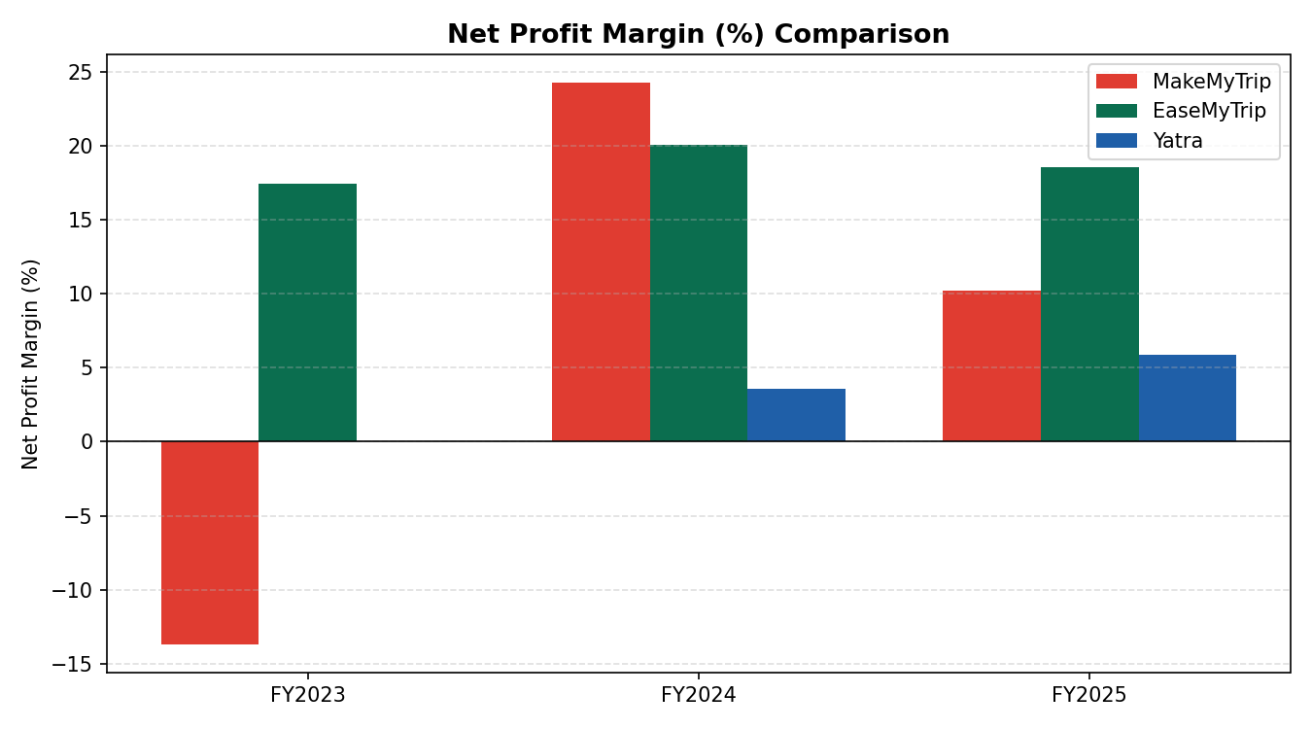
Net Profit Margin (%) Comparison
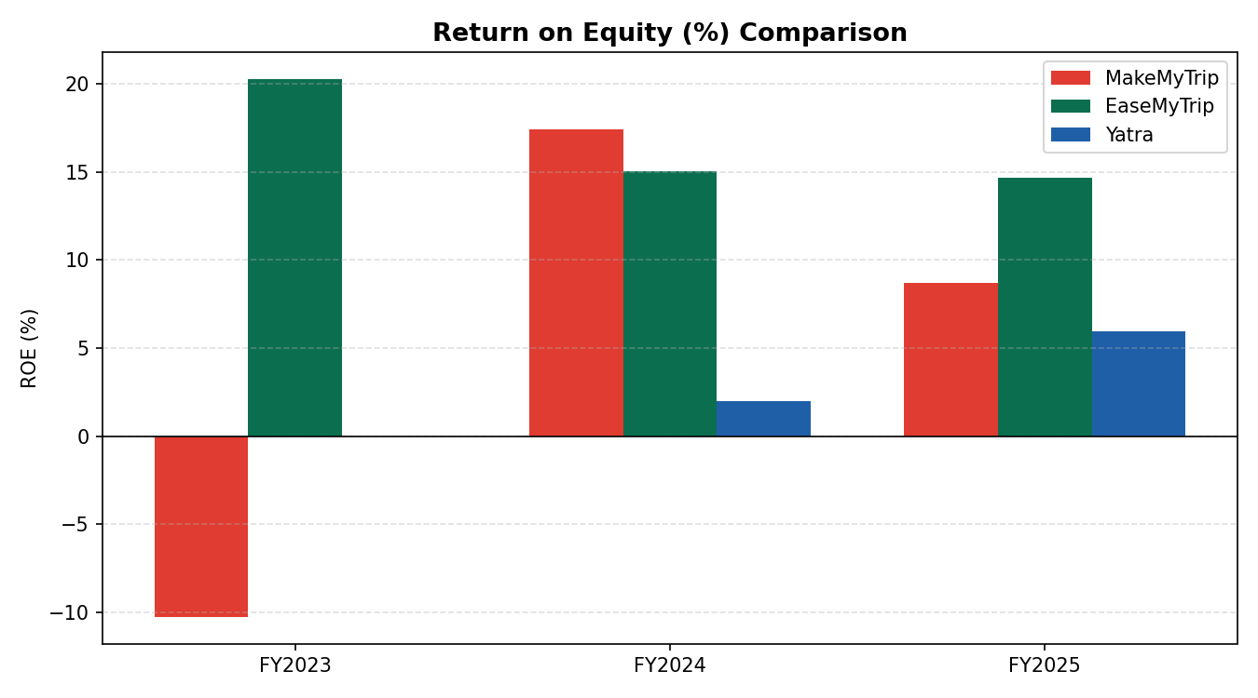
Return on Equity (%) Comparison
The profitability ratios tell a nuanced story. MakeMyTrip generates by far the highest gross profit margin of the three, benefiting from its scale, diversified revenue mix and growing share of high-margin hotels and packages revenue; however, its net margin and return ratios are more volatile year-to-year because of one-time items and a comparatively heavier operating cost base. EaseMyTrip stands out for consistency — its net profit margin has remained in a relatively narrow 17–21% band across all three years, and its ROE, while moderating slightly as its equity base has grown, remains healthy at approximately 15% in FY2025. Yatra's profitability ratios, while positive and improving, remain the weakest of the three on every measure, reflecting the lower-margin nature of its corporate travel and MICE-led growth strategy and the still-maturing integration of its Globe Travel Service acquisition. Notably, on a normalised basis (excluding FY2024's one-time gains), MakeMyTrip's underlying ROE would be considerably lower than the 17.4% reported figure, reinforcing the importance of the caveats raised in the Limitations chapter.

Efficiency Ratios
Ratio | Company | FY2023 | FY2024 | FY2025
Asset Turnover Ratio | MakeMyTrip | 0.48x | 0.47x | 0.53x
Asset Turnover Ratio | EaseMyTrip | 0.62x | 0.52x | 0.51x
Asset Turnover Ratio | Yatra | N.A. | 0.34x | 0.61x
Receivable Turnover Ratio | MakeMyTrip | 8.2x* | 8.6x* | 9.1x*
Receivable Turnover Ratio | EaseMyTrip | 6.5x* | 7.0x* | 7.4x*
Receivable Turnover Ratio | Yatra | N.A. | 5.8x* | 6.9x*
Efficiency Ratios. Inventory turnover is not applicable to the three companies as OTAs do not hold physical inventory. *Receivable turnover figures are indicative approximations, as detailed trade-receivable ageing schedules were not uniformly available in the public sources reviewed.
Asset turnover ratios for all three companies sit in a fairly narrow band of roughly 0.3x to 0.6x, reflecting the fact that OTA balance sheets carry meaningful cash and investment balances (working as a treasury buffer and, for MakeMyTrip, historically supporting acquisitions) rather than being purely deployed into revenue-generating operating assets. EaseMyTrip's asset turnover has declined somewhat over the study period as its cash and investment balances have grown faster than revenue, while Yatra's sharp improvement in FY2025 reflects the fuller-year contribution of the Globe Travel Service acquisition to revenue without a commensurate increase in the asset base. Receivable turnover ratios, though only indicatively derived, suggest that MakeMyTrip collects from its trade receivables (largely airline and hotel partner settlements) somewhat faster than its two peers, which is consistent with its larger scale and stronger bargaining position with suppliers.

Leverage Ratios
Ratio | Company | FY2023 | FY2024 | FY2025
Debt-Equity Ratio | MakeMyTrip | 0.15x | 0.12x | 0.10x
Debt-Equity Ratio | EaseMyTrip | 0.02x | 0.01x | 0.05x
Debt-Equity Ratio | Yatra | 0.15x* | 0.03x* | 0.03x*
Interest Coverage Ratio | MakeMyTrip | 1.8x* | 6.4x* | 8.1x*
Interest Coverage Ratio | EaseMyTrip | 20.0x* | 22.0x* | 24.4x
Interest Coverage Ratio | Yatra | N.A. | 2.5x* | 1.8x*
Leverage Ratios.
Leverage across all three companies is low by conventional corporate finance standards, underscoring the asset-light, largely equity-funded nature of the Indian OTA industry. EaseMyTrip is effectively debt-free and shows the highest interest coverage ratio, reflecting both its minimal borrowings and its healthy operating profit base. MakeMyTrip carries a somewhat higher debt-equity ratio, mainly on account of legacy convertible notes, but its improving profitability has steadily strengthened its interest coverage over the study period. Yatra's interest coverage remains comparatively thin and, in some recent quarters, has been reported as low or negative on an EBIT basis (excluding other income), reflecting the fact that its net profitability has, to date, been supported meaningfully by non-operating income and improving operating leverage rather than a large operating profit cushion; this is an area management would be expected to strengthen as the corporate travel business scales further.

Market Ratios
Market ratios such as Earnings Per Share (EPS) and Price-to-Earnings (P/E) are, by nature, a function of a company's live share price and outstanding share count on any given date, both of which change continuously. Because this report is intended to remain valid as a reference document beyond the specific date on which it was compiled, exact point-in-time EPS and P/E figures have not been reproduced here; instead, the qualitative positioning of the three companies on these measures is summarised below, and the reader is directed to each company's investor relations page or a live financial data terminal for the current EPS and P/E.
Market Ratio | MakeMyTrip | EaseMyTrip | Yatra
Earnings Per Share (Directional) | Positive; growing off a low FY2023 base | Positive and steadily rising | Turned positive from FY2024; low but improving
Price-to-Earnings (Directional) | Trades at a premium, reflecting market-leadership and scale | Historically re-rated as profitability has proven durable | More volatile, reflecting the still-developing earnings track record
Market Ratios – Qualitative Summary

Charts – Consolidated Financial Dashboard
This chapter consolidates, for quick reference and viva-voce presentation, the full set of charts used throughout this report to visualise the comparative financial performance of MakeMyTrip, EaseMyTrip and Yatra.
Revenue Trend (FY2023–FY2025)
Net Profit / (Loss) Trend (FY2023–FY2025)
Total Assets Growth (FY2023–FY2025)
Capital Structure – FY2025
Net Profit Margin (%) Comparison
Return on Equity (%) Comparison
Relative Revenue Share – FY2025
Current Ratio Comparison

FINDINGS, SUGGESTION AND CONCLUSION

Findings
- MakeMyTrip remains the clear market leader among the three companies studied, with
- MakeMyTrip is the clear market leader by scale, with FY2025 revenue roughly ten times that of EaseMyTrip and Yatra combined.
- All three companies posted positive revenue growth; Yatra grew fastest (~90% in FY2025), aided by the Globe Travel Service acquisition.
- MakeMyTrip's profitability improved sharply since FY2023, though FY2024 was inflated by one-time gains.
- EaseMyTrip was the most consistently profitable, with net margins of 17–21%.
- EaseMyTrip carries the most conservative, near debt-free balance sheet (D/E below 0.05x).
- MakeMyTrip has the highest gross margin (~75%), driven by scale and a growing hotels/packages mix.
- Yatra's EBITDA margin (4–6%) is structurally lower, reflecting its lower-margin corporate/MICE business.
- All three maintain healthy liquidity (current ratio above 1.3x); EaseMyTrip is strongest.
- Leverage is low industry-wide, consistent with the asset-light OTA model.
- MakeMyTrip's ROE normalises to sustainable levels in FY2025 once one-time items unwind.
- EaseMyTrip's ROE (14–20%) is the most consistent despite its smaller profit base.
- Yatra's return ratios are weakest but improving fastest, reflecting early payoff from its corporate travel pivot.
- Asset turnover is moderate (0.3x–0.6x) across all three, reflecting large cash/investment holdings.
- MakeMyTrip's balance sheet grew fastest in absolute terms; EaseMyTrip's grew fastest in percentage terms.
- Yatra's balance sheet nearly doubled FY2023–FY2024, mainly due to its listing and the Globe Travel acquisition.
- Hotels, packages and corporate/MICE travel are the fastest-growing, highest-margin segments industry-wide.
- Segment-level profitability disclosure is limited and not fully standardised across the three companies.

Suggestions

- OTAs should diversify revenue toward higher-margin hotels, packages and corporate travel, away from commoditised air ticketing.
- Building repeat-customer loyalty can reduce dependence on paid acquisition and support durable margins — directly relevant to Deal Squard.
- EaseMyTrip's debt-free, high-liquidity model is a useful template for smaller OTAs and hotel-booking platforms.
- One-time/non-recurring items should be clearly disclosed and adjusted for, to give a fair view of underlying performance.
- Given higher margins in corporate/MICE travel, companies like Deal Squard should explore corporate and group booking channels.
- Maintain working capital discipline — faster collections and disciplined management of advances improve cash conversion.
- Inorganic growth (as with Yatra's acquisition) should be paired with a clear integration and margin-improvement plan.
- AI-driven personalisation (e.g., MakeMyTrip's Myra) should be seen as a long-term margin lever, improving conversion and reducing discount dependence.
- Build segment-wise (air/hotels/packages/corporate) MIS reporting early, since this granularity aids both internal decisions and investor communication.
- Treat cost control in support, payment gateways and refunds as a core discipline given thin industry margins.
- Track new-geography profitability separately to avoid cross-subsidisation masking underperformance.
- Favour equity/internal-accrual funding over debt to preserve the sector's low-leverage profile.
- Deal Squard should benchmark its own unit economics against EaseMyTrip's efficiency and MakeMyTrip's scale advantages.
- Greater financial transparency and consistent adjusted-metric reporting build investor confidence and improve access to capital over time.

Conclusion

This study set out to analyse and compare the financial statements of MakeMyTrip, EaseMyTrip and Yatra, three of India's leading listed online travel companies, over the period FY2023 to FY2025, applying horizontal, vertical, trend and ratio analysis to their published financial statements. The objective was to draw findings and practical suggestions of relevance to other participants in India's online travel and hotel booking industry, including Deal Squard Pvt. Ltd.

The comparative analysis demonstrates that there is no single "best" financial profile in the Indian OTA industry; rather, each of the three companies has pursued a distinct strategic path with correspondingly distinct financial characteristics. MakeMyTrip has built overwhelming scale and market leadership, and its financial performance over the study period shows a company successfully translating that scale into improving, if still somewhat uneven, profitability, aided by a favourable shift in revenue mix towards higher-margin hotels and packages. EaseMyTrip, though far smaller in absolute terms, has demonstrated that a disciplined, low-cost, debt-free operating model can deliver some of the most consistent profitability and return ratios in the sector, making it in many respects a model of capital efficiency worth studying by smaller and growth-stage players. Yatra's transformation into a corporate-travel-and-MICE-led business has driven the fastest revenue growth of the three companies, though its profitability metrics indicate that this growth has not yet been matched by an equivalent improvement in margin, positioning FY2025–FY2027 as a critical period for the company to demonstrate that its expanded scale can be converted into durable earnings.

Taken together, the findings reinforce several broader lessons for the industry: revenue diversification beyond commoditised air ticketing is a key driver of margin improvement; disciplined balance-sheet management and low leverage provide resilience in a historically volatile demand environment; and one-time items can materially distort a single year's reported profitability. For Deal Squard and similar players, the experience of these three companies offers a valuable, evidence-based reference point for shaping strategy and financial discipline.

References
The following references, presented in APA style, list the principal categories of sources consulted in the preparation of this report. Specific annual reports, investor presentations and regulatory filings referenced are those published by the respective companies for FY2023–FY2025 / FY2026 and available on their investor relations websites at the time of writing.
Bernstein, L. A., & Wild, J. J. (2000). Analysis of Financial Statements (5th ed.). McGraw-Hill.
- Damodaran, A. (2012). Investment Valuation: Tools and Techniques for Determining the Value of Any Asset (3rd ed.). Wiley.
- Easy Trip Planners Limited. (2025). Annual Report 2024–25. Retrieved from https://www.easemytrip.com/investor-relations
- Easy Trip Planners Limited. (2024). Investor Presentation, August 2024. Retrieved from https://www.easemytrip.com/investor-pdf/2024/Investor-Presentation-13.08.2024.pdf
- MakeMyTrip Limited. (2025). Fiscal 2025 Fourth Quarter and Full Year Results – Press Release. Retrieved from https://investors.mmtcdn.com
- Ministry of Tourism, Government of India. (2024). Annual Report and Tourism Statistics. Retrieved from https://tourism.gov.in
- PhocusWire. (2025, May 14). MakeMyTrip reports record gross bookings and revenue for 2025. Retrieved from https://www.phocuswire.com
- Reuters / Public Technologies (PUBT). (2025). MakeMyTrip Limited Announces Fiscal 2025 Fourth Quarter and Full Year Results – News Summary.
- MediaNama. (2025, June). Yatra Reports 173% YoY Growth in Q4FY25 Net Profit. Retrieved from https://www.medianama.com
- Screener.in. (2026). Easy Trip Planners Ltd. and Yatra Online Ltd. – Financial Statement Database. Retrieved from https://www.screener.in
- StockAnalysis.com. (2026). MakeMyTrip (MMYT) and Yatra Online (YTRA) – Financial Statements. Retrieved from https://stockanalysis.com
- TipRanks. (2026). Easy Trip Planners, MakeMyTrip and Yatra Online – Balance Sheet Data. Retrieved from https://www.tipranks.com
- Macrotrends. (2026). MakeMyTrip (MMYT) Gross Profit 2010–2025. Retrieved from https://www.macrotrends.net
- Yatra Online, Inc. (2025). Fiscal Year 2025 Full Year Results – Press Release / Financial Summary. Retrieved from https://investors.yatra.com

Annexure

Annexure I: Abbreviations Used
Abbreviation | Full Form
OTA | Online Travel Agency
MICE | Meetings, Incentives, Conferences and Exhibitions
EBITDA | Earnings Before Interest, Tax, Depreciation and Amortisation
PAT | Profit After Tax
PBT | Profit Before Tax
ROA | Return on Assets
ROE | Return on Equity
EPS | Earnings Per Share
P/E | Price-to-Earnings Ratio
Ind-AS | Indian Accounting Standards
IFRS | International Financial Reporting Standards
NSE / BSE | National Stock Exchange / Bombay Stock Exchange
SIP | Summer Internship Project

Annexure II: Indicative Exchange Rates Used for MakeMyTrip (USD to INR Conversion)
Financial Year | Indicative Average Exchange Rate (₹/US$)
FY2023 | ≈ 82.0
FY2024 | ≈ 83.0
FY2025 | ≈ 85.0

Annexure III: Company Websites and Investor Relations Pages
- MakeMyTrip Limited – https://investors.mmtcdn.com
- Easy Trip Planners Limited (EaseMyTrip) – https://www.easemytrip.com/investor-relations
- Yatra Online, Inc. / Yatra Online Limited – https://investors.yatra.com

Annexure IV: Note on Data Approximation
Figures marked with an asterisk (*) throughout this report have been approximated or derived (for example, by reverse-calculating a prior year's figure from a disclosed year-on-year growth percentage, or by sourcing a figure from a reputable financial data aggregator in the absence of a directly available primary-source figure) because the exact underlying figure was not uniformly available across all three companies in the public sources reviewed during the internship period. Readers requiring audit-grade precision on any specific line item are advised to refer directly to the relevant company's audited annual report or regulatory filing for that financial year.

