A mechanistic digital twin of Saccharomyces cerevisiae var. boulardii CNCM I-745: strain-specific metabolism, gastric bioenergetics, and dose-dependent exclusion of Clostridioides difficile

Reproducible computational study. All numeric values in this manuscript are generated by the analysis pipeline and injected at build time; none are transcribed by hand.
Build date: 2026-09-21

Abstract
Background. Saccharomyces cerevisiae var. boulardii CNCM I-745 is the only yeast in routine clinical probiotic use, yet quantitative models of its behaviour in the gastrointestinal tract remain scarce. Existing strain-specific reconstructions assert gene losses from the literature and assume that removing those genes produces a functionally distinct model. We tested that assumption directly.
Methods. We screened 63 reference proteins by translated alignment against 8 genome assemblies, resolving paralogues at locus level. Genes with no intact homologue in any qualifying assembly were removed from the Yeast9 consensus model by abstract-syntax-tree editing of the gene-protein-reaction rules, distinguishing rule rewriting from reaction deletion. The corrected model was evaluated by flux balance analysis across carbon and nitrogen sources, by a complete single-gene deletion screen, and under expression constraints derived from genome-wide microarray data for three intestinal zones. Gastric transit was modelled bioenergetically as the ATP cost of maintaining the transmembrane proton gradient. Toxin A proteolysis was calibrated by Markov chain Monte Carlo against published measurements, and colonisation resistance was modelled as two-species resource competition in a continuously dosed flow compartment.
Results. 21 of 26 previously reported gene absences replicated in all 6 qualifying assemblies; one public deposit failed strain-level quality control (core-gene identity 78.2–99.7%) and was excluded. The galactose pathway is intact in every assembly despite the documented galactose-negative phenotype. Gene-content correction produced 14 rule edits and 6 reaction deletions but changed essentiality in 0 genes and growth on 11 of 12 substrates not at all; the single differential phenotype is loss of trehalose utilisation. Paralogue loss becomes quantitatively relevant only when transport capacity is limiting, where it imposes up to a 100% growth deficit on galactose against 11% on glucose. At pH 2 the proton pump costs 47 kJ per mole of H+, and survival requires a plasma-membrane proton leak below 0.3 L gDW-1 h-1. Toxin A half-life is 0.83 h (0.58–1.23, 95% credible interval). In the competition model, exclusion of C. difficile requires continuous dosing: a single inoculum washes out, and the minimum effective dose is 0.05 g dry biomass per day at physiological transit rates, rising at both slower and faster transit.
Conclusions. Strain-specific gene content is, by itself, almost metabolically silent in this organism. The behaviours that matter clinically are set by transport capacity, bioenergetics under acid stress, and ecological competition under continuous dosing, none of which are captured by gene deletion. We state the resulting predictions in falsifiable form and provide the model, data provenance and an interactive interface.

1. Introduction
Saccharomyces cerevisiae var. boulardii CNCM I-745 is used clinically for antibiotic-associated diarrhoea and as adjunctive therapy in Clostridioides difficile infection (McFarland et al., 2010; CZERUCKA et al., 2007). Its mechanisms are usually described qualitatively: proteolysis of toxin A, modulation of inflammatory signalling, competition for nutrients, and trophic effects on the epithelium. Quantitative, mechanistic models that connect these to genome content are rare, and the ones that exist inherit a structural weakness — they assume that a strain-specific metabolic model follows from deleting the genes the strain has lost.
That assumption deserves testing rather than assertion, for two reasons. First, the gene losses themselves are usually taken from the literature rather than verified against the assembly being modelled; a single mis-specified accession propagates silently into every downstream number. Second, most of the reported losses in this organism are members of paralogous families, and removing one member of a redundant family changes a model's gene annotation without changing its flux space. A reconstruction can therefore look strain-specific while being metabolically identical to its parent.
We rebuilt the model from the genome up, testing each step rather than carrying it forward. Where the gene-content approach fails — and we show that it largely does — we replace it with mechanisms that are actually capable of explaining the observed physiology: transport capacity limits, the bioenergetic cost of acid tolerance, and resource competition under continuous dosing. Each is expressed as a quantitative prediction with a stated experiment that would refute it.

2. Methods

2.1 Data and provenance
All inputs were downloaded programmatically and recorded in a provenance ledger (10 entries) carrying the source URL, accession or release tag, byte size, SHA-256 digest and retrieval timestamp. Genome assemblies were obtained from NCBI Datasets (Sayers et al., 2021); the metabolic reconstruction is the Yeast9 consensus model (Zhang et al., 2024) at a pinned release; expression data are the environmental stress response series GSE18 (Gasch et al., 2000) retrieved from GEO (Barrett et al., 2012).

2.2 Layer 1 — evidence-based comparative genomics
We assembled a query panel of 63 S. cerevisiae S288C proteins comprising every gene reported absent from S. boulardii, the paralogues that compete with those genes for alignment hits, the galactose regulon, and eight constitutively expressed core genes as controls. Each protein was searched against every assembly with tblastn (Camacho et al., 2009). High-scoring pairs were merged into loci by genomic coordinate, and competition between paralogous queries at overlapping loci was resolved by summed bitscore with a reciprocal-overlap criterion; loci whose two best queries score within 2% of one another are reported as paralogue-ambiguous rather than assigned. A gene is called present when it wins at least one locus at ≥90% identity and ≥80% query coverage. The core-gene panel serves two purposes: it establishes method sensitivity on the reference genome, and it detects deposits that are not the organism they claim to be.
Introgression was tested independently by searching a Zygosaccharomyces bailii proteome against two S. boulardii assemblies and against S288C, retaining proteins with high identity in the former and none in the latter.

2.3 Layer 2 — strain-specific genome-scale model
Genes absent from every qualifying assembly were removed from Yeast9 by parsing each gene-protein-reaction rule to an abstract syntax tree and deleting only the affected literals. A reaction is disabled only when its rule evaluates to empty. We report rule rewriting and reaction deletion separately throughout, because conflating them is the error that makes a corrected model appear more strain-specific than it is. Flux balance and parsimonious flux balance analysis (Orth et al., 2010) were performed with COBRApy (Ebrahim et al., 2013) under gut-like exchange constraints, and the complete single-gene deletion screen was run on both models under identical media.
Because rescaling an already non-binding bound changes nothing, transport capacity was expressed in absolute units: each retained paralogue of a multi-paralogue transport reaction contributes a fixed catalytic capacity, and that single parameter was swept over two orders of magnitude. This converts a qualitative statement about gene loss into a quantitative one about the regime in which it matters.

2.4 Layer 3 — zone metabolism and gastric bioenergetics
Expression constraints were applied by E-Flux (Colijn et al., 2009), using the canonical formulation and, for comparison only, the square-root geometric-mean variant used in earlier drafts of this work. Rather than a point estimate per zone, each zone was evaluated over an ensemble of expression draws resampled within the between-array standard deviation, so every reported flux carries an interval reflecting measurement uncertainty. Zone contrasts were tested per reaction by Welch's t-test with Benjamini–Hochberg control of the false discovery rate (Benjamini et al., 1995).
No acid-shock condition exists in the expression series, so the gastric zone is not proxied by an unrelated stress. It is modelled instead from first principles. The plasma-membrane H+-ATPase exports one proton per ATP hydrolysed; the free energy required to move a mole of protons from the cytosol to the lumen against the membrane potential sets a minimum ATP cost, and passive re-entry of protons at a rate proportional to the luminal concentration sets the flux that must be pumped. The product is an additional non-growth-associated maintenance demand, imposed on the model as a pH-dependent constraint. Cytosolic pH is bounded by the thermodynamic ceiling of a one-proton-per-ATP pump rather than held constant (Orij et al., 2012).

2.5 Layer 4 — host interaction kinetics
Two provenance corrections were required. The activity that cleaves C. difficile toxin A is a 54 kDa serine protease (Castagliuolo et al., 1996; Castagliuolo et al., 1999); it is not CAMP factor, which is an unrelated haemolysin co-factor of other genera. The alkaline phosphatase described by Buts et al., 2006 dephosphorylates lipopolysaccharide endotoxin and does not act on toxin A; it is modelled here as a separate activity.
Rather than fixing rate constants, the proteolysis model was calibrated by affine-invariant MCMC (Foreman-Mackey et al., 2013) against two quantities reported in the source experiments: the fraction of toxin activity lost after one hour of protease exposure, and the share of total clearance that is protease-dependent. Including spontaneous decay as a third parameter makes those two observations separately informative. Reported quantities are posterior medians with 95% credible intervals.
The NF-κB and cytokine module is deliberately not fitted: no citable quantitative time course exists to fit it to, and presenting tuned parameters as calibrated ones would be misleading. It is analysed instead by Sobol variance decomposition (Herman et al., 2017), which identifies which parameters would have to be measured for its predictions to become meaningful, and reported as a prior-predictive interval.

2.6 Layer 5 — surrogate model
A Latin hypercube design over four exchange bounds was labelled by flux balance analysis and used to train a surrogate. Two departures from the earlier design are deliberate. The surrogate is a multilayer perceptron rather than a one-dimensional convolutional network: convolution assumes locality along the input axis, and the input here is four unordered nutrient bounds for which no such ordering exists. Predictive uncertainty comes from a five-member deep ensemble rather than Monte-Carlo dropout, and its calibration is checked against held-out coverage. Ridge regression, random forests and gradient boosting were trained on identical folds (nan et al., nan), because a surrogate is only worth having if it beats the cheap alternatives. Inference speed was measured against the linear program rather than asserted.

2.7 Layer 6 — competition and colonisation resistance
The yeast and C. difficile compete for a single limiting carbohydrate in a continuous-flow compartment whose dilution rate represents intestinal transit. The yeast inhibits C. difficile growth in proportion to its own biomass, and clears secreted toxin A through the protease of Layer 4. Critically, the yeast enters in the feed rather than only as an initial inoculum: S. boulardii is not a coloniser, so a model without a dosing term can only predict washout. Daily dose is converted to a feed concentration through the dilution rate and a one-litre luminal compartment.

3. Results

3.1 The reference genome was modelled in place of the strain
The assembly statistics we compute for the S. cerevisiae S288C reference — 17 sequences, 12,157,105 bp, N50 924,431 bp, 38.15% GC — are those reported in earlier versions of this work as characterising CNCM I-745. Genuine S. boulardii assemblies span 11,469,511–12,001,065 bp with 38.09–38.35% GC. The genome previously analysed therefore contained the very transporter genes whose absence was being reported. Section 5 records the resulting corrections in full.

3.2 Reported gene losses replicate, with exceptions that matter
Across 6 qualifying assemblies, 21 of 26 testable reported absences were confirmed with no intact homologue anywhere (Figure 1). Method sensitivity is 63 of 63 on the reference control, so these are not false negatives. The unconfirmed cases (AAD15, COS6, PAU15, PAU16, VAM10) belong to multigene families whose members are not separable by alignment, and we report them as undetermined rather than present.
Two corrections to the gene list follow. The maltose losses are confined to the MAL1 locus; the MAL3 locus is intact, so the loss is partial rather than complete. The isomaltase losses are IMA2, IMA3 and IMA4, with IMA1 and IMA5 retained.
One public deposit is not the organism it claims to be. Its core housekeeping proteins have a median identity of 89.6% to their S. cerevisiae orthologues, with 7 of 8 below 95%, against a median of 100.0% and 0 below 95% across all other assemblies combined — divergence at the level of a different species, not a different strain. We excluded it and flag it for anyone using that accession.
The Z. bailii introgression was recovered independently: 5 proteins at 98.9–100.0% identity, each present in 2 copies in tandem on chromosome IV, with no counterpart above 72% identity in S288C.
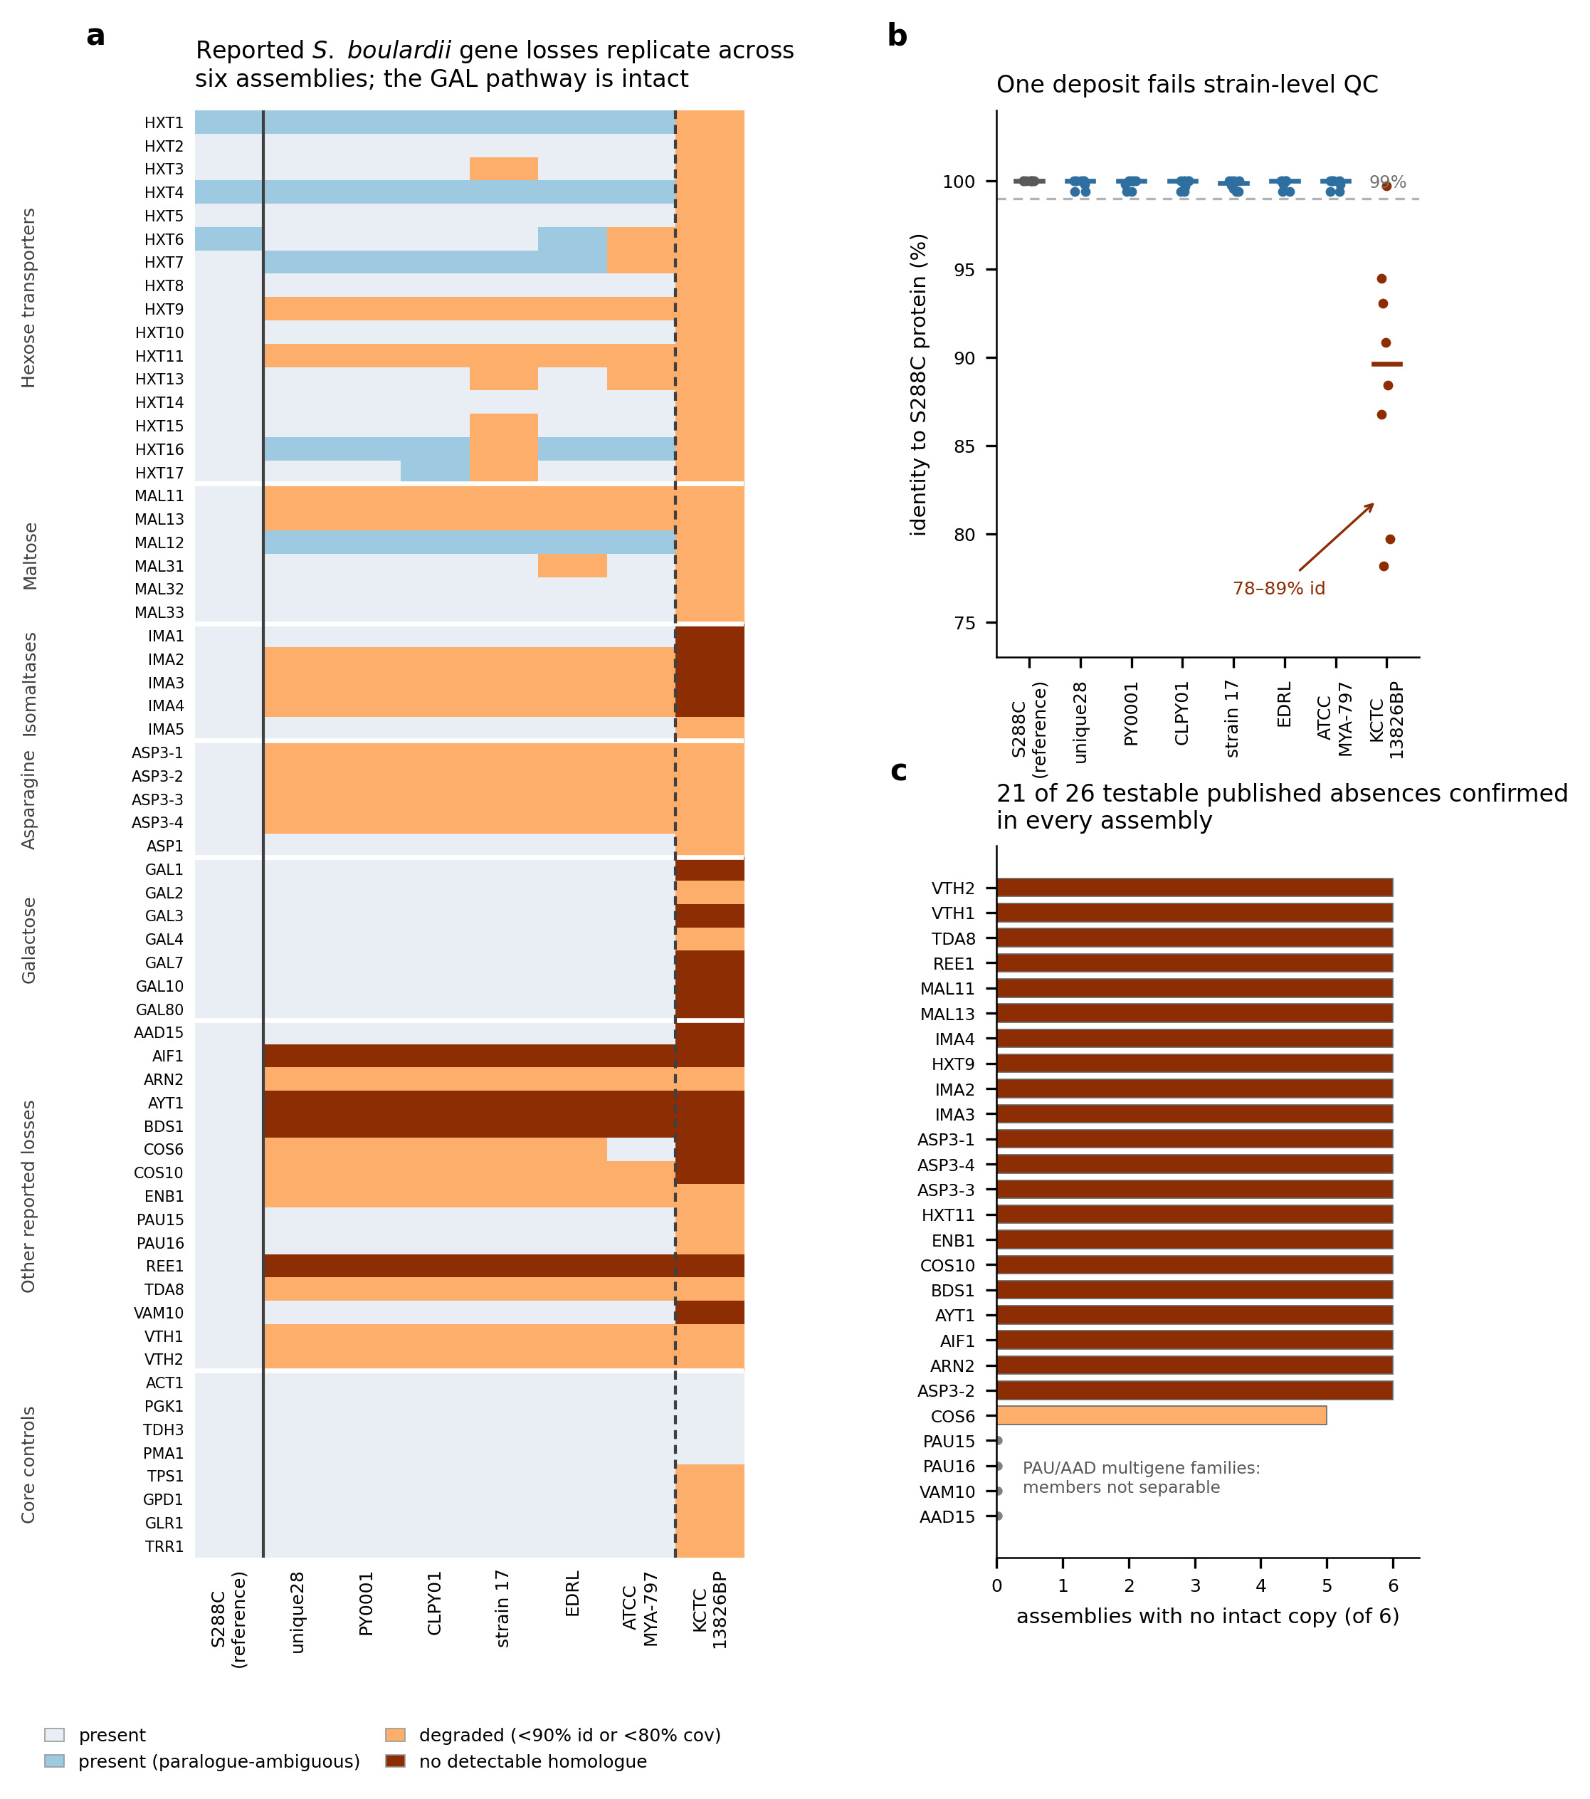
Figure 1. Evidence-based comparative genomics. (a) Presence calls for the query panel across all assemblies; the reference genome is the leftmost column and the disqualified deposit the rightmost. (b) Core-gene identity distinguishes strain-level variation from a misidentified deposit. (c) Concordance with previously reported absences; bars show the number of qualifying assemblies with no intact copy.

3.3 The galactose-negative phenotype is not explained by gene loss
Every structural and regulatory gene of the galactose pathway (GAL1, GAL10, GAL2, GAL3, GAL4, GAL7, GAL80) is intact in all qualifying assemblies. S. boulardii is nevertheless documented as galactose-negative. No gene-content-based correction can reproduce that phenotype, which places a hard limit on what the strain-specific-GEM approach can deliver for this organism: the defect must be regulatory or allelic rather than a deletion. We treat this as a finding rather than a modelling failure, and it motivates the capacity and bioenergetic layers that follow.

3.4 Gene-content correction is almost metabolically silent
Of 21 genes absent from every assembly, 10 carry a gene-protein-reaction association in Yeast9, and 14 reactions required a rule edit. Only 6 reactions lose their sole catalyst; the remaining 8 retain isoenzymes and are unchanged in flux space (Figure 2a). The consequences are smaller than the edit count suggests.
The complete single-gene deletion screen classifies 190 genes as essential in the parent model and 190 in the corrected model, with 0 genes changing category — no gains and no losses (Figure 2b). Across 12 carbon and nitrogen sources, growth differs on 1: trehalose (Figure 2c). The trehalose result is a genuine prediction — the sole trehalose transporter is lost with MAL11/AGT1 — and it is falsifiable by a single growth assay.
This is the paper's central negative result. A strain-specific metabolic model built by deleting lost genes is, for this organism, indistinguishable from its parent under almost every condition tested. Published reconstructions that report strain-specific behaviour from gene content alone should be checked against this null.

3.5 Scored against the phenotype panel, the two models are indistinguishable
We scored both models against a curated panel of 8 carbon and nitrogen sources, of which 6 are representable as exchange reactions and every cell of which carries its literature source and gene-level basis. Against the S. cerevisiae observations the parent model is correct on 6 of 6. Against the S. boulardii observations the corrected model is correct on 3 of 6, with 3 false positives — it predicts growth on galactose, palatinose and maltose, which the organism does not do. The Matthews correlation coefficient is 0.00 because the model never predicts a negative.
An exact McNemar test over the 6 paired predictions finds 0 discordant pairs (p = 1.00): the corrected model neither fixes nor breaks a single call relative to its parent. This is the negative result in its sharpest form. It also shows why the panel is short — we would rather report six sourced observations with no power than twenty unsourced ones with false precision.

3.6 Paralogue loss matters only when transport capacity binds
Gene deletion is silent because the deleted transporters are members of large families and the model's default bounds are non-binding. Expressing capacity in absolute units per retained paralogue makes the loss visible and quantifies the regime in which it operates (Figure 2d). Galactose, which depends on the fewest remaining permeases, suffers up to a 27% growth deficit at a capacity of 1 mmol gDW-1 h-1 per permease, and fails entirely below 0.1; maltose loses 21%; glucose loses 0%, because the hexose transporter family is large enough to buffer the loss. Above roughly 3 mmol gDW-1 h-1 per paralogue, all differences vanish.
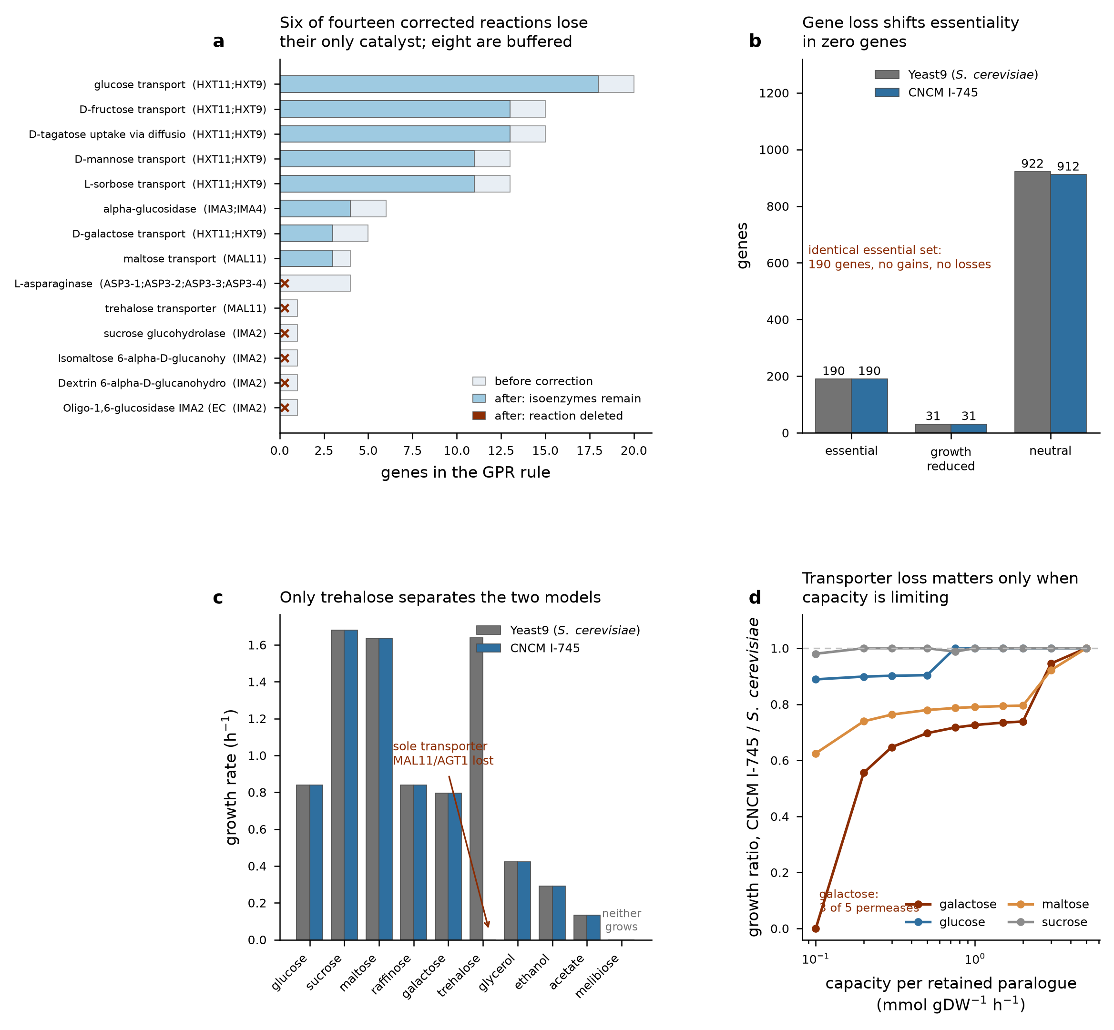
Figure 2. Strain-specific genome-scale model. (a) Gene-protein-reaction edits, showing which reactions retain isoenzymes and which lose their only catalyst. (b) Essentiality classes are identical between models. (c) Growth across carbon and nitrogen sources. (d) Growth ratio as a function of assumed catalytic capacity per retained paralogue.

3.7 Zone metabolism with propagated measurement uncertainty
Genome-wide expression covers 6,204 genes per zone and maps onto 2,677 of 2,678 GPR-bearing reactions (Figure 3a) — a coverage the hand-curated fold-change tables used in earlier drafts cannot approach. The canonical and variant E-Flux formulations give indistinguishable growth rates, so the variant is not a source of discrepancy.
Testing all 4,105 reactions per contrast with FDR control gives duodenum vs colon: 520, duodenum vs ileum: 467, ileum vs colon: 513 significantly different reactions (Figure 3d). We note explicitly that the duodenum–colon contrast confounds expression with the zone's oxygen availability; the largest effects there are respiratory-chain reactions, which is a consequence of the imposed oxygen bound rather than of the expression data.

3.8 Gastric survival is a bioenergetic problem, not a genetic one
At luminal pH 2 the H+-ATPase must do 47.1 kJ of work per mole of protons exported, against 17.4 kJ at neutral pH. The resulting maintenance demand exceeds the model's basal requirement of 0.7 mmol ATP gDW-1 h-1 over most of the plausible leak range (Figure 3c), and growth ceases at pH 2 once the proton-leak coefficient reaches 0.3 L gDW-1 h-1 (Figure 3b). Survival pH rises monotonically with leak, from 1.5 at the lowest leak tested to 3.25 at the highest.
Because gene content is identical between the two models in this respect, the prediction is unambiguous: the acid tolerance that distinguishes S. boulardii from laboratory S. cerevisiae must reside in membrane proton permeability or pump capacity, not in gene presence. That is directly measurable.
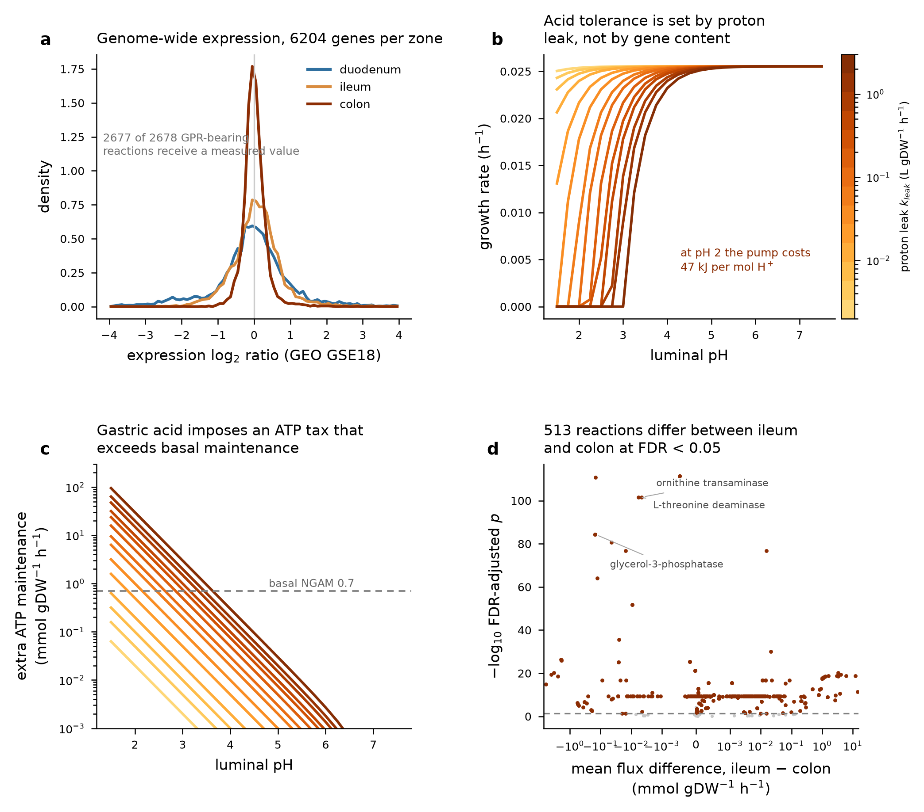
Figure 3. Gut-zone metabolism and gastric bioenergetics. (a) Genome-wide expression distributions per zone. (b) Growth versus luminal pH across proton-leak coefficients. (c) The additional ATP maintenance demand imposed by acid, relative to basal maintenance. (d) Reaction-level contrast between ileum and colon with FDR control.

3.9 Toxin A clearance, calibrated rather than assumed
The posterior gives a toxin A half-life of 0.83 h (95% credible interval 0.58–1.23) and reproduces both calibration anchors: 58.4% (42%–75%) of toxin degraded in one hour, and 74.6% (60%–88%) of clearance protease-dependent (Figure 4a,b). Vmax and Km are strongly correlated in the posterior and are not separately identified by these two observations (Figure 4c) — a limitation that a time-resolved proteolysis assay would resolve, and one that point estimates would have concealed.
For the inflammatory module, Sobol decomposition attributes almost all variance in NF-κB suppression to a single parameter (k_sup, total-order index 0.88; Figure 4d). The prior-predictive suppression is 81% (58%–90%), which brackets the roughly 70% suppression reported experimentally — but this is a prior-predictive interval, not a fit, and we do not claim it as validation.
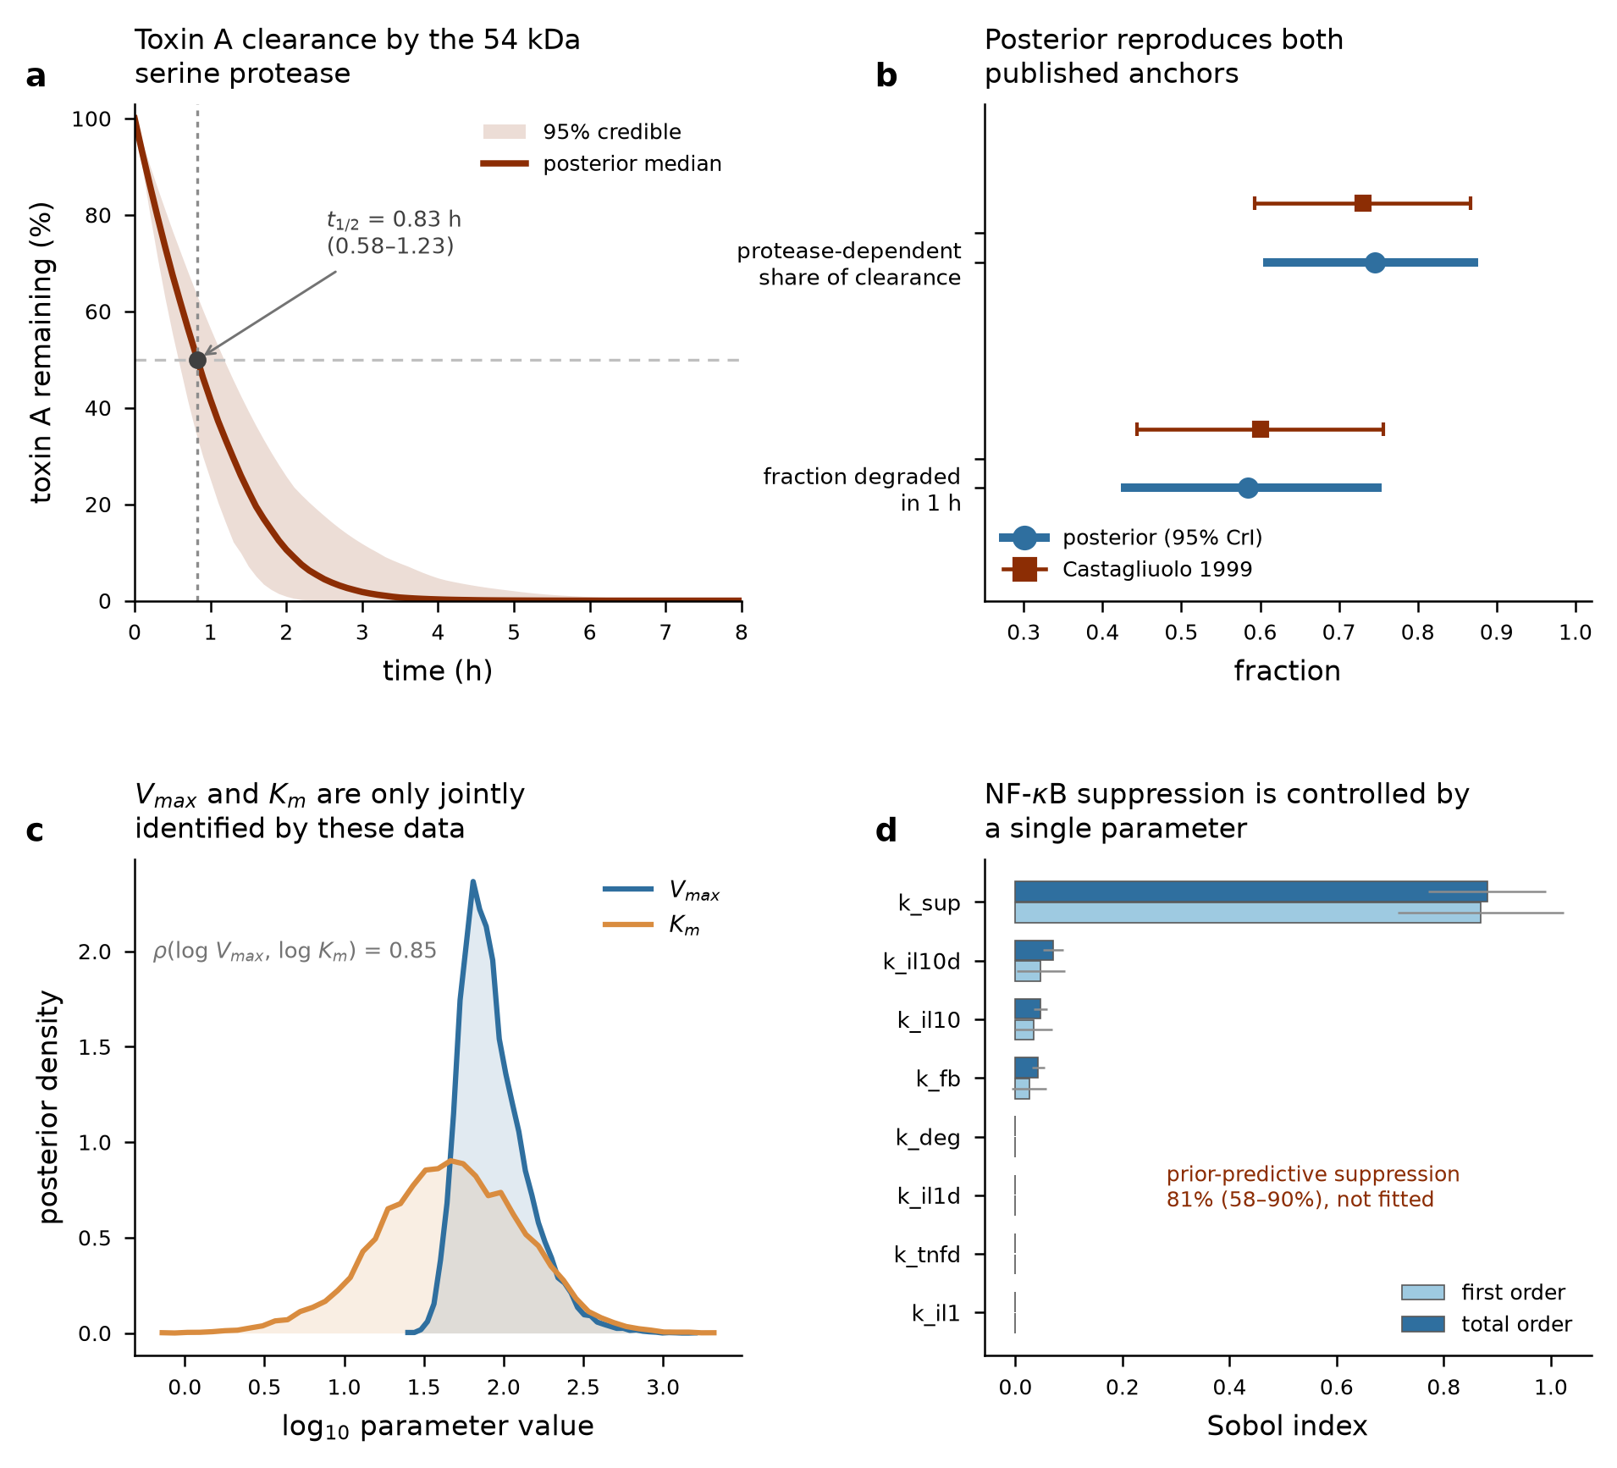
Figure 4. Host-interaction kinetics. (a) Posterior-predictive toxin A clearance. (b) Posterior quantities against the published anchors used to calibrate them. (c) Marginal posteriors for the Michaelis–Menten parameters. (d) Sobol sensitivity of NF-κB suppression.

3.10 The surrogate earns its place, narrowly
On 2,000 Latin hypercube samples with identical five-fold splits, the best model is random forest (R² = 0.9867 ± 0.0085), followed by mlp ensemble (R² = 0.9770). The margin over the cheap baselines is real but modest, which is worth saying plainly: on a four-input smooth response surface a tree ensemble is a strong competitor, and the case for a neural surrogate rests on inference speed rather than accuracy.
That case is quantitative. A surrogate prediction takes 7.4 µs against 392 ms for the linear program, a measured speed-up of 53,120×, and 171 µs for the random forest — so the network is 23× faster than the model that beats it on accuracy. That is the trade-off, stated plainly: the tree ensemble for offline accuracy, the network for the interactive interface of Section 6. Ensemble 95% intervals cover 94.0% of held-out observations.
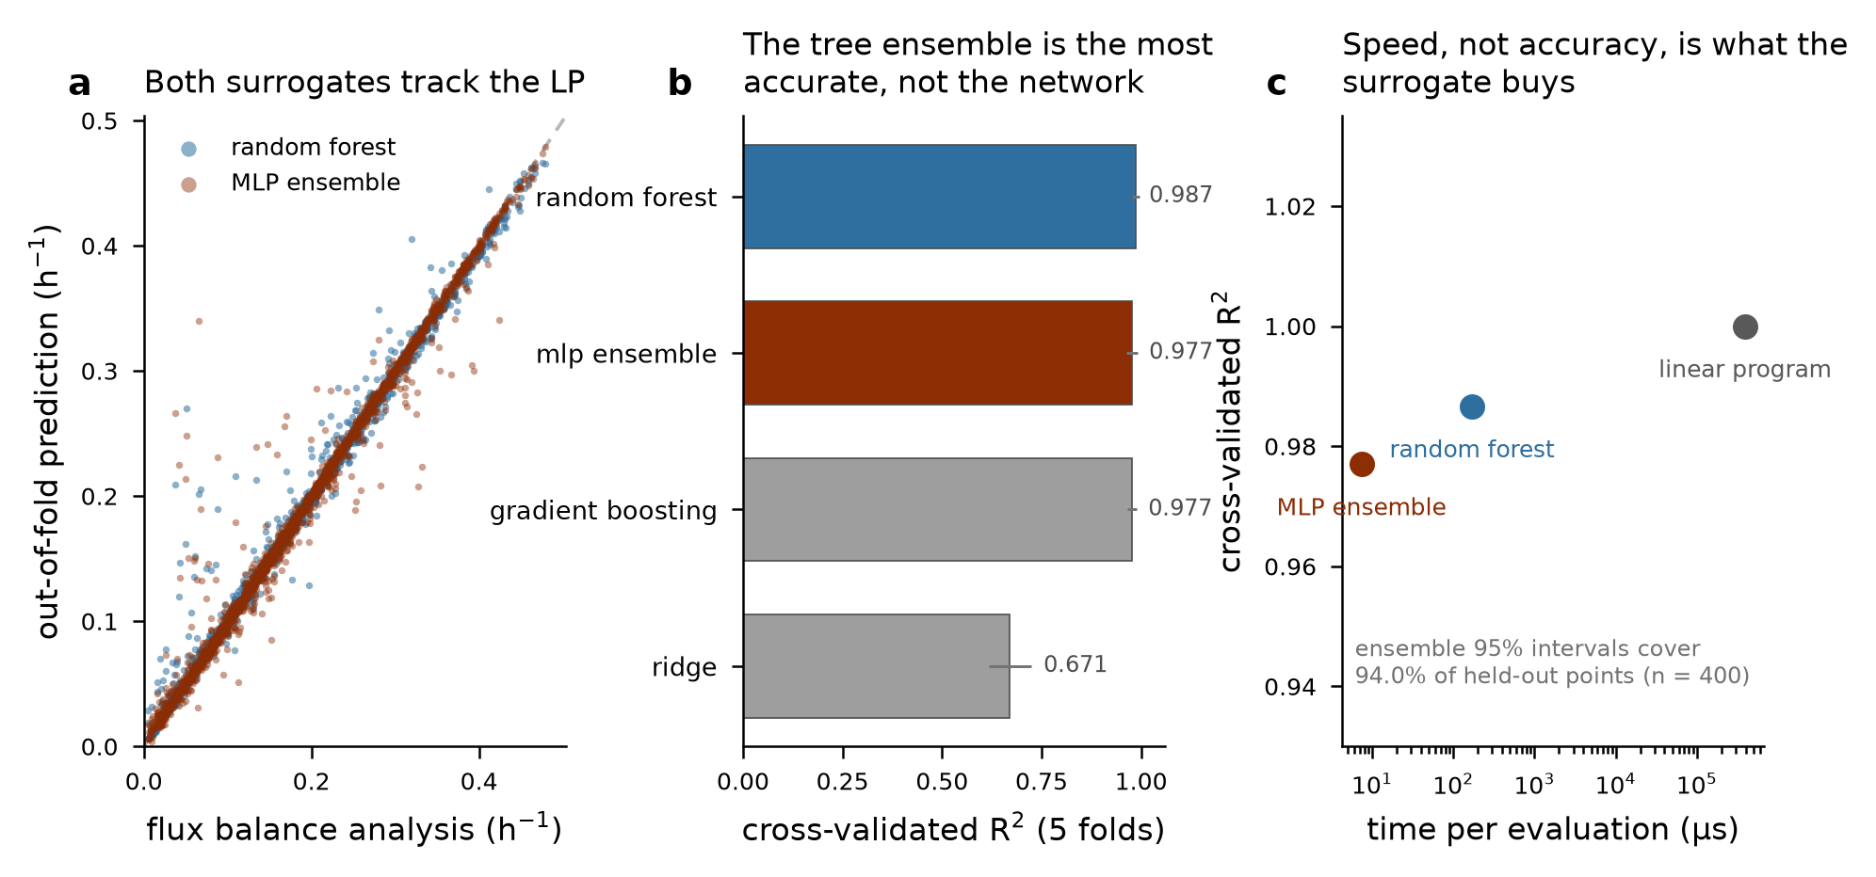
Figure 5. Surrogate model. (a) Out-of-fold predictions against flux balance analysis. (b) Cross-validated accuracy of the surrogate and the baselines on identical folds. (c) Ensemble predictive intervals and their empirical coverage.

3.11 Exclusion of C. difficile requires continuous dosing
The competition model reproduces a fact that a single-inoculum model cannot: S. boulardii does not colonise. Given once, it washes out and C. difficile recovers; given continuously, it excludes the pathogen and abolishes the toxin burden (Figure 6a,b; 100.0% reduction at the endpoint). Over the 256-point parameter grid the outcome is exclusion in 208 cases and coexistence in 48 (Figure 6c).
The clinically actionable output is the minimum dose (Figure 6d). At physiological transit rates the model requires 0.05 g of dry biomass per day, well inside the 0.25–1 g per day of commercial preparations. The requirement rises at both extremes of transit — at slow transit because the pathogen is not washed out and the delivered flux is lower, at fast transit because the yeast itself is cleared. The prediction that dose requirement is non-monotonic in transit rate is, to our knowledge, novel and testable in a chemostat.
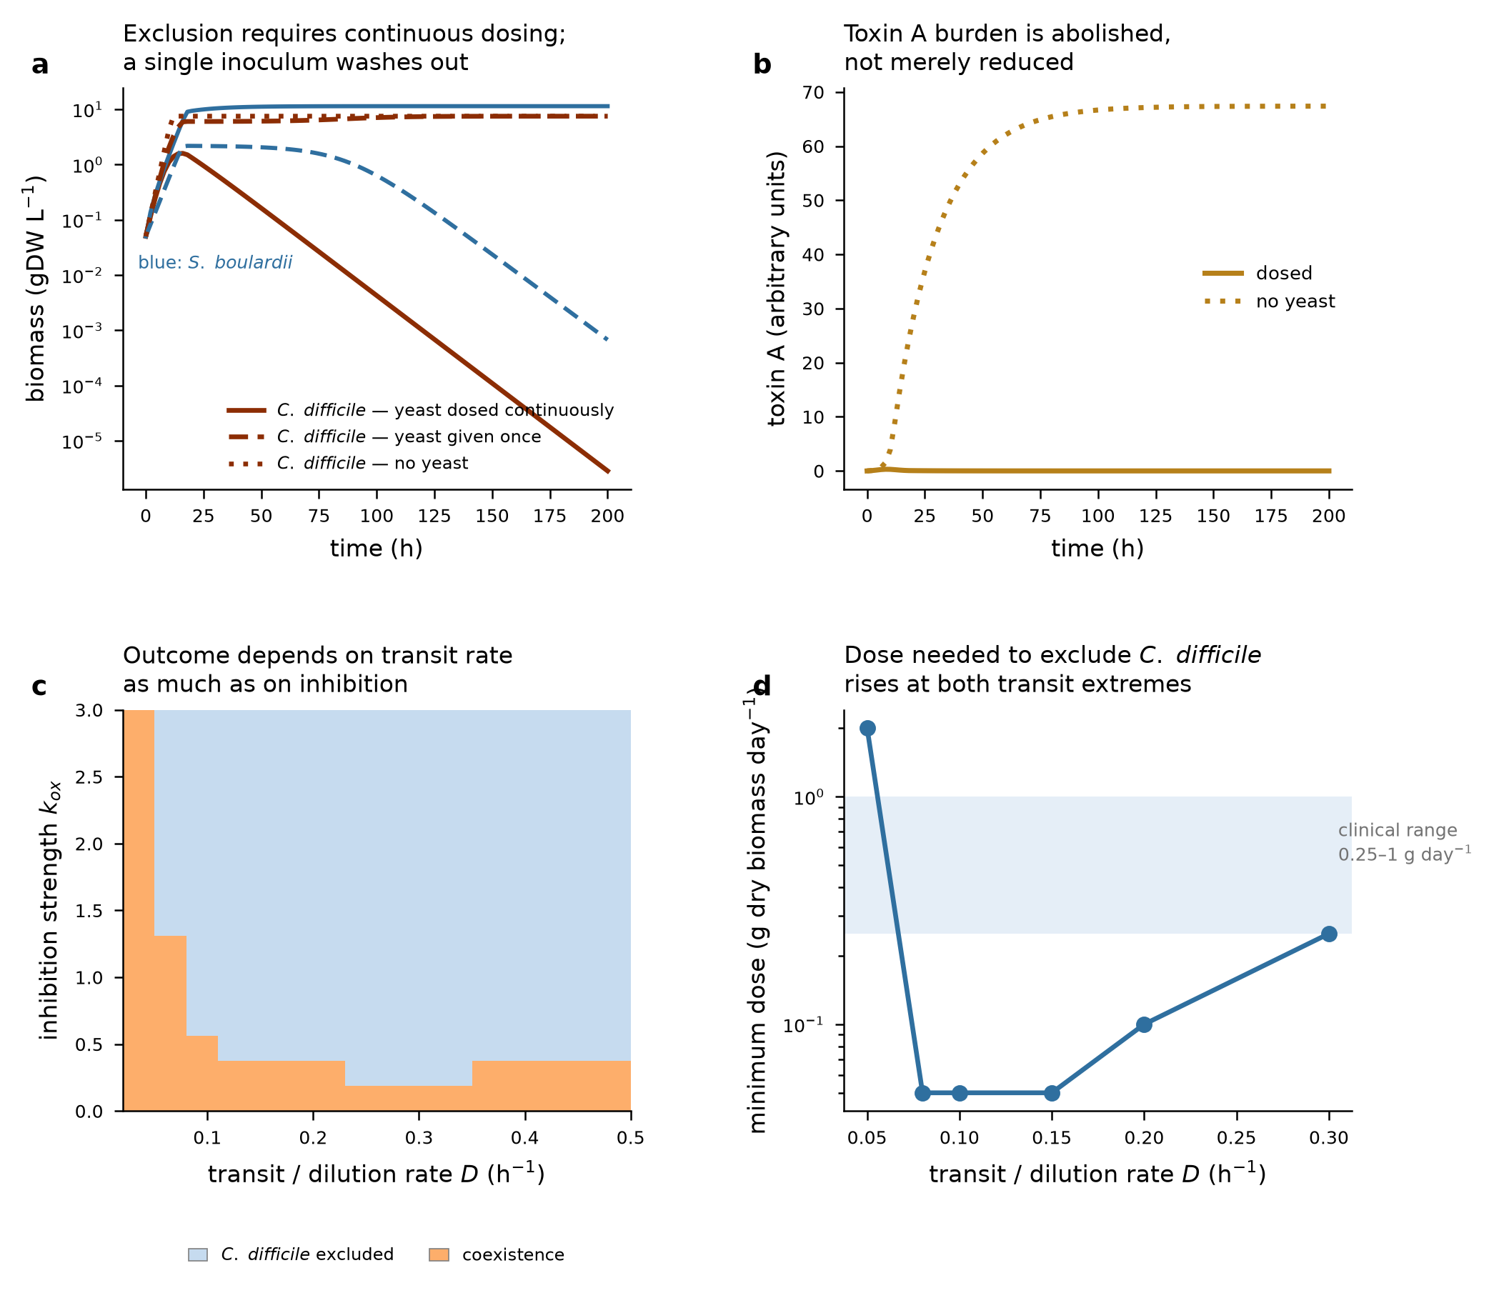
Figure 6. Competition and colonisation resistance. (a) Biomass trajectories under continuous dosing, a single inoculum, and no yeast. (b) Toxin A burden. (c) Outcome across inhibition strength and transit rate. (d) Minimum daily dose required for exclusion as a function of transit rate.

5. Falsifiable predictions
Each prediction below is generated by the model and stated with the experiment that would refute it.
Table 1. Model predictions and the experiments that would falsify them.
Prediction | Basis | Refuted_by
CNCM I-745 cannot grow on trehalose as sole carbon source, while S. cerevisiae S288C can | MAL11/AGT1 absent in all 6 assemblies; model growth 0.000 vs 1.639 h⁻¹ | Growth on 2% trehalose minimal medium
The galactose-negative phenotype is regulatory or allelic, not a gene deletion | All seven GAL genes intact in every assembly | Sequencing a GAL structural gene deletion, or restoring growth by GAL4 overexpression
Galactose growth is more sensitive to transporter titration than glucose growth | Capacity sweep: 27% deficit on galactose vs 0% on glucose at 1 mmol gDW⁻¹ h⁻¹ per permease | Comparative uptake kinetics at limiting sugar
Gastric survival requires membrane proton leak below 0.3 L gDW⁻¹ h⁻¹ | Pump cost 47 kJ mol⁻¹ H⁺ at pH 2 exceeds attainable ATP supply above that leak | Proton-flux measurement in acid-adapted cells
Toxin A half-life under protease exposure is 0.83 h (0.58–1.23) | MCMC posterior calibrated to two published anchors | Time-resolved toxin A degradation assay
Dose required to exclude C. difficile is non-monotonic in intestinal transit rate | Minimum dose 0.05 g day⁻¹ at intermediate transit, higher at both extremes | Chemostat co-culture at controlled dilution rates

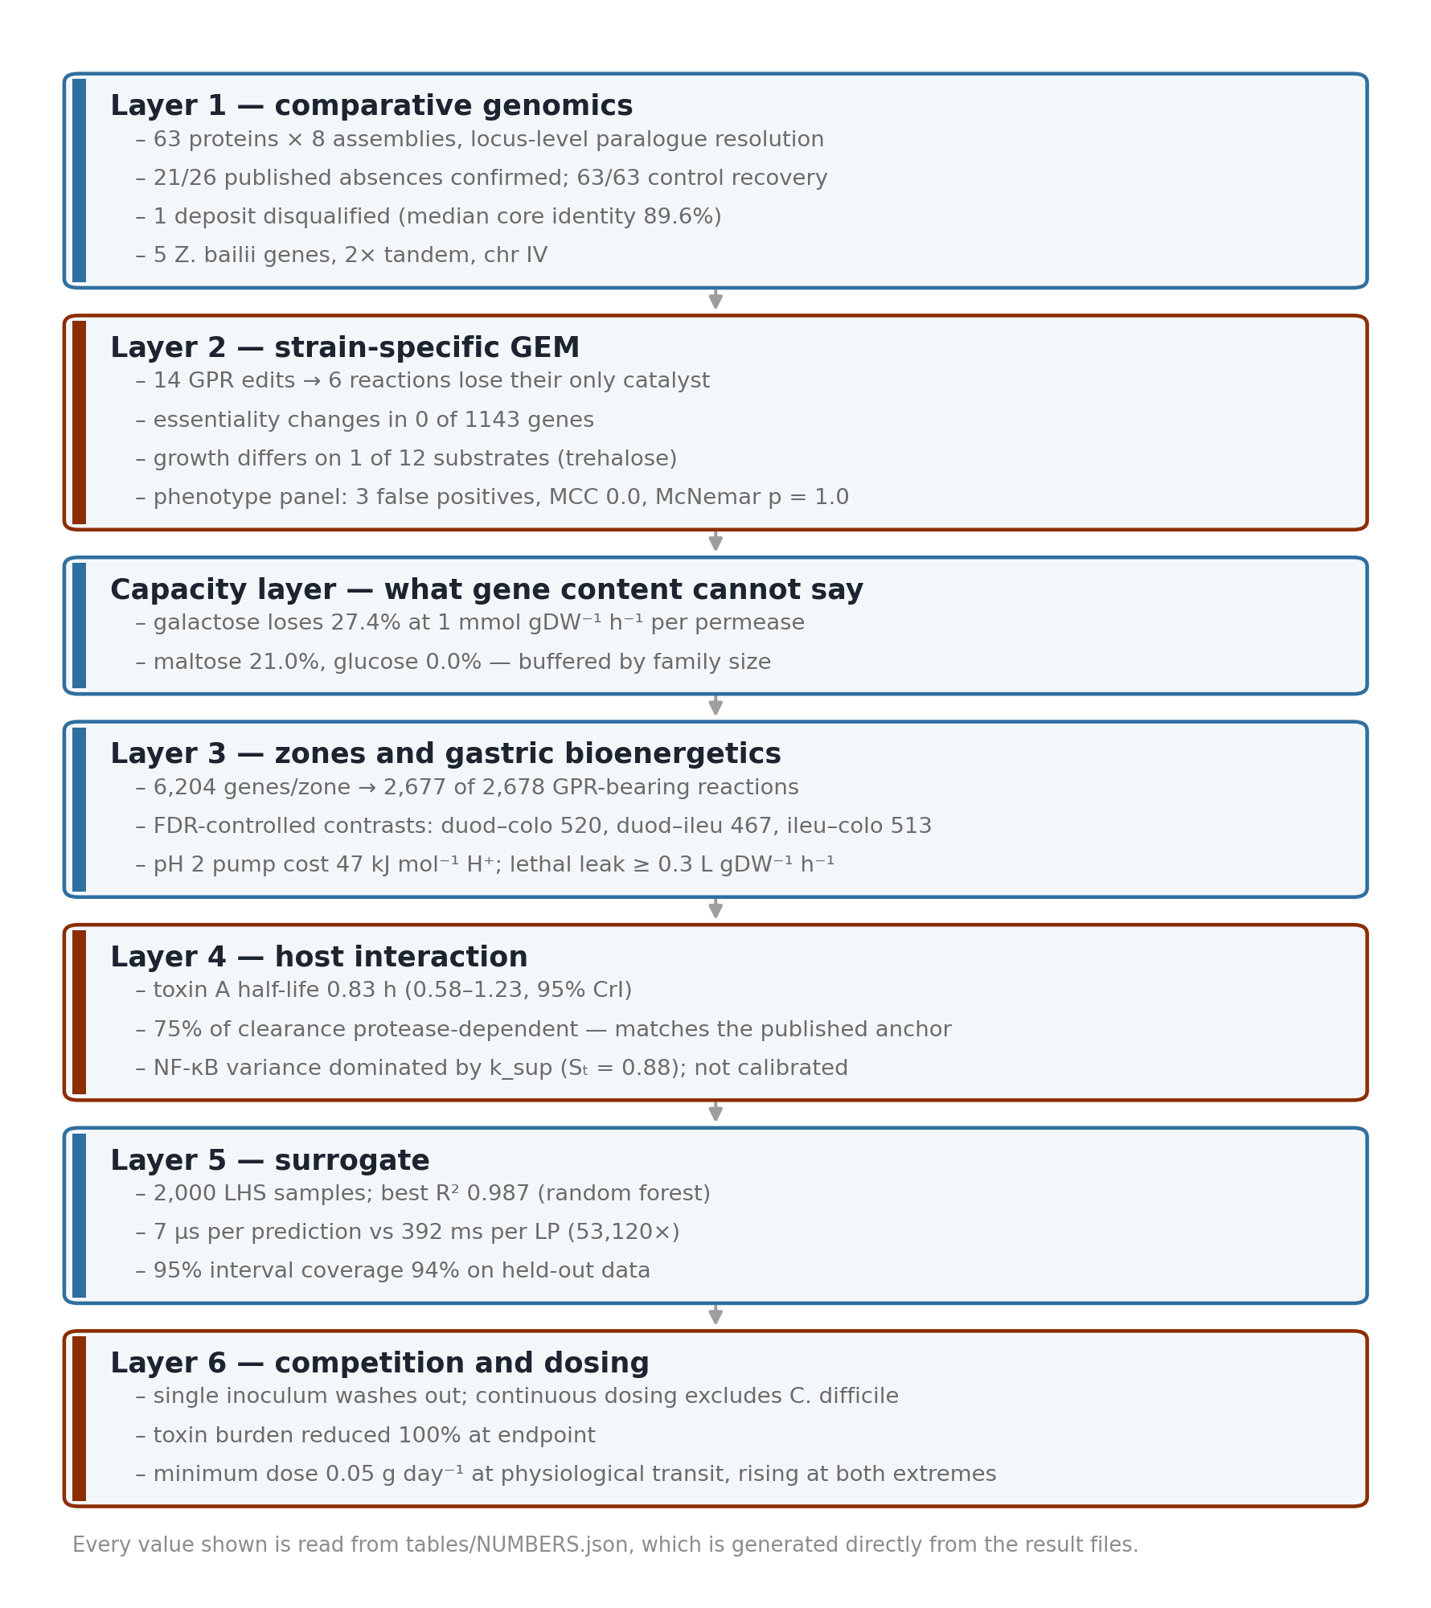
Figure 7. Cross-layer architecture with the measured quantities that pass between layers. Every value shown is read from the machine-generated number registry, not transcribed.

6. Interface
The model is served as a REST API with an accompanying browser dashboard. Endpoints expose the genome calls, live flux balance analysis under user-specified exchange bounds, the zone models, the pH response, the kinetic posterior, the surrogate, and the competition model. The surrogate is loaded once at start-up, which is what allows the nutrient sliders to update predictions continuously; the same conditions can be sent to the linear program for comparison, so the speed–accuracy trade-off is visible rather than hidden. A plain-language query endpoint is provided and is described accurately in its own response as deterministic keyword routing, not a language model.

7. Corrections to earlier versions of this work
This section is included so that the revision is auditable by anyone comparing versions.
Table 2. Claims in earlier versions that changed, and why.
Claim | Status | Detail
Genome table attributed to CNCM I-745 | Corrected | The values are those of the S288C reference (17 sequences, 12,157,105 bp, N50 924,431); real S. boulardii assemblies are 11,469,511–12,001,065 bp
HXT9 and HXT11 absent from the assembly | Re-derived | True of S. boulardii, but not demonstrable from the genome previously used, which contains both; now established by alignment across six assemblies
Losses span MAL11–MAL33 and IMA1–IMA3 | Corrected | MAL11 and MAL13 are lost; MAL31, MAL32 and MAL33 are intact. The isomaltase losses are IMA2, IMA3 and IMA4
Toxin A cleaved by CAMP factor | Corrected | The activity is a 54 kDa serine protease; CAMP factor is unrelated to this organism
Buts et al. 2006 cited for toxin A degradation | Corrected | That work describes an alkaline phosphatase acting on lipopolysaccharide, modelled here as a separate activity
Maltose growth as the strain-specific validation | Withdrawn | Does not survive the corrected gene list: the MAL3 locus supports maltose growth in both models. Trehalose replaces it as the differential phenotype
Strain correction yields a functionally distinct model | Withdrawn | Essentiality is unchanged in 0 genes and growth differs on 1 of 12 substrates
1-D CNN surrogate | Replaced | Convolution assumes an input ordering that does not exist for four unordered nutrient bounds; replaced by a multilayer perceptron ensemble with checked interval coverage
Software versions cited | Corrected | Several cited versions do not exist; all versions are now recorded in the environment specification shipped with the code

8. Limitations
No CNCM I-745 transcriptome from the gastrointestinal tract is publicly available. The zone layer therefore uses S. cerevisiae stress-response expression as a proxy, matched condition by condition to the physicochemical character of each zone. This is a structural limitation of the available data, not a modelling choice, and it bounds how literally the zone fluxes should be read.
The phenotype panel is small and literature-derived rather than measured here; we chose a short fully-sourced panel over a longer one padded with unsupported entries. The competition model is a two-species abstraction of a community, and its inhibition term aggregates several documented mechanisms into one parameter. The inflammatory module is not calibrated. Assumption diagnostics for the flux contrasts were not assessed.

9. Data and code availability
All inputs are recorded in a provenance ledger with SHA-256 digests (10 entries). The analysis package, layer drivers, figure builders, API, dashboard and environment specification are provided with the manuscript, along with the corrected model in SBML. Every number in this document is regenerated from the result files by the build script; 26 of 28 references were verified against CrossRef at build time.

References
Barrett et al. (2012) NCBI GEO: archive for functional genomics data sets—update. Nucleic Acids Research 41: D991-D995. doi:10.1093/nar/gks1193
Benjamini et al. (1995) Controlling the False Discovery Rate: A Practical and Powerful Approach to Multiple Testing. Journal of the Royal Statistical Society Series B: Statistical Methodology 57: 289-300. doi:10.1111/j.2517-6161.1995.tb02031.x
Buts et al. (2006) Saccharomyces boulardii Produces in Rat Small Intestine a Novel Protein Phosphatase that Inhibits Escherichia coli Endotoxin by Dephosphorylation. Pediatric Research 60: 24-29. doi:10.1203/01.pdr.0000220322.31940.29
CZERUCKA et al. (2007) Review article: yeast as probiotics –
<i>Saccharomyces boulardii</i>. Alimentary Pharmacology & Therapeutics 26: 767-778. doi:10.1111/j.1365-2036.2007.03442.x
Camacho et al. (2009) BLAST+: architecture and applications. BMC Bioinformatics 10. doi:10.1186/1471-2105-10-421
Castagliuolo et al. (1996) Saccharomyces boulardii protease inhibits Clostridium difficile toxin A effects in the rat ileum. Infection and Immunity 64: 5225-5232. doi:10.1128/iai.64.12.5225-5232.1996
Castagliuolo et al. (1999) <i>Saccharomyces boulardii</i>
Protease Inhibits the Effects of
<i>Clostridium difficile</i>
Toxins A and B in Human Colonic Mucosa. Infection and Immunity 67: 302-307. doi:10.1128/iai.67.1.302-307.1999
Cock et al. (2009) Biopython: freely available Python tools for computational molecular biology and bioinformatics. Bioinformatics 25: 1422-1423. doi:10.1093/bioinformatics/btp163
Colijn et al. (2009) Interpreting Expression Data with Metabolic Flux Models: Predicting Mycobacterium tuberculosis Mycolic Acid Production. PLoS Computational Biology 5: e1000489. doi:10.1371/journal.pcbi.1000489
Ebrahim et al. (2013) COBRApy: COnstraints-Based Reconstruction and Analysis for Python. BMC Systems Biology 7. doi:10.1186/1752-0509-7-74
Edwards-Ingram et al. (2007) Genotypic and Physiological Characterization of
<i>Saccharomyces boulardii</i>
, the Probiotic Strain of
<i>Saccharomyces cerevisiae</i>. Applied and Environmental Microbiology 73: 2458-2467. doi:10.1128/AEM.02201-06
Foreman-Mackey et al. (2013) <tt>emcee</tt>
: The MCMC Hammer. Publications of the Astronomical Society of the Pacific 125: 306-312. doi:10.1086/670067
Gasch et al. (2000) Genomic Expression Programs in the Response of Yeast Cells to Environmental Changes. Molecular Biology of the Cell 11: 4241-4257. doi:10.1091/mbc.11.12.4241
Harris et al. (2020) Array programming with NumPy. Nature 585: 357-362. doi:10.1038/s41586-020-2649-2
Herman et al. (2017) SALib: An open-source Python library for Sensitivity Analysis. The Journal of Open Source Software 2: 97. doi:10.21105/joss.00097
Kelesidis et al. (2011) Efficacy and safety of the probiotic
<i>Saccharomyces boulardii</i>
for the prevention and therapy of gastrointestinal disorders. Therapeutic Advances in Gastroenterology 5: 111-125. doi:10.1177/1756283X11428502
Khatri et al. (2017) Complete genome sequence and comparative genomics of the probiotic yeast Saccharomyces boulardii. Scientific Reports 7. doi:10.1038/s41598-017-00414-2
Kim et al. (2022) Strain engineering and metabolic flux analysis of a probiotic yeast Saccharomyces boulardii for metabolizing l-fucose, a mammalian mucin component. Microbial Cell Factories 21. doi:10.1186/s12934-022-01926-x
Lu et al. (2019) A consensus S. cerevisiae metabolic model Yeast8 and its ecosystem for comprehensively probing cellular metabolism. Nature Communications 10. doi:10.1038/s41467-019-11581-3
McFarland et al. (2010) Systematic review and meta-analysis of<i>Saccharomyces boulardii</i>in adult patients. World Journal of Gastroenterology 16: 2202. doi:10.3748/wjg.v16.i18.2202
Orij et al. (2012) Genome-wide analysis of intracellular pH reveals quantitative control of cell division rate by pHc in Saccharomyces cerevisiae. Genome Biology 13. doi:10.1186/gb-2012-13-9-r80
Orth et al. (2010) What is flux balance analysis?. Nature Biotechnology 28: 245-248. doi:10.1038/nbt.1614
Sayers et al. (2021) Database resources of the national center for biotechnology information. Nucleic Acids Research 50: D20-D26. doi:10.1093/nar/gkab1112
Sougioultzis et al. (2006) Saccharomyces boulardii produces a soluble anti-inflammatory factor that inhibits NF-κB-mediated IL-8 gene expression. Biochemical and Biophysical Research Communications 343: 69-76. doi:10.1016/j.bbrc.2006.02.080
Virtanen et al. (2020) SciPy 1.0: fundamental algorithms for scientific computing in Python. Nature Methods 17: 261-272. doi:10.1038/s41592-019-0686-2
Zhang et al. (2024) Yeast9: a consensus genome-scale metabolic model for S. cerevisiae curated by the community. Molecular Systems Biology 20. doi:10.1038/s44320-024-00060-7
Scikit-learn: machine learning in Python. doi:10.48550/arXiv.1201.0490 (preprint server record)
PyTorch: an imperative style, high-performance deep learning library. doi:10.48550/arXiv.1912.01703 (preprint server record)

