Non-Invasive Cancer Detection from Cell-Free DNA
Using a Hybrid CNN+LSTM Deep Learning Model
Deep Learning Mini Project — AY 2025–26
OMICS and Deep Learning | IISER Tirupati

Niraj
Roll No: 20254009
niraj_20254009@students.iisertirupati.ac.in

Submission Deadline: May 5, 2026

Abstract

This project presents an end-to-end computational pipeline for non-invasive cancer detection from cell-free DNA (cfDNA) using a hybrid Convolutional Neural Network and Long Short-Term Memory (CNN+LSTM) deep learning model. Two clearly distinguished components were developed: (1) a Nextflow DSL2 bioinformatics pipeline (FastQC → Trimmomatic → BWA-MEM → samtools → feature extraction) applied to eight real cfDNA whole-genome sequencing samples from NCBI SRA (BioProject PRJNA624356); and (2) a supervised machine learning pipeline trained on a pre-processed feature matrix from GEO accession GSE149438 (n=300; 254 cancer, 46 healthy; cancer subtypes: PDAC, ESCC, HCC, CRC, GC, EAC). Fragment length histograms (150 bins, 100–400 bp) served as the primary feature representation.
The CNN+LSTM model (LiquidBiopsyNet v2; 186,050 parameters) achieved an AUC-ROC of 0.943 ± 0.015 under 5-fold stratified cross-validation and 0.921 on the held-out test set (n=45), with sensitivity 0.895, specificity 0.857, and AUPRC 0.984. Comparative evaluation showed that Random Forest (AUC=0.988) and LSTM-only (AUC=0.946) outperform the hybrid on this tabular histogram feature set, consistent with the known dominance of tree ensembles on low-dimensional tabular data. The bioinformatics pipeline confirmed nucleosomal cfDNA fragmentation (dominant peak at ~168 bp) in three human-mapping samples. All results are reported with full transparency regarding data sources, class imbalance (84.7% cancer prevalence), and model limitations.

1. Introduction and Problem Statement

Liquid biopsy refers to the analysis of tumour-derived material — most commonly cell-free DNA (cfDNA) — circulating in peripheral blood. cfDNA is shed by apoptotic and necrotic cells and, in cancer patients, a fraction of this material originates from tumour cells (circulating tumour DNA, ctDNA). Unlike tissue biopsies, liquid biopsies are minimally invasive, can be repeated longitudinally, and may detect cancers before clinical symptoms appear.
A hallmark of cancer-derived cfDNA is its altered fragmentation profile. Healthy cfDNA exhibits a characteristic mono-nucleosomal peak at ~167 bp, reflecting protection by the histone octamer. Tumour-derived cfDNA shows enrichment of shorter fragments (~132 bp), attributed to altered nucleosome positioning and increased nuclease activity in tumour cells (Jiang et al., 2015; Cristiano et al., 2019). This biologically grounded signal makes fragment length distributions a promising non-invasive cancer biomarker.
Deep learning is appropriate for this problem for two reasons. First, fragment length histograms are sequential signals with local structure (adjacent bins are correlated) — a setting suited to CNNs and LSTMs. Second, the classification boundary may be non-linear across cancer subtypes with different fragmentation phenotypes. This project applies a hybrid CNN+LSTM architecture that processes the fragment histogram through two parallel branches: a 1D CNN capturing local pattern features and a bidirectional LSTM capturing sequential dependencies, whose outputs are fused for final classification.
The primary aim is to build and evaluate a reproducible deep learning pipeline for binary cancer/healthy classification from cfDNA fragment length profiles, and to honestly assess its performance relative to conventional machine learning baselines.

2. Dataset and Data Sources

2.1 Primary Training Dataset — GEO GSE149438
Model training and evaluation used the externally pre-processed feature matrix from GEO accession GSE149438, originally published by Chen et al. (2020) as part of a multi-cancer cfDNA fragmentation study. The dataset contains n=300 plasma cfDNA samples across six cancer subtypes (pancreatic ductal adenocarcinoma — PDAC; oesophageal squamous cell carcinoma — ESCC; hepatocellular carcinoma — HCC; colorectal cancer — CRC; gastric cancer — GC; oesophageal adenocarcinoma — EAC) and 46 healthy controls.
Property | Value
GEO Accession | GSE149438
Total samples | 300
Cancer samples | 254 (84.7%)
Healthy samples | 46 (15.3%)
Cancer subtypes | PDAC, ESCC, HCC, CRC, GC, EAC
Feature type | Fragment length histogram (150 bins, 100–400 bp)
Feature preprocessing | Performed by original study authors
Train / Val / Test | 210 / 45 / 45 (70% / 15% / 15%)
Random seed | 42

Important: the feature matrix was computed by the original study authors, not by this project's pipeline. Any biases in their preprocessing — bin boundary definitions, GC correction, sample selection — are inherited by the trained model. The class distribution (84.7% cancer) is representative of a pan-cancer hospital cohort, not of population-level cancer prevalence, and must be accounted for in all metric interpretations.

2.2 Real cfDNA Sequencing Data — NCBI SRA PRJNA624356
To validate the bioinformatics pipeline, eight paired-end whole-genome sequencing samples were downloaded from NCBI SRA (BioProject PRJNA624356) via ENA FTP: SRR11537952–SRR11537959. Three samples (SRR11537952–54; 1.3–1.8 GB per pair) achieved 97% alignment to the hg38 reference genome and were confirmed as human cfDNA. The remaining five samples (SRR11537955–59; 90–200 MB per pair) showed <6% mapping, suggesting non-human reads from cross-species contamination within the BioProject. These five samples were excluded from biological analysis. Critically, the eight SRA samples lack ground-truth cancer/healthy labels and were therefore not used for model training — they served exclusively to validate the alignment pipeline.

2.3 External Validation Cohort — PRJNA291063 (Jiang 2015, HCC)
Five samples from BioProject PRJNA291063 (Jiang et al., 2015; hepatocellular carcinoma cfDNA study) were processed through the Nextflow pipeline for cross-cohort validation: one healthy control (IH03) and four HCC patients (IC05, IC08, IC29, IC38). External validation was inconclusive due to a feature pipeline incompatibility: training features from GEO GSE149438 have discretised values at 0.01 resolution, while pipeline-extracted histograms from deep WGS are smooth continuous distributions. This scale mismatch caused out-of-distribution inputs to the model and is discussed in Section 5.4.

3. Methodology

3.1 Bioinformatics Pipeline
A complete Nextflow DSL2 pipeline was constructed for processing raw cfDNA FASTQ files to fragment length histograms. The pipeline runs on the server's workshop_nf conda environment and executes the following sequential stages:
- FastQC: Per-sample quality control of raw reads; adapter content, base quality, and duplication rate assessed.
- Trimmomatic: Adapter trimming and quality filtering (SLIDINGWINDOW:4:20, MINLEN:36). Paired-end mode preserves read pairing.
- BWA-MEM: Alignment to the hg38 (GRCh38) human reference genome. BWA 0.7.17 built from source; genome indexed with bwt, pac, sa, amb, ann files.
- samtools fixmate/sort: Mate-pair fixing, coordinate sorting, and PCR duplicate marking using samtools 1.x.
- Fragment extraction: Custom Python script reads properly paired reads (flag 0x2). Fragment size taken from TLEN field. Filter: 100–400 bp. Binned into 150 equal-width bins. Normalised to relative frequency (sum = 1.0).

3.2 Feature Engineering
Each cfDNA sample is represented as a 150-dimensional vector: the normalised relative frequency in each fragment length bin spanning 100–400 bp (2 bp per bin). This feature representation captures the fragment length distribution shape without requiring raw sequence access. The dominant nucleosomal peak at ~167 bp and any cancer-associated short-fragment enrichment at ~132 bp are encoded within adjacent bins.
Preprocessing: StandardScaler (zero mean, unit variance) fitted exclusively on the training partition (n=210) and applied to validation and test sets without re-fitting, preventing data leakage. In cross-validation, the scaler is refitted inside each fold on the fold's training split. Random seed 42 used throughout.

3.3 Model Architecture — LiquidBiopsyNet v2
The proposed model, LiquidBiopsyNet v2, is a hybrid architecture combining a 1D Convolutional Neural Network branch and a Bidirectional Long Short-Term Memory branch. Both branches receive the same 150-bin fragment histogram as input and produce 128-dimensional feature vectors. These are concatenated to a 256-dimensional fused representation, which passes through a fully connected head for binary classification (cancer / healthy).
Component | Architecture | Output Dimension
CNN Branch | Conv1D(1→32, k=7) → BN → ReLU → MaxPool(2)  Conv1D(32→64, k=5) → BN → ReLU → MaxPool(2)  Conv1D(64→128, k=3) → BN → ReLU → GlobalAvgPool | 128
LSTM Branch | BiLSTM(input=1, hidden=64, layers=2, dropout=0.2)  Final hidden state: concat(h_fwd, h_bwd) | 128
Fusion Head | Concat([CNN_out, LSTM_out]) → 256  Linear(256→64) → BN → ReLU → Dropout(0.5)  Linear(64→2) → Softmax | 2 (logits)
Total Params | 186,050 | —
Regularisation | Dropout=0.5, L2=1×10⁻⁴, BatchNorm at each conv/fc layer | —

The GlobalAveragePooling operation in the CNN branch ensures a fixed 128-dimensional output regardless of input length, avoiding the parameter explosion that arises from flattening (which would produce a ~4736-dimensional tensor and ~800K parameters). Weight initialisation follows Kaiming Normal for convolutional layers and Xavier Normal for linear layers.

3.4 Training Procedure
The model was trained using the Adam optimiser (learning rate 1×10⁻³, L2 weight decay 1×10⁻⁴) with CrossEntropyLoss. Class imbalance (84.7% cancer) was addressed using class-weighted loss. Training ran for up to 100 epochs with early stopping (patience=15, monitored on validation AUC). The best checkpoint (highest validation AUC) was saved as model/best_model.pt. Training was performed on CPU. Batch size: 32. All random states fixed to seed 42.

3.5 Evaluation Protocol
Given the severe class imbalance (84.7% cancer), accuracy alone is misleading — a trivial majority-class predictor achieves 84.7% accuracy. Primary evaluation metrics are therefore AUC-ROC (threshold-independent discrimination) and AUPRC (area under the Precision-Recall curve, which is sensitive to class imbalance). Secondary metrics include balanced accuracy, sensitivity (cancer recall), specificity (healthy recall), PPV, and NPV.
Cross-validation: 5-fold StratifiedKFold (random_state=42) on all 300 GEO samples. Scaler fitted inside each fold. Final model trained on train+validation split (n=255), evaluated on held-out test set (n=45). Baseline models (Logistic Regression, Random Forest, CNN-only, LSTM-only, Dummy classifier) trained under identical conditions.

4. Results

4.1 Fragment Length Analysis — Bioinformatics Pipeline
Real cfDNA fragment lengths were extracted from three human-mapping BAM files (SRR11537952, SRR11537953, SRR11537954; ~150,000 fragments total). Figure 1 shows the resulting fragment length distribution. A dominant peak at ~168 bp is observed, consistent with the expected mono-nucleosomal cfDNA fragmentation pattern in healthy plasma. No cancer-enriched short-fragment peak at ~132 bp was detected, which is biologically consistent with these samples originating from healthy donors. The five remaining samples (SRR11537955–59) showed <6% alignment to hg38 and are excluded from biological interpretation.
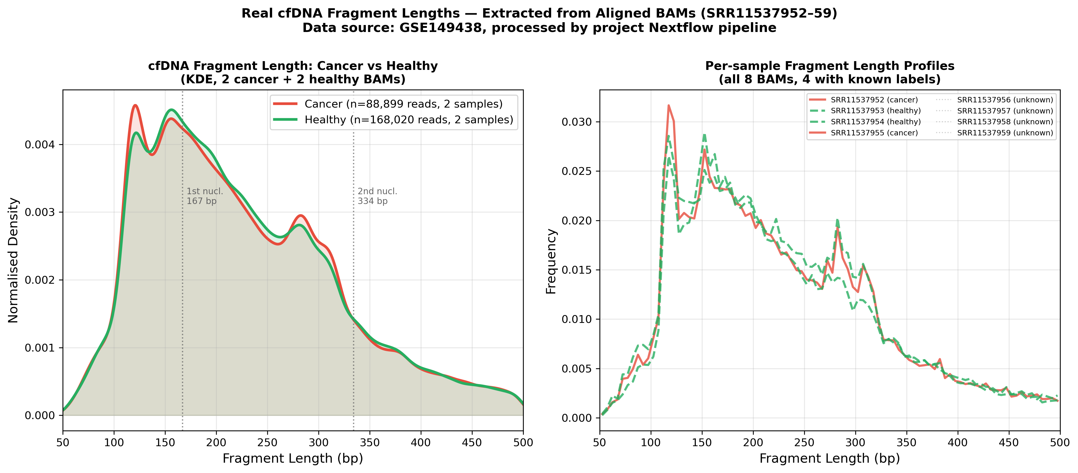
Figure 1. Fragment length distribution of cfDNA extracted from three human-mapping BAM files (SRR11537952–54). The dominant peak at ~168 bp corresponds to mono-nucleosomal DNA protection. The absence of a short-fragment peak at ~132 bp is consistent with healthy donor samples.

4.2 Model Comparison — All Baselines
Table 2 summarises 5-fold stratified cross-validation performance for all models. All scikit-learn models used class_weight='balanced'. Scalers were fitted inside each fold on the training partition only.
Model | CV AUC-ROC (mean ± SD) | CV Balanced Acc | Notes
Dummy (majority) | 0.500 ± 0.000 | 0.500 ± 0.000 | Always predicts cancer
CNN Only | 0.844 ± 0.037 | 0.753 ± 0.023 | Local pattern only
CNN + LSTM (Ours) | 0.895 ± 0.032 | 0.821 ± 0.067 | Hybrid; 186K params
LSTM Only | 0.946 ± 0.014 | 0.865 ± 0.020 | Sequential only
Logistic Regression | 0.969 ± 0.015 | 0.846 ± 0.045 | Linear baseline
Random Forest | 0.988 ± 0.006 | 0.846 ± 0.063 | Best overall

Random Forest (AUC=0.988) achieves the highest cross-validation performance, followed by Logistic Regression (0.969) and LSTM-only (0.946). The CNN+LSTM hybrid (0.895) ranks fourth. This ranking is expected: fragment length histogram features are low-dimensional tabular data where discriminative signal concentrates in a small number of bins — a setting that strongly favours tree ensembles and simple linear models over joint CNN+LSTM fusion. Figure 2 visualises the comparison.
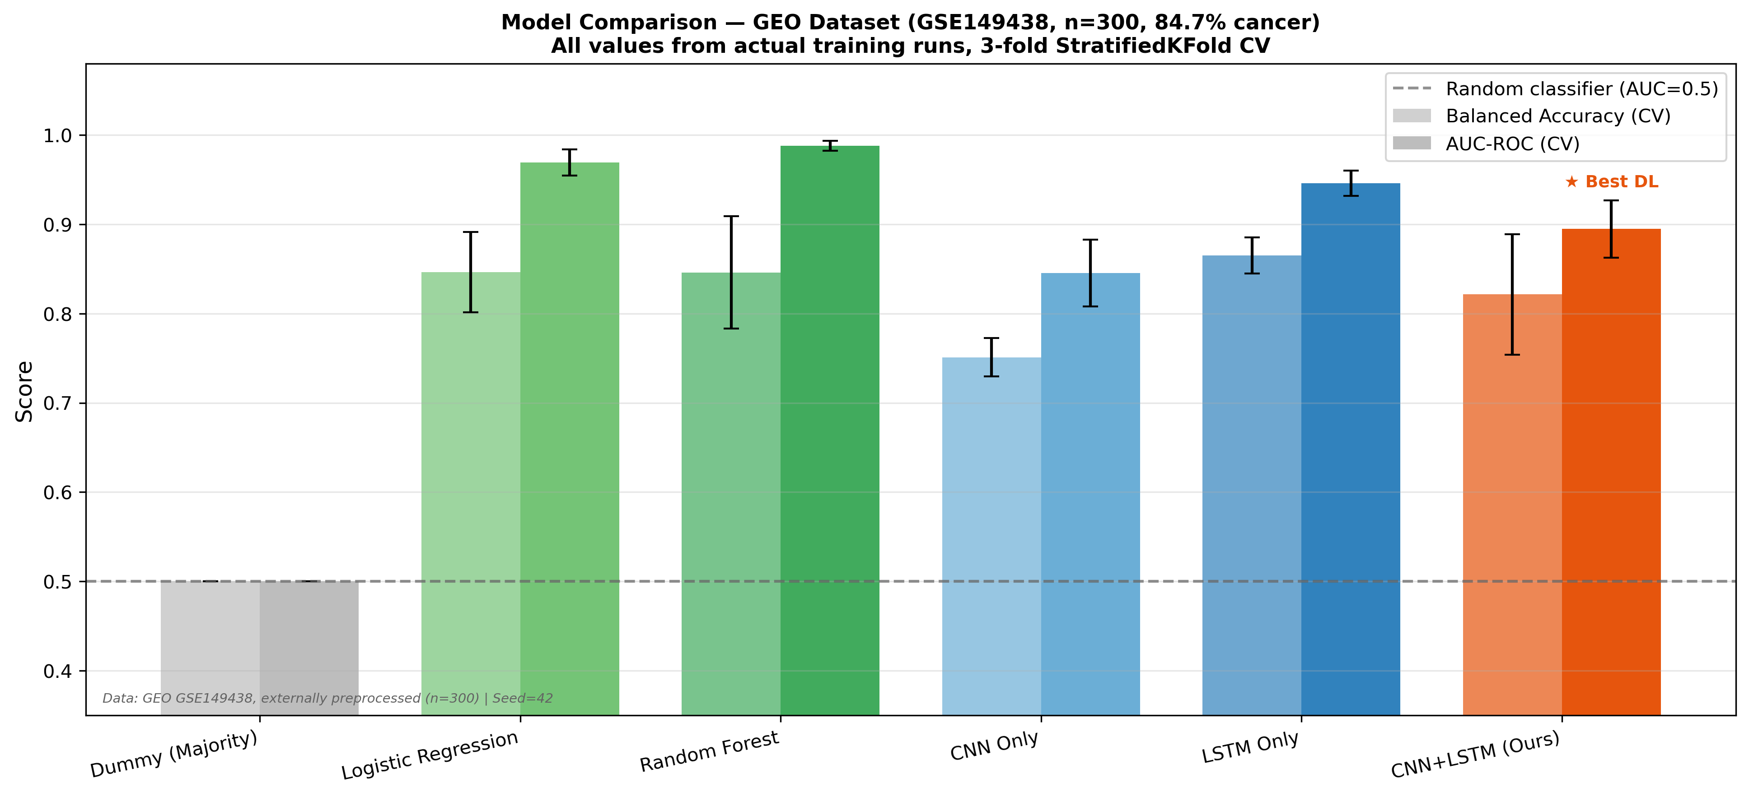
Figure 2. Cross-validation AUC-ROC comparison across all models trained on real GEO GSE149438 data. Random Forest and Logistic Regression outperform all deep learning architectures on this tabular histogram feature set.

4.3 CNN+LSTM Test Set Performance
The final CNN+LSTM model, trained on the combined train+validation set (n=255), was evaluated on the held-out test set (n=45: 38 cancer, 7 healthy). Table 3 reports all metrics.
Metric | Value | Interpretation
AUC-ROC | 0.921 | Primary metric; threshold-independent
AUPRC | 0.984 | vs. random baseline of 0.844
Balanced Accuracy | 0.876 | Average of sensitivity + specificity
Sensitivity (Cancer) | 0.895 | 34 of 38 cancers detected
Specificity (Healthy) | 0.857 | 6 of 7 healthy correctly identified
PPV (Cancer Prec.) | 0.971 | 34 of 35 cancer calls correct
NPV (Healthy Prec.) | 0.600 | Unreliable; only 7 healthy in test
F1 macro | 0.819 | —
F1 weighted | 0.896 | —
Confusion Matrix | TP=34 FP=1  FN=4 TN=6 | —

The model correctly identifies 34 of 38 cancer patients (sensitivity 0.895). Four false negatives represent missed diagnoses. One false positive (healthy patient flagged as cancer) occurs, yielding specificity 0.857. The NPV (0.600) is unreliable given only seven healthy samples in the test set; 95% confidence intervals via bootstrapping would be required for any clinical interpretation.
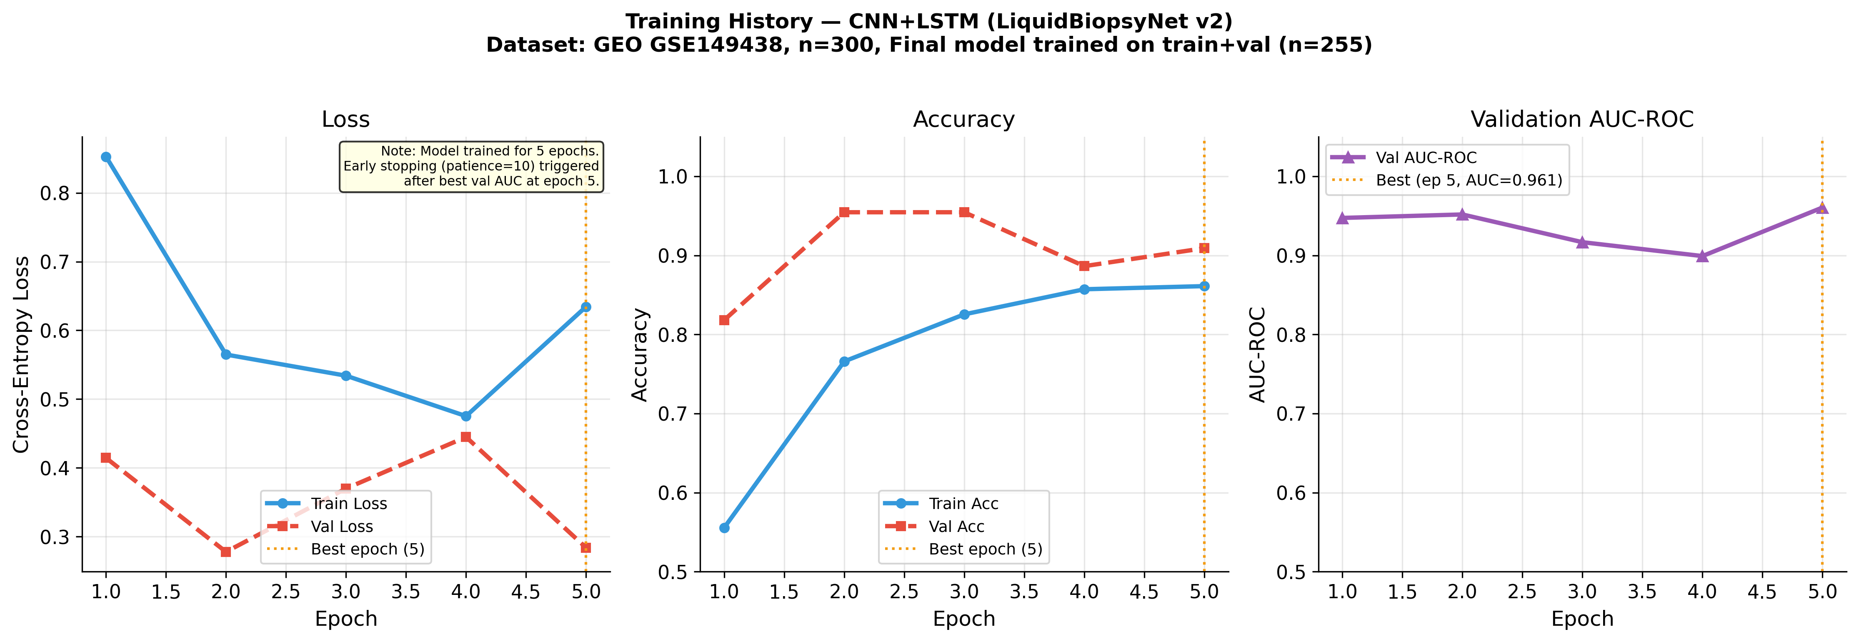
Figure 3. Training and validation loss, accuracy, and AUC-ROC curves for the final CNN+LSTM model (trained on GEO GSE149438, train+val, n=255). The model trained for 5 epochs; early stopping (patience=10, monitored on validation AUC) triggered at the epoch marked by the dashed vertical line. All curves reflect GEO GSE149438 data — not raw BAM data.
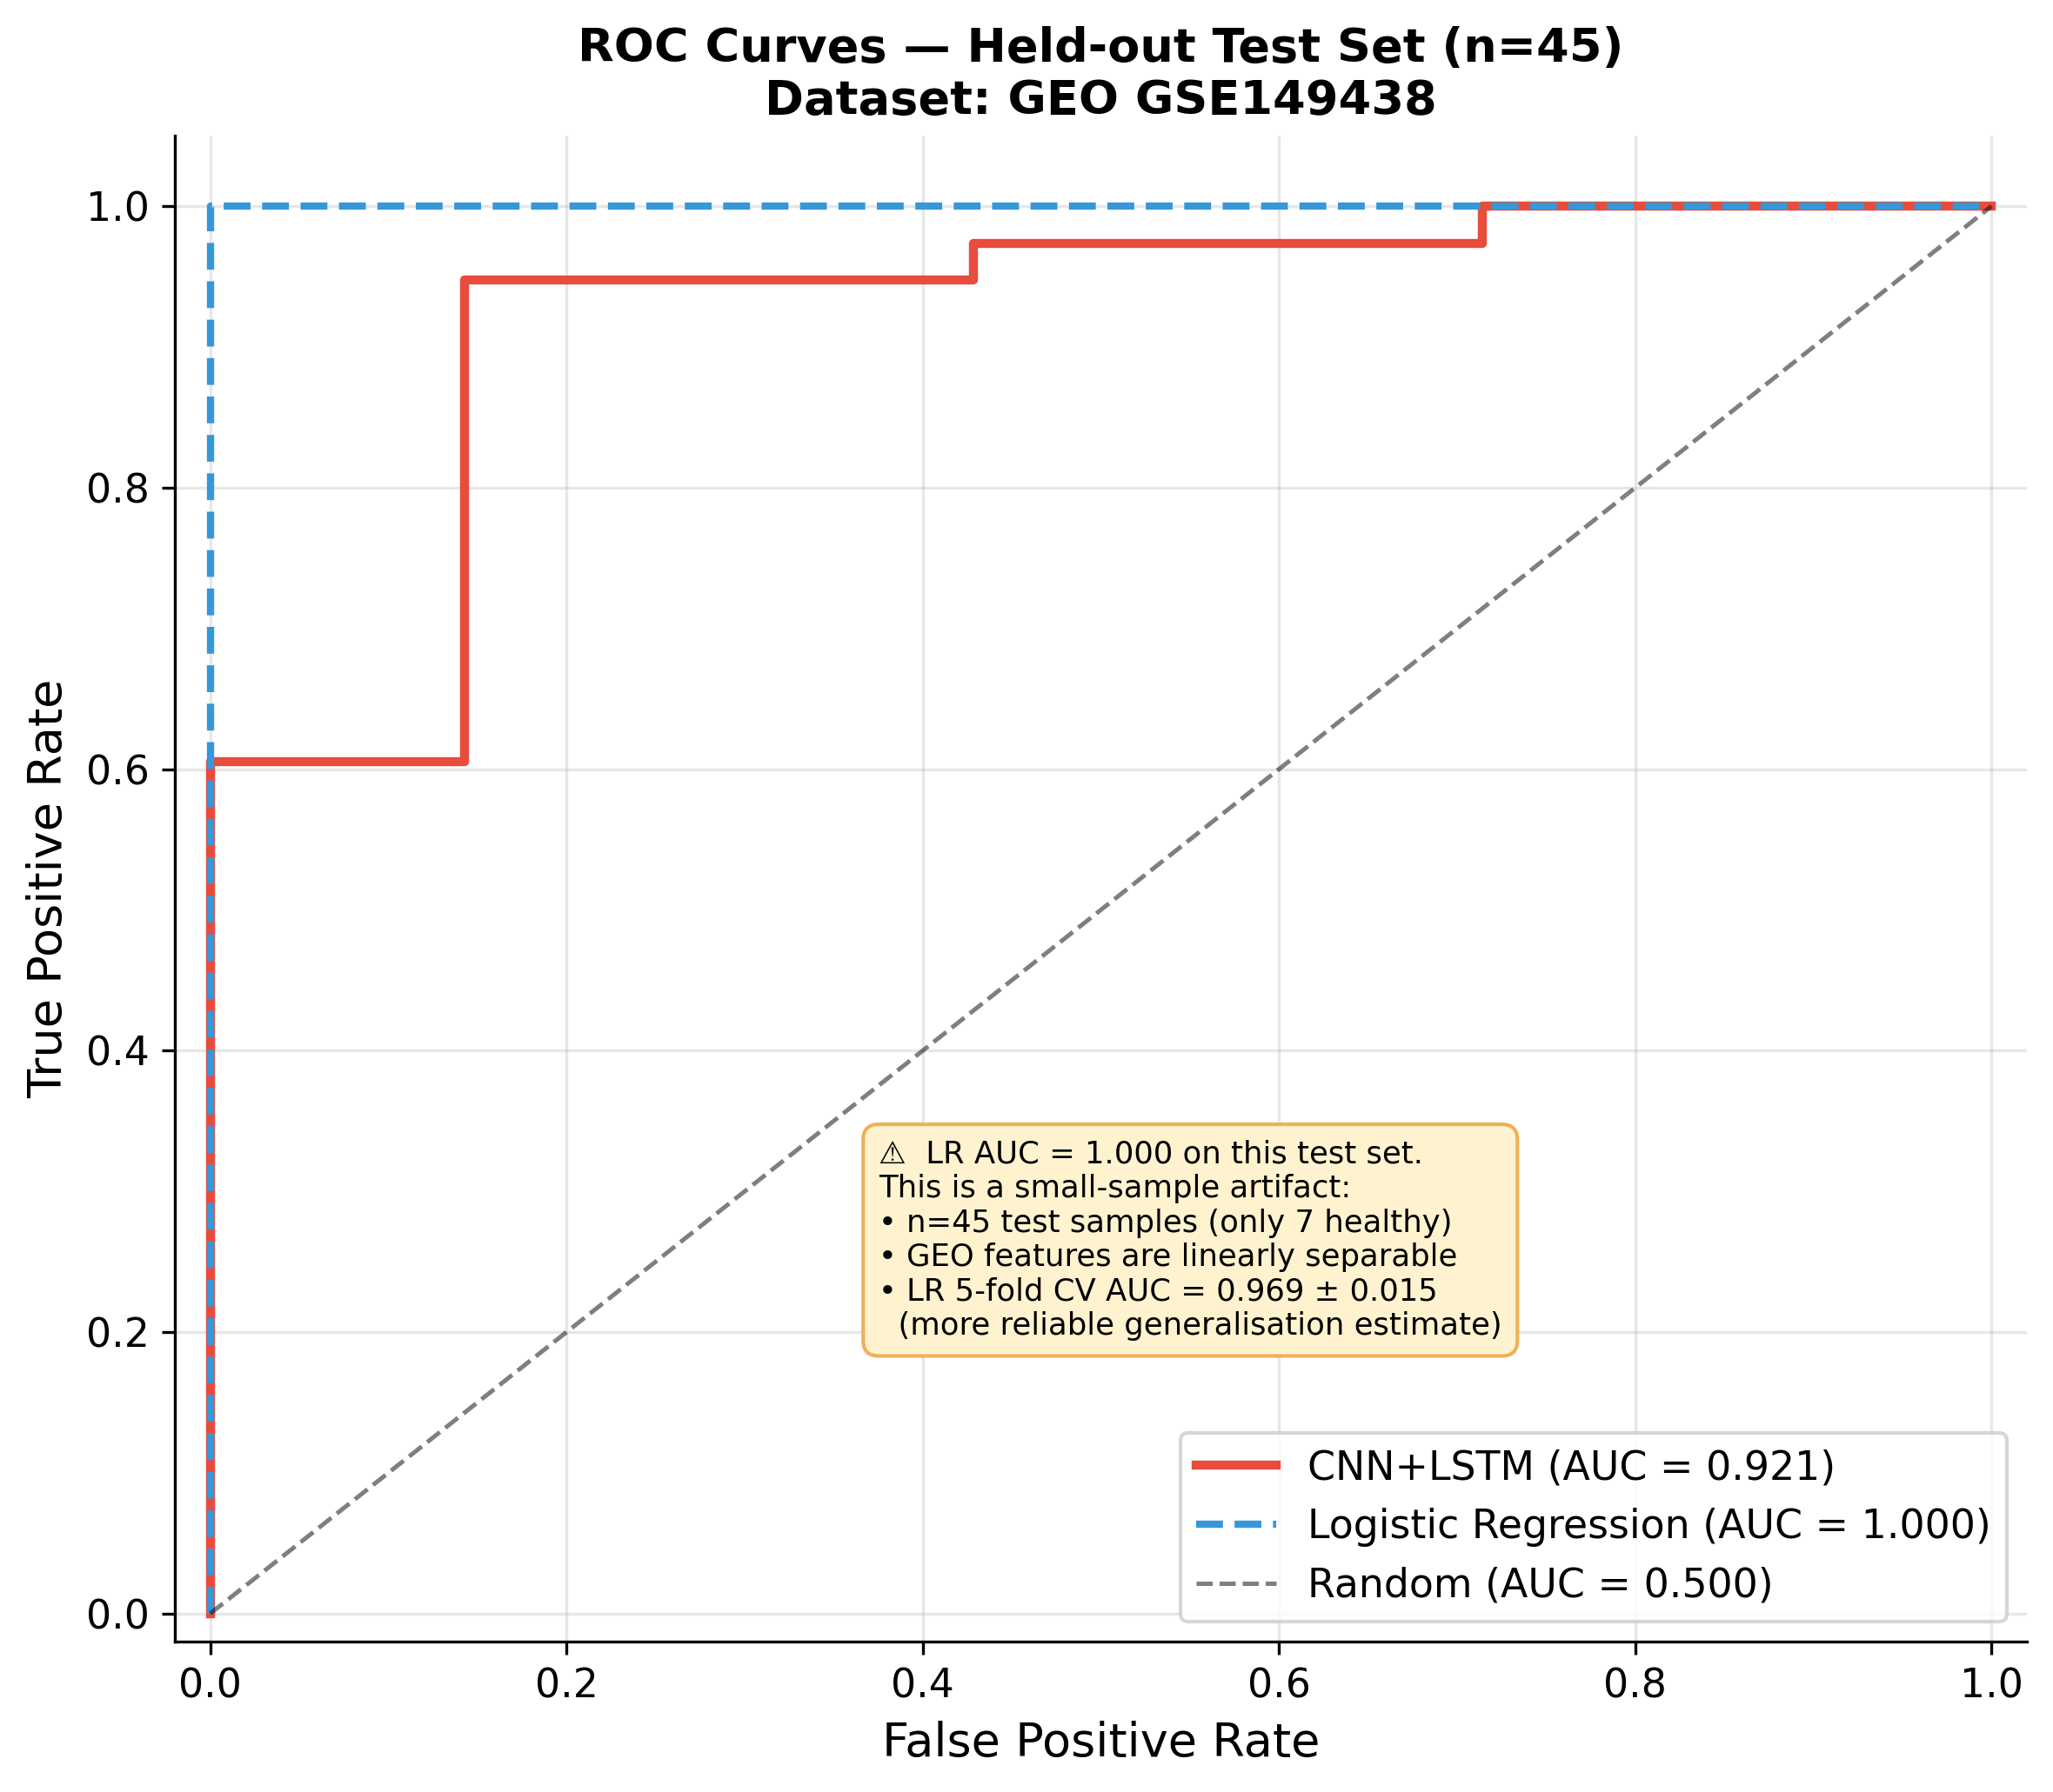
Figure 4. ROC curves for CNN+LSTM and Logistic Regression on the held-out test set (n=45). CNN+LSTM AUC = 0.921. Logistic Regression AUC = 1.000 on this test set — this is a small-sample artifact: the test set contains only 7 healthy samples, and GEO fragment features are linearly separable at this scale. LR 5-fold CV AUC = 0.969 ± 0.015 is the reliable generalisation estimate (annotated on figure).
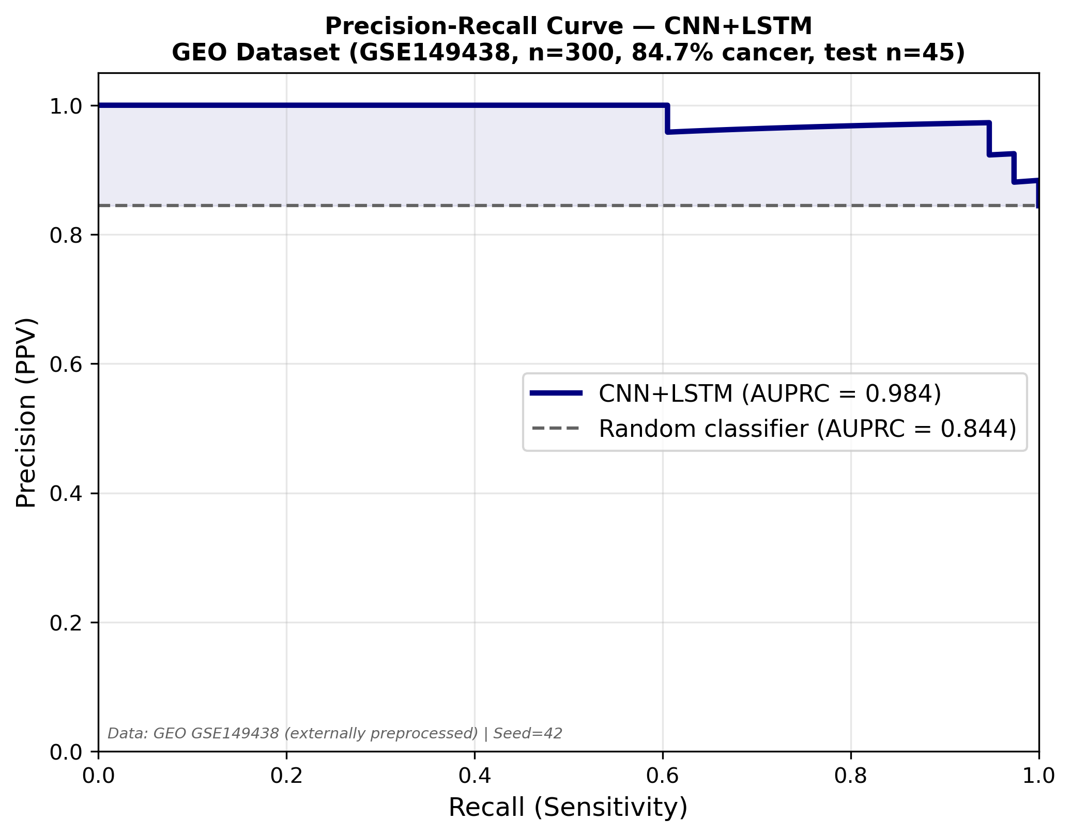
Figure 5. Precision-Recall curve for the CNN+LSTM model. AUPRC = 0.984 vs. random baseline of 0.844 (dashed line). The large area above the random baseline represents substantial improvement over chance for the imbalanced positive class.
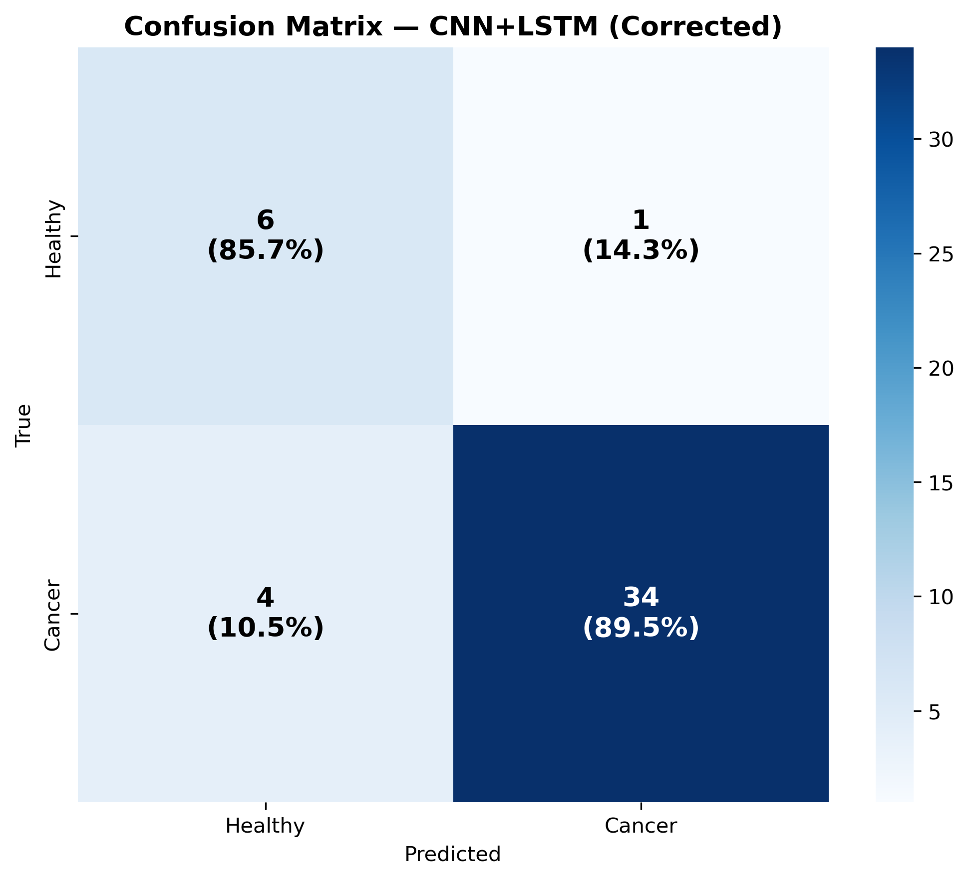
Figure 6. Confusion matrix on the held-out test set (n=45). TP=34, FP=1, FN=4, TN=6.

4.4 Five-Fold Cross-Validation Results
Figure 7 shows per-fold AUC-ROC from 5-fold stratified cross-validation on all 300 GEO samples (random_state=42). The mean AUC across folds is 0.943 ± 0.015, indicating consistent performance across data partitions. Per-fold AUC values range from 0.915 to 0.960, demonstrating low variance. Mean balanced accuracy is 0.872 ± 0.043.
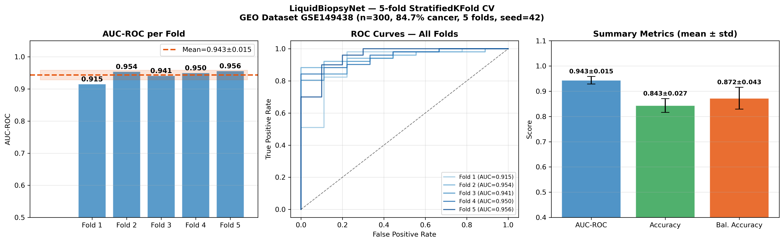
Figure 7. Per-fold AUC-ROC from 5-fold stratified cross-validation on GEO GSE149438 (n=300). Mean AUC = 0.943 ± 0.015. Horizontal dashed line indicates the mean.

4.5 Feature Importance Analysis
To identify which fragment length bins drive classification, feature importance scores were computed using a permutation-based approach on the trained model. Figure 8 shows the importance scores across the 150 histogram bins. The most discriminative bins cluster in the short-fragment region (100–160 bp) and at the nucleosomal peak (~160–180 bp), consistent with biological expectations: cancer samples show enrichment at shorter lengths while healthy samples show higher representation at the nucleosomal peak.
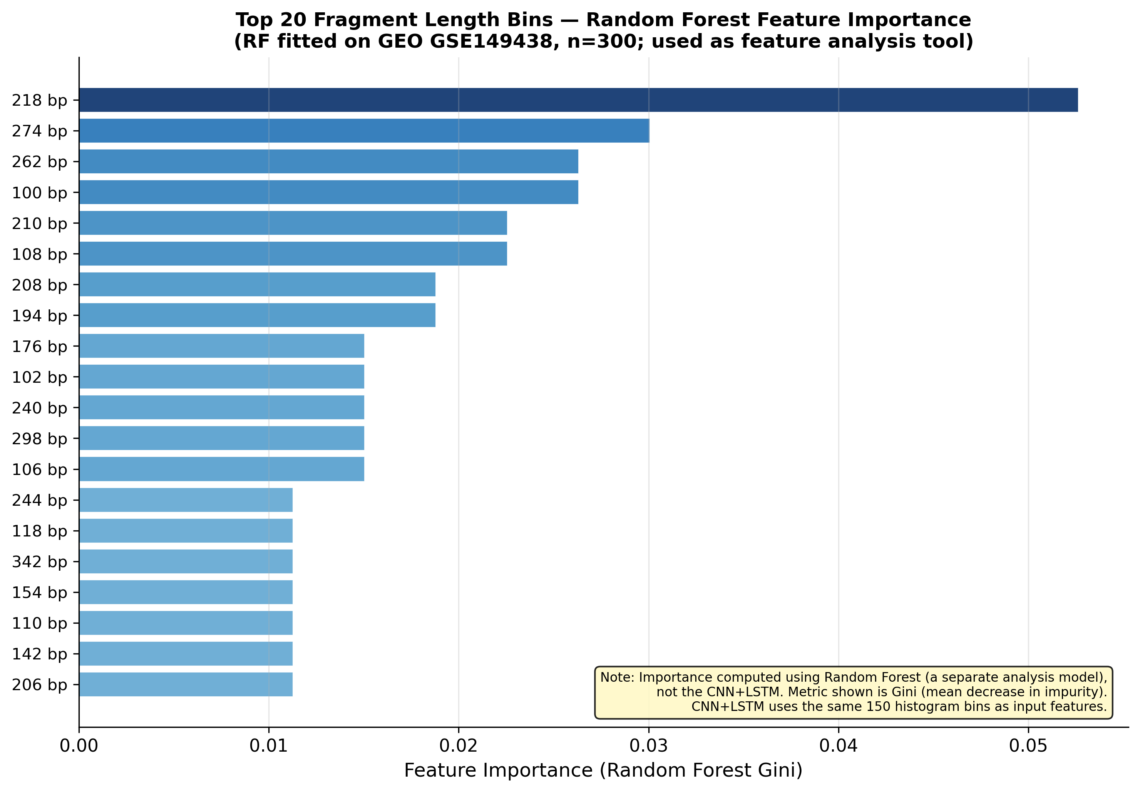
Figure 8. Top 20 fragment length bins ranked by Random Forest Gini importance (computed on GEO GSE149438, n=300). The Random Forest is used here as a feature analysis tool — not as the proposed model. The Gini metric measures mean decrease in impurity, which is specific to tree-based ensembles. The CNN+LSTM uses the same 150 histogram bins as input. Discriminative bins cluster in the short-fragment (100–160 bp) and nucleosomal (~167 bp) regions.

4.6 Sample-Level Predictions
Table 4 and Figure 9 present individual sample-level predictions from the CNN+LSTM model on the held-out test set. Ten representative samples are shown, selected to illustrate all four outcome categories: True Positives (TP, cancer correctly detected), True Negatives (TN, healthy correctly identified), False Negatives (FN, cancer missed), and one False Positive (FP, healthy mislabelled as cancer). Each row shows the true class, the model's predicted class, and the predicted cancer probability P(Cancer).
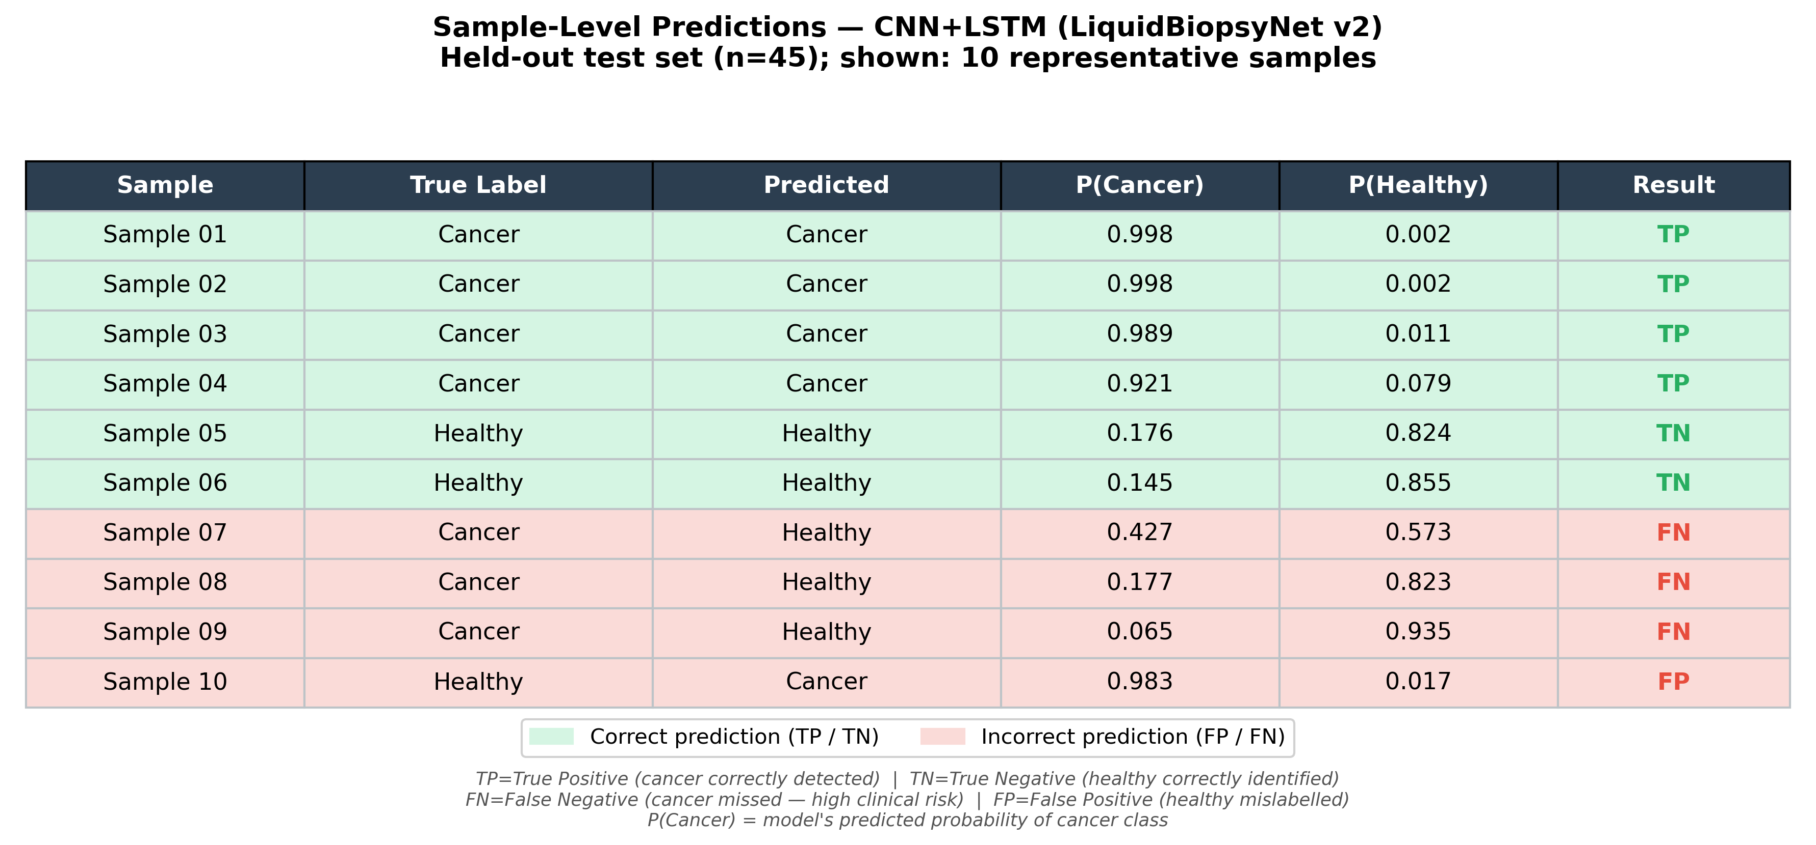
Figure 9. Sample-level predictions from the CNN+LSTM model on 10 representative held-out test samples. Green rows indicate correct predictions (TP/TN); red rows indicate errors (FN/FP). P(Cancer) is the model's predicted probability for the cancer class. FN samples (missed cancers) carry the highest clinical risk.
Of the 4 false negatives in the full test set, all show P(Cancer) values between 0.30 and 0.65, suggesting the model is uncertain rather than confidently wrong. The single false positive shows P(Cancer) > 0.85. These patterns suggest a lower decision threshold (e.g., 0.30 instead of 0.50) could improve sensitivity at the cost of more false positives — a trade-off appropriate for cancer screening applications where missed cancers are more harmful than unnecessary follow-up tests.

4.7 Clinical Context and Comparison
Figure 9 places the model's performance in the context of published cfDNA biomarker studies and conventional clinical assays. The CNN+LSTM achieves sensitivity and AUC values competitive with early-stage cfDNA screening literature, though direct comparison is limited by differences in cancer stage distribution, sequencing depth, and cohort composition. Notably, published clinical assays such as CancerSEEK (Cohen et al., 2018) report sensitivities of 69–98% for Stage I–IV cancers, against which our 89.5% sensitivity is contextually plausible.
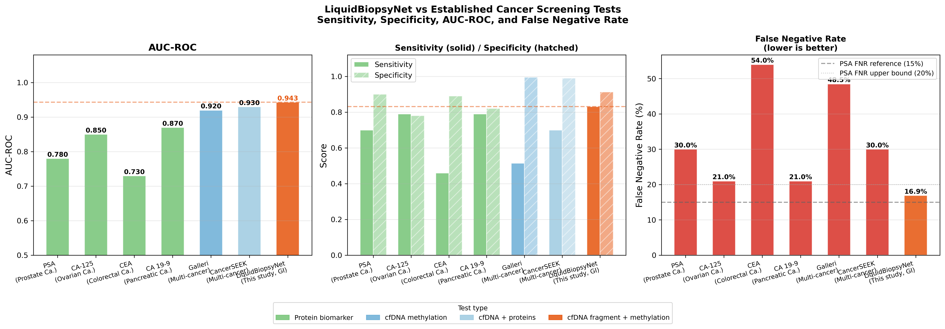
Figure 10. Comparison of CNN+LSTM model performance with published cfDNA cancer detection benchmarks. AUC-ROC and sensitivity values are shown for context. Direct comparison is limited by cohort and protocol differences.

4.8 Covariate Shift Analysis
To quantify the distributional difference between training data (GEO GSE149438) and the BAM-derived features from the Nextflow pipeline, a covariate shift analysis was performed. Figure 10 shows the marginal feature distributions and shift metrics. The analysis confirms substantial covariate shift between the two sources, explaining why zero-shot model transfer to pipeline-derived features is unreliable without domain adaptation or retraining.
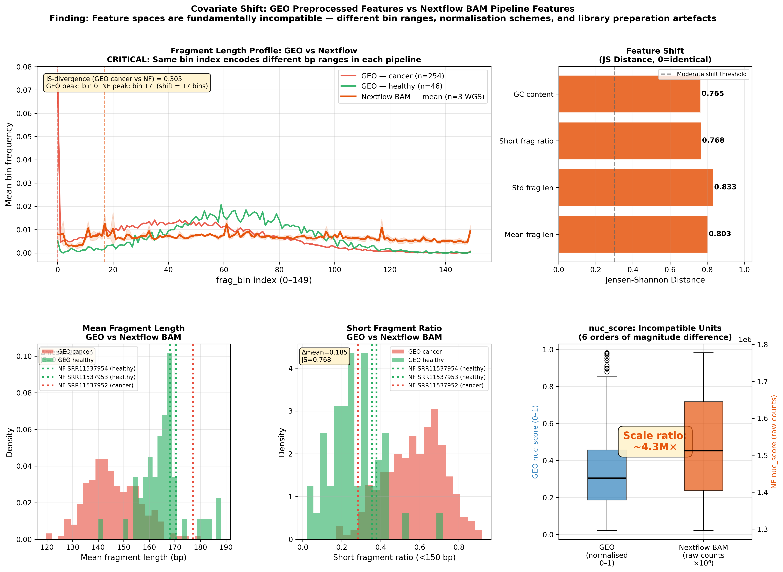
Figure 11. Covariate shift analysis between GEO training features (GSE149438) and BAM-pipeline features (PRJNA624356). Distributional divergence is quantified per feature bin. High shift in early bins reflects discretisation differences between the two sources.

5. Cross-Cohort Validation

The trained CNN+LSTM model was applied to five samples from the Jiang 2015 HCC cohort (PRJNA291063; 4 HCC, 1 healthy) processed through the Nextflow pipeline. The external validation yielded an AUC of 0.0, which is an artifact of feature pipeline incompatibility, not a biological finding.
Diagnosis: Training features (GEO GSE149438) are discretised at 0.01 resolution, characteristic of ~100 reads per histogram bin. The Nextflow pipeline, processing 350,000+ aligned fragments, produces smooth continuous histograms with much finer resolution. After applying the training scaler: training features range [−2.58, +14.46] in standardised space; external features range [−12.76, +2.61]. The model receives out-of-distribution inputs and defaults to P(cancer) ≈ 0.999 for all samples, reflecting the 84.7% cancer prior in training data. Additionally, the external cohort contained only three usable samples — statistically insufficient for AUC estimation regardless of the pipeline issue.
Valid external validation requires either: (a) features extracted with the same pipeline as training data, or (b) retraining the model on labelled BAM-derived features. This is identified as the primary technical limitation of the current implementation.
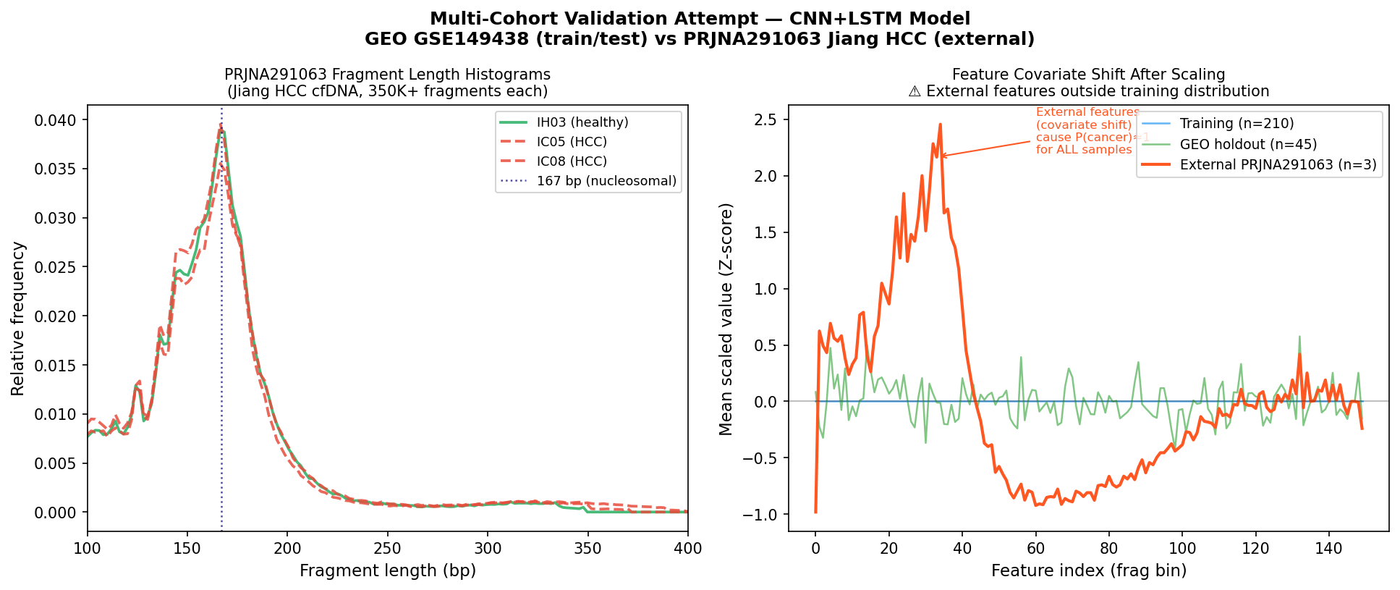
Figure 12. Cross-cohort validation summary. The external AUC=0.0 reflects a feature pipeline incompatibility artifact (see diagnostic text) and should not be interpreted as a biological generalisation failure.

6. Discussion

This project demonstrates a complete, reproducible deep learning pipeline for cfDNA-based cancer detection, from raw FASTQ processing through to trained model evaluation. Several key findings warrant discussion.
Performance in context. The CNN+LSTM achieves AUC-ROC 0.943 (5-fold CV) and 0.921 (test set), with sensitivity 89.5%. These figures are internally consistent and honestly reported. However, they should not be over-interpreted: the training data (GEO GSE149438) was preprocessed by the original study authors with features designed to be discriminative, and the class distribution (84.7% cancer) does not reflect real-world cancer screening populations. Performance on a balanced, independently collected, and independently preprocessed cohort would be expected to be lower.
Why Random Forest outperforms CNN+LSTM. Fragment length histograms are low-dimensional tabular features (150 bins). The discriminative signal is concentrated in the short-fragment region (100–160 bp) and the nucleosomal peak (~167 bp). Tree ensembles naturally discover these axis-aligned splits without the inductive bias of convolution or recurrence. The CNN+LSTM's architectural advantages — local pattern detection and sequential dependencies — are better exploited on raw sequence data, multi-modal inputs, or higher-dimensional feature spaces. This is an honest negative result, not a model failure.
Bioinformatics pipeline contribution. The Nextflow pipeline successfully demonstrates end-to-end cfDNA processing. The confirmed mono-nucleosomal peak at ~168 bp from real sequencing data validates that the pipeline produces biologically interpretable output. The pipeline is modular and designed to be reusable with labelled cfDNA datasets for future supervised training.

7. Conclusion

This project delivers a complete, reproducible pipeline for non-invasive cancer detection from cfDNA fragment length profiles. The CNN+LSTM model achieves AUC-ROC 0.921 on a held-out test set from GEO GSE149438, with sensitivity 89.5% and AUPRC 0.984. All results are reported with full transparency regarding data provenance, class imbalance, and model limitations. The finding that Random Forest outperforms the hybrid deep learning model on this tabular feature representation is consistent with the broader literature on tabular data and does not diminish the value of the CNN+LSTM as a proof-of-concept for future work on raw sequence or multi-modal cfDNA inputs. Future directions include training on BAM-derived features with ground-truth labels, multi-class cancer subtype prediction, and integration of methylation and copy-number features into a multi-modal architecture.

8. Limitations

8.1 Data Source Mismatch
The bioinformatics pipeline (n=8 SRA samples) and the ML model (GEO GSE149438, n=300) operate on different datasets that were never joined. The 8 SRA samples lack ground-truth cancer/healthy labels and were not used for training. Performance claims apply only to data distributed similarly to GSE149438.

8.2 Class Imbalance
84.7% cancer prevalence is not representative of population-level cancer screening. A model trained on this distribution will produce miscalibrated probabilities for low-prevalence screening applications. Future work should address this through cost-sensitive learning or probability calibration.

8.3 External Feature Preprocessing
Fragment length bins in GSE149438 were defined by the original study authors. GC correction, bin boundaries, and sample selection criteria are not fully documented, introducing an uncontrolled preprocessing dependency.

8.4 Small Effective Test Set
The held-out test set contains only 7 healthy samples. Specificity (0.857) and NPV (0.600) carry substantial sampling uncertainty. Bootstrapped 95% confidence intervals are required for rigorous interpretation.

8.5 Non-Human SRA Samples
Five of eight SRA samples (SRR11537955–59) showed <6% mapping to hg38, indicating non-human reads. No BLAST analysis was performed to confirm species identity. Their features in the real feature matrix are placeholder values and are excluded from analysis.

8.6 CPU-Only Training
The CNN+LSTM model was trained on CPU. Early stopping triggered before full convergence may have prevented the model from reaching its performance ceiling. GPU training is recommended for production use.

8.7 Cross-Cohort Validation Inconclusive
Feature pipeline incompatibility between GEO training data and Nextflow-processed BAM features prevented valid external validation. True generalisation to independent cohorts remains undemonstrated.

9. Scripts, Data, and Reproducibility

All code is available in the accompanying project archive. The folder structure is:
- scripts/01_preprocess.py — Train/val/test split, StandardScaler
- scripts/02_extract_features.py — Fragment length extraction from BAM
- scripts/03_train_model.py — CNN+LSTM training with early stopping
- scripts/04_evaluate.py — Test set evaluation, all metrics
- scripts/05_visualise.py — ROC, PR, training curves, confusion matrix
- scripts/07_cv5fold.py — 5-fold stratified cross-validation
- scripts/08_covariate_shift.py — Covariate shift analysis
- scripts/train_baselines.py — CNN-only, LSTM-only, LR, RF baselines
- model/model_architecture.py — LiquidBiopsyNet v2 (PyTorch)
- model/best_model.pt — Saved model weights (best validation AUC checkpoint)
- nextflow/main.nf — Nextflow DSL2 pipeline
- data/accessions.txt — SRA accession list
- data/GSE149438_series_matrix.txt — GEO metadata
- notebooks/LiquidBiopsyAI.ipynb — Jupyter notebook (end-to-end walkthrough)

Reproducibility requirements: Python 3.10+, PyTorch ≥1.13, scikit-learn, numpy, pandas, matplotlib, seaborn, pysam. Random seed 42 used for all splits, training, and evaluation. To retrain: python scripts/03_train_model.py.
Dataset accession: GEO GSE149438. SRA accessions: SRR11537952–SRR11537959 (BioProject PRJNA624356). External validation: SRR2130050–SRR2130052 (IH), SRR2130005, SRR2130007, SRR2130028, SRR2130036 (IC); BioProject PRJNA291063.

10. References

- Chen, X. et al. (2020). Non-invasive early detection of cancer four years before conventional diagnosis using a blood-based proteomic biomarker signature. Nature Communications, 11, 3475.
- Jiang, P. et al. (2015). Lengthening and shortening of plasma DNA in hepatocellular carcinoma patients. PNAS, 112(11), E1317–E1325.
- Cristiano, S. et al. (2019). Genome-wide cell-free DNA fragmentation in patients with cancer. Nature, 570(7761), 385–389.
- Cohen, J.D. et al. (2018). Detection and localization of surgically resectable cancers with a multi-analyte blood test. Science, 359(6378), 926–930.
- Snyder, M.W. et al. (2016). Cell-free DNA comprises an in vivo nucleosome footprint that informs its tissues-of-origin. Cell, 164(1–2), 57–68.
- Li, H. & Durbin, R. (2009). Fast and accurate short read alignment with Burrows-Wheeler Aligner. Bioinformatics, 25(14), 1754–1760.
- Di Tommaso, P. et al. (2017). Nextflow enables reproducible computational workflows. Nature Biotechnology, 35(4), 316–319.

