**ISIT207 Frontend Web Programming**

**Assignment 3**

Nicodemus Seet

Tutorial Group – T01

UOWID – 7894880

**Deliverables**

|  |  |
| --- | --- |
| **Item** | **URL** |
| Website | https://nseet095.github.io/ISIT207/ |
| Video Recording | https://drive.google.com/file/d/1UBzSIHq8DFE1Cb_WKgIwaUnEtHO6nXs2/view |
| Source Files | https://drive.google.com/file/d/13ciFgS4wHhSEB3hmfw8zqkxBOnmSOgwA/view |

**Web Design Considerations**

* To advertise the company’s brand name and its image is being represented through the website
* To ensure that website navigation by the customer is clear and logical.
* Ensure that the customer has an easy-to-use interface and layout to reserve, pick up and return a car
* To make the website responsive so that the customer can feel engaged

**Appendix**

|  |  |  |
| --- | --- | --- |
| **Item** | **Description** | **Source** |
| Logo |  | Generated by https://app.logo.com/ |
| Font | Open Sans | https://fonts.google.com/specimen/Open+Sans |

Screenshots:

**Homepage**

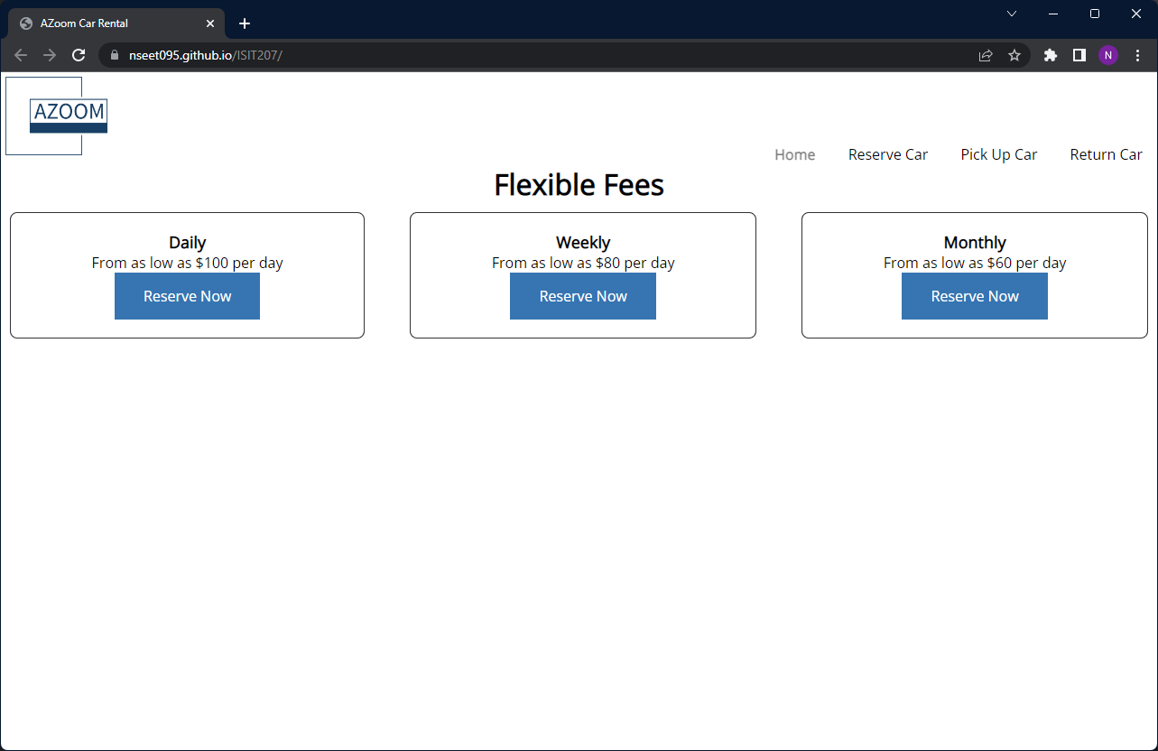

**Reserve Car**

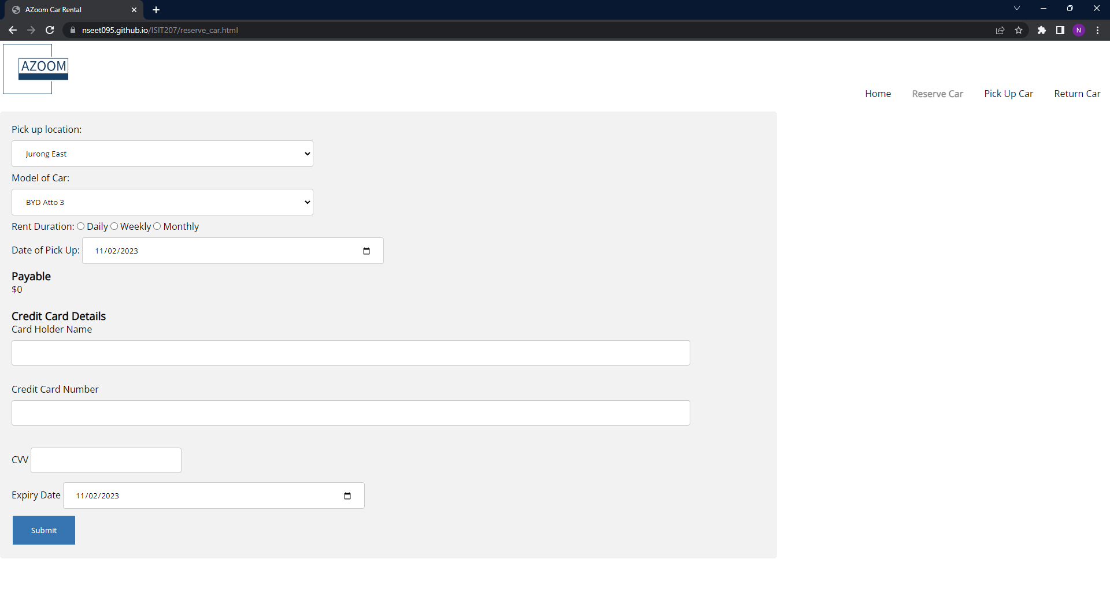

**Car Pickup**

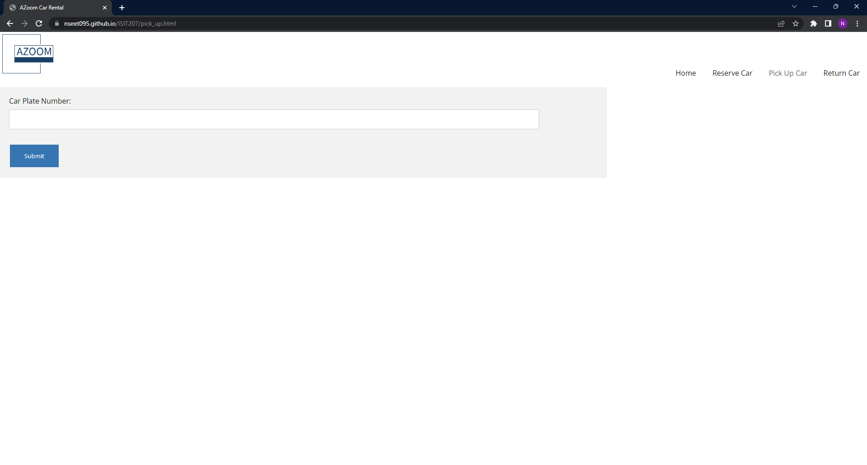

**Car Return**