NSEKETELOSUCCESS MASWANGANYE
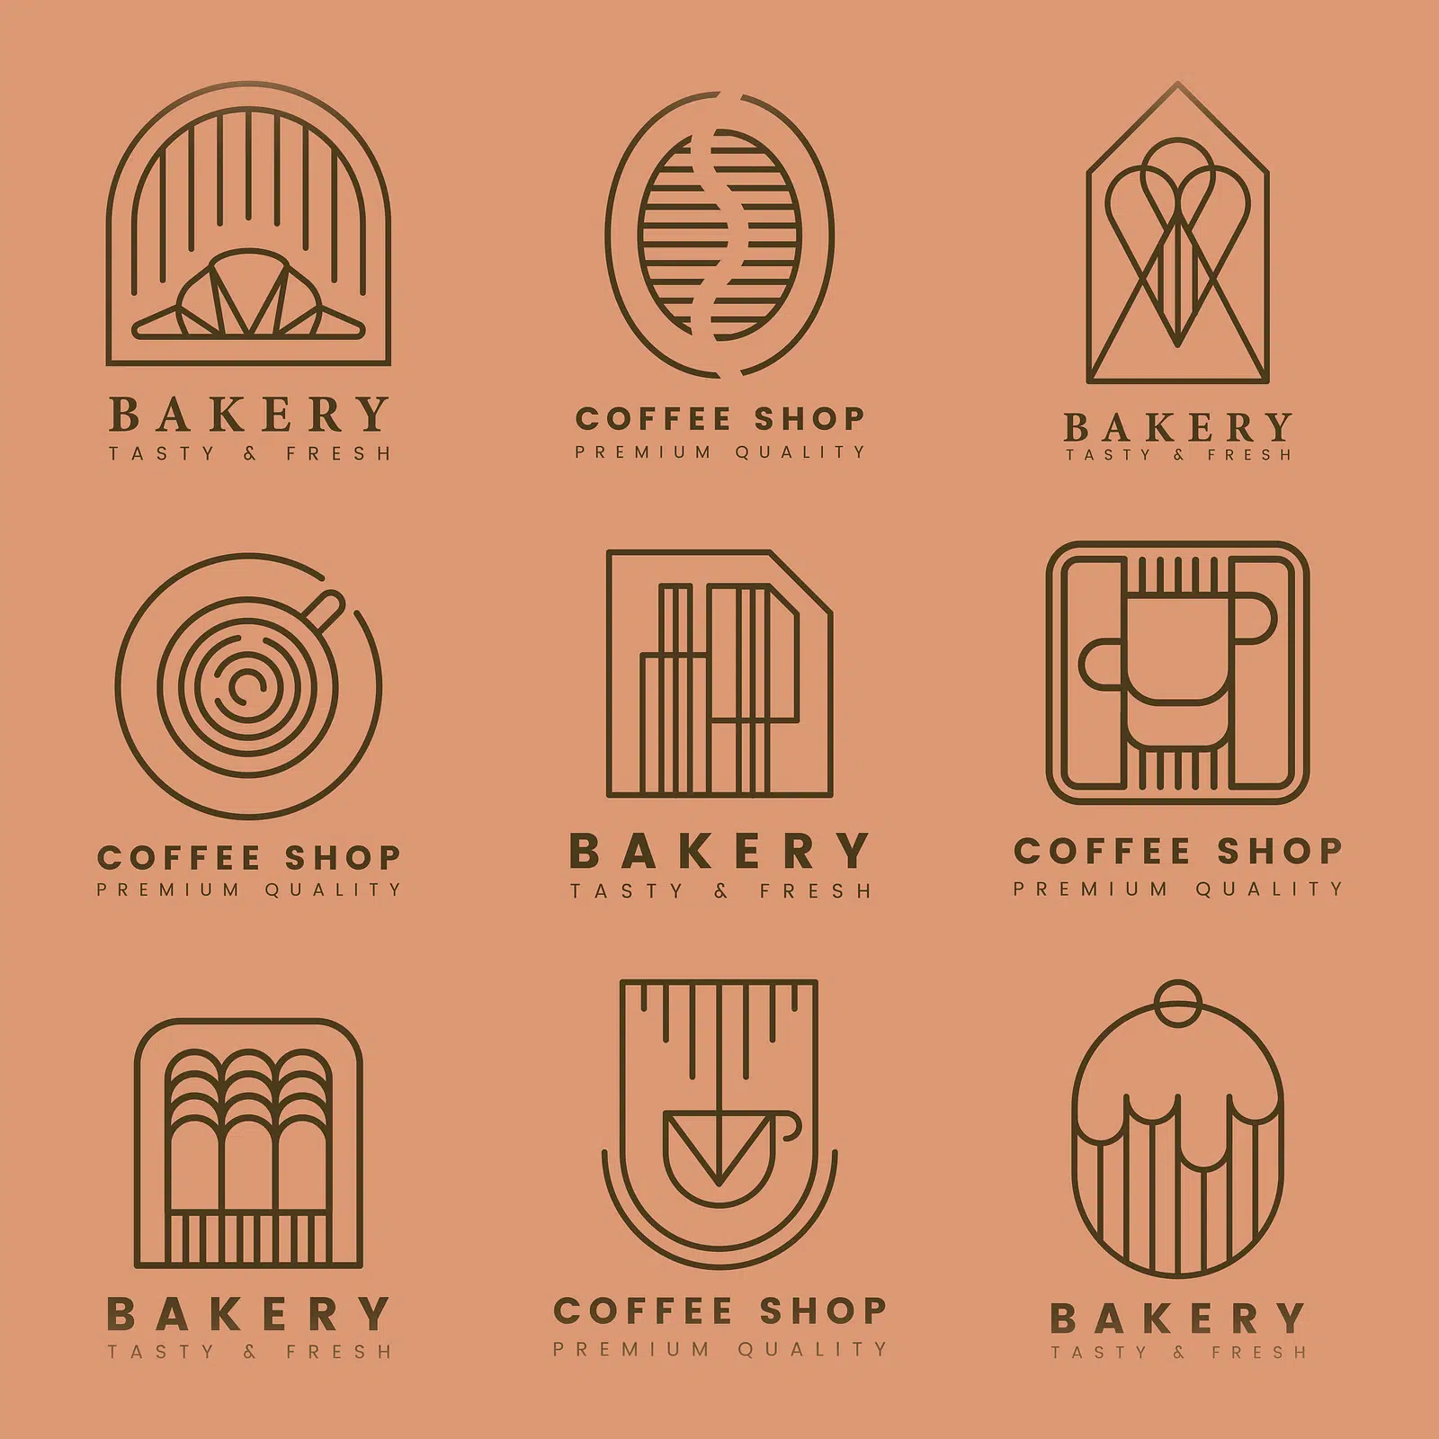  jo’s BAKERY | Current Website Analysis Currently Jo's Bakery does not have an existing website. Strength: None. Weakness: No online presence cannot take online enquiries, limited reach to customers outside store vicinity. Opportunity: A new website will give 24/7 access to products and contact info.

# WEBSITE DEVELOPMENT PROPOSAL FOR JO'S BAKERY

1. Introduction and Organisation Overview

Jo's Bakery is a small local business specializing in the baking and selling of fresh, delicious and affordable baked products such as cakes, cupcakes, pies, pastries and bread. The objective of Jo's Bakery is to offer high-quality baked goods at fair and reasonable price to individual, families and organizations, whilst also offering excellent customer service. At present, word-of-mouth and store front marketing are the primary advertising methods. These forms of advertisement are useful for customers within the vicinity of the store, yet it does not provide a method for customers who are seeking more online information about the bakery. Development of a professional website will therefore enable Jo's Bakery to acquire a marketing and communication platform online that allows easy interaction and communication between customers and the business. Customers will be able to acquire useful information about the business, its products and services, store hours and contact information. The mission of Jo's Bakery is to make tasty reasonably priced freshly baked cakes and other baked goods along with a top-class customer service. The vision of Jo's Bakery is to build enduring trust and good reputation by delivering continuously good customer relationship and fine fresh and quality cakes, breads and other baked goods.

2. Background and Problem Statement
Many people search for local businesses, products and services online before making a purchase. Jo's Bakery has very little online exposure as much of the current marketing depends on word-of-mouth and advertisement based on store front sales. This implies that some of the potential customers might not have access to, nor are aware of the products and services provided at Jo's Bakery. Visitors might not be aware of, or find it inconvenient, to get information regarding their cakes, products, services, address and operating hours from the business itself. The key problem to be solved by this project is: "lack of a readily available, central online platform for customers to find information on Jo's Bakery products and services" Developing a website will provide the business with an online footprint, allow for communication with customers, give access for customers to browse products, make product enquires and request quotes for custom cake requests. It will allow them to refer new customers to the business through recommendations on the website to their family and friends.
3. Aim of the Project
The primary goal of this project is to design and develop a professional and easy-to-use and informative and responsive website for Jo's Bakery. The website will function as a marketing and communication tool, enabling customers to receive information on Jo's Bakery, without requiring them to be physically present. Customers will be able to learn more about the business and its products/services, view the wide range of cakes and specialized products offered, submit product orders and custom cake enquiry forms and all contact details. The website should focus on good usability, clear navigation, appropriate content, good design and functionality and responsive design. The basic digital footprint will provide Jo's Bakery with an online presence which can later be built on as the business grows.

4. Website Goals and Objectives

The main goal of the website is to provide the bakery with an online platform that is both professional and easy-to-use and where customers can find any relevant information they require. The website will enhance the bakery's online profile and allow customers to easily find out details about the bakery and their products. It will also provide customers with an online contact form, for submitting enquiries for all their product orders and custom cake requests. One important aspect for this website is that it needs to be responsive across all different types of devises being used, from the latest desktops all the way through to the smallest mobile devices. Jo's Bakery's products (cakes, other baked goods) should be displayed clearly and information organized in an easy to access format. Essential details such as Jo's Bakery's physical address, phone number, email address and store operating hours should readily be available, and the bakery's story should be accessible for potential customers to learn from. Customers should also be able to refer their friends and family to the bakery online. The main performance indicators being looked at are visitors to the website and customer engagement originating from the website.

5. Target Audience
The audience of the website will consist of current customers of Jo's Bakery, potential customers, individuals, families and businesses and members of the local community interested in bakery services. The website will cater to people with a wide range of varying abilities to operate computer systems, so the website navigation and content will be easy and simple to understand. A customer wanting an online service to find out about cakes, cupcakes, breads, pies, pastries, birthday and custom cakes, or catering may find Jo's Bakery useful. The website will be built in a way that it caters to various devices. Responsive web design principles will therefore be applied, so that website information can be viewed by users on desktops, laptops, tablets and smartphones.

6. Proposed Website Features and Functionality

The website will consist of a minimum of five pages which can be linked from each other through the navigation menu. These pages should consist of a Home, About Us, Products/Services, Enquiries and Contact page.

The Home page will aim to be a welcoming introduction into Jo's Bakery and will highlight some of its most popular items and also include a strong call to action for visitors of the site. It will contain the business's logo, a welcoming message of "Welcome to Jo's Bakery! Freshly Baked Goods Every Day." and a brief intro into the bakery, accompanied by a link to all the other sections of the site. The About Us page will contain information on how the business first came to be, what the aim of the business is, who owns the business, what its values and vision, and of course what their mission is toward the public as well as customer service and high-quality baked goods. The Products/Services page will show the range of products/services Jo's Bakery has to offer, such as freshly baked breads, cakes, cupcakes, pastries, birthday and custom cakes, and catering. Some pictures or images of the cakes and various specialties would be useful along with a description on the different options available. The Enquiries page would need to contain an interactive form to allow visitors of the website to send product and custom cake enquiries. This enquiry form may require details such as, the customer's name, email address, phone number and their comment or enquire subject/message. The Contact page will provide all the necessary contact information for Jo's Bakery including physical address, map, telephone number, email address and opening hours.
7. Design and User Experience
Our website will utilize a warm, welcoming, inviting colour scheme in colours related to our bakery including cream, which is friendly, approachable and makes for a visually pleasing site. The Design Our design will be clean and professional, using headings to create organisation as well as a clean, readable font so visitors can consume the website content with no strain. Where needed to aid and give our customers a vivid sight of what our delights entail use the use of imagery to add flavour to our online display of goods as well as cakes, bread etc and much more. The navigation and website elements We will use elements such as buttons, forms, and navigation menus which we will create a uniform style for the overall design of the site. Navigation will maintain consistency across all pages of our site so our customers can experience smooth, simple, yet seamless navigation of our site. With responsive design we are offering our site to suit and fit any size device on screen at any one-time including laptops, desk top computers, mobile devices as well as tables. This allows customers a seamless experience regardless of device type. Overall User experiences the overall user experience will encompass simplify, ease of access, clearness, simplicity, to enable customers to find that something special of they have been hoping to discover on our site.
8. Technical Requirements
Our development environment for the website shall be of visual studio Code to develop the website in use of HTML, CSS and JavaScript. HTML to structure and construct both visual aspect of our website the content which will contain pages such as “index”, “services”, “about”, “enquires” and “contact” as listed below, respectively: 1.index.html.
2.services.html.
3. About.html.
4. Enquires.html.
5.contact.html CSS to control how our website looks (the display of colours, type of writing (font), spacing, and even arrange our pages with specific images etc.). HTML, CSS will primarily define and dictate the appearance of our entire website and JavaScript we’ll implement should we find we have a need for any extra, optional and sometimes interactive form, button and other aspects to further aid and improve on its user interface.
6. Images The use of photographs, including the Jo's Bakery logo will feature prominently and all will be clearly displayed, under their separate sub heading that would represent and clearly categorize them under a relevant. This all we store in one Folder named Images to streamline organization.
7. GitHub management All of our website shall be stored in and contained within our project. We’d make sure that all our individual work is committed and stored on GitHub on a Private Repository for project storage, management and submissions,
8. JavaScript may be optional when developing as it not always used.
9. Site Navigation and Usability The navigation is consistently displayed on all pages to enable seamless browsing. Responsive design principles will be utilized so website adapt itself for optimal viewing across different devices and screen sizes i.e. Desktops, laptops, tablets and smart phones. Usability principles guiding this website: easy to navigate, access friendly information, well organized and customer-friendly website.

10. Technical Requirements Software Development Tools and Languages visual studio code IDE - This will be the integrated environment for all website development (front-end development).html, css and JavaScript – these three languages/protocols will form the backbone of the website. Html is for structure, layout and design elements, html tags are used to structure HTML document in blocks of HTML code. They structure elements with basic structure in a website and also to make a HTML a valid document by use HTML validation and other measures CSS is for design and appearance to control what you do to that structure html it is used to format the web page layout i.e. Colour scheme, layout structure, typeface….). Java script is for add functionality and interactivity to create or to run simple actions to the website it will not be used in this website as it requires only front-end web-development and not dynamic scripting, if java script is needed for dynamic effects and popups it will be applied as applicable. The html codes used will all conform to standards set by (w3) World Wide Web Consortium. Source Images will be stored in folders to help in the proper arrangement of the project files, and all image references will correspond to proper links to those image files. HTML folder will contain all html files (.html). CSS folder will contain all cascading style sheets (.css). Image Folder (Images) will contain all images for use throughout the website (jpg, png and jpeg files). HTML Files to be developed, 9. Site Navigation and Usability The navigation is consistently displayed on all pages to enable seamless browsing. Responsive design principles will be utilized so website adapt itself for optimal viewing across different devices and screen sizes i.e. Desktops, laptops, tablets and smart phones. Usability principles guiding this website: easy to navigate, access friendly information, well organized and customer-friendly website. 10. Website Content Sourcing & Research To generate the content to the website I will ensure that it accurately portrays information that is relevant to the company ‘Jo’s bakery’ to provide visitors and potential customers with details. I will research information regarding Jo’s bakery on other local bakery websites to obtain insight to what a standard bakery website could consist of in terms of functionality and appearance and consider their layout and content structure as guidance, html coding and how their responsive designs adapt to the users’ screen sizes, to gain a clear understanding for the Jo’s bakery bakery website I will investigate some of the existing bakeries websites. World Wide Web Consortium (W3C) to obtain information to how to develop websites correctly including html and css standards for good structure and layout; Javascrit.org website for scripting related advice. All the information I gather will be put in to one folder, “research”; and then zipped file. A word document describing what each file type is, why html, CSS, JavaScript have been chose as languages for development will be completed. A compressed Zipped folder called POE folder will be formed including all research papers and the zipped research will be compressed again in a Zipped format for example Zip. All images will have alt tags to describe each image content for website access ability.
11. Version control
GitHub After initial code, HTML files, and basic CSS styling for the Jo’s Bakery website structure are complete, the project code and structure will be uploaded to the GitHub repository to facilitate version control and collaboration. Regular commits will be made with descriptive messages to document the progress of development and specific changes. This will aid in managing the project effectively, tracking changes made over time, and allowing for reversion to previous versions if necessary. The GitHub repository link will be a required deliverable for the Project of Electronic Work. Repository link: (Provide a space here to indicate where the GH repo will be hosted for submission)
12. Testing and Quality Assurance
Before the final submission the website will be tested thoroughly to ensure functionality and user experience. Testing activities will include i. Validating and rendering on different browsers: - Chrome – Firefox
ii. Content testing to ensure all information provided is accurate, legible, and professionally written.
Iii. Image verification to ensure they load correctly, display without distortion and have appropriate alt attributes.
Iv. Navigation testing: to ensure all links are working, leading to the correct pages, and are easily accessible. V. Responsive design testing to evaluate website appearance and functionality across a range of device types and screen resolutions.
Vii. Cross-platform testing to check the performance and experience on both desktop and mobile platforms.
Viii. Html validation.
Ix. Error checking (e.g. Broken links, console errors, script errors). 13. Budget and Timeline The total cost associated with maintaining the website will be the sum of annual domain name registration and website hosting costs, estimated at a combined total of R1500 per year. The development of the website will be carried out as a school project, and therefore, there will be no direct financial expenditure for its creation. The development process is divided into key phases as outlined below: 1.

13.Planning and research; and sitemap design for the website of bakery.
1. HTML Document Creation: Building the foundation of each page.
2. CSS Styling Development: Enhancing the website's aesthetic and layout.
3. Testing & Refinement.
4. Completion of documentation for presentation as part of the Project Electronic Work (POE).
14. Project Outcomes Upon completion, the Jo's Bakery website project will deliver a polished, user-friendly, and professionally designed digital presence. The key outcomes will be a fully functional and responsive website encompassing: • Home page – displaying basic business introduction.
• Services or Products Page – listing detailed information about bakery’s offerings.
• About us page – providing business information. • Contact and enquiry page – facilitating customer interaction and leads. • Seamless navigation across all pages. • Optimized responsiveness for optimal display on various devices and screen resolutions.
• Well-structured HTML, CSS, and JavaScript code organised into dedicated folders (HTML, CSS, Images, Script if applied).
• A documented development process managed via the GitHub repository. • A downloadable Zipped folder of sourced content and research. The completed project will provide Jo's Bakery with a foundational online platform that meets industry standards, enhance its credibility and reach to a broader audience, and set the stage for future online growth.

15. Conclusion
In conclusion, this project proposal outlines a comprehensive plan for creating an efficient, user-friendly, and aesthetically pleasing website for Jo's Bakery. The proposed website will significantly enhance the bakery's online presence, enabling customers to easily access relevant information and engage with the business. By adhering to best practices in web development, utilizing appropriate technologies (HTML, CSS, JavaScript), and ensuring responsive design, the website will cater to a wide audience across various devices. The meticulous plan for research, content sourcing, development, version control (GitHub), and rigorous testing will ensure a high-quality and professional final product. With a clear timeline and budget defined, this project aims to deliver valuable digital assets to Jo's Bakery and contribute to its overall success and growth in the competitive food industry.
16. References
W3C. (2026). HTML & CSS Standards. https://www.w3.org
Pexels. (2026). Stock Images for Bakery. https://www.pexels.com
Competitor Research: [Name 2 local bakery websites you looked at]

