**Screenshot 1: Circuits ~ Test Case One – Circuit One**

Parallel Circuit 1 resistance: 100.0 Ohms

1/100.0 = 0.01 (More detailed calculations on page(s) 4-5)

Serial Circuit 2 resistance: 100.0 + 200.0 = 300.0 Ohms

1/300.0 = 0.003333333

Combined complex circuit resistance: 75.00 Ohms

0.01 + 0.003333333 = 0.013333333 🡪 1/0.013333333 = 75.00

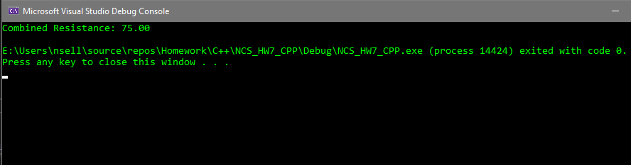

Circuit Model:



**Screenshot 2: Circuits ~ Test Case Two – Circuit Two**

Serial Circuit 1 resistance: 300.0 + 450.0 = 750.0 Ohms

1/750.0 = 0.001333333

Parallel Circuit 2 resistance: 275.0, 125.0 = 85.94 Ohms

(1/275.0 = 0.003636364) + (1/125.0 = 0.008) = 1/0.011636364 = 85.94

Combined complex circuit resistance: 835.94 Ohms

750.0 + 85.94 = 835.94

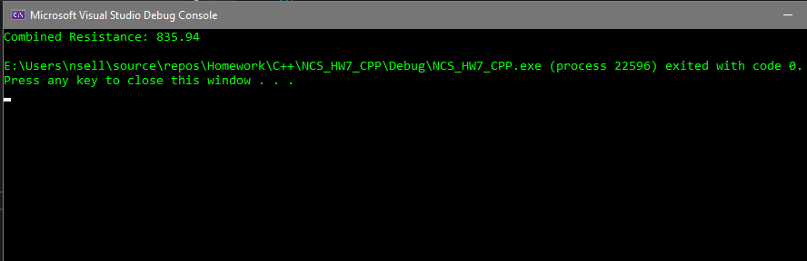

Circuit Model:

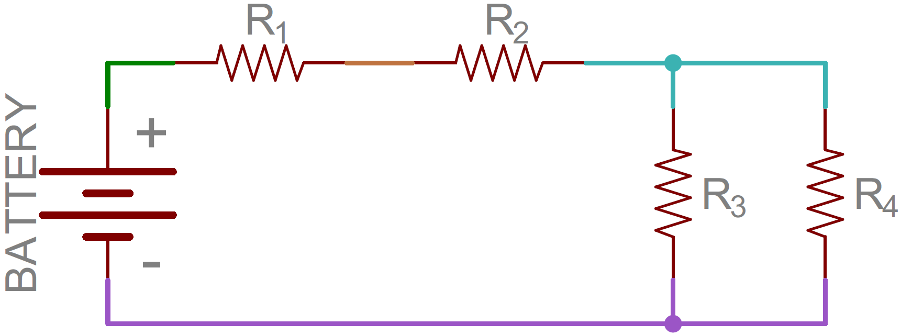

**Screenshots 7-9: Circuits ~ Test Case Three – Circuit Three**

Parallel Circuit 1 resistance: 25.72, 31.41

(1/25.72 = 0.038880249) + (1/31.41 = 0.031836995) = 1/0.070717243

Parallel Circuit 2 resistance: 112.58, 87.98

(1/112.58 = 0.008882572) + (1/87.98 = 0.01136622) = 1/0.020248792

Combined complex circuit resistance: 10.99 Ohms

1/0.090966035 = 10.99

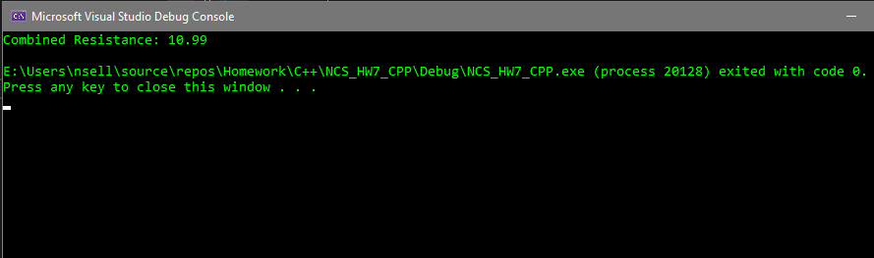

Circuit Model:

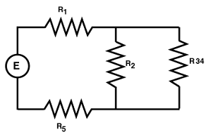

**Resistance Calculations:**

Serial Resistance – Test Case 1 Example

Rtotal = R1 + R2 + R3 and so on.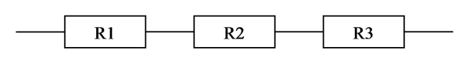

Rtotal = R1 + R2 + R3

= 100 + 100 + 200 Ohms

= 400 Ohms

Parallel Resistance – Test Case 1 Example

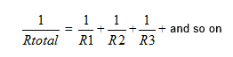

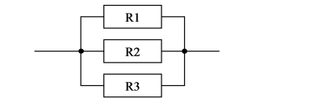

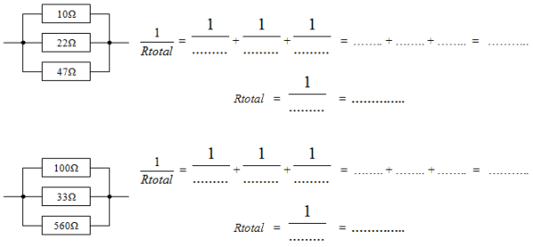

= 1/100 + 1/100 + 1/200 = 0.01 + 0.01 + 0.005 + 0.025 Ohms

Rtotal = 1/0.025 = 40 Ohms

**Both Serial and Parallel:**

Combined Resistance – test case 1 example

Parallel is 100 Ohms

Serial is 100 and 200 Ohms

* 1/100 + 100 + 200 = 1/100 + 1/300
* 0.01 + 0.0033 = 1/0.0130 ≈ 75 Ohms