**Code Test Cases: Complex Circuits**

**Screenshot 1: Test Case 1 – code from assignment**

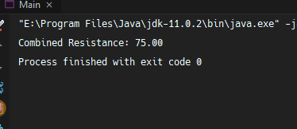

Circuit1 resistance calculated above.

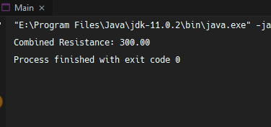

Circuit2 resistance calculated above.

Circuit Model:



**Screenshot 2: Test Case 2 – other code example**

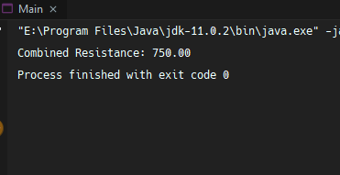

Serial circuit1 (R1 & R2) resistance calculated above.

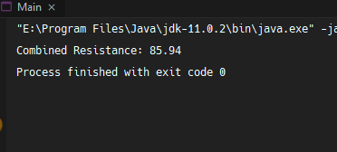

Parallel circuit2 (R3 & R4) resistance calculated above.

Circuit Model:

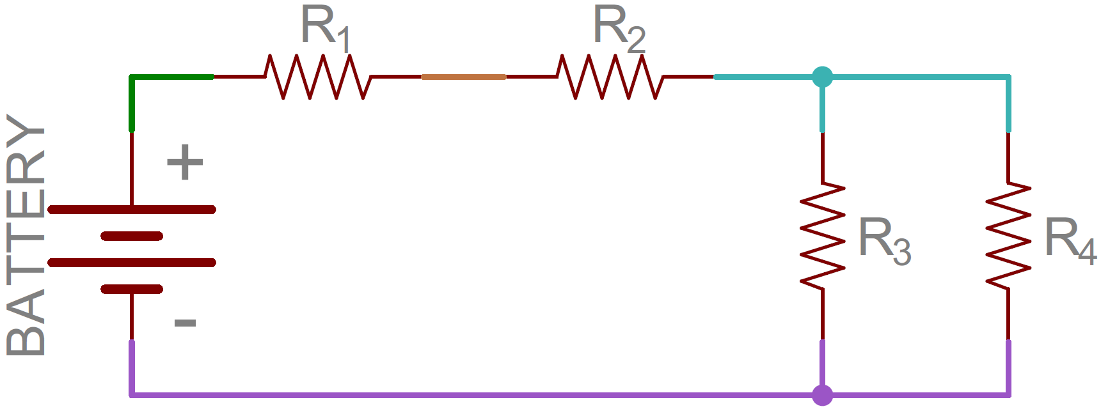

**Screenshot 3: Test Case 3 – another code example**

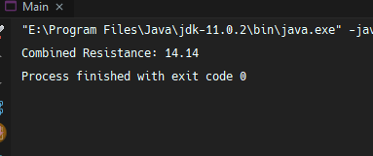

Parallel circuit1 (R1 & R5) resistance calculated above.

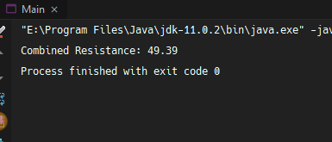

Parallel circuit2 (R2 & R34) resistance calculated above.

Circuit Model:

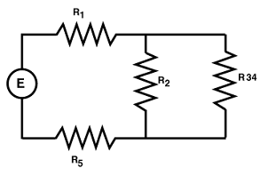

**Resistance Calculations:**

Serial Resistance – test case 1 example

Rtotal = R1 + R2 + R3 and so on.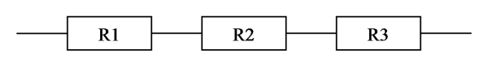

Rtotal = R1 + R2 + R3

= 100 + 100 + 200 Ohms

= 400 Ohms

Parallel Resistance – test case 1 example

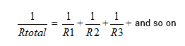

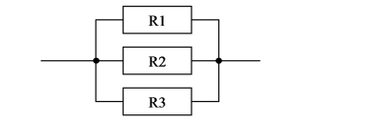

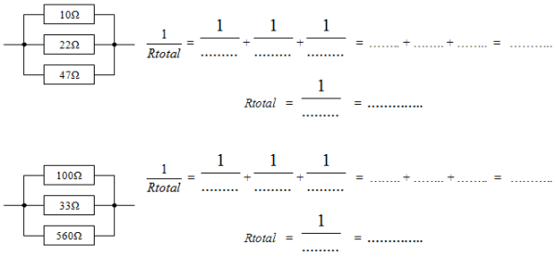

= 1/100 + 1/100 + 1/200 = 0.01 + 0.01 + 0.005 + 0.025 Ohms

Rtotal = 1/0.025 = 40 Ohms

**Both Serial and Parallel:**

Combined Resistance – test case 1 example

Parallel is 100 Ohms

Serial is 100 and 200 Ohms

* 1/100 + 100 + 200 = 1/100 + 1/300
* 0.01 + 0.0033 = 1/0.0130 ≈ 75 Ohms