**Screenshot 1: Complex Numbers ~ Form Start**

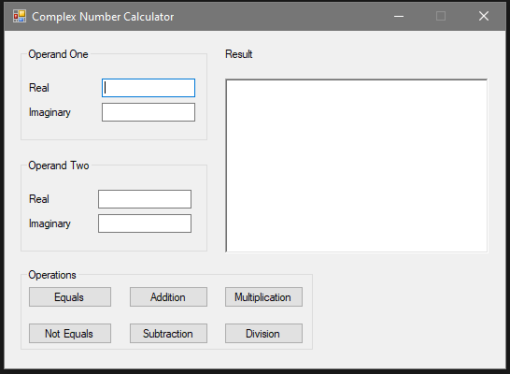

**Screenshots 2-7: Complex Numbers ~ Data Validation**

Operand One: (Left blank)

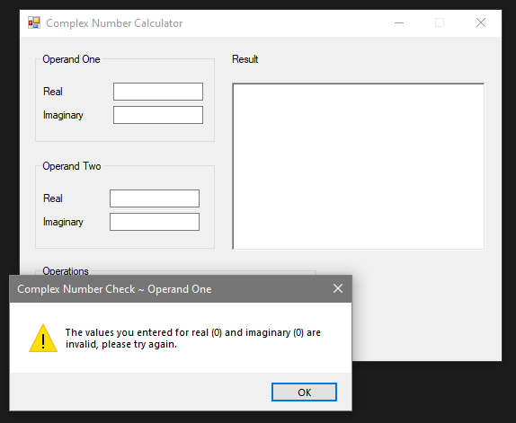

Operand Two: (Left blank)

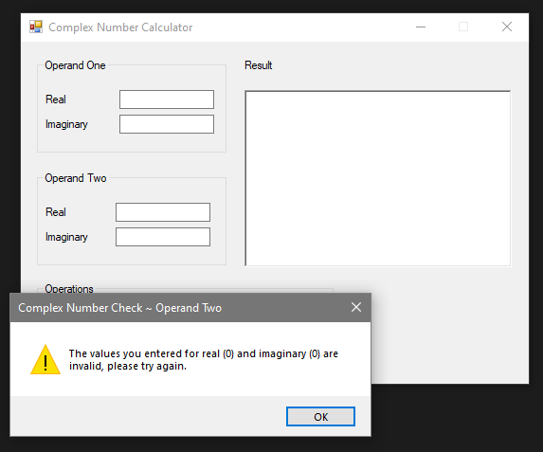

Result: (Left blank)

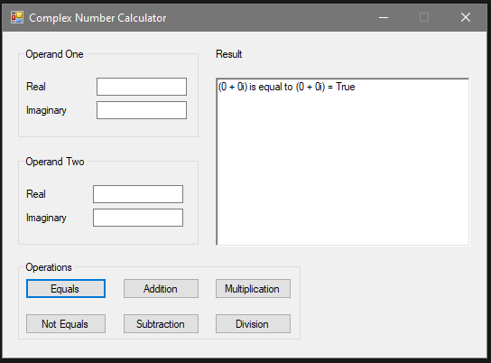

Data Validation continued: ↓

Operand One: (Not numbers)

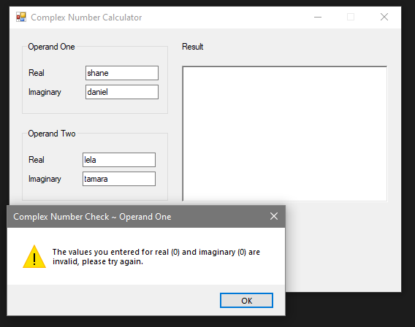

Operand Two: (Not numbers)

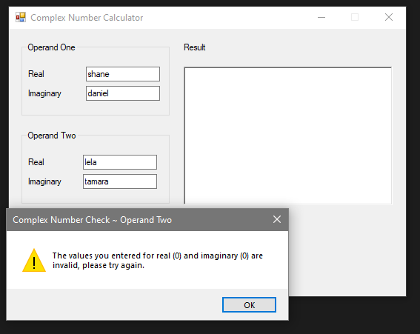

Result: (Not Numbers)

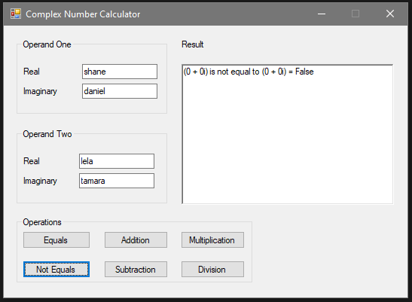

**Screenshots 8 & 9: Complex Numbers ~ Addition**

Test Case One: 2+3i, 1+4i

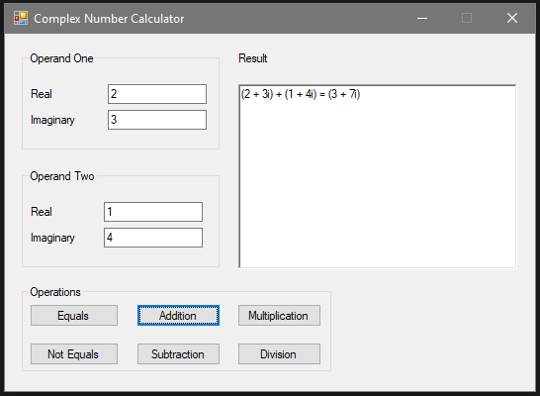

Test Case Two: 4-5i, 2-6i

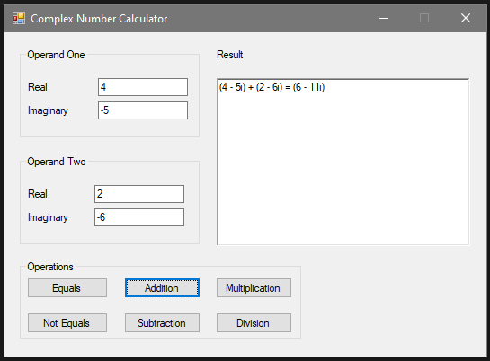

**Screenshots 10 & 11: Complex Numbers ~ Subtraction**

Test Case One: 2+3i, 1+4i

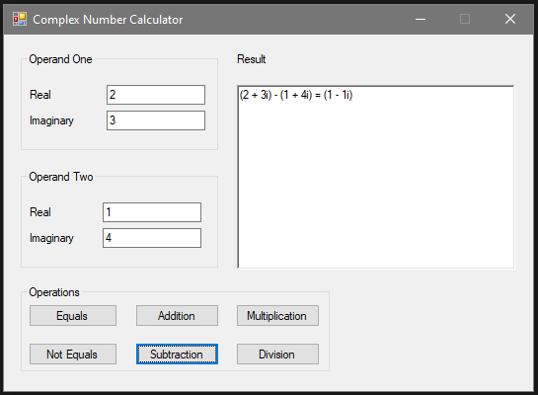

Test Case Two: 4-5i, 2-6i

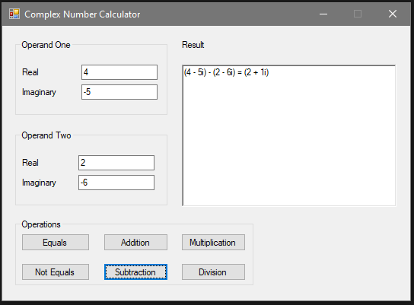

**Screenshots 12 & 13: Complex Numbers ~ Multiplication**

Test Case One: 2+3i, 1+4i

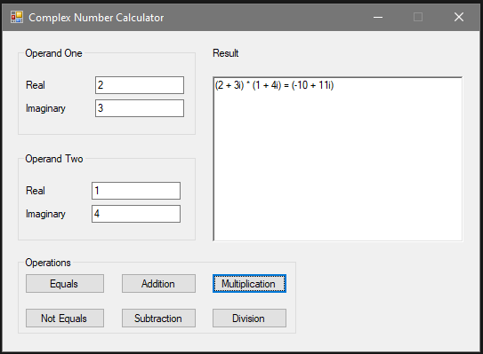

Test Case Two: 4-5i, 2-6i

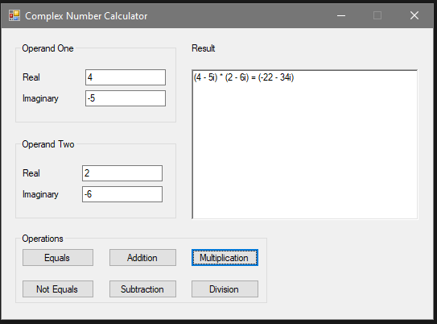

**Screenshots 14 & 15: Complex Numbers ~ Division**

Test Case One: 2+3i, 1+4i

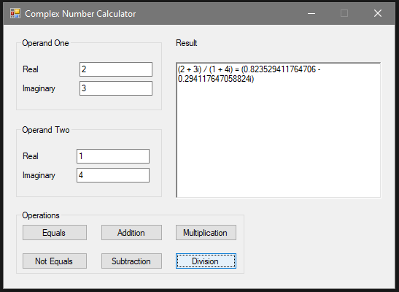

Test Case Two: 4-5i, 2-6i

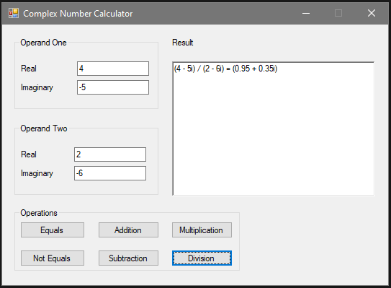

**Screenshots 16 & 17: Complex Numbers ~ Equals**

Test Case One: 2+3i, 1+4i

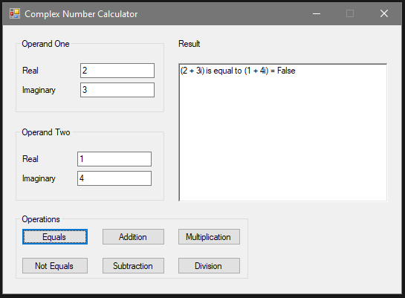

Test Case Two: 4-5i, 2-6i

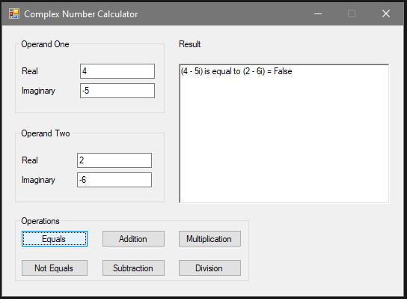

**Screenshots 18 & 19: Complex Numbers ~ Not Equals**

Test Case One: 2+3i, 1+4i

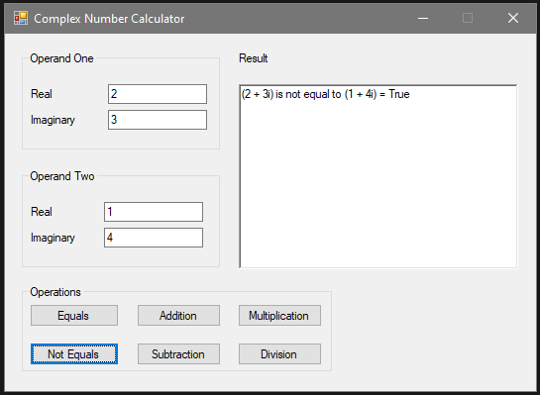

Test Case Two: 4-5i, 2-6i

