**Code Test Cases: Conversions**

**Screenshot 1: Test Case 1 – Output from Form – Two-way Conversion**

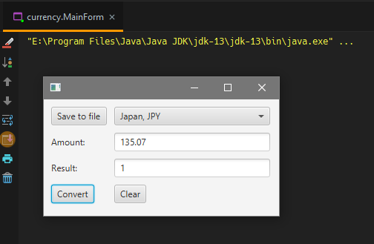

Converting Japanese Yen to British Pounds Sterling.

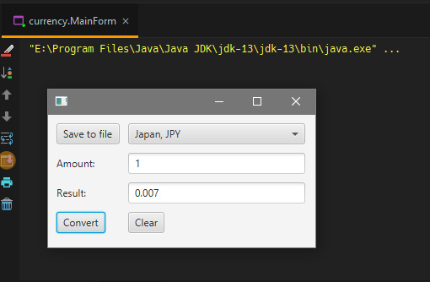

Converting British Pounds Sterling to Japanese Yen.

**Screenshot 2: Test Case 2 – Output from Form - Invalid**

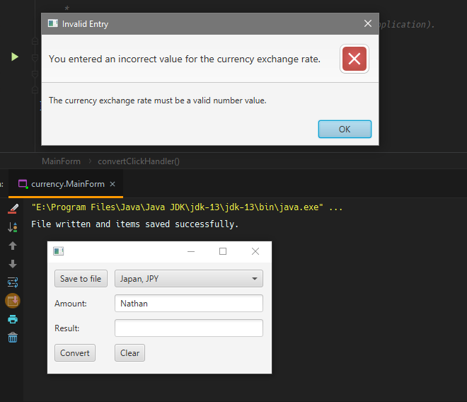

Invalid input with warning.

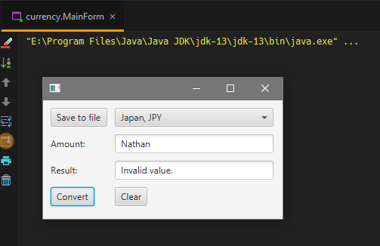

Invalid input on form.

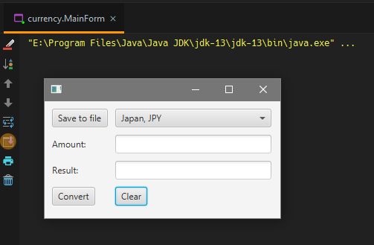

Cleared form.

**Screenshot 3: Test Case 3 – Output from Form – Save File**

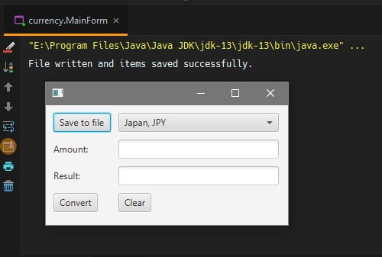

Save to file on form and console.

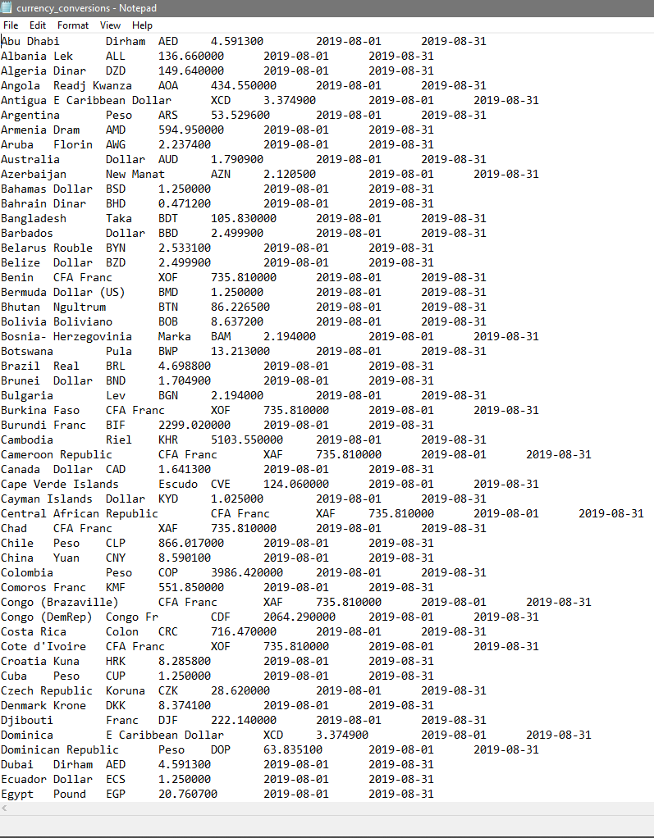

Output in save file.