**Screenshot 1 & 2: index.php**

Before CRUD changes:

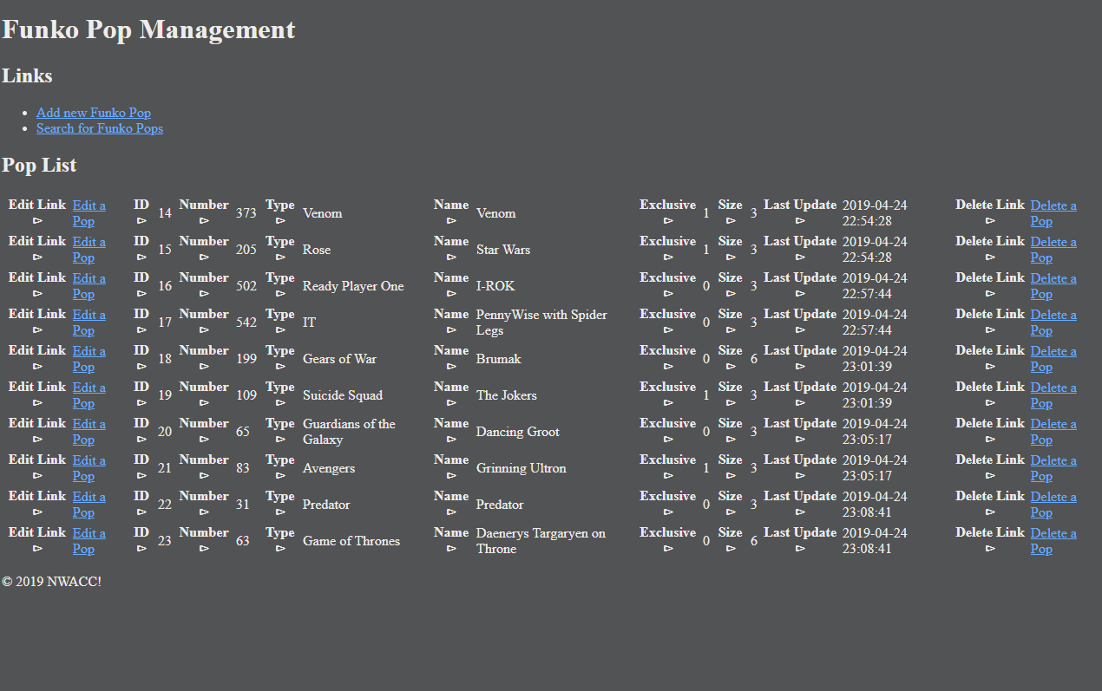

After CRUD Changes:

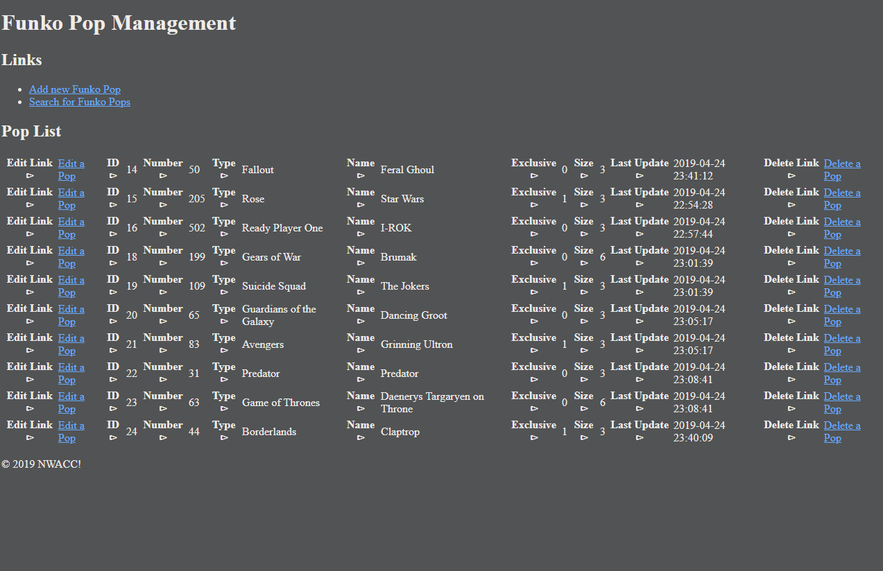

**Screenshot 3: Create**

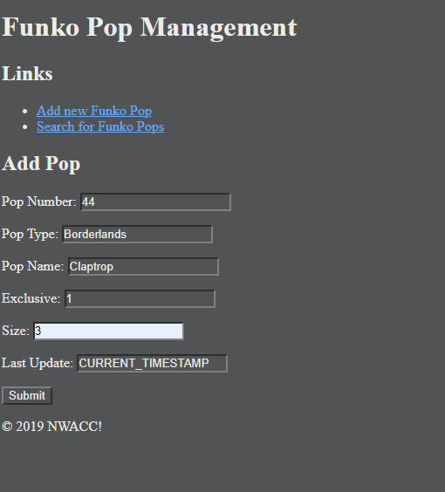

**Screenshot 4: Retrieve**

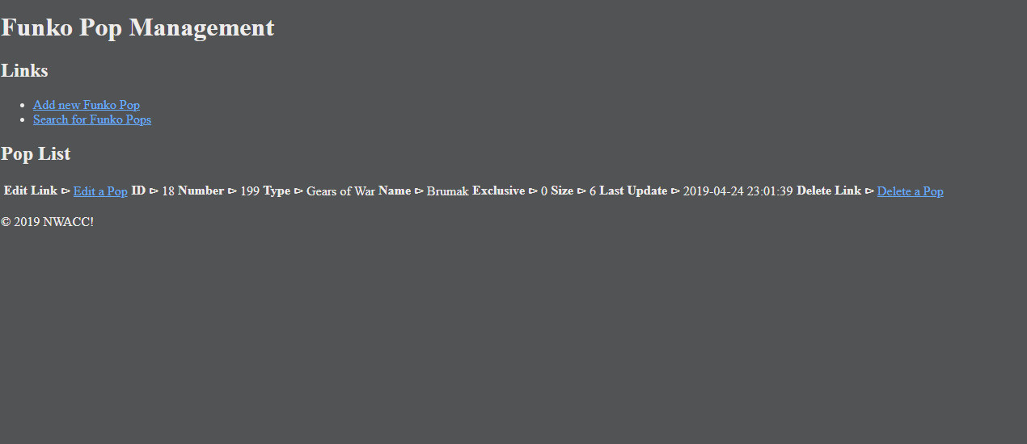

**Screenshot 5: Update**

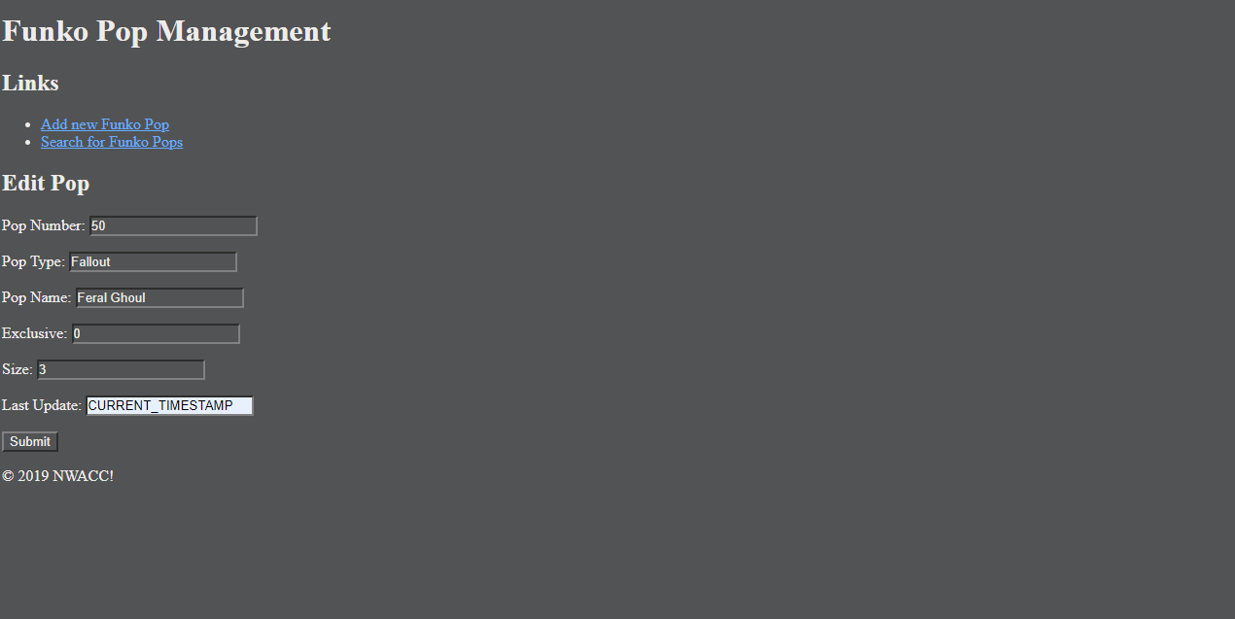

**Screenshot 6: Delete**

ID 17 (PennyWise with Spider Legs) was removed from Screenshot 1.

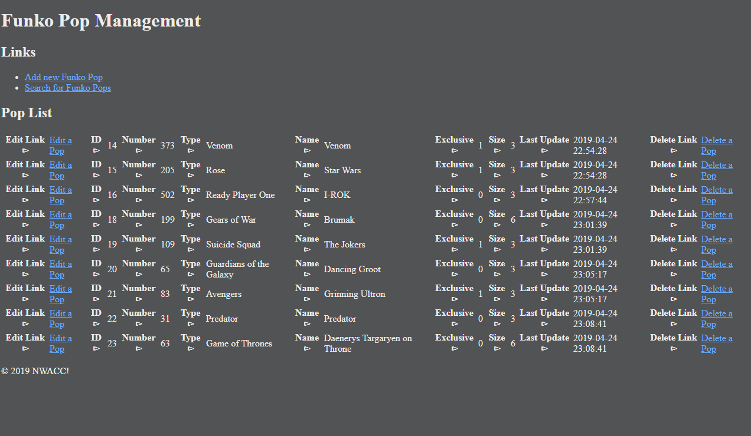

**Screenshot 7: HTML Validation**

index.php

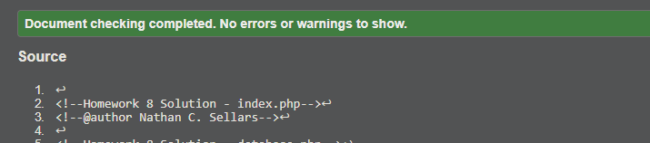

**Screenshot 8: CSS Validation**

pops.layout.css

