AI-Powered HR Assistant Documentation

1. Project Overview
This project implements a Retrieval-Augmented Generation (RAG) based HR Assistant that answers questions about Nestlé’s HR policy document using OpenAI GPT-3.5 Turbo and Chroma Vector Database.

2. System Architecture
The system follows a Retrieval-Augmented Generation (RAG) pipeline. The architecture diagram below illustrates the complete workflow.
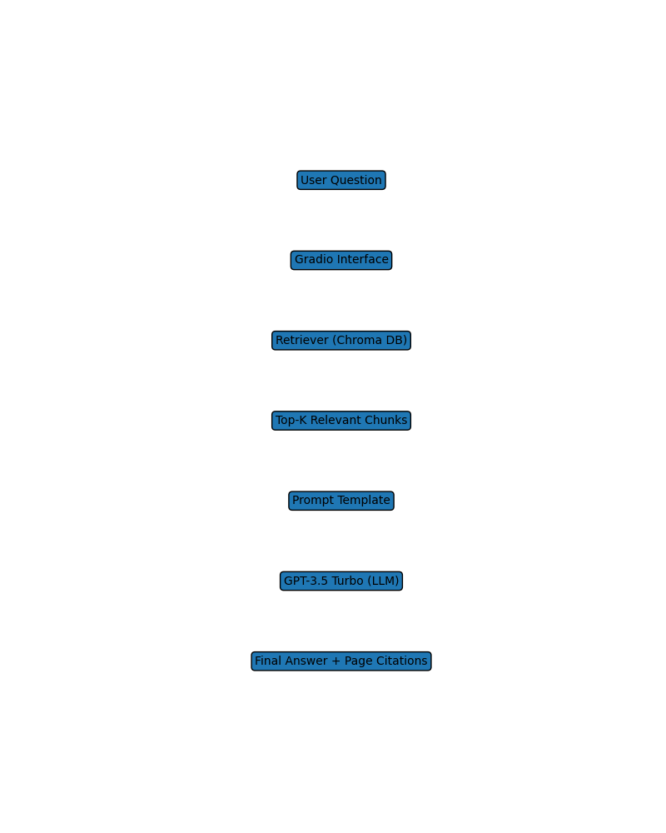

3. Component Explanation
• PDF Loader: Extracts text from the HR policy PDF.
• Text Splitter: Divides document into manageable chunks.
• OpenAI Embeddings: Converts text chunks into semantic vectors.
• Chroma DB: Stores and retrieves vector embeddings.
• Retriever: Fetches the most relevant chunks based on similarity search.
• Prompt Template: Guides GPT-3.5 to answer using only retrieved context.
• GPT-3.5 Turbo: Generates grounded responses.
• Gradio UI: Provides an interactive chatbot interface.

4. Data Flow Explanation
User Question → Embedding Comparison → Retrieval from Chroma DB → Context inserted into Prompt Template → GPT-3.5 Turbo generates answer → Answer returned with source page citations.

5. Conclusion
This project demonstrates a complete RAG pipeline including document ingestion, text preprocessing, embedding generation, vector database storage, retrieval, LLM-based answer generation, and user interface deployment.

