- Replace Maha Shivaratri Poster with pournima poster as given below:
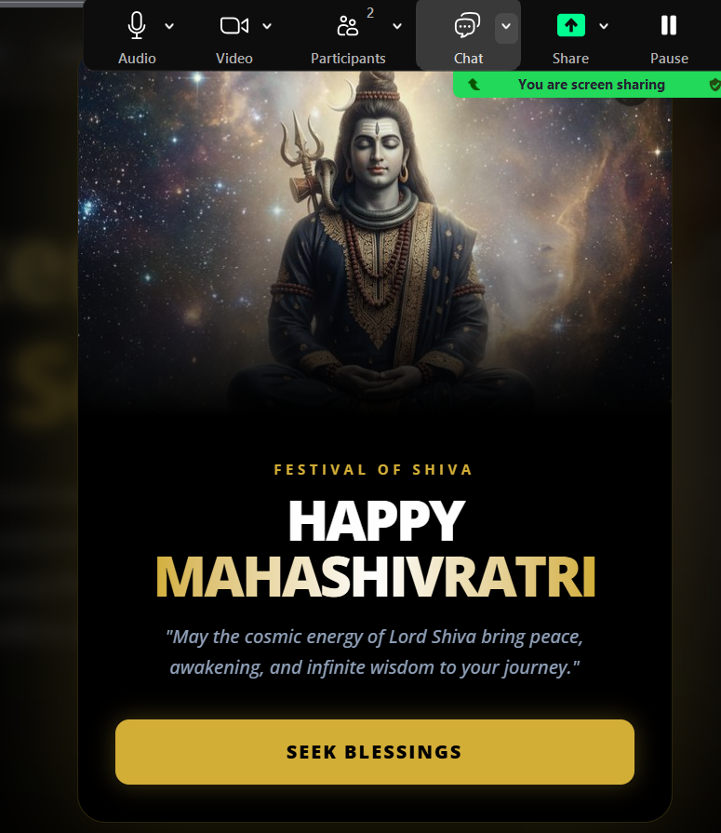
Replace with :
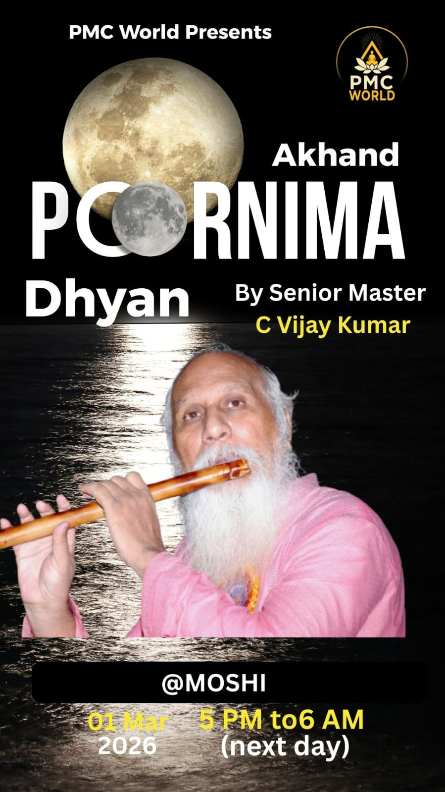

2.
The above header should be as below header (titles)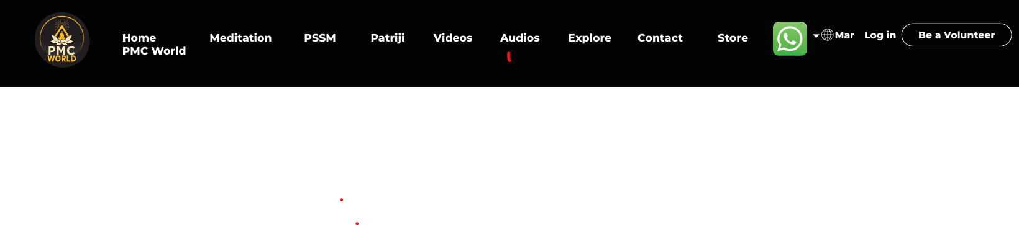
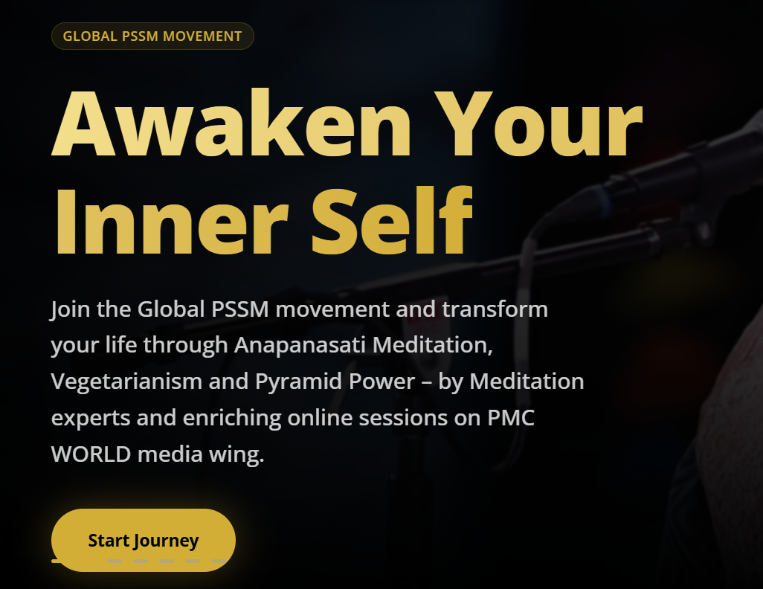
Above Design should be as a separate section on home page (as mentioned below) not on scrollbar

3. Corrections:
- Remove Full stop towards the end
- No other corrections (for website content)

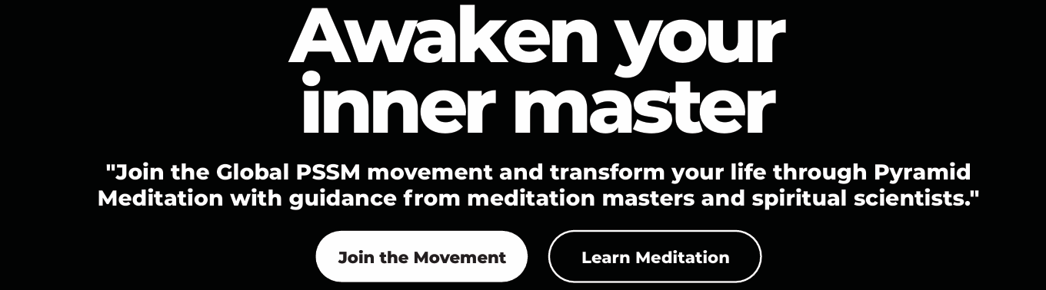

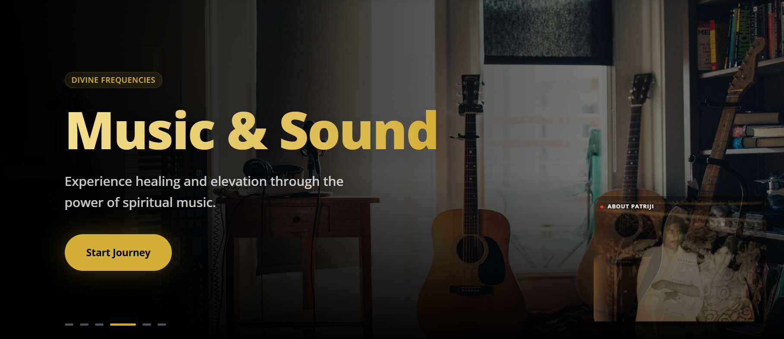

4. Scrollbars
- Live zoom sessions link (to connect on zoom with a click) with below poster to be included
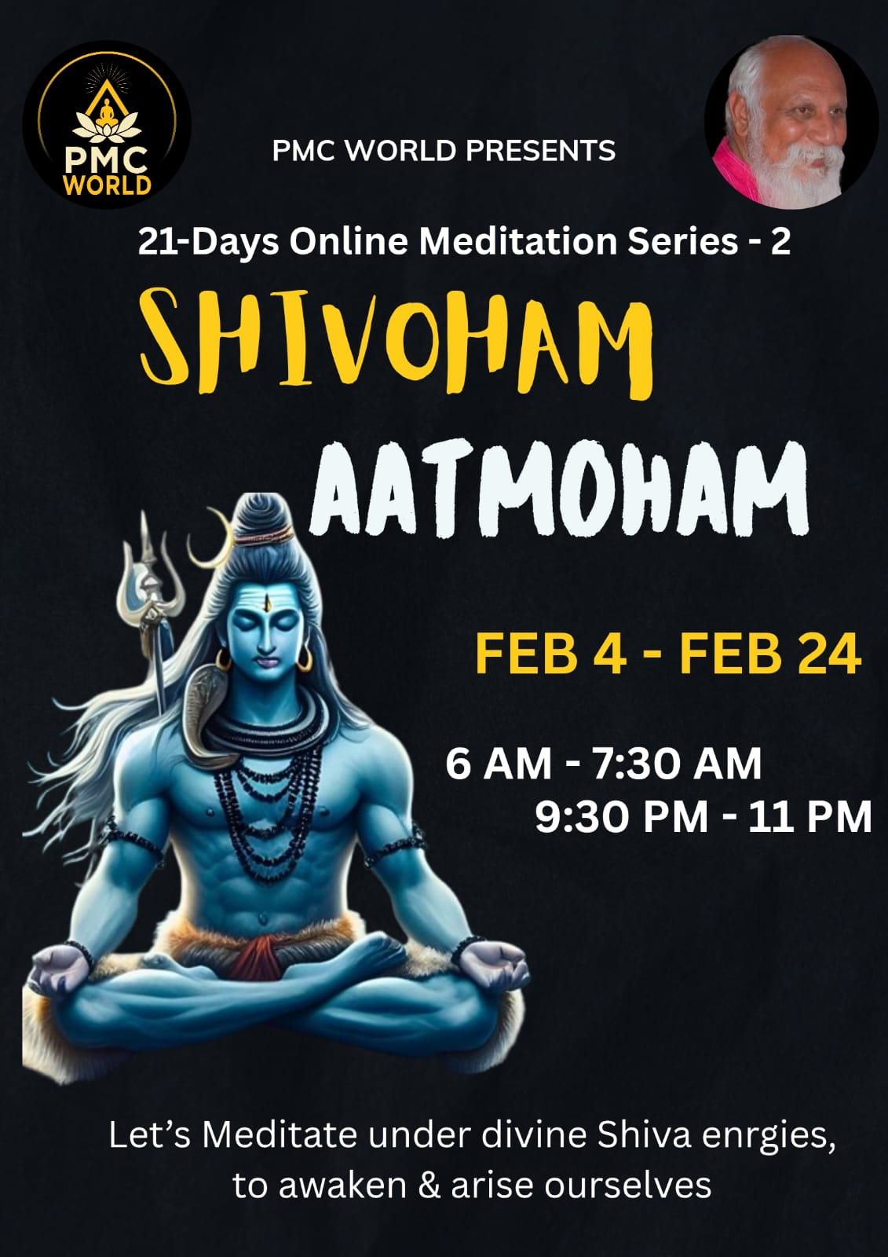
Zoom link : https://us06web.zoom.us/j/87232070764?pwd=QvobowdzfPiDupA6iO9dfOVRxtwBNl.1
Meeting ID : 872 3207 0764
Password: pssm

- Upcoming /ongoing offline and online session
- Subscribe to PMC World YT channel
- Our work – a photo collage of our programs/seva when clicked should redirect to events page

- Corrections:
Do you have the hunger to increase the quality of your life?

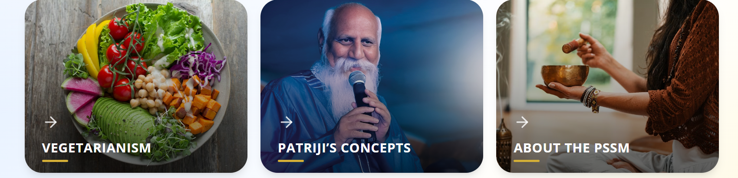
The above screen shot should be as below (size and redirection), it should not be a photo but a video when clicked should redirect, as given on tony robbins website below.
Official Website of Tony Robbins: Personal & Business Results Coach | Tony Robbins
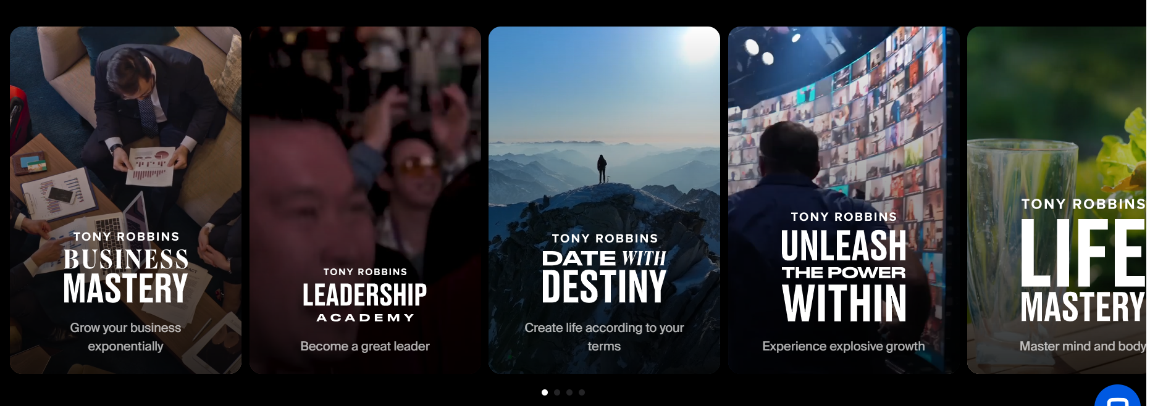
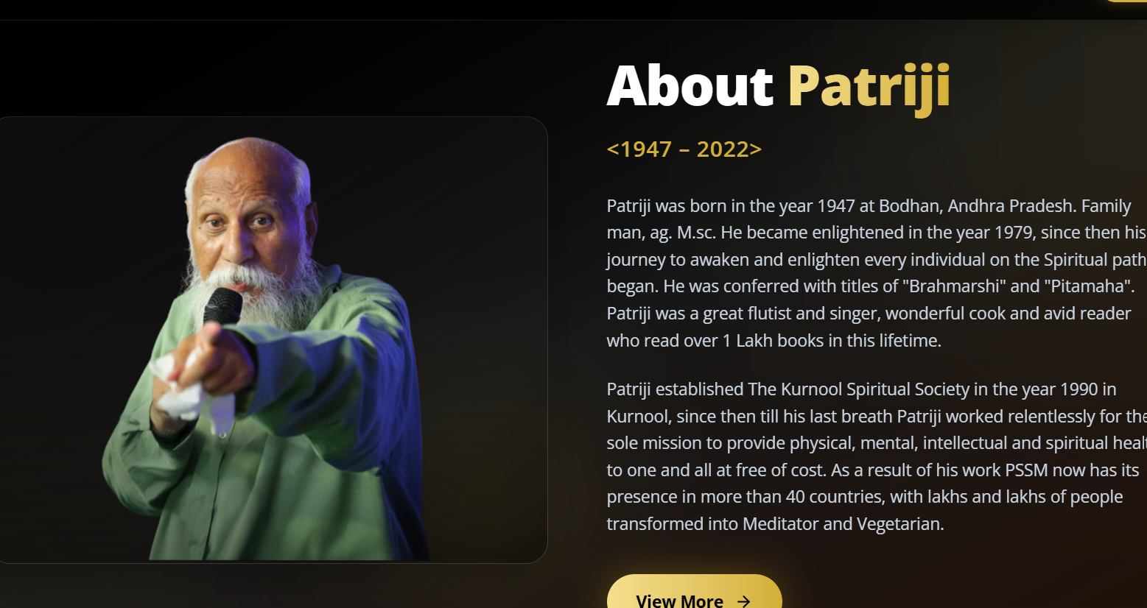
The above screen shot should be as below, when clicked should redirect, as given on tony robbins website below.
Official Website of Tony Robbins: Personal & Business Results Coach | Tony Robbins

- Corrections:
Update Patriji matter as below:
Dr. Brahmarshi Pitamaha Patriji hails from Telangana, a Family man with Ag.Msc degree, flutist, avid reader with many more feathers to his hat. Became enlightened in the year 1979, since then his journey to awaken and enlighten every individual on the Spiritual path began. Hence, PSSM now has presence in more than 40 countries with crores and crores of people imbibing meditation.
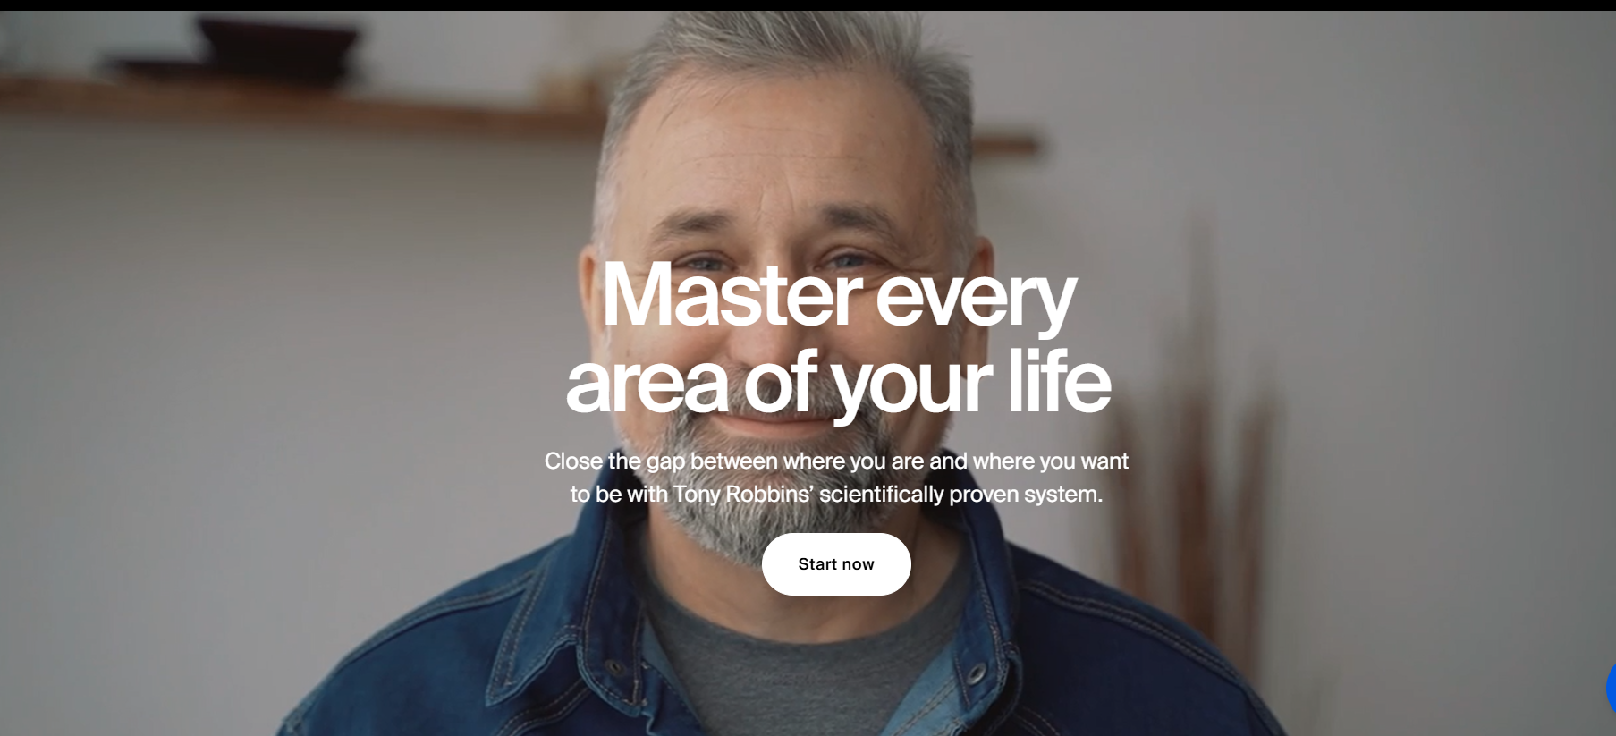
About patriji should show 2-3 line with know more button, when clicked should show screen as below, with leftside patriji video and rightside matter as above. And click to know more
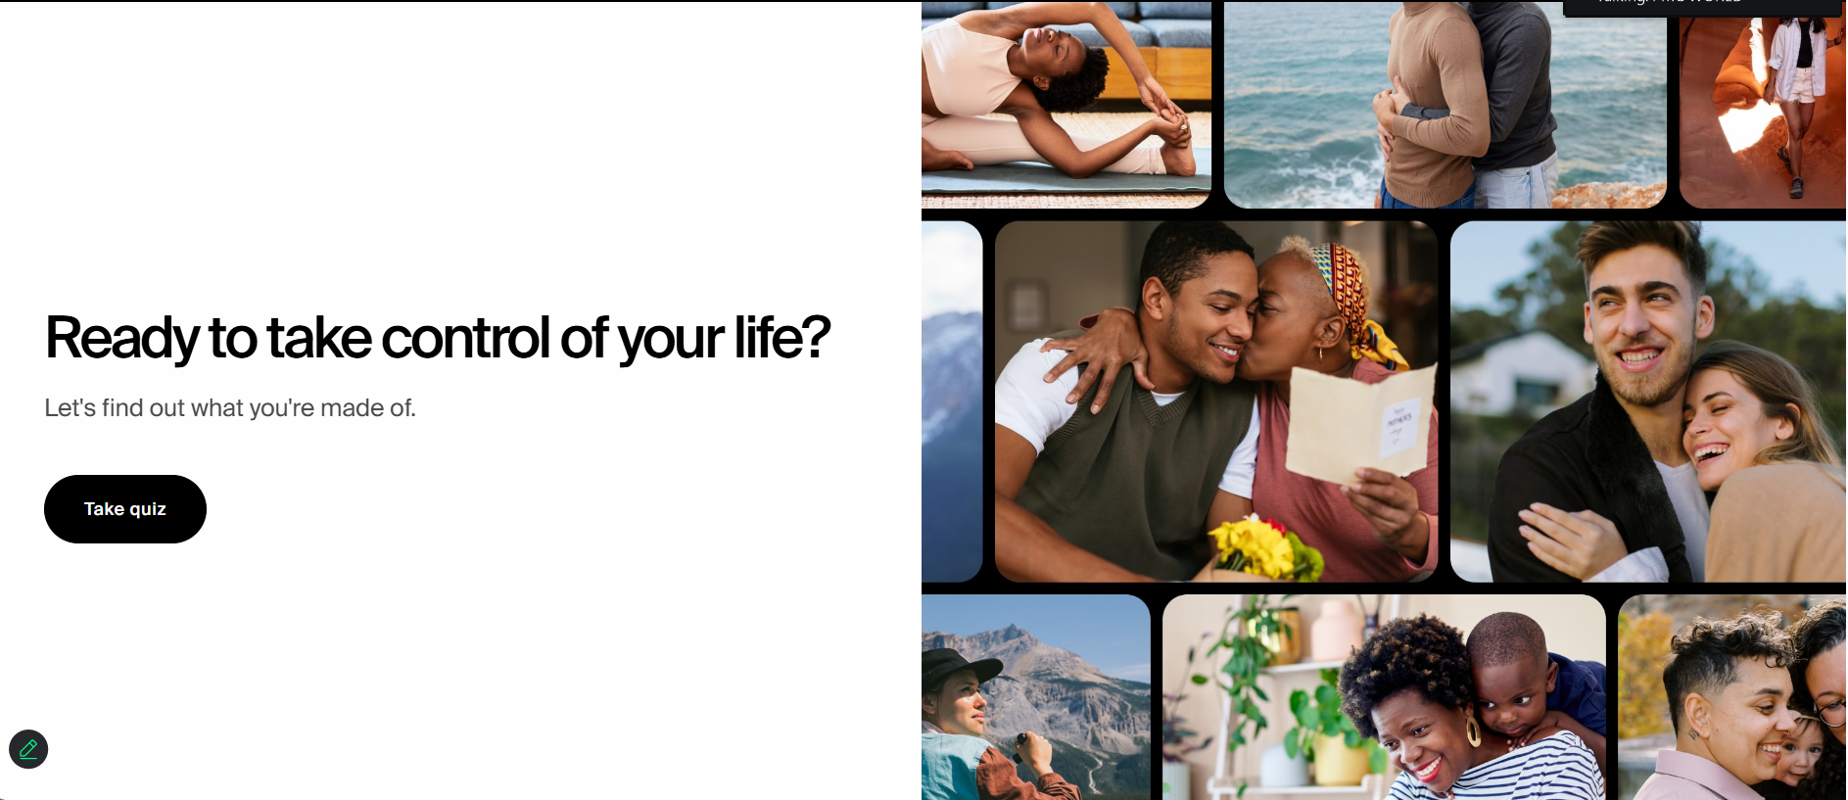

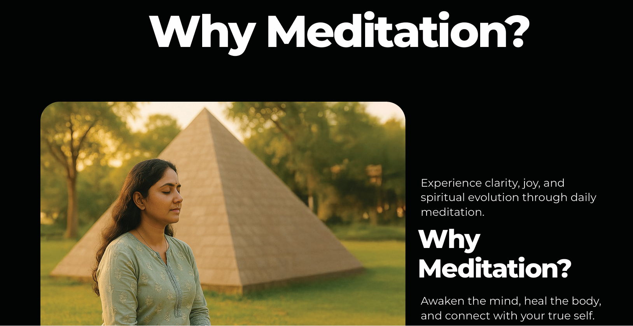
Instead of lady photo it should patriji short video doing meditation, which will play on website itself. Use this video: https://www.youtube.com/shorts/P9ktQk2RCvE. <no redirection to youtube>

- Corrections:

- What is the right age for Meditation?
- All diseases healed quickly
- Remove full stop towards the end
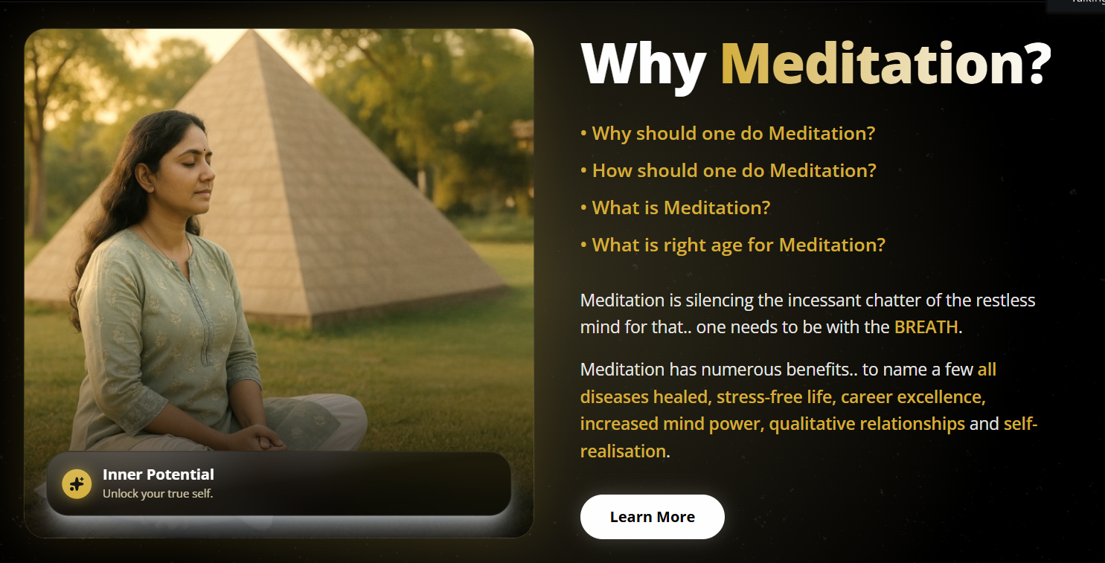
Instead of Learn More replace with “Let’s Meditate Now”, when clicked below screen should appear.
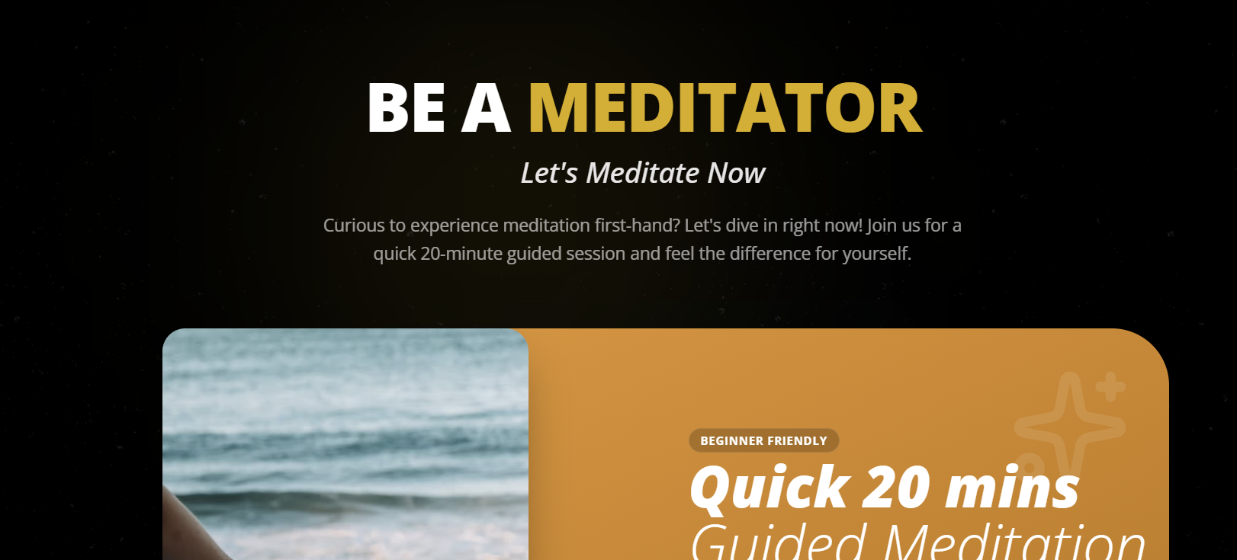
Be A Meditator design should be like below. The video thumbnail should be below image. Keep the original video in the website.
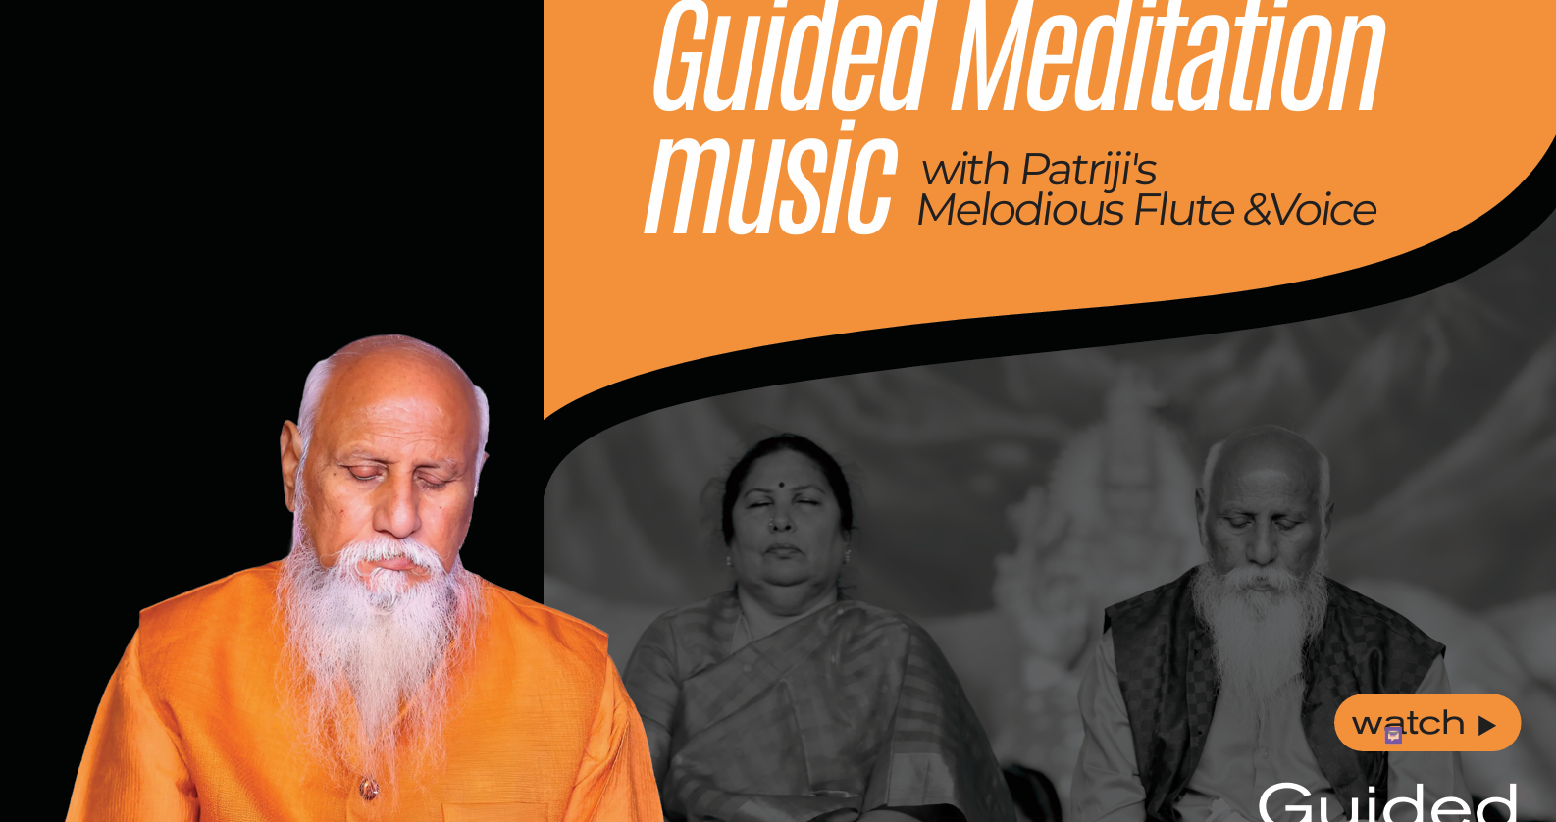

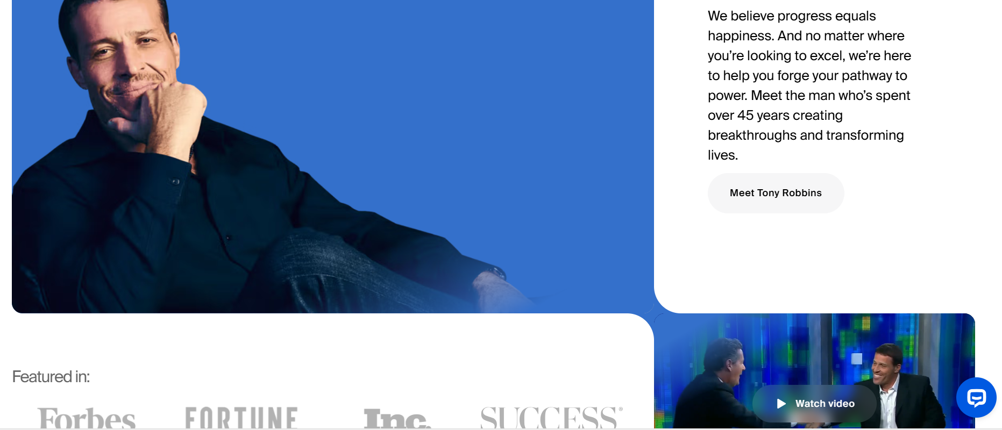
‘About Patriji’ section should be like above. Keep the original PAtriji video.
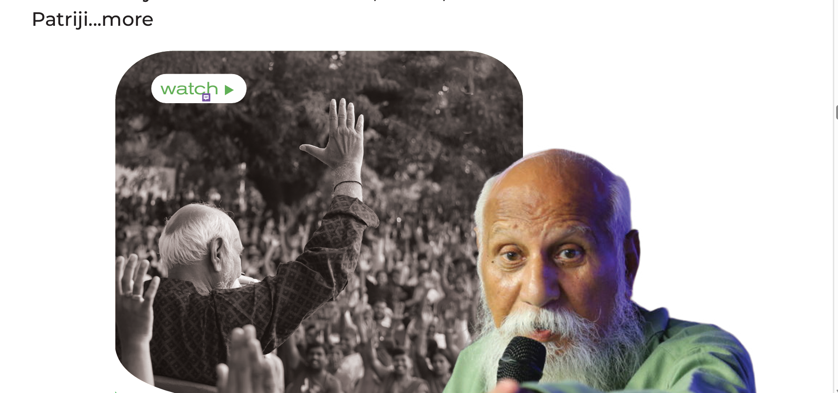

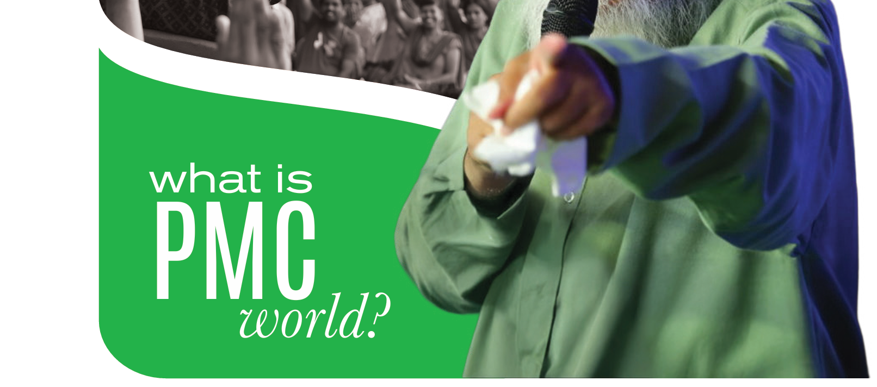
Choose any of the above designs for PMC World concept

