- Ablation study on proposed model
To assess the limitations and failure points of the proposed model, additional experiments were conducted on SAVEE and RAVDESS datasets using the same optimization strategy. The ablation study focused on the impact of modalities (spatial and temporal), convolution hyperparameters, and dropout rates. Occlusion tests on facial images and auditory MFCC features were performed to evaluate the significance of these features in the model's predictions. Integrated Gradient (IG) [1] was also applied for validation. The negative gradient does not indicate redundancy but reflects a negative contribution to the prediction score.
  - Importance of spatial and temporal models in aver
The spatial and temporal components of the proposed model were individually disabled to evaluate their standalone performance, with results shown in Table I. For the SAVEE dataset, the temporal model achieved 53.75% accuracy, while the spatial model performed significantly better at 93.96%. Combining both models improved accuracy by 3.61%, with only a 9.47% increase in parameters and a 0.59% rise in FLOPs, demonstrating that a minimal complexity increase enhances emotion recognition. Similarly, for the RAVDESS dataset, the temporal model achieved 45.85% accuracy, while the spatial model reached 92.03% (3.86% lower than the combined spatio-temporal model). These results highlight the dominance of facial features in emotion recognition, but integrating auditory features provides better generalization and performance at a low cost of model complexity. The spatio-temporal model’s attributes were visualized using Integrated Gradient (IG) analysis, with mean gradients for each emotion class presented in Figs. 1 and 2. For SAVEE, results align with Table V, showing a higher dependency on facial features, while auditory features act as auxiliary inputs, boosting recognition rates. In contrast, for RAVDESS, temporal features contributed more significantly to “Anger”, “Disgust”, “Happiness”, and “Sadness.” The gradients suggest that with actor-diverse datasets like RAVDESS, both facial and auditory features are critical, whereas facial features dominate in less diverse datasets.
TABLE I
Ablation result of unimodal

Dataset | Model | Accuracy (%) | Precision (%) | Recall (%) | F1-Score (%)
SAVEE | Temporal | 53.75 | 52.73 | 48.59 | 50.58
SAVEE | Spatial | 93.96 | 93.44 | 93.21 | 93.33
RAVDESS | Temporal | 45.85 | 48.80 | 43.68 | 46.09
RAVDESS | Spatial | 92.03 | 91.59 | 92.19 | 91.89

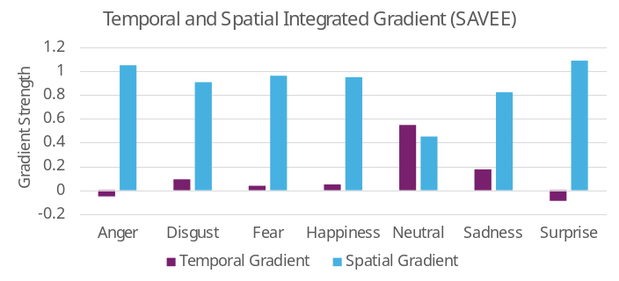

Fig. 1. Integrated gradient of temporal and spatial model for SAVEE.

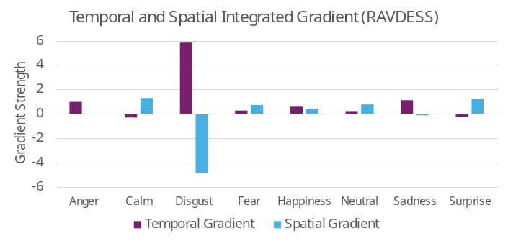

Fig. 2. Integrated gradient of temporal and spatial model for RAVDESS.

  - Effect of convolution kernel sizes
A series of experiments was conducted to evaluate the impact of convolution kernel sizes on the spatial and temporal models. For the temporal model, with the spatial model's kernel size fixed at 3×3, kernel sizes ranging from 2×1 to 12×1 were tested. For the spatial model, with the temporal model's kernel size fixed at 5×1, kernel sizes from 2×2 to 9×9 were evaluated, considering the convolution output size constrained by the 64×64 input facial image size. Results are detailed in Table II, with precision and recall metrics plotted for SAVEE (Fig. 3) and RAVDESS (Fig. 4). Optimal performance was achieved with a 5×1 kernel for the temporal model and 3×3 for the spatial model. While larger kernels extract more information, they also capture irrelevant features and noise, especially for small input sizes, leading to reduced precision and recall as shown in Figs. 3 and 4. This performance decline was more pronounced with actor-scarce datasets like SAVEE, where larger kernels amplified noise and non-facial features.
TABLE II
Ablation test result on kernel size
Dataset | Ablation | Accuracy (%) | Precision (%) | Recall (%) | Specificity (%) | F1-Score (%)
SAVEE | 1D: 2x1 | 96.88 | 96.62 | 96.49 | 99.48 | 96.55
SAVEE | 1D: 3x1 | 96.25 | 95.95 | 95.91 | 99.38 | 95.93
SAVEE | 1D: 4x1 | 95.87 | 95.63 | 95.42 | 99.31 | 95.52
SAVEE | 1D: 5x1 | 97.50 | 97.24 | 97.14 | 99.59 | 97.19
SAVEE | 1D: 6x1 | 95.21 | 94.86 | 94.68 | 99.21 | 94.77
SAVEE | 1D: 7x1 | 95.00 | 94.43 | 94.40 | 99.18 | 94.42
SAVEE | 1D: 8x1 | 94.48 | 94.38 | 93.81 | 99.08 | 94.09
SAVEE | 1D: 9x1 | 94.24 | 93.96 | 93.59 | 99.03 | 93.78
SAVEE | 1D: 10x1 | 94.10 | 93.82 | 93.41 | 99.01 | 93.62
SAVEE | 1D: 11x1 | 93.96 | 94.13 | 93.19 | 98.97 | 93.66
SAVEE | 1D: 12x1 | 93.92 | 93.82 | 93.15 | 98.97 | 93.49
SAVEE | 2D: 2x2 | 96.74 | 96.59 | 96.33 | 99.45 | 96.46
SAVEE | 2D: 3x3 | 97.50 | 97.24 | 97.14 | 99.59 | 97.19
SAVEE | 2D: 4x4 | 96.35 | 96.14 | 96.07 | 99.39 | 96.11
SAVEE | 2D: 5x5 | 95.73 | 95.43 | 95.30 | 99.29 | 95.37
SAVEE | 2D: 6x6 | 95.73 | 95.43 | 95.30 | 99.29 | 95.37
SAVEE | 2D: 7x7 | 95.00 | 94.49 | 94.52 | 99.18 | 94.51
SAVEE | 2D: 8x8 | 94.17 | 93.47 | 93.39 | 99.04 | 93.43
SAVEE | 2D: 9x9 | 82.33 | 82.55 | 80.10 | 96.97 | 81.30
RAVDESS | 1D: 2x1 | 94.36 | 94.23 | 94.63 | 99.19 | 94.43
RAVDESS | 1D: 3x1 | 94.12 | 94.17 | 94.21 | 99.16 | 94.19
RAVDESS | 1D: 4x1 | 94.30 | 94.23 | 94.08 | 99.18 | 94.15
RAVDESS | 1D: 5x1 | 95.89 | 95.91 | 95.89 | 99.41 | 95.90
RAVDESS | 1D: 6x1 | 94.30 | 94.28 | 94.31 | 99.18 | 94.30
RAVDESS | 1D: 7x1 | 94.15 | 94.25 | 93.94 | 99.16 | 94.10
RAVDESS | 1D: 8x1 | 94.24 | 94.18 | 94.37 | 99.17 | 94.28
RAVDESS | 1D: 9x1 | 94.51 | 94.35 | 94.59 | 99.21 | 94.47
RAVDESS | 1D: 10x1 | 93.25 | 93.28 | 93.16 | 99.03 | 93.22
RAVDESS | 1D: 11x1 | 92.75 | 92.35 | 92.83 | 98.96 | 92.59
RAVDESS | 1D: 12x1 | 94.00 | 94.12 | 94.06 | 99.14 | 94.09
RAVDESS | 2D: 2x2 | 92.39 | 92.48 | 92.23 | 98.91 | 92.36
RAVDESS | 2D: 3x3 | 95.89 | 95.91 | 95.89 | 99.41 | 95.90
RAVDESS | 2D: 4x4 | 94.69 | 94.45 | 94.59 | 99.24 | 94.52
RAVDESS | 2D: 5x5 | 94.27 | 94.11 | 94.25 | 99.18 | 94.18
RAVDESS | 2D: 6x6 | 92.96 | 93.09 | 92.97 | 98.99% | 93.03
RAVDESS | 2D: 7x7 | 93.55 | 93.36 | 93.67 | 99.08% | 93.51
RAVDESS | 2D: 8x8 | 91.58 | 91.75 | 91.56 | 98.79% | 91.66
RAVDESS | 2D: 9x9 | 89.82% | 89.48% | 89.88% | 98.54% | 89.68%

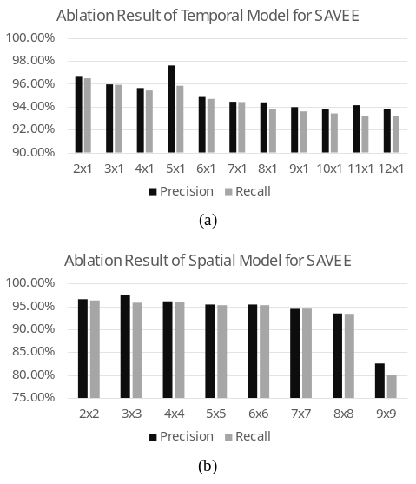

Fig. 3. Ablation result of convolution kernel size for SAVEE when (a) Spatial model convolution size is set to 3×3 and temporal model convolution size is experimented from 2×1 to 12×1 (b) Temporal model convolution size is set to 5×1 and spatial model convolution size is tested from 2×2 to 9×9.

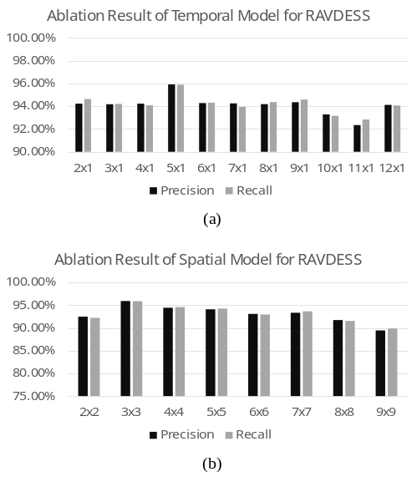

Fig. 4. Ablation result of convolution kernel size for RAVDESS when (a) Spatial model convolution size is set to 3×3 and temporal model convolution size is experimented from 2×1 to 12×1 (b) Temporal model convolution size is set to 5×1 and spatial model convolution size is tested from 2×2 to 9×9.

  - Effect of dropout rates
To assess the impact of dropout rates, the proposed model's optimal configuration (3×3 convolution for the spatial model, 5×1 for the temporal model) was tested with dropout rates ranging from 0 to 0.9. Precision and recall are shown in Fig. 5, with full results in Table III. For SAVEE, the best balance between feature retention and performance occurred at a 0.5 dropout rate, while for RAVDESS, it was 0.4. SAVEE exhibited significant performance differences across dropout rates, whereas RAVDESS showed minimal variation. This suggests that dropout regularization is less critical for datasets like RAVDESS, which include diverse actors. Nonetheless, applying dropout during training is recommended to optimize the model without incurring additional computational costs.

TABLE III
Ablation test result on dropout rate

Dataset | Ablation | Accuracy (%) | Precision (%) | Recall (%) | Specificity (%) | F1-Score (%)
SAVEE | Dropout: 0 | 93.89 | 93.45 | 93.23 | 98.98 | 93.34
SAVEE | Dropout: 0.1 | 94.93 | 94.60 | 94.35 | 99.16 | 94.47
SAVEE | Dropout: 0.2 | 95.38 | 94.92 | 94.88 | 99.24 | 94.90
SAVEE | Dropout: 0.3 | 95.94 | 95.61 | 95.62 | 99.33 | 95.61
SAVEE | Dropout: 0.4 | 95.97 | 95.59 | 95.46 | 99.34 | 95.52
SAVEE | Dropout: 0.5 | 97.50 | 97.24 | 97.14 | 99.59 | 97.19
SAVEE | Dropout: 0.6 | 93.99 | 94.24 | 93.29 | 98.97 | 93.76
SAVEE | Dropout: 0.7 | 94.27 | 94.20 | 93.55 | 99.03 | 93.87
SAVEE | Dropout: 0.8 | 91.91 | 91.13 | 90.93 | 98.67 | 91.03
SAVEE | Dropout: 0.9 | 89.83 | 88.98 | 88.71 | 98.32 | 88.85
RAVDESS | Dropout: 0 | 93.37 | 93.62 | 93.47 | 99.05 | 93.55
RAVDESS | Dropout: 0.1 | 94.63 | 94.54 | 94.56 | 99.23 | 94.55
RAVDESS | Dropout: 0.2 | 94.78 | 94.74 | 94.99 | 99.25 | 94.87
RAVDESS | Dropout: 0.3 | 94.78 | 94.59 | 94.73 | 99.25 | 94.66
RAVDESS | Dropout: 0.4 | 95.89 | 95.91 | 95.89 | 99.41 | 95.90
RAVDESS | Dropout: 0.5 | 94.15 | 94.09 | 94.03 | 99.16 | 94.06
RAVDESS | Dropout: 0.6 | 92.45 | 92.36 | 92.14 | 98.92 | 92.25
RAVDESS | Dropout: 0.7 | 90.06 | 90.05 | 89.85 | 98.57 | 89.95
RAVDESS | Dropout: 0.8 | 82.21 | 83.20 | 81.16 | 97.44 | 82.17
RAVDESS | Dropout: 0.9 | 50.15 | 45.85 | 47.00 | 92.81 | 46.42

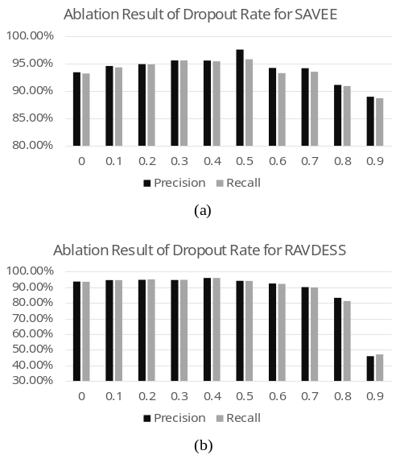

Fig. 5. Ablation result of dropout rates for (a) SAVEE (b) RAVDESS. Regularizing model training with dropout in actor-diverse dataset (i.e., RAVDESS) appears to be optional, otherwise, the dropout rate needs to be carefully considered for optimal results.

  - Occlusion test on facial features
To evaluate the impact of facial features on the spatial model, an occlusion test was conducted on eyebrows, eyes, and mouth by zeroing these features in actor images from SAVEE and RAVDESS. Facial landmarks were detected using the 68-point dlib model (v19.24.2) [2], and bounding boxes were used to create three sub-datasets: (a) without eyebrows, (b) without eyes, and (c) without mouth. The same 2D unimodal configuration and training settings were applied, with performance metrics summarized in Table IV. Compared to the spatial model with no occlusion, accuracy, precision, recall, and F1-score showed negligible average drops (<2%) for both datasets, though individual emotion classes exhibited fluctuations (detailed in Table V).
For SAVEE, precision and recall differences between occluded and non-occluded tests are shown in Fig. 6. Eyebrow occlusion caused significant drops in precision for “Disgust” and “Surprise” and in recall for “Anger” and “Sadness”. Removing eyes increased false positives and negatives in “Anger”, “Disgust”, and “Neutral” while “Sadness” showed minimal improvement. Similar increment in either false positive and negative is also observed in “Surprise” and “Fear”, respectively. Mouth occlusion universally reduced precision and recall across emotions. All emotion classes in SAVEE had a declined precision or recall in general, highlighting the importance of eyebrows, eyes, and mouth in emotion recognition. Notably, “Happiness” was unaffected, likely due to expressive cues around the cheeks (Duchenne marker) [3].
For RAVDESS, as shown in Fig. 7, there is no simultaneous improvement in precision and recall when either of the facial features is occluded, unlike in SAVEE. Occlusion consistently deteriorated precision and recall across all emotion classes, including “Happiness”. This discrepancy may stem from ethnic differences affecting habitual expression cues [4]. Easterners had different preferences over diagnostic cues in eyes and mouth for “Happiness” and exhibits different expression cues for social interactions [5]. Specifically, Easterners tended to rely more on eye cues, while non-Easterners preferred mouth cues for identifying “Happiness” [6]. While actor ethnicity is unspecified in SAVEE and RAVDESS, general visual inspection revealed distinct expression patterns. SAVEE actors displayed stronger mouth cues, while RAVDESS actors exhibited more all-rounded expression cues on all facial features when acting for “Happiness”. Although the differences may stem from the context of happy emotion manipulation, the Duchenne marker should be generally applicable to identify happy faces, of which is not included for the general occlusion test, except for the eyebrows.
Results indicate that eyebrows, eyes, and mouth are crucial for reducing false positives and negatives in both actor-scarce (SAVEE) and actor-diverse (RAVDESS) datasets. Exceptions include “Happiness”, which relies less on eyes and mouth, and “Sadness”, which showed minimal improvement in both precision and recall during eye occlusion in SAVEE. Despite performance variations, no facial feature dominated across emotion classes, underscoring the relevance of all features in emotion recognition, consistent with findings in [7]. To validate the occlusion test findings, Integrated Gradients (IG) was applied to recover facial features for each emotion class in SAVEE and RAVDESS. IG heatmaps were generated and summarized across all samples for visual comparison. Additionally, facial landmarks from the occlusion tests were aggregated using the median of the 68-point model, creating a single landmark mask for each emotion class. These masks were overlaid on the IG heatmaps for better localization of facial features, as shown in Fig. 7a (SAVEE) and Fig. 7b (RAVDESS) in the main text.
For SAVEE, positive and negative gradients highlighted the importance of eyes and eyebrows, explaining the drop in precision during their occlusion. Emotions like “Disgust” and “Happiness” relied heavily on cheek and eyebrow features (e.g., Duchenne markers), indicated by red gradients. The mouth area generally contributed positively, except for “Anger”, which showed minimal contribution, and “Neutral”, “Sadness”, and “Surprise”, which showed negative contributions. This explains the recall drop for “Anger” and “Sadness” during mouth occlusion, due to dependencies for positive and negative contributions in all other emotion classes. Conversely, “Surprise” was unaffected (i.e., no changes in recall) since a highly positive contribution comes from the area of eyes and eyebrows (i.e., drops in precision during the occlusion of these facial features).
For RAVDESS, gradients demonstrated better representation than SAVEE, reflecting the richer expression diversity of the actor-diverse dataset. Alike SAVEE, gradients predominantly focused on eyes, eyebrows, with added attention to the cheek area. Emotions like “Anger”, “Disgust”, and “Sadness” appeared to have near zero contributions on mouth area, while other classes exhibited positive or negative contributions. The dependency of mouth features caused an overall drop in precision and recall across all emotion classes, like eye features. While the facial features of “Happiness” had different signs and magnitudes for actors in SAVEE and RAVDESS, both datasets showed similarities in gradient flow (i.e., red and blue gradients) around the Duchenne markers, besides the general features around the mouth. These findings align with [8], confirming that Duchenne markers are key facial cues for perceiving happiness and are effectively captured by the spatial model.

TABLE IV
Occlusion test result on both eyebrows, eyes and mouth for each emotion

 |  |  | Emotion
Dataset | Occlusion | Metrics | Anger | Disgust | Fear | Happiness | Neutral | Sadness | Surprise | Calm
SAVEE | N/A | Precision (%) | 89.90 | 96.59 | 84.14 | 95.41 | 99.17 | 91.88 | 97.00 | N/A
SAVEE | N/A | Recall (%) | 96.39 | 86.67 | 91.39 | 98.06 | 99.17 | 91.11 | 89.72 | N/A
SAVEE | Occlusion (Eyes) | Precision (%) | 86.07 | 95.10 | 89.52 | 94.64 | 97.53 | 92.94 | 94.48 | N/A
SAVEE | Occlusion (Eyes) | Recall (%) | 96.11 | 80.83 | 87.78 | 98.06 | 98.89 | 91.39 | 95.00 | N/A
SAVEE | Occlusion (Mouth) | Precision (%) | 89.87 | 92.49 | 84.29 | 95.92 | 96.26 | 92.50 | 94.72 | N/A
SAVEE | Occlusion (Mouth) | Recall (%) | 93.61 | 88.89 | 89.44 | 98.06 | 100.00 | 82.22 | 89.72 | N/A
SAVEE | Occlusion (Eyebrows) | Precision (%) | 88.67 | 88.60 | 84.34 | 95.66 | 96.13 | 95.35 | 94.89 | N/A
SAVEE | Occlusion (Eyebrows) | Recall (%) | 89.17 | 86.39 | 92.78 | 98.06 | 100.00 | 79.72 | 92.78 | N/A
SAVEE | Differences (Eyes) | Precision (%) | -3.83 | -1.50 | 5.38 | -0.77 | -1.63 | 1.06 | -2.52 | N/A
SAVEE | Differences (Eyes) | Recall (%) | -0.28 | -5.83 | -3.61 | 0.00 | -0.28 | 0.28 | 5.28 | N/A
SAVEE | Differences (Mouth) | Precision (%) | -0.03 | -4.11 | 0.15 | 0.52 | -2.91 | 0.62 | -2.28 | N/A
SAVEE | Differences (Mouth) | Recall (%) | -2.78 | 2.22 | -1.94 | 0.00 | 0.83 | -8.89 | 0.00 | N/A
SAVEE | Differences (Eyebrows) | Precision (%) | -1.22 | -7.99 | 0.20 | 0.26 | -3.04 | 3.47 | -2.11 | N/A
SAVEE | Differences (Eyebrows) | Recall (%) | -7.22 | -0.28 | 1.39 | 0.00 | 0.83 | -11.39 | 3.06 | N/A
RAVDESS | N/A | Precision (%) | 94.46 | 94.69 | 90.85 | 94.01 | 83.47 | 94.08 | 91.83 | 89.36
RAVDESS | N/A | Recall (%) | 87.11 | 95.54 | 92.67 | 94.85 | 94.52 | 92.19 | 86.04 | 94.59
RAVDESS | Occlusion (Eyes) | Precision (%) | 91.36 | 95.32 | 87.80 | 93.45 | 89.33 | 87.44 | 85.16 | 92.65
RAVDESS | Occlusion (Eyes) | Recall (%) | 86.89 | 90.85 | 89.56 | 92.62 | 91.78 | 88.62 | 89.19 | 93.69
RAVDESS | Occlusion (Mouth) | Precision (%) | 89.06 | 95.84 | 87.90 | 93.36 | 90.50 | 90.83 | 88.41 | 90.77
RAVDESS | Occlusion (Mouth) | Recall (%) | 90.44 | 92.63 | 92.00 | 91.28 | 91.32 | 90.63 | 87.61 | 90.77
RAVDESS | Occlusion (Eyebrows) | Precision (%) | 91.61 | 92.94 | 87.50 | 91.83 | 86.81 | 91.52 | 89.86 | 91.40
RAVDESS | Occlusion (Eyebrows) | Recall (%) | 92.22 | 91.07 | 88.67 | 93.06 | 93.15 | 91.52 | 85.81 | 90.99
RAVDESS | Differences (Eyes) | Precision (%) | -3.10 | 0.63 | -3.05 | -0.56 | 5.87 | -6.63 | -6.67 | 3.29
RAVDESS | Differences (Eyes) | Recall (%) | -0.22 | -4.69 | -3.11 | -2.24 | -2.74 | -3.57 | 3.15 | -0.90
RAVDESS | Differences (Mouth) | Precision (%) | -5.40 | 1.15 | -2.95 | -0.65 | 7.03 | -3.25 | -3.42 | 1.40
RAVDESS | Differences (Mouth) | Recall (%) | 3.33 | -2.90 | -0.67 | -3.58 | -3.20 | -1.56 | 1.58 | -3.83
RAVDESS | Differences (Eyebrows) | Precision (%) | -2.85 | -1.75 | -3.35 | -2.18 | 3.34 | -2.56 | -1.97 | 2.04
RAVDESS | Differences (Eyebrows) | Recall (%) | 5.11 | -4.46 | -4.00 | -1.79 | -1.37 | -0.67 | -0.23 | -3.60

TABLE V
Occlusion test result on both eyebrows, eyes and mouth
Dataset | Occlusion | Accuracy (%) | Precision (%) | Recall (%) | F1-Score (%)
SAVEE | N/A | 93.96 | 93.44 | 93.21 | 93.33
SAVEE | Eyes | 93.37 | 92.90 | 92.58 | 92.74
SAVEE | Mouth | 92.74 | 92.29 | 91.71 | 92.00
SAVEE | Eyebrows | 92.36 | 91.95 | 91.27 | 91.61
SAVEE | Differences (Eyes) | -0.59 | -0.54 | -0.63 | -0.59
SAVEE | Differences (Mouth) | -1.22 | -1.15 | -1.50 | -1.33
SAVEE | Differences (Eyebrows) | -1.60 | -1.49 | -1.94 | -1.72
RAVDESS | N/A | 92.03 | 91.59 | 92.19 | 91.89
RAVDESS | Eyes | 90.30 | 90.31 | 90.40 | 90.36
RAVDESS | Mouth | 90.81 | 90.83 | 90.84 | 90.83
RAVDESS | Eyebrows | 90.66 | 90.43 | 90.81 | 90.62
RAVDESS | Differences (Eyes) | -1.73 | -1.28 | -1.79 | -1.53
RAVDESS | Differences (Mouth) | -1.22 | -0.76 | -1.35 | -1.06
RAVDESS | Differences (Eyebrows) | -1.37 | -1.16 | -1.38 | -1.27
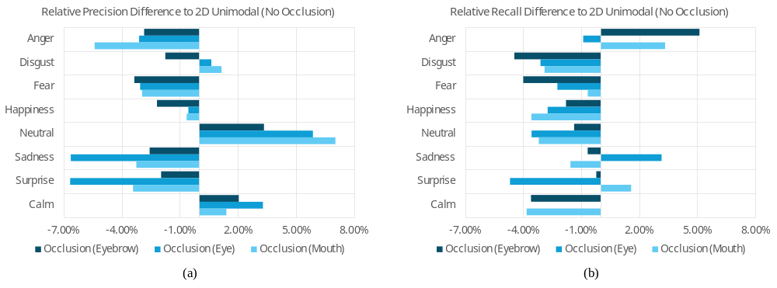
Fig. 7. RAVDESS relative (a) Precision (b) Recall difference of occlusion test (eyebrow, eye, and mouth) to spatial model results. Increment in precision and recall indicates lower false positives and negatives, respectively, and vice versa. Occlusion of either facial feature generally resulted a drop in precision and recall. However, ‘Neutral’ and ‘Calm’ had a significant improvement in precision for all occlusions but compensated with lower recall.

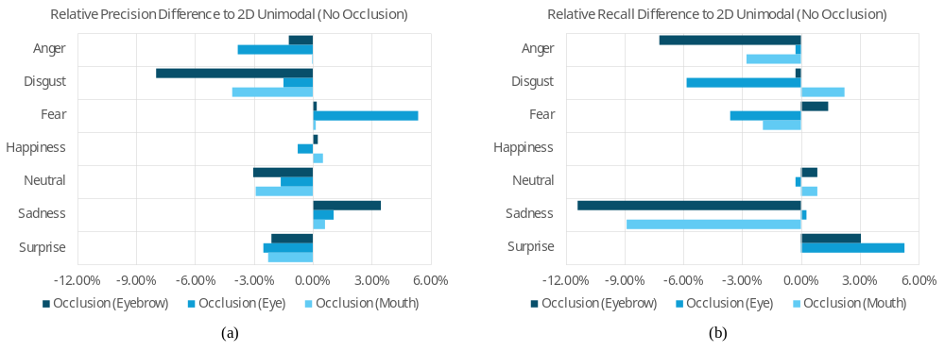
Fig. 6. SAVEE relative (a) Precision (b) Recall difference of occlusion test (eyebrow, eye, and mouth) to spatial model results. Increment in precision and recall indicates lower false positives and negatives, respectively, and vice versa. Occlusion of either facial feature generally resulted a drop in precision and recall.

  - Occlusion test on audio features
An occlusion test was conducted on the 40 extracted MFCCs by slicing the feature matrix into two sub-datasets: (a) retaining the first 20 MFCCs (lower order) and (b) retaining the last 20 MFCCs (higher order). This aimed to evaluate the effectiveness of lower- and higher-order MFCCs in the temporal model. Precision and recall differences between occlusion and no occlusion are presented in Fig. 8 (SAVEE) and Fig. 9 (RAVDESS). Unlike facial features, occluding lower or higher order MFCCs showed almost no improvement on both datasets, except for “Happiness” in RAVDESS, where precision improved during occlusion but compensated on recall. This suggests that general representations from lower-order MFCCs alone are insufficient for emotion recognition, while subtle frequency details from higher-order MFCCs also fail to capture emotions independently. The substantial precision and recall drop during higher-order MFCC occlusion highlight the importance of finer audio characteristics in emotion recognition. Integrated Gradients (IG) analysis was applied to validate these findings by averaging gradients across all samples for each emotion class (Fig. 8 in the main text). Positive and negative gradients were evenly distributed across low- and high-order MFCCs, explaining the significant declines in precision and recall observed during occlusion tests. This underscores the necessity of both lower- and higher-order MFCCs for robust emotion recognition.

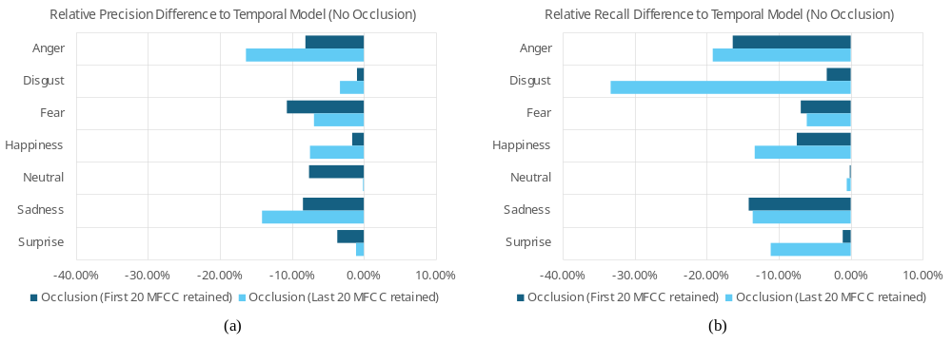
Fig. 8. SAVEE relative (a) Precision (b) Recall difference of occlusion test (low and high order MFCCs) to temporal model results. Increment in precision and recall indicates lower false positives and negatives, respectively, and vice versa. Occlusion of either low or high order MFCC does not improve precision and recall.

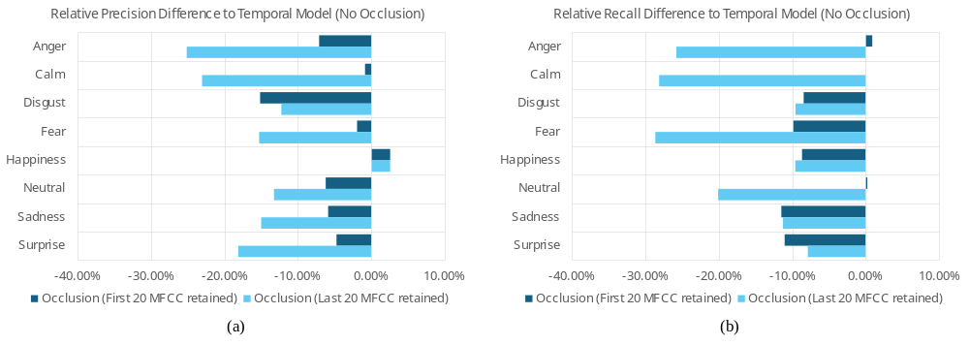
Fig. 9. RAVDESS relative (a) Precision (b) Recall difference of occlusion test (low and high order MFCCs) to temporal model results. Increment in precision and recall indicates lower false positives and negatives, respectively, and vice versa. Occlusion of either low or high order MFCC does not improve precision and recall. Except for “Happiness”, occlusion of either low or high order MFCCs improved the precision but compensated on recall.
TABLE VI
Targeted embedded device with theoretical computability for optimal implementation

Embedded computing board (launch year) | Memory type | Memory bandwidth (GB/sec) | FP32 (GFLOPs/sec) | Arithmetic intensity (FLOPs/byte) | Implementation possibility
 |  |  |  |  | [9] | [10] | [11] | [12] | [13] | Proposed
Raspberry Pi Family
4B (2019) | 32-bit LPDDR4 | 12.80 | 30.00 | 2.34 | / | / | ✖ | / | / | /
5B (2023) | 32-bit LPDDR4X | 17.10 | 120.00 | 7.01 | / | / | / | / | / | /
NVIDIA Jetson Family
Nano (2019) | 64-bit LPDDR4 | 25.60 | 235.80 | 9.21 | / | / | / | ✔ | / | /
Xavier NX (2020) | 128-bit LPDDR4X | 59.71 | 844.80 | 14.14 | / | / | / | ✔ | / | /
Orin Nano (2023) | 64-bit LPDDR5 | 34.14 | 640.00 | 18.74 | / | / | / | ✔ | / | ✔

The tick (‘✔’) indicates fulfilled criteria on the arithmetic intensity ratio of ECB and proposed architecture is larger than 1 for optimal implementation. The cross (‘✖’) indicates the GFLOPs of architecture exceeded the capped GFLOPs of ECB. The forward slash (‘/’) indicates possible implementation with more clock cycle due to arithmetic intensity overhead.

References
- M. Sundararajan, A. Taly, and Q. Yan, “Axiomatic attribution for deep networks,” in Proc. Int. Conf. Mach. Learn., Aug. 2017, pp. 3319–3328.
- V. Kazemi and J. Sullivan, “One millisecond face alignment with an ensemble of regression trees,” in IEEE Conf. Comput. Vis. Pattern Recognition, Columbus, OH, USA, Jun. 2014, pp. 1867–1874.
- M. G. Frank, P. Ekman, and W. V. Friesen, “Behavioral markers and recognizability of the smile of enjoyment,” J. Pers. Soc. Psycol., vol. 64, no. 1, pp. 83–93, Jan. 1993.
- K. M. Sheldon, M. Corcoran, and M. Sheldon, “Duchenne Smiles as Honest Signals of Chronic Positive Mood,” Perspect. Psychol. Sci., vol. 16, no. 3, pp. 654–666, Feb. 2021.
- X. Mai et al., “Eyes Are Windows to the Chinese Soul: Evidence from the Detection of Real and Fake Smiles,” PLoS ONE, vol. 6, no. 5, May 2011, Art. no. e19903.
- R. Kestenbaum, “Feeling happy versus feeling good: The processing of discrete and global categories of emotional expressions by children and adults,” Dev. Psychol., vol. 28, no. 6, pp 1132–1142, 1992.
- H. Eisenbarth and G. W. Alpers, “Happy mouth and sad eyes: scanning emotional facial expressions,” Emotion, vol. 11, no. 4, pp. 860–865, Aug. 2011.
- S. D. Gunnery and J. A. Hall, “The Expression and Perception of the Duchenne Smile,” in The Social Psychology of Nonverbal Communication, London, Palgrave Macmillan, 2015, ch. 5, pp. 114–133.
- A. I. Middya, B. Nag, and S. Roy, “Deep learning based multimodal emotion recognition using model-level fusion of audio–visual modalities,” Knowledge-Based Syst., vol. 244, no. 1, May 2022, Art. no. 108580.
- M. Sharafi, M. Yazdchi, R. Rasti, and F. Nasimi, “A novel spatio-temporal convolutional neural framework for multimodal emotion recognition,” Biomed. Signal Process. Control, vol. 78, Sep. 2022, Art. no. 103970.
- M. Sharafi, M. Yazdchi, and J. Rasti, “Audio-Visual Emotion Recognition Using K-Means Clustering and Spatio-Temporal CNN,” in Int. Conf. Pattern Recognition Image Anal., Qom, Iran, Feb. 2023.
- A. Radoi, A. Birhala, N.-C. Ristea, and L.-C. Dutu, “An End-To-End Emotion Recognition Framework Based on Temporal Aggregation of Multimodal Information,” IEEE Access, vol. 9, pp. 135559–135570, Sep. 2021.
- U. Bilotti, C. Bisogni, M. De Marsico, and S. Tramonte, “Multimodal Emotion Recognition via Convolutional Neural Networks: Comparison of different strategies on two multimodal datasets,” Eng. Appl. Artif. Intell., vol. 130, Apr. 2024, Art. no. 107708.

