**The UK’s Nuclear History**

The first commercial nuclear power station in the United Kingdom began operation in 1956 in Sellafield, Cumbria. For more than 60 years now, nuclear power has been generating electricity and supporting the country’s defence. The UK’s energy policy focuses on producing electricity from nuclear power alongside other sources such as gas, solar and wind. Today, nuclear power provides one-fifth of the country’s total energy requirements. Like many other nuclear power producing countries in the world, the UK also believes in tackling the global climate emergency by supporting nuclear power.

Like any other industry, the nuclear industry also produces waste. Besides power generation, nuclear waste also comes from the medical facilities which use radioactive sources for sterilisation, diagnosis and treatment, from industries which uses radiation sources for industrial purposes such as to test quality of welds, thickness of products, from defence activities such as decommissioning of nuclear powered submarines, and from research and development activities. In the UK, radioactive waste is temporarily stored above ground at 30 sites around the country. The UK also supports the global consensus of eventual geological disposal.

Nuclear waste is segregated into high-level waste (HLW), intermediate-level, and low-level waste based on the amount of the radioactivity contained in it. HLW accounts for ~95% of the total radioactivity coming from nuclear reactors. The principle sources of high-level radioactive waste are the reprocessing of commercial spent nuclear fuel and spent fuel from nuclear defence research programs. There are two strategies to dispose the spent nuclear fuel. If the spent fuel in not reprocessed, the fuel cycle is referred to as an “open” or “once -through” nuclear fuel cycle. This strategy follows the direct disposal of spent nuclear fuel. The other strategy known as the “closed” fuel cycle follows the reprocessing of the spent fuel to extract the uranium and plutonium which remain in the nuclear fuel elements for reuse. Most of the nuclear power producing nations including the UK follow the “closed” nuclear fuel cycle.

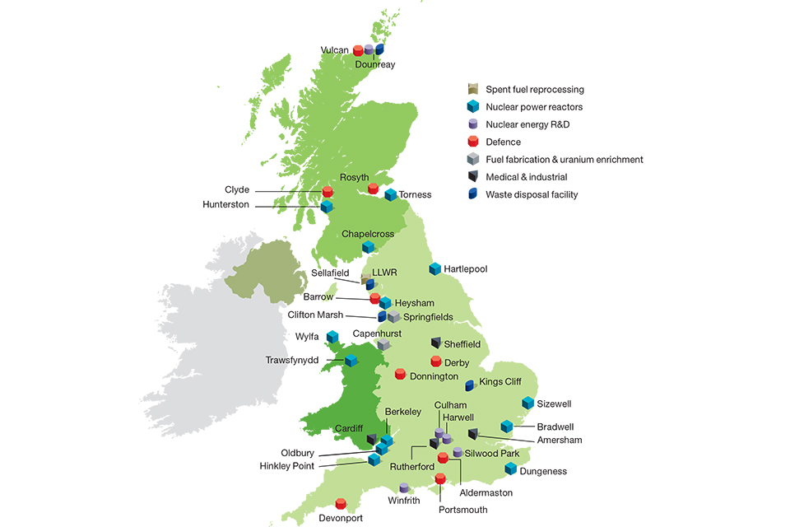

Nuclear Sites in the UK

According to the official data, more than 94% of all radioactive waste to be produced in the UK will be Low Level Waste (LLW) or Very Low-Level Waste (VLLW). This is the existing waste stored at the waste sites and that which is expected to arise in the next 100 years. LLW is defined as having a radioactive content not exceeding 4 Giga-becquerels per tonne of alpha activity or 12 Giga-becquerels per tonne of beta/gamma activity. VLLW is a sub-category of LLW. Intermediate level waste (ILW) will be less than 6% of all the radioactive waste to be produced in the UK and less than 0.1% will be High Level Waste (HLW).

‘Geological disposal’ is the preferred route of permanent disposal and management of the HLW by the UK government. The government is working with the environmental protection agencies, waste regulators, radioactive waste consultants and technical specialists to confirm and find a geological repository site. A geological repository will be a multi-barrier, engineered and underground facility where the vitrified (waste which is contained and immobilised in molten glass) waste canisters will be stored for many years. This structured repository provides a barrier against the dispersion of radioactivity. There is no intention to retrieve the waste once the facility is closed. Nuclear Decommissioning Authority (NDA) is a government entity, Radioactive Waste Management Limited (a subsidiary of the NDA) are responsible for implementing the long-term solution for managing Higher Activity Wastes in England and Wales. The Department for Business Energy and Industrial Strategy (BEIS) and the Scottish Government are responsible for developing policies for managing these wastes safely.

Reference and information taken from:

1. (https://www.forepoint.co.uk), F., 2020. *Applying The Waste Hierarchy | UK Radioactive Waste Inventory (UKRWI)*. [online] Ukinventory.nda.gov.uk. Available at: <https://ukinventory.nda.gov.uk/about-radioactive-waste/what-is-the-waste-hierarchy/> [Accessed 15 March 2020].

2. Woodfield, J., 2020. *How Much Radioactive Waste Is There In The UK? - Cleaning Up Our Nuclear Past: Faster, Safer And Sooner*. [online] Nda.blog.gov.uk. Available at: <https://nda.blog.gov.uk/2020/01/10/how-much-radioactive-waste-is-there-in-the-uk/> [Accessed 15 March 2020].