Logo Design Brief

Company Name: Nuclear Energy – The Better Energy

Company Bio: Nuclear Energy - The Better Energy is a website designed for a non-science population to create awareness about the benefits of Nuclear Energy and to help the society get rid of the fears and misconceptions related to this environment friendly source of energy.

My simple vision behind developing 'Nuclear Energy - The Better Energy' is to bridge the gap between my research as a Nuclear Scientist and my responsibilities towards the society. I consider myself an advocate of Nuclear energy and so I decided to work on developing and designing this website not for people who are specialists in the field but for a non-science population, to introduce them to Nuclear physics, starting from its basic applications to nuclear power production being the need of the day.

Through this website, I hope to be able to contribute to the society and prove to be a resource for anyone and everyone who might be interested and help them make well-informed and educated decisions about Nuclear power that could eventually help save the world.

Target Audience: Mostly targeting high school students. The website has basically been designed for anyone and everyone over the age of 15. The school teachers are also a major part of the target audience as they would be paying for the product.

Color Preferences: Radiation (which is an integral part of Nuclear Power/Energy) has the following logo in yellow and black. We can try and aim for a similar background and contrast so that when people look at it, they know what we are trying to represent. Alternatively, we can also make our base green to make the point that we are dealing with a ‘green’ i.e., an environment friendly source of energy. We definitely need colors but should probably stick to just two colors to give a good contrast and at the same time, make our point boldly.
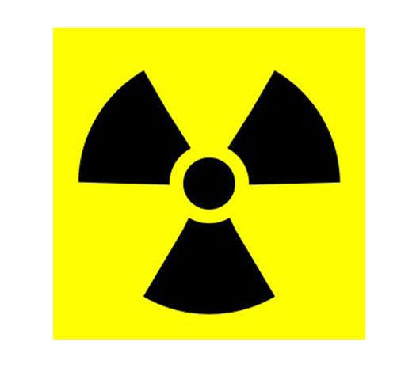

Some logos that I have used in the past:

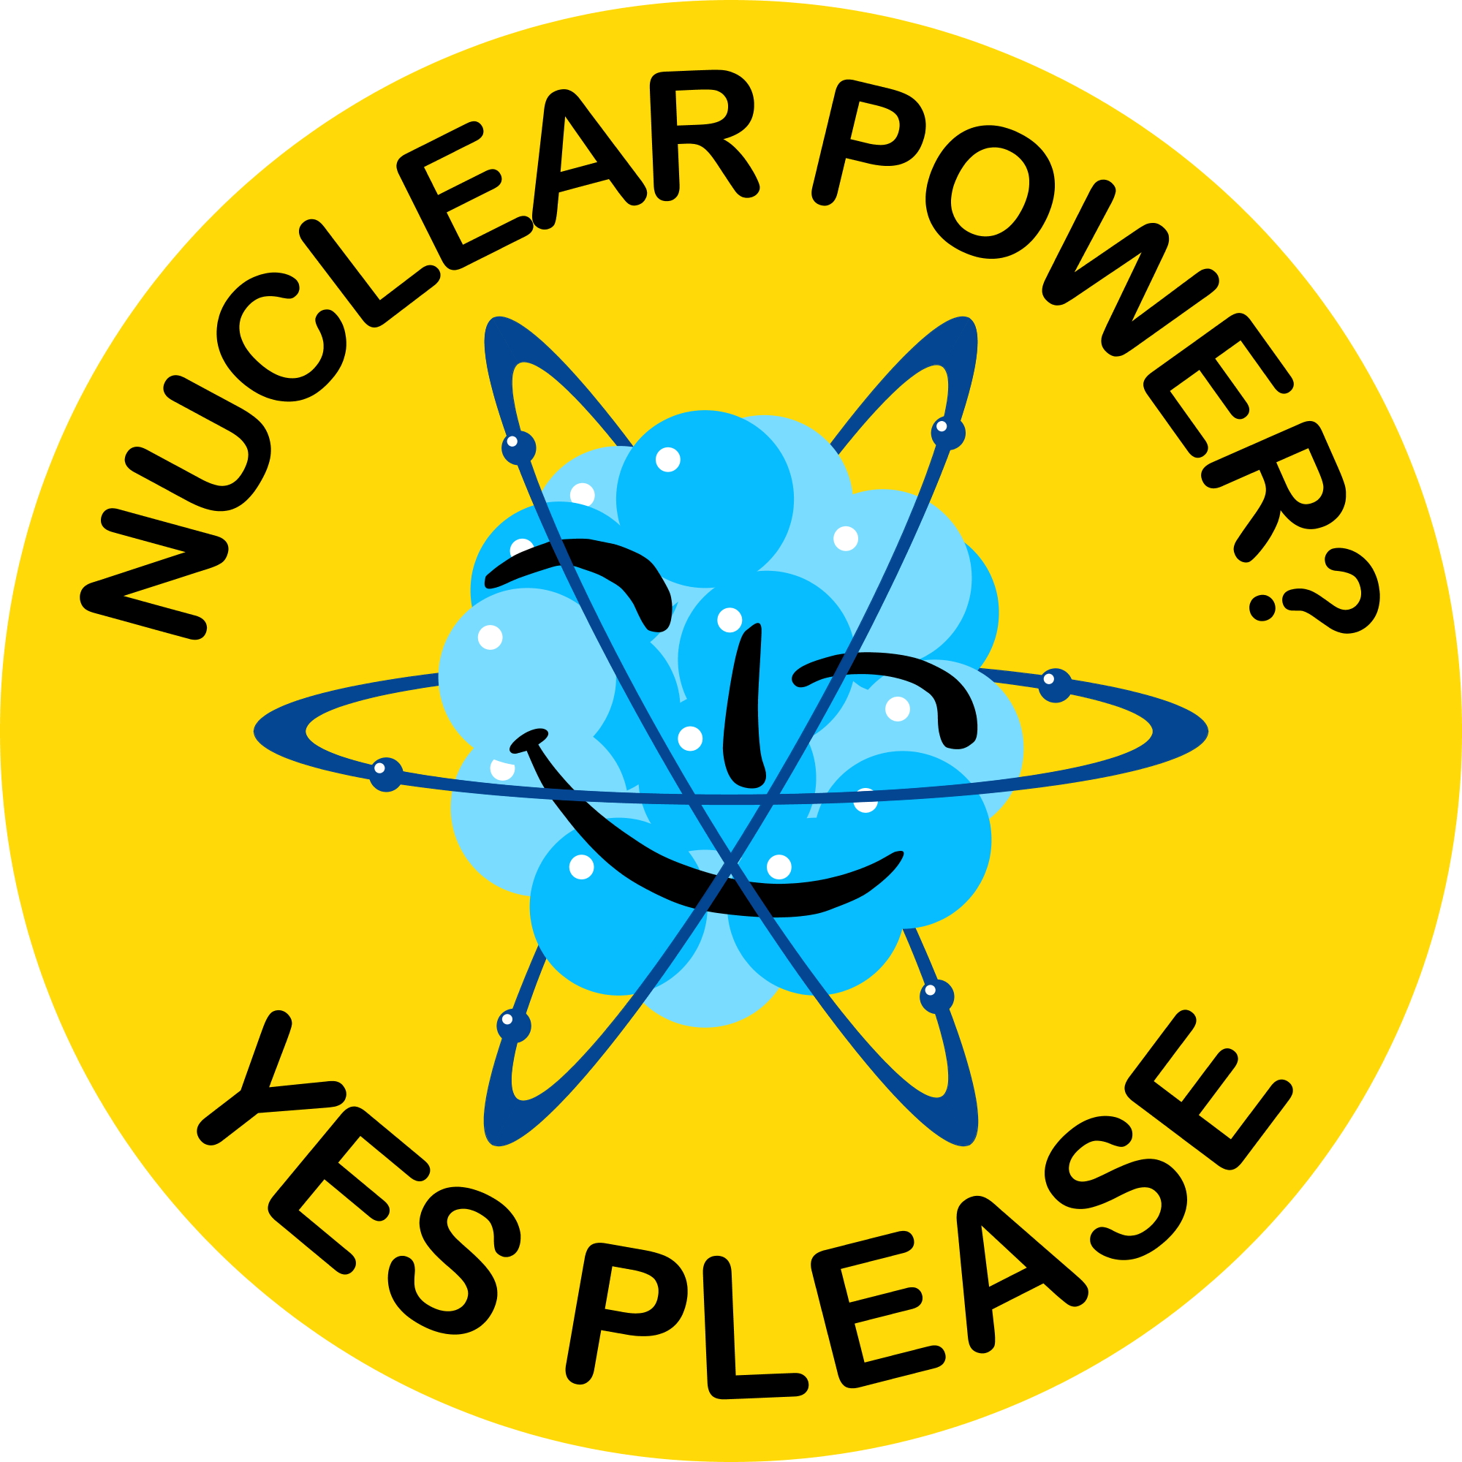
Good:

Clearly states that the representatives support Nuclear Power. It also shows the cartoon of a nucleus in the middle indicating that Nuclear power is generated from an atomic nucleus.
The background has been maintained with yellow and text in black, keeping in mind the radiation logo.

Bad:

This design shows an atom with its constituents (nucleus and electrons) are shown in green color. This indirectly indicates that the energy generated from an atomic nucleus is environment friendly and therefore ‘green’. This design, I think, is counter-intuitive and might not serve as a self-explanatory logo for a general population.

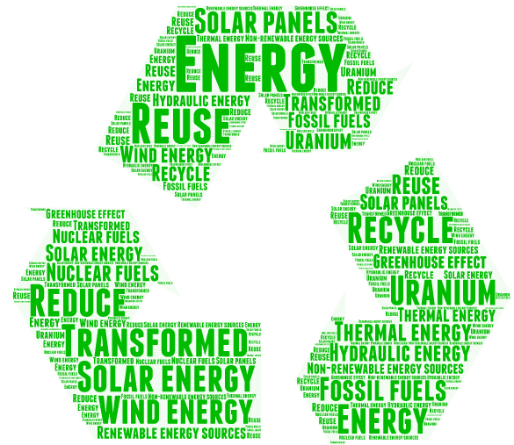
Good:

This design basically focuses on all kinds of energy sources that are considered ‘green’. I like that it uses the ‘reuse-recycle’ symbol as the base of the logo. Moreover, all the text is in green implying that the logo is specifically for environment friendly energy options. Also, it is self-explanatory for a general audience.

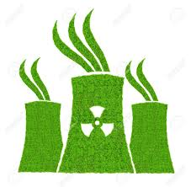
Bad:

This design shows the much-feared cooling towers from a Nuclear Power Plant. These are shown in green, with a radiation symbol and some gases coming out of these. This is a misconception that cooling towers release radiation and this logo reinforces that misconception. This is something that we don’t want. Cooling towers release steam, not radiation. Whereas, this logo, even though, is shown in green, fuels a fear of radiation. So, we need to avoid such logos that might, in any way, contradict our mission.

Look and Feel: The design needs to make it clear that we are dealing with Nuclear Power/Energy and that we support Nuclear Energy as an environment friendly power. It should be self-explanatory as our target audience is a general non-science population. The logo should also not be too complex (with too many technical terms) as that would sway the general public away from it.

Timing: As soon as possible

