How to Get the Printable Version

For the sake of the copy right protection, we encrypted our PDF files. Please install the license according to the instruction to active the products.

If you need to get the printable or editable version of the product, please submit your ticket here: http://www.itexamservice.com/. Please include your order number and your registered email address in your ticket. We will arrange the printable version for you and send it to you via email within 8 hours.

Thanks for your kindly understanding. Good luck!

How to Install the Adobe Reader

- If you do not have Adobe Reader on your computer, please visit the official site of Adobe and download the Adobe Reader (Ignore this step if you have this software on your computer already)
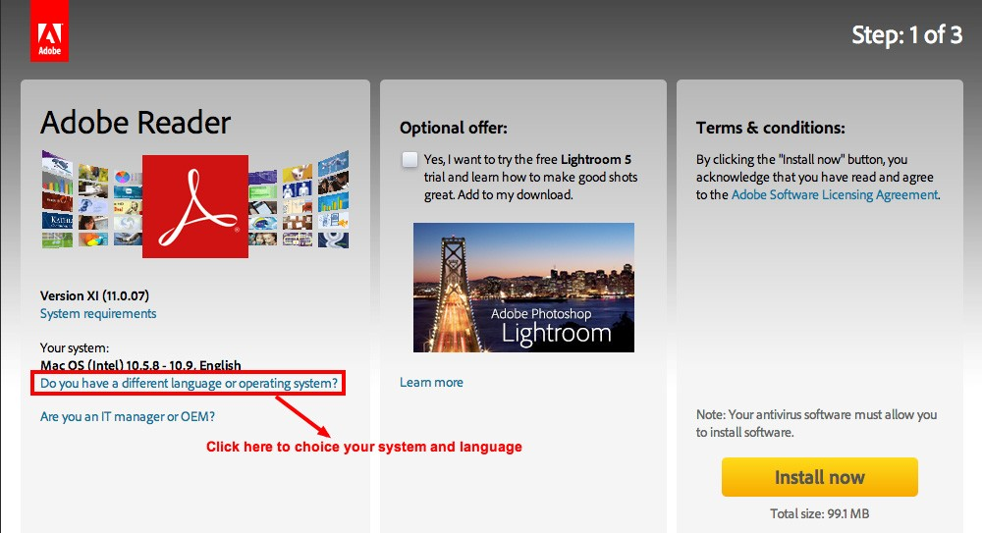

- Choose the language version according your need and download.

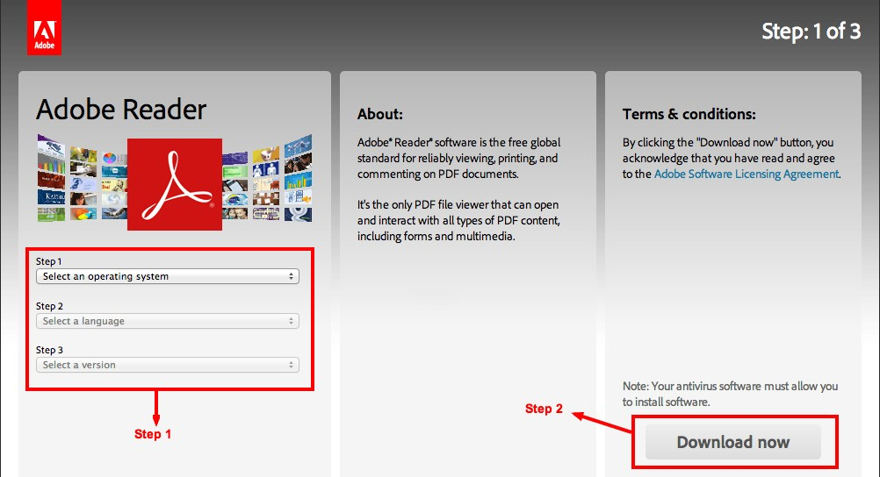

- Install the software on your computer according to the instruction.

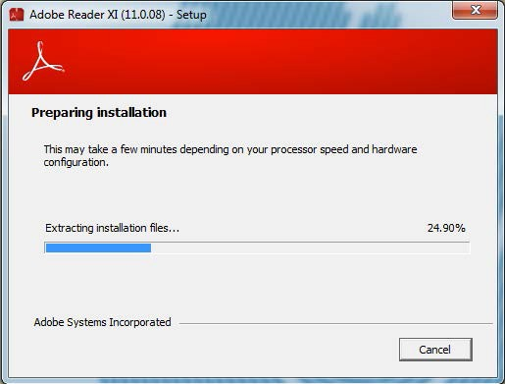

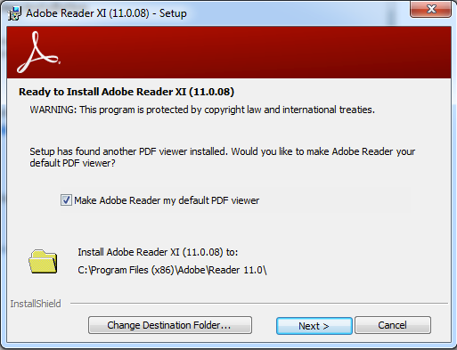

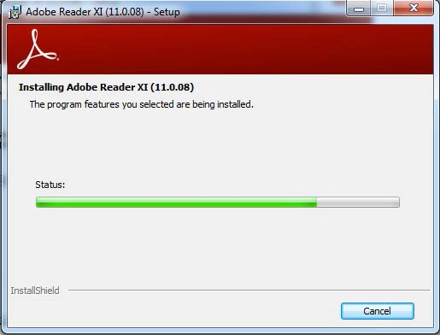

How to Install the Product Certificate

- Install Pass4Lead product certification according to the instruction.

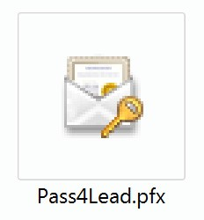

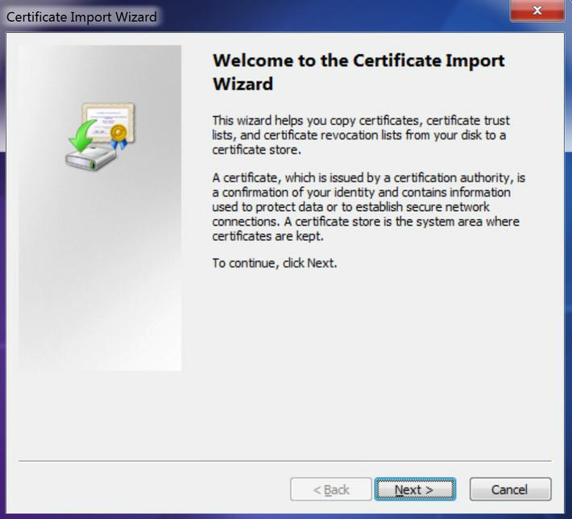

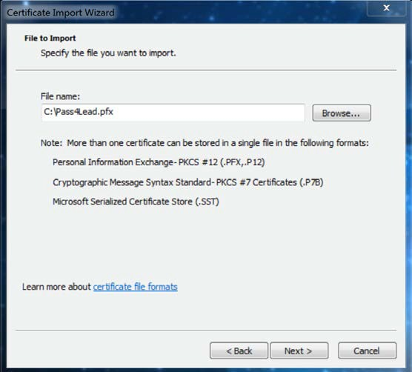

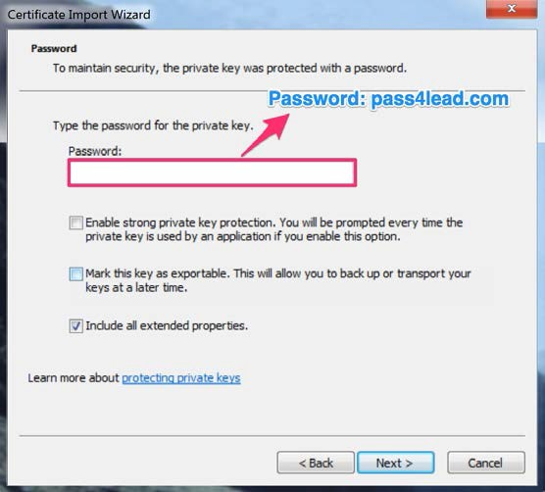

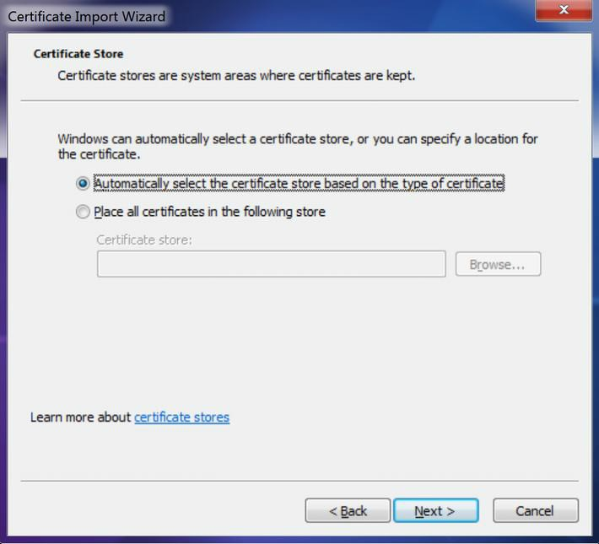

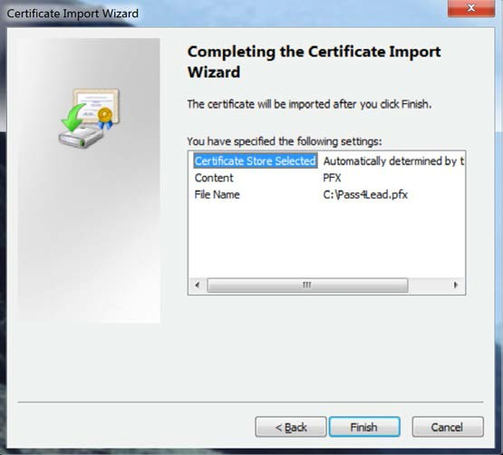

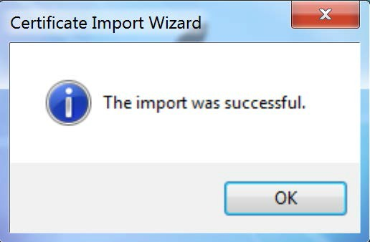

- Now you can open Pass4Lead products after the installation.

