MR. NSEREKO NAJIB,
TEL: +256748675870,
KAMPALA, MUKONO,
05th/November/2025
TO:
BELOVED FATHER MR: SSENKUNGU ALI
SUBJECT: REQUEST FOR AN NIKKAH CEREMONY
Assalamu Alaikum warahmatullahi wabarakatuh
I pray this letter finds you in good health and I thank you sincerely for your guidance, support, and the noble work your hands do for our family and community.
With utmost respect and humility, I kindly write to request permission to visit your home on 25th July 2026 at 2:00 PM to formally seek the hand of your daughter, Lunkunse Nabirah, in marriage, in accordance with Islamic tradition.
I also kindly request approval to be accompanied by my family members and close friends, totaling 15 people, to witness and support this honorable occasion.
It would truly be a blessing and great honor if my request is granted.
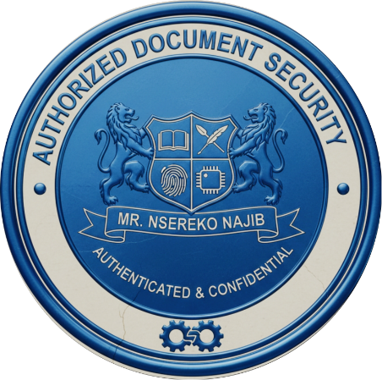
May Allah bless you abundantly, reward your efforts, and grant success and happiness to our families.
Sincerely,
Nsereko Najib

