**Assignement 5**

Rita fadlallah

**Question 1**

Write a summary of the topics about radiative heat transfer we went through including the definitions of emissivity, absorptivity and reflectivity, the view factor, the heat exchange between two black surfaces, the heat exchange between the two gray surfaces and finally the definition of radiative resistances.

* **Radiative Heat Transfer**

Radiation differs from Conduction and Convection heat transfer mechanisms, in the sense that it does not require the presence of a material medium to occur. Radiation heat transfer is the process by which the thermal energy is exchanged between two surfaces which temperatures are above zero. The transfer of heat from a body with high temperature to one with lower temperature is the process of heat radiation. All physical substances in solid, liquid, or gaseous states can emit energy through a process of electromagnetic. The intensity of heat radiation depends upon the temperature of the body and the nature of its surface. The radiation occurs constantly around us and at all temperatures, with the rate of emission increasing with the temperature.

* **Emissivity**

The emissivity of the surface of a material is its ability in emitting energy as thermal radiation. It is defined as the ratio of the radiation emitted by the surface to the radiation emitted by a blackbody at the same temperature. Emissivity is a measure of how closely a surface is to being a blackbody. The emissivity coefficient is in the range 0 < ε < 1, depending on the type of material and the temperature of the surface.

* **Absorptivity**

Absorptivity (α) of the surface of a material is a measure of its effectiveness in absorbing radiant energy. Like emissivity, value of absorptivity is in the range 0 < α < 1. It is the ratio of current radiation absorbed by the surface. It is calculated by α $=\frac{Absorbed rad}{Irradiation}= \frac{Gabs}{G}$

A blackbody, which is an idealized physical body, absorbs all incident electromagnetic radiation, regardless of frequency or angle of incidence. That is, a blackbody is a perfect absorber. Since for real objects the absorptivity is less than unity, a real object cannot absorb all incident light. The incomplete absorption can be due to some of the incident light being transmitted through the body or to some of it being reflected at the surface of the body.

* **Reflectivity**

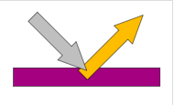Reflectivity (ρ): is the fraction of irradiation reflected by the surface. It is expressed through ρ $=\frac{Reflected rad}{Incident radiation}= \frac{Gref}{G}$ with 0 < ρ < 1

Reflectivity is an optical property of material, which describes how much light is reflected from the material in relation to an amount of light incident on the material. The reflection occurs always on the surface of the material.

* **The View Factor**

The view factor is the fraction of radiation leaving one surface which is intercepted by a second surface. It is the degree to which heat carried by radiation can be passed between two surfaces. Radiation heat transfer between surfaces depends on the orientation of the surfaces relative to each other as well as their radiation properties and temperatures. View factor (or shape factor) is a purely geometrical parameter.

* **The heat exchange between two black surfaces**

It is the difference between the radiation leaving a first surface and colliding with the radiation leaving a second surface.

* **The heat exchange between the two gray surfaces**

A gray body is the term for a non-existent, ideal body that has the same value of emissivity at all wavelengths. It is closer to a real object than an ideal black body, since it may have absorptivity less than 1 and reflectivity and transmissivity greater than 0. Grey bodies absorb a certain amount of radiation while reflecting a portion of the radiation off of the surface back into space.

* **Radiative Resistances**

It is the capacity of a surface to stand up against radiation heat exchange this property depends on geometry and in general warm resistance of the fabric.

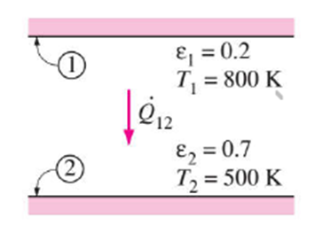**Question 2**

Find the radiative heat exchange between two parallel plates considering the two emissivities to be 0.1. What can you conclude from the result?

When ɛ1= 0.2; ɛ2= 0.7

RTotal= = + - 1= 5.43

Q ̇12= Aσ (T14 – T24) / (1/ϵ1) + (1/ϵ2)-1 = = 3625.4*A W

When ɛ1 = ɛ2= 0.1;

RTotal= + - 1= 19

Q ̇ 12= = 1035.8*A W

Increasing the emissivity of a body also increases the heat exchange between the two parallel plates.