Source code:
(ns bmi734-hw1.problem-1
(:gen-class)
(:import (org.opencv.core Mat Core CvType)
(org.opencv.imgproc Imgproc)
(org.opencv.imgcodecs Imgcodecs)))

(defn write-cleaned-image []
(let [embryos (Imgcodecs/imread "resources/embryos.jpg")
embryos_cleaned (Mat.)]
(Imgproc/medianBlur embryos embryos_cleaned 3)
(Imgcodecs/imwrite "embryos_cleaned.jpg" embryos_cleaned)
)
)
(defn write-segmented-image []
(def mri-brain (Imgcodecs/imread "resources/mri_brain.jpg"))
(def mri-brain-segmented (Mat.))
(Imgproc/Canny mri-brain mri-brain-segmented 75 200)
(let [
imsize (.size mri-brain-segmented)
zeros (Mat/zeros imsize CvType/CV_8U)
overlay (Mat.)
output (Mat.)
]
(Core/merge [zeros zeros mri-brain-segmented] overlay)
(Core/scaleAdd overlay 255 mri-brain output)
(Imgcodecs/imwrite "mri_brain_segd.jpg" output)
)
)
(defn generate-test-images [input-filename output-filename]
(let [input-image (Imgcodecs/imread input-filename)
;steps (range 4096 65536 (/ 65536 16))
steps (range 70 80 1)
neg (Mat.)
;steps (range 100 200 5)
;steps (range 200 300 5)
;steps (range 300 400 5)
output-image (Mat.)]
(doseq [step steps]
(println step)
(Core/bitwise_not input-image neg)
(Imgproc/Canny neg output-image 200 step)
(Imgcodecs/imwrite (str "tmp/" output-filename step ".jpg") output-image)
)
)
)

(defn -main []
(write-cleaned-image)
(write-segmented-image)
)

Output Images:
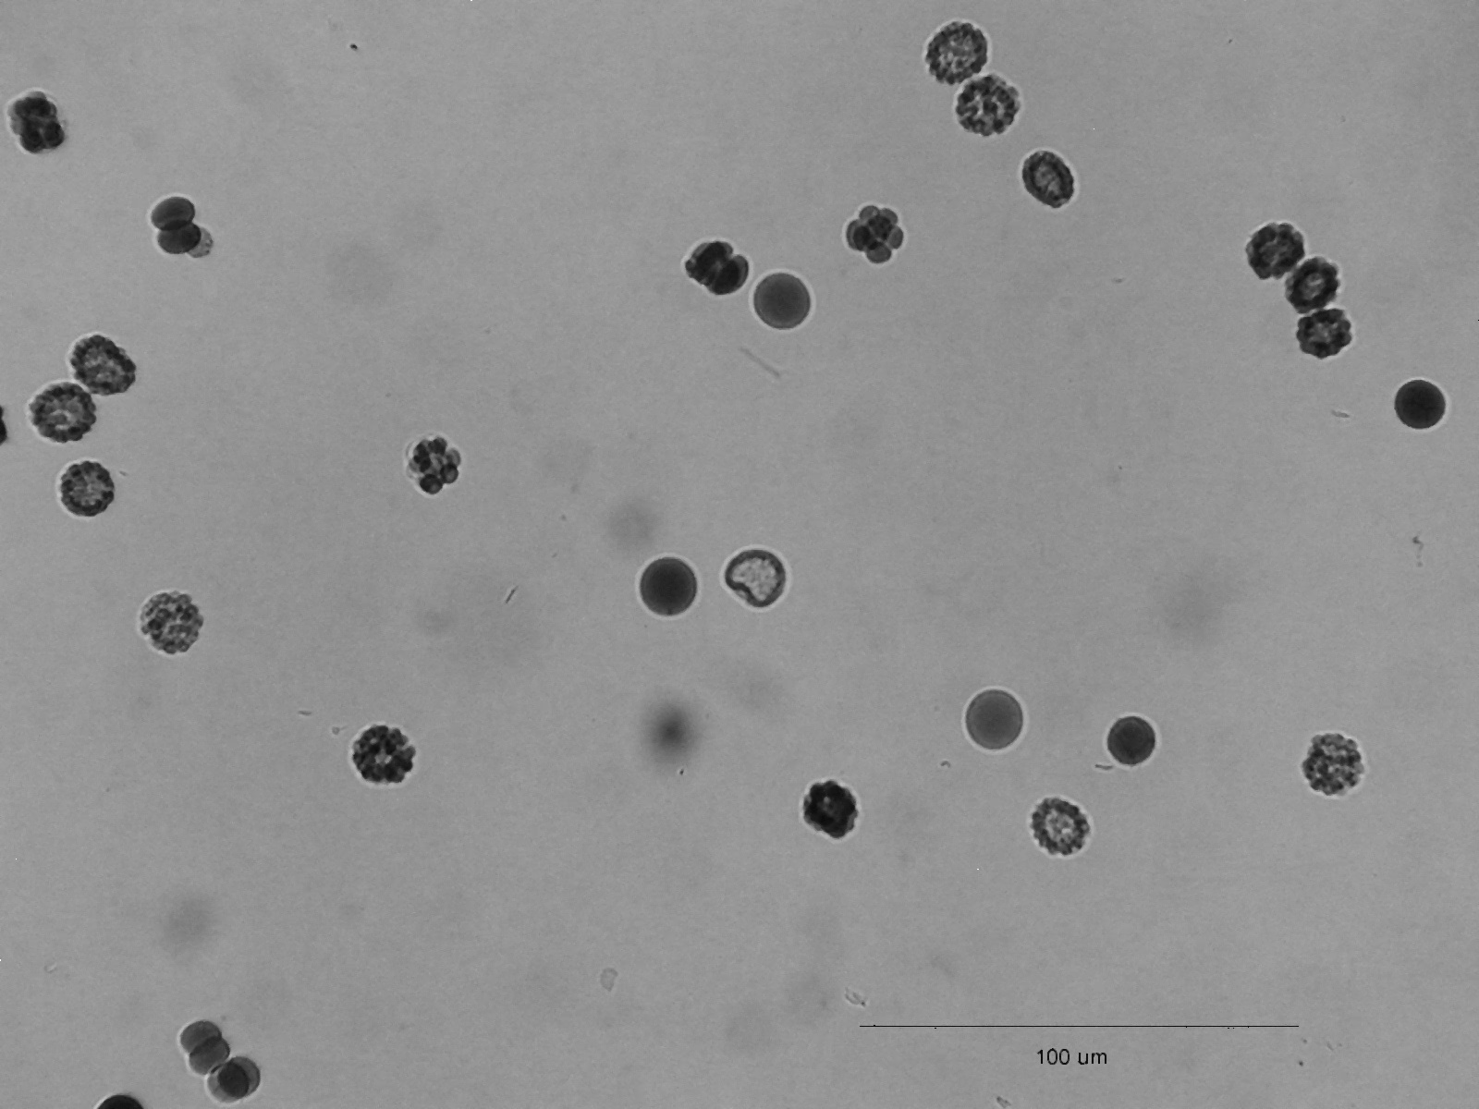

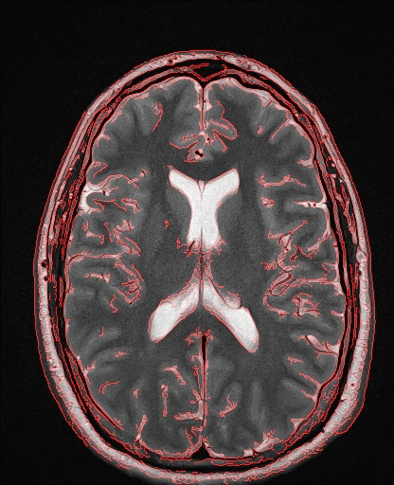

Implementation Notes:
I used the OpenCV library. I had to build the library and its Java bindings from source. Leiningen (common Clojure dependency manager) does not include the openCV library files properly, so my code ran without complaint in my local REPL but fails when packaged as an uberjar.

Cleaning the “embryos” image was straightforward. I chose to use a median filter because it gave the best results for removing salt and pepper noise in the lecture slides. I chose the smallest possible kernel (3x3) to minimize the amount of blurring applied while still removing the noise.
For the image segmentation task, I use a Canny edge detector. I found parameter values that looked “good enough” by generating test images and choosing the best-looking image. I used information from https://en.wikipedia.org/wiki/Canny_edge_detector to guide my initial choices. First, I set the upper and lower thresholds to the same value. This removed the “possible” edges from the output and only included the “definite edges”. Once I found a good value for the higher threshold, I varied the lower threshold until I found a combination of parameters that yields a good result. I took the output from the edge detector, converted it to a 3-channel color image, removed the blue and green channels, scaled it so all nonzero pixels in the red channel had maximum value, and added the resulting image to the original.

